Ashish Gupta

50134737

Homework1

**Note:** Running the runfile_hw1.m will execute the run_me.m file in the part1 and part2 folders. The output images are not being shown in the ‘figure’ but they are being saved in the respective folders (part1 and part2).

**Part1**

The output color images for the six glass plate images that were provided is shown below.

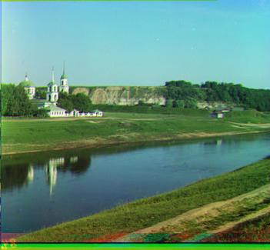 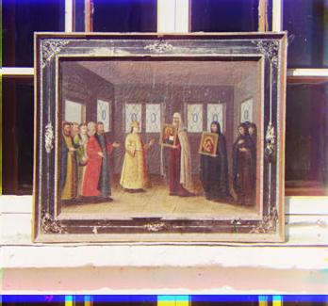

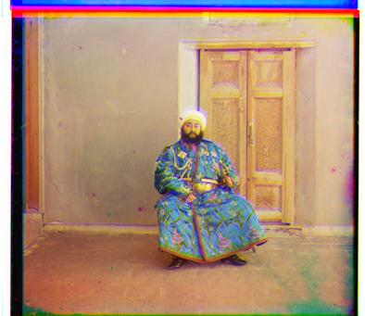 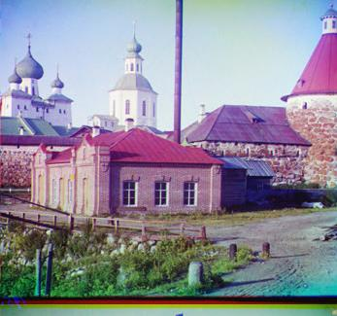

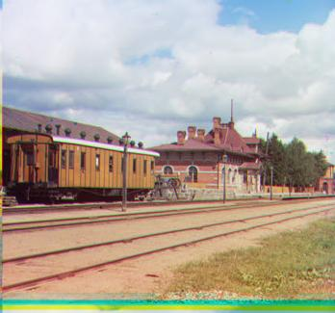 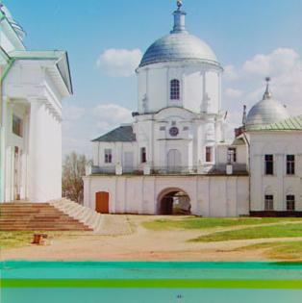

**Displacement vector for each glass plate image**

|  |  |
| --- | --- |
| Part1_1  Aligning G with B  Displacement vector  -10 1  Aligning R with B  Displacement vector  -22 1 | Part1_2  Aligning G with B  Displacement vector  -12 2  Aligning R with B  Displacement vector  -23 2 |
| Part1_3  Aligning G with B  Displacement vector  11 1  Aligning R with B  Displacement vector  19 3 | Part1_4  Aligning G with B  Displacement vector  -12 0  Aligning R with B  Displacement vector  -19 1 |
| Part1_5  Aligning G with B  Displacement vector  -10 2  Aligning R with B  Displacement vector  -21 3 | Part1_6  Aligning G with B  Displacement vector  -26 0  Aligning R with B  Displacement vector  -47 1 |

**Approach**

The glass plate image that was provided was first cropped on all sides by 25px. Cropping is needed to avoid any false results appearing when aligning the images. I have used normalized cross correlation (NCC) to align my images. Removing the white and black borders from all sides will avoid any false peaks appearing in the cross correlation map. However, it was observed that not cropping the borders for patt1_3 (fat man) and adding a cropping of 15px for the part1_6 (tomb) helped in the aligning the images properly.

After cropping the images, the plate was divided into 3 equal parts giving us three plates B, G, R (from top to bottom). The G and R plates were then aligned with the B plate using normalized cross correlation. Normalized cross correlation moves the whole template image over the reference image and finds the correlation coefficients for each point. The coefficient with max value accounts for the best match. This shows as a peak in the cross correlation map. The peak coordinates were then used to find the displacement needed for each of G and R. The NCC adds padding to the resulting coefficient matrix. The padding needs to be accounted for when calculating the displacement vector by subtracting the template image size. The G and R images are then shifted by using the displacement vectors and then stacked together to give the final RGB color image.

NCC Map

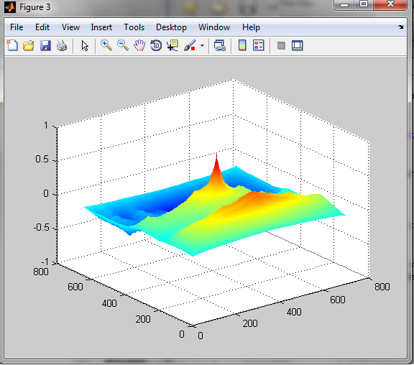

**Part 2**

**Solution Description**

Photometric stereo uses the local shading model (shading is caused by light that comes from the luminaire, there are no interreflections) and assumes that there is no ambient illumination. I started the implementation by getting the images and then subtracting the ambient image from each image so that we get the pixel intensities only illuminated by the light source (i.e. there is no ambient illumination) . The images were then rescaled by dividing all values by 255. Any negative values were reset to 0.

I then setup a linear equation of form Vg=I, for each point by traversing over the images. V is the property of the illumination and the camera, g(x,y) describes the surface and I(x,y) is the value of the pixel at (x,y) , assuming the response of the camera is linear in surface radiosity. Since we have 64 sources, I stacked up the light source directions in a vector V (64X3) and the pixel intensity at each point in a vector Ix_y(64X1) across the 64 images. Solving the equation using the least squares solution gives us the surface description at each point.

The recovered albedo(which is the magnitude of g) from the surface description provides a check on the measurement since all values lie between 0 and 1. The surface normals are extracted from g ( g divided by the magnitude of g) . The partial derivatives were calculated from the surface normal. I first tried to reconstruct the surface by finding the height map by summing up the partial derivatives along the rows. This is possible because partial derivatives provide the change in surface height in a particular direction. However this introduced a problem in the surface plot for subject ‘yaleB05’. The chin was getting elongated. This is quiet possible if there is noise in the pixel values at the starting of the integration. This error due to the noise gets passed on to the neighboring pixels with each addition across the whole surface plot. I then tried another method to calculate height map by trying a different integration path by summing up the partial derivatives along the columns and then averaging the result with the result of the first integration. The resulting surface was much better than the previous result.

Using only one integration path Averaging the integrations along two paths

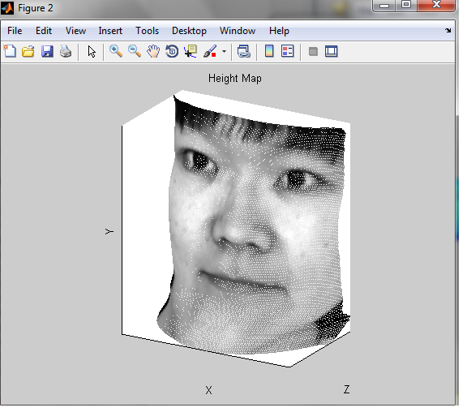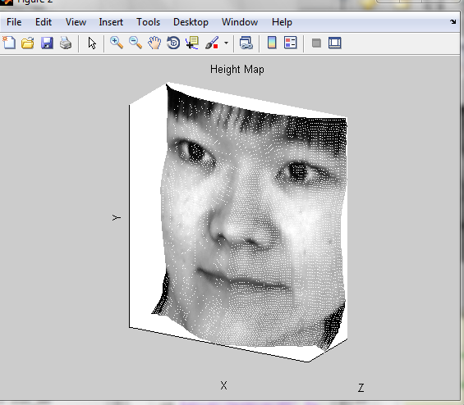

**Limitations of the implementation:**

* If the object being photographed moves as the images are being taken, this implementation would fail as we will need to align the images first and then proceed with the process to get proper surface plots.
* If the images have a lot of noise, we will need to work with the noise first or integrate along more paths before averaging out the results.
* This implementation assumes that there are no specularities. The specularities are bright patches that appear in an image and can hamper the height map formation. The specularities can easily be identified and removed.
* This implementation assumes that there are no interreflections and shadows .There can be shadows that occur due to the surface features and should be removed to get accurate surface plot.
* If the direction of the light sources is not given, this implementation will fail.
* We assume that camera performs othrographic projection.

**Albedo Maps and Height Maps**

Subject1: yaleB01

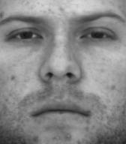 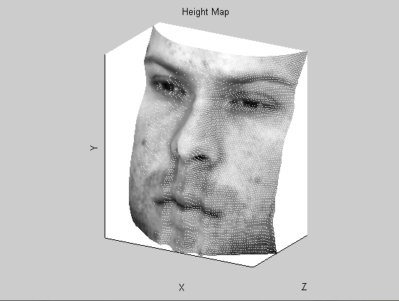

Subject2:YaleB02

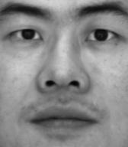 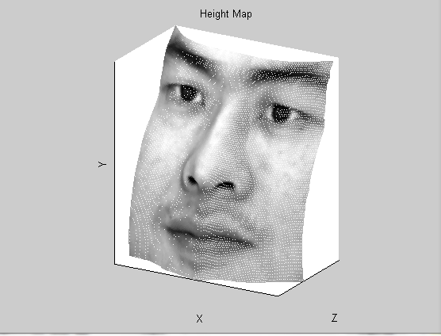

Subject3:YaleB05

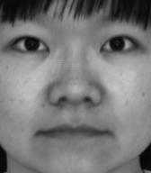 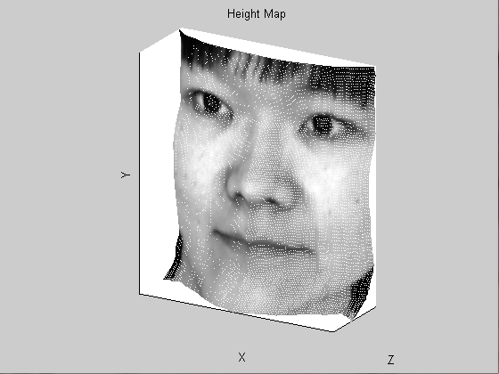

Subject4:YaleB07

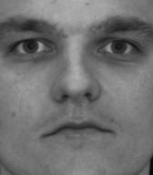 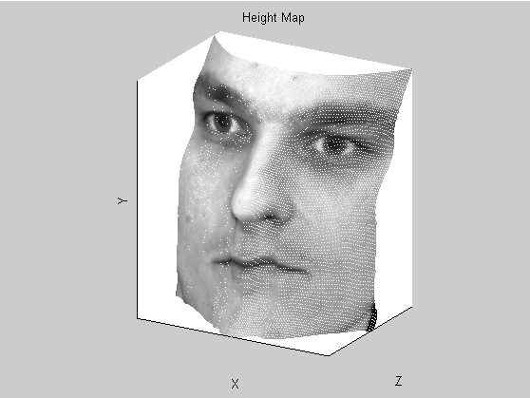

**Yale Face Data Violations**

* We assume that the object being photographed is not moving while the photographs are being taken but I noticed that images in the beginning are slightly misaligned. Here is sample example of the misalignment.

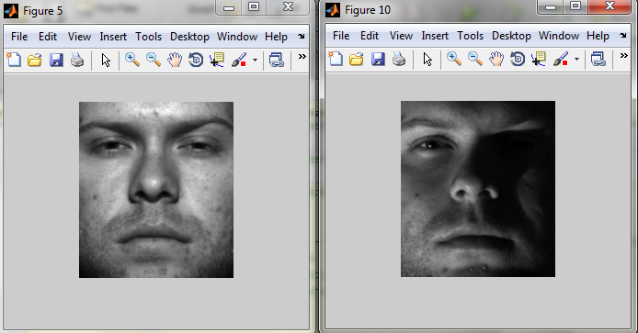

* We also assume that there are no shadows or interreflections. The image shown below has shadows occurring from the surface features i.e. eyebrows.

