Ashish Gupta

50134737

Homework3

**Problem1**

**Files**

BlockMatch.m – Written as a function which takes 4 inputs which are stereo pairs (ref,temp) , half the window size (win) (e.g. if window size being used is 3 , pass this parameter as 1 ) and ground truth for the view for which disparity is being calculated (groundTruth)

runfile_hw3.m – This runfile only calculates the disparity Maps and MSE values for all the images in the Data and Evaluation folder.

BackProjection.m – Written as a script . Performs consistency checking using back projection.

1. I tried block sizes of 3, 5 and 9 (win parameters 1,2,4). As the window size increased, the noise reduced and the disparity maps became smoother. Increasing the window size averages out any kind of noise in the neighborhood, provides better matches leading to smoother disparity maps.

Here are best estimated disparity maps:

**Disparity Map for View 1: Window Size: 9X9 MSE: 22.72**



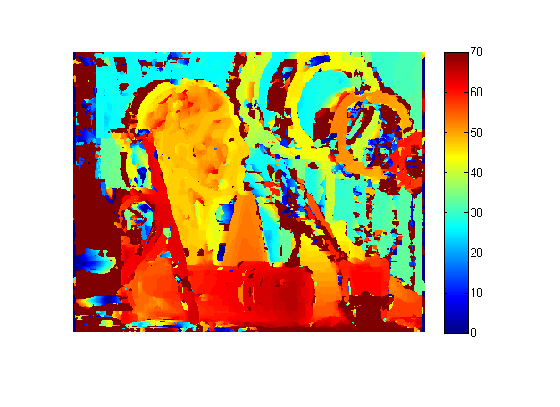

**Disparity Map for View 5**

**Window Size: 9X9 MSE : 20.07**

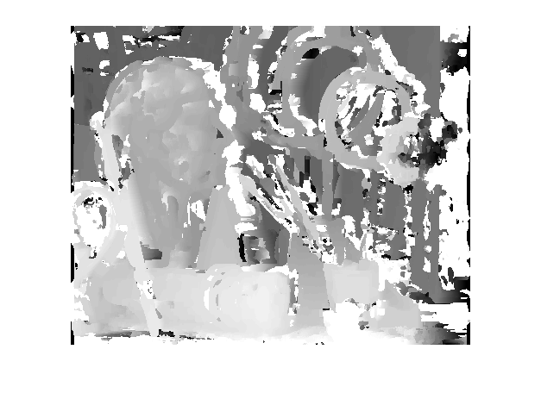

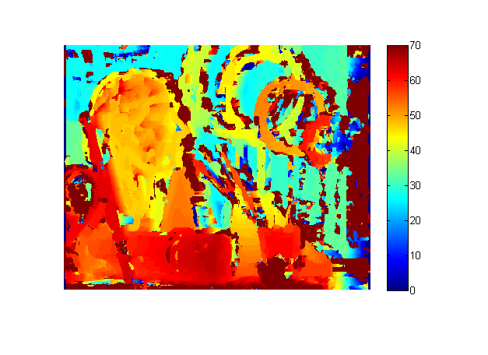

Also, I tried to estimate the disparity maps by checking the highest disparity value in the ground truth.

Max disparity: 70 Max Disparity: 100

 

**(ii)** Disparity Maps after consistency checking using back projection and marking inconsistent disparities as NaN are shown below. NaN masking was done by setting all NaN values to the ground truth value so that they get cancelled out when calculating MSE.

**Disparity Map for View 1: Window Size : 9X9 MSE after NaN masking: 2.22**

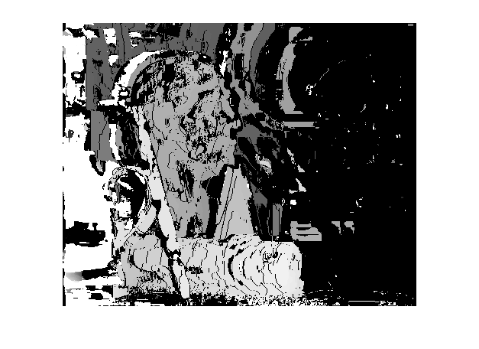

**Disparity Map for View 5 : Window Size : 9X9 MSE after NaN masking : 1.75**

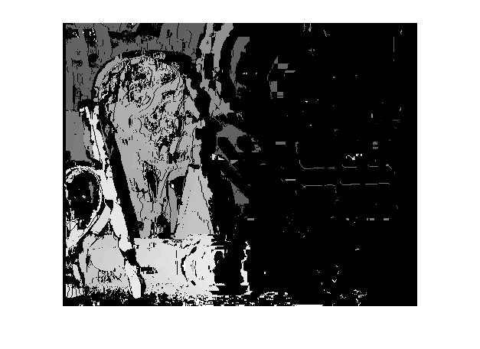

**Problem 2**

**Disparity Estimation Using Dynamic Programming**

The the implentation in the file DynamicProg.m is written as a script and the idea has been taken from the paper <http://raycast.org/powerup/publications/stereo.cvpr.pdf> . This implementation imposes ordering constraint at the pixel level . Difference.m and minValue.m files are functions that has been used within the dynamic programming implementation.

Here are the estimated Disparities using Dynamic Programming by imposing ordering constraint at the pixel level.

**Disparity Map for View 1**

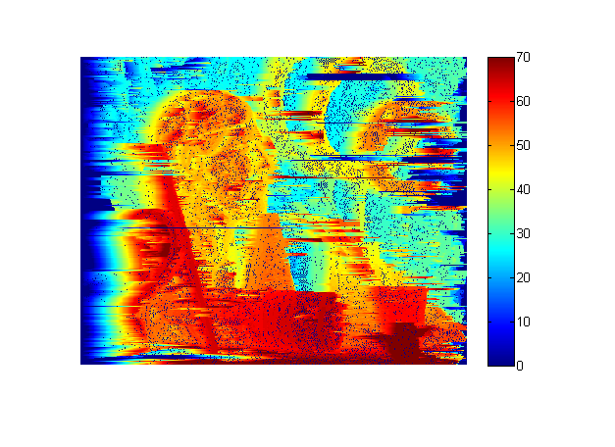

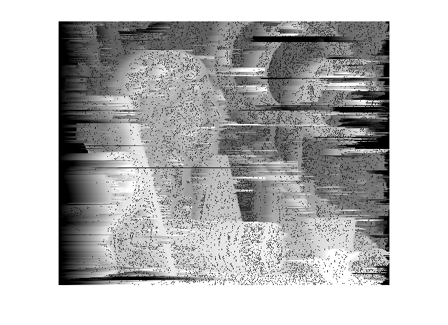

**Disparity Map for View 5**

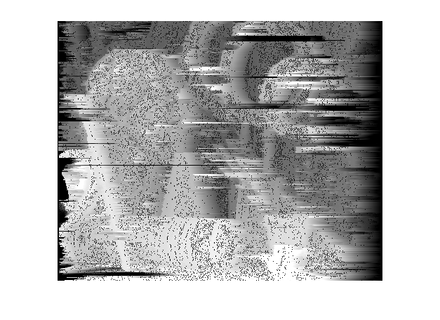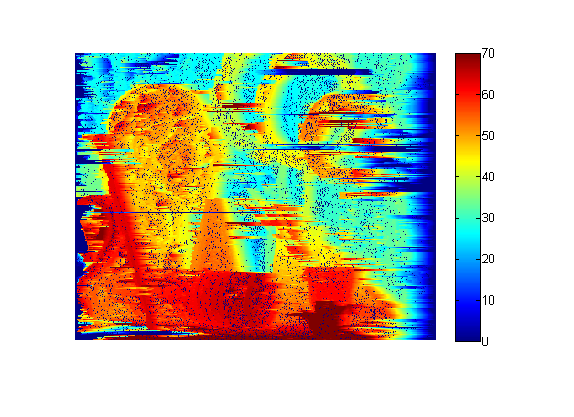

**Problem 3**

**View Interpolation - Stereo Application**

**Files :** ViewInterpolation.m has been written as a script.

Given the ground truth disparity maps of the stereo images, view3 was constructed using view1 and its ground truth disparity map by shifting pixels with half the disparity value . The resulting images had holes which were filled using view5 and its ground truth disparity map, by shifting the pixels by half the disparity. Here is the resulting image.



**Problem 4**

1. There were no chages required in my implementation of Block Matching to get it working with the Evaluation images and to generate their disparity maps. The disparity maps for all the evaluation images are shown below with the window size and MSE.

**Dolls**

Disparity Map for View1 : **Window size : 9X9 MSE 10.64**



Disparity Map for View5 : **Window Size 9X9 MSE:12.20**



**Books**

Disparity Map for View1 **: Window Size : 9X9 MSE : 33.82**



Disparity Map for View5 : **Window Size 9X9 MSE 33.17**



**Reindeer**

Disparity Map for View1 **: Window Size : 9X9 MSE 13.30**

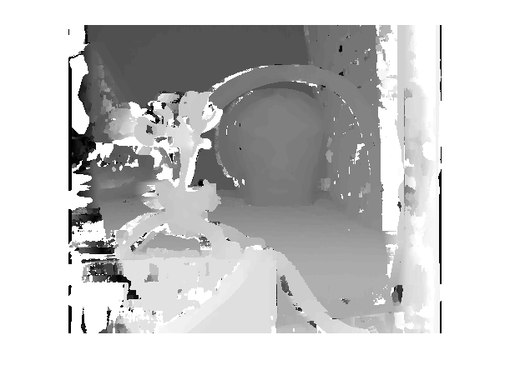

Disparity Map for View5 **: Window Size : 9X9 MSE 9.77**

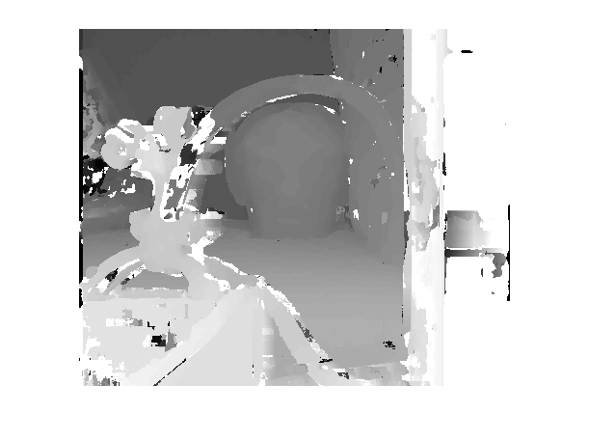

1. Similarity Constraint (Local Constraints) used here in Basic Block Matching fails when region is textureless, in case of occlusions and with Non-Lamertian surfaces. One way for matching textureless regions in the stereo images is to apply non-local constraints when matching . These non-local constraints can be:

* Uniqueness Constraints - For any point in one image, there should be at most one matching point in the other image
* Ordering Constraints - Corresponding points should be in the same order in both the images (fails in case of occlusions)
* Smoothness Constraint - The disparity value from pixel to pixel changes slowly

The Books and Reindeer images had the least texture and the MSE values for these images were comparatively high .

The Basic Block matching algotrithm and the Dynamic programming algorithm can be adapted to match textureless regions by applying the uniqueness constraint and smoothness constraint .

1. Window size is on the x-axis and MSE on the y-axis

Graph for image in the Data Set

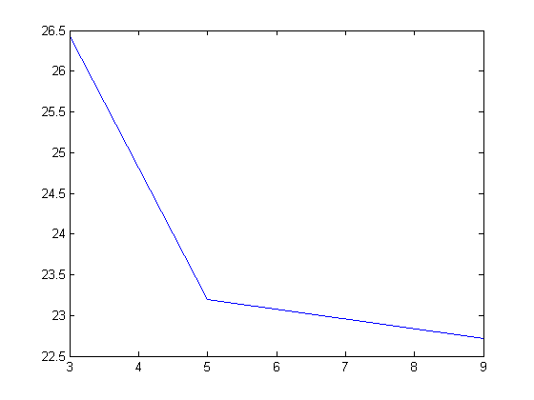

Dolls

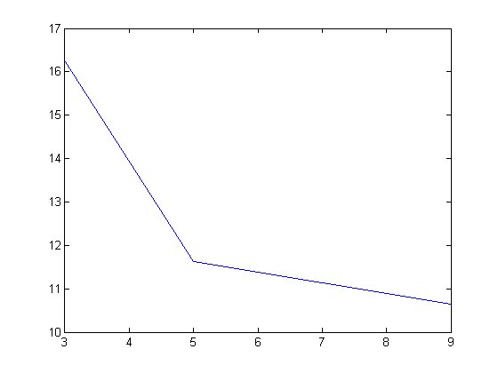

Reindeer

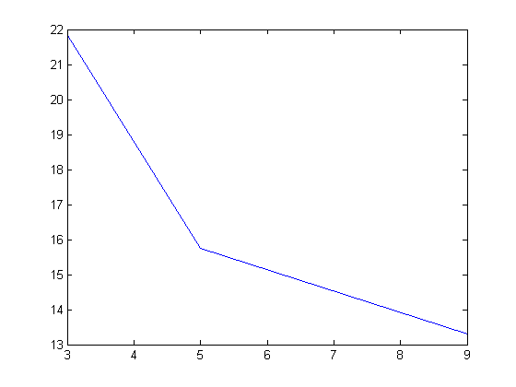

Books

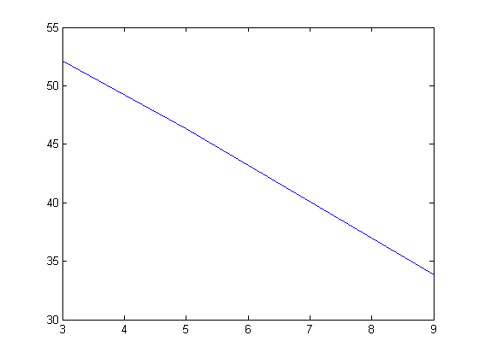

1. Built in functions used:

* Element wise operators .^
* To get window size : Image(1:value , 1:value)
* Padarray to pad the imges to accommodate the usage of windows
* Matrix subtraction instead of looping over the pixels to subtract each value.

1. Run time analysis

**Block Matching : (rows*cols*cols*windowsize)**

For each pixel in the left image (row,col) , we are scanning the same row (over all columns) to find a matching pixel using a window.

**Dynamic Programming:**

Since we are imposing the ordering constraint at the pixel level , so the overall time complexity is **(rows*cols*cols)**

As the image size goes up, excution time of both the Block matching and the Dynamic Programming goes up.

As the window size goes up, the execution time of Block Matching goes up. Dynamic Programming is independent of window size.

**Advanced Algorithms/Articles**

1. Smoothness Constraints and Combinatorial Optimization over Graphs

This method defines a combinatorial optimization algorithm aimed at minimizing an error function over discrete variables defined as correspondences between pairs of features . It relies on smoothness constraint and can be modeled as a min cut/ max flow algorithm. This enforces a global constraint and helps in estimating disparity for textureless regions .

1. Stereo Matching using Belief Propagation by Jian Sun , Heung-Yeung Shum and Nan-Ning Zheng

This article formulates the problem as a Markov Network consisting of three MRF’s which model a smooth field for disparity , line process for depth discontinuity and a binary process for occlusion. This algorithm in this article then obtains a MAP estimation in the Markov network by applying Belief Propagation.

The Block matching algorithm and dynamic programm performs badly in estimating the disparity of textureless regions . Belief Propagation via message passing is capable of sending the influence of a message far away. The message passing provides a time varying adaptive smoothing mechanism for stereo mathching which is capable of dealing with texturelss region and depth discontinuities.