

A Project Report

ON

Real Time Eye Tracking Interface-
Eye Gesture Recognition

BY

ASHISH GUPTA (1PI07I017)
ANKIT MANDAL (1PI07I017)
MAYSUN JAMIL FAISAL (1PI07I017)

Internal Guide External Guide
Prakash C.O. Rajesh Kumar
Senior Lecturer
Department of IS & E, Tata Elxsi
PESIT
Bangalore

January 2011 – May 2011

DEPARTMENT OF INFORMATION SCIENCE & ENGINEERING

PES INSTITUTE OF TECHNOLOGY
100 FEET RING ROAD, BANASHANKARI III STATE

BANGALORE-560085

PES Institute of Technology,
100 Feet Ring Road, BSK 3rd Stage, Bangalore-560085

DEPARTMENT OF INFORMATION SCIENCE & ENGINEERING

CERTIFICATE

Certified that the project work entitled Real Time Eye Tracking Interface- Eye Gesture Recognition is a bonafied work carried out by Ankit Mandal (1PI07IS017), Ashish Gupta(1PI07IS021) and Maysun Jamil Faisal(1PI07IS059) in partial fulfillment for the award of degree of Bachelor of Engineering in Information Science of the Autonomous Institute under Visvesvaraya Technological University, Belgaum during the year 2011. It is to certify that all corrections / suggestions indicated for Internal Assessment have been incorporated in the Report deposited in the Departmental Library. The Project has been approved as it satisfies the academic requirements in respect of Project work prescribed for the Bachelor of Engineering Degree.

Signature of the Guide Signature of the HOD Signature of the Principal
Mr. Prakash C.O. Prof. S.S. Shylaja Dr. K. N. Balasubramanya Murthy

Ankit Mandal -1PI07IS017

Name of the Examiners Signature with Date
1)

2)

ABSTRACT

With a growing number of computer devices around us, and the increasing time we spend for interacting with such devices, we are strongly interested in finding new interaction methods which ease the use of computers or increase interaction efficiency. Eye tracking seems to be a promising technology to achieve this goal. In this project we present a computationally efficient and cost effective solution for detection and tracking of eyes in real time. We also present a framework that can be used to investigate various strategies for human computer interaction. We commence with the extraction of human face and its various features from a low-resolution video stream. These extracted features, in particular eyes, are tracked and monitored in real time to detect any movements and variations. These variations then form the basis of various actions or responses. Lastly we demonstrate the effectiveness of our technique through experimental results and provide recommendations for future development and improvement.

ACKNOWLEDGEMENT

The completion of this project brings with a sense of satisfaction, but it is never complete without thanking the persons responsible for its successful completion

I extend my deep sense of sincere gratitude to Dr. K N B Murthy, Principal and Director, P E S Institute of Technology, Bangalore, for providing me facilities required for the semester project.

I express my in-depth, heartfelt, sincere gratitude to Prof. Shylaja S S, Head, Department of Information Science and Engineering, P E S Institute of Technology, Bangalore, for her valuable suggestions and support.

I extend my heartfelt, sincere gratitude to Mr Prakash C.O, Senior Lecturer, Department of Information Science and Engineering, P E S Institute of Technology, Bangalore, for his constant support and valuable guidance for completion of the Project.

Finally, I would like to thank all the faculty members of Department of Information Science and Engineering, P E S Institute of Technology, Bangalore, for their support.

Ashish Gupta

TABLE OF CONTENTS

- Introduction 1
- Problem Definition 2
- Literature Survey 3
  - History of Eye Tracking
  - Application Domains of Eye Tracking 4
  - Eye Gaze for Computer Input 6
  - Available Video-based Eye Tracking Systems 10
    - Types of Video Based Eye Trackers
    - Low cost Open Source Eye Trackers for HCI 11
    - Commercial Eye Trackers for HCI 12
  - Criteria for the Quality of an Eye Tracker 13
  - Difficulties and Constraints Involved 14

- Project Requirement Specification 16

- System Requirement Specification 17
  - User Requirement
  - Hardware Requirement
  - Software Requirements 18
    - Microsoft Visual Studio 2008
    - OpenCV-2.1.0a-win32
    - CMake-2.8.4-win32-X86
    - Qt-4.6 X86 19

- Gantt Chart 20
- System Design 21
  - Architecture
  - Use-Case Diagram 22
    - Use-case Description

- Detailed Design 25
  - Activity Diagrams
    - Activity Diagram for Face-detection
    - Activity Diagram for Eye-detection 26
    - Activity Diagram for Eyeball-detection 28

- Implementation 29
  - Face Detection
    - Using Haar Transformation
    - Using Continuously Adaptive Mean Shift Algorithm 31
  - Eye Detection 34
  - Eye Ball Detection and Tracking 43
    - Circle Detection by means of Contours
    - Circle Detection by means of Hough Transform 44
    - Based On Pixel Intensity

  - Sample Applications 50
    - Zooming Image Using Face
    - Drowsiness Alert 54

- Testing 56
  - Graphical Analysis
  - Snapshots 58
  - Sample timings for Test runs 62

Conclusion 63

Further Enhancements 64

Bibliography 65

LIST OF FIGURES AND TABLES

Fig 3.1: ERICA Eye Tracker 12
Fig 3.2: The Tobii X120 (stand-alone) and the Tobii
T60 (integrated into a display) 13
Fig 6.1: Gantt Chart 20
Fig 7.1: Overall flow of the Project 21
Fig 7.2: Use Case Diagram for the entire system 22
Fig 8.1: Activity Diagram for Face Detection 26
Fig 8.2: Activity Diagram for Eye Detection 27
Fig 8.3: Activity Diagram for Eyeball Detection 28
Fig 9.1: Haar-like features 30
Fig 9.2: First two Haar-like features 30
Fig 9.3: Working of Continuously Adaptive
Mean-Shift 32
Fig 9.4: Different Positions of Eye 35
Fig 9.5: Intensity Y Axis 44
Fig 9.6: Intensity X Axis 44
Fig 9.7: Detected Eye-balls using pixel intensity
variation (Scan-line Coherence) 45
Fig 10.1: Performance Comparison 56
Fig 10.2: Accuracy Comparison 57
Fig 10.3: User Interface with the coordinates of the tracked objects 58
Fig 10.4: Face, Eye and Eye Ball Detection using
Haar, Template Matching and Pixel Intensity
variation Technique respectively 59
Fig 10.5: Face, Eye and Eye Ball Detection using
Camshift, Template Matching and Pixel
Intensity variation Technique respectively 60
Fig 10.6: Zooming Image using Face 61
Fig 10.7: Drowsiness Alert Alarm 61

Table 3.1: Properties of pointing devices 9
Table 10.1: Test runs timings for different
algorithms 65

Chapter 1
Introduction

With the invention of the computer in the middle of the last century there was also the need of an interface for users. In the beginning experts used teletype to interface with the computer. Due to the tremendous progress in computer technology in the last decades, the capabilities of computers increased enormously and working with a computer became a normal activity for nearly everybody. With all the possibilities a computer can offer, humans and their interaction with computers are now a limiting factor. This gave rise to a lot of research in the field of HCI (human computer interaction) aiming to make interaction easier, more intuitive, and more efficient. Interaction with computers is not limited to keyboards and printers anymore. Different kinds of pointing devices, touch-sensitive surfaces, high-resolution displays, microphones, and speakers are normal devices for computer interaction nowadays.
There are new modalities for computer interaction like speech interaction, input by gestures or by tangible objects with sensors. A further input modality is using the eye gestures which nowadays finds its application in accessibility systems. Such systems typically use eye gaze as the sole input, but outside the field of accessibility eye gaze can be combined with any other input modality. Therefore, eye gaze could serve as an interaction method beyond the field of accessibility. The aim of this work is to find new forms of interactions utilizing eye gaze and suitable for standard users.

Chapter 2
Problem Definition

The term Real Time Eye Gesture Recognition as it is used here means the estimation of direction of the user’s gaze. Eye trackers differ in the degrees of freedom which they can track. Simple eye trackers report only the direction of the gaze relatively to the head. Systems that are more sophisticated allow free head movements in front of a stationary system. Such systems do some kind of (implicit) head tracking. In addition, wearable eye trackers for use in 3D virtual worlds have to report the direction of the gaze in space and not only relatively to the head. This project uses the term eye tracking as a synonym to eye-gesture recognition.

The Project aims at detecting Face, Eye and Eyeballs and then track those eyeballs thus defining actions for various gestures. Apart from eyeballs, the detected face and eye have also been used to define gestures.

Chapter 3
Literature Survey
3.1 History of Eye Tracking
First unobtrusive study on eye-tracking was done in 1901. A photo-graphic method and light reflections from the eye were used, recording eye movements in horizontal direction only. Judd, McAllister & Steel in 1905 applied motion picture photography for eye movement recording. The invention of motion picture photography gave the possibility of frame-by-frame analysis of the eyes’ motion and enabled quantitative research on a solid basis. In the 1950s, Alfred L. Yarbus did important eye tracking research and his 1967 book is very highly quoted. He showed the task given to a subject has a very large influence on the subject's eye movement. He also wrote about the relation between fixations and interest:
"All the records ... show conclusively that the character of the eye movement is either completely independent of or only very slightly dependent on the material of the picture and how it was made, provided that it is flat or nearly flat” The cyclical pattern in the examination of pictures "is dependent not only on what is shown on the picture, but also on the problem facing the observer and the information that he hopes to gain from the picture." "Records of eye movements show that the observer's attention is usually held only by certain elements of the picture.... Eye movement reflects the human thought processes; so the observer's thought may be followed to some extent from records of eye movement (the thought accompanying the examination of the particular object). It is easy to determine from these records which elements attract the observer's eye (and, consequently, his thought), in what order, and
how often”

"The observer's attention is frequently drawn to elements which do not give important information but which, in his opinion, may do so. Often an observer will focus his attention on elements that are unusual in the particular circumstances, unfamiliar, incomprehensible, and so on."
"... when changing its points of fixation, the observer's eye repeatedly returns to the same elements of the picture. Additional time spent on perception is not used to examine the secondary elements, but to re-examine the most important elements."

In the 1970s, there was a lot of improvement in eye-tracking technology. The eye trackers became less intrusive, provided better accuracy, and were able to dissociate eye from head movements by multiple reflections from the eye. From the 1990s up to now, there has been a steady increase in the use of eye trackers. Falling prices for the tracking systems caused wider use typically for marketing research or usability studies. Scientists started to research the possibilities of eye trackers for human computer interaction. From the 1990s up to now, there has been a steady increase in the use of eye trackers. Falling prices for the tracking systems caused wider use typically for marketing research or usability studies. Scientists started to research the possibilities of eye trackers for human computer interaction. The motivation for the system proposed here is to provide an inexpensive, unobtrusive means for disabled people to interact with simple computer applications in a meaningful way that requires minimal effort.

3.2 Application Domains of Eye Tracking
Typical application domains for eye trackers are:
- Market research and advertising testing
The perhaps biggest field in terms of money is the use of eye trackers for market research. When designing posters for an advertisement

campaign the marketing research department likes to test the materials. They present the posters to potential clients whose eyes are tracked to get answers to questions like “Did the person look at the product?”, “How much time did the gaze spend on the company’s logo?” and so on. With a portable eye tracker it is also possible to send people to a supermarket to find out which products the people notice and how much influence the form or colour or positioning of the product has on being noticed

- Usability research

Another field of commercial interest is usability testing. The first use of eye trackers, mentioned already in the section on the history of eye trackers, was done in 1947 for the American air force to find out the best positions for the controls in an aircraft cockpit. With the rise of the World Wide Web as a commercial platform the usability of web pages became an important topic. The user interfaces provided by web pages are very often the only contact of the company and the client and if only few percent of the users are irritated and do not click the “I order now” button the company loses sales.

- Eye control for accessibility

Another field for eye trackers is accessibility. Quadriplegics and people with diseases, causing a loss of control over the muscles, use eye trackers to interact with the world. Such eye tracker systems provide an eye-typing interface with a text-to-speech output. In addition, other types of eye-control, for instance directing the wheel 2 Overview and Related Work 17 chair or switching on the TV, are common in this field.

- Medical research, diagnostics and rehabilitation

Eye trackers are also a valuable tool for medical research and diagnostics to examine the function of the eyes especially on people with eye injuries or brain damage causing partial loss of vision. In these cases eye tracking is used to monitor the success of physical rehabilitation.
- Gaze interaction and car assistant systems

Future applications for eye-tracking technologies are gaze interaction for regular users. A TV set could switch on by itself when somebody is looking at it. The car industry does research in this field too, with the aim of developing assistant systems for cars. For example, an eye tracker in the car could warn the driver when she or he falls asleep while driving the car. This field of application for eye tracking is not yet commercially available and needs further research.

3.3 Eye Gaze for Computer Input

An eye-gaze interface seems to be a promising candidate for a new interface technique, which may be more convenient than the ones we use. Traditionally, disabled people who cannot move anything except their eyes use eye gaze interaction. These systems are designed to direct the computer solely by the eyes. Such systems work well and are a great help for people who need them, but for others they are cumbersome and less efficient than keyboard and mouse. This contradicts the fact that looking is an easy task and that eye movements are fast. Consequently, eye-gaze interfaces for the masses need a different design to bring benefit to the average user.

An eye-gaze interface might offer several potential benefits:
• Ease of use
A benefit of eye tracking could be reduced stress for hand and arm muscles by transferring the computer input from the hand to the eyes. This need not necessarily put extra load on the eye muscles because for most interactions the eyes move anyway. For example, when clicking a button on the screen in most cases mouse and eyes move to the target (see 4.4.2 for a detailed discussion).
• Interaction speed-up
Eye-tracking interfaces could speed up the interaction, as the eyes are quick. Although existing eye-typing systems are slower than traditional keyboard input, the combination of eye gaze with another input modality can provide fast interaction.
• Maintenance free
Video-based eye tracking works contact free which means that no maintenance is necessary. There is no need to clean the device, which is a typical problem for keyboards and mouse devices. Placing the camera behind strong transparent material results in a vandalism-proofed interface, which is nearly impossible to realize for keyboards and mouse devices.
• Hygienic interface
In environments with high hygienic demands, like an operation room for surgery, an eye-gaze interface would be useful because it allows interacting without anything to touch. Also for public interfaces, especially in times of pandemic threats, hygienic interaction is desirable.
• Remote control
Another benefit resulting from eye tracking is possible remote control. Zoom lenses and high-resolution cameras make eye gaze detection

possible over some meters of distance. Even the low-cost eye tracker used in the user studies of this thesis offers one meter distance which is longer than an arm length.
• Safer interaction
Eye tracking not only guarantees the presence of a person but also his or her attention. A mobile phone, which requires eye contact for an outgoing call, will not call somebody because of accidentally pressed buttons while in a pocket. Eye tracking can ensure certain behaviour of
the users. For example, a system can demand that a warning text is read before allowing the user to continue with other functions.
- More information on the users activity
The eyes tell a lot about what somebody is doing. Tracking the eyes provides useful information for context-aware systems. In the simplest form an eye tracker tells where the attention is, which already has a big potential for the implementation of context-awareness. Simple analysis of the eye tracker data can detect activities like reading. Analysis that is more sophisticated could reveal the physical or emotional condition of a user, her or his age, and degree of literacy.

Of course, there are also possible problems.
- Ability to control
The eyes perform unconscious movements and this might disturb their use as computer input. It is not clear to which degree people are able to control the movement of their eyes. The ability to control the eyes consists of both suppressing unintended movements and performing intended eye movements. It seems that we are at least able to control where we look because this is required by our social protocols. However, it is not clear whether we can train the motor skills of the

eye muscles to the same extent as we can train the fingers for playing the piano.

• Conflict of input and vision
The primary function of the eyes is to enable vision. Using the eyes for computer input might result in conflicts. The well-known conflict is the Midas Touch problem – for the eye-gaze interface it is difficult to decide whether our gaze is on an object just for inspection or for invoking an action. Misinterpretation by the gaze interface can trigger unwanted actions wherever we look. The situation is similar when triggering actions by eye movements, i.e. gestures. The eye-gaze interface has to separate natural eye movements from intentional gaze gestures. Distraction by moving or blinking objects might also cause conflicts. The question how blinking advertisements on a web page interfere with eye gaze interaction is still a topic of research.
• Fatigue of the eye muscles
From other input devices we know that extensive use of particular muscles or muscle groups can cause physical problems called RSI (repetitive strain injury). There are fears that this might happen to the eye muscles too. The concern is justified and should be taken seriously, but as the eyes move constantly, even while we sleep, it might not turn out to be a problem.
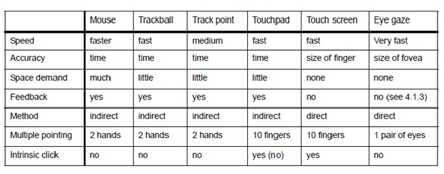
Table 3.1 : Properties of pointing devices

3.4 Available Video-Based Eye Tracker Systems

3.4.1 Types of Video-Based Eye Trackers
The most common mechanical setup is a stationary eye tracker. Such systems are commercially available as a laboratory tool and are typically used in medical research or marketing research. These systems comprise

of as a desktop computer with integrated eye tracker and with a software package for analyzing and visualizing eye-gaze data. While medical eye trackers often have a chin rest for head fixation, marketing research prefers systems with additional head tracking for free head motion in front of the device. Such systems often have two cameras for stereoscopic view but details on how the system works exactly are a business secret of the producing company.
Accessibility systems typically use a tablet computer with an external camera which both can be mounted on a wheel chair. Such systems normally come along with an eye-typing application and a speech synthesizer.
An alternative mechanical setup is a head-mounted eye tracker. With a laptop for the image processing in a backpack head-mounted eye trackers are wearable and allow free mobility of the user. Beside a camera which observes the eye such systems have an additional head-mounted camera which records the field of view.
The number of research eye-tracker systems is immense and they are normally not available for purchase. Such systems are typically purpose-built with properties a commercial eye tracker does not have or even to research new eye-tracking technologies.

3.4.2 Low-Cost Open Source Eye Trackers for HCI
For research in the field of HCI it is sometimes advantageous to build an eye tracker yourself. This allows modifications for research purposes, which are difficult with commercial systems as the company who builds the eye tracker normally tries to protect their intellectual property, and does not provide the necessary information. A self-built eye tracker is also much cheaper.
Another category uses electric potentials measured with electrodes placed around the eyes. The eyes are the origin of a steady electric potential field, which can also be detected in total darkness and if the eyes are closed. It can be modeled to be generated by a dipole with its positive pole at the cornea and its negative pole at the retina. The electric signal that can be derived using two pairs of contact electrodes placed on the skin around one eye is called Electrooculogram (EOG). If the eyes move from the centre position towards the periphery, the retina approaches one electrode while the cornea approaches the opposing one. This change in the orientation of the dipole and consequently the electric potential field results in a change in the measured EOG signal. Inversely, by analyzing these changes in eye movement can be tracked. Due to the discretization given by the common electrode setup two separate movement components – a horizontal and a vertical – can be identified. A third EOG component is the radial EOG channel, which is the average of the EOG channels referenced to some posterior scalp electrode. This radial EOG channel is sensitive to the saccadic spike potentials stemming from the extra-ocular muscles at the onset of saccades, and allows reliable detection of even miniature saccades.

3.4.3 Commercial Eye Trackers for HCI
The number of available systems is continuously increasing. The selection presented here is not a recommendation and chosen only for the purpose of illustration.
A typical eye tracker for the field of accessibility comes from ERICA. The eye tracker consists of a tablet PC and an external camera and it can easily be mounted on a wheel chair.

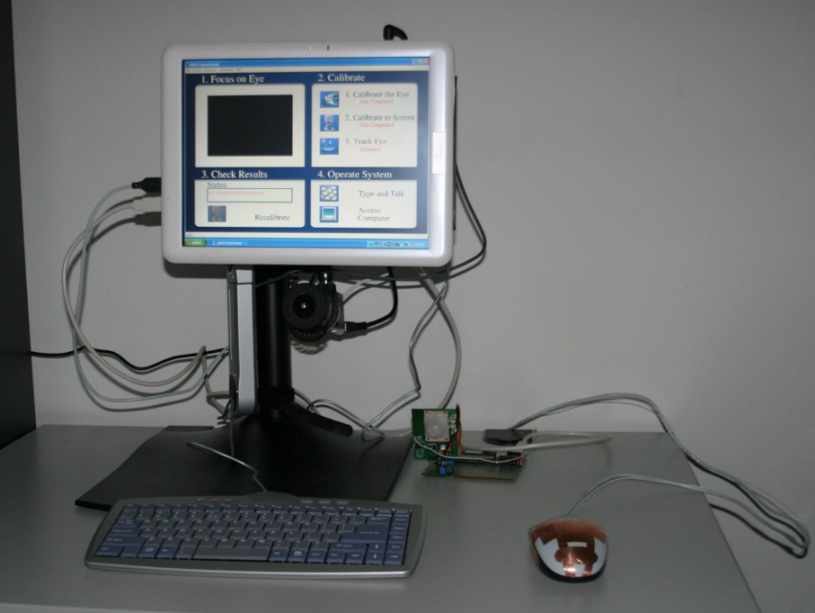
Fig 3.1: ERICA Eye Tracker

Probably the most popular eye tracker manufacturer is Tobii. The Tobii eye trackers allow free head movements in front of the device and can be found at psychology departments and marketing research companies.

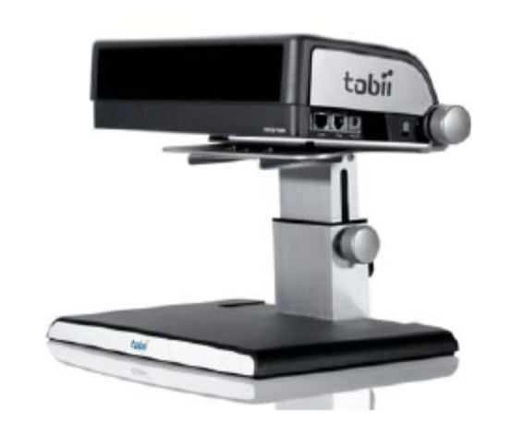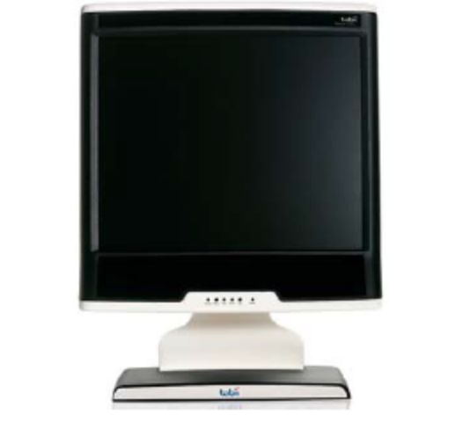
Fig 3.2 : The Tobii X120 (stand-alone) and the Tobii T60 (integrated into a display)

3.5 Criteria for the Quality of an Eye Tracker

There are many different criteria for the quality of an eye tracker. The question how to weigh these criteria depends on the purpose the eye tracker should be used for. Beside the main criteria as the technology of the eye tracker (black or white pupil detection, etc.) and the mechanical setup (stationary or mobile) there are the following further aspects:
• Accuracy As explained later there is an accuracy limit for the eye of about ±0.5° caused by the anatomy of the eye. Most eye trackers today state exactly this value in their data sheets. Such accuracy is sufficient for human-computer interaction. Research on micro saccades and tremor requires better accuracy.
• Time resolution and latency Every eye tracker reports the gaze direction in certain time intervals. For video-based eye trackers the time intervals are determined by the frame rate of the video camera. However, the frame rate does not necessarily correspond to the time resolution. For example, the ERICA eye tracker used for the user studies presented later reports coordinates with a frame rate of 60 Hz but does not report any

data during a saccade. In many cases the latency, that means the delay in reporting the data, is more important than the time resolution especially in the field of HCI where instant response of a system is crucial.

• Robustness An eye tracker should work reliably in any situation and with all persons. A situation where an eye tracker does not work any more could be difficult light conditions. The same can happen if a person wears contact lenses or glasses.
• Low-level filtering The raw data from an eye tracker are noisy and have gaps while the eye is closed when blinking. For this reason the eye tracker filters the noise and smoothes the signal. In consequence, the eye tracker does not report small movements of the eye. It depends on the eye-tracker system to which extent it is possible to set parameters to control the smoothening of the signal.
• Application programming interface and data visualization Most eye trackers come along with a software package for visualization and evaluation of recorded eye movements. An eye tracker also provides some kind of application programming interface, which makes it possible to write applications for the eye tracker.

3.6 Difficulties and Constraints Involved

Constraints

- One major issue with the cameras currently being used is that low contrast among eye/ facial features renders the tracking system un-operable. In other words, individuals with brown/dark pupils and/or eyebrows closely matched to their skin tone are hard to track, due to the small differences in the contrast between these features.

Higher quality cameras with greater contrast ratios may remedy this problem.

- Some persons cannot be eye tracked for physiological reasons: the pupil may not reflect enough light, or the iris may be too light in colour to be distinguished from the pupil reflection; the pupil may be too large or it may be occluded by eye lashes or eye lids, making the eye difficult to track; the person may have a wandering eye; etc.

Other persons cannot be eye tracked, for external reasons, such as eyeglasses or hard contacts.

- Problems can occur during the eye-tracking process: a person’s eyes may dry out during an experiment and become difficult to track. Sometimes a participant can be eye tracked one day and not the next, or half way through a test the eye track degrades to the point that the data collected cannot be used

- While using a remote eye-tracking system, head movement may cause a delay until the eye tracker reacquires the eye, and may also cause loss of calibration. Restraining methods to keep the participant’s head stationary may cause the participant to feel awkward and the testing situation to become completely unnatural.

- Interpreting eye-tracking data isn’t always easy, and can be an issue. Integrating eye-tracking data with data from traditional interviewing and observing methods can be even more challenging.

Negative consequences of these constraints are:

Restricting participants to those for instances without glasses limits the participant pool and may affect how representative the sample is.

The low success rate of gaining useful eye-tracking data from participants, and as a consequence the loss of participants (because of unacceptable data), means time and money wasted.

Chapter 4
Project Requirement Specification

Eye tracking and the information provided by the eye features have the potential to become an interesting way of communicating with a computer in a human-computer interaction (HCI) system. Providing a real-time eye feature tracking interface is the aim of this project.

Scope of Work

The purpose of the project was to implement a real-time eye tracker with the following capabilities and to integrate it with Qt:
- Real-time face tracking with scale and rotation invariance
- Tracking the eye areas individually
- Detecting and tracking the eyeball
- Analyzing the values obtained to define gestures in Qt
- Integration of the above into a framework and development of a sample application
Sample Application Examples-
- Image Zoomer using Face
- Ball in the Hole
- Drowsiness Alert

Chapter 5
System Requirement Specification

The complete code for the system is written in C++ using the OpenCV libraries. OpenCV means Open Source Computer Vision Library. It is a collection of C functions and a few C++ classes that implement many popular Image Processing and Computer Vision algorithms. OpenCV provides cross-platform middle-to-high level API that includes about 300 functions and a few C++ classes.
The integrated development environment, IDE used is Microsoft Visual Studio 2008 Full Edition. All the libraries of OpenCV are integrated with Visual Studio to make the application for image processing using C++. Cmake is used to create a wrapper for the OpenCV to integrate with Microsoft Visual Studio 2008 Full Edition.

5.1 User Requirements
The user requires to be physically present in front of the webcam if possible should not be wearing glasses and other ornaments. Fair complexion and clean shaved faces provide a better result.

5.2 Hardware Requirements
The hardware requirements for complete installation of Visual C++ 2008 Express Edition are as follows:
- Minimum: 1.6 GHz CPU, 192 MB RAM, 1024x768 display, 5400 RPM hard disk
- Recommended: 2.2 GHz or higher CPU, 384 MB or more RAM, 280x1024 display, 7200 RPM or higher hard disk
- On Windows Vista: 2.4 GHz CPU, 768 MB RAM
- 1.3 GB of available disk space for the full installation

5.3 Software Requirements
The system requires a set of image processing libraries that are used for performing image processing tasks in C++ language. These libraries are provided by OpenCV. To create a wrapper for OpenCV and intergrate it with Microsoft Visual Studio 2008 Full Edition, Cmake is used. User Interface has been built using a cross platform software Nokia Qt.

The Softwares used for the creation of the project are as follows:
    - Microsoft Visual Studio 2008
Microsoft Visual Studio is a commercial, integrated development environment (IDE) product from Microsoft for the C, C++, and C++/CLI programming languages. It has tools for developing and debugging C++ code, especially code written for the Microsoft Windows API, the DirectX API, and the Microsoft .NET Framework

    - OpenCV-2.1.0a-win32
OpenCV is a collection of C functions and a few C++ classes that implement many popular Image Processing and Computer Vision algorithms. OpenCV provides cross-platform middle-to-high level API that includes about 300 functions and a few C++ classes.

5.3.3 CMake-2.8.4-win32-x86
CMake is a unified, cross-platform, open source build system that enables developers to build, test and package software by specifying build parameters in simple, portable text files. It works in a compiler-independent manner and the build process works in conjunction with native build environments, such as make, Apple's Xcode and Microsoft Visual Studio.

The system also needs the Haar classifier cascade for face detection. It is an external xml file that is loaded in the system. Besides this, for the creation of the histograms for eye localization, the training set images are used by the system.

    - Qt 4.6 –win32-x86
Qt is a cross-platform application framework that is widely used for developing application software with a graphical user interface (GUI) (in which cases Qt is referred to as a widget toolkit), and also used for developing non-GUI programs such as command-line tools and consoles for servers.

Chapter 6
Gantt Chart
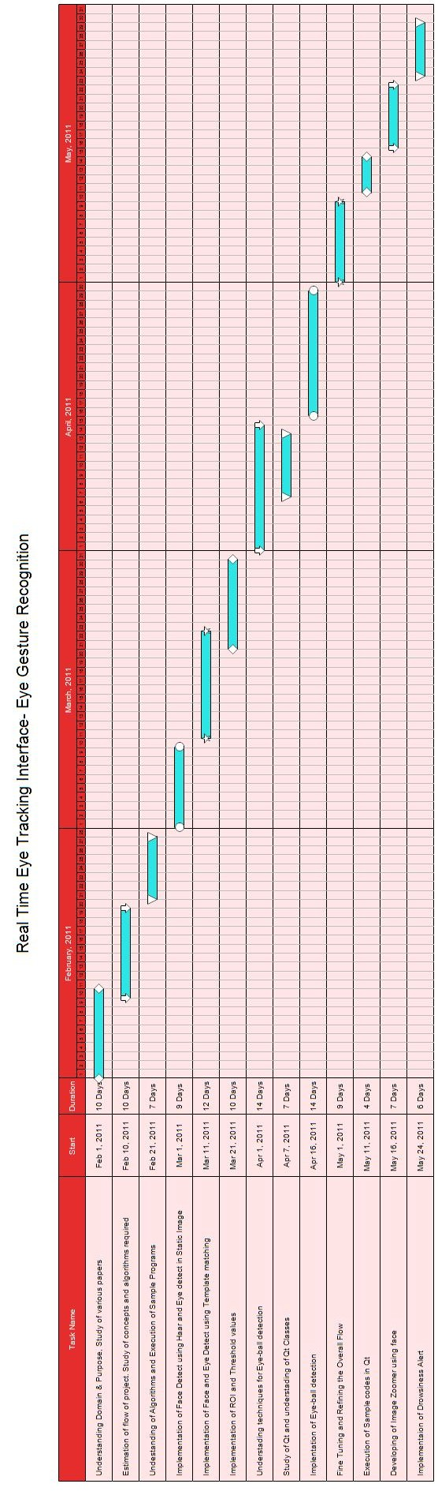
Fig: 6.1 Gantt Chart

Chapter 7
System Design

The complete real time Eye Tracking Interface is divided into three phases: face detection, eye detection and eye ball detection and tracking.

7.1 Architecture

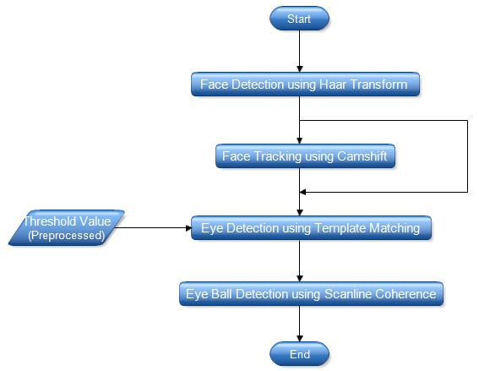

Fig 7.1: Flowchart of the Project

7.2 Use Case Diagram
The following use cases diagram shows the static view of the system and represents how the user interacts with the system.

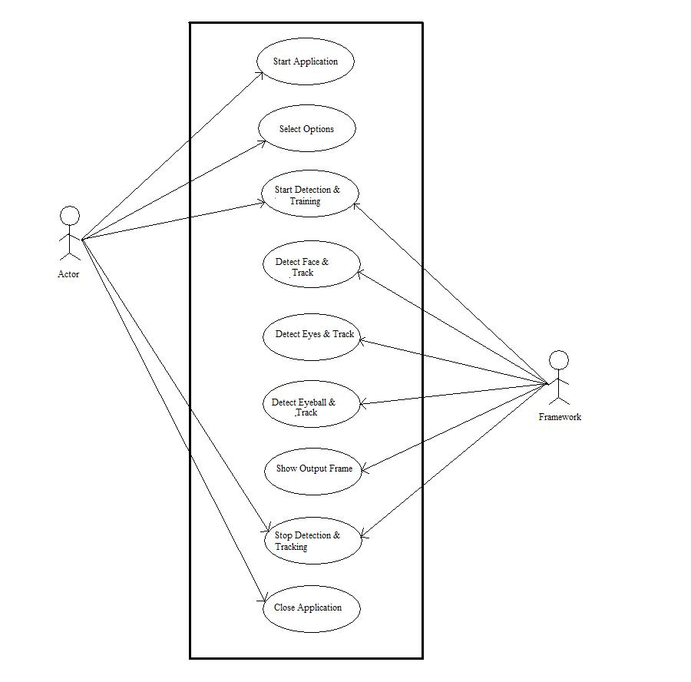
Fig 7.2: Use Case Diagram for the entire system

7.2.1 Use Case Description
Use Case 1
Name: Start Application
Primary Actor: User
Task: To open the UI of the application, where the user can interact with the framework.
Use Case 2

Name: Select Options
Primary Actor: User
Task: Gives the user options as to whether he wants to use Haar or Camshift, ROI or without ROI etc. And whether to launch the sample application
Use Case 3

Name: Start Detect & Tracking
Primary Actor: User & Framework
Task: When the user clicks the start button, the control is transferred to the framework which interacts with the user.
Use Case 4

Name: Detect & Track Face
Primary Actor: Framework
Task: It detects the face after the training the system with Haar cascade classifiers, and tracks the face if Camshift is enabled.
Use Case 5

Name: Detect & Track Eye
Primary Actor: Framework
Task: It detects and tracks the eye after finding the threshold.

Use Case 6

Name: Detect & Track Eyeball
Primary Actor: Framework

Task: It detects the Eyeball after finding the threshold and necessary variables.

Use Case 7

Name: Show Output Frame
Primary Actor: Framework
Task: It displays the output on the screen with the detected face, eye and eyeball.

Use Case 8

Name: Stop Detection & Tracking
Primary Actor: User & Framework
Task: It stops the detection and tracking of all the entities once the user has clicked stop.

Use Case 9

Name: Close Application
Primary Actor: User
Task: It closes the UI of the application when the user presses the close button
Chapter 8
Detailed Design
8.1 Activity Diagrams
8.1.1 Activity Diagram for Face Detection
Haar-like features encode the existence of oriented contrasts between regions in the image. A set of these features can be used to encode the contrasts exhibited by a human face and their spacial relationships. Haar-like features are so called because they are computed similar to the coefficients in Haar wavelet transforms.
The classifier is trained with a few hundreds of sample views of a part of face c, that are scaled to the same size (say, 20x20), and negative examples - arbitrary images of the same size.
The classifier is designed so that it can be easily "resized" in order to be able to find the objects of interest at different sizes, which is more efficient than resizing the image itself. So, to find an object of an unknown size in the image the scan procedure should be done several times at different scales.
The Camshift skillfully exploits the mean-shift algorithm by changing the size of the window when it came to convergence . Camshift differs from the mean shift in that the search window adjusts itself in size.
Many people think of mean-shift and camshift as tracking using color features, but this is not entirely correct. Both of these algorithms track the distribution of any kind of feature that is expressed in the problem image; hence they make for very lightweight, robust, and efficient trackers.

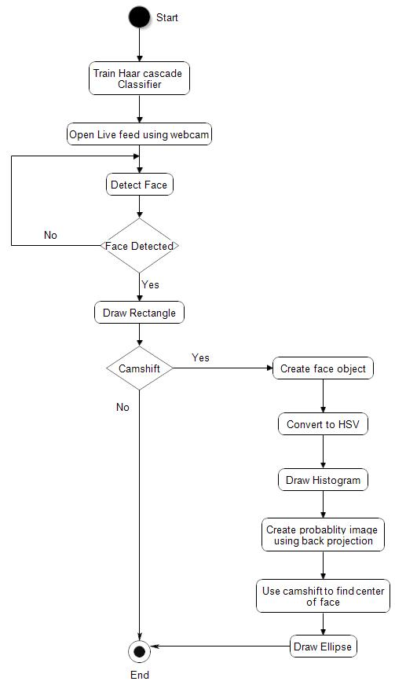
Fig 8.1: Activity Diagram for Face Detection

8.1.2 Activity Diagram for Eye Detection
After the face is detected and tracked then comes detection and tracking of the eye. We use Template matching. It is a technique in digital imaging for finding small parts of an image which match a template image. For templates without strong features, or for when the bulk of the template image constitutes the matching image, a template-based approach may be effective. Since template-based template matching may potentially require sampling of a large number of points, it is possible to reduce the number of sampling points by reducing the resolution of the search and template images by the same factor and performing the operation on the resultant downsized images (multi resolution, or pyramid, image processing), providing a search window of data points within the search image so that the template does not have to search every viable data point, or a combination of both.

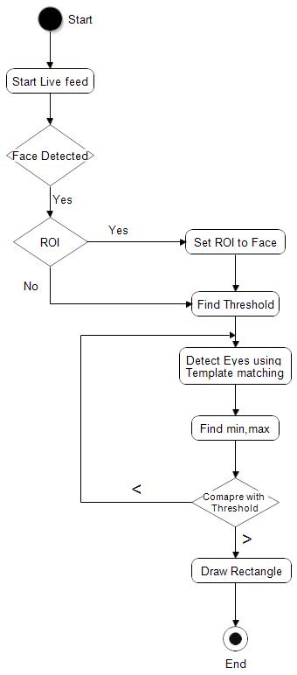
Fig 8.2: Activity Diagram for Eye Detection

8.1.3 Activity Diagram for Eye Ball Detection
After the face and the eyes are detected and tracked, the eyeball comes next in line. To detect the eyes, the ROI is set to the eyebox of the eyes. We scan the X-axis and the Y-axis of the eyebox for the average minimum and the average maximum for both the axes. We then find the threshold based on the values. The eyeball center is determined and the with the help of radius, the circle around the eyeball is drawn.

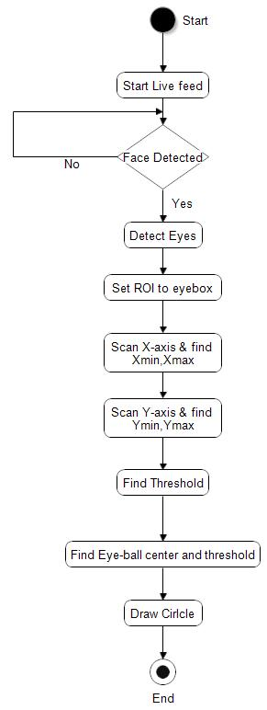
Fig 8.3: Activity Diagram for Eyeball Detection
Chapter 9
Implementation
9.1 Face Detection
9.1.1 Using Haar Transformation
A recognition process can be much more efficient if it is based on the detection of features that encode some information about the class to be detected. This is the case of Haar-like features that encode the existence of oriented contrasts between regions in the image. A set of these features can be used to encode the contrasts exhibited by a human face and their spacial relationships. Haar-like features are so called because they are computed similar to the coefficients in Haar wavelet transforms. A classifier (namely a cascade of boosted classifiers working with haar-like features) is trained with a few hundreds of sample views of a particular object (i.e., a face), called positive examples, that are scaled to the same size, and negative examples - arbitrary images of the same size. The classifier outputs a "1" if the region is likely to show the object (i.e. face), and "0" otherwise. To search for the object in the whole image one can move the search window across the image and check every location using the classifier. The classifier is designed so that it can be easily "resized" in order to be able to find the objects of interest at different sizes, which is more efficient than resizing the image itself. So, to find an object of an unknown size in the image the scan procedure should be done several times at different scales. The actual rectangle combinations used for visual object detection are not true Haar wavelets. Instead, they contain rectangle combinations better suited to visual recognition tasks. Because of that difference, these features are called Haar features, or Haar-like features, rather than Haar wavelets.

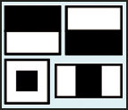
Fig. 9.1 Haar-like features

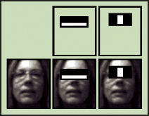
Fig. 9.2 First two Haar-like features

CvRect* haardetect( IplImage* frame,CvHaarClassifierCascade* cascade,
CvMemStorage* storage )
{
CvRect* rect=0;
if(cascade)
{
CvSeq* faces = cvHaarDetectObjects( frame, cascade, storage, 1.1, 2, CV_HAAR_DO_CANNY_PRUNING,cvSize(40, 40) );
if(faces && faces->total)
rect = (CvRect*) cvGetSeqElem(faces, 0);
}
return rect;
}

9.1.2 Using Continuously Adaptive Mean-Shift(Camshift)
Algorithm
Camshift uses colour information, but rather than relying on a single colour, it tracks a combination of colours. Since it tracks by color, it can follow a face through orientation changes that the Haar detect can't handle histogram. Camshift represents the face and it's tracking as a histogram (also called a bar-chart) of colour values. As new video frame arrive, the hue for each pixel is determined. From that, the face histogram is used to assign a face probability to the pixel. This process is called “histogram back-projection”.

The back-projection of the target histogram with any consecutive frame generates a probability image where the value of each pixel characterizes probability that the input pixel belongs to the histogram that was used. With each new video frame, Camshift shifts its estimate of the face location, keeping it centered over the area with the highest concentration of bright pixels in the face-probability image. lt finds this new location by starting at the previous location and computing the centre of gravity of the face-probability values within a rectangle. lt then shifts the rectangles so that it is right over the centre of gravity.

And that is how the face is tracked even when it is tilted or moved from frame to frame.

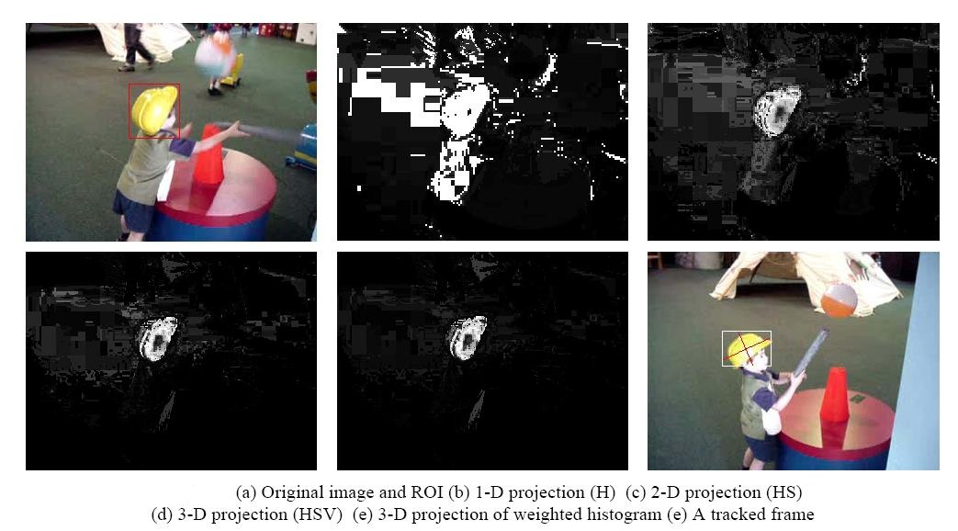
Fig 9.3: Working of Continuously Adaptive Mean-Shift

TrackedObj* EyeGesturesUI:: makeobject (IplImage* image, CvRect* region)
{
TrackedObj* obj;

//allocate memory for tracked object struct
if((obj = (TrackedObj*)malloc(sizeof(*obj))) != NULL) {
//create-image: size(w,h), bit depth, channels
obj->hsv = cvCreateImage(cvGetSize(image), 8, 3);
obj->mask = cvCreateImage(cvGetSize(image), 8, 1);
obj->hue = cvCreateImage(cvGetSize(image), 8, 1);
obj->prob = cvCreateImage(cvGetSize(image), 8, 1);

int hist_bins = 30; //number of histogram bins
float hist_range[] = {0,180}; //histogram range
float* range = hist_range;
obj->hist = cvCreateHist(1, //number of hist dimensions

&hist_bins, //array of dimension sizes
CV_HIST_ARRAY, //representation format
&range, //array of ranges for bins
1); //uniformity flag
}
void EyeGesturesUI:: updatehue (const IplImage* image, TrackedObj* obj)
{
//limits for calculating hue
int vmin = 65, vmax = 256, smin = 55;
//convert to HSV color model
cvCvtColor(image, obj->hsv, CV_BGR2HSV);
//source
cvScalar(0, smin, MIN(vmin, vmax), 0), //lower bound
cvScalar(180, 256, MAX(vmin, vmax) ,0), //upper bound
obj->mask); //destination
//extract the hue channel, split: src, dest channels
cvSplit(obj->hsv, obj->hue, 0, 0, 0 );
}
CvBox2D EyeGesturesUI::camshifttracking (IplImage* image, TrackedObj* obj)
{
CvConnectedComp components;

//create a new hue image
updatehue(image, obj);
//create a probability image based on the face histogram

cvAnd(obj->prob, obj->mask, obj->prob, 0);
//use CamShift to find the center of the new face probability
cvCamShift(obj->prob, obj->prev_rect,
cvTermCriteria(CV_TERMCRIT_EPS| CV_TERMCRIT_ITER, 10, 1),
&components, &obj->curr_box);
//update face location and angle
obj->prev_rect = components.rect;
obj->curr_box.angle = -obj->curr_box.angle;
return obj->curr_box;
}

9.2 Eye Detection
After the successful detection of the face, the location of the eyes is estimated. A rectangle is drawn around the detected face and this rectangle is considered as the region of interest (ROI) for detection of the eyes. Having the eye template and live video feed from camera, the system will try to locate the user's eye in the subsequent frames using template matching. The searching is limited in a small search window since searching the whole image will use extensive amount of CPU resources.
During the process, the system can find some false positives. To reduce those false positives, a threshold value has been calculated. The eyes used for calculating threshold have been taken from the Indian Face Database, IIT Kanpur. Eyes have been extracted from the faces and then matched with each other through template matching using normalized cross correlation to calculate a threshold value.
The minimum of the values in the below array is taken as the candidate for the threshold.

Basic 2D array for calculating threshold:-
{ 1,v01,v02,v03........v0n
V10,1,v12,v13.........v1n
................................
.................................
Vn0,vn1,vn2...............1 }

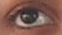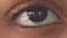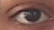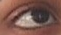
Fig 9.4: Different Positions of Eye
This threshold value also helps in matching and detecting eye when in various positions as shown in the above figure. The threshold has been calculated from the eye in different positions and the minimum value is estimated so that the proper eye candidate can be found.
double EyeGesturesUI:: threshold()
{
double img[51][51];
int i,j;
char *str="";
IplImage *imgResult;
char *form=".jpg";
for(i=0;i<51;i++)
{
IplImage *src=0,*temp=0;
char c1[10]="e";

sprintf(c1,"%s%d",c1,i);
sprintf(c1,"%s%s",c1,".jpg");
if((src=cvLoadImage(c1,0))==0)
printf("Error loading source");
//printf("Source: %s\n",c1);
for(j=0;j<51;j++)
{
char c2[10]="e";
sprintf(c2,"%s%d",c2,j);
sprintf(c2,"%s%s",c2,".jpg");
//printf("Template:%s\n",c2);
if((temp=cvLoadImage(c2,0))==0)
printf("Error loading template\n");

imgResult = cvCreateImage(cvSize(src->width-temp->width+1,src->height-temp->height+1), IPL_DEPTH_32F, 1);
cvZero(imgResult);
cvMatchTemplate(src, temp, imgResult,CV_TM_CCORR_NORMED );
// cvNormalize(imgResult,imgResult,1,0,CV_MINMAX);
double min_val, max_val;
CvPoint min_loc, max_loc;
cvMinMaxLoc(imgResult, &min_val, &max_val, &min_loc, &max_loc);
img[i][j]=max_val;
//printf("minval=%f\n",min_val);
//printf("maxval=%f\n",max_val);
cvReleaseImage(&imgResult);
cvReleaseImage(&temp);

}

cvReleaseImage(&src);

}
double min_of_max=img[0][0];
double max_of_max=img[0][1];
for(int i=0;i<51;i++)
{
for(int j=0;j<51;j++)
{
if(j==i)
;
else
{
if(img[i][j]<min_of_max)
min_of_max=img[i][j];
if(img[i][j]>max_of_max)
{
if(img[i][j]==1)
;
else
max_of_max=img[i][j];
}
}
}
}

double ret_value=min_of_max-(0.15*min_of_max);
return min_of_max;
}
int EyeGesturesUI:: TrackEye(IplImage *frame,int x,int y,float width,float height)

{
IplImage* frame_gray=0;IplImage* imgResult=0;
CvRect rect123;
rect123= cvRect(x,y,width,height);
IplImage* imgTemplate = cvLoadImage("i0.jpg",0);
IplImage* imgTemplate1 = cvLoadImage("i1.jpg",0);

frame_gray=cvCreateImage(cvSize(frame->width,frame->height),IPL_DEPTH_8U,1);
cvCvtColor( frame, frame_gray, CV_RGB2GRAY );
if (USEROI)
{
if (x<0)
x = 0;
if (y<0)
y = 0;
if (x+width > frame->width)
width = frame->width - x - 1;
if (y+height > frame->height)
height = frame->height - y - 1;
if (width < imgTemplate->width || height < imgTemplate->height)
return -1 ;
if (x<0 || y<0 || x+width > frame->width || y+height > frame->height)
{
//printf("%d %f %d %f %d %d\n",x, width, y, height, frame->width, frame->height);
}
cvRectangle(frame, cvPoint(x, y), cvPoint(x+width, y+height), cvScalar(0),

}
cvMatchTemplate(frame_gray, imgTemplate, imgResult,CV_TM_CCORR_NORMED);
double min_val=0, max_val=0;
CvPoint min_loc1, max_loc1,min_loc2, max_loc2;

cvMinMaxLoc(imgResult, &min_val, &max_val, &min_loc1, &max_loc1);
if(max_val<eye_threshold)
{
return -1;
//main_func();
}
if (USEROI)
{
max_loc1.x += x;
max_loc1.y += y;
}
cvMatchTemplate(frame_gray, imgTemplate1, imgResult, CV_TM_CCORR_NORMED);
cvMinMaxLoc(imgResult, &min_val, &max_val, &min_loc2, &max_loc2);
if(max_val<eye_threshold)
{
return -1;
//main_func();
}

if (USEROI)
{
max_loc2.x += x;
max_loc2.y += y;

}
//Code to check separation of two eye boxes
if( abs(max_loc1.x-max_loc2.x)<20)
{
return -1;
}
if(max_val>eye_threshold)
{
teye=clock();
diff=teye-tstart;
File<<"Eye :"<<diff<<endl;
}
if(abs(max_loc1.y-max_loc2.y)==0)
{
cvRectangle(frame, max_loc1, cvPoint(max_loc1.x+imgTemplate->width, max_loc1.y+imgTemplate->height), cvScalar(0), 1);
cvRectangle(frame, max_loc2, cvPoint(max_loc2.x+imgTemplate1->width, max_loc2.y+imgTemplate1->height), cvScalar(0), 1);
}
if(abs(max_loc1.y-max_loc2.y)>0 && abs(max_loc1.y-max_loc2.y)<5)
{
cvRectangle(frame, max_loc1, cvPoint(max_loc1.x+imgTemplate->width, max_loc1.y+imgTemplate->height), CV_RGB(0,0,255), 1);
cvRectangle(frame, max_loc2, cvPoint(max_loc2.x+imgTemplate1->width, max_loc2.y+imgTemplate1->height), CV_RGB(0,0,255), 1);
}

if(abs(max_loc1.y-max_loc2.y)>=5 && abs(max_loc1.y-max_loc2.y)<10)
{
cvRectangle(frame, max_loc1, cvPoint(max_loc1.x+imgTemplate->width, max_loc1.y+imgTemplate->height), CV_RGB(0,192,0), 1);
cvRectangle(frame, max_loc2, cvPoint(max_loc2.x+imgTemplate1->width, max_loc2.y+imgTemplate1->height), CV_RGB(0,192,0), 1);
}
if(abs(max_loc1.y-max_loc2.y)>=10 && abs(max_loc1.y-max_loc2.y)<15)
{
cvRectangle(frame, max_loc1, cvPoint(max_loc1.x+imgTemplate->width, max_loc1.y+imgTemplate->height), CV_RGB(0,192,255), 1);
cvRectangle(frame, max_loc2, cvPoint(max_loc2.x+imgTemplate1->width, max_loc2.y+imgTemplate1->height), CV_RGB(0,192,255), 1);
}

char str[20];
itoa(max_loc1.x,str,10);
eye1xv->setText(QString(str));
itoa(max_loc1.y,str,10);
eye1yv->setText(QString(str));
itoa(imgTemplate->width,str,10);
eye1wv->setText(QString(str));
itoa(imgTemplate->height,str,10);
eye1hv->setText(QString(str));
itoa(max_loc2.x,str,10);
eye2xv->setText(QString(str));

itoa(max_loc2.y,str,10);
eye2yv->setText(QString(str));
itoa(imgTemplate->width,str,10);
eye2wv->setText(QString(str));
itoa(imgTemplate->height,str,10);
eye2hv->setText(QString(str));
if(imgResult && Detecteyeball==1 )
{
e1=eyeballdetect(frame,max_loc1.x,max_loc1.y,imgTemplate->width,imgTemplate->height);
e2=eyeballdetect(frame,max_loc2.x,max_loc2.y,imgTemplate->width,imgTemplate->height);
teyeball=clock();
diff=teyeball-tstart;
File<<"EyeBall :"<<diff<<endl;

itoa(e1.x,str,10);
eyeball1xv->setText(QString(str));
itoa(e1.y,str,10);
eyeball1yv->setText(QString(str));
itoa(e1.radius,str,10);
radius1v->setText(QString(str));
itoa(e2.x,str,10);
eyeball2xv->setText(QString(str));
itoa(e2.y,str,10);
eyeball2yv->setText(QString(str));
itoa(e2.radius,str,10);
radius2v->setText(QString(str));

}

//cvCircle(frame,cvPoint(min_loc1.x+20,min_loc1.y-21),5, CV_RGB(0,192,255), 2, CV_AA, 0);

if(USEROI)
{
cvResetImageROI(frame_gray);
}
cvReleaseImage(&frame_gray);

cvReleaseImage(&imgTemplate);

cvReleaseImage(&imgTemplate1);
return 1;
}

9.3 Eye Ball Detection and Tracking
There is no knowledge in OpenCV 2.0 for eye ball detection, so in order to apply the haar classifier, we would have to encapsulate it in a file, but for our application it's not worth it.
Thus, we tried three different methods:
- Circle detection by means of contours
- Circle detections by means of hough transform
- Based on pixel intensity

9.3.1 Circle detection by means of contours
The eye ball is almost a perfect circle, so why we don't search this contour. We tried it and sometimes it worked although the results weren't consistent basically due to the eyelash.
At that point we tried to seek the pupil instead of the iris, the pupil was a perfect white circle and just inverting the colours would have been enough. However this method is too light dependent.

9.3.2 Circle detections by means of Hough transform

The Hough transform is a method for finding lines, circles, or other simple eforms in an image. The original Hough transform was a line transform, which is a relatively fast way of searching a binary image for straight lines.
The purpose of the technique is to find imperfect instances of objects within a certain class of shapes by a voting procedure. This voting procedure is carried out in a parameter space, from which object candidates are obtained as local maxima in called accumulator space that is explicitly constructed by the algorithm for computing the Hough transform. Unfortunately, this method is really noise sensitive.

9.3.3 Based on pixel intensity
We used an algorithm which sum all the pixel intensities in the X and Y axis.

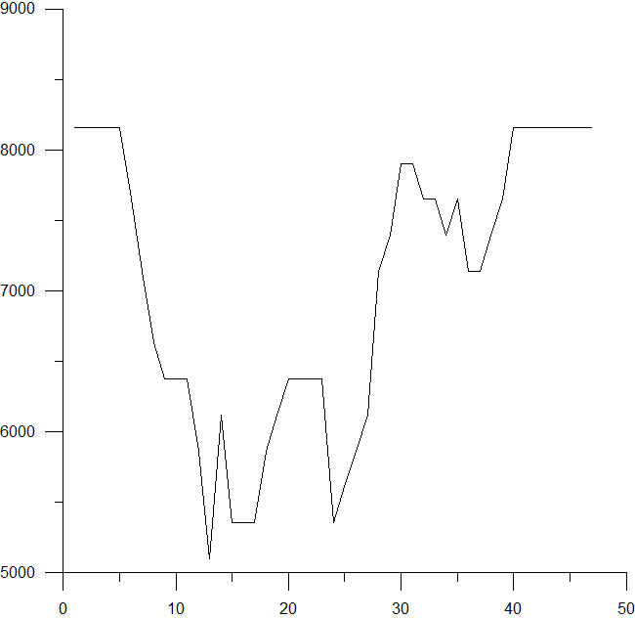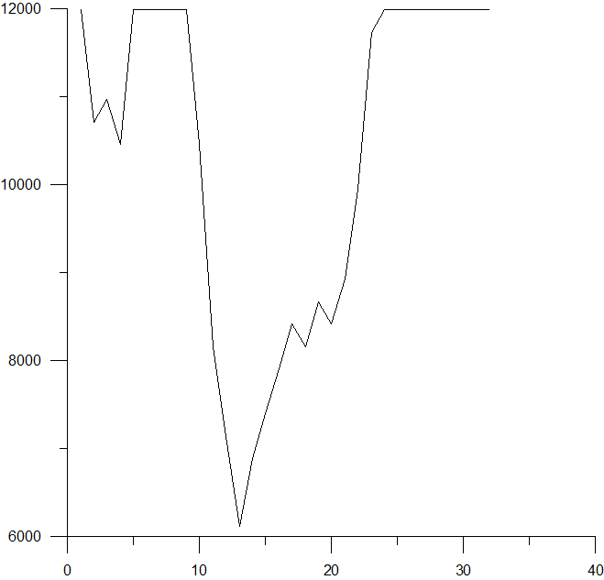

Fig 9.5: Intensity Y Axis Fig 9.6: Intensity X Axis

According to the X graphic we could say that the width of the eyeball will be represented with the minimum values. In the same way with graphic Y, we could say that the iris height will be located with the minimum values.
As both the values must be similar (eye ball should be round) and that we are adding the eyelash values we execute these actions:
- Calculate accumulated values
- Search maximum and minimum
- Look inside the accumulated values to find an area lower than (max-min)/2 + min which will mean the beginning of the eye ball
- Continue until finding an area higher than (max-min)/2 + min provided that we have already found the absolute minimum, it will mean the end of the eye ball.

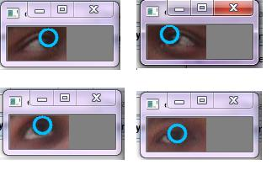
Fig 9.7: Detected Eye-balls using pixel intensity variation (Scan-line Coherence)
ball EyeGesturesUI:: eyeballdetect(IplImage* img,int xx,int yy,int width,int height)
{
IplImage* img_gray=0;
//IplImage* img=cvLoadImage("e25.jpg",1);
CvRect recteye;
recteye= cvRect(xx,yy,width,height);
img_gray=cvCreateImage(cvSize(img->width,img->height),IPL_DEPTH_8U,1);
cvCvtColor( img, img_gray, CV_RGB2GRAY );
cvSetImageROI(img_gray,recteye);
//int count=0;
//const int width=img_gray->width-1;
//const int height=img_gray->height-1;
int imgintensity[39][74];
for( int y=yy+1,s=0; y<yy+height; y++,s++ )
{
uchar* ptr = (uchar*) (img_gray->imageData + y * img_gray->widthStep);
for( int x=xx+1,t=0; x<xx+width; x++,t++ )

{
//printf("%d ",ptr[x]);
imgintensity[s][t]=ptr[x];
}
//printf("\n\n");
}
float xavg[74];
//printf("Moving on X-Axis\n");
for(int i=0; i<width-1;i++)
{
int total=0;
for(int j=0;j<height-1;j++)
{
total=total+imgintensity[j][i];
}
float avg=0;
avg=total/height-1;
//printf("%f \n ",avg);
xavg[i]=avg;
}

float yavg[39];
//printf("Moving on Y-Axis\n");
for(int i=0; i<height-1;i++)
{
int total=0;
for(int j=0;j<width-1;j++)
{
total=total+imgintensity[i][j];
}
float avg=0;

avg=total/width-1;
//printf("%f \n ",avg);
yavg[i]=avg;
}
xavg_min=xavg[0];float xavg_max=xavg[0];
int x_abs_min=0;
for(int i=0;i<width-1;i++)
{
if(xavg[i]<xavg_min)
{
xavg_min=xavg[i];
x_abs_min=i;
}

if(xavg[i]>xavg_max)
xavg_max=xavg[i];
}

//printf("\nxavg_min:%f xavg_max:%f x_abs_min:%d\n",xavg_min,xavg_max,x_abs_min);

float x_thre=(xavg_max-xavg_min)/2 +xavg_min;
int x_min,x_max;
int b=x_abs_min;
while (xavg[b]<x_thre-5 && b>0)
b--;
x_min=xx+b+1;
b=x_abs_min;
while (xavg[b]<x_thre-5 && b<69)
b++;
x_max=xx+b-1;

//printf("\nx_thre=%f x_min=%d x_max=%d Probable eye width=%d\n",x_thre,x_min,x_max,x_max-x_min);
int y_abs_min=0;
yavg_min=yavg[0]; float yavg_max=yavg[0];
for(int i=0;i<height-1;i++)
{
if(yavg[i]<yavg_min)
{
yavg_min=yavg[i];
y_abs_min=i;
}
if(yavg[i]>yavg_max)
yavg_max=yavg[i];
}

//printf("\nyavg_min:%f yavg_max:%f y_abs_min:%d \n",yavg_min,yavg_max,y_abs_min);
float y_thre=(yavg_max-yavg_min)/2 +yavg_min;
int d=y_abs_min;
int y_min,y_max;
while (yavg[d]<y_thre-5 && d>0)
d--;
y_min=yy+d+1;
d=y_abs_min;
while (yavg[d]<y_thre-5 && d<39)
d++;
y_max=yy+d-1;

//printf("\ny_thre=%f y_min=%d y_max=%d Probable eye height=%d\n",y_thre,y_min,y_max,y_max-y_min);
int r1=abs(x_max-x_min);

int r2=abs(y_max-y_min);
int radius;
if(r1<=r2)
radius=r1;
else if(r1>=r2)
radius=r2;
if(radius>10 || radius<=5)
radius=10;
CvPoint center;
center.x=xx+x_abs_min;
center.y=yy+y_abs_min;
ball eyeb;
eyeb.x=center.x;
eyeb.y=center.x;
eyeb.radius=radius;
cvCircle(img,center,radius, CV_RGB(0,192,255), 2, CV_AA, 0);
return eyeb;
cvResetImageROI(img_gray);
}

9.4 Sample Applications
9.4.1 Zooming Image using Face
This application has been built using Qt classes and events, so that we can zoom in and out of an image without the use of a mouse or a keyboard. The application makes use of the detected face and based on the area of the face detected, the zoom factor is based. The zoom factor is decided based on whether one’s moving towards or away from the camera.

What does it do?
As the person moves towards the camera, the image zooms in as the face area increases and as the person moves away from the camera the image is zoomed out as the area decreases.

How can it help?
This application has been built keeping in mind the application’s usability with the disabled people. It has the advantage of not requiring any mouse or keyboard.

PixmapWidget::PixmapWidget( const QString &filename, QWidget *parent ) : QWidget( parent )
{
prev_area=0;
m_pm = new QPixmap( filename );
zoomFactor = 1;
QVBoxLayout *msgs=new QVBoxLayout();
msg = new QLabel();
msgs->addWidget(msg);
setLayout(msgs);

setMinimumSize( m_pm->width()*zoomFactor, m_pm->height()*zoomFactor );
resize(300,400);
}
PixmapWidget::~PixmapWidget()
{
delete m_pm;
}
void PixmapWidget::setZoomFactor( float f )
{
int w, h;

if( f == zoomFactor )
return;

zoomFactor = f;
emit( zoomFactorChanged( zoomFactor ) )
w = m_pm->width()*zoomFactor;
h = m_pm->height()*zoomFactor;
setMinimumSize( w, h );
QWidget *p = dynamic_cast<QWidget*>( parent() );
if( p )
resize( p->width(), p->height() );

repaint();
}
bool PixmapWidget::event(QEvent *evnt)
{
if(evnt->type() == QFaceEvent::FaceDetected)
{
return faceEvent(static_cast<QFaceEvent *>(evnt));

}
return QWidget::event(evnt);
}

bool PixmapWidget::faceEvent(QFaceEvent *evnt)
{
float f;
if(evnt->areavalue()>prev_area)
{
f = zoomFactor + .000002*evnt->areavalue();
}
else if(evnt->areavalue()<prev_area)
{
f = zoomFactor - .000002*evnt->areavalue();
}
else
{
f=zoomFactor;
}

if( f < 32.0/m_pm->width() )
f = 32.0/m_pm->width();

QString txt = "Face Detected with area " % QString::number(evnt->areavalue()) % " square units";
msg->setText(txt);
msg->resize(8 * txt.size(), 10);
msg->setStyleSheet("QLabel { color : black; font-family:Calibri; font-weight:bold; font-size:12px; }");
msg->show();
prev_area=evnt->areavalue();

setZoomFactor( f );
return true;
}
void PixmapWidget::paintEvent( QPaintEvent *event )
{
int xoffset, yoffset;
bool drawBorder = false;

if( width() > m_pm->width()*zoomFactor )
{
xoffset = (width()-m_pm->width()*zoomFactor)/2;
drawBorder = true;
}
else
{
xoffset = 0;
}
if( height() > m_pm->height()*zoomFactor )
{
yoffset = (height()-m_pm->height()*zoomFactor)/2;
drawBorder = true;
}
else
{
yoffset = 0;
}

QPainter p( this );
p.save();
p.translate( xoffset, yoffset );
p.scale( zoomFactor, zoomFactor );

p.drawPixmap( 0, 0, *m_pm );
p.restore();
if( drawBorder )
{
p.setPen( Qt::black );
p.drawRect( xoffset-1, yoffset-1, m_pm->width()*zoomFactor+1, m_pm->height()*zoomFactor+1 );
}
}

9.4.2 Drowsiness Alert
This application has been built using Qt classes and events. As the technology in automobile has been becoming more advanced, this feature is a great add-on to its armoury. Most of the European based cars already comes with this feature built-in. This application makes use of scan line coherence, it exploits the fact that when the eyes are closed, the pixel intensities increases as when the eyes are open. As the value goes beyond a certain threshold, the alarm goes off.

What does it do?
This application sounds an alarm when the drives is drowsy, thus alarming of the danger that prevails while driving.

How can it help?
This can help in reducing road accidents and saving lives of innocent people.
if(alerts->checkState()==Qt::Checked)
{
QSound wake("sound.wav");

if( xavg_min>54 || xavg_min>54)
{
wake.play();
status->setText("WAKE UP !!!");
}
else
{
wake.stop();
status->setText("Check Detect Eyeball only after checking Detect Eye");
}
}
Chapter X
TESTING
10.1 Graphical Analysis
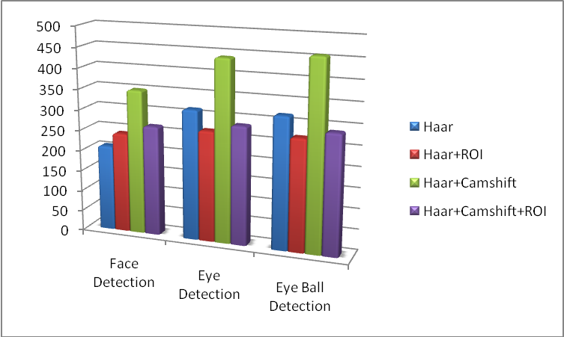
Fig:10.1 Performance Comaparison

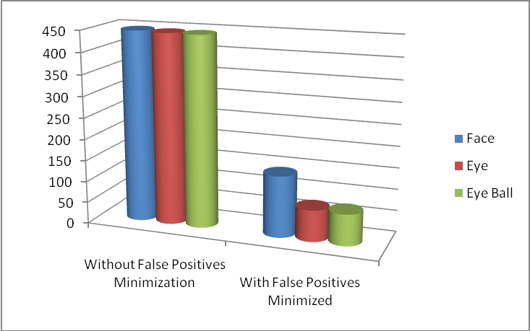
Fig:10.2 Accuracy Comparison

10.2 Snapshots
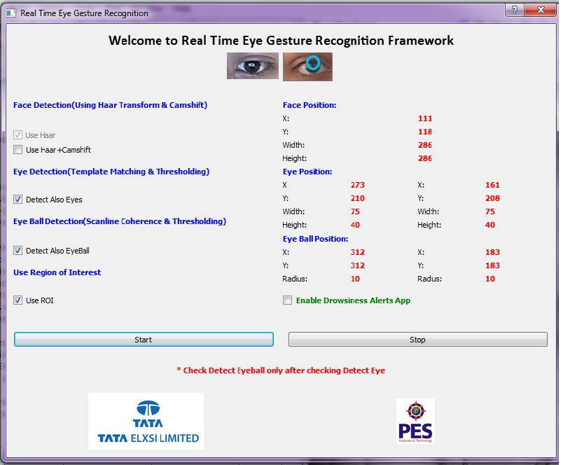
Fig 10.3: User Interface with the coordinates of the tracked objects

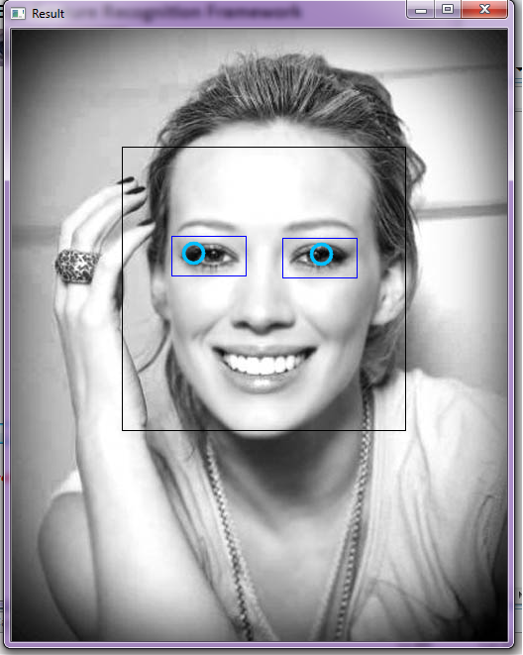

Fig 10.4: Face, Eye and Eye Ball Detection using Haar, Template Matching and
Pixel Intensity variation Technique respectively

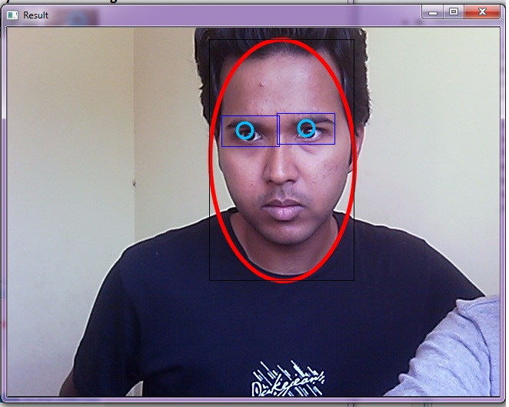
Fig 10.5: Face, Eye and Eye Ball Detection using Camshift, Template Matching
and Pixel Intensity variation Technique respectively

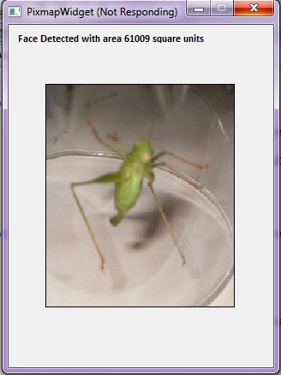

Fig 10.6: Zooming Image using Face

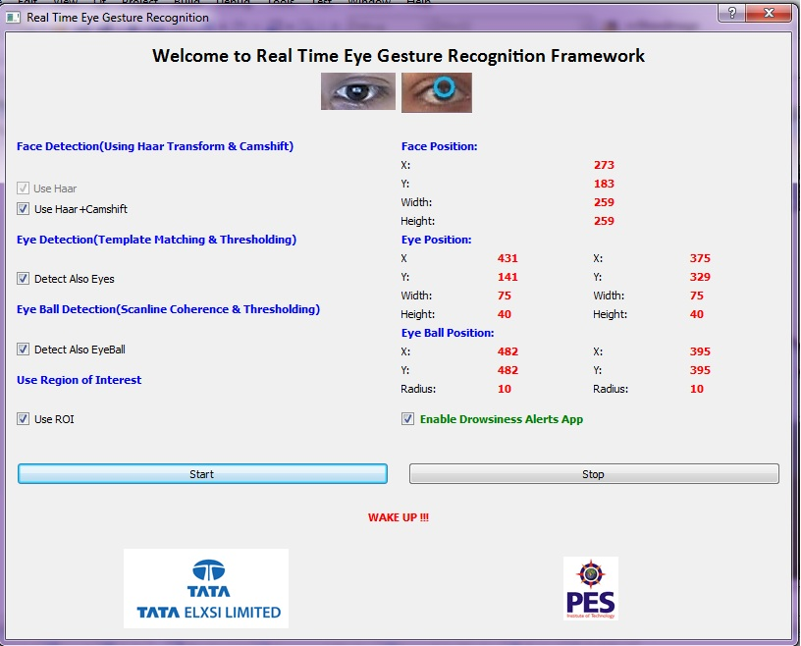

Fig 10.7: Drowsiness Alert Alarm

10.3 Sample timings for Test Runs
 | Haar  T1 T2 T3 |  |  | Haar  +ROI  T1 T2 T3 |  |  | Haar  +  Camshift  T1 T2 T3 |  |  | Haar+  Camshift  +ROI  T1 T2 T3
Face Detection | 215 | 208 | 203 | 255 | 224 | 249 | 382 | 335 | 336 | 292 | 253 | 255
Eye Detection | 320 | 324 | 302 | 280 | 248 | 277 | 488 | 440 | 436 | 311 | 273 | 277
Eye-ball Detection | 323 | 328 | 306 | 283 | 251 | 280 | 491 | 445 | 439 | 314 | 275 | 281

Table 10.1: Test runs timings for different algorithms

- All times in milliseconds(ms)
- All times are measured after the Camera starts after the Start button is clicked on the UI.
- All times recorded for full single runs in each trial for each algorithmic case.
- Threshold value is calculated only once and has not been included in the times above. It is a pre-processed value
CONCLUSION
This Project in Real Time can help devise new methods for Human Computer Interaction. The Human can interact with the machine with very little effort. The project goes further from touch screens which require some effort from the users.
In this project, we have used various methods and algorithms for reaching our objective. Face detection is based on the Haar features and Camshift Tracking. The advantage of the Haar-like features is the rapidness in detection phase. Due to the use of integral images, a Haar-like feature of any size can be calculated in constant time. Camshift has the advantage that, the face can be tracked even when the face is tilted or has a certain skew which could not have been possible with only Haar.
We have used Template Matching for detecting and tracking the eyes. It uses a database comprising over 200 images for calculation of threshold value. This value is in turn used to approximate the location of the eye on any sample input. The threshold calculation and usage reduces many false positives as that could have appeared which have the same colour distribution as eyes.
We have used a method where the pixel intensity variation inside the detected eye box is used for eyeball detection and tracking. The method used is called Scan-Line Coherence and is based on the fact that two nearby lines having same colour distribution have some similarity between them. The centre is approximated and with the help of its approximated radius and the circle is drawn around the eyeball.
In the output window, the recognised face of the concerned user is shown with a face box drawn around it. The recognized eyes are shown with a eye box drawn within the face box and the eyeball is shown with a circle covering the eyeball.

FURTHER ENHANCEMENTS
The frame rate can be improved. So, that we get a more continuous live stream from the webcam rather than the present condition.
Better method & algorithms like Eigen method can be used in place of Template Matching for eye detection. The Eigen method has a more better success rate than the Template Matching and give us more favourable results.
The database used for Template Matching can be more diversified, taking into consideration various races and cultures rather than our present Indian database and hence we can get better acceptability rates.
The overall time required for the whole process could be much further reduced, with our studies showing considerable improvements can be made in this regard.
With the use of Template Matching and certain other algorithms, the system may not be stable for long. We can use and toggle with other algorithms to get better results.
One major issue with the cameras currently being used is that low contrast among eye/facial features renders the tracking system un-operable. In other words, individuals with brown/dark pupils and/or eyebrows closely matched to their skin tone are hard to track, due to the small differences in the contrast between these features. Higher quality cameras with greater contrast ratios may remedy this problem.

BIBLIOGRAPHY
- Gary Bradski and Adrian Kaehler “Learning OpenCV”, O’REILLY.
September 2008: First Edition
- Heiko Drewes “Eye Gaze Tracking for Human Computer
Interaction” ,2000
- Intel Corporation “Open Source Computer Vision Library” ,
December 2000
- Issa Ashwash, Willie Hu & Garrett Marcotte “Eye Gesture
Recognition: A Mechanism for hands-free Computer Control”
- Michael Chau and Margrit Betke, Boston University “Real Time
Eye Tracking and Blink Detection with USB Cameras” , 2005
- Jens Bache-Wiig “Using Multi-Touch and Gestures with Qt”, 2009
- S. A. Sirohey and Azriel Rosenfeld. "Eye detection in a face image using linear and nonlinear filters." Pattern Recognition. 2001
- W. Zhao, R. Chellappa, P. J. Phillips and A. Rosenfeld, ”Face Recognition: A Literature Survey”, ACM Computing Survey, vol. 35, no. 4, Dec. 2003, pp.399–458.

