TASK:3
Implementation of A * Algorithm to find the optimal path using Python by following
constraints.
3(A) A* Algorithm
Aim : To implement of A * Algorithm to find the optimal path using Jupiter notebook.
Algorithm:
Step 1: start
Step 2: Place the starting node into open and find its f(n) [start node] value.
Step 3: Remove the node from OPEN, having the smallest f(n) value, if it is x goal node, then
stop and return to success.
Step 4: Else remove the node from OPEN, and find all its successors.
Step 5: Find the f(n) value of all the successors, Place them into OPEN and place the removed
node into close
Step 6: Go to step 2.
Step 7: Exit.
PROGRAM
def aStarAlgo(start_node, stop_node):
open_set = set([start_node])
closed_set = set()
g = {} # distance from start node
parents = {} # to reconstruct path

g[start_node] = 0
parents[start_node] = start_node

while open_set:
n = None
# node with lowest f() = g(n) + h(n)
for v in open_set:
if n is None or g[v] + heuristic(v) < g[n] + heuristic(n):
n = v

if n is None:
break

if n == stop_node:
# reconstruct path
path = []
while parents[n] != n:
path.append(n)
n = parents[n]
path.append(start_node)
path.reverse()
print('Path found:', path)
return path

for m, weight in get_neighbors(n):
if m not in open_set and m not in closed_set:
open_set.add(m)
parents[m] = n
g[m] = g[n] + weight
else:
if g[m] > g[n] + weight:
g[m] = g[n] + weight
parents[m] = n
if m in closed_set:
closed_set.remove(m)
open_set.add(m)

open_set.remove(n)
closed_set.add(n)

print('Path does not exist!')
return None

def get_neighbors(v):
return Graph_nodes.get(v, [])

def heuristic(n):
def heuristic(n):
h_dist = {
"A": 11,
"B": 6,
"C": 5,
"D": 7,
"E": 3,
"F": 6,
"G": 5,
"H": 3,
"J": 0
}
return h_dist[n]

Graph_nodes = {
"A": [("B", 6), ("F", 3)],
"B": [("A", 6), ("C", 3), ("D", 2)],
"C": [("B", 3), ("D", 1), ("E", 5)],
"D": [("B", 2), ("C", 1), ("E", 2), ("G", 6)],
"E": [("C", 5), ("D", 2), ("H", 3)],
"F": [("A", 3), ("G", 1), ("C", 4)],
"G": [("D", 6), ("F", 1), ("H", 7)],
"H": [("E", 3), ("G", 7), ("J", 5)],
"J": [("H", 5)]
}
print("Following is the A* Algorithm:")
aStarAlgo("A", "J")

OUTPUT
Path found: ['A', 'F', 'G', 'D', 'E', 'H', 'J']
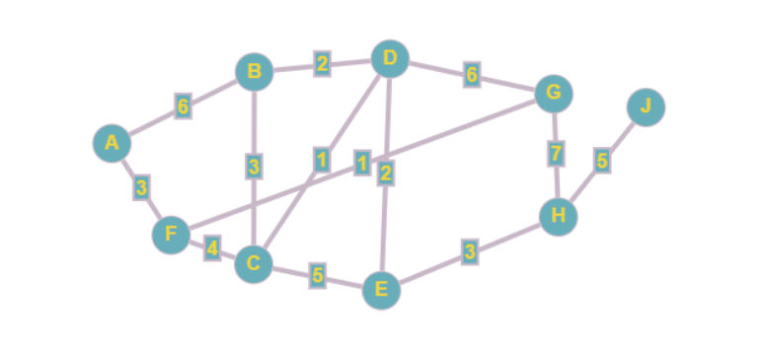

3(B) – Simplified A* Algorithm.
Aim: To implement the simplified A*Algorithm using Jupiter notebook.
Algorithm:
Step 1 : start.
Step 2: place the starting node into open and find its f(n) value
Step 3: Remove the node from OPEN , having the smallest f(n) value, if it is a goal node , then
stop and return to success.
Step 4: else remove the node from OPEN, and find all its successors
Step 5:Find the f(n) value of all the successors, Place them into OPEN and place the removed
node into close
Step 6: Go to step 2.
Step 7: Exit.
PROGRAM
# Corrected A* Algorithm

# Define the neighbors for each node
Graph_nodes = {
'A': [('B', 2), ('E', 3)],
'B': [('A', 2), ('C', 1), ('G', 9)],
'C': [('B', 1), ('F', 3)],
'D': [('E', 6), ('G', 1)],
'E': [('A', 3), ('D', 6)],
'F': [('C', 3), ('G', 2)],
'G': [('B', 9), ('D', 1), ('F', 2)]
}

# Heuristic distances to goal node 'G'
def heuristic(n):
h_dist = {
'A': 5,
'B': 3,
'C': 4,
'D': 1,
'E': 2,
'F': 2,
'G': 0 # Goal node
}
return h_dist[n]

# Function to return neighbors and their distances
def get_neighbors(v):
if v in Graph_nodes:
return Graph_nodes[v]
return None

# A* Algorithm
def aStarAlgo(start_node, stop_node):
open_set = set([start_node])
closed_set = set()
g = {} # distance from start node
parents = {} # parent nodes for path reconstruction

g[start_node] = 0
parents[start_node] = start_node

while len(open_set) > 0:
n = None
# Find node with lowest f() = g + h
for v in open_set:
if n is None or g[v] + heuristic(v) < g[n] + heuristic(n):
n = v

if n == stop_node or n is None or n not in Graph_nodes:
break

for m, weight in get_neighbors(n):
if m not in open_set and m not in closed_set:
open_set.add(m)
parents[m] = n
g[m] = g[n] + weight
else:
if g[m] > g[n] + weight:
g[m] = g[n] + weight
parents[m] = n
if m in closed_set:
closed_set.remove(m)
open_set.add(m)

open_set.remove(n)
closed_set.add(n)
if n == stop_node:
path = []
while parents[n] != n:
path.append(n)
n = parents[n]
path.append(start_node)
path.reverse()
print('Path found:', path)
return path

print('Path does not exist!')
return None
print("Following is the A* Algorithm:")
aStarAlgo('A', 'G')
OUTPUT
Following is the A* Algorithm:
Path found: ['A', 'B', 'C', 'F', 'G']

RESULT
Thus the implementation of the simplified A*Algorithm using Jupiter notebook was
successfully executed and output was verified.

