Task :2
Implementation of Hill climbing algorithm for Heuristic search approach using following
constraints in python.
Aim: To Implement Hill climbing algorithm for Heuristic search approach for travelling
salesman problem using python
Algorithm:
Step 1: start
Step 2: define TSP with (graph, s) and assign value for vertex.
Step 3: store all vertex apart from source vertex.
Step 4: store minimum weight hamiltonian cycle and assign permutation (vertex).
Step 5: store current path weight (cost) and compute current path weight.
Step 6: Update minimum and matrix representation of the graph values and print it.
Step 7: stop
PROGRAM
from sys import maxsize
from itertools import permutations

V = 5 # Updated for 5 cities

def travellingSalesmanProblem(graph, s):
vertex = []
for i in range(V):
if i != s:
vertex.append(i)
min_path = maxsize
next_permutation = permutations(vertex)
for i in next_permutation:
current_pathweight = 0
k = s
for j in i:
current_pathweight += graph[k][j]
k = j
current_pathweight += graph[k][s]
min_path = min(min_path, current_pathweight)
return min_path

if __name__ == "__main__":
graph = [
[0, 10, 15, 20, 8],
[10, 0, 35, 25, 9],
[15, 35, 0, 30, 11],
[20, 25, 30, 0, 12],
[8, 9, 11, 12, 0]
]
s = 0
print("Minimum cost of TSP:", travellingSalesmanProblem(graph, s))

OUTPUT
Minimum cost of TSP: 73
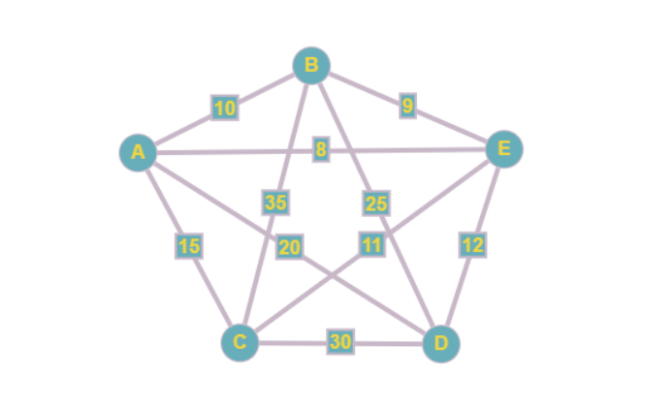

RESULT
Thus the Implementation of Hill climbing algorithm for Heuristic search approach for travelling salesman problem using python was successfully executed and output was verified.

