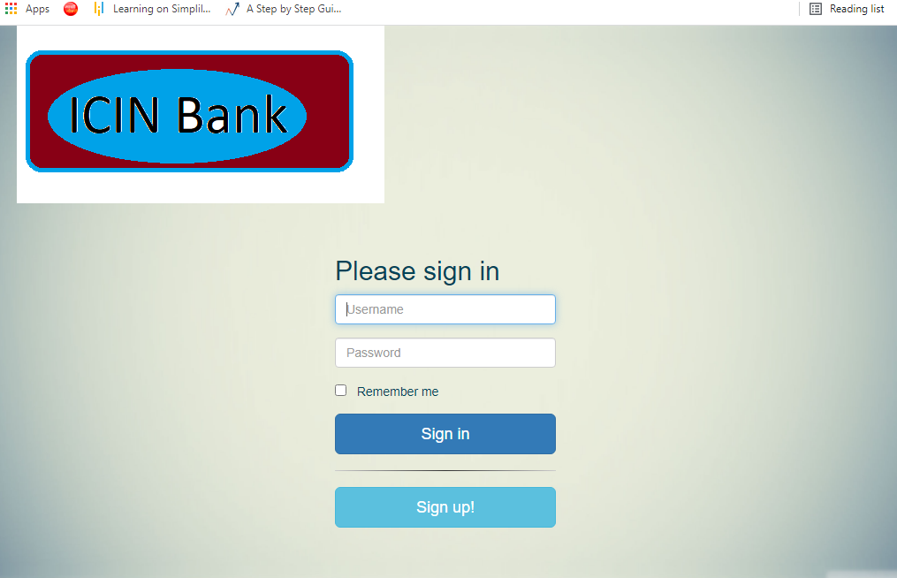

INDEX PAGE

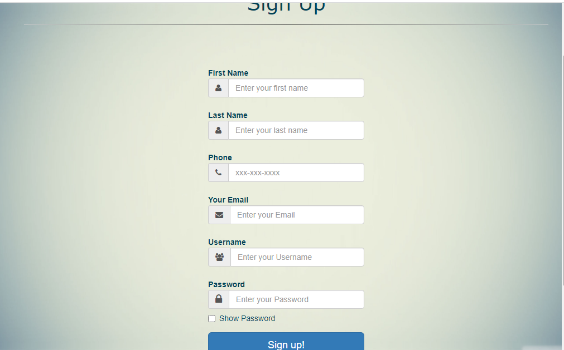

SIGNUP PAGE

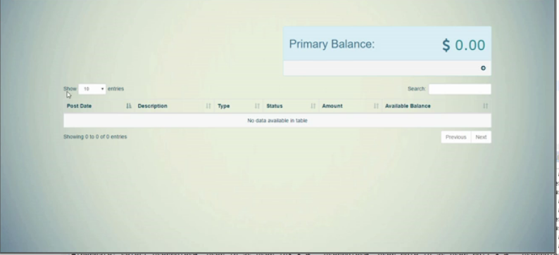

ADDING PRIMARY ACCOUNT

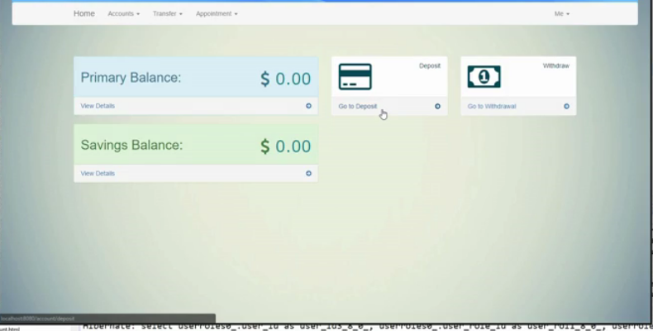ADDING SAVING ACCOUNT

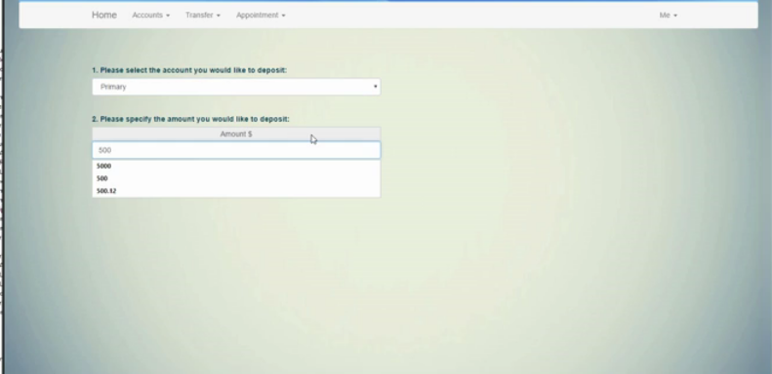

DEPOSIT FUNCTIONILITY IN PRIMARY ACCOUNT

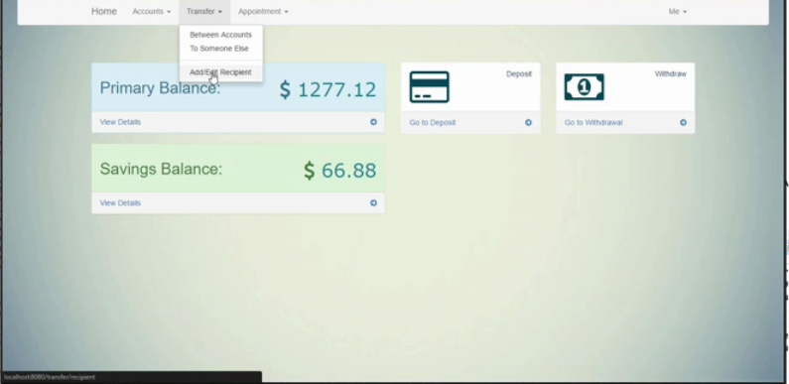

TRANSFER MENU OPTIONS

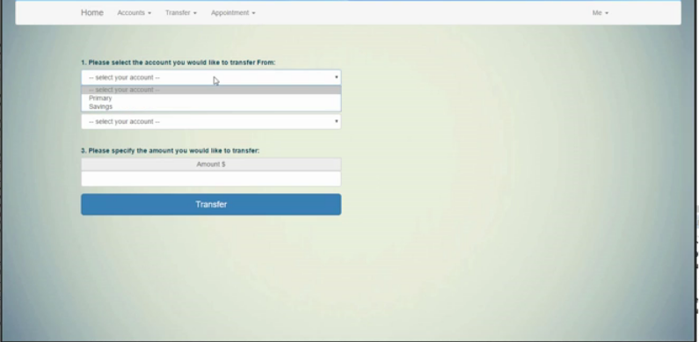

TRANSFER BETWEEN ACCOUNTS

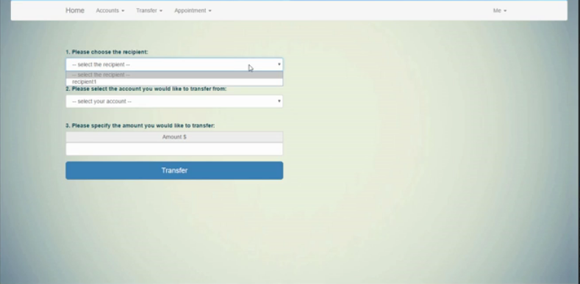TANSFER TO SOMEONE ELSE

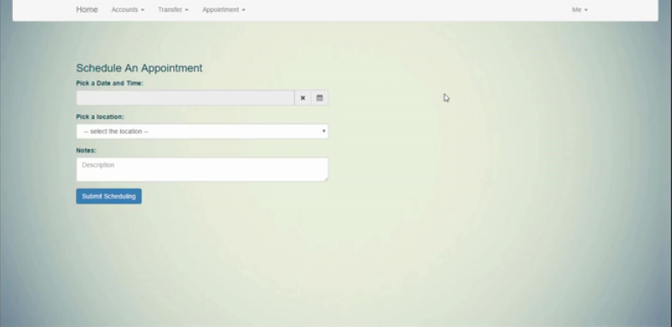

SCHEDULE AN APPOINTMENT

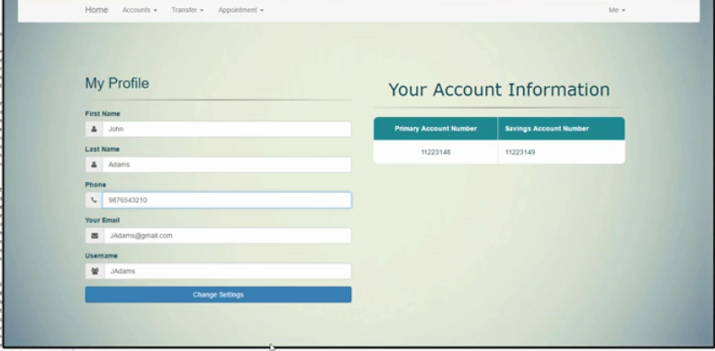

Edit PROFILE OPTION

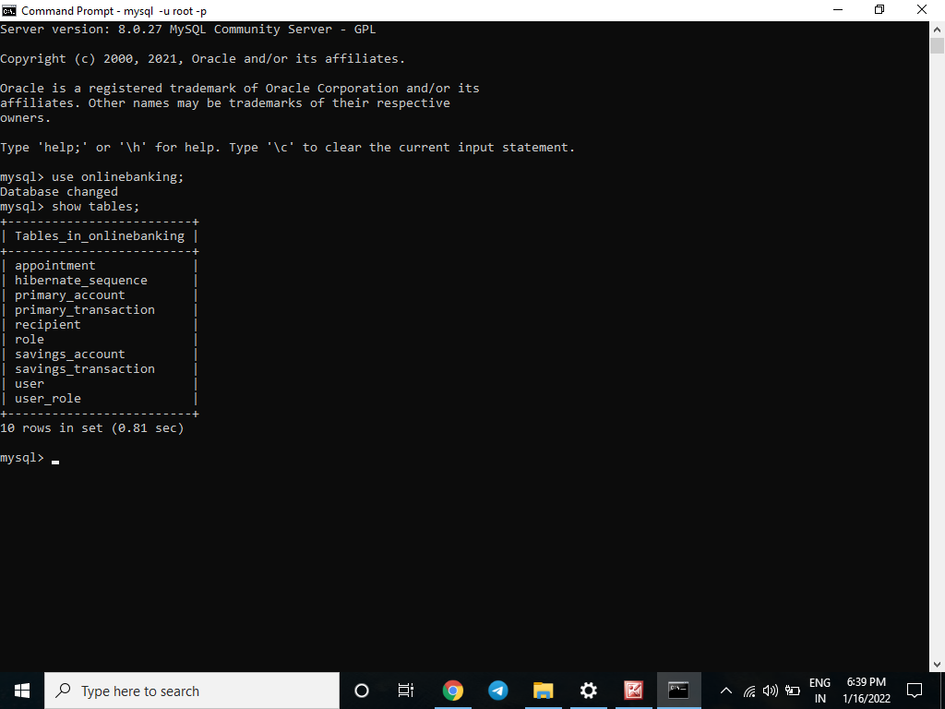

MYSQL DB SHOWING DIFFERENT TABLES FROM ONLINE BANKING DB

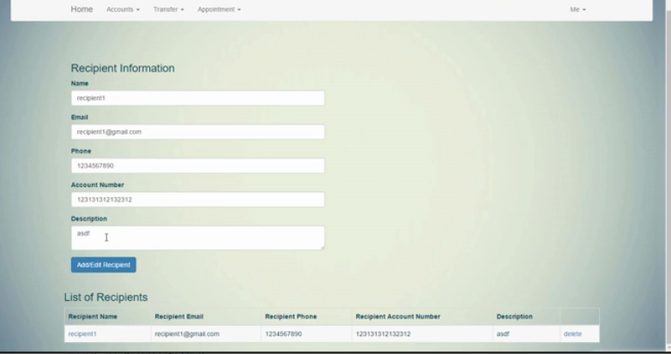

RECIPIENT LIST

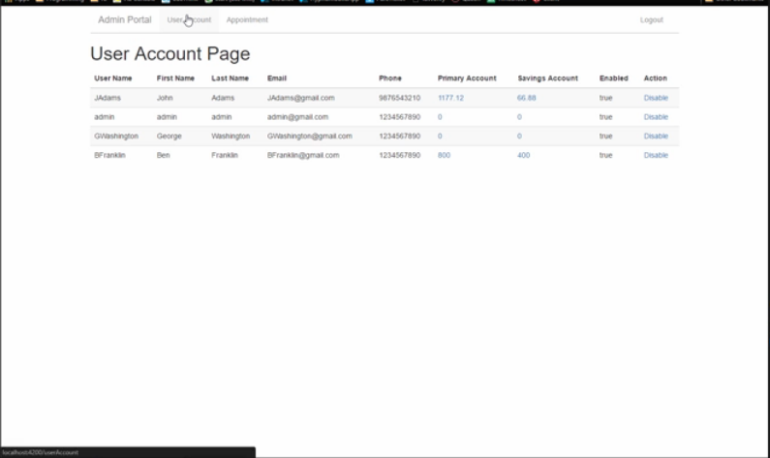

ADMIN PORTAL

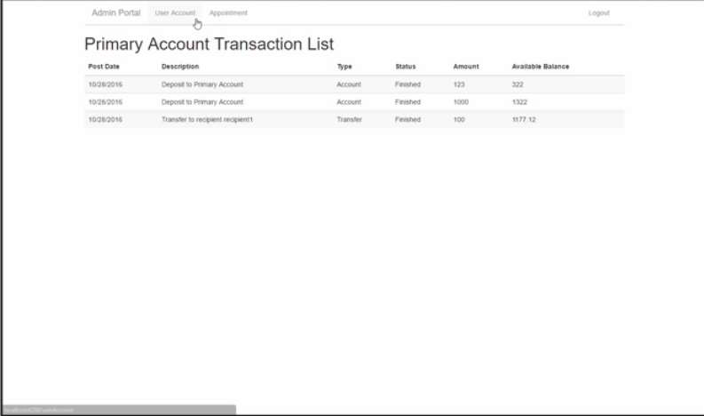

ADMIN PORTAL SHOWING USER TRANSACTIONS

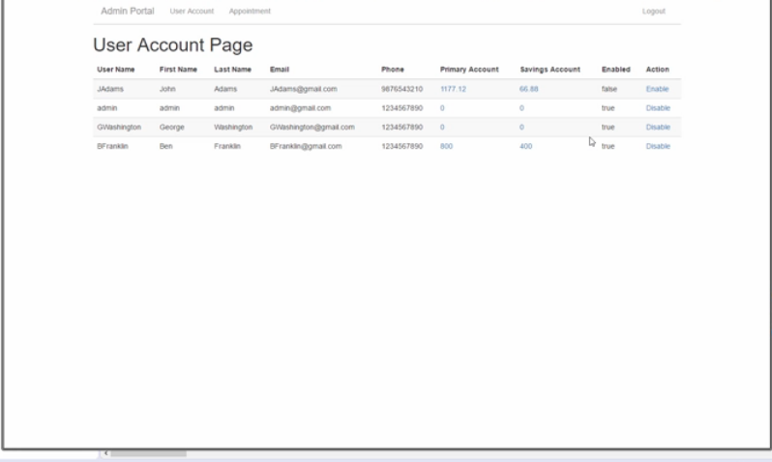

ADMIN AUTHORITY TO ENABLE/DISABLE USER USING ACTION

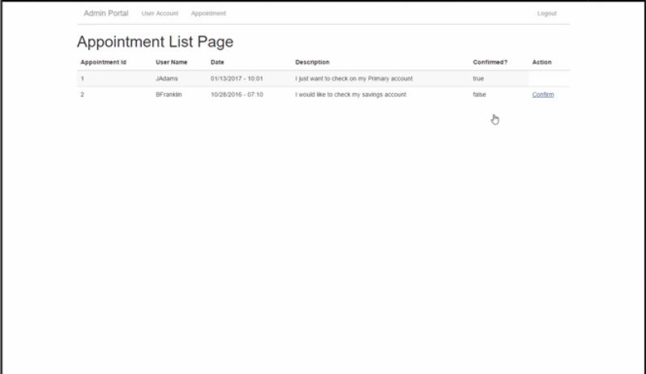

ADMIN AUTHORITHY TO CONFIRM APPOINTEMENTS

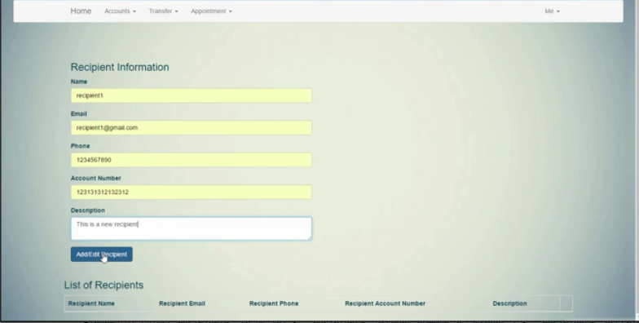

USER CAN ADD AND EDIT RECIPIENT TO TRANSFER MONEY

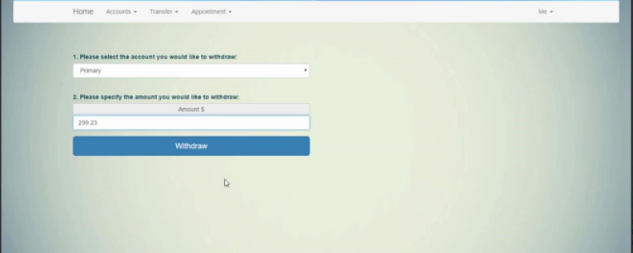

WITHDRAW OTIONS TO BOTH PRIMARY AND SAVING ACCOUNTS