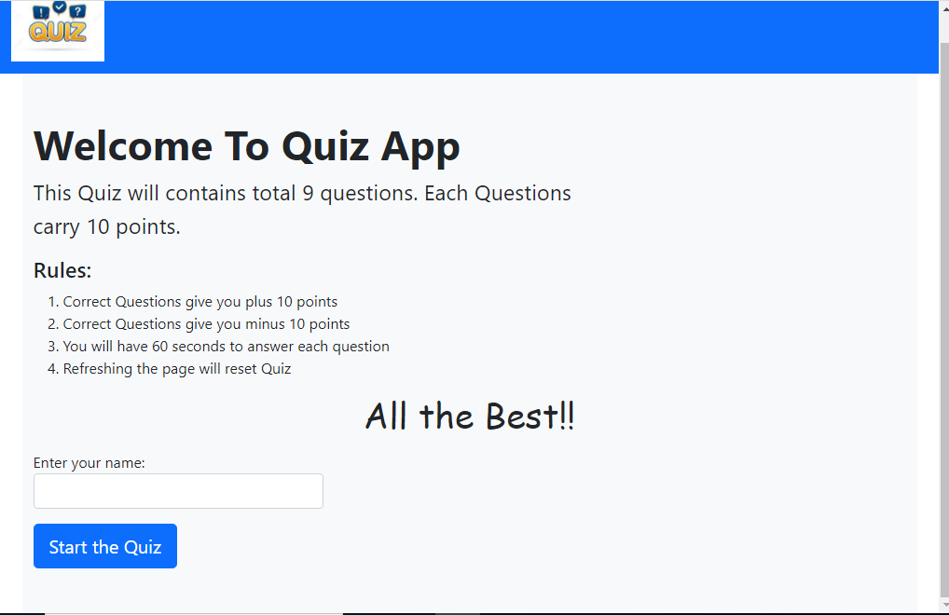

Fig.1 Welcome page of Quiz App

A

A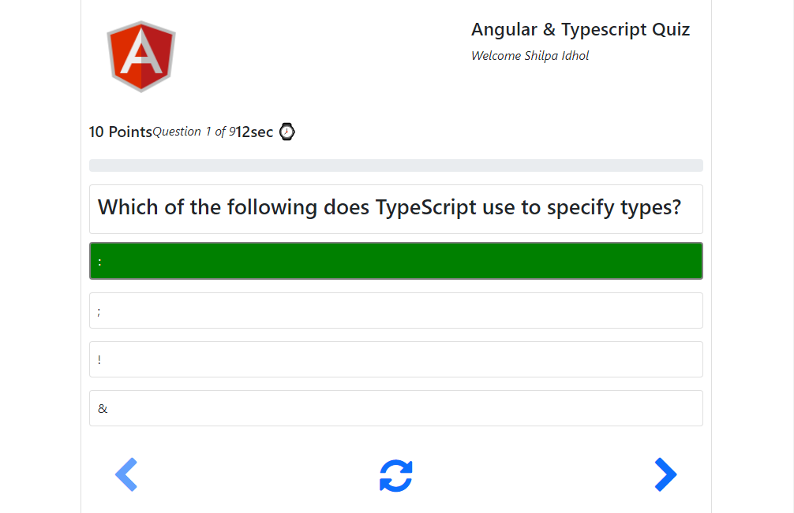

Fig.2 Question panel showing correct answer with green background

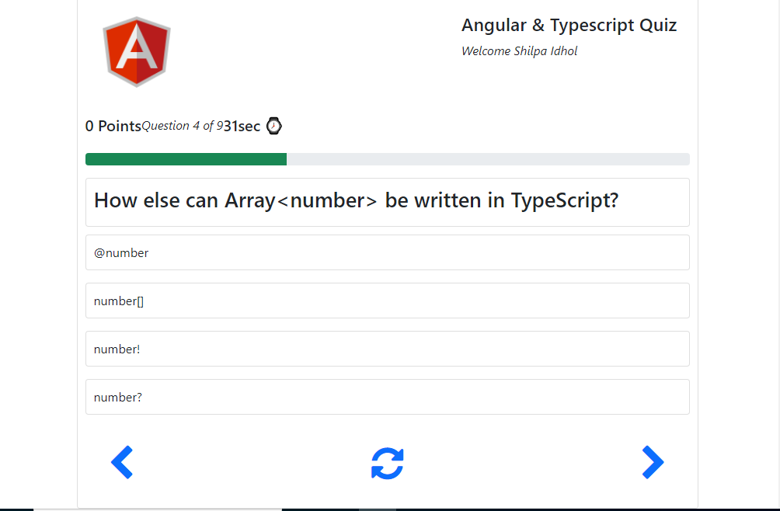

Fig.3 shows Progress bar and timer at top of the question panel

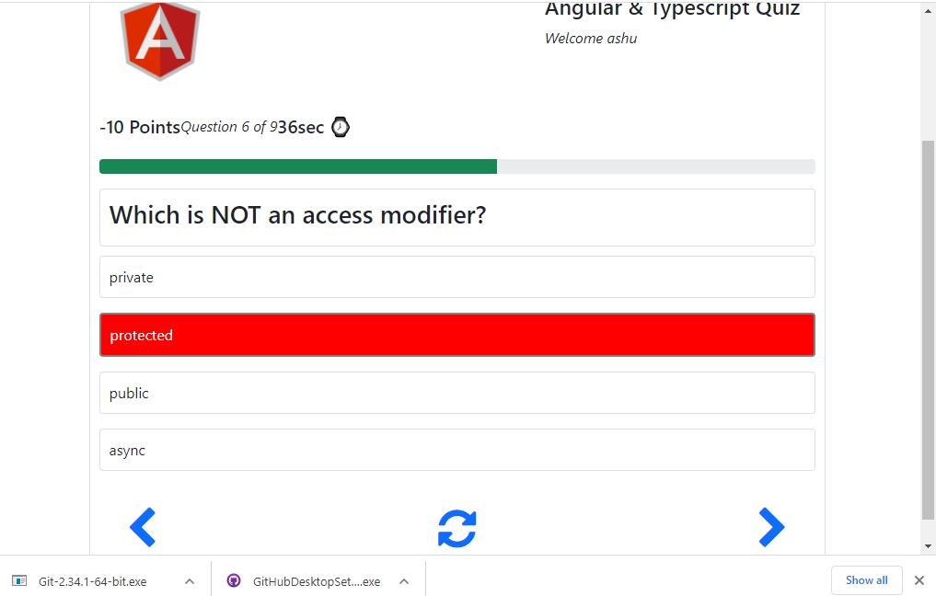

Fig.4 shows question panel with incorrect answer with red background

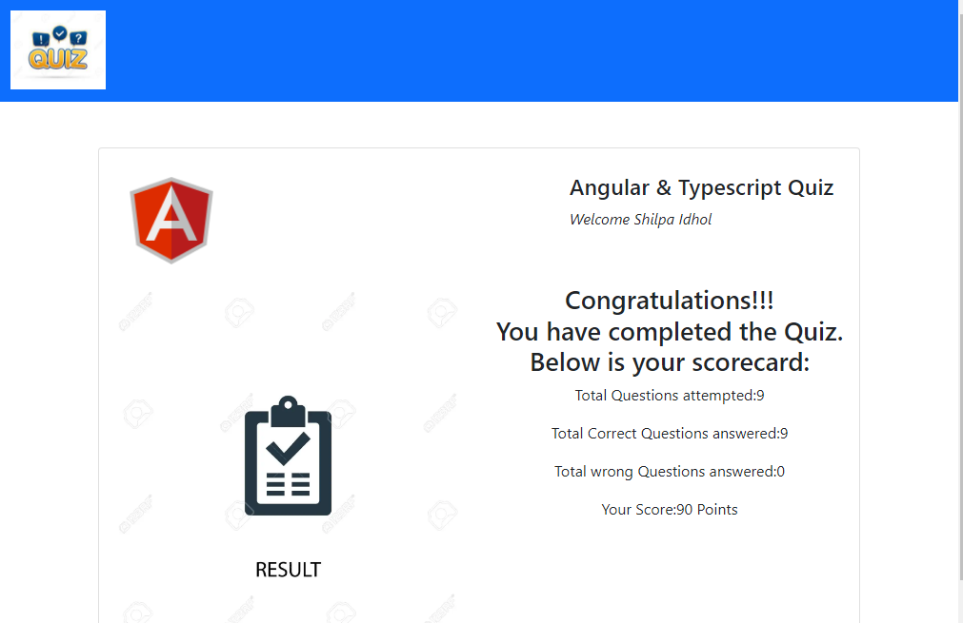

Fig.5 Result Panel