Header.component.html

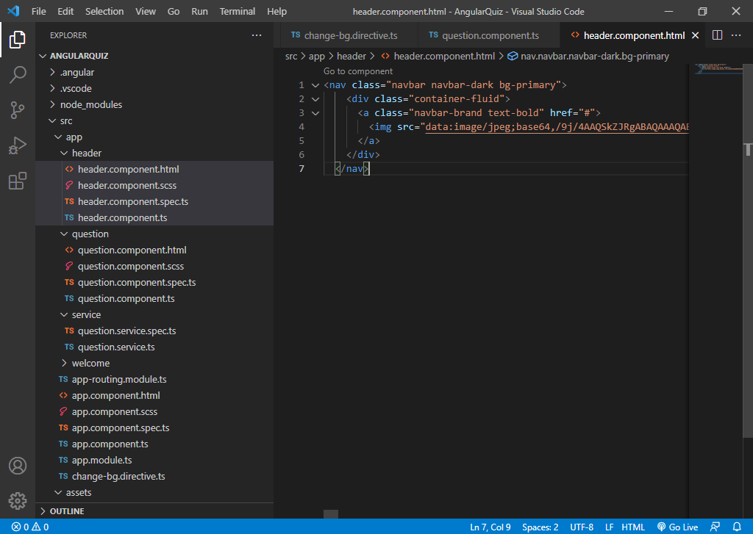

Questions.component.html

<div class="container mt-5">

<div class="card">

    <div class="d-flex justify-content-between p-3">

    <div class="image">

        <img src="https://img.icons8.com/color/96/000000/angularjs.png" width="100" alt="logo">

        </div>

        <div class="quiz-header">

          <h4 font="font-family">Angular & Typescript Quiz</h4>

          <span style="font-style: italic;">Welcome {{name}}</span>

        </div>

    </div>

    <ng-container \*ngIf="!isQuizCompleted">

        <div class="d-flex justify-content-arround py-3">

            <div class="score">

            <h5>{{points}} Points</h5>

            </div>

            <div class="question remaining">

            <span style="font-style: italic;">Question {{currentQuestion+1}} of {{questionList.length}} </span>

            </div>

            <div class="timer">

            <h5>{{counter}}sec ⌚</h5>

                </div>

                </div>

                <div class="progress mb-3">

                    <div class="progress-bar bg-success" role="progressbar" [ngStyle]="{'width':progress+'%'}" aria-valuenow="25" aria-valuemin="0" aria-valuemax="100"></div>

                  </div>

                  <div class="Question">

                      <div class="card">

                          <h3>{{questionList[currentQuestion]?.questionText}}</h3>

                      </div>

                  </div>

                  <div class="Option">

            <ol \*ngFor="let option of questionList[currentQuestion]?.options">

                <li (click)="answer(currentQuestion+1,option)">

                    <div appChangeBg [isCorrect]="option.correct" class="card">

                        {{option.text}}

                    </div>

                    </li>

            </ol>

                  </div>

                  <div class="d-flex justify-content-between p-3">

                      <button [disabled]="currentQuestion==0" class="btn" (click)="previousQuestion()"><i class="fa text-primary fa-chevron-left fa-3x" aria-hidden="true"></i></button>

                      <button class="btn" (click)="resetQuiz()"><i class="fa text-primary fa-refresh fa-3x" aria-hidden="true"></i></button>

                      <button class="btn"(click)="nextQuestion()"><i class="fa text-primary fa-chevron-right fa-3x" aria-hidden="true"></i></button>

                  </div>

    </ng-container>

    <ng-container \*ngIf="isQuizCompleted" >

        <div class="row d-flex justify-content-between">

            <img style="width: 50%;" class="img-fluid col-sm-12 mx-auto" src="https://previews.123rf.com/images/rashadashurov/rashadashurov1909/rashadashurov190903486/130223025-result-icon-simple-element-illustration-result-concept-symbol-design-can-be-used-for-web.jpg" width="100" alt="logo">

        <div class="result text-center col-md-6 col-sm-12">

    <h3>Congratulations!!! <br>You have completed the Quiz. <br>Below is your scorecard:</h3>

    <p>Total Questions attempted:{{questionList.length}}</p>

    <p>Total Correct Questions answered:{{correctAnswer}}</p>

    <p>Total wrong Questions answered:{{IncorrectAnswer}}</p>

    <p>Your Score:{{points}} Points</p>

    </div>

</div>

    </ng-container>

Question.component.ts

import { Component, OnInit } from '@angular/core';

import { QuestionService } from '../service/question.service';

import { interval } from 'rxjs';

@Component({

  selector: 'app-question',

  templateUrl: './question.component.html',

  styleUrls: ['./question.component.scss']

})

export class QuestionComponent implements OnInit {

public name: string="";

public questionList: any= [];

public currentQuestion:number=0;

public points:number=0;

counter=60;

correctAnswer:number=0;

IncorrectAnswer:number=0;

progress:string="0";

interval$:any;

isQuizCompleted : boolean = false;

  constructor(private questionService:QuestionService) { }

  ngOnInit(): void {

    this.name=localStorage.getItem("name")!;

    this.getAllQuestions();

    this.startCounter();

  }

getAllQuestions(){

this.questionService.getQuestionJson()

.subscribe(res=>{

  this.questionList=res.questions;

})

}

nextQuestion(){

this.currentQuestion++;

}

previousQuestion(){

this.currentQuestion--;

}

answer(currentQno:number,option:any){

if(currentQno === this.questionList.length){

  this.isQuizCompleted = true;

  this.stopCounter();

}

if(option.correct){

  this.points+=10;

  this.correctAnswer++;

  setTimeout(() => {

    this.currentQuestion++;

  this.resetCounter();

  this.getProgressPercent();

  }, 1000);

}else{

setTimeout(() => {

this.currentQuestion++;

this.IncorrectAnswer++;

this.resetCounter();

this.getProgressPercent();

}, 1000);

this.points-=10;

}

}

startCounter(){

this.interval$ =interval(1000)

.subscribe(val=>{

this.counter--;

if (this.counter==0){

  this.currentQuestion++;

  this.counter=60;

  this.points-=10;

}

});

setTimeout(() =>{

  this.interval$.unsubscribe();

},600000);

}

stopCounter(){

this.interval$.unsubscribe();

this.counter=0;

}

resetCounter(){

this.stopCounter();

this.counter=60;

this.startCounter();

}

resetQuiz(){

  this.resetCounter();

  this.getAllQuestions();

  this.points=0;

  this.counter=60;

  this.currentQuestion=0;

}

getProgressPercent(){

  this.progress=((this.currentQuestion/this.questionList.length)\*100).toString();

  return this.progress;

}

}

Welcome.component.html

<div class="container bg-light py-5">

<h1 class="display-5 fw-bold">Welcome To Quiz App</h1>

<p class="col-md-8 fs-4"> This Quiz will contains total 9 questions. Each Questions carry 10 points.</p>

<h4>Rules:</h4>

<ol>

    <li>Correct Questions give you plus 10 points</li>

    <li>Correct Questions give you minus 10 points</li>

    <li>You will have 60 seconds to answer each question</li>

    <li>Refreshing the page will reset Quiz</li>

</ol>

<h1 style="font-family: cursive;text-align:center">All the Best!!</h1>

<div class="name col-md-4 my-3">

<label for="">Enter your name:</label>

<input #name type="text" class="form-control">

</div>

<button class="btn btn-primary btn-lg" routerLink="/question" (click)="startQuiz()">Start the Quiz</button>

</div>

========================= ==============

Welcome.component.ts

import { Component, OnInit,ViewChild,ElementRef } from '@angular/core';

@Component({

  selector: 'app-welcome',

  templateUrl: './welcome.component.html',

  styleUrls: ['./welcome.component.scss']

})

export class WelcomeComponent implements OnInit {

@ViewChild('name') nameKey!:ElementRef;

  constructor() { }

  ngOnInit(): void {

  }

  startQuiz(){

    localStorage.setItem("name",this.nameKey.nativeElement.value)

  }

}

Change-bg.directive.ts

import { Directive, ElementRef, HostListener, Input, Renderer2 } from '@angular/core';

@Directive({

  selector: '[appChangeBg]'

})

export class ChangeBgDirective {

@Input() isCorrect :Boolean =false;

  constructor(private el :ElementRef, private render :Renderer2) { }

@HostListener('click') answer(){

if(this.isCorrect){

this.render.setStyle(this.el.nativeElement,'background','green')

this.render.setStyle(this.el.nativeElement,'color','#fff')

this.render.setStyle(this.el.nativeElement,'border','2px solid grey')

}

else{

  this.render.setStyle(this.el.nativeElement,'background','red')

  this.render.setStyle(this.el.nativeElement,'color','#fff')

  this.render.setStyle(this.el.nativeElement,'border','2px solid grey')

}

}

}

Questions.json

{

    "questions": [{

            "questionText": "Which of the following does TypeScript use to specify types?",

            "options": [{

                    "text": ":",

                    "correct": true

                },

                {

                    "text": ";"

                },

                {

                    "text": "!"

                },

                {

                    "text": "&"

                }

            ],

            "explanation": "TS uses a colon (:) to separate the property name from the property type"

        },

        {

            "questionText": "Which of the following is NOT a type used in TypeScript?",

            "options": [{

                    "text": "number"

                },

                {

                    "text": "string"

                },

                {

                    "text": "boolean"

                },

                {

                    "text": "enum",

                    "correct": true

                }

            ],

            "explanation": "enum is not used as a type in TypeScript"

        },

        {

            "questionText": "How can we specify properties and methods for an object in TypeScript?",

            "options": [{

                    "text": "Use classes."

                },

                {

                    "text": "Use interfaces.",

                    "correct": true

                },

                {

                    "text": "Use enums."

                },

                {

                    "text": "Use async/await."

                }

            ],

            "explanation": "interfaces are typically used to list the properties and methods for an object"

        },

        {

            "questionText": "How else can Array<number> be written in TypeScript?",

            "options": [{

                    "text": "@number"

                },

                {

                    "text": "number[]",

                    "correct": true

                },

                {

                    "text": "number!"

                },

                {

                    "text": "number?"

                }

            ],

            "explanation": "number[] is another way of writing Array<number> in TypeScript"

        },

        {

            "questionText": "In which of these does a class take parameters?",

            "options": [{

                    "text": "constructor",

                    "correct": true

                },

                {

                    "text": "destructor"

                },

                {

                    "text": "import"

                },

                {

                    "text": "subscribe"

                }

            ],

            "explanation": "a constructor is used by a class to take in parameters"

        },

        {

            "questionText": "Which is NOT an access modifier?",

            "options": [{

                    "text": "private"

                },

                {

                    "text": "protected"

                },

                {

                    "text": "public"

                },

                {

                    "text": "async",

                    "correct": true

                }

            ],

            "explanation": "async is not used as an access modifier type in TypeScript"

        },

        {

            "questionText": "Which keyword allows us to share information between files in TypeScript?",

            "options": [{

                    "text": "import"

                },

                {

                    "text": "export",

                    "correct": true

                },

                {

                    "text": "async"

                },

                {

                    "text": "constructor"

                }

            ],

            "explanation": "the export keyword allows for the information to be transmitted between files"

        },

        {

            "questionText": "Which is an array method to generate a new array based on a condition?",

            "options": [{

                    "text": "filter",

                    "correct": true

                },

                {

                    "text": "map"

                },

                {

                    "text": "async"

                },

                {

                    "text": "enum"

                }

            ],

            "explanation": "filter is a method used to conditionally create a new array"

        },

        {

            "questionText": "How is a property accessible within a class?",

            "options": [{

                    "text": "Using this.propertyName",

                    "correct": true

                },

                {

                    "text": "Accessors"

                },

                {

                    "text": "Destructuring"

                },

                {

                    "text": "Arrow function"

                }

            ],

            "explanation": "this.propertyName is the way to access a specific property within a class"

        }

    ]

}