
Department of CSE

B.Tech. CSE Trimester -5

Roll Number-2520030042
Name-K.Ashish

Computer Networks and Network Programming
25CS2208E

LAB RECORD
2026

Experiment -1

AIM: To analyze a PCAP (Packet Capture) file using Wireshark, identify the total number of captured packets, determine the number of TCP, UDP, and ICMP packets using display filters, and identify the top five protocols using the Protocol Hierarchy statistics.

Steps:
Step 1:Open the PCAP file
- Open Wireshark.
- Click on File → Open.
- Select the required PCAP file.
- Click Open to load the captured packets.
- Observe the packets displayed in the Wireshark window.
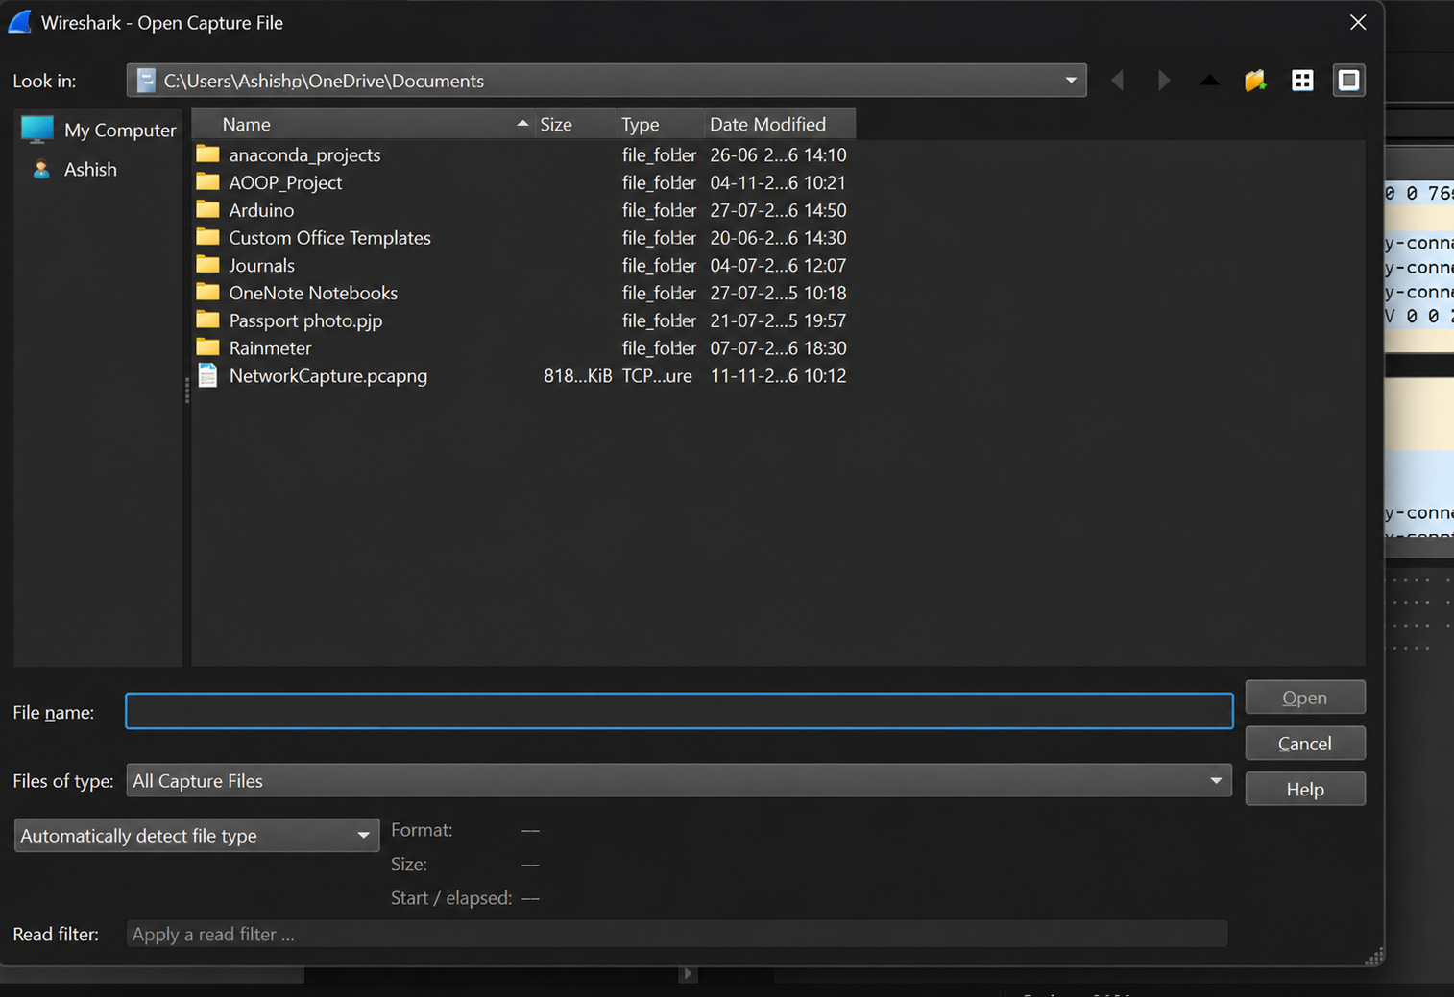
Step 2: Identify total number of packets
- Open the PCAP file in Wireshark.
- Look at the bottom of the Wireshark window.
- Find the packet count displayed in the status bar.
- Record the total number of packets.
Result: Total packets captured = 3959
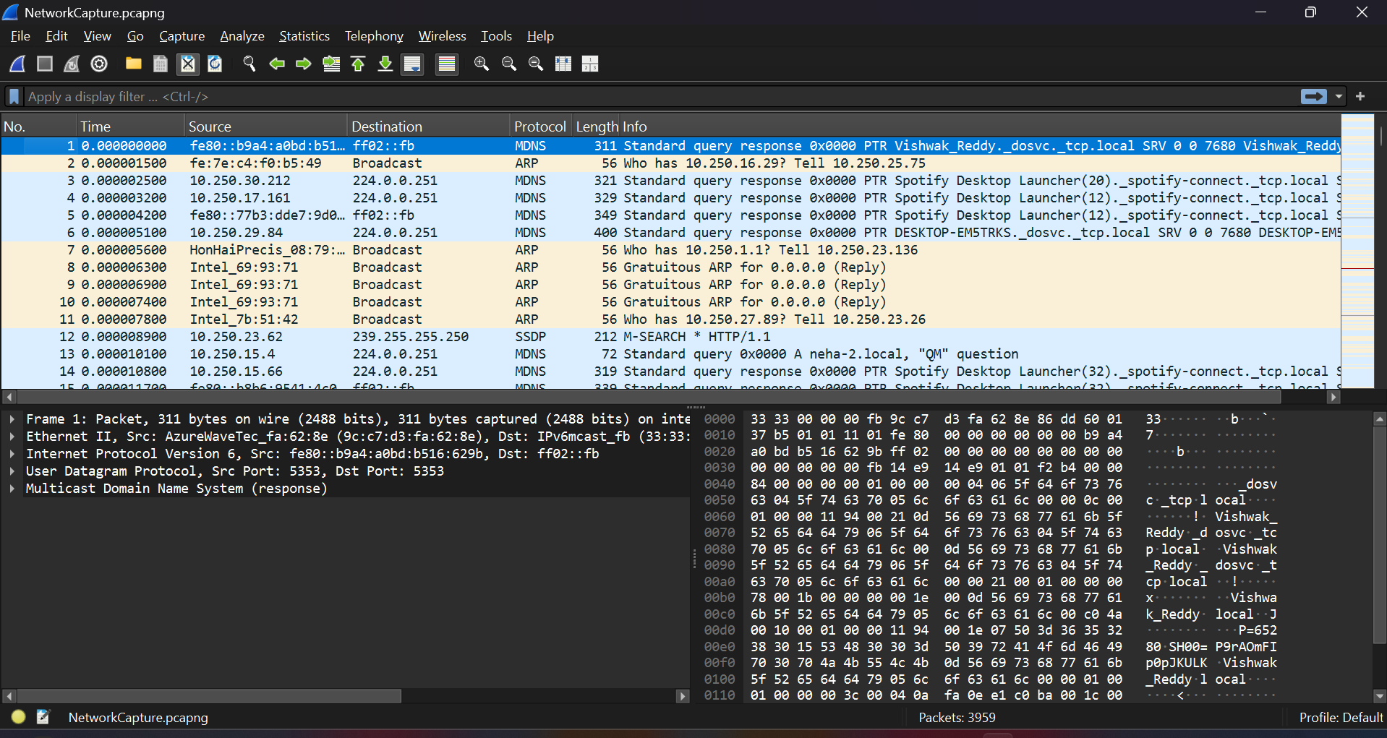Step 3: Identify TCP packets
- Click the display filter bar at the top.
- Type the filter:tcp
- Press Enter.
- Wireshark displays only TCP packets.
- Check the packet count at the bottom.
- Record the number.
Result: Total TCP packets = 34518, Displayed = 3959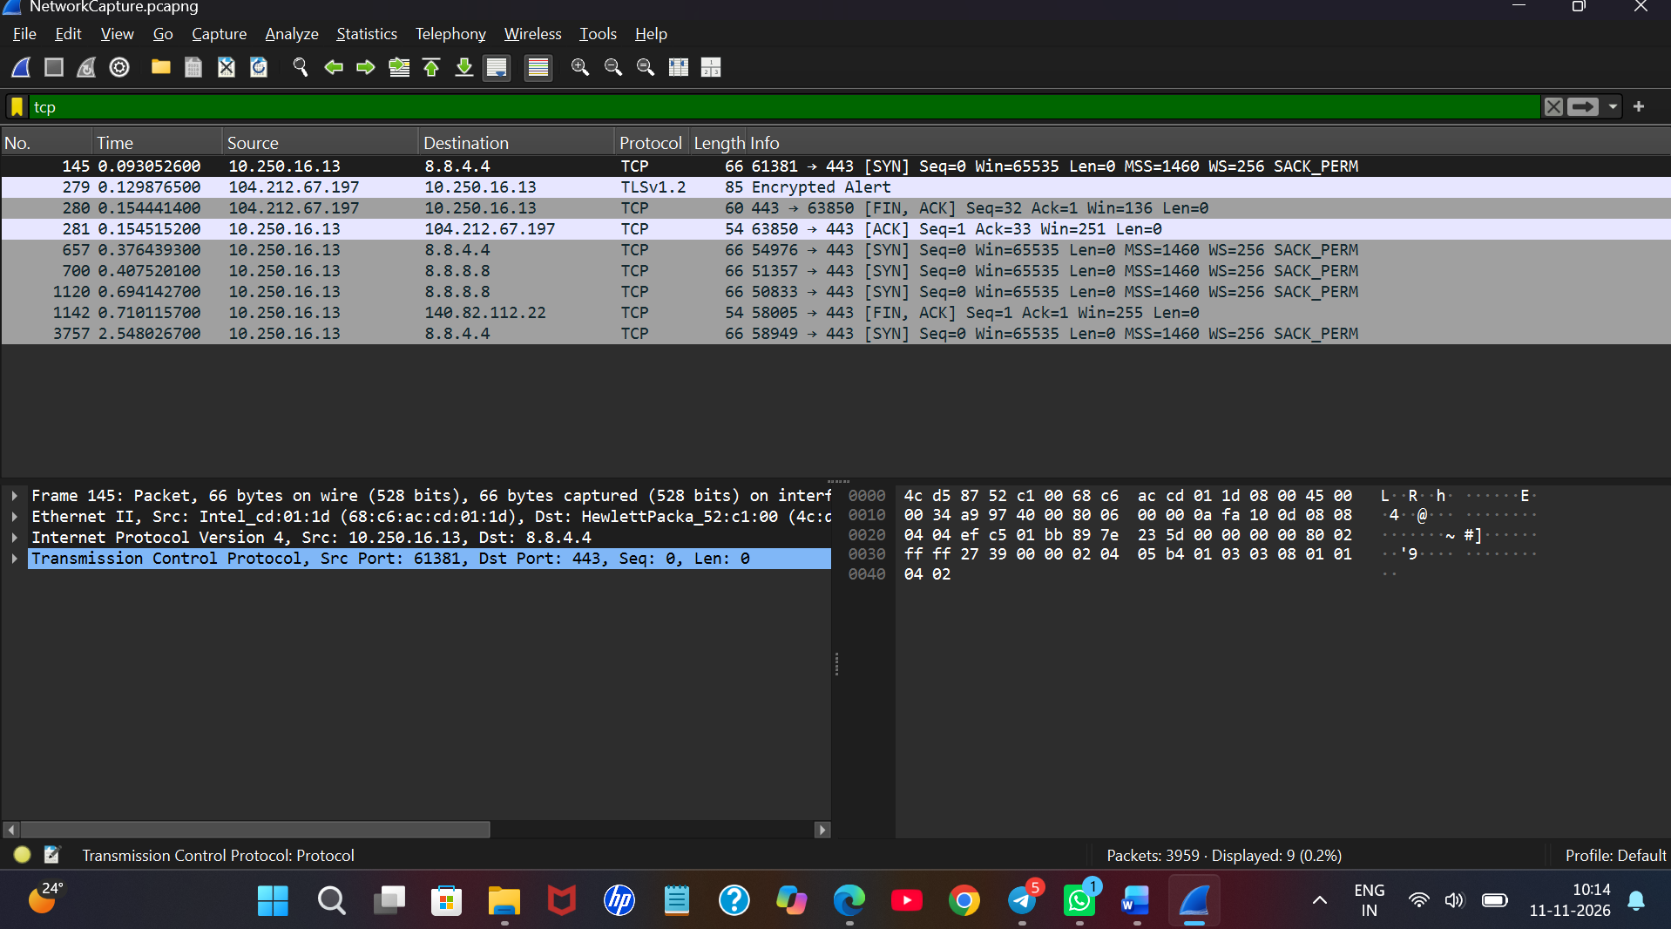

Step 4: Identify UDP packets
- Click the display filter bar.
- Remove the previous filter.
- Type:udp
- Press Enter.
- Only UDP packets will be displayed.
- Check the packet count at the bottom.
- Record the number.
Result: Total UDP packets = 3959, Displayed = 2434
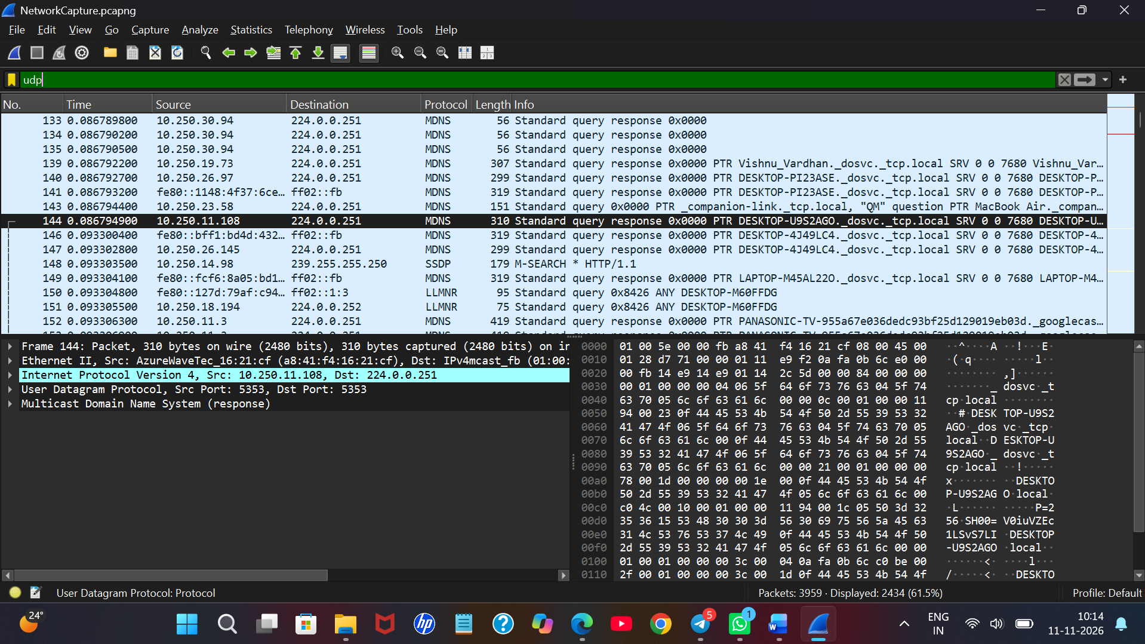

Step 5: Identify ICMP packets
- Click the display filter bar.
- Remove the previous filter.
- Type:icmp
- Press Enter.
- Only ICMP packets will be displayed.
- Check the packet count at the bottom.
- Record the number.
Result: Total ICMP packets = 3959 , Displayed = 0
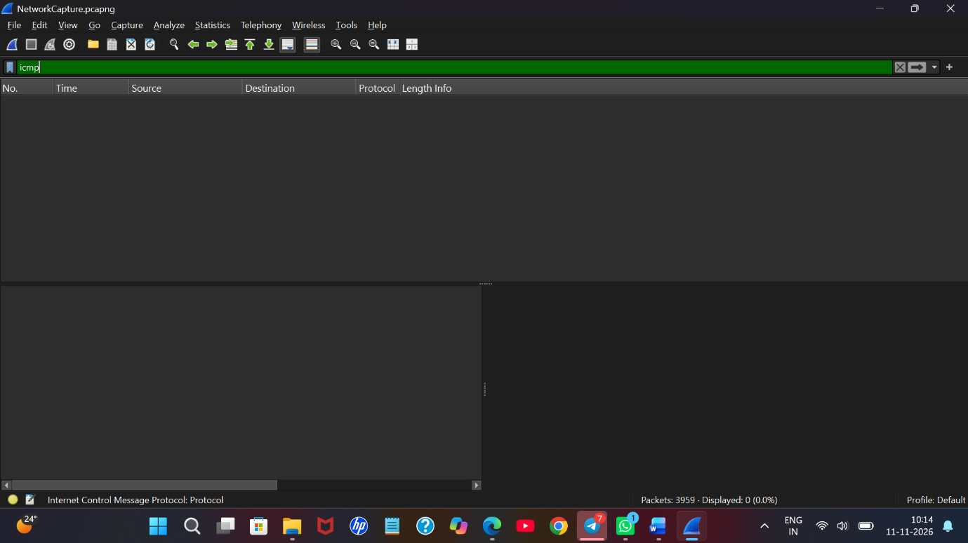
Step 6: Identify the top five protocols
- Click on Statistics in the menu bar.
- Select Protocol Hierarchy.
- A new window will appear.
- Observe the list of protocols.
- Identify the top five protocols based on packet count or percentage.
- Record their names and corresponding packet counts.
- Take a screenshot for your record.
Protocol | Packet Count
Multicast DNS (mDNS) | 2312
ICMPv6 | 523
Simple Service Discovery Protocol (SSDP) | 130
Link-Local Multicast Name Resolution (LLMNR) | 126
NetBIOS Name Service | 54


