CBA: Practice Problem Set 2
Topics: Sampling Distributions and Central Limit Theorem

- Examine the following normal Quantile plots carefully. Which of these plots indicates that the data …
- Are nearly normal?
Ans : C
- Have a bimodal distribution? (One way to recognize a bimodal shape is a “gap” in the spacing of adjacent data values.)
Ans : B
- Are skewed (i.e. not symmetric) ?
Ans : A, C , D
- Have outliers on both sides of the center?
Ans : A

- For each of the following statements, indicate whether it is True/False. If false, explain why.

The manager of a warehouse monitors the volume of shipments made by the delivery team. The automated tracking system tracks every package as it moves through the facility. A sample of 25 packages is selected and weighed every day. Based on current contracts with customers, the weights should have μ = 22 lbs. and σ = 5 lbs.

- Before using a normal model for the sampling distribution of the average package weights, the manager must confirm that weights of individual packages are normally distributed.
Ans : TRUE.
In this case, at least 30 sample packages must be selected and weighedeveryday. Based on the central limit theorem, the sampling distribution of thesample mean approach normal distribution as the sample size become bigger (over30).

- The standard error of the daily average SE($\overline{x}$) = 1.

Ans : TRUE.
Standard error equal to standard deviation divided by square root of samplesize = 5/sqrt(25) =1

- Auditors at a small community bank randomly sample 100 withdrawal transactions made during the week at an ATM machine located near the bank’s main branch. Over the past 2 years, the average withdrawal amount has been $50 with a standard deviation of $40. Since audit investigations are typically expensive, the auditors decide to not initiate further investigations if the mean transaction amount of the sample is between $45 and $55. What is the probability that in any given week, there will be an investigation?

- 1.25%
- 2.5%
- 10.55%
- 21.1%
- 50%

Ans : D

n=100, Pop Mean=50, Pop SD=40 As no. of samples is more than 30, we can consider it normal distribution

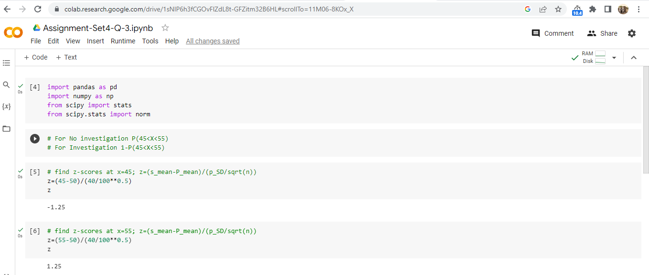

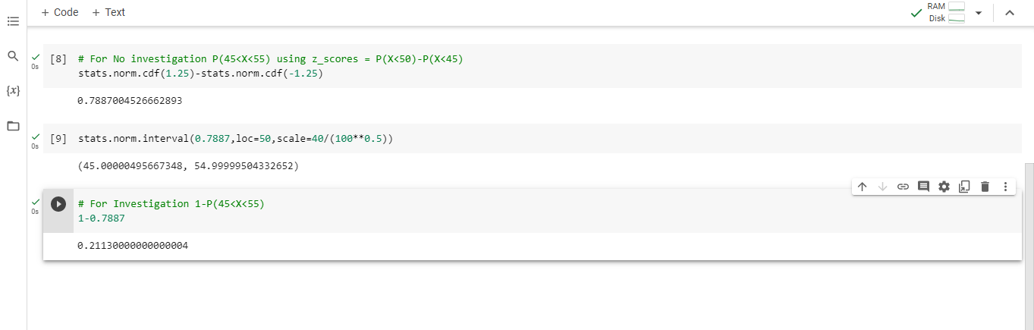

- The auditors from the above example would like to maintain the probability of investigation to 5%. Which of the following represents the minimum number transactions that they should sample if they do not want to change the thresholds of 45 and 55? Assume that the sample statistics remain unchanged.

- 144
- 150
- 196
- 250
- Not enough information
Ans : D
z=(x-mean)/sigma/sqrt(n); z-test, because sd is given for the long term

= 5/40/sqrt(100)
=1.25
The probability of z between those values is 0.7887, so probability of an investigation is 1-0.7887, or 0.2113.
-
For 5%, z has to be +/-1.96
so 1.96=(5)*sqrt(n)/40
sqrt(n)=15.68
n=245.86 or 250

- An educational startup that helps MBA aspirants write their essays is targeting individuals who have taken GMAT in 2012 and have expressed interest in applying to FT top 20 b-schools. There are 40000 such individuals with an average GMAT score of 720 and a standard deviation of 120. The scores are distributed between 650 and 790 with a very long and thin tail towards the higher end resulting in substantial skewness. Which of the following is likely to be true for randomly chosen samples of aspirants?

- The standard deviation of the scores within any sample will be 120.
- The standard deviation of the mean of across several samples will be 120.
- The mean score in any sample will be 720.
- The average of the mean across several samples will be 720.
- The standard deviation of the mean across several samples will be 0.60

Ans : E
Average GMAT score of randomly chosen samples of 100 MBA aspirants is likely to be normally distributed with a mean equal to the population mean (720) and a standard deviation equal to the population standard deviation divided by the square root of the sample size (120/sqrt(100) = 12).

Using the normal distribution, we can calculate the probability that the sample mean will fall within a certain range. For example, the probability that the sample mean will be between 710 and 730 is:

P(710 ≤ X̄ ≤ 730) = P((710-720)/12 ≤ (X̄-720)/12 ≤ (730-720)/12)
= P(-0.83 ≤ Z ≤ 0.83)
= 0.4158

Therefore, we can say that it is likely (with 41.58% probability) that the average GMAT score of a randomly chosen sample of 100 MBA aspirants will fall between 710 and 730.

To calculate this probability, we can use the normal distribution with a mean of 720 and a standard deviation of 12 (as calculated in answer 1).

P(X̄ > 750) = P((X̄-720)/12 > (750-720)/12)
= P(Z > 2.5)
= 0.0062

Therefore, we can say that it is unlikely (with only 0.62% probability) that a randomly chosen sample of 100 MBA aspirants will have an average GMAT score above 750.

