Experiment no.: | Date of Performance:

Title: To Simulate Binary phase shift keying modulation and demodulation
Objectives: 1) To understand generation of BPSK signal
2) To demodulate BPSK signal

Software Required: Octave Online

Theory:

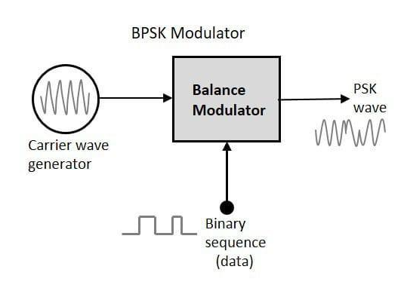

Algorithm: BPSK Modulation and Demodulation

Step 1: Initialize parameters
- Set bit duration T=1 second.
- Define the input bit stream b=[1 0 1 0 1]
- Set the peak voltage Vp=1V.
- Define an empty array NRZ_out to store the encoded waveform.

Step 2: NRZ (Non-Return-to-Zero) Line Coding
- For each bit in the bit stream:
  - If the bit = 1, append 200 samples of +Vp+V_p+Vp​ to NRZ_out.
  - If the bit = 0, append 200 samples of −Vp-V_p−Vp​ to NRZ_out.
- The result is a bipolar NRZ waveform representing the bit sequence.

Step 3: Plot the bit impulses and NRZ waveform
- Plot the original bits using a stem plot.
- Plot the continuous NRZ waveform using a line plot.

Step 4: Generate the carrier signal
- Define the carrier frequency f=5 Hz
- Define a time vector t ranging from 0.005 to 5 seconds with step size 0.005.

Step 5: BPSK Modulation
- Multiply the NRZ waveform with the carrier signal:
Modulated=NRZ_out×( √2)Tcos(2πft)
This multiplication shifts the NRZ signal to a higher frequency — generating a BPSK modulated signal.
- Plot the modulated signal.

Step 6: Demodulation (Coherent Detection)
- Multiply the received (modulated) signal again by the same carrier:
demodulated=Modulated×(√2)Tcos
- Integrate the demodulated signal over each bit duration T using the trapezoidal rule (trapz function) to simulate the action of a correlator receiver.

Step 7: Decision and Bit Recovery
- For each integrated value:
  - If the result > 0, decide the received bit = 1.
  - Else, decide the received bit = 0.
- Store the detected bits in the array received.

Step 8: Plot the received bit impulses
- Use a stem plot to show the recovered bits after demodulation.

Conclusion:

Name of Teaching Staff: | Signature

