Experiment no.: | Date of Performance:

Title: Simulation study of various Entropies and mutual information in a communication system.
Objectives: To simulate
- entropies of transmitted and received symbol
- Joint entropy,
- conditional entropy,
- mutual information

Software Required: Octave Online

Theory:
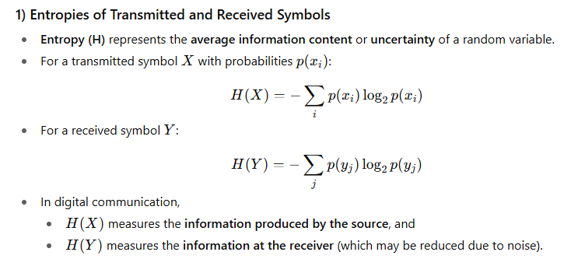

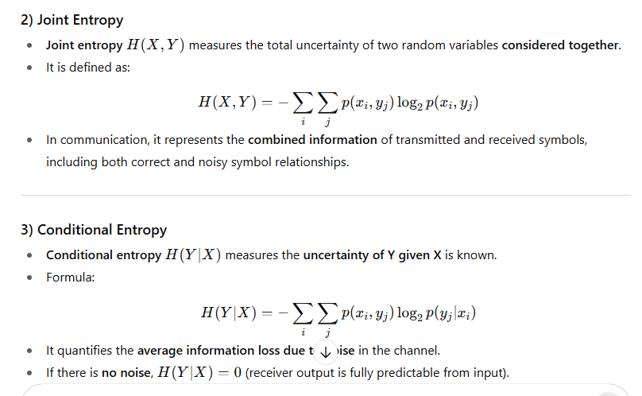

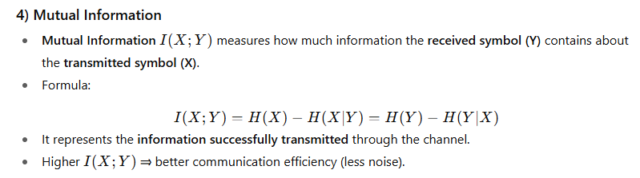

Conclusion:

Name of Teaching Staff: | Signature

