**Contents**

**Organizational Structure:** 2

**Member Profiles:** 3

**How are we monitoring:** 5

**Budget:** 5

**Revenue Target:** 5

**Packages:** 6

**Target:** 6

# **Organizational Structure:**

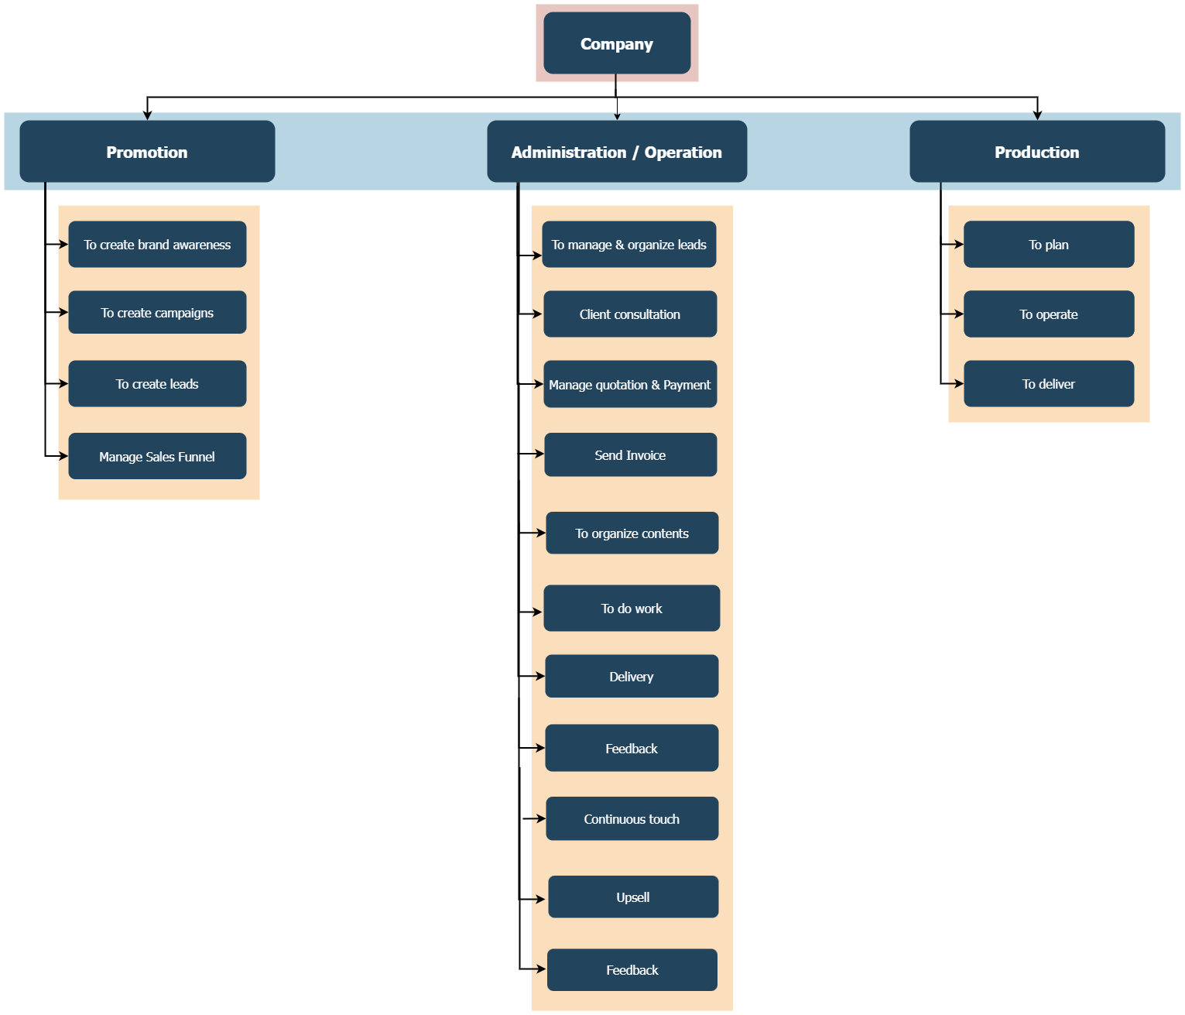

# **Member Profiles:**

Paban Bhuyan Charu Saikia Abhijit Kalita

Paban (Promotion):

1. Paban will create brand awareness using freelancers.
2. Paban will create campaigns using Academy Interns.
3. Paban will create leads using Academy Interns.

Abhijit:

1. Abhijit will organize all the leads from various platforms.
2. Based on the leads or service type Abhijit will distribute it to the concerned person.

Basis of led distribution is-

1. If the lead or the customer needs any service which does not need any customization, sales value is less than Rs. 20,000 or the client is from Indian Territories, the lead will be handled by Abhijit.
2. If the lead or the customer needs any type of promotional packages or customized e-commerce websites, the lead will be distributed to Charu.
3. If the lead or the customer needs any type of customized website (hard coded), software or mobile app or any other type of requirement which cannot be handled by Abhijit or Charu, it will be distributed to Paban.
4. If the lead is handled by Abhijit, Abhijit will do a consultation with the client, prepare a quotation and invoice and forward it to the client.
5. On approval of the invoice, Abhijit will prepare the project document and handover to the following persons-
6. Graphic design: Freelancers
7. Digital Marketing (To Paban till March 2022 and then to upcoming intern Hirok/Parag/Dhruva whoever can perform well).
8. Web Design (To Charu till March 2022 and then to the upcoming intern Hirok).
9. Web Portal: To Paban
10. Software and Mobile Apps: To Paban

Charu:

1. Charu will update leads received on her mobile number from Google Map and Websites.
2. Based on the lead or customer type Charu will assign the leads.
3. If the lead is handled by Charu, she will do a video or audio consultation with the client.
4. On approval---

Paban:

1. Paban will contact the assigned leads, prepare quotation and invoice.
2. Prepare project document.

Charu:

1. Create projects and share updates to client.
2. Complete project and delivery.
3. Earn final milestone.

Paban:

1. Create projects and share updates to client.
2. Complete project and delivery.
3. Earn final milestone.

Abhijit:

1. If the project is handled by a freelancer, Abhijit will get it done.
2. Complete project and delivery.
3. Earn final milestone.
4. Share monthly updates to client for basic packages and push for upsell.

Charu:

1. Will have client review meetings from April 2022.

Paban:

1. Will have client review meeting till 1st April 2022

Charu:

1. Manage HR

Paban:

1. Manage Accounts

# **How are we monitoring:**

Every team member will have to submit a report of the last week on Monday at 11am in the conference room.

# **Budget:**

Present Monthly Expense-

1. Room Rent- Rs. 17,000
2. Electricity- Rs. 2,000
3. Salary-

Paban— Rs. 25,000

Charu— Rs. 20,000

Abhijit— Rs. 12,000, Rs. 7,000

1. Google Ads- Rs. 10,000

Social Media- Rs. 5,000

1. Freelancers- Rs. 20,000
2. Cleaning & Maintenance- Rs. 5,000
3. Travel- Rs. 5,000
4. Utilities- (phone/internet) Rs. 1,000

Rs. 1,22,000

# **Revenue Target:**

For the next 13 months

December 2021- Rs. 2,00,000

January 2022- Rs. 2,50,000

February 2022- Rs. 3,00,000

March 2022- Rs. 5,00,000

April 2022- Rs. 6,00,000

May 2022- Rs. 6,50,000

June 2022- Rs. 7,00,000

July 2022- Rs. 7,50,000

August 2022- Rs. 8,00,000

September 2022- Rs. 8,50,000

October 2022- Rs. 9,00,000

November 2022- Rs. 9,50,000

December 2022- Rs. 10,00,000

Rs. 97,00,000

# **Packages:**

1. Starter Packages won’t have any name.
2. Growth Package (Average price will be Rs. 7,000 to Rs. 15,000 per Month)

Digital Combo for startup- Rs. 7,000

Digital Combo for companies- Rs. 10,000 & Rs. 13,000

Digital Combo for enterprises- More than Rs. 13,000

1. Software Package- (Custom CRM & ERP) One time selling amount from 1 lac to 5 lacs.

# **Target:**

1. In one month we have to get Rs. 2,00,000 from Starter Packages.
2. Every month we have to get atleast 6 customers for Growth Package.
3. Every month we have to get atleast 1 customer for Software Package.