**INNER JOIN**

// intersection

// order of table A nd B does not matter

// INNER JOIN ON

// final result has all the columns of A + B

// avoid dupliacy

// JOIN is treated as INNER JOIN in Postgresql

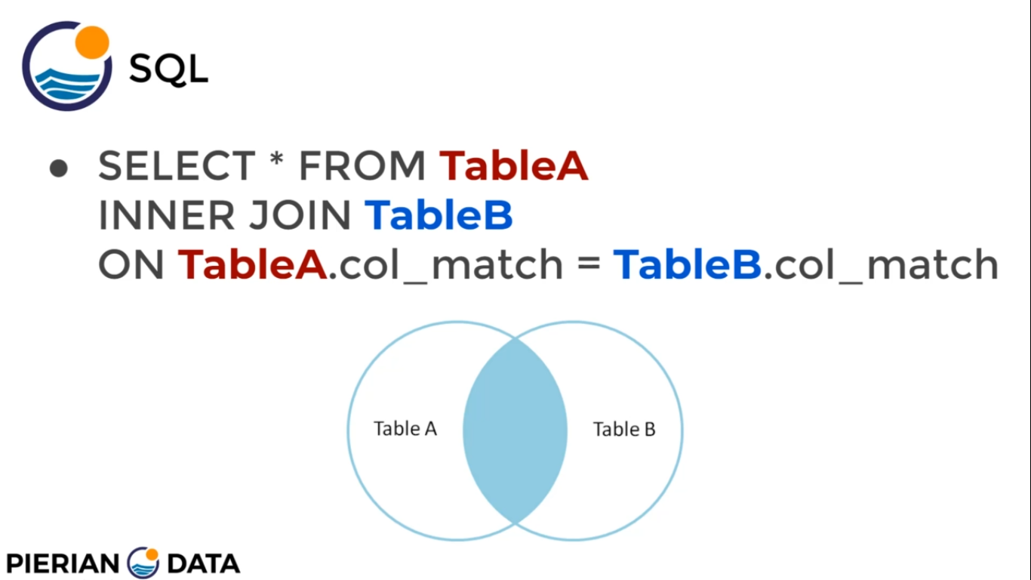

Situation - find customer that are in both table

**SELECT * FROM payment INNER JOIN customer ON payment.customer_id = payment.customer_id**

**SELECT email, payment.customer_id ,amount FROM payment INNER JOIN customer ON payment.customer_id = payment.customer_id**

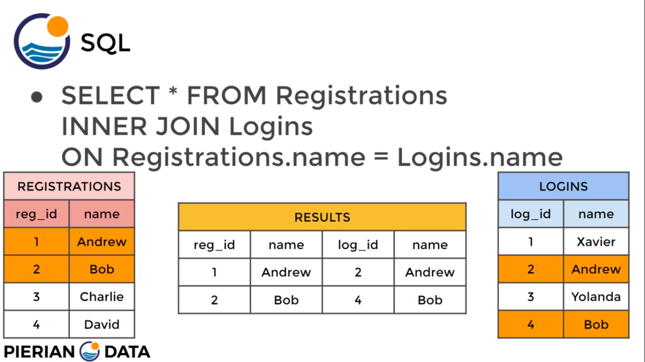

**OUTER JOIN**

// union

// with condition removes the intersection part of venn diagram

// order of table A nd B does not matter

// FULL OUTER JOIN ON

// final result has all the columns of A + B

// for a match in A and B values are filled in columns

// for no match NULL is filled

// can be used to get unique items to A nd B

// FULL OUTER JOIN contains INNER JOIN

situation- find customer that are not in both table(present in either of the table)

**SELECT * FROM customer FULL OUTER JOIN payment ON customer.customer_id = payment.customer_id**

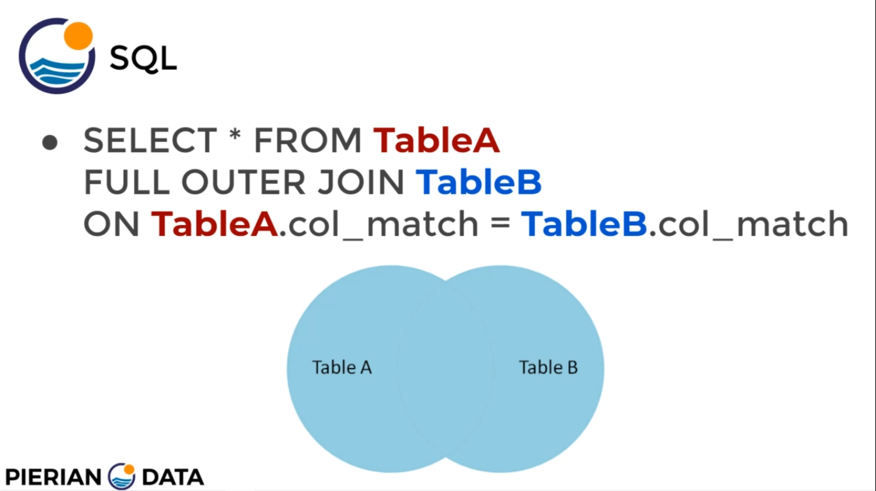

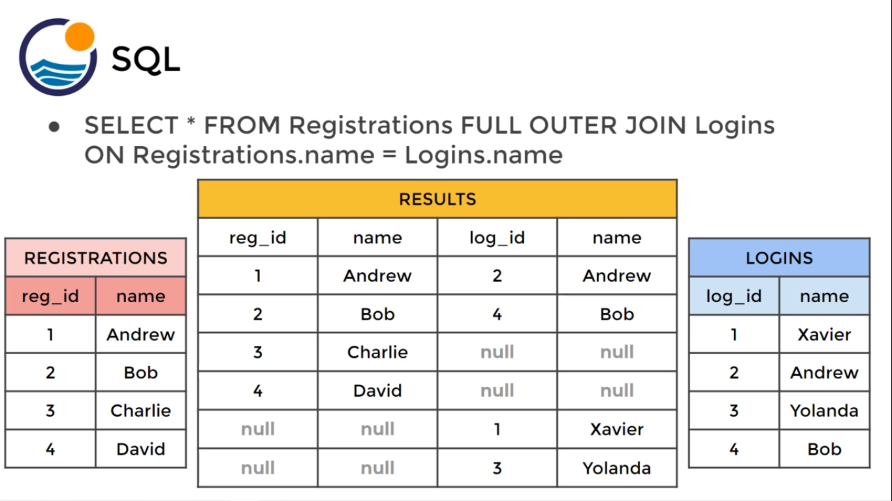

**SELECT * FROM customer FULL OUTER JOIN payment ON customer.customer_id = payment.customer_id**

**WHERE customer.customer_id IS null AND payment.customer_id IS null**

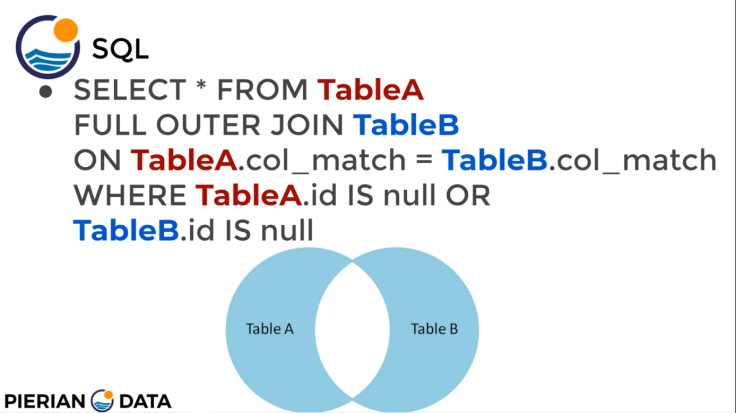

**LEFT JOIN**

// considers only LEFT table A

// with condition removes the intersection part of venn diagram

// order of table A nd B does matter

// LEFT OUTER JOIN ON

// final result has all the columns of A + B

// has all the rows of A

// for a match in A and B values are filled in columns

// for no match in B null is filled

// can be used to get unique items to A nd B

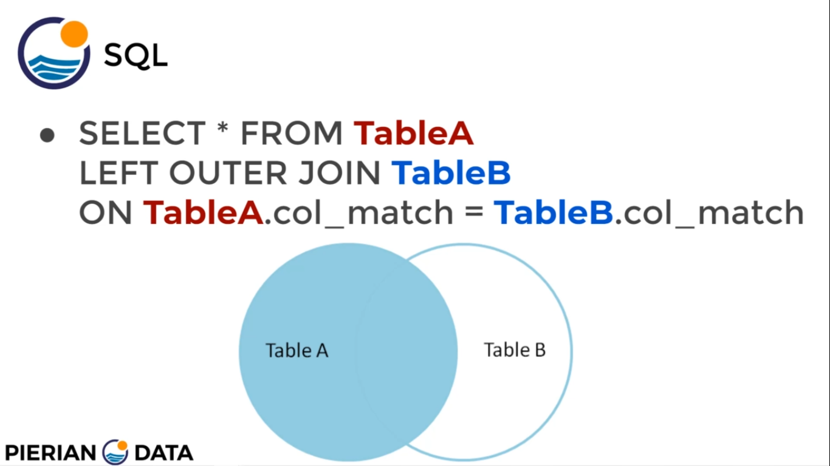

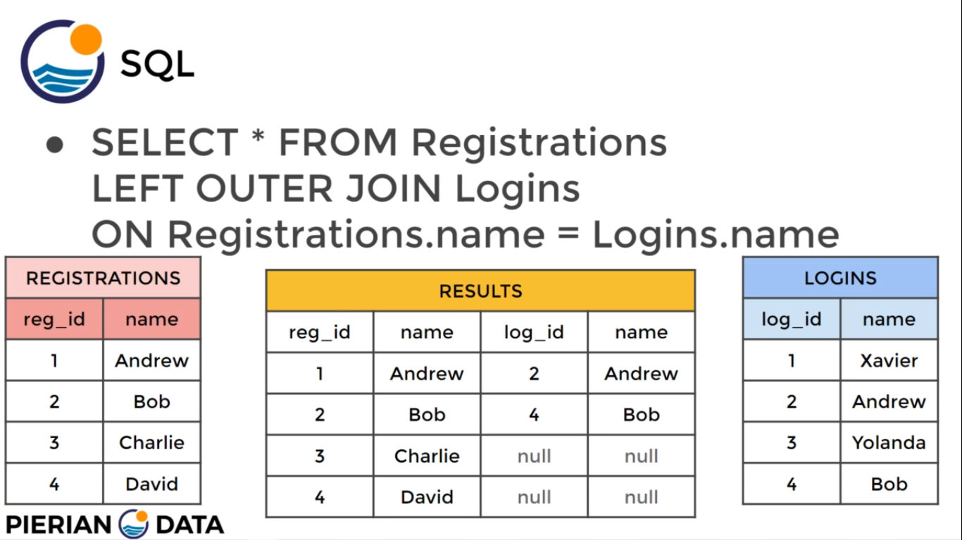

**SELECT * FROM film LEFT OUTER JOIN inventory**

**ON film.film_id = inventory.film_id WHERE inventory.film_id IS null**

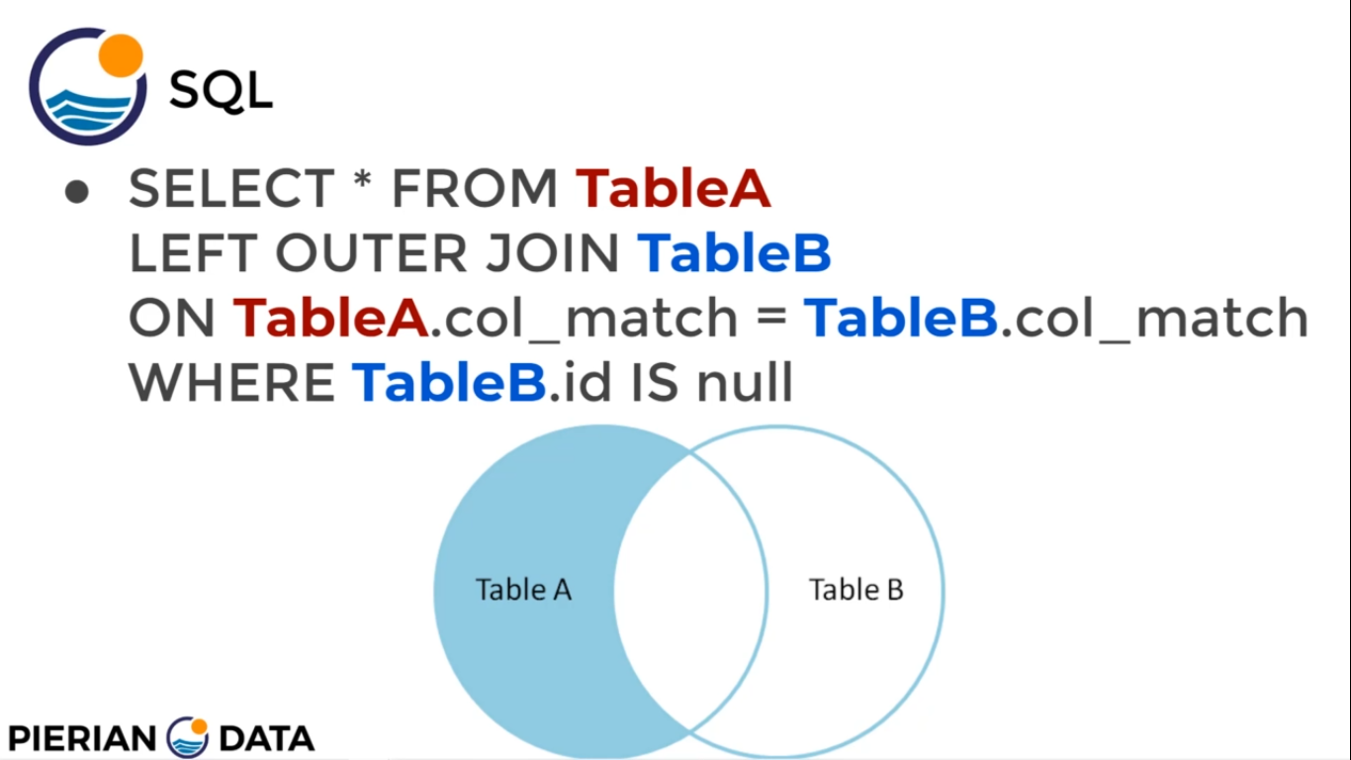

**RIGHT JOIN**

// considers only RIGHT table B

// with condition removes the intersection part of venn diagram

// order of table A nd B does matter

// RIGHT OUTER JOIN ON

// final result has all the columns of A + B

// has all the rows of B

// for a match in A and B values are filled in columns

// for no match in A null is filled

// can be used to get unique items to A nd B

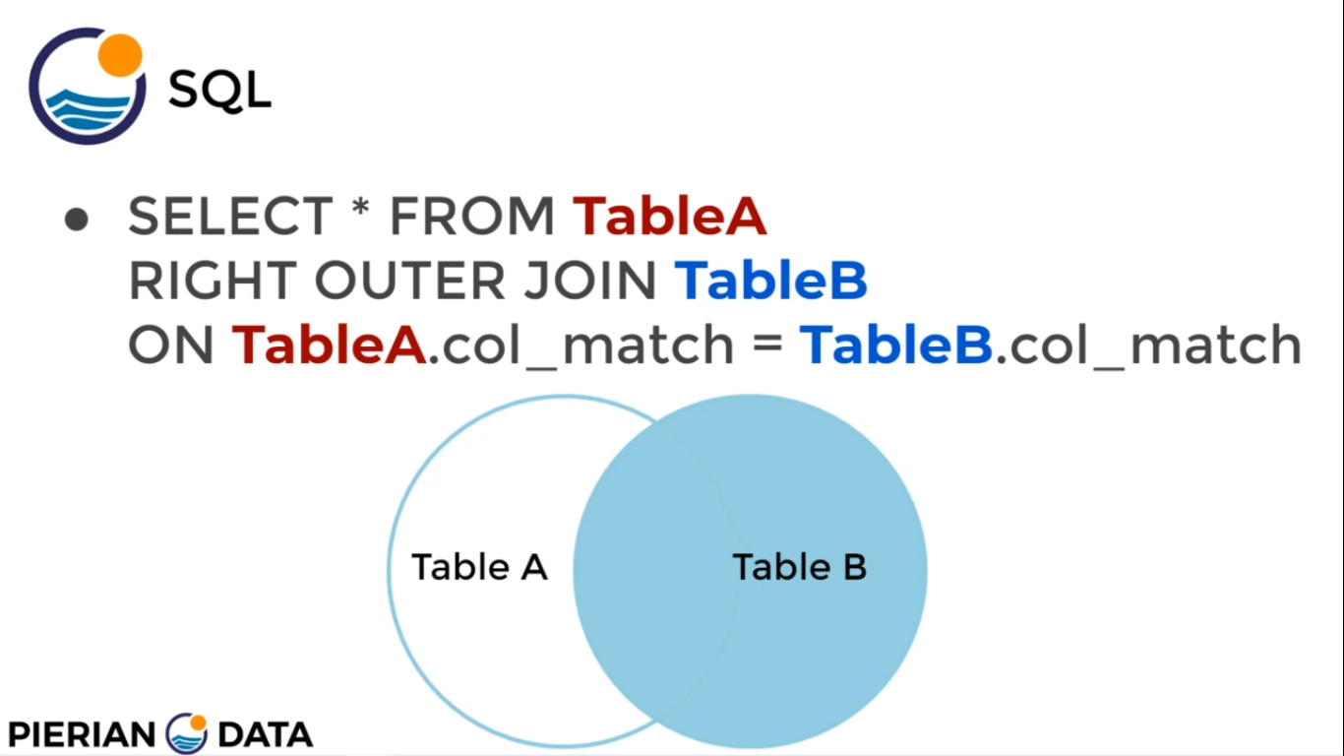

**SELECT * FROM film RIGHT OUTER JOIN inventory**

**ON film.film_id = inventory.film_id WHERE film.film_id IS null**

**UNION**

// has 2 SELECT statment

// simple pasting on top of other

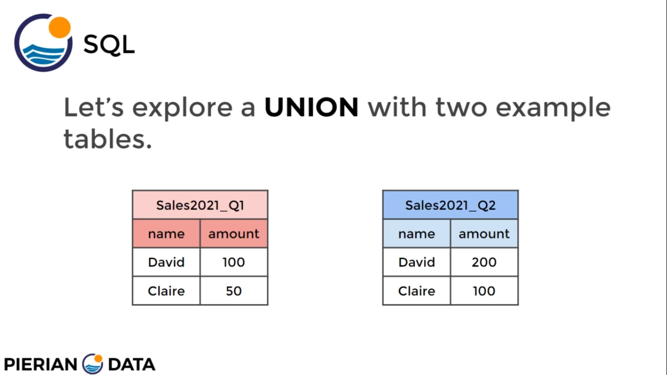

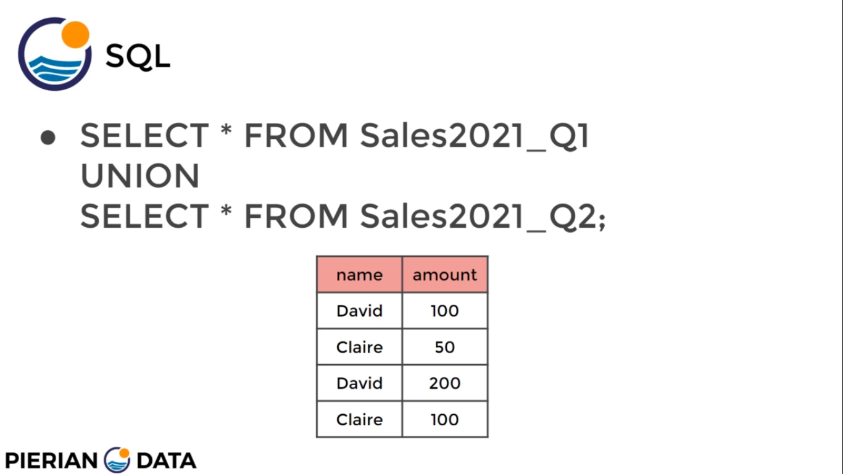

//CHALLANGE

SELECT email FROM address INNER JOIN customer

ON address.address_id = customer.address_id

WHERE address.district = 'California'

SELECT title,first_name,last_name FROM actor AS act INNER JOIN film_actor AS fa

ON act.actor_id = fa.actor_id

INNER JOIN film

ON fa.film_id = film.film_id

WHERE first_name = 'Nick' AND last_name LIKE 'W%'

**SELF JOIN**

// join within the same table

// when all the info is in same table

// use two alias for same table

situation- make pairs of film with same length

**SELECT f1.title,f2.title,f1.length FROM film AS f1 INNER JOIN film AS f2**

**ON f1.film_id != f2.film_id AND f1.length = f2.length**

**ORDER BY f1.length**