STUDY NOTES
Biological and Anatomical Aspects of Elephants
Dr. Parag Nigam, PhD · Wildlife Institute of India, Dehradun

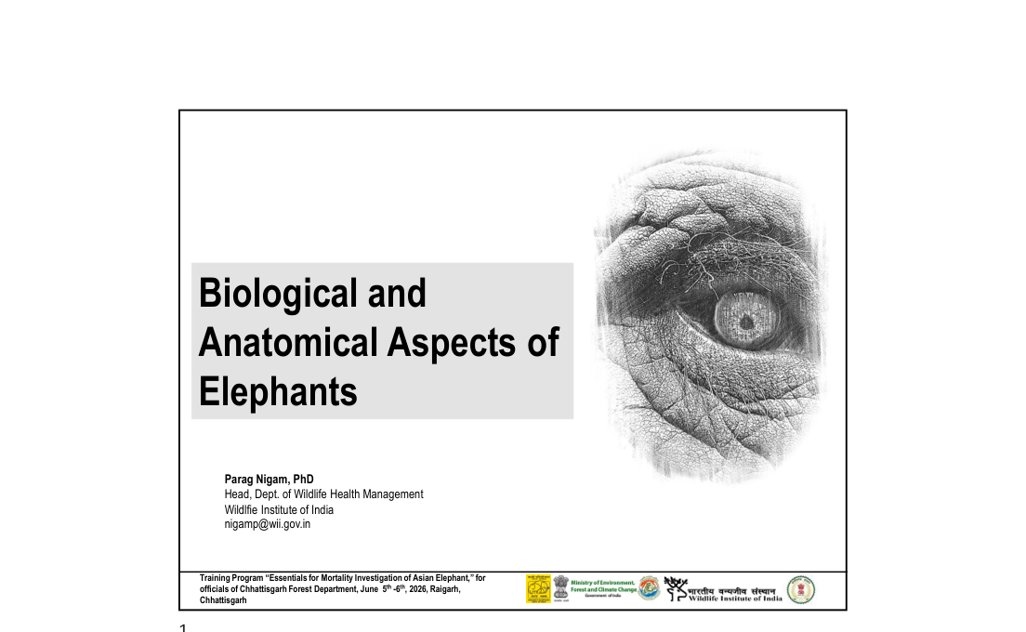
Slide 1 — Title slide
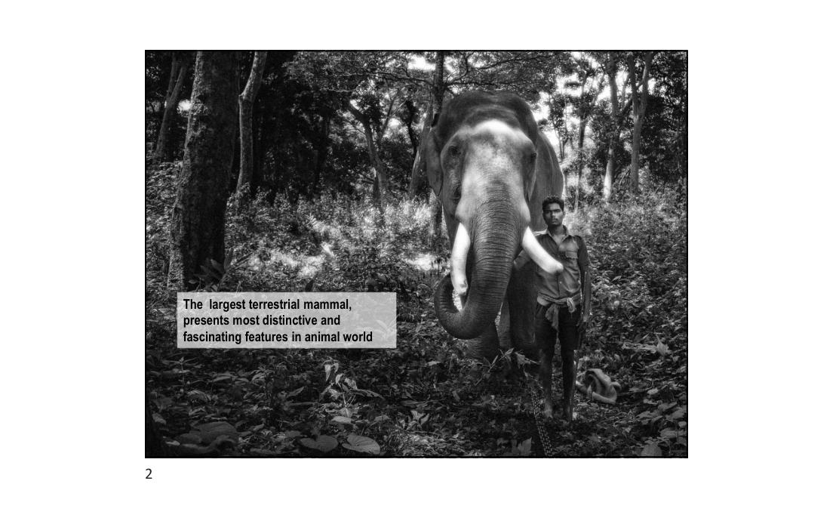
Slide 2 — The Asian elephant: largest terrestrial mammal
Dr. Parag Nigam, PhD | Head, Dept. of Wildlife Health Management, Wildlife Institute of India
Training Program: "Essentials for Mortality Investigation of Asian Elephant"
Chhattisgarh Forest Department · 5–6 June 2026, Raigarh, Chhattisgarh

1. Taxonomy & Overview
1. Taxonomy & Overview

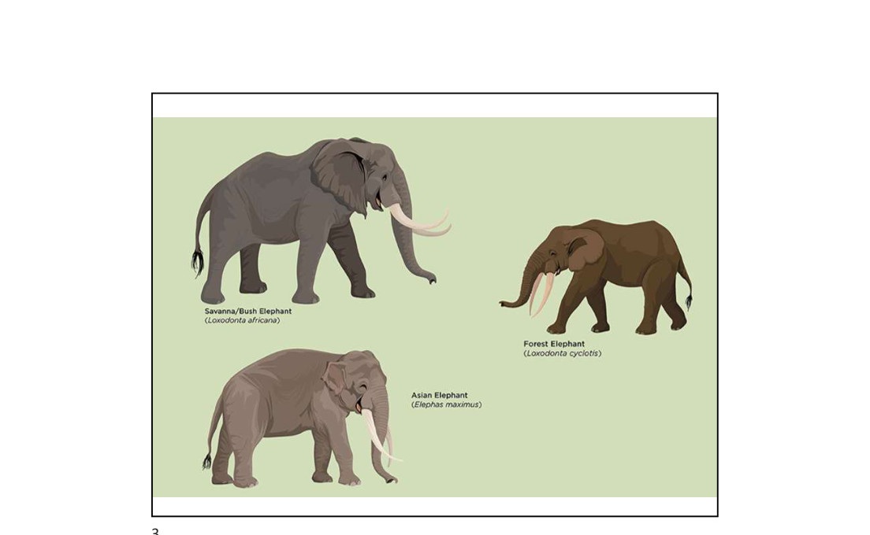
Slide 3 — Three species of elephants: Savanna, Forest and Asian
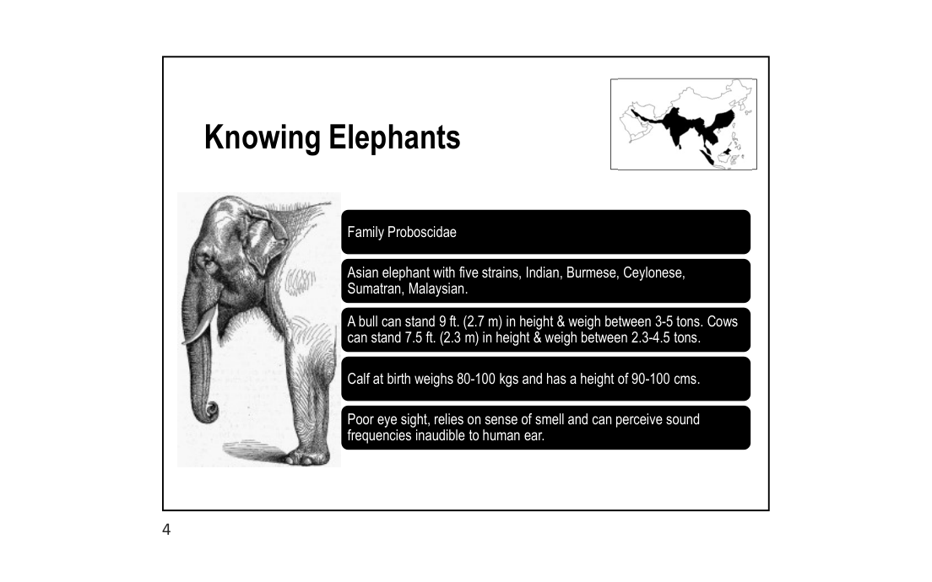
Slide 4 — Knowing Elephants: key facts

1.1 Classification & Species
1.1 Classification & Species

• Family: Proboscidae
• Three living species:
• Savanna / Bush Elephant (Loxodonta africana) — largest, found in sub-Saharan Africa
• African Forest Elephant (Loxodonta cyclotis) — smaller, central African rainforests
• Asian Elephant (Elephas maximus) — India, Sri Lanka & SE Asia
• Asian elephant has FIVE sub-strains: Indian, Burmese, Ceylonese, Sumatran, Malaysian

1.2 Body Size & Weight
1.2 Body Size & Weight

Parameter | Bull (Male) | Cow (Female)
Height | 9 ft / 2.7 m | 7.5 ft / 2.3 m
Weight | 3–5 tons | 2.3–4.5 tons
Calf at birth — Height | 90–100 cm | 90–100 cm
Calf at birth — Weight | 80–100 kg | 80–100 kg

1.3 Senses & Behaviour
1.3 Senses & Behaviour

• Poor eyesight; highly dependent on senses of smell and hearing
• Can perceive sound frequencies inaudible to the human ear (infrasound communication)
• Distribution limited to South Asia and South-East Asia (see map — Slide 4)

2. The Trunk (Proboscis)
2. The Trunk (Proboscis)

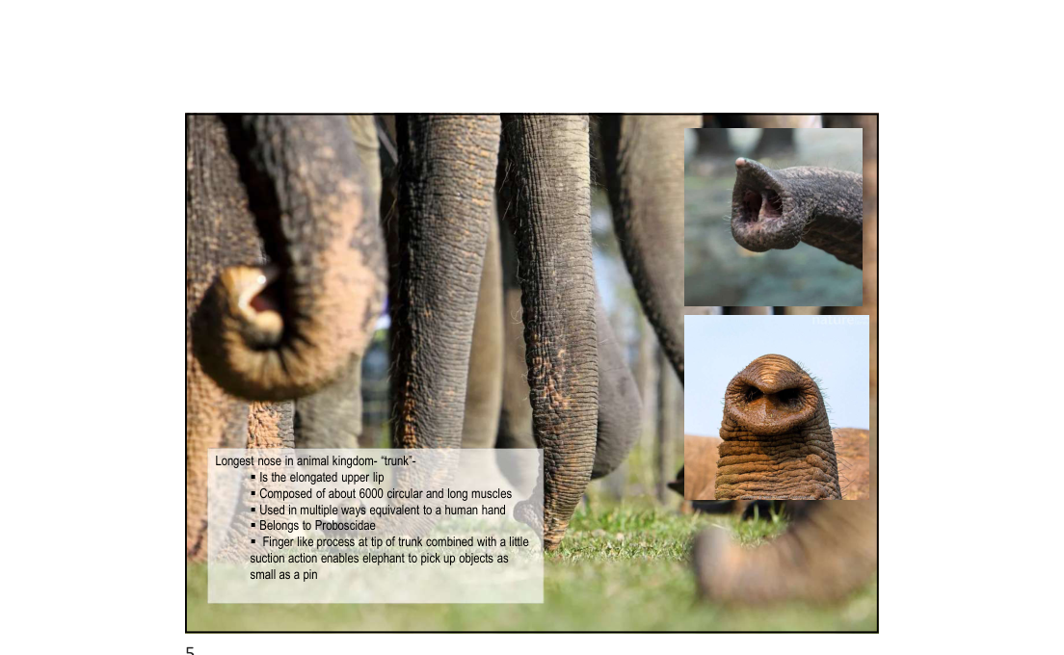
Slide 5 — The trunk: longest nose in the animal kingdom

2.1 Structure
2.1 Structure

• The trunk is the elongated upper lip of the elephant
• Composed of approximately 6,000 circular and longitudinal muscles
• Belongs to Order Proboscidae (defines the order)
• Has NO bones — entirely muscular structure

2.2 Function
2.2 Function

• Used in multiple ways equivalent to a human hand
• Finger-like process at tip of trunk combined with suction action
• Can pick up objects as small as a pin
• Used for breathing, smelling, drinking, bathing, grasping food and social interaction
KEY FACT: The trunk is the most versatile appendage in the animal kingdom — 6,000+ muscles, no bones.

3. Skeletal System
3. Skeletal System

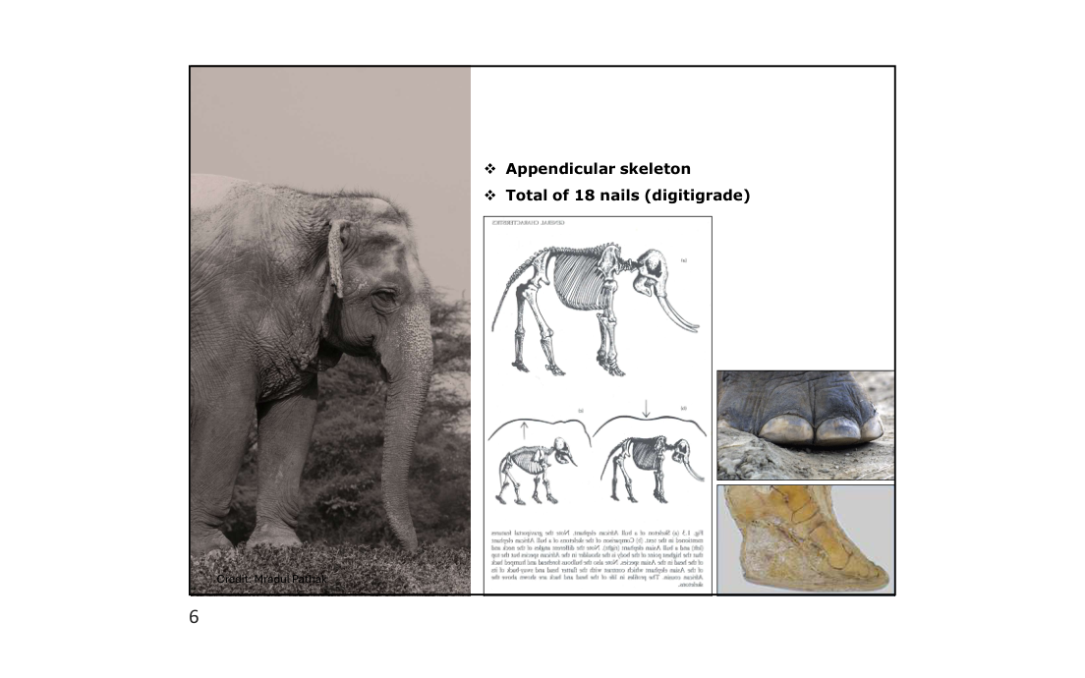
Slide 6 — Appendicular skeleton, 18 nails and foot anatomy
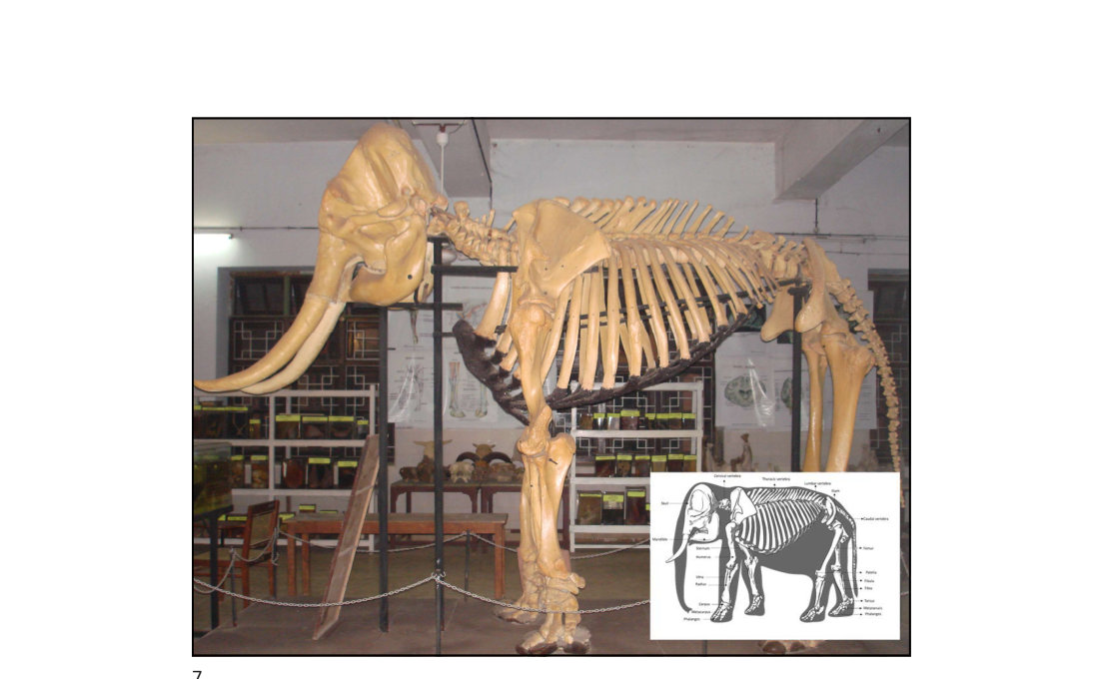
Slide 7 — Full articulated skeleton on display
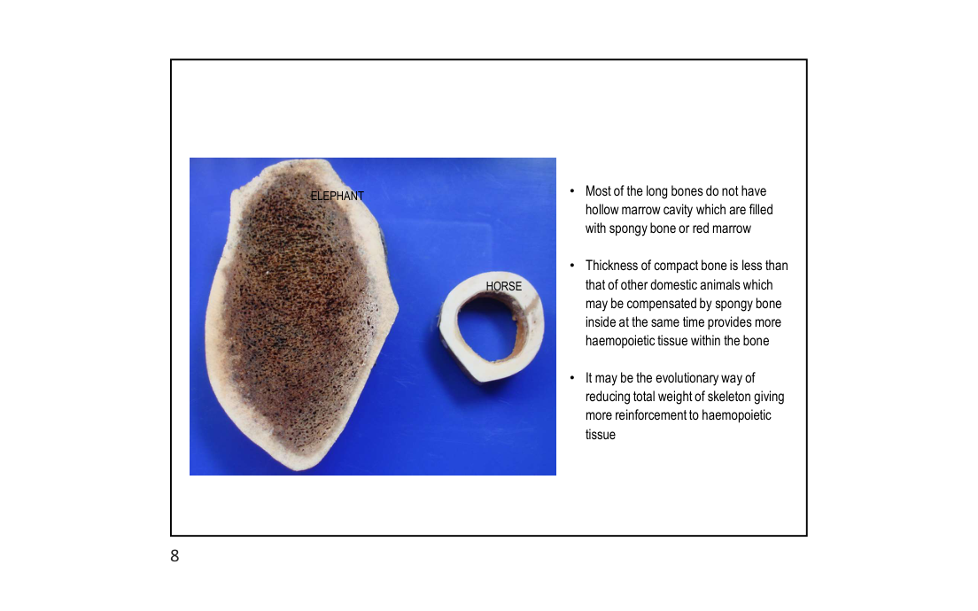
Slide 8 — Bone structure: Elephant vs Horse cross section

3.1 General Features
3.1 General Features

• Appendicular skeleton — limbs adapted for supporting enormous body weight
• Total of 18 nails (digitigrade stance)
• Limbs function as pillars — bones aligned vertically under the body

3.2 Bone Microstructure
3.2 Bone Microstructure

• Most long bones do NOT have hollow marrow cavities
• Filled with spongy bone or red marrow instead of hollow space
• Thickness of compact bone is LESS than that of other domestic animals
• Compensated by spongy bone inside — simultaneously provides more haemopoietic tissue
• Evolutionary advantage: reduces total skeletal weight while reinforcing haemopoietic tissue production
NOTE: Compact bone thinner than horse/cattle — do not mistake for pathology during necropsy.

4. Foot Anatomy
4. Foot Anatomy

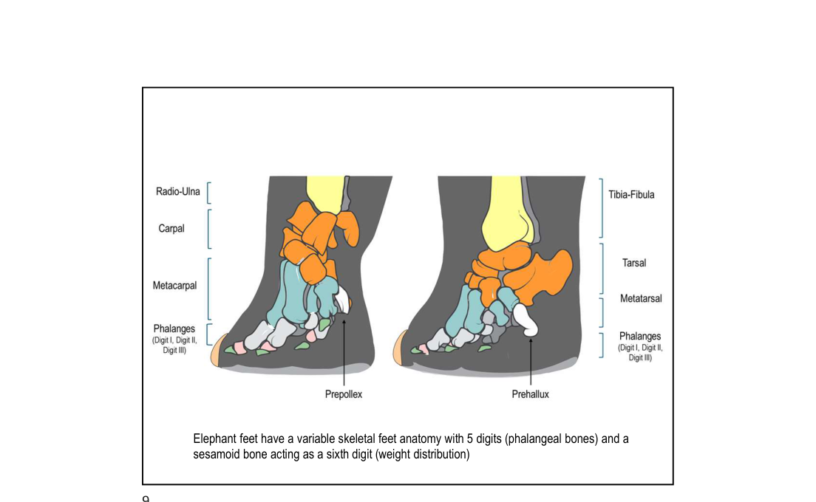
Slide 9 — Foot skeletal anatomy: forefoot (Prepollex) and hindfoot (Prehallux)

4.1 Structure
4.1 Structure

• Forefoot: Radio-Ulna → Carpal → Metacarpal → Phalanges (Digits I, II, III)
• Hindfoot: Tibia-Fibula → Tarsal → Metatarsal → Phalanges (Digits I, II, III)
• Elephant feet have variable skeletal foot anatomy with 5 digits (phalangeal bones)
• Sesamoid bone acts as a SIXTH digit for weight distribution
• Prepollex (forefoot) and Prehallux (hindfoot) — extra weight-bearing bony processes
The foot's unique sesamoid "sixth digit" distributes weight across a wide surface — critical for supporting 3–5 tons.

5. Thorax & Rib Cage
5. Thorax & Rib Cage

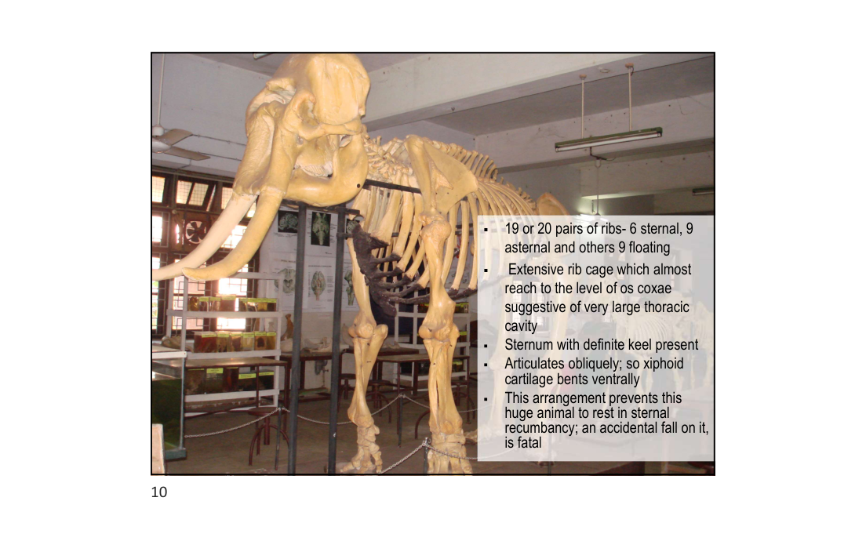
Slide 10 — Thoracic skeleton showing rib cage structure

5.1 Rib Count & Structure
5.1 Rib Count & Structure

• 19 or 20 pairs of ribs:
• 6 sternal ribs (attached to sternum)
• 9 asternal ribs (attached to cartilage)
• 9 floating ribs (free)
• Extensive rib cage almost reaching the level of os coxae — indicates VERY LARGE thoracic cavity
• Sternum has a definite keel present
• Articulates obliquely — xiphoid cartilage bends ventrally
CRITICAL: The xiphoid arrangement prevents sternal recumbency. An accidental fall in sternal position is FATAL for an elephant — lungs are crushed by body weight. Always keep anesthetized/down elephants in lateral recumbency.

6. Skull Morphology & Sexual Dimorphism
6. Skull Morphology & Sexual Dimorphism

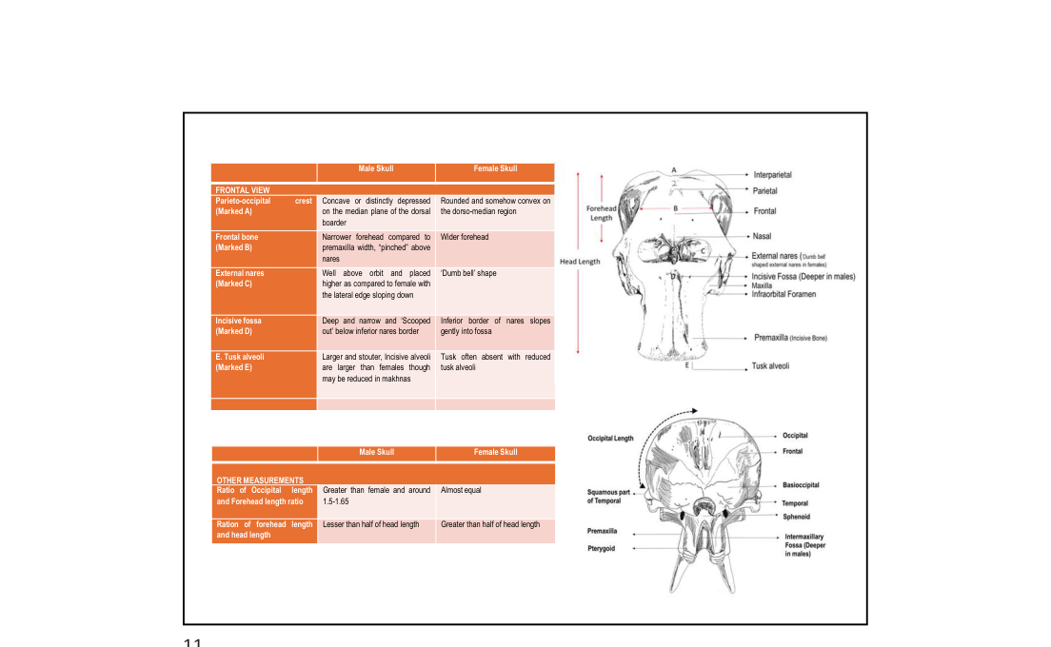
Slide 11 — Skull: Male vs Female comparison (Frontal view)
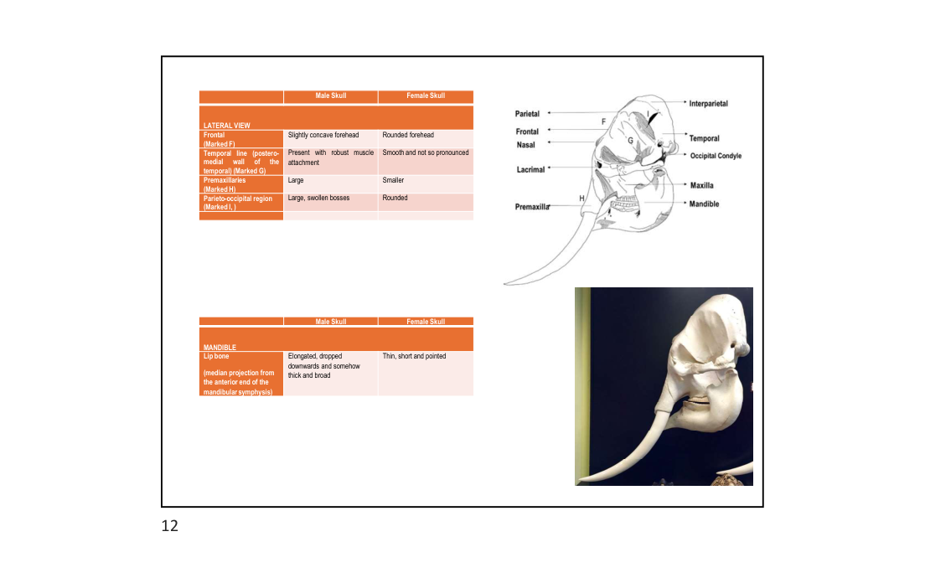
Slide 12 — Skull: Lateral view and Mandible comparison
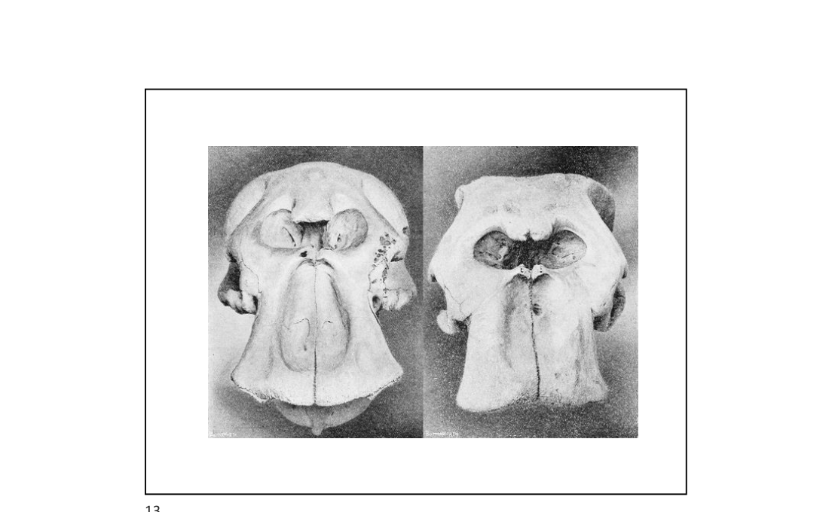
Slide 13 — Skull photographs: male (left) vs female (right)

6.1 Frontal View Differences
6.1 Frontal View Differences

Feature | Male Skull | Female Skull
Parieto-occipital crest | Concave / distinctly depressed on median plane of dorsal border | Rounded and somewhat convex on dorso-median region
Frontal bone | Narrow forehead, "pinched" above nares | Wider forehead
External nares | Well above orbit, placed higher, lateral edge sloping down | Dumb-bell shape
Incisive fossa | Deep and narrow, "Scooped out" below inferior nares border | Inferior border slopes gently into fossa
Tusk alveoli | Larger and stouter; incisors larger, though may be reduced in makhna | Tusk often absent or with reduced alveoli

6.2 Lateral View Differences
6.2 Lateral View Differences

Feature | Male Skull | Female Skull
Frontal | Slightly concave forehead | Rounded forehead
Temporal line (post. medial wall) | Present with robust muscle attachment | Smooth and not so pronounced
Premaxillaries | Large | Smaller
Parieto-occipital region | Large, swollen bosses | Rounded

6.3 Mandible
6.3 Mandible

Feature | Male Skull | Female Skull
Chin (median projection from anterior end of mandibular symphysis) | Elongated, dropped downwards and somewhat thick and broad | Thin, short and pointed

6.4 Other Measurements
6.4 Other Measurements

Measurement | Male | Female
Ratio of occipital length and forehead length | Greater than female; around 1.5–1.65 | Almost equal
Ratio of forehead length to head length | Less than half head length | Greater than half head length

PRACTICAL USE: Skull morphology allows sex determination of a carcass even when soft tissue is absent — important for mortality investigations.

7. Age Estimation
7. Age Estimation

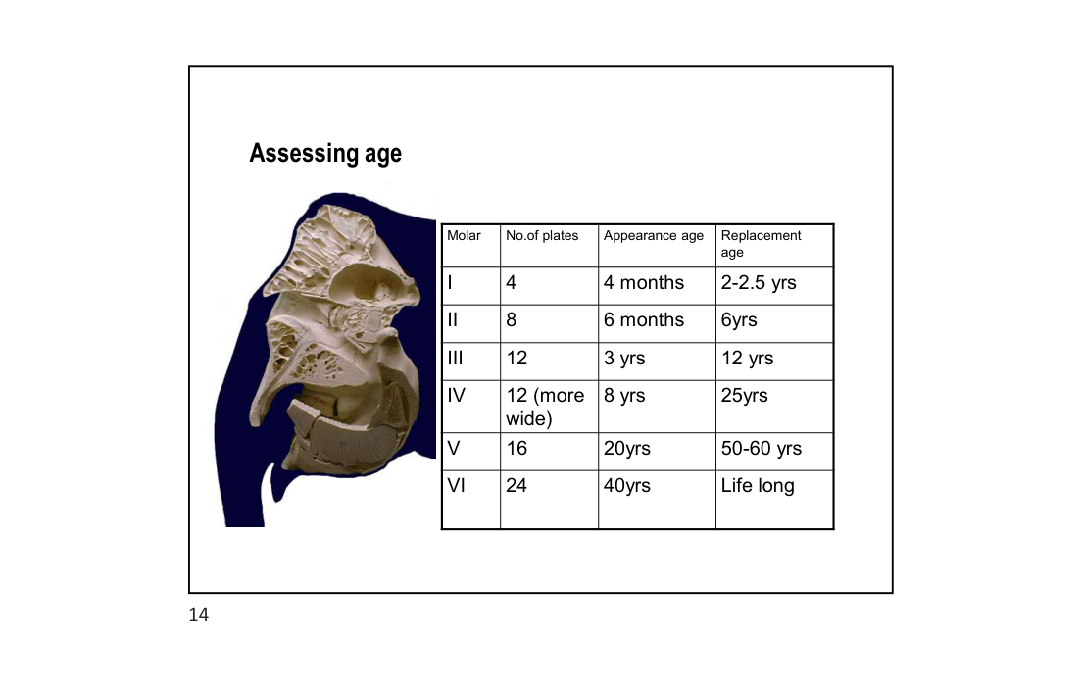
Slide 14 — Molar progression table for assessing age

7.1 Molar Progression Method
7.1 Molar Progression Method

Elephants have a unique horizontal molar replacement system — molars progress forward in the jaw and are replaced sequentially (M1 to M6). Age can be estimated by examining which molar set is currently in use.
Molar Set | Number of Plates | Appearance Age | Replacement Age
I | 4 | 4 months | 2–2.5 years
II | 8 | 6 months | 6 years
III | 12 | 3 years | 12 years
IV | 12 (more wide) | 8 years | 25 years
V | 16 | 20 years | 50–60 years
VI | 24 | 40 years | Life long

RULE: When M6 is worn out (~60–70 yrs), the elephant can no longer chew food efficiently and starves to death — the biological clock of elephant longevity.

8. Dentition — Tusks & Molars
8. Dentition — Tusks & Molars

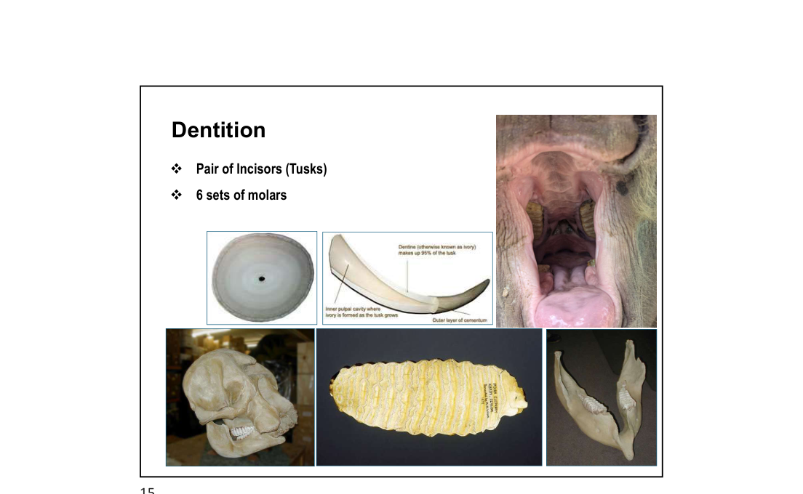
Slide 15 — Dentition: tusks (incisors), molar progression and cross sections
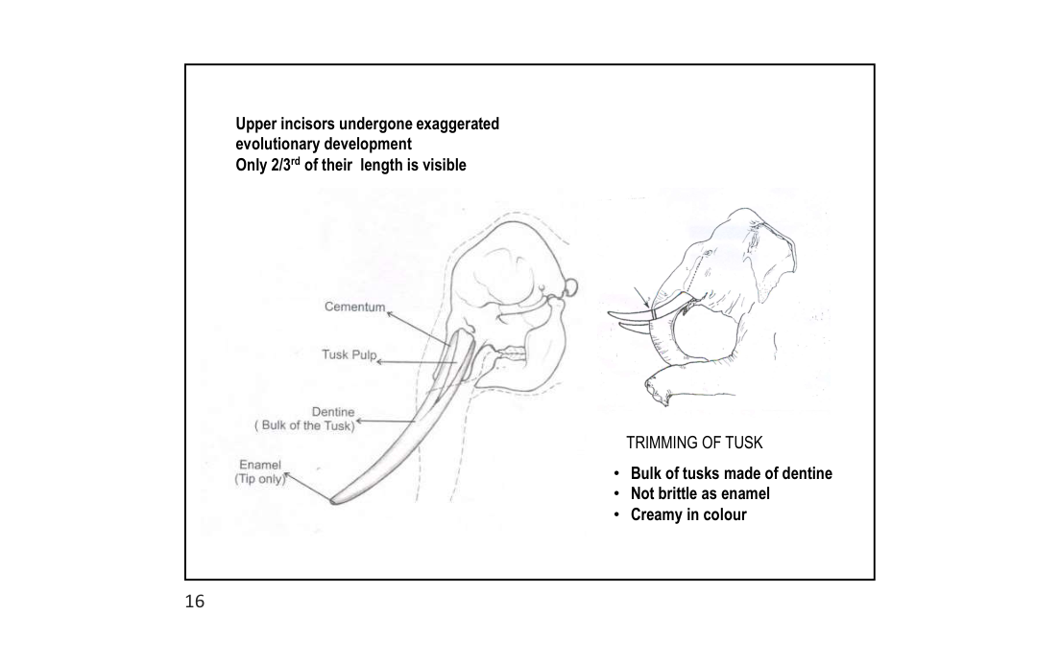
Slide 16 — Tusk anatomy: cross section showing cementum, dentine, pulp and enamel

8.1 Dental Formula
8.1 Dental Formula

• Pair of Incisors (Tusks) — upper incisors only
• 6 sets of molars (M1–M6), one active at a time per jaw quadrant
• No canines or premolars

8.2 Tusks
8.2 Tusks

• Upper incisors that have undergone exaggerated evolutionary development
• Only 2/3rd of total tusk length is visible externally — 1/3rd embedded in skull
• Tusk structure (outside to inside):
• Enamel — tip only
• Cementum — outer layer
• Dentine — bulk of the tusk (makes up ~90% of volume)
• Tusk pulp cavity — inner core where ivory is formed as tusk grows
• Ivory properties:
• Bulk of tusks made of DENTINE — not enamel
• Not brittle (unlike enamel)
• Creamy in colour
• Has characteristic Schreger lines (cross-hatched pattern) — diagnostic of true ivory

8.3 Schreger Lines
8.3 Schreger Lines

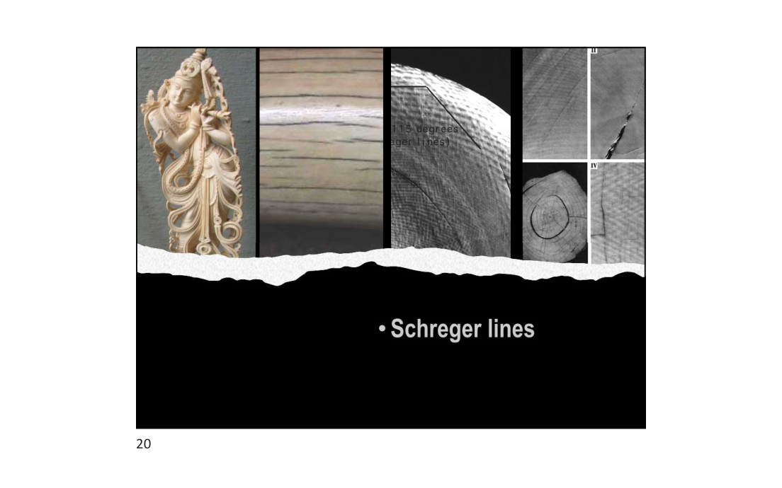
Slide 20 — Schreger lines visible in ivory cross-section
• Distinctive cross-hatching visible on cut surface of ivory
• Unique to proboscideans — used forensically to identify real elephant ivory
• Pattern results from the architecture of dentinal tubules in the dentine matrix
FORENSIC: Schreger lines confirm identity of ivory even in worked/carved pieces — legally important under CITES and Wildlife Protection Act.

9. Skin, Eyes & Integumentary Glands
9. Skin, Eyes & Integumentary Glands

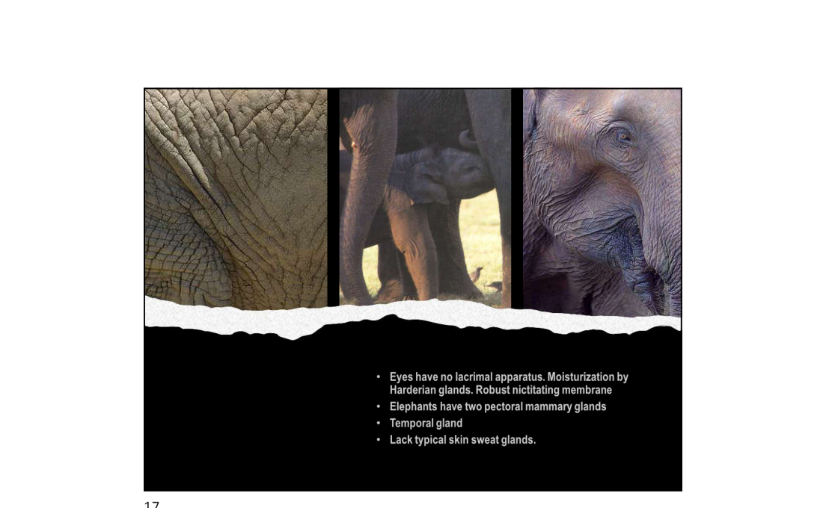
Slide 17 — Skin texture, mammary glands and temporal gland

9.1 Eyes
9.1 Eyes

• Eyes have NO lacrimal apparatus (no conventional tear glands)
• Moisturization provided by Harderian glands
• Robust nictitating membrane (third eyelid) present
• Poor visual acuity — compensated by excellent olfaction and hearing

9.2 Mammary Glands
9.2 Mammary Glands

• Elephants have TWO pectoral mammary glands (located on the chest between forelegs)
• Unique among mammals — most other mammals have inguinal/abdominal mammary glands
• Lactation can last up to 4–5 years

9.3 Temporal Gland
9.3 Temporal Gland

• Located between the eye and ear on both sides of the head
• Secretes musth fluid in bulls during musth (heightened testosterone phase)
• Both sexes have temporal glands; secretion more pronounced during musth in males

9.4 Skin & Sweat Glands
9.4 Skin & Sweat Glands

• Lack typical skin sweat glands
• Thermoregulation achieved via:
• Ear flapping — large surface area with blood vessels for heat dissipation
• Water/mud bathing
• Skin: thick, deeply wrinkled — wrinkles increase surface area for cooling
NOTE: Absence of sweat glands means elephants are highly vulnerable to heat stress — critical consideration during capture and transport operations.

10. Internal Organs
10. Internal Organs

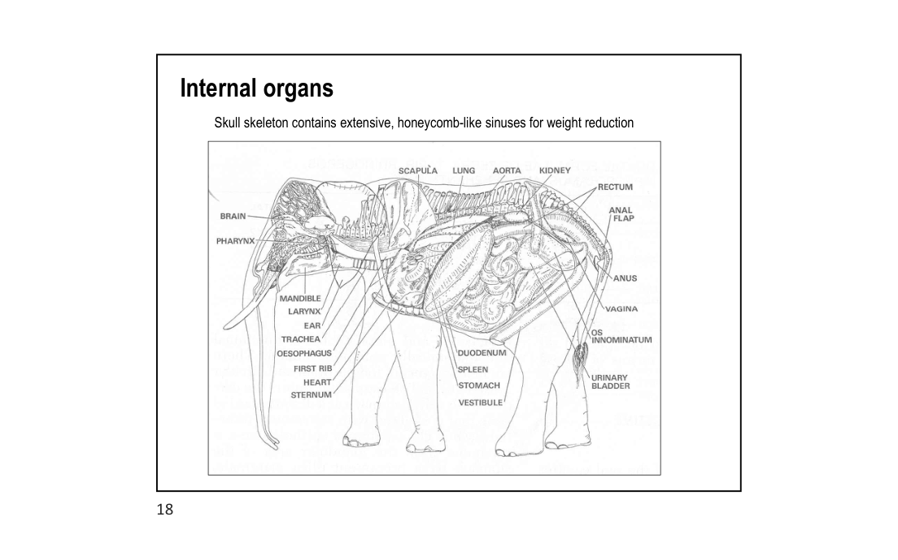
Slide 18 — Full internal organ diagram (labelled)
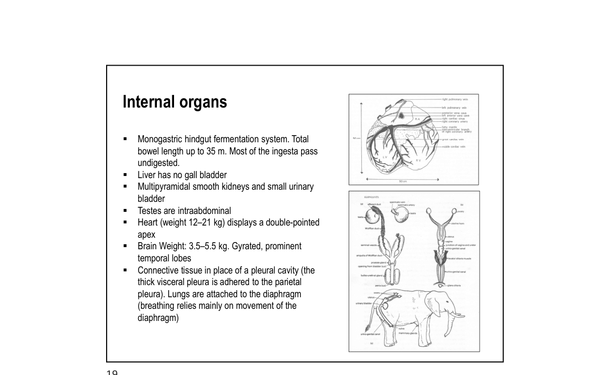
Slide 19 — Internal organ details: heart, reproductive system, lungs

10.1 Digestive System
10.1 Digestive System

• Monogastric hindgut fermentation system
• Total bowel length up to 35 metres
• Most of the ingesta pass UNDIGESTED (poor digestive efficiency ~40%)
• Liver has NO gall bladder
• Stomach is simple and single-chambered

10.2 Urinary System
10.2 Urinary System

• Multipyramidal smooth kidneys (lobulated — similar to cetaceans)
• Small urinary bladder relative to body size

10.3 Reproductive System
10.3 Reproductive System

• Testes are INTRAABDOMINAL (do not descend into scrotum)
• No external scrotum — testes located near kidneys
• Female: bicornuate uterus; vaginal opening ventral, far forward

10.4 Cardiovascular System
10.4 Cardiovascular System

• Heart weight: 12–21 kg
• Heart displays a DOUBLE-POINTED apex (bifid apex) — unique among mammals
• Located centrally in thoracic cavity

10.5 Nervous System
10.5 Nervous System

• Brain weight: 3.5–5.5 kg (largest land animal brain)
• Gyrated (folded) brain with prominent temporal lobes
• High cognitive ability — tool use, self-recognition, mourning behaviour documented

10.6 Respiratory System
10.6 Respiratory System

• Connective tissue (no pleural cavity) — the thick visceral pleura is adhered to the parietal pleura
• Lungs are attached to the diaphragm
• Breathing relies mainly on MOVEMENT OF THE DIAPHRAGM (not rib expansion)
CRITICAL for anaesthesia: Lungs are glued to chest wall — no true pleural space. Thoracic wounds cause rapid respiratory compromise. In sternal recumbency, the weight of abdominal organs crushes lungs → FATAL.

KEY FACTS SUMMARY:
• No gall bladder • Intraabdominal testes • Bifid heart apex
• No pleural cavity • Hindgut fermentation • 35 m bowel
• Multipyramidal kidneys • Breathing via diaphragm only

11. Field Estimation of Height & Weight
11. Field Estimation of Height & Weight

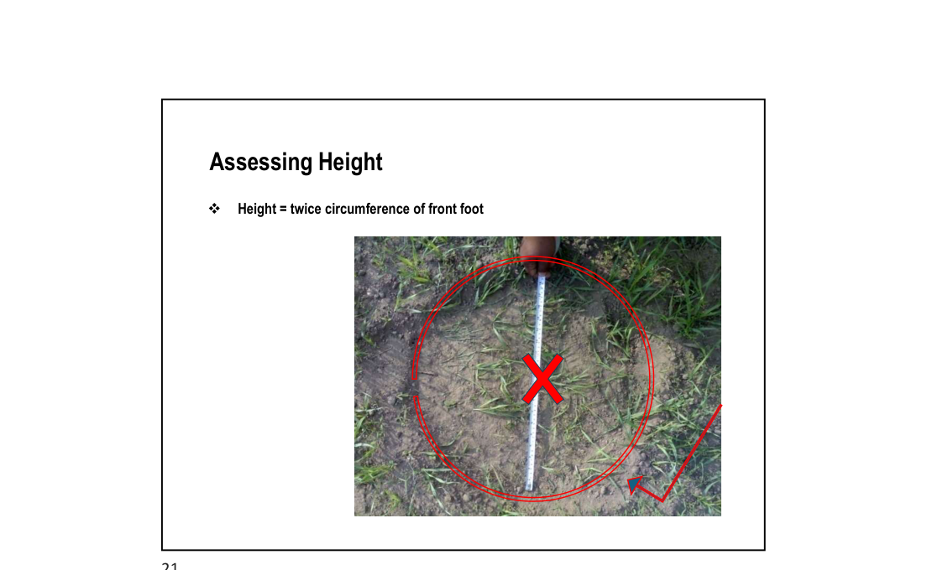
Slide 21 — Assessing height using front foot circumference
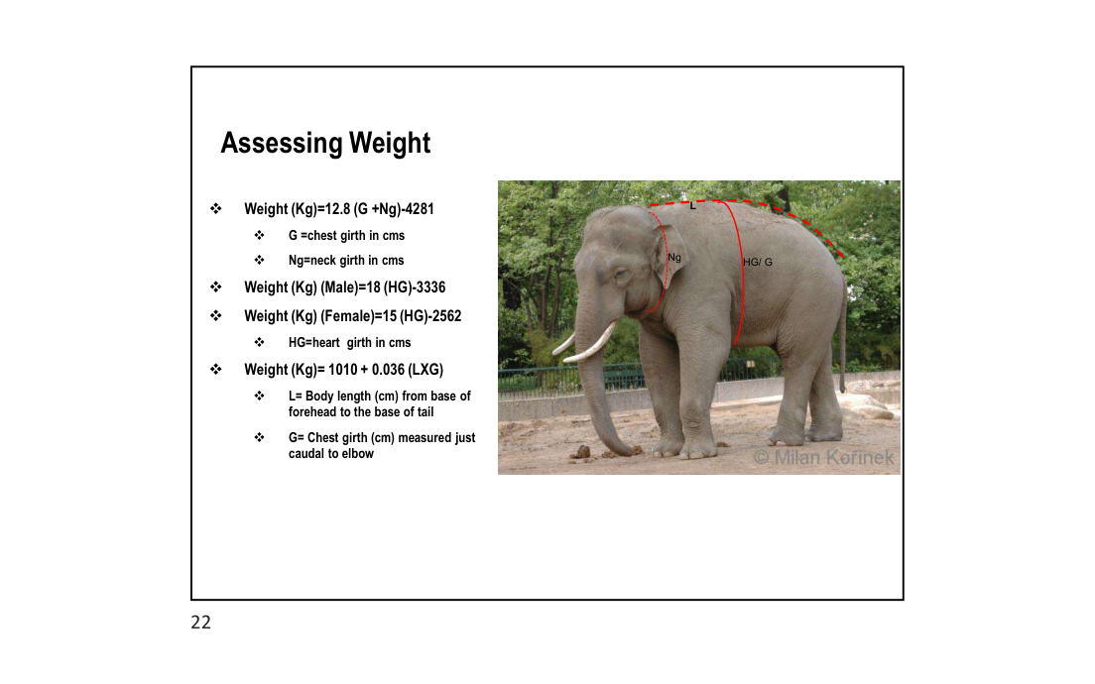
Slide 22 — Assessing weight using body girth measurements

11.1 Height Estimation
11.1 Height Estimation

• Simple field formula:
• Height = 2 × Circumference of the front foot
• Measure the circumference of the front footprint at ground level
• Quick method usable at a mortality site even without the animal present (footprints in soil)

11.2 Weight Estimation Formulae
11.2 Weight Estimation Formulae

Formula | Parameters | Notes
Weight (kg) = 12.8 (G + Ng) − 4281 | G = Chest girth (cm)  Ng = Neck girth (cm) | General formula
Weight (kg) = 18 (HG) − 3336 | HG = Heart girth (cm) | Male specific
Weight (kg) = 15 (HG) − 2562 | HG = Heart girth (cm) | Female specific
Weight (kg) = 1010 + 0.036 (L × G) | L = Body length, base of forehead to base of tail (cm)  G = Chest girth just caudal to elbow (cm) | Alternative formula

• Heart girth (HG) — measured just caudal to the elbow
• Chest girth (G) — same as heart girth in some formulae
• Neck girth (Ng) — measured at mid-neck
FIELD USE: Height and weight data are MANDATORY fields in elephant mortality forms — use front-foot circumference for height and heart-girth for weight estimate even from a carcass.

12. Key References & Notes
12. Key References & Notes

• Nigam P. (2026). Biological and Anatomical Aspects of Elephants. Training Program: Essentials for Mortality Investigation of Asian Elephant. WII, Dehradun.
• Laws RM (1966). Age criteria for the African elephant. East African Wildlife Journal 4:1–37.
• Shoshani J & Tassy P (1996). The Proboscidea: Evolution and Palaeoecology of Elephants and their Relatives. Oxford University Press.
• Sukumar R (2003). The Living Elephants: Evolutionary Ecology, Behaviour, and Conservation. Oxford University Press.

Notes compiled from PPT slides by Dr. Parag Nigam, PhD — Wildlife Institute of India
Training Program: Essentials for Mortality Investigation of Asian Elephant | 5–6 June 2026, Raigarh

