LEARNING FROM DEAD
Postmortem Examination of Asian Elephant
Comprehensive Study Notes with Slide Images
Prof. Dr. A B Shrivastava · Founder Director, School of Wildlife Forensic and Health
Nanaji Deshmukh Veterinary Science University, Jabalpur 482001, M.P.

Training Program: Essentials for Mortality Investigation of Asian Elephant
Chhattisgarh Forest Department · 5–6 June 2026, Raigarh · Technical Support: WII Dehradun
Lab Partners: ICAR-IVRI & NDVSU Jabalpur · Notes elaborated with peer-reviewed literature

ABOUT THE PRESENTER
Prof. Dr. Avadh Bihari Shrivastava is a pioneer in Wildlife Forensic and Health in India. He is the Founder Director of the School of Wildlife Forensic and Health at Nanaji Deshmukh Veterinary Science University (NDVSU), Jabalpur. He serves as Honorary Member on the State Wildlife Boards of Chhattisgarh and Bihar, and is an Honorary Board Member of the Management Committee of ICAR-NIHSAD. He received the Amrita Devi Vishnoi Award for Wildlife Conservation in 2005 and leads the ICAR Niche Area of Excellence on Wildlife Forensic and Health Management. He was felicitated as an Outstanding Veterinarian by the Hon. Minister, GOI for Animal Husbandry on World Veterinary Day, 29 April 2023 at Vigyan Bhawan, New Delhi. His authored/edited works include: Manual on Postmortem Examination of Felids; Learning from Dead (with Dr. Parag Nigam); Big Cats; Necropsy & Carcass Disposal of Asian Elephant: Recommended Operating Procedure; and Caring for Elephants: Managing Health & Welfare in Captivity.

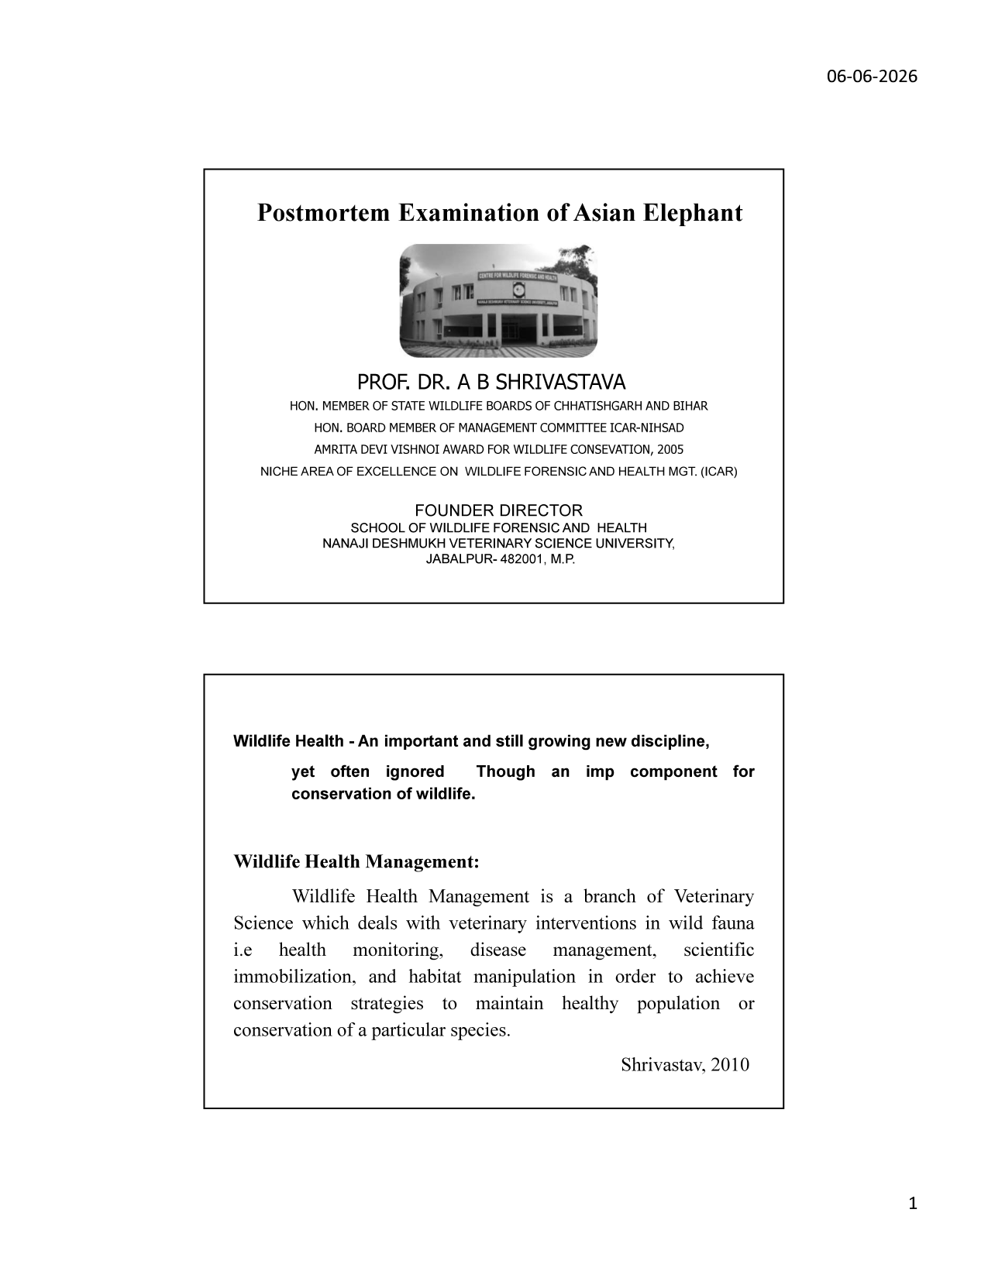
Slide 1 — Title slide: NDVSU Jabalpur and author credentials

1. Wildlife Health Management — Foundations

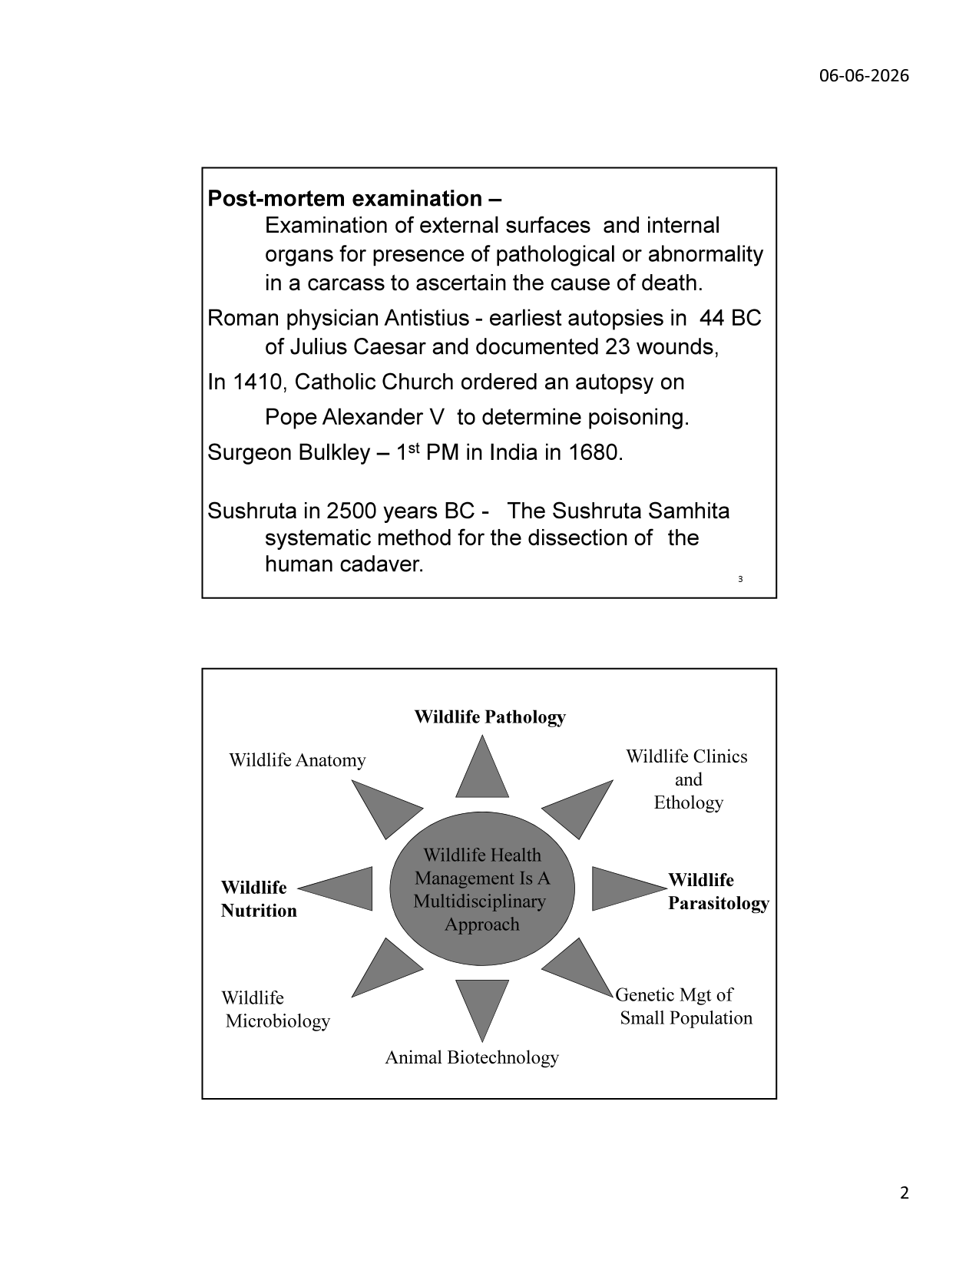
Slide 2 — Wildlife Health Management as a Multidisciplinary Approach
1.1 Definition

Wildlife Health Management is a branch of Veterinary Science that deals with veterinary interventions in wild fauna — specifically health monitoring, disease management, scientific immobilisation, and habitat manipulation — in order to achieve conservation strategies that maintain healthy populations or ensure conservation of particular species. (Shrivastav, 2010)
1.2 Multidisciplinary Nature

Wildlife Health Management is inherently multidisciplinary. It integrates expertise from eight major scientific domains, all converging on the central goal of maintaining healthy wildlife populations:
Discipline | Relevance to Elephant Health Management
Wildlife Pathology | Core of mortality investigation; disease identification from gross and histopathological findings
Wildlife Anatomy | Essential for recognising normal vs pathological anatomy during necropsy; species-specific features
Wildlife Clinics & Ethology | Clinical signs pre-mortem and normal behavioural baselines to identify deviations
Wildlife Parasitology | Internal/external parasite identification; zoonotic risk assessment
Genetic Management of Small Populations | Conservation genetics; inbreeding depression; population viability analysis
Animal Biotechnology | PCR-based pathogen detection; DNA forensics; vaccine development (e.g., EEHV vaccines)
Wildlife Microbiology | Bacterial/viral culture; antimicrobial resistance profiling; zoonosis risk
Wildlife Nutrition | Nutritional deficiency diseases; body condition scoring; digestive health

1.3 Importance in Conservation

Wildlife health is often the "silent" conservation tool — consistently under-resourced yet critical. Population-level disease events can be as devastating as habitat loss. Systematic necropsy data from deceased animals builds epidemiological baselines, identifies emerging threats (EEHV, TB, anthrax), and informs captive management protocols. In India, the Elephant Task Force (2010) and Project Elephant guidelines mandate systematic mortality investigation for all Schedule I species including elephants.
KEY PRINCIPLE: Wildlife Health is an important, still-growing discipline — yet often ignored. Though an important component for conservation of wildlife. Every elephant death is a data point that can protect the living population. Systematic, scientific necropsy is not optional — it is a conservation imperative.

2. History of Postmortem Examination

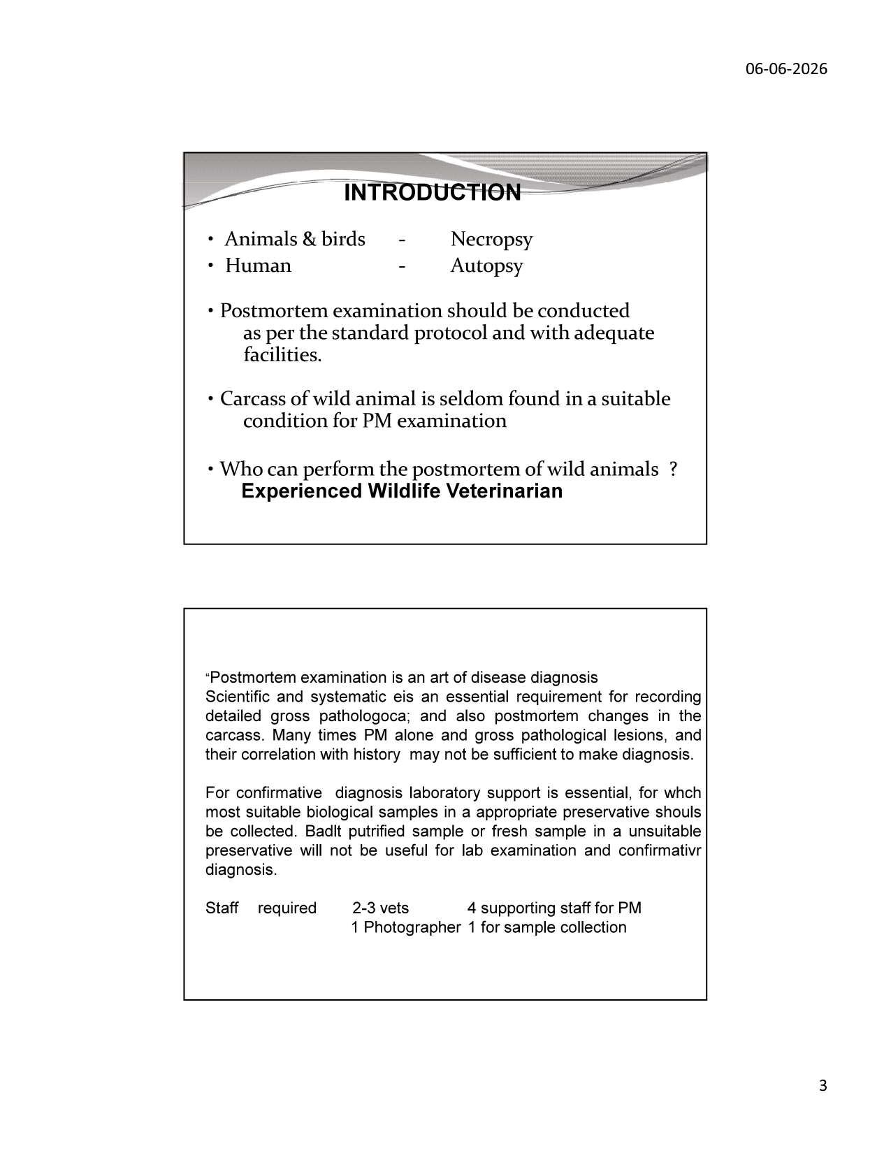
Slide 3 — Introduction: Necropsy vs Autopsy terminology; standard protocol requirements
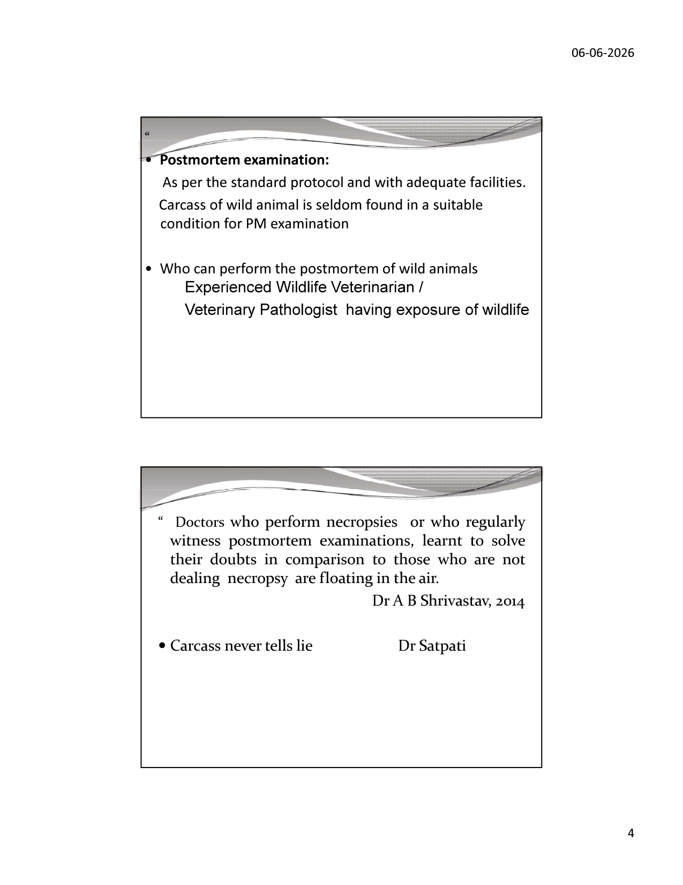
Slide 4 — Professional quotes on necropsy importance; "Carcass never tells lie"
2.1 Definition

Post-mortem examination is the examination of external surfaces and internal organs for the presence of pathological changes or abnormality in a carcass to ascertain the cause of death. The term NECROPSY is used for animals and birds; AUTOPSY is used for humans. Both derive from Greek: "nekros" (dead) + "opsis" (a seeing) — literally "seeing the dead."
2.2 Historical Milestones

Era / Person | Contribution
Sushruta, 2500 BC | Sushruta Samhita documented systematic methods for dissection of human cadavers in ancient India — earliest systematic approach to internal anatomy
Roman physician Antistius, 44 BC | Performed earliest documented autopsies on Julius Caesar; identified and documented 23 stab wounds; first forensic pathology record
Catholic Church, 1410 | Ordered autopsy on Pope Alexander V to determine if he was poisoned; established medicolegal precedent
Surgeon Bulkley, 1680 | Performed first documented postmortem examination in India
Modern Era | Development of standardised necropsy protocols; histopathology; molecular diagnostics; digital documentation standards

2.3 Wildlife Necropsy vs Clinical Autopsy

• "Postmortem examination is an art of disease diagnosis" — requires scientific and systematic approach
• Gross pathological findings alone and correlation with history may not be sufficient for diagnosis
• Confirmative diagnosis requires laboratory support: biological samples must be collected in appropriate preservatives
• Badly putrefied samples or fresh samples in unsuitable preservatives are useless for lab examination
• "Doctors who perform necropsies or who regularly witness postmortem examinations, learnt to solve their doubts in comparison to those who are not dealing necropsy are floating in the air." — Dr A B Shrivastav, 2014
• "Carcass never tells lie" — Dr Satpati. Every lesion, every finding carries diagnostic truth.
• Carcasses of wild animals are SELDOM found in suitable condition — the pathologist must work with what is available
2.4 Staff Requirements for Elephant Necropsy

Role | Minimum Number | Responsibilities
Veterinarians / Wildlife Pathologists | 2–3 | Lead necropsy; gross pathological examination; interpretation; report writing
Supporting Staff | 4 | Manual labour: positioning, skinning, organ removal, labelling
Photographer | 1 | Continuous photographic documentation; scale bar in all shots; video recording
Sample Collection Personnel | 1 | Label, fix, preserve and package biological samples correctly

3. Necropsy Objectives & Pre-Necropsy Evaluation

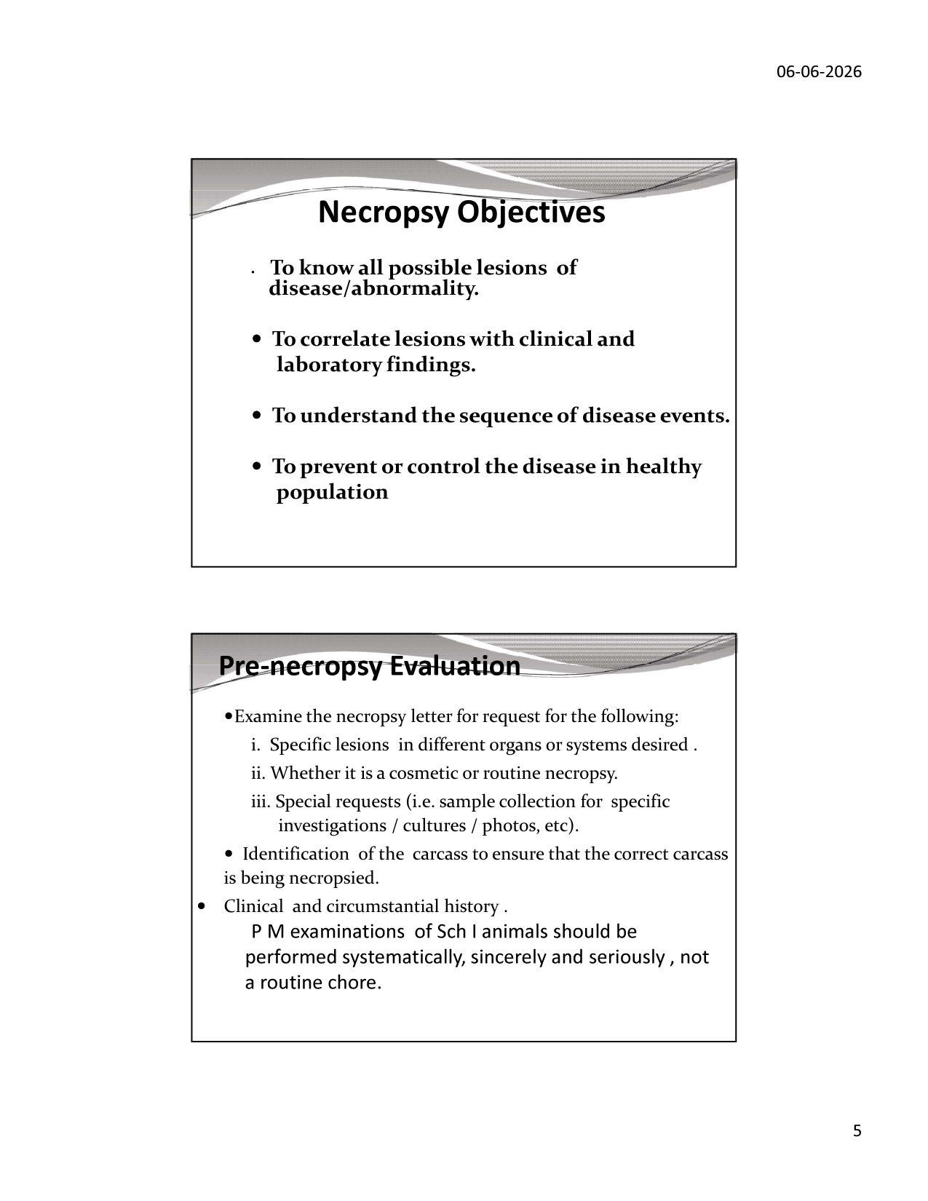
Slide 5 — Necropsy Objectives and Pre-necropsy Evaluation
3.1 Necropsy Objectives

• To know all possible lesions of disease or abnormality present in the carcass
• To correlate lesions with clinical and laboratory findings
• To understand the sequence of disease events — what happened first, what followed
• To prevent or control disease in the healthy living population by identifying the pathogen or cause
In the context of Schedule I species (including elephant), systematic and sincere PM examination is a legal and ethical obligation under the Wildlife Protection Act 1972. It provides evidence for legal proceedings (poaching, electrocution, train-kill), conservation management decisions (disease control), and scientific research.
3.2 Pre-Necropsy Evaluation

a. Examine the Necropsy Request Letter for:
◦ Specific lesions in different organs or systems suspected by the referring officer
◦ Whether it is a cosmetic or routine necropsy (legal vs scientific)
◦ Special requests: sample collection for specific investigations, cultures, photographs
b. Carcass Identification:
◦ Ensure correct carcass is being necropsied — identity by microchip/ear notch/GPS collar/physical description
◦ Record: species, sex, estimated age, location GPS coordinates, date and time of death (if known)
c. Clinical and Circumstantial History:
◦ Probable cause of death (as reported by field staff)
◦ Clinical signs observed prior to death and any treatment given
◦ Circumstances of death — found in water, near railway track, near village, etc.
◦ Time elapsed since death (post-mortem interval) — critical for autolysis assessment
LEGAL REMINDER: PM examinations of Schedule I species (including Asian elephant — Elephas maximus) must be performed systematically, sincerely and seriously — not as a routine chore. Under WPA 1972 Section 49, improper or negligent necropsy of a protected species can be a criminal offence. Every finding must be documented and signed by the performing veterinarian.

4. Protocol for PM Examination & Equipment

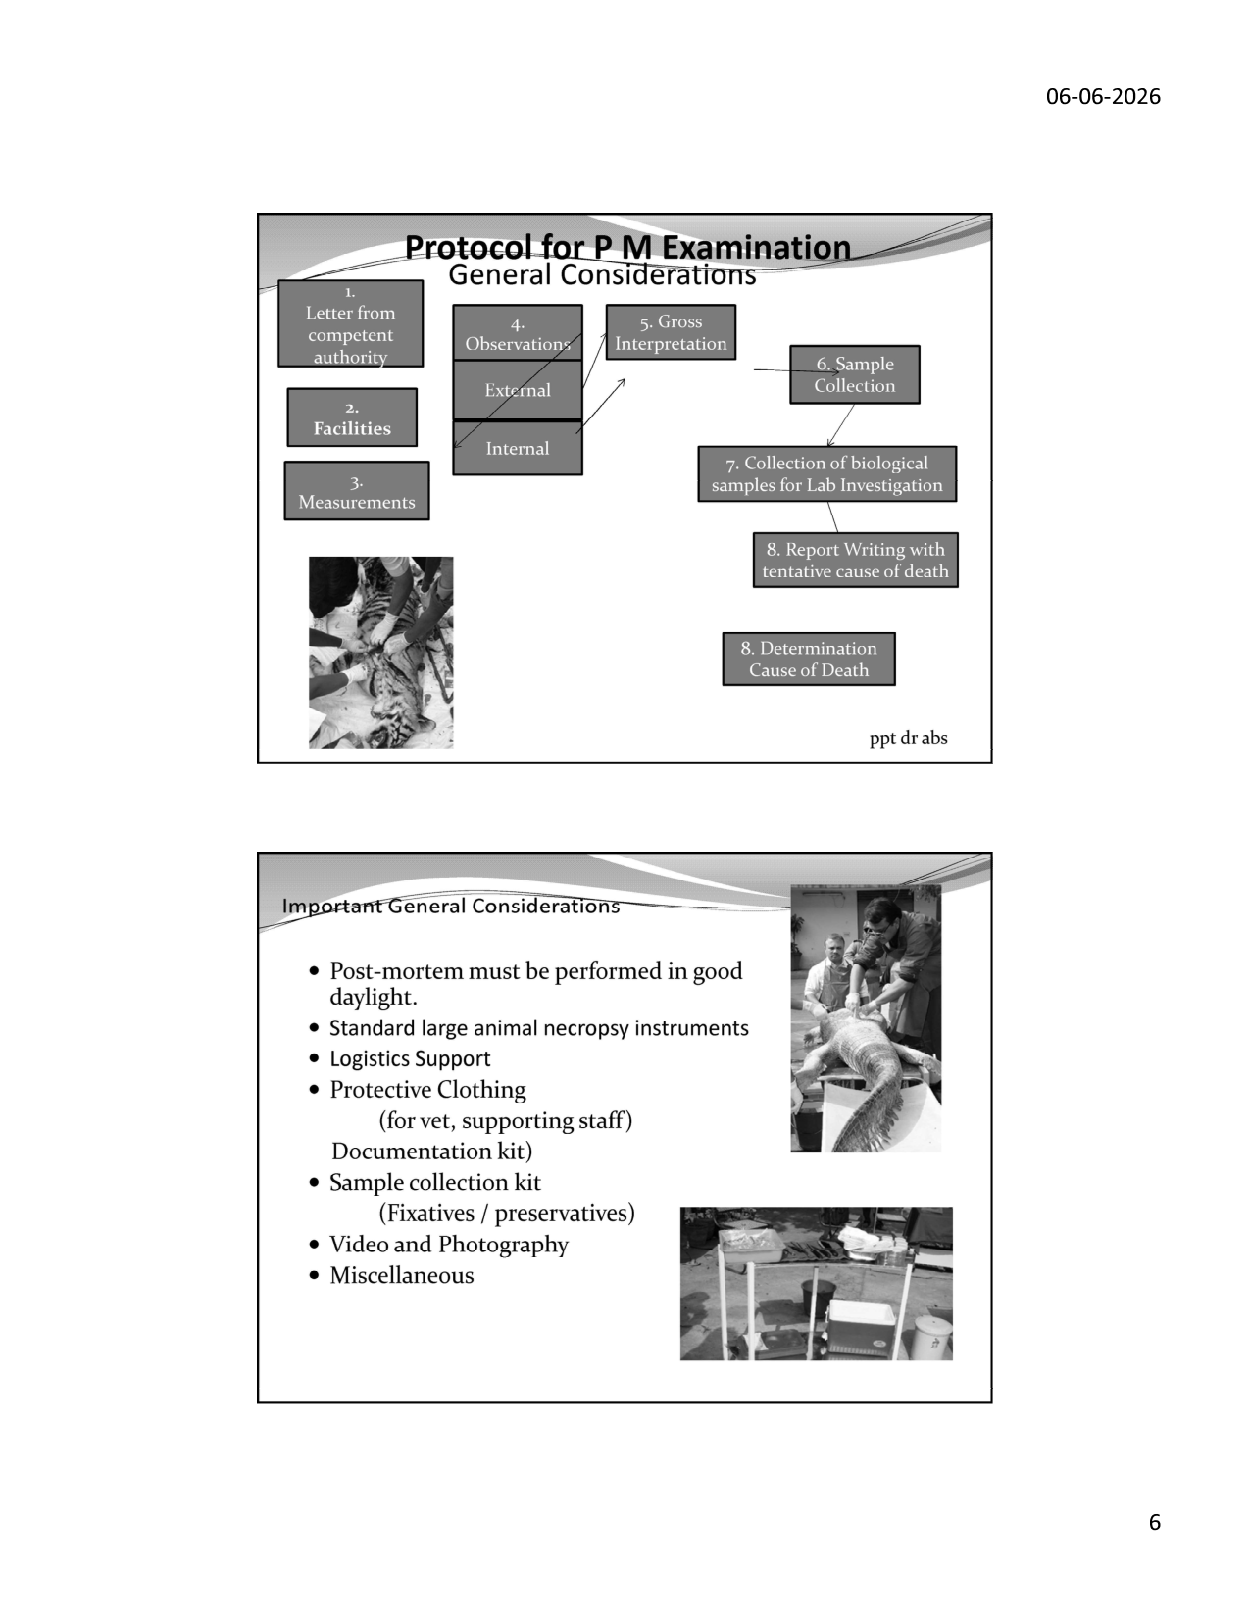
Slide 6 — PM Protocol flowchart; field necropsy photographs
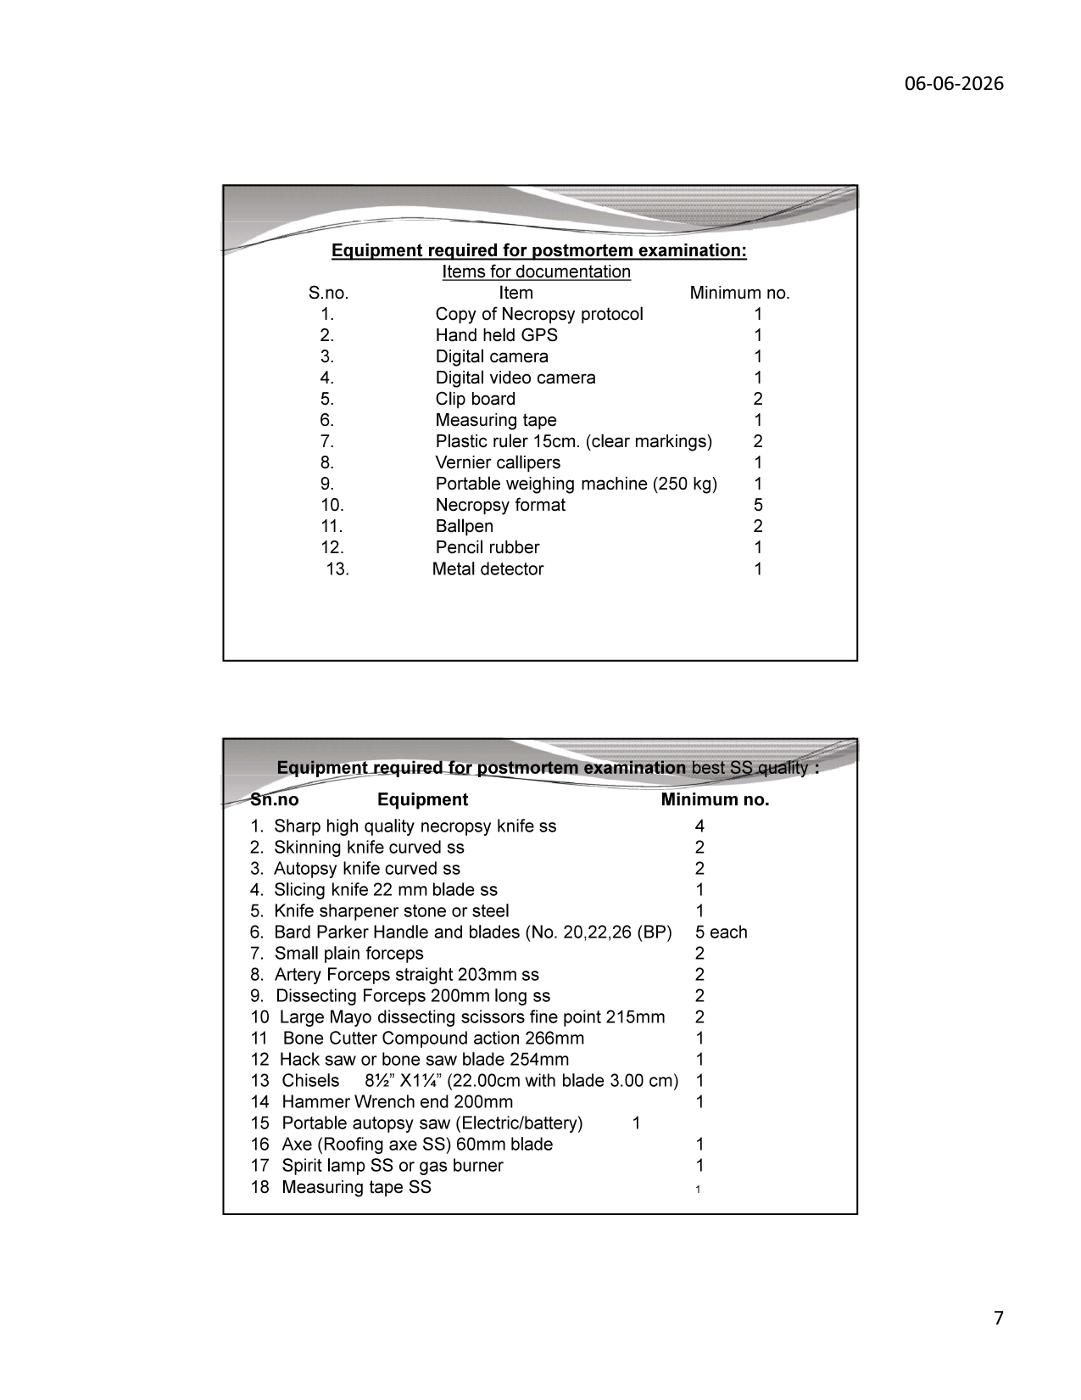
Slide 7 — Equipment lists: documentation items and surgical instruments
4.1 General Protocol — Step-by-Step Flow

Step | Action | Notes
1 | Obtain letter from competent authority | DFO/CCF authorisation mandatory; legal protection for veterinarian
2 | Assess facilities available | Field vs laboratory setting; natural light vs artificial; water access
3 | Measurements | Body weight (if possible), body length, girth, tusk length, foot circumference
4a | External Observations | Gross external examination before any incision
4b | Internal Observations | Systematic cavity-by-cavity examination
5 | Gross Interpretation | Correlate all gross findings; form differential diagnosis list
6 | Sample Collection | Tissues for histopathology, microbiology, virology, toxicology
7 | Biological Samples for Lab | Package with correct fixatives; label with case ID, date, organ
8a | Report Writing | Tentative cause of death with supporting findings
8b | Determination of Cause of Death | Final cause pending lab results; interim report if needed

4.2 General Considerations

• Postmortem MUST be performed in GOOD DAYLIGHT — artificial light misses subtle colour changes (haemorrhage, icterus, cyanosis)
• Standard LARGE ANIMAL necropsy instruments — domestic animal instruments are inadequate for elephant-scale tissue
• Logistics support: vehicle access, manpower for positioning, clear working area around carcass
• Protective clothing for ALL personnel: waterproof overalls, gloves (double-layered), goggles, face masks, gumboots
• Documentation kit: GPS, camera, video recorder, forms, ballpen
• Sample collection kit: fixatives (10% buffered formalin), preservatives (70% ethanol, DMSO), sterile tubes, swabs, biohazard bags
• Metal detector: mandatory — checks for bullets/pellets/metallic foreign bodies in carcass before incision
4.3 Equipment Required — Documentation Items

S.No. | Item | Minimum No.
1 | Copy of Necropsy Protocol | 1
2 | Hand-held GPS (for recording exact death location) | 1
3 | Digital camera (with macro capability) | 1
4 | Digital video camera | 1
5 | Clip board | 2
6 | Measuring tape (cloth/flexible) | 1
7 | Plastic ruler 15 cm (clear markings, as scale bar in photos) | 2
8 | Vernier callipers (for precise measurements: lamellae, lesion size) | 1
9 | Portable weighing machine 250 kg capacity | 1
10 | Necropsy format (pre-printed forms) | 5
11 | Ballpen (permanent ink) | 2
12 | Pencil rubber | 1
13 | Metal detector | 1

4.4 Equipment Required — Surgical Instruments (Best SS Quality)

S.No. | Instrument | Qty
1 | Sharp high-quality necropsy knife SS | 4
2 | Skinning knife curved SS | 2
3 | Autopsy knife curved SS | 2
4 | Slicing knife 22 mm blade SS | 1
5 | Knife sharpener stone or steel | 1
6 | Bard Parker Handle and blades (No. 20, 22, 26 BP) | 5 each
7 | Small plain forceps | 2
8 | Artery Forceps straight 203 mm SS | 2
9 | Dissecting Forceps 200 mm long SS | 2
10 | Large Mayo dissecting scissors fine point 215 mm | 2
11 | Bone Cutter Compound action 266 mm | 1
12 | Hack saw or bone saw blade 254 mm | 1
13 | Chisels 8½" × 1¼" (22.00 cm with blade 3.00 cm) | 1
14 | Hammer Wrench end 200 mm | 1
15 | Portable autopsy saw (Electric/battery) | 1
16 | Axe (Roofing axe SS) 60 mm blade | 1
17 | Spirit lamp SS or gas burner (for flaming instruments) | 1
18 | Measuring tape SS | 1

5. External Examination

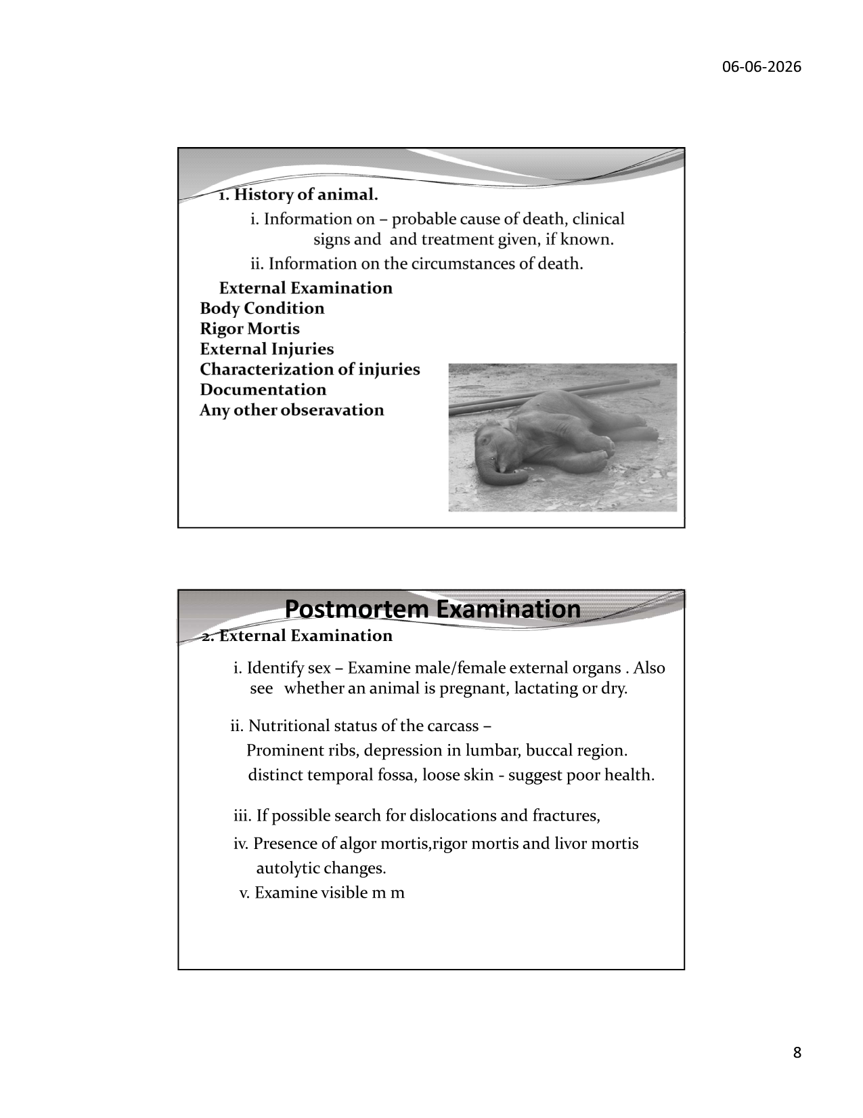
Slide 8 — External examination protocol; photograph of carcass with rigor mortis
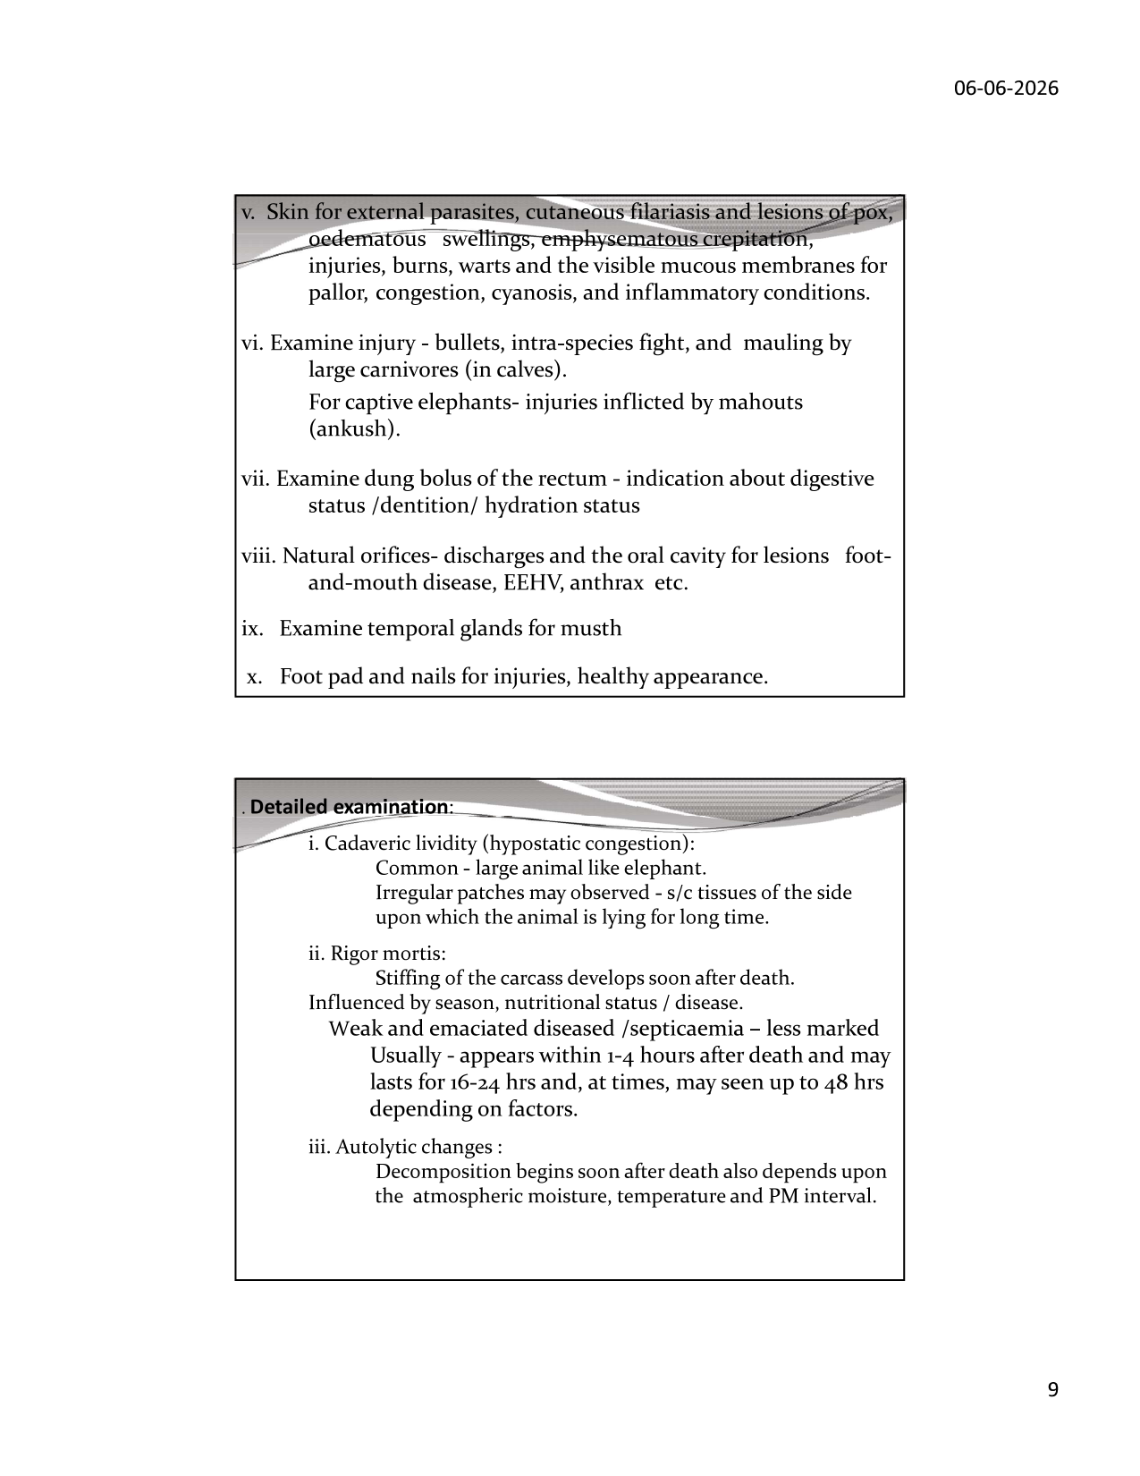
Slide 9 — External examination details: skin, orifices, temporal glands, foot pad
5.1 History Collection

• Information on probable cause of death, clinical signs and treatment given, if known
• Information on circumstances of death — location type, proximity to human habitation, railway, powerlines
• Last seen alive time: critical for calculating post-mortem interval (PMI) and assessing autolysis
5.2 Initial External Survey

• BODY CONDITION: Record Body Condition Score (BCS) — prominent ribs, depression in lumbar/buccal region, distinct temporal fossa, loose skin = poor health/emaciation
• RIGOR MORTIS: Stiffening of the carcass; develops soon after death; assess degree
• EXTERNAL INJURIES: Characterize every wound, bruise, burn or cut — shape, size, depth, edges
• DOCUMENTATION: Photograph every external finding with scale bar BEFORE manipulation
• ANY OTHER OBSERVATION: Unusual posture, presence of scavengers, soil disturbance, drag marks
5.3 Detailed External Examination — 10-Point Protocol

i. Sex Identification
◦ Examine male/female external organs — penis, scrotal region, vulva, mammary glands
◦ Determine if female is pregnant (abdominal distension, mammary engorgement), lactating, or dry
◦ Note: pregnant females may not show obvious abdominal enlargement until late gestation (22-month gestation)
ii. Nutritional Status Assessment
◦ Prominent ribs visible/palpable → poor fat reserves → chronic undernutrition
◦ Depression in lumbar region → gluteal muscle wasting
◦ Depression in buccal (cheek) region → masseter muscle wasting
◦ Distinct temporal fossa ("sunken temples") → chronic poor condition
◦ Loose, wrinkled, excess skin → severe emaciation — skin hangs in folds
iii. Fractures and Dislocations
◦ If possible, search for dislocations and fractures — especially limb bones, ribs, skull
◦ Fractures suggest HEC (Human-Elephant Conflict) injuries, fall, or train impact
iv. Post-mortem Changes
◦ ALGOR MORTIS: Cooling of body to ambient temperature after death (rate varies with ambient temp)
◦ RIGOR MORTIS: Usually appears within 1–4 hours after death; lasts 16–24 hrs (up to 48 hrs); less marked in emaciated/septicaemic animals
◦ LIVOR MORTIS (Cadaveric Lividity / Hypostatic Congestion): Irregular patches in subcutaneous tissues on the side on which animal is lying — NORMAL POST-MORTEM CHANGE, not pathological haemorrhage
◦ AUTOLYTIC CHANGES: Decomposition begins immediately after death; rate depends on ambient moisture, temperature, and PMI
v. Skin Examination
◦ External parasites: ticks (Haemaphysalis, Amblyomma spp.), lice
◦ Cutaneous filariasis: nodular swellings, especially around legs and ventral abdomen
◦ Pox lesions: characteristic crusted papulovesicular eruptions on trunk, ears, periocular skin
◦ Oedematous swellings: pitting oedema especially of dependent limbs (heart failure, hypoproteinaemia)
◦ Emphysematous crepitation: gas under skin — indicates post-mortem putrefaction or gas-forming bacterial infection (Clostridium)
◦ Burns: superficial (singeing of hair, skin hyperaemia) vs deep (charring) — critical in electrocution/lightning
◦ Warts: viral papillomata; common in young elephants, usually benign
◦ Visible mucous membranes (conjunctiva, oral): assess pallor (anaemia), congestion (septicaemia), cyanosis (respiratory/cardiac failure), inflammatory signs
vi. Injury Examination
◦ Bullet wounds: entry (small, round, inverted edges) vs exit (larger, everted, irregular edges)
◦ Intra-species fighting injuries: tusk wounds in musth bulls; deep puncture lacerations
◦ Mauling by large carnivores: in calves — deep claw/bite marks from tiger/leopard
◦ Captive elephants: injuries inflicted by mahouts using ankush (bull hook) — distinctive puncture wounds, bruising
◦ Train impact injuries: severe bilateral fractures, visceral crush injuries, skin abrasion patterns consistent with vehicle contact
vii. Dung Bolus of Rectum
◦ Examine dung bolus at the rectum — it is an indicator of:
◦ Digestive status: normal formed bolus (healthy) vs liquid/absent (diarrhoea, impaction)
◦ Dentition status: coarsely undigested material = poor molar function (dental exhaustion in old animals)
◦ Hydration status: dry, hard bolus = dehydration; moist/liquid = diarrhoea
◦ Parasites: tape worm proglottids, oxyurid eggs may be visible grossly
viii. Natural Orifices
◦ Discharges from nostrils, mouth, ears, vulva/prepuce, anus — note colour, consistency, odour
◦ Oral cavity: examine for ulcers (Foot-and-Mouth Disease — FMD), haemorrhagic lesions (EEHV), anthrax lesions, foreign bodies
◦ EEHV oral lesions: characteristic haemorrhagic plaques on tongue, gingiva in young calves
ix. Temporal Glands — Musth Examination
◦ Temporal glands (one on each side of head, between eye and ear)
◦ In musth: gland swollen, actively secreting dark oily substance — examine duct and gland for inflammation
◦ Abnormal temporal gland secretion (outside musth) may indicate infection, toxin, neurological disease
x. Foot Pad and Nails
◦ Examine for injuries: cracks, abscesses, overgrowth (captive elephants)
◦ Healthy appearance: smooth, well-worn, even distribution of wear
◦ Abnormal: deep fissures, purulent discharge (osteomyelitis risk), disproportionate wear (lameness/musculoskeletal disease)

6. Dentition & Age Determination

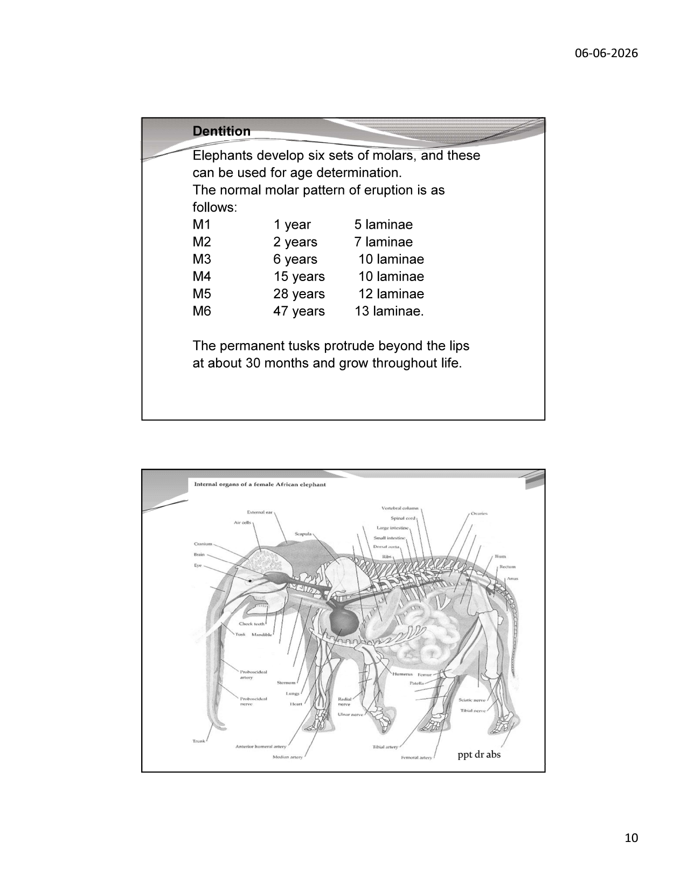
Slide 10 — Molar eruption table and lamellae count for age estimation
6.1 Unique Horizontal Molar Progression

Elephants develop six successive sets of molar teeth (M1–M6) on each side of the upper and lower jaw (24 molar positions total). Unlike vertical tooth replacement in all other mammals, elephants use HORIZONTAL MOLAR PROGRESSION: new molars develop at the posterior of the jaw and move FORWARD as older teeth wear down. Worn tooth fragments shed from the front of the jaw. When M6 (the final molar) is exhausted, the animal can no longer chew food — it progressively starves. This mechanism sets the biological maximum lifespan at approximately 60–70 years for Asian elephants.
6.2 Molar Eruption Table (Dr. A B Shrivastava / Shoshani & Eisenberg)

Molar | Eruption Age | Lamellae (Enamel Plates) | Period of Active Use | Notes
M1 (Deciduous) | ~4 months | 5 laminae | 0–1 year | Shed rapidly; very small
M2 (Deciduous) | ~1–2 years | 7 laminae | 1–4 years | Overlap with M1 briefly
M3 | ~6 years | 10 laminae | 4–15 years | First large permanent molar
M4 | ~15 years | 10 laminae (WIDER) | 15–28 years | Same count as M3 — wider lamellae distinguish it
M5 | ~28 years | 12 laminae | 28–47 years | Longest use; prime adulthood
M6 (Final) | ~47 years | 13 laminae | 47 years → death | Never replaced; exhaustion = death

• At any time: maximum 2 molars in simultaneous wear on any one side of any one jaw
• PERMANENT TUSKS: protrude beyond the lips at approximately 30 months; continue growing throughout life
• Tusk growth rate: ~15–17 cm per year in bulls (variable); used as supplementary age indicator
• Makhna bulls (tuskless males): tusk alveoli small/absent; confirm maleness by other skull features
NECROPSY AGE ESTIMATION PROTOCOL:
1. Open jaw; identify active molar (flat worn occlusal surface)
2. Count enamel plates (lamellae) using a probe after cleaning
3. Distinguish M3 (10 narrow plates) from M4 (10 WIDE plates) by lamellae width
4. Assess wear gradient: anterior plates more worn = tooth in later stage
5. Check for erupting molar behind active molar = near upper age of current set
6. Cross-reference with body size, temporal hollowing, tusk size, skin wrinkling
7. Give age as a RANGE with confidence: e.g., "M5 in wear, ~60% worn → est. 35–45 years"

7. Internal Anatomy of the Elephant

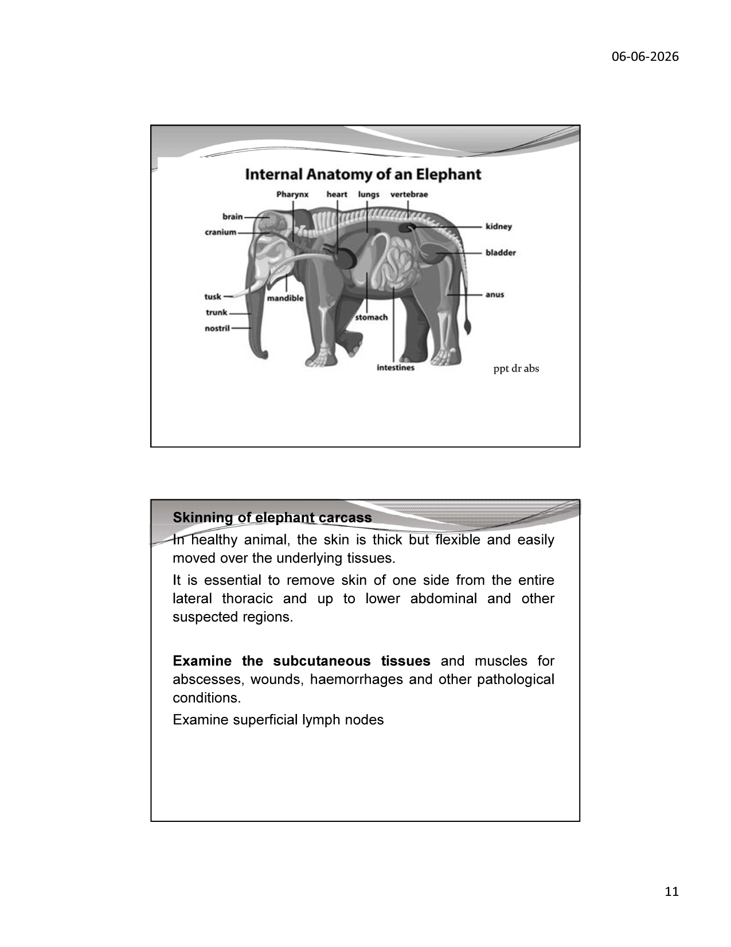
Slide 11 — Labelled internal anatomy diagram (cross-sectional view)
7.1 Overview of Internal Organ Systems

The internal anatomy of the elephant is broadly similar to other large mammals but with several critically important unique features that directly affect necropsy technique, interpretation of findings, and differential diagnosis.
System | Key Organs | Elephant-Specific Notes
Respiratory | Trachea, Lungs (+ Pleura) | NO pleural space — lungs fused to chest wall; diaphragm-only breathing; bifid heart apex
Cardiovascular | Heart (12–21 kg), major vessels | Bifid (double-pointed) cardiac apex — NORMAL; proboscideal artery prominent
Digestive | Pharynx, oesophagus, stomach, intestines, caecum, rectum, liver, pancreas | Simple (monogastric) stomach 100–140 cm long; cecum large ~90 L; GI tract >20 m
Urogenital | Kidneys, bladder, uterus/testes | Kidneys multi-lobulated (renculated); testes permanently abdominal — no scrotal descent
Nervous | Brain, spinal cord | Largest brain of any land mammal — 4–6 kg; well-developed temporal lobes
Musculoskeletal | 19–20 ribs, spine, limbs, skull | No pleural space; pneumatised skull; 19–20 thoracic vertebrae
Lymphatic | Superficial + deep lymph nodes | Standard large mammal pattern; key nodes for TB/EEHV diagnosis

7.2 Unique Anatomical Features Critical for Necropsy

• PLEURAL FUSION: No pleural space — firm lung-chest wall adhesion is NORMAL (not pleuritis); no thoracocentesis possible
• BIFID HEART APEX: Double-pointed cardiac apex — characteristic of elephants; do NOT record as cardiac anomaly
• ABDOMINAL TESTES: Male elephants retain testes permanently in the abdomen adjacent to kidneys — they do NOT descend into a scrotum (cryptorchidism in other species, but NORMAL in elephants)
• TOENAIL COUNT: Asian elephant — 5 toenails front, 4 rear (commonly); African — 4 front, 3 rear
• CARDIAC WEIGHT: 12–21 kg — enormous; heart/body weight ratio similar to other mammals
• TEMPORAL GLAND: Between eye and ear; secretes in musth; bilateral; examine at necropsy

8. Skinning of the Carcass & Internal Examination Procedure

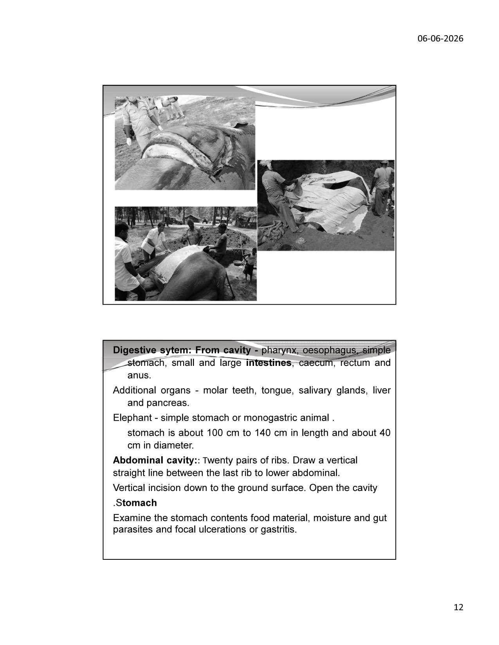
Slide 12 — Field photographs: skinning of elephant carcass with team
8.1 Skinning Technique

In a healthy animal, the elephant skin is THICK but FLEXIBLE and easily moved over the underlying tissues. In emaciated or diseased animals, the skin may adhere tightly. Proper skinning of one lateral surface is the standard elephant necropsy approach in field conditions where the carcass cannot be turned.
• Position carcass in lateral recumbency (right or left — whichever is accessible)
• Make a long median incision from the angle of the mandible along the dorsal midline to the tail base
• Reflect the skin over the ENTIRE lateral thoracic region and extending to the lower abdominal and other suspected regions
• Examine the SUBCUTANEOUS TISSUES immediately: look for abscesses, wounds, haemorrhages, oedema, parasitic cysts
• Examine SUPERFICIAL MUSCLES: haemorrhage patterns (electrocution), atrophy (chronic disease), abscesses
• Identify and incise SUPERFICIAL LYMPH NODES: submandibular, parotid, prescapular, femoral
• Healthy lymph node: small, firm, pale/cream coloured
• Pathological: enlarged, haemorrhagic, caseous (TB), gelatinous (oedema), suppurative
8.2 Opening the Thoracic Cavity

• The elephant has 19–20 (Asian) or 21 (African) pairs of ribs forming the thoracic cage
• Cut through the intercostal muscles and ribs on the lateral surface
• Observe: lungs WILL appear firmly attached to the chest wall — this is NORMAL (fused pleura)
• Any fluid between lung surface and chest wall is PATHOLOGICAL
• Examine the pericardial sac before opening: distension, haemopericardium, fibrinous deposits
• Remove the heart: examine size, weight, epicardium, myocardium, endocardium, valves
• Examine the trachea: mucus, parasites (Mammomonogamus), foreign bodies
• Examine lungs: colour, consistency, consolidation areas, parasites (Protostrongylus), tuberculosis nodules
8.3 Opening the Abdominal Cavity

The elephant has approximately 20 pairs of ribs. Draw a vertical straight line between the last rib and the lower abdominal region. Make a vertical incision down to the ground surface and open the cavity.
• On opening: note smell, colour of peritoneal fluid, presence of fibrin strands, blood
• Examine the omentum and mesentery for fat stores (good condition = fat-laden)
• Identify all organs in situ before removing any
• Photograph the opened cavity with scale bar

9. Digestive System Examination

9.1 Anatomy of the Elephant Digestive System

The elephant is a MONOGASTRIC (simple-stomached) herbivore — a hindgut fermenter. Despite an enormous intake (150–300 kg fresh forage/day), the digestive efficiency is relatively low (~40–45%), which necessitates near-continuous feeding.
Organ / Segment | Key Features | Necropsy Examination Points
Pharynx | Common passage for food and air | Foreign bodies, ulcers, FMD lesions
Oesophagus | Long; may show strictures in older animals | Perforation, parasites, foreign bodies
Stomach (monogastric) | 100–140 cm long; 40 cm diameter; simple sac | Contents: moisture, food material, gut parasites; focal ulcerations or gastritis; Gongylonema parasites in mucosa
Small Intestine | Very long; site of primary digestion and absorption | Intussusception, volvulus; haemorrhage (salmonellosis); parasites (Quilonia, Pfenderius)
Caecum | LARGE — ~90 L capacity; primary site of hindgut fermentation | Bloat/tympany; impaction; parasitic nodules
Large Intestine | Long; water absorption | Colitis, ulcerations; tapeworm segments
Rectum | Terminal; dung bolus formed here | Diarrhoea, impaction, rectal prolapse
Liver | 36–45 kg; multilobulated | Abscesses, fatty infiltration, TB granulomas, fascioliasis
Pancreas | Elongated; associated with duodenum | Pancreatitis; parasitic cysts (uncommon)
Salivary Glands | Parotid, mandibular, sublingual | EEHV necrosis; ranula
Teeth / Tongue | Molar teeth — primary age indicator | See Section 6; tongue for EEHV lesions, FMD

9.2 Stomach Examination Protocol

• Open along the greater curvature and drain contents into container
• Examine contents for: food material type (normal foraging vs abnormal items), moisture content, gut parasites (Physaloptera, Gongylonema), protozoal oocysts
• Examine mucosa for: focal ulcerations, diffuse gastritis, haemorrhage, parasitic nodules
• pH of gastric contents: pH 1.5–3.0 normal; elevated pH = poor acid secretion / alkali ingestion
• Collect swabs from gastric mucosa for bacterial culture (Salmonella, Clostridium, Campylobacter)

10. Systematic Organ Examination

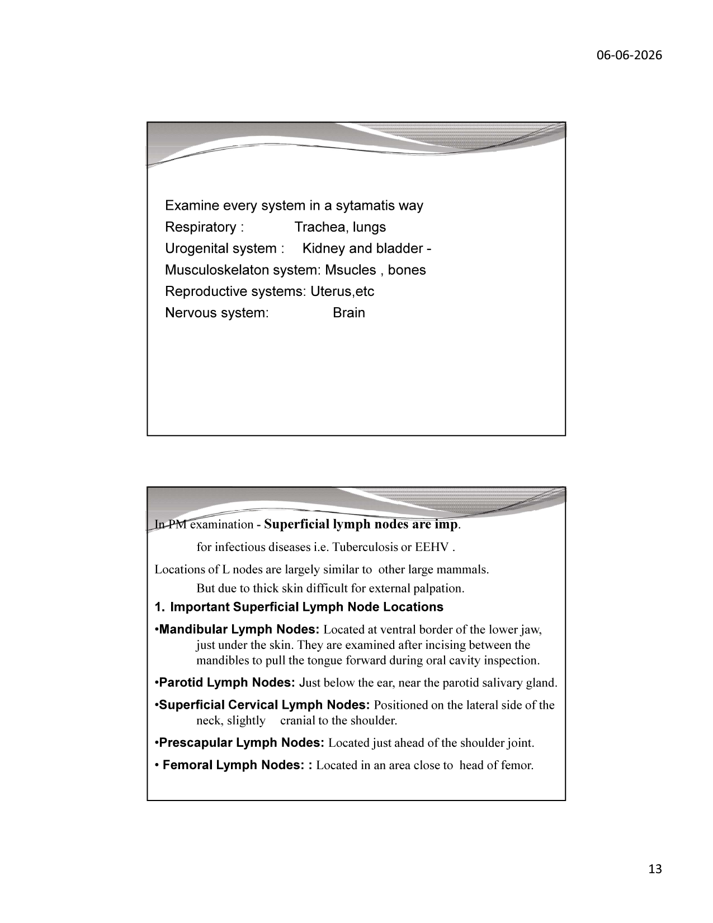
Slide 13 — Systematic examination checklist; lymph node locations
10.1 Respiratory System

• TRACHEA: large-diameter; inspect mucosa for haemorrhage, parasites (Mammomonogamus elephantis), exudate
• LUNGS: examine each lobe; colour (pink-grey normal; red/consolidated = pneumonia; pale/emphysematous; dark/hyperaemic); texture (spongy vs firm); cut surface findings
• TB lesions: grey-white focal caseous nodules distributed throughout lung parenchyma — MUST be sampled for Mycobacterium tuberculosis complex culture and PCR
• EEHV lesions (calves): haemorrhagic/necrotic foci in lung parenchyma; endothelial cell necrosis on histopathology
• Collect: lung tissue in formalin (histopathology) and fresh (virology/microbiology); tracheal swab; bronchial lavage
10.2 Urogenital System

• KIDNEYS: multi-lobulated (renculated structure); examine for infarcts, abscesses, nephritis, TB granulomas
• BLADDER: examine for cystitis, haemorrhage, calculi
• UTERUS (females): check gravidity; examine endometrium, myometrium; sample for reproductive pathogens
• TESTES (males): located ABDOMINALLY adjacent to kidneys — normal; examine for orchitis, tumour
• ADRENAL GLANDS: enlarged/haemorrhagic in septicaemia; cortical atrophy in chronic disease
10.3 Musculoskeletal System

• MUSCLES: examine for pallor (myopathy), haemorrhage (trauma/electrocution), oedema, calcification (nutritional myopathy — white muscle disease)
• BONES: long bone fractures; vertebral fractures/dislocations; periosteal reactions; osteomyelitis (common in captive foot pad disease)
• JOINTS: examine for septic arthritis, degenerative joint disease (older animals)
10.4 Reproductive System

• FEMALE: examine uterus (bifurcate at cervix into two uterine horns); if pregnant: fetal age, placenta
• MALE: testes abdominally; epididymis; accessory glands; penis sheath examination
• Reproductive tract pathology: endometritis, pyometra, tumours (uncommon), trauma
10.5 Nervous System

• BRAIN: heaviest of any land mammal (4–6 kg); access by removing calvarium with saw
• Examine for: haemorrhage (epidural, subdural, intraparenchymal), oedema, softening (encephalitis), Negri bodies (rabies — histopathology mandatory)
• SPINAL CORD: examine at multiple levels for myelitis, haemorrhage, compression
• Collect: brain stem, hippocampus, cerebellum in 10% buffered formalin for histopathology; fresh brain for virology (rabies FA test)

11. Lymph Node Examination

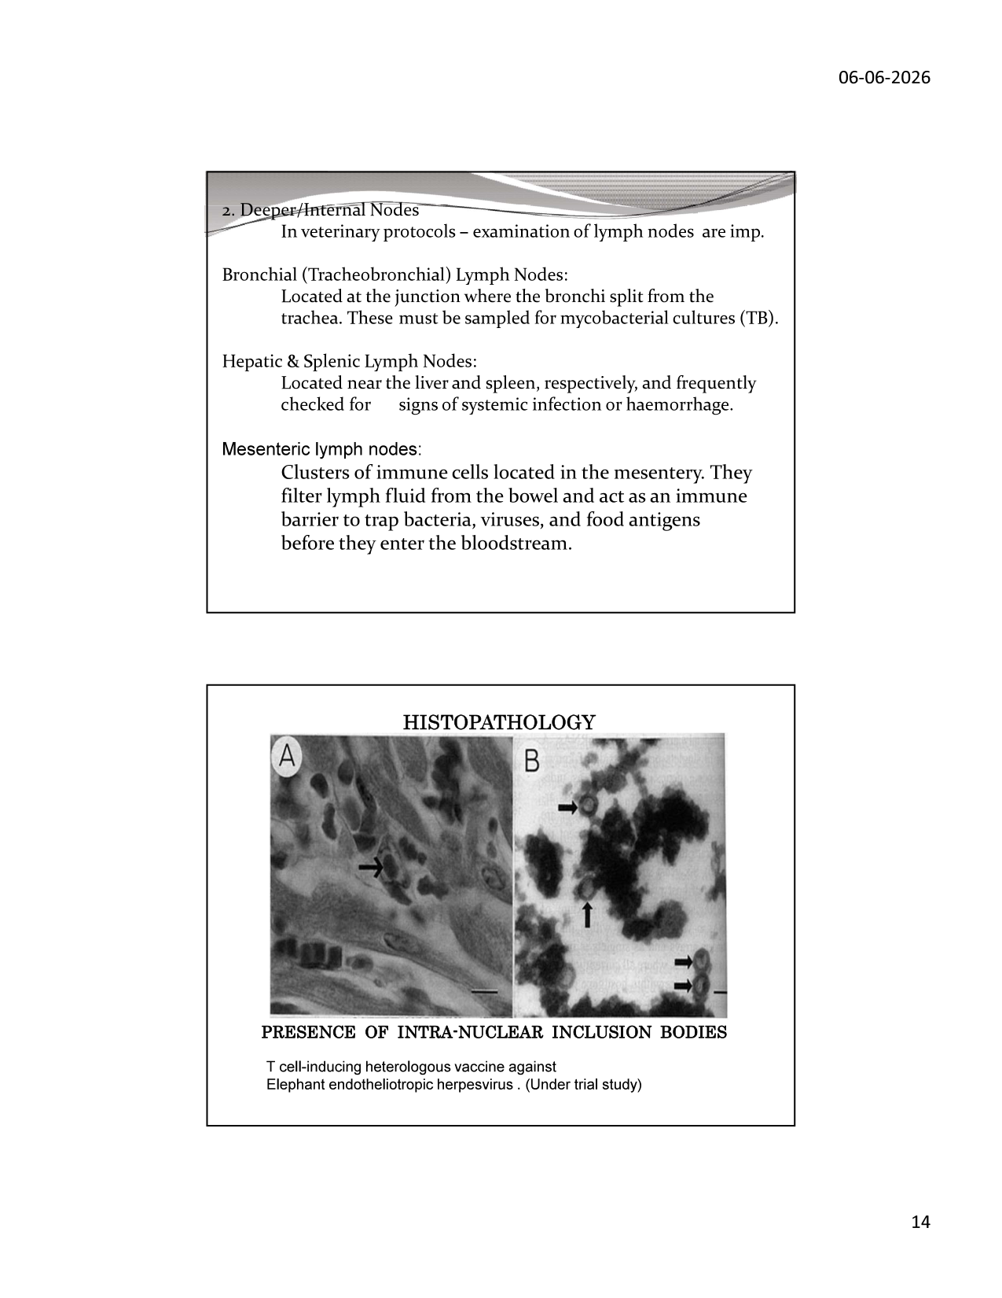
Slide 14 — Histopathology: intra-nuclear inclusion bodies in EEHV; lymph node locations
11.1 Importance in Elephant PM Examination

Superficial lymph nodes are critically important in elephant postmortem examination for detecting infectious diseases such as Tuberculosis (TB) and Elephant Endotheliotropic Herpesvirus (EEHV). Lymph node locations in the elephant are largely similar to other large mammals, but their depth under the thick skin makes external palpation in live animals difficult — they are more accessible at necropsy.
11.2 Superficial Lymph Nodes

Lymph Node | Location | Diseases to Check
Mandibular (Submandibular) | Ventral border of lower jaw, just under skin; examined after incising between mandibles during oral cavity inspection | TB (caseous granulomas); strangles-like infection; EEHV
Parotid | Just below the ear, near the parotid salivary gland | Parotid abscess; systemic disease; TB
Superficial Cervical | Lateral side of neck, slightly cranial to shoulder | TB; trypanosomiasis; systemic infection
Prescapular | Just ahead of the shoulder joint | Systemic disease screening; TB; lymphoma
Femoral | Area close to head of femur (inguinal region) | Pelvic/hindlimb infections; TB; lymphosarcoma

11.3 Deep / Internal Lymph Nodes

Lymph Node | Location | Key Diagnostic Use
Bronchial (Tracheobronchial) | Junction where bronchi split from trachea (carina) | MANDATORY sample for mycobacterial culture (TB); EEHV PCR; systemic viral disease
Hepatic & Splenic | Near liver and spleen, respectively | Systemic infection or haemorrhage; TB hepatic involvement; EEHV
Mesenteric | Clusters in the mesentery of small/large intestine | Intestinal infections (Salmonella, Johne disease-like); enteritis; parasitic disease

11.4 Histopathology — EEHV Inclusion Bodies

Elephant Endotheliotropic Herpesvirus (EEHV) is the leading infectious cause of death in captive elephant calves worldwide. The definitive histopathological diagnosis is the identification of INTRA-NUCLEAR INCLUSION BODIES (Cowdry Type A) in vascular endothelial cells of multiple organs — most consistently in heart, tongue, trunk skin, liver, and spleen.
• Gross: petechial/ecchymotic haemorrhages on multiple serosal surfaces; haemopericardium; oedematous head and neck (particularly EEHV1A)
• Histopathology: swollen endothelial cells with large eosinophilic intranuclear inclusion bodies surrounded by clear halo (arrow markers in slide)
• PCR confirmation: trunk wash, blood, and tissue samples — send fresh (unfixed) for EEHV DNA PCR
• Seven EEHV species known (EEHV1–7); EEHV1A and EEHV4 most commonly fatal
• Vaccine development: T cell-inducing heterologous vaccines are currently under trial (as noted in slide)
EEHV SAMPLING PROTOCOL at necropsy:
• Trunk wash / nasal swab (fresh) → EEHV PCR
• Blood (EDTA) → haematology + EEHV PCR
• Heart, tongue, trunk skin, liver, spleen → 10% formalin (histopathology)
• Heart, tongue, trunk skin (fresh, snap-frozen) → EEHV PCR / EM
• Lymph nodes (fresh) → EEHV PCR
• Median survival after clinical signs appear: ~36 hours — early sampling is critical

12. Differential Diagnosis — Diseases Causing Sudden Death

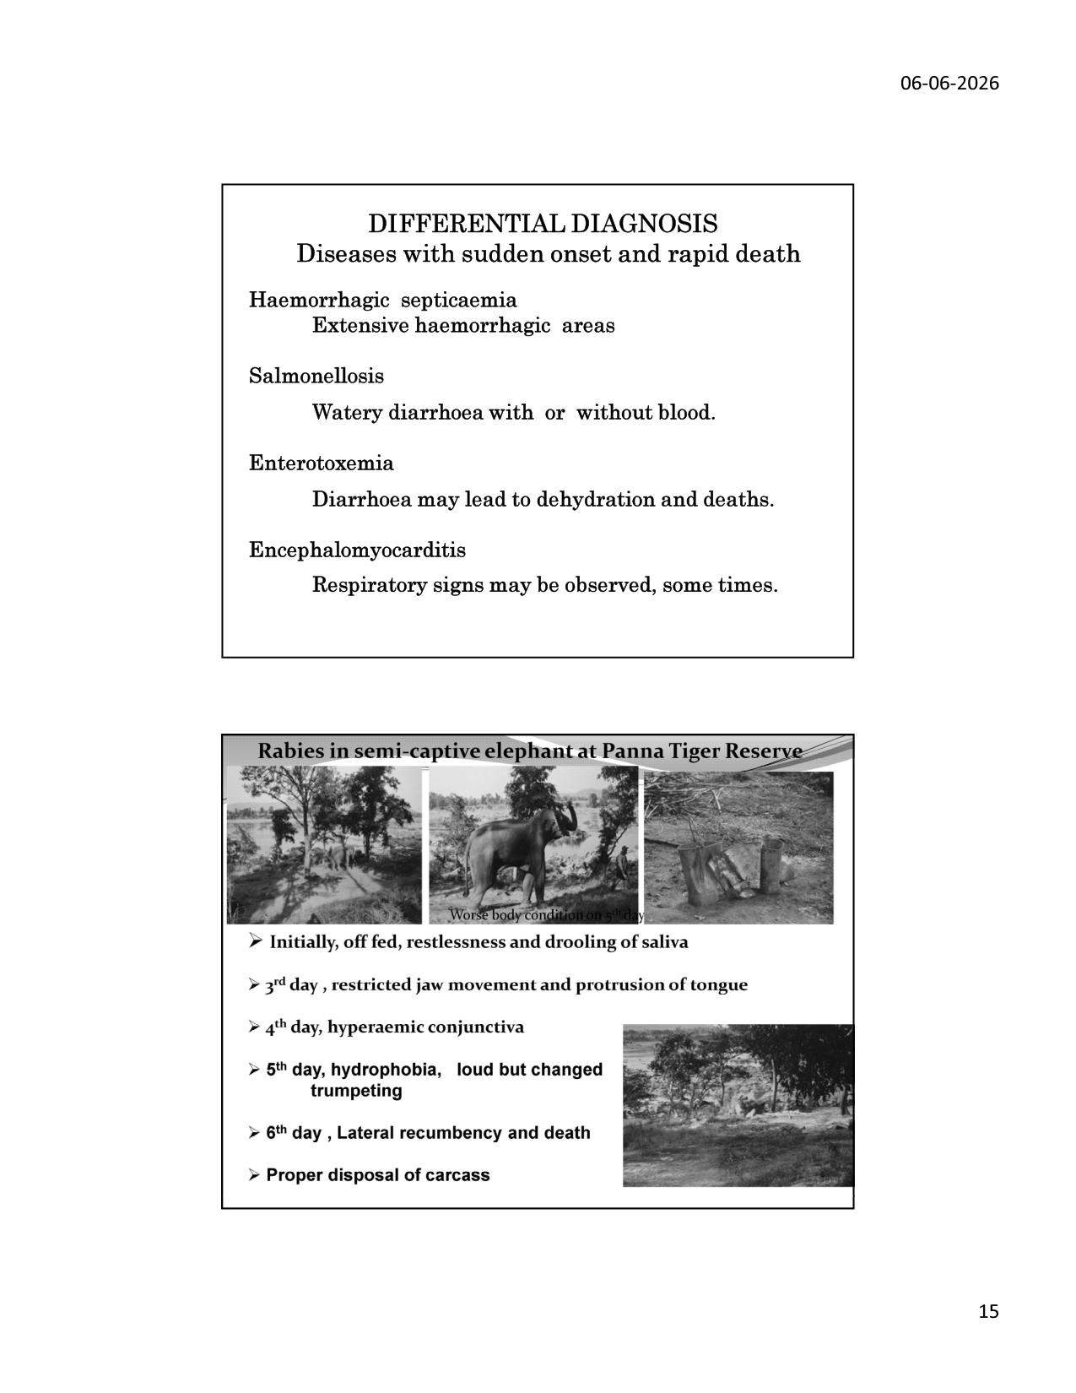
Slide 15 — Differential diagnosis table; Rabies case at Panna Tiger Reserve
12.1 Diseases with Sudden Onset and Rapid Death

Disease | Causative Agent | Key PM Findings | Samples Required
Haemorrhagic Septicaemia | Pasteurella multocida type B (or E) | Extensive haemorrhagic areas in subcutaneous tissues, serous surfaces, lymph nodes; pulmonary oedema; splenomegaly | Blood (anaerobic); lung, spleen, liver for culture; fresh tissue for PCR
Salmonellosis | Salmonella spp. (S. typhimurium, S. dublin) | Haemorrhagic enteritis; watery diarrhoea with or without blood; mesenteric lymph node haemorrhage; hepatic necrosis | Intestinal content; mesenteric lymph nodes; blood for culture; faeces for PCR
Enterotoxaemia | Clostridium perfringens type C/D | Haemorrhagic enteritis; diarrhoea leads to dehydration and death; gas in intestinal lumen; rapid autolysis | Intestinal content (fresh, frozen) for toxin ELISA; intestinal mucosa for PCR
Encephalomyocarditis (EMC) | EMC Virus (Cardiovirus) | Cardiac necrosis; white/pale foci in myocardium; encephalitis; respiratory distress sometimes | Heart (fresh + formalin); brain (fresh + formalin); blood for serology and PCR
Rabies | Rabies Lyssavirus | Behavioural signs (below); brain stem Negri bodies; non-suppurative encephalitis | Brain stem (fresh, frozen) for FA test; brain in formalin for Negri body histology
Anthrax | Bacillus anthracis | Sudden death; blood-stained discharges from orifices; splenomegaly; blood fails to clot; DO NOT OPEN CARCASS until anthrax excluded | Blood smear (Giemsa/McFadyean stain); peripheral blood culture; CAUTION — zoonosis

12.2 Case Report — Rabies in Semi-Captive Elephant at Panna Tiger Reserve

Prof. Dr. Shrivastava documented a confirmed case of Rabies in a semi-captive elephant at Panna Tiger Reserve — one of the very few documented cases of rabies in elephants. The clinical progression was rapid and characteristic:
Day | Clinical Signs Observed
Day 1 (Initially) | Off feed; restlessness; drooling of saliva (hypersalivation)
Day 3 | Restricted jaw movement; protrusion of tongue (progressive paresis)
Day 4 | Hyperaemic conjunctiva (bloodshot eyes — autonomic involvement)
Day 5 | Hydrophobia; loud but changed, distorted trumpeting (laryngeal paralysis)
Day 6 | Lateral recumbency and death (ascending paralysis complete)
Post-mortem | Proper carcass disposal mandatory — deep burial or incineration; carcass biohazardous

• Rabies diagnosis in elephant: histopathology for Negri bodies in hippocampus and cerebellum; direct FA test on brain stem
• Source of infection: likely bite from a rabid domestic dog (common vector in India)
• ZOONOSIS RISK: Rabies virus present in saliva; ALL personnel who had contact must receive post-exposure prophylaxis (PEP) immediately

13. Tuberculosis in Free-Range Asian Elephants

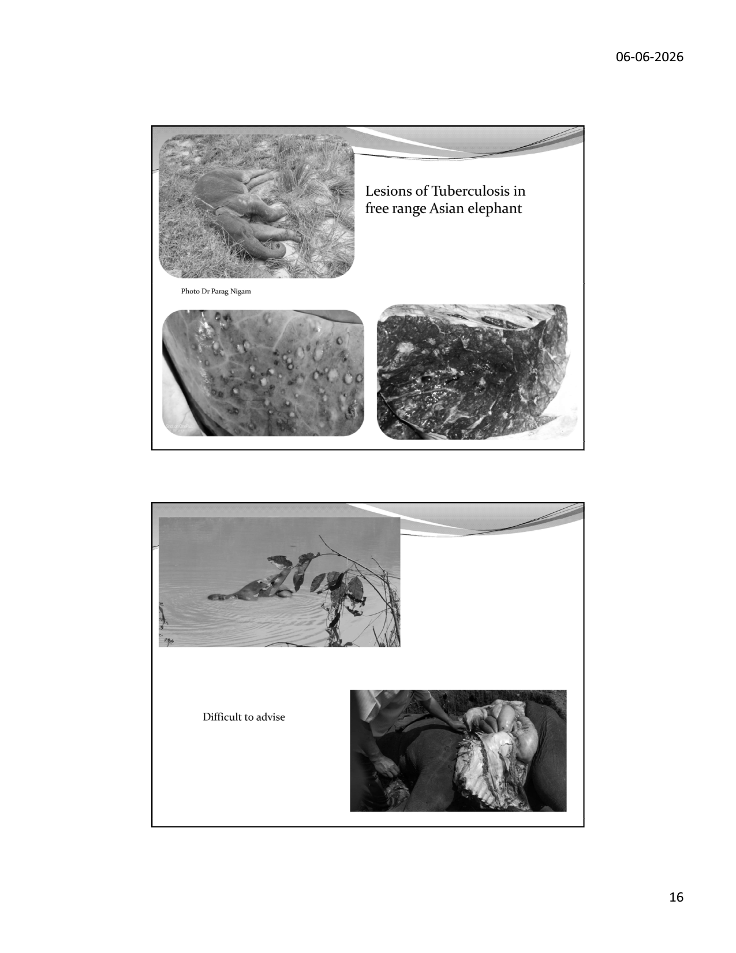
Slide 16 — Gross lesions of TB in free-range Asian elephant (photos by Dr. Parag Nigam); decomposed carcass PM
13.1 TB in Elephants — Overview

Tuberculosis caused by Mycobacterium tuberculosis (human strain) is increasingly documented in both captive and free-ranging Asian elephants in India. The disease is a significant zoonotic risk to mahouts, forest staff, and veterinarians. TB in elephants typically presents as a chronic, progressive disease with non-specific clinical signs until advanced stages.
13.2 Gross PM Lesions of Elephant TB

• LUNGS: Multiple grey-white to caseous nodules (granulomas) of varying size distributed throughout parenchyma — typically 5 mm to 5 cm diameter
• PLEURA/PERITONEUM: Miliary (millet-seed) nodules on serosal surfaces; fibrous adhesions
• LIVER: Caseous granulomas; hepatomegaly
• LYMPH NODES: Enlarged, caseous, calcified (in chronic cases); tracheobronchial LN most commonly affected
• As shown in the slide: lung cross-section with multiple pale nodular granulomas throughout the parenchyma (right image); pleural/peritoneal involvement (left lower image)
13.3 TB Diagnostic Protocol at Necropsy

• Collect tracheobronchial lymph nodes (fresh + formalin) as PRIORITY — highest mycobacterial burden
• Collect lung tissue from multiple nodular lesions (fresh + formalin)
• Nasal/trunk wash (fresh) — for culture and PCR; useful for inter-elephant transmission assessment
• Impression smears from cut lymph node: Ziehl-Neelsen stain for acid-fast bacilli
• Samples to ICAR-NRC on Mithun / ICAR-IVRI for culture (8–12 weeks incubation) + PCR (species confirmation)
• TB lesions in decomposed carcass: caseous/calcified nodules persist — collect even from advanced autolysed carcasses
ZOONOSIS WARNING — ELEPHANT TB:
Mycobacterium tuberculosis in elephants is the HUMAN strain — it is fully infectious to humans by respiratory route. All PM personnel must wear:
• N95 or higher respiratory protection (NOT surgical mask)
• Double gloves + waterproof gown
• Eye protection (goggles)
All personnel with elephant contact should undergo regular tuberculin test and chest X-ray. Post-exposure notification mandatory if contact with open TB lesions occurred.

14. Case Study — HCN Poisoning in Asian Elephants

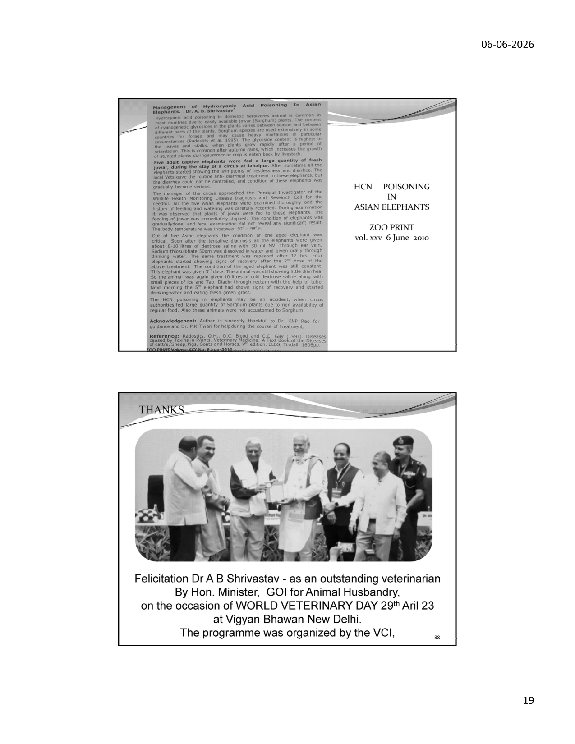
Slide 19 — HCN poisoning case report (Zoo Print 2010); felicitation of Dr. Shrivastava
14.1 Hydrocyanic Acid (HCN) Poisoning

Hydrocyanic acid (prussic acid) poisoning in domestic and captive herbivores is commonly caused by consumption of cyanogenic glycoside-containing plants, especially Sorghum (jowar/sorghum bicolor) and Sudangrass. The cyanogenic glycoside content varies by plant part, season (highest in young shoots after wilting/frosting), and growth stage. When ingested, plant enzymes release HCN which binds cytochrome oxidase → inhibits cellular respiration → rapid death.
14.2 Case — Five Adult Captive Elephants, Circus, Tahalpur

• Five adult captive elephants were fed large quantities of fresh Jowar (Sorghum) during their circus stay — animals were not accustomed to Sorghum
• Clinical signs: restlessness, diarrhoea — elephants could not be controlled; condition gradually became serious
• One aged elephant became critical; the other four showed early signs of recovery
• Treatment given: Sodium thiosulphate 50 gm dissolved in water and given orally through drinking water; repeated after 12 hours
• Additional treatment: 1 litre 5% dextrose saline + Rice and Tab Diulin through rectum via tube
• Outcome: 5th elephant showed signs of recovery next morning; started drinking water and eating fresh green grass
• Body temperature during illness: 97–98°F (slightly subnormal — characteristic of HCN)
• Source publication: Zoo Print vol. xxv, 6 June 2010
14.3 HCN Poisoning — PM Findings

• Bright cherry-red colour of blood and tissues (due to cyanmethaemoglobin formation) — pathognomonic
• Smell of bitter almonds from stomach contents and blood
• Rapid rigor mortis (lactic acid accumulation inhibited)
• Congested viscera; petechial haemorrhages
• Diagnosis: Chemical analysis of stomach contents / blood for HCN/cyanide levels
TOXICOLOGY SAMPLING for HCN POISONING:
• Stomach contents (sealed container, refrigerated or frozen)
• Liver and kidney (50g each, frozen)
• Blood (10 mL, fluoride-oxalate tube, frozen)
• Plant material suspected as source (labelled)
Send to forensic/toxicology laboratory (IVRI Izatnagar / FSL Sagar) with suspected diagnosis.

15. Key References & Recommended Reading

15.1 Works by Prof. Dr. A B Shrivastava

• Shrivastav AB & Sharma RK (2008). A Manual of Wildlife Health Management in Protected Areas. CVAH, JNKVV, Jabalpur
• Shrivastav AB & Singh KP (Ed.) (2011). Big Cats. InTech Open Access Publisher
• Shrivastav AB & Nigam P (2019). Learning from Dead: Necropsy Essentials for Large Felids. Published, Jabalpur
• Shrivastav AB (2020). Manual on Postmortem Examination of Felids. NDVSU, Jabalpur
• Nigam P, Habib J & Pandey H (Ed.) (2021). Caring for Elephants: Managing Health & Welfare in Captivity
• MoEFCC/WII (2020). Necropsy and Carcass Disposal of Asian Elephant: Recommended Operating Procedure. GoI
• Shrivastav AB (2010). Management of Hydrocyanic Acid Poisoning in Asian Elephants. Zoo Print vol. xxv, 6 June 2010
15.2 Peer-Reviewed Literature

• Fowler ME & Mikota SK (2006). Biology, Medicine and Surgery of Elephants. Blackwell Publishing, Iowa
• Mikota SK et al. (2001). Elephants TB. International Zoo Yearbook 37: 122–135
• Richman LK et al. (2000). Novel Endotheliotropic Herpesviruses Fatal for Asian and African Elephants. Science 288: 1171–1176
• West JB (2001). Anatomical Basis for Unusual Properties of the Lung in an Extreme Environment. Respiration Physiology 127: 1–11
• Sukumar R (2003). The Living Elephants: Evolutionary Ecology, Behaviour & Conservation. Oxford University Press
• Vidya TNC & Sukumar R (2005). Social Organisation of Asian Elephant. Proceedings Royal Society London B 272: 3011–3020
• MoEFCC (2017). Gajah: Securing the Future for Elephants in India. Project Elephant, Government of India
• Lynsdale CL et al. (2024). Elephant molar eruption timeline. Scientific Reports, PMC update
• Loo AHB et al. (2024). Sexual dimorphism in Asian elephant skeletal morphology. PMC12383435
Notes prepared from the presentation of Prof. Dr. A B Shrivastava (06-06-2026), elaborated with peer-reviewed literature and current guidelines. Training Program: Essentials for Mortality Investigation of Asian Elephant, Chhattisgarh Forest Department, 5–6 June 2026, Raigarh.

