STUDY NOTES — CHAPTER 5
Thorax & Rib Cage
Biological and Anatomical Aspects of Elephants
Dr. Parag Nigam, PhD · Wildlife Institute of India, Dehradun

Training Program: Essentials for Mortality Investigation of Asian Elephant
Chhattisgarh Forest Department · 5–6 June 2026, Raigarh | Technical Support: WII Dehradun
Notes elaborated with peer-reviewed literature and web sources.

CONTENTS OF THIS DOCUMENT:
5.1 Rib Count & Structure — rib pairs, sternal vs asternal vs floating ribs, keel sternum
5.2 Comparison with Domestic Species — rib counts, pleural space, breathing mechanisms
5.3 No Pleural Space — Unique Respiratory Anatomy — fused pleura, diaphragm-only breathing
5.4 Diaphragm — Structure & Function — respiratory rate, tidal volume, evolutionary reason
5.5 Necropsy Findings — Thorax — normal vs pathological findings, heart, trachea parasites
CRITICAL DANGER KEYBOX — sternal recumbency, thoracocentesis, IPPV, necropsy note

5. Thorax & Rib Cage
5. Thorax & Rib Cage

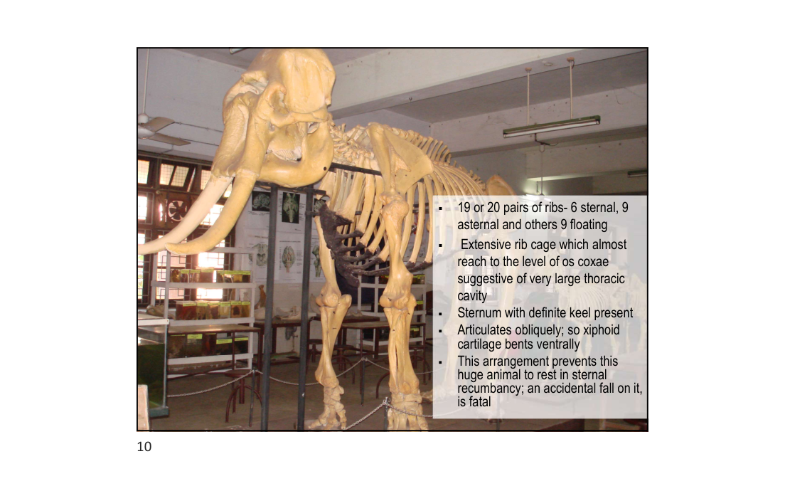
Slide 10 — Thoracic skeleton: extensive rib cage reaching to os coxae level

5.1 Rib Count & Structure
5.1 Rib Count & Structure

The elephant rib cage is one of the most expansive of any terrestrial mammal. It extends posteriorly almost to the level of the os coxae (pelvis), enclosing the enormous thoracic cavity needed to house a 12–21 kg heart and very large lungs.
Parameter | Asian Elephant | African Elephant
Total rib pairs | 19–20 | 21
Sternal ribs (attached directly to sternum) | 6 | 6
Asternal ribs (attached via costal cartilage) | 9 | 9
Floating ribs (free — no sternal attachment) | ~4–5 | ~6
Extent of rib cage | Reaches nearly to os coxae level | Similar extent
Thoracic cavity volume | Very large — accommodates 12–21 kg heart | Very large

• Sternum: has a definite keel (carina) — unlike most domestic animals where the sternum is flat
• Xiphoid cartilage: articulates obliquely and bends ventrally — relevant to positioning during anaesthesia
• Costal cartilages: wide, calcify with age; useful at necropsy for gross age estimation
• Thoracic vertebrae: 19–20 in Asian elephant; each bears a pair of ribs; spinous processes elongated dorsally

5.2 Comparison with Domestic Species
5.2 Comparison with Domestic Species

Species | Rib Pairs | Pleural Space | Breathing Mechanism
Asian Elephant | 19–20 | ABSENT — pleura fused | Diaphragm ONLY
African Elephant | 21 | ABSENT — pleura fused | Diaphragm ONLY
Horse | 18 | Present — fluid-filled | Diaphragm + rib cage expansion
Cattle | 13 | Present — fluid-filled | Diaphragm + rib cage expansion
Dog | 13 | Present — fluid-filled | Diaphragm + rib cage expansion
Human | 12 | Present — fluid-filled | Diaphragm + rib cage expansion

5.3 No Pleural Space — Unique Respiratory Anatomy
5.3 No Pleural Space — Unique Respiratory Anatomy

The elephant is the ONLY mammal known to have no true pleural space. In all other mammals, a fluid-filled pleural cavity separates the visceral pleura (covering the lung) from the parietal pleura (lining the chest wall), creating a sealed pressure-differential space that passively drives lung inflation and deflation. In elephants, this space does not exist:
• Both visceral and parietal pleura are composed of DENSE CONNECTIVE TISSUE (not the typical serous membrane found in other mammals)
• The two pleural layers are FUSED together via loose connective tissue — no fluid-filled pleural cavity exists between them
• Lungs are therefore physically ADHERED to the chest wall — they cannot collapse passively as in other mammals
• Breathing is driven almost ENTIRELY by DIAPHRAGM MOVEMENT — no contribution from rib cage expansion/contraction
• The diaphragm is unusually THICK AND MUSCULAR to generate the required inspiratory pressure differentials alone
• This adaptation may be related to semi-aquatic evolutionary ancestry — swimming elephants submerge with trunk as snorkel; pleural fusion may prevent lung compression at depth
• West JB (2001): confirmed the biophysical significance of this arrangement for deep-water breathing during swimming

5.4 Diaphragm — Structure & Function
5.4 Diaphragm — Structure & Function

• Diaphragm is the PRIMARY and near-exclusive respiratory muscle in elephants
• Much thicker and more muscular than in other large mammals
• On contraction: pulls lungs downward and posteriorly (caudoventrally), increasing thoracic volume → inspiration
• On relaxation: thoracic volume decreases → passive expiration
• Accessory respiratory muscles (intercostals) play a MINIMAL role compared to other species
• Resting respiratory rate: ~4–8 breaths per minute (slower than most mammals of similar metabolic rate)
• Tidal volume: very large, compensating for slow rate
• The central tendon of the diaphragm is anchored to the caudal border of the sternum and the thoracic vertebral column
• Diaphragm weight estimated at 2–4% of total body weight — reflects the enormous musculature required
CRITICAL CLINICAL DANGERS — UNIQUE TO ELEPHANTS:
1. STERNAL RECUMBENCY IS FATAL
In sternal (prone) position, abdominal viscera shift cranially and compress the diaphragm from the ventral aspect, preventing its caudal movement → complete respiratory arrest develops within minutes. The xiphoid cartilage arrangement also physically prevents full sternal recumbency. ALWAYS maintain LATERAL recumbency (left lateral preferred) for any sedated or anaesthetised elephant.
2. NO THORACOCENTESIS / CHEST DRAINAGE POSSIBLE
Because the visceral and parietal pleura are fused, there is NO pleural cavity to drain. Fluid (haemothorax, exudate) accumulates WITHIN the connective tissue, making thoracocentesis impossible and diagnostically misleading. Fluid accumulation in this region is a serious clinical emergency with no simple drainage solution.
3. ANAESTHESIA — IPPV PARAMETERS DIFFER
Intermittent Positive Pressure Ventilation (IPPV) parameters differ significantly from other large mammals. Inspiratory pressures must overcome the resistance of the fused pleural connective tissue. Standard equine or bovine IPPV protocols are NOT directly applicable.
4. NECROPSY NOTE
Never mistake the normal firm lung-wall adhesion for pathological pleuritis or fibrinous pleurisy. The adhesion is present in ALL elephants — it is the normal anatomical state, not a disease finding.

5.5 Necropsy Findings — Thorax
5.5 Necropsy Findings — Thorax

• On opening the chest wall: lungs appear firmly attached to the inner chest wall surface — this is NORMAL anatomy, not adhesion from pleuropneumonia
• No fluid should be present in the "pleural space" — any fluid collection between chest wall and lung surface is pathological (haemorrhage, exudate, oedema)
• Heart: positioned centrally in the thorax; apex is BIFID (double-pointed) — distinctive and normal; weight 12–21 kg
• Lungs: large, soft, pink-grey; spongy texture; may show mild congestion post-mortem (gravitational)
• Trachea: large-diameter; check for foreign bodies, mucus plugs, parasites (Mammomonogamus)
• Pericardium: check for haemopericardium, fibrinous deposits (endotheliotropic herpesvirus — EEHV — in calves)
• Intercostal spaces: examine for intercostal muscle haemorrhage — may indicate electrocution (lightning or poaching)
• Diaphragm: inspect for tears, herniation, parasitic cysts (Taenia spp.) on peritoneal surface
MORTALITY INVESTIGATION — THORAX DOCUMENTATION CHECKLIST:
• Measure heart weight; document bifid apex; check for EEHV haemorrhages (calves)
• Describe lung colour, texture, consolidation, parasites, foreign bodies
• Document any fluid between lung and chest wall (volume, colour, odour, consistency)
• Collect tracheal swabs for respiratory pathogen PCR (EEHV, Elephant Poxvirus, Mycobacterium)
• Inspect diaphragm integrity — tears are common in HEC (human-elephant conflict) fatalities
• Intercostal muscle haemorrhage: photograph and sample (histology for lightning/electrocution)

Notes compiled from lecture by Dr. Parag Nigam, PhD — Wildlife Institute of India | Web-elaborated June 2026
Training Program: Essentials for Mortality Investigation of Asian Elephant · 5–6 June 2026, Raigarh, Chhattisgarh

