STUDY NOTES — CHAPTERS 5, 6 & 7
Thorax & Rib Cage · Skull Morphology · Age Estimation
Biological and Anatomical Aspects of Elephants
Dr. Parag Nigam, PhD · Wildlife Institute of India, Dehradun

Training Program: Essentials for Mortality Investigation of Asian Elephant
Chhattisgarh Forest Department · 5–6 June 2026, Raigarh | Technical Support: WII Dehradun
Notes elaborated with peer-reviewed literature and web sources.

CONTENTS OF THIS DOCUMENT:
Chapter 5 — Thorax & Rib Cage (rib count, sternal anatomy, NO pleural space — critical danger)
Chapter 6 — Skull Morphology & Sexual Dimorphism (honeycomb sinuses, frontal/lateral/mandible comparisons)
Chapter 7 — Age Estimation — Molar Progression (M1–M6 table, lamellae counting, forensic ageing rules)

5. Thorax & Rib Cage
5. Thorax & Rib Cage

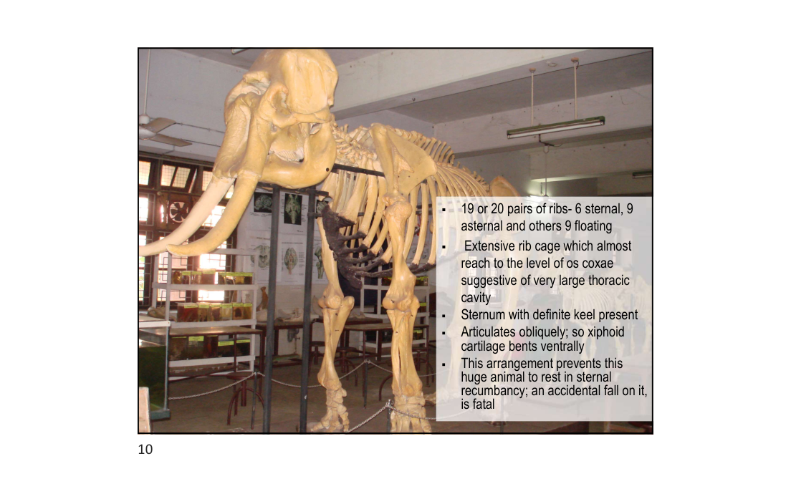
Slide 10 — Thoracic skeleton: extensive rib cage reaching to os coxae level

5.1 Rib Count & Structure
5.1 Rib Count & Structure

The elephant rib cage is one of the most expansive of any terrestrial mammal. It extends posteriorly almost to the level of the os coxae (pelvis), enclosing the enormous thoracic cavity needed to house a 12–21 kg heart and very large lungs.
Parameter | Asian Elephant | African Elephant
Total rib pairs | 19–20 | 21
Sternal ribs (attached directly to sternum) | 6 | 6
Asternal ribs (attached via costal cartilage) | 9 | 9
Floating ribs (free — no sternal attachment) | ~4–5 | ~6
Extent of rib cage | Reaches nearly to os coxae level | Similar extent
Thoracic cavity volume | Very large — accommodates 12–21 kg heart | Very large

• Sternum: has a definite keel (carina) — unlike most domestic animals where the sternum is flat
• Xiphoid cartilage: articulates obliquely and bends ventrally — relevant to positioning during anaesthesia
• Costal cartilages: wide, calcify with age; relevant to ageing at necropsy
• Thoracic vertebrae: 19–20 in Asian elephant; each bears a pair of ribs; spinous processes elongated dorsally

5.2 Comparison with Domestic Species
5.2 Comparison with Domestic Species

Species | Rib Pairs | Pleural Space | Breathing Mechanism
Asian Elephant | 19–20 | ABSENT — pleura fused | Diaphragm ONLY
African Elephant | 21 | ABSENT — pleura fused | Diaphragm ONLY
Horse | 18 | Present — fluid-filled | Diaphragm + rib cage expansion
Cattle | 13 | Present — fluid-filled | Diaphragm + rib cage expansion
Dog | 13 | Present — fluid-filled | Diaphragm + rib cage expansion
Human | 12 | Present — fluid-filled | Diaphragm + rib cage expansion

5.3 No Pleural Space — Unique Respiratory Anatomy
5.3 No Pleural Space — Unique Respiratory Anatomy

The elephant is the ONLY mammal known to have no true pleural space. In all other mammals, a fluid-filled pleural cavity separates the visceral pleura (covering the lung) from the parietal pleura (lining the chest wall), creating a sealed pressure-differential space that passively drives lung inflation and deflation. In elephants, this space does not exist:
• Both visceral and parietal pleura are composed of DENSE CONNECTIVE TISSUE (not the typical serous membrane found in other mammals)
• The two pleural layers are FUSED together via loose connective tissue — no fluid-filled pleural cavity exists between them
• Lungs are therefore physically ADHERED to the chest wall — they cannot collapse passively as in other mammals
• Breathing is driven almost ENTIRELY by DIAPHRAGM MOVEMENT — no contribution from rib cage expansion/contraction
• The diaphragm is unusually THICK AND MUSCULAR to generate the required inspiratory pressure differentials alone
• This adaptation may be related to semi-aquatic evolutionary ancestry — swimming elephants submerge with trunk as snorkel; pleural fusion may prevent lung compression at depth
• West JB (2001): confirmed the biophysical significance of this arrangement for deep-water breathing during swimming

5.4 Diaphragm — Structure & Function
5.4 Diaphragm — Structure & Function

• Diaphragm is the PRIMARY and near-exclusive respiratory muscle in elephants
• Much thicker and more muscular than in other large mammals
• On contraction: pulls lungs downward and posteriorly (caudoventrally), increasing thoracic volume → inspiration
• On relaxation: thoracic volume decreases → passive expiration
• Accessory respiratory muscles (intercostals) play a MINIMAL role compared to other species
• Resting respiratory rate: ~4–8 breaths per minute (slower than most mammals of similar metabolic rate)
• Tidal volume: very large, compensating for slow rate
CRITICAL CLINICAL DANGERS — UNIQUE TO ELEPHANTS:
1. STERNAL RECUMBENCY IS FATAL
In sternal (prone) position, abdominal viscera shift cranially and compress the diaphragm from the ventral aspect, preventing its caudal movement → complete respiratory arrest develops within minutes. The xiphoid cartilage arrangement also physically prevents full sternal recumbency. ALWAYS maintain LATERAL recumbency (left lateral preferred) for any sedated or anaesthetised elephant.
2. NO THORACOCENTESIS / CHEST DRAINAGE POSSIBLE
Because the visceral and parietal pleura are fused, there is NO pleural cavity to drain. Fluid (haemothorax, exudate) accumulates WITHIN the connective tissue, making thoracocentesis impossible and diagnostically misleading. Fluid accumulation in this region is a serious clinical emergency with no simple drainage solution.
3. ANAESTHESIA — IPPV PARAMETERS DIFFER
Intermittent Positive Pressure Ventilation (IPPV) parameters differ significantly from other large mammals. Inspiratory pressures must overcome the resistance of the fused pleural connective tissue. Standard equine or bovine IPPV protocols are NOT directly applicable.

5.5 Necropsy Findings — Thorax
5.5 Necropsy Findings — Thorax

• On opening the chest wall: lungs appear firmly attached to the inner chest wall surface — this is NORMAL anatomy, not adhesion from pleuropneumonia
• No fluid should be present in the "pleural space" — any fluid collection between chest wall and lung surface is pathological (haemorrhage, exudate, oedema)
• Heart: positioned centrally in the thorax; apex is BIFID (double-pointed) — distinctive and normal; weight 12–21 kg
• Lungs: large, soft, pink-grey; spongy texture; may show mild congestion post-mortem (gravitational)
• Trachea: large-diameter; check for foreign bodies, mucus plugs, parasites (Mammomonogamus)
NECROPSY NOTE: Never mistake the normal firm lung-wall adhesion for pathological pleuritis or fibrinous pleurisy. The adhesion is present in ALL elephants — it is the normal anatomical state, not a disease finding.

6. Skull Morphology & Sexual Dimorphism
6. Skull Morphology & Sexual Dimorphism

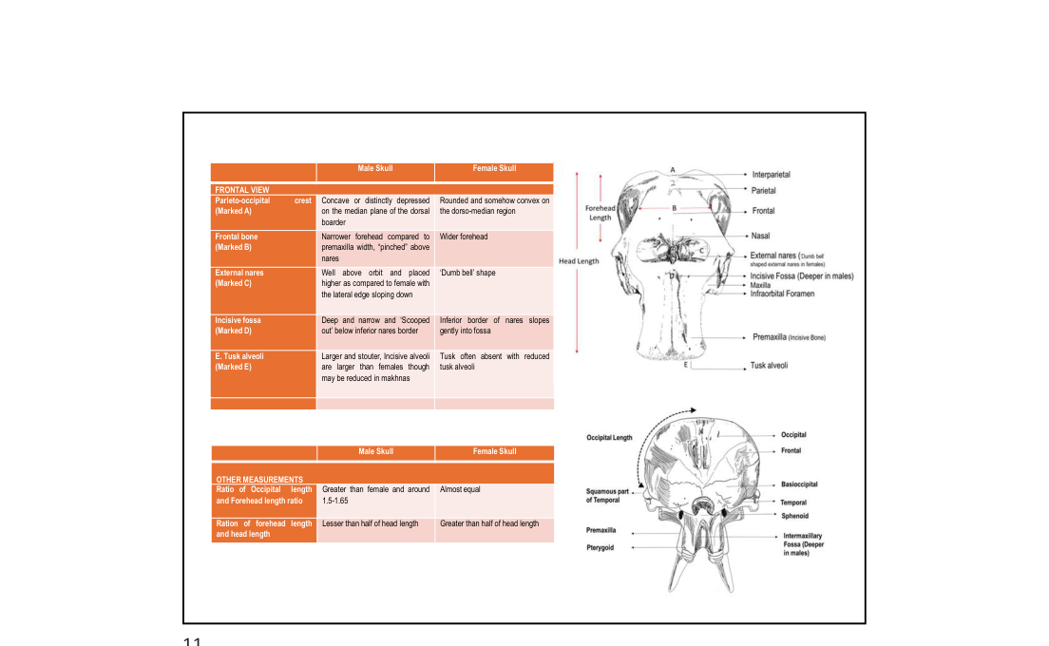
Slide 11 — Skull: Male vs Female (Frontal view) with labelled anatomy
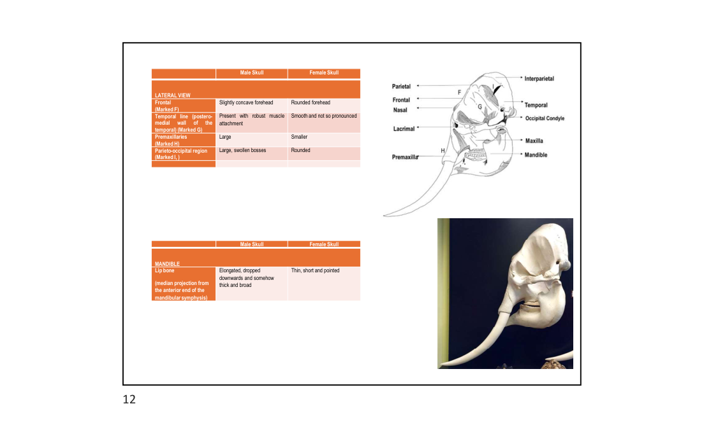
Slide 12 — Skull: Lateral view, mandible comparison and photograph
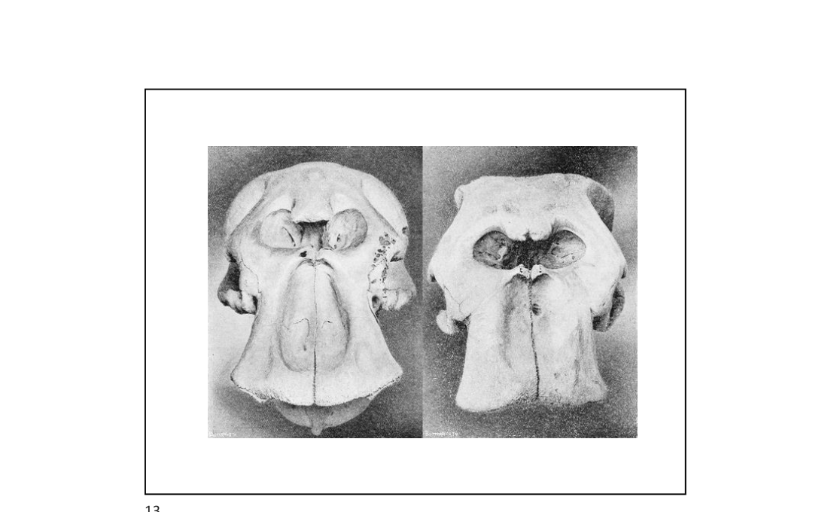
Slide 13 — Skull photographs: male (left) vs female (right)

6.1 Skull Architecture — General Features
6.1 Skull Architecture — General Features

The elephant skull is one of the most architecturally distinctive in the animal kingdom. Its imposing external size is largely an illusion created by a massive internal network of air sinuses (diploë) — a honeycomb-like trabecular structure of bone that reduces skull weight while maintaining structural strength. This engineering solution is essential for supporting the weight of the long trunk, heavy tusks, and large mandible without overloading the cervical vertebrae and neck musculature.
• Diploic (honeycomb) sinuses: massive air-filled trabecular network in the frontal and parietal bones — give the skull its characteristic domed appearance
• The actual BRAIN CASE is relatively small and positioned posteriorly within the skull mass — the brain accounts for only a small fraction of apparent head size
• Skull bones present: interparietal, parietal, frontal, nasal, lacrimal, maxilla, premaxilla, temporal, occipital bones, mandible
• Incisive fossa: deep socket in the premaxilla bone — houses the base (alveolus / root) of the tusks; 1/3 of tusk length is buried here
• Infraorbital foramen: located on the dorsal skull surface below the orbit — larger than in most mammals
• Temporal fossa: large and deep — accommodates the powerful temporal muscles used for mastication

6.2 Comparison of Skull Regions — Functional Anatomy
6.2 Comparison of Skull Regions — Functional Anatomy

Skull Region | Structure | Function / Clinical Relevance
Frontal bone | Filled with extensive diploic sinuses | Lightweight structural dome; NOT an indicator of brain size
Premaxilla | Bears the incisive fossa (tusk alveolus) | Deep socket for tusk root — 1/3 of tusk length here; enlarged in males
Temporal bone | Temporal fossa for temporal muscle origin; temporal gland overlies it | Temporal gland between eye and ear; musth secretion exits via duct here
Occipital bone | Posterior skull; occipital condyles articulate with atlas (C1) | Occipital bosses (enlarged in older males) — sex determination feature
Nasal bones | Short, posterior-set; external nares high on skull | Trunks attach at nares; high placement allows trunk flexibility
Mandible | Lower jaw; symphysis (chin region) sexually dimorphic | Key sex determination feature — elongated in males, short/pointed in females

6.3 Sexual Dimorphism — Frontal View
6.3 Sexual Dimorphism — Frontal View

The following features are identifiable on a frontal (anterior) view of the skull and allow sex determination even from a heavily decomposed or skeletonised carcass:
Feature | Label | Male Skull | Female Skull
Parieto-occipital crest | A | CONCAVE / distinctly depressed along median plane of dorsal border — "saddle-shaped" | Rounded and somewhat CONVEX on dorso-median region — "dome-shaped"
Frontal bone | B | NARROW forehead; "pinched" appearance above nares; steep lateral walls | WIDER forehead; more gradual lateral slope
External nares | C | Well ABOVE orbit level; placed higher on skull; lateral edge slopes sharply downward | DUMB-BELL shape; less elevated; more symmetric
Incisive fossa | D | DEEP and narrow; "scooped out" below inferior border of nares; abrupt transition | Inferior border SLOPES GENTLY into fossa; less abrupt
Tusk alveoli (sockets) | E | LARGER and stouter sockets; tusks well-developed (may be reduced in makhna bulls) | Tusk often absent or greatly reduced alveoli; small tushes common

6.4 Sexual Dimorphism — Lateral View
6.4 Sexual Dimorphism — Lateral View

Feature | Label | Male Skull | Female Skull
Frontal bone (profile) | F | Slightly CONCAVE forehead when viewed from the side | Gently ROUNDED forehead — smoother curve
Temporal line / postero-medial wall | G | PROMINENT — robust temporal muscle attachment ridges clearly visible | Smooth; ridges not pronounced
Premaxillaries | H | LARGE and well-developed; reflect large tusk root sockets | Smaller
Parieto-occipital region | I | LARGE, swollen BOSSES on either side of occipital crest — more pronounced with age | Rounded; bosses absent or minimal
Mandible chin (symphysis) | — | ELONGATED; drops downward; THICK and broad — projects anteriorly | THIN; SHORT and POINTED — does not project forward

6.5 Cranial Proportions — Quantitative Ratios
6.5 Cranial Proportions — Quantitative Ratios

Measurement Ratio | Male | Female | Clinical Use
Occipital length : Forehead length | Greater; ~1.5–1.65 | Almost equal (ratio ~1.0) | Single ratio gives reliable sex indication
Forehead length : Total head length | Less than 0.5 (forehead <50% of head) | Greater than 0.5 (forehead >50% of head) | Measurable from skulls in any condition

6.6 Mandible — Detailed Comparison
6.6 Mandible — Detailed Comparison

Feature | Male Mandible | Female Mandible
Symphysis (chin) shape | Elongated, dropped downwards; thick and broad — distinct "chin" projection | Thin, short and pointed — barely projects
Ramus (vertical part) | Tall and robust | Shorter and more gracile
Molar tooth row length | Longer (larger M5–M6 molars) | Shorter
Overall mass | Heavier and more robust | Lighter
Use at necropsy | Mandible alone sufficient to sex a carcass | Reliable in animals >5 years old

6.7 Age-Dependency of Sexual Dimorphism
6.7 Age-Dependency of Sexual Dimorphism

• Skull sexual dimorphism is AGE-DEPENDENT — during the first two years of life, male and female skulls are nearly identical in shape
• Differences become progressively more pronounced as males grow: tusk alveoli enlarge, temporal muscle attachment ridges develop, occipital bosses form
• By age 10–15 years: male skull features reliably identifiable
• By age 25–30 years: full sexual dimorphism expressed; skull sex determination is straightforward
• Recent research (Loo AHB et al. 2024, PMC12383435): the PELVIC BONE shows the GREATEST degree of sexual dimorphism — especially overall pelvic girdle length and pubic symphysis morphology; skull is second most dimorphic
• Makhna bulls (tuskless males): common in Sri Lankan population, rare in India; skull shows male features in all other respects except reduced/absent tusk alveoli

6.8 Practical Guide to Skull-Based Sex Determination at Mortality Site
6.8 Practical Guide to Skull-Based Sex Determination at Mortality Site

Step | Action | Look For
1 | Identify parieto-occipital crest (top rear of skull) | Male: saddle-shaped depression on median line; Female: smooth dome
2 | Assess frontal bone width | Male: narrow "pinched" forehead above nares; Female: wider
3 | Examine incisive fossa (below trunk attachment) | Male: deep, narrow, scooped; Female: gently sloping
4 | Check tusk alveoli size | Male: large deep sockets; Female: small or absent
5 | Examine mandible chin (symphysis) | Male: elongated, drops forward, thick; Female: short, pointed
6 | Measure forehead:head length ratio | Male: <0.5; Female: >0.5
7 | Check for occipital bosses (rear of skull) | Male >10 yrs: enlarged bosses; Female: absent/minimal
8 | Record findings | Document ALL features in mortality investigation form

MORTALITY INVESTIGATION — SKULL KEY POINTS:
• Skull morphology alone permits DEFINITIVE SEX DETERMINATION even from a fully skeletonised or badly decomposed carcass — use this when soft tissues are absent
• The apparent large size of the skull is mostly AIR SINUSES — do not mistake for a large brain
• Diploic sinuses may trap putrefactive gases — be aware during incision of skull at necropsy
• Tusk alveoli depth indicates past tusk size — document even if tusks have been removed by poachers
• Makhna identification: male skull without tusk alveoli — confirm via other features (occipital bosses, mandible, pelvis)

7. Age Estimation — Molar Progression
7. Age Estimation — Molar Progression

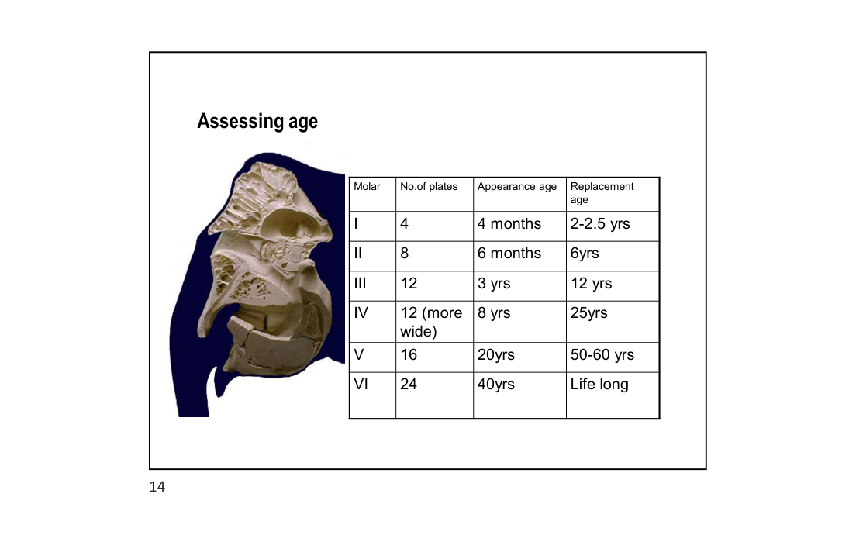
Slide 14 — Molar table for assessing age with skull cross-section

7.1 Unique Horizontal Molar Replacement
7.1 Unique Horizontal Molar Replacement

Elephants possess the most unusual dental replacement mechanism of any living mammal — HORIZONTAL MOLAR PROGRESSION (anteroposterior tooth displacement). Unlike vertical tooth replacement (where new teeth erupt below the old ones and push them upward) seen in all other mammals, elephant molars develop at the BACK of the jaw and progressively move FORWARD (anteriorly) as each preceding molar wears down. The worn tooth fragments drop off from the front of the jaw as the new tooth pushes it out from behind — like a slow conveyor belt of teeth moving through the jaw across the animal's lifetime.
• Six molar sets (M1–M6) develop sequentially on each side of the UPPER AND LOWER jaw = 24 total molar positions
• At any given time: maximum 2 molars in wear simultaneously on any one side (one active, one partially replacing the front)
• Each succeeding molar set is LARGER, has MORE enamel plates (lamellae), and persists in use for LONGER than the preceding one
• This mechanism evolved in late Oligocene epoch — characterises all elephantimorphs (fossil + modern elephants)
• The number of enamel plates (lamellae) visible on the occlusal (chewing) surface is the PRIMARY KEY for molar identification

7.2 How to Examine the Molars at Necropsy
7.2 How to Examine the Molars at Necropsy

• Open the mouth or cut the jaw to expose the molar teeth on each side (upper and lower)
• Identify the ACTIVE molar (the one with the worn, flat occlusal surface currently being used for chewing)
• COUNT the enamel plates (lamellae) — vertical ridges of enamel running transversely across the tooth surface
• ASSESS DEGREE OF WEAR: the occlusal surface tilts front-to-back as anterior plates wear first and posterior plates are still developing
• Note whether an ERUPTING molar is visible behind the active molar — indicates transition between molar sets
• Document BOTH upper and lower jaw molars; record which side was examined (left/right)

7.3 Molar Identification & Age Table — Asian Elephant (Elephas maximus)
7.3 Molar Identification & Age Table — Asian Elephant (Elephas maximus)

Molar | No. of Enamel Plates (Lamellae) | Appearance Age | Replacement Age (worn out by) | Estimated Animal Age When in Active Use | Notes
M1 (deciduous) | 4 | 4 months | 2–2.5 years | 0 – 2.5 years | Deciduous; very small; worn rapidly; first to drop off
M2 (deciduous) | 8 | 6 months | ~6 years | 6 months – 6 years | Still a milk tooth; may overlap with M1 in early life
M3 | 12 | 3 years | ~12 years | 3 – 12 years | First "permanent-like" molar; noticeably larger than M2
M4 | 12 (WIDER plates) | 8 years | ~25 years | 8 – 25 years | Same plate count as M3 but WIDER lamellae — key distinguishing feature
M5 | 16 | 20 years | 50–60 years | 20 – 50/60 years | Longest period of use; present during prime adulthood
M6 (last) | 24 | ~40 years | Death (never replaced) | 40 years – end of life | Final molar; when exhausted → starvation → death

7.4 Comparison: Asian vs African Elephant Molar Timeline
7.4 Comparison: Asian vs African Elephant Molar Timeline

Molar | Asian Elephant — Replacement Age | African Elephant — Replacement Age | Key Difference
M1 | 2–2.5 years | 2–3 years | Similar
M2 | ~6 years | ~5 years | Similar
M3 | ~12 years | ~10 years | Slightly longer in Asian
M4 | ~25 years | ~22 years | Slightly longer in Asian
M5 | 50–60 years | ~40 years | MAJOR difference — Asian M5 lasts longer
M6 | Life long (60–70+ yrs) | ~47 years | African elephants die of M6 exhaustion ~47 yrs; Asian ~65–70 yrs

7.5 Forensic Age Assessment Protocol — Step by Step
7.5 Forensic Age Assessment Protocol — Step by Step

Step | Action | Interpretation
1 | Identify which molar is in active wear (flat occlusal surface, forward in jaw) | Gives molar number; cross-check with lamellae count
2 | Count enamel plates (lamellae) on the active molar | M1=4, M2=8, M3=12, M4=12w, M5=16, M6=24
3 | Distinguish M3 (12 plates) from M4 (12 wider plates) | Measure lamellae width — M4 lamellae are noticeably broader
4 | Assess wear gradient | Anterior plates flatter/more worn = tooth is in later wear stage → animal closer to upper age range for that molar
5 | Check if erupting tooth is visible behind the active molar | If yes: animal is transitioning — age is near upper end of current molar range
6 | Cross-reference with body size and other indicators | Shoulder height, temporal muscle development, skin wrinkling, tusk size
7 | Record age estimate with confidence range | Always give a range, e.g. "M5 in wear, ~50–60% worn → estimated age 35–50 years"

7.6 Age Estimation from Other Anatomical Features
7.6 Age Estimation from Other Anatomical Features

While molar wear is the most reliable single indicator, several other anatomical features contribute to age estimation:
Feature | Young / Juvenile | Middle-aged Adult | Old (>45 years)
Temporal hollowing | None — full temples | Slight hollowing begins | Deep temporal depression — "sunken temples"
Skin texture | Relatively smooth | Progressively more wrinkled | Deeply wrinkled, very dry
Tusk size (males) | Short (<50 cm) | Medium (50–100 cm) | Long (>100 cm); sometimes broken
Skull sexual dimorphism | Minimal | Developing | Fully expressed; occipital bosses prominent in males
Nail / foot pad condition | Intact, even | Some wear | Cracked, uneven wear
Body condition | Good muscling | Good | Often thin; prominent skull and hip bones

MORTALITY INVESTIGATION — AGE ESTIMATION RULES:
1. ALWAYS open and examine the molars — molar wear is the MOST RELIABLE age indicator
2. NEVER age an elephant by tusk size alone — tusk growth varies hugely between individuals
3. Count lamellae (enamel plates) with a probe/brush after cleaning — DO NOT estimate
4. Distinguish M3 (12 narrow plates) from M4 (12 WIDE plates) — they look similar but span very different age ranges
5. M6 status is critical: if M6 is fully worn / absent → animal was >60 years; cause of death may be nutritional/starvation secondary to dental exhaustion
6. Document BOTH sides of the jaw: right and left mandibular and maxillary molars
7. Photograph the molar(s) in situ before removal — scale bar mandatory
8. Record: molar number identified, lamellae count, estimated % of wear, presence of erupting molar behind it

Notes compiled from lecture by Dr. Parag Nigam, PhD — Wildlife Institute of India | Web-elaborated June 2026
Training Program: Essentials for Mortality Investigation of Asian Elephant · 5–6 June 2026, Raigarh, Chhattisgarh

