ANALYTICAL REPORT
Elephant Mortality Analysis
Raigarh & Dharamjaigarh Forest Divisions · District Raigarh, Chhattisgarh
Based on official divisional death registers, 2020–2026 (n = 51)

Prepared for: Workshop on Essentials for Mortality Investigation of Asian Elephant · Chhattisgarh Forest Department · 5–6 June 2026, Raigarh · Technical support: WII Dehradun

1. Executive Summary

This report analyses 51 elephant deaths recorded by two adjacent forest divisions of Raigarh district — Dharamjaigarh (31, calendar years 2020–2026) and Raigarh (20, financial years 2021-22 to 2026-27). Two causes dominate: electrocution (21, 41%) and drowning in water bodies (11, 22%), together 63% of all deaths. 22 deaths (43%) were unnatural and 29 natural; 25 (49%) were calves/juveniles under five years. The two divisions show distinct mortality signatures — Dharamjaigarh loses prime adults to illegal-wire electrocution, Raigarh loses calves to drowning.
Metric | Dharamjaigarh | Raigarh | Combined
Total deaths | 31 | 20 | 51
Electrocution | 13 | 8 | 21
Drowning / water body | 4 | 7 | 11
Unnatural deaths | 13 | 9 | 22
Calves/juveniles (<5 yr) | 10 | 15 | 25
Legal action (accused booked) | 12 | 0 | 12

2. Data Sources & Method

Two official Chhattisgarh Forest Department registers were transcribed and translated: 'Elephant Death 2020 to 2026' (Dharamjaigarh) and 'Last Five Years Elephant Death' (Raigarh). Each dead elephant is one record; multi-death incidents were split. Register-stated causes (per post-mortem) were mapped to standardised categories. Dharamjaigarh runs by calendar year, Raigarh by financial year; temporal charts use the incident calendar year. Age ranges/months were converted to mid-point years for age-class assignment; a few calf sexes were unstated ('Unknown').

3. Key Findings

3.1 Electrocution is the single largest killer.
21 of 51 deaths (41%) were caused by electrocution — 13 in Dharamjaigarh and 8 in Raigarh. It accounts for 21 of the 22 'unnatural' deaths (the 22nd being a train hit). Most Dharamjaigarh cases involved illegal live wires strung around crop fields; 11 of 21 electrocution victims were prime adults (>15 yr), the reproductively most valuable animals.
3.2 Drowning in water bodies is the second-largest cause and an emerging crisis.
11 deaths (22%) were drownings in dams, ponds and marshes — 7 in Raigarh and 4 in Dharamjaigarh. Almost all victims were calves. Department-built ponds and specific dams (Panikhet, Rabo, Ghoghra, Saraimuda, Amabada, Kera Jharia) recur in the records, indicating a man-made infrastructure hazard concentrated in the Gharghoda and Chhal ranges.
3.3 Calf and juvenile mortality dominates.
25 of 51 deaths (49%) were calves/juveniles under 5 years. Raigarh's mortality is overwhelmingly of calves (drowning, weakness, brain injury, heat stroke), whereas Dharamjaigarh loses more prime adults to electrocution — two distinct mortality signatures in adjacent divisions.
3.4 A 2026 infectious-disease cluster in Dharamjaigarh calves warrants surveillance.
Within weeks in April–May 2026, three Dharamjaigarh calves (1–6 months) died of acute serohaemorrhagic pneumonia, acute bacterial hepatitis, and bacterial septicaemia respectively. Such a temporally clustered set of fatal infections in young calves should trigger active EEHV / bacterial disease surveillance, histopathology and PCR on future calf deaths.
3.5 Enforcement is recorded only for electrocution, and only in one division.
Accused were booked in 12 cases — every one an electrocution in Dharamjaigarh. Raigarh's register does not capture an action column, and the single accidental 11 kV-line electrocution had no accused. This points to (a) genuine offences behind illegal-wire deaths and (b) an inconsistency in how the two divisions record enforcement.
3.6 Post-mortem coverage is complete; laboratory backing is improving.
Every death carries a post-mortem reference. From 2024 onward an increasing share also carries a laboratory report ('PM & Lab'), a positive trend that this workshop's necropsy-and-sampling training directly reinforces.
3.7 Mortality peaked in 2023 (Dharamjaigarh) and 2024–25 (Raigarh).
Dharamjaigarh's worst year was 2023 with 8 deaths, six of them electrocution. Raigarh's toll is concentrated in 2024–2026, driven by the calf-drowning cluster. Lightning (2 deaths, 2022) and inter-elephant fight (1) round out the natural causes.

4. Visual Analysis

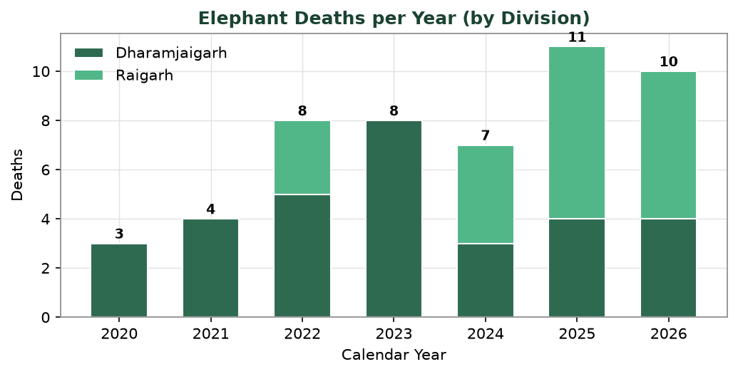
Fig 1 — Elephant deaths per year, by division
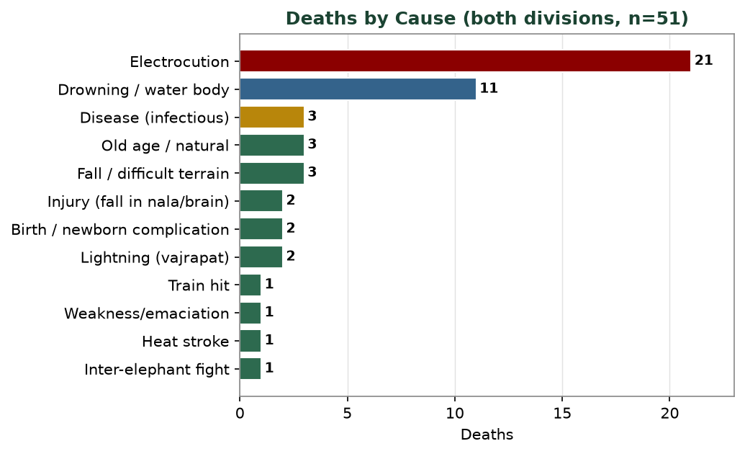
Fig 2 — Deaths by cause (both divisions, n=51)
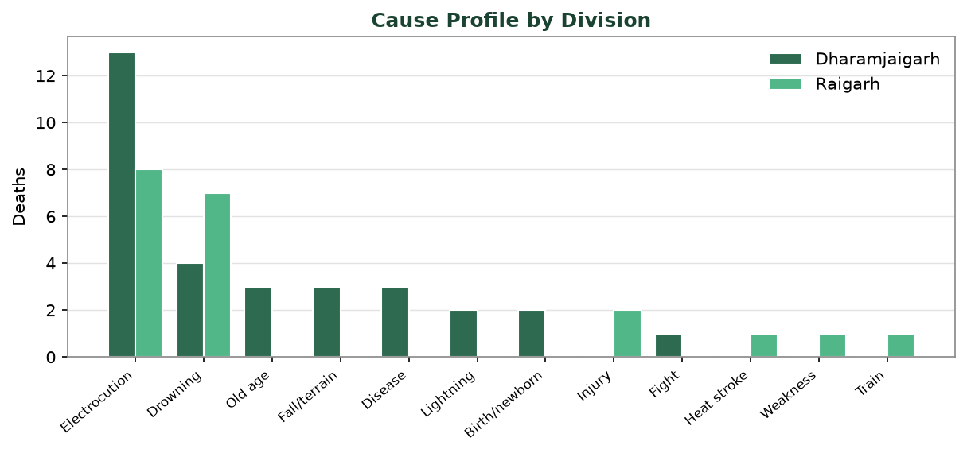
Fig 3 — Cause profile compared across the two divisions
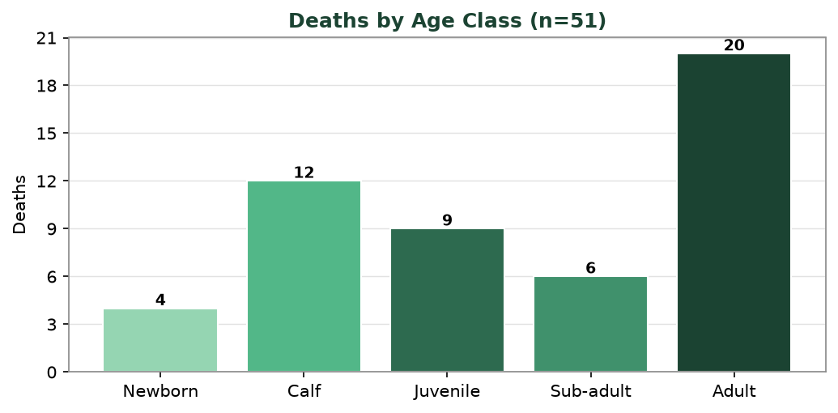
Fig 4 — Deaths by age class
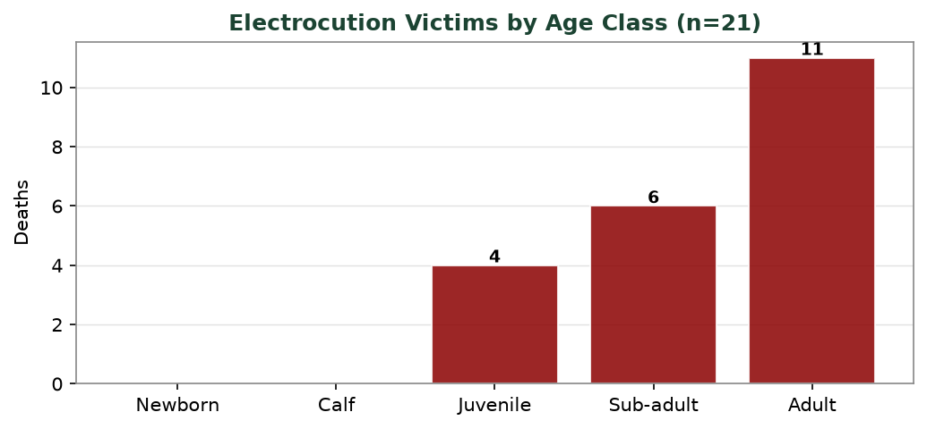
Fig 5 — Electrocution victims by age class
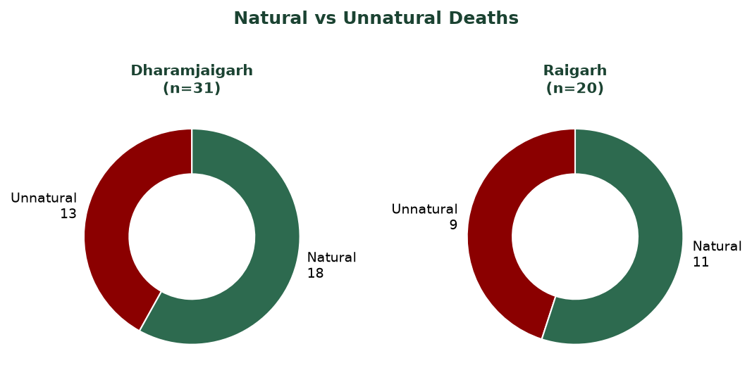
Fig 6 — Natural vs unnatural deaths per division
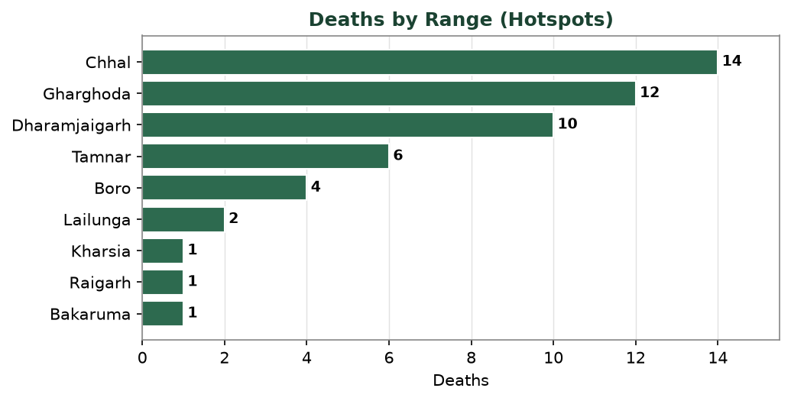
Fig 7 — Range-wise hotspots

5. Data Tables

5.1 Deaths by year & division
Year | Dharamjaigarh | Raigarh | Total
2020 | 3 | 0 | 3
2021 | 4 | 0 | 4
2022 | 5 | 3 | 8
2023 | 8 | 0 | 8
2024 | 3 | 4 | 7
2025 | 4 | 7 | 11
2026 | 4 | 6 | 10
TOTAL | 31 | 20 | 51

5.2 Deaths by cause
Cause group | Dharamjaigarh | Raigarh | Total | %
Electrocution | 13 | 8 | 21 | 41%
Drowning / water body | 4 | 7 | 11 | 22%
Fall / difficult terrain | 3 | 0 | 3 | 6%
Old age / natural | 3 | 0 | 3 | 6%
Disease (infectious) | 3 | 0 | 3 | 6%
Lightning (vajrapat) | 2 | 0 | 2 | 4%
Birth / newborn complication | 2 | 0 | 2 | 4%
Injury (fall in nala/brain) | 0 | 2 | 2 | 4%
Inter-elephant fight | 1 | 0 | 1 | 2%
Heat stroke | 0 | 1 | 1 | 2%
Weakness/emaciation | 0 | 1 | 1 | 2%
Train hit | 0 | 1 | 1 | 2%

6. Recommendations

6.1 Electrocution — joint enforcement & line safety
• Constitute a standing Forest–Electricity Board task force for Chhal, Dharamjaigarh, Boro, Bakaruma (DJH) and Tamnar, Gharghoda (RGH) ranges.
• Audit, insulate/raise or underground sagging 11 kV lines in elephant corridors; enforce statutory ground clearance.
• Detect and dismantle illegal hooked live-wire fences; replace with legal pulsed solar energisers.
• Register FIRs under WPA 1972 (Sec 51) + Electricity Act (Sec 135/161); invoke strict liability of utilities.
• Standardise the enforcement/action column in BOTH divisions' registers.
6.2 Drowning — water-body engineering
• Barricade or fence steep-sided department ponds/dams implicated in deaths (Panikhet, Rabo, Ghoghra, Saraimuda, Amabada, Kera Jharia).
• Provide gentle-slope exit ramps / graded banks so calves can climb out.
• Prioritise Gharghoda and Chhal ranges, where calf drownings cluster.
• Audit all new water structures in elephant-movement zones for calf-safety before commissioning.
6.3 Calf health & disease surveillance
• Activate EEHV / bacterial disease surveillance for calf deaths; collect fresh + fixed tissue for PCR and histopathology.
• Investigate the April–May 2026 Dharamjaigarh calf cluster as a potential outbreak.
• Train field vets in calf-specific necropsy and sampling (this workshop).
6.4 Data & monitoring
• Merge both divisions onto one standardised register (identical fields, fixed cause categories, geo-tag, action column).
• Maintain the accompanying Excel database and update after every mortality.
• Produce an annual division-level mortality analysis for management review.
PRIORITY: Electrocution and calf-drowning together cause two-thirds of all deaths and are almost entirely PREVENTABLE. A Forest–Electricity Board task force on illegal wires and 11 kV sag, plus barricading/ramping of department water bodies in Gharghoda and Chhal ranges, would address the two largest killers directly.

7. Annexure — Full Line-List (n=51)

# | Div | Date | Range | Cause | Nat | Sex | Age | Age class | Act
1 | Dhar | 2020-06-16 | Dharamjaigarh | Electrocution | Unnat | M | 12 | Sub-adult | Y
2 | Dhar | 2020-06-18 | Chhal | Electrocution | Unnat | M | 37 | Adult | Y
3 | Dhar | 2020-09-23 | Dharamjaigarh | Electrocution | Unnat | M | 30 | Adult | Y
4 | Dhar | 2021-03-29 | Boro | Fall | Natur | M | 18 | Adult | —
5 | Dhar | 2021-06-22 | Chhal | Electrocution | Unnat | F | 15 | Sub-adult | Y
6 | Dhar | 2021-08-14 | Boro | Old age | Natur | F | 52 | Adult | —
7 | Dhar | 2021-08-22 | Dharamjaigarh | Electrocution | Unnat | M | 16 | Adult | Y
8 | Dhar | 2022-02-04 | Lailunga | Fall | Natur | F | 42 | Adult | —
9 | Dhar | 2022-07-31 | Chhal | Lightning | Natur | M | 41 | Adult | —
10 | Dhar | 2022-09-26 | Bakaruma | Lightning | Natur | F | 45 | Adult | —
11 | Dhar | 2022-10-14 | Chhal | Electrocution | Unnat | M | 20 | Adult | Y
12 | Dhar | 2022-11-22 | Dharamjaigarh | Fall | Natur | M | 62 | Adult | —
13 | Dhar | 2023-01-10 | Dharamjaigarh | Electrocution | Unnat | M | 75 | Adult | Y
14 | Dhar | 2023-02-04 | Dharamjaigarh | Old age | Natur | F | 75 | Adult | —
15 | Dhar | 2023-04-17 | Chhal | Electrocution | Unnat | M | 5 | Sub-adult | Y
16 | Dhar | 2023-06-15 | Chhal | Inter-elephant fight | Natur | M | 1 | Juvenile | —
17 | Dhar | 2023-09-10 | Dharamjaigarh | Electrocution | Unnat | M | 45 | Adult | Y
18 | Dhar | 2023-10-11 | Dharamjaigarh | Electrocution | Unnat | M | 50 | Adult | —
19 | Dhar | 2023-10-23 | Chhal | Electrocution | Unnat | F | 42 | Adult | Y
20 | Dhar | 2023-12-20 | Boro | Electrocution | Unnat | M | 15 | Sub-adult | Y
21 | Dhar | 2024-09-03 | Chhal | Birth | Natur | U | 0.0 | Newborn | —
22 | Dhar | 2024-11-17 | Boro | Birth | Natur | U | 0.05 | Newborn | —
23 | Dhar | 2024-11-21 | Chhal | Drowning | Natur | U | 0.05 | Newborn | —
24 | Dhar | 2025-01-21 | Dharamjaigarh | Electrocution | Unnat | M | 10 | Sub-adult | Y
25 | Dhar | 2025-01-31 | Dharamjaigarh | Old age | Natur | M | 60 | Adult | —
26 | Dhar | 2025-03-18 | Chhal | Drowning | Natur | F | — | Calf | —
27 | Dhar | 2025-10-28 | Chhal | Drowning | Natur | F | — | Calf | —
28 | Dhar | 2026-04-22 | Lailunga | Disease | Natur | M | 0.08 | Newborn | —
29 | Dhar | 2026-05-08 | Chhal | Disease | Natur | M | 0.5 | Calf | —
30 | Dhar | 2026-05-11 | Chhal | Disease | Natur | M | 0.46 | Calf | —
31 | Dhar | 2026-05-24 | Chhal | Drowning | Natur | M | 1.75 | Juvenile | —
32 | Raig | 2022-06-12 | Gharghoda | Heat stroke | Natur | U | 0.125 | Calf | —
33 | Raig | 2022-11-20 | Gharghoda | Electrocution | Unnat | F | 11 | Sub-adult | —
34 | Raig | 2022-12-09 | Gharghoda | Electrocution | Unnat | F | 1 | Juvenile | —
35 | Raig | 2024-10-26 | Tamnar | Electrocution | Unnat | F | 2.5 | Juvenile | —
36 | Raig | 2024-10-26 | Tamnar | Electrocution | Unnat | F | 55 | Adult | —
37 | Raig | 2024-10-26 | Tamnar | Electrocution | Unnat | M | 65 | Adult | —
38 | Raig | 2024-12-31 | Gharghoda | Drowning | Natur | M | 2 | Juvenile | —
39 | Raig | 2025-01-14 | Gharghoda | Drowning | Natur | F | 0.2 | Calf | —
40 | Raig | 2025-01-22 | Gharghoda | Drowning | Natur | F | 2 | Juvenile | —
41 | Raig | 2025-05-12 | Gharghoda | Injury | Natur | F | 0.25 | Calf | —
42 | Raig | 2025-05-25 | Gharghoda | Drowning | Natur | M | 0.42 | Calf | —
43 | Raig | 2025-10-20 | Tamnar | Electrocution | Unnat | M | 20 | Adult | —
44 | Raig | 2025-11-25 | Tamnar | Drowning | Natur | M | 0.58 | Calf | —
45 | Raig | 2025-12-20 | Raigarh | Drowning | Natur | M | 0.5 | Calf | —
46 | Raig | 2026-01-28 | Gharghoda | Injury | Natur | M | 1 | Juvenile | —
47 | Raig | 2026-02-21 | Tamnar | Weakness/emaciation | Natur | F | — | Calf | —
48 | Raig | 2026-03-11 | Gharghoda | Electrocution | Unnat | F | 2.5 | Juvenile | —
49 | Raig | 2026-03-11 | Gharghoda | Electrocution | Unnat | M | 2.5 | Juvenile | —
50 | Raig | 2026-06-01 | Kharsia | Drowning | Natur | M | 0.3 | Calf | —
51 | Raig | 2026-06-16 | Gharghoda | Train hit | Unnat | F | 45 | Adult | —

Analytical report compiled from Dharamjaigarh & Raigarh Forest Division death registers · Workshop on Mortality Investigation of Asian Elephant · Raigarh, Chhattisgarh · June 2026

