MONGO DB (NoSQL)

Source: <https://www.javamadesoeasy.com/>

MONGO DB Installation

**********************

**1. Install the msi file from MongoDB official website for windows.**

**2. Run the Installer File.**

**3. Create a "data\db" under "C:\Program Files\MongoDB"**

**4. Open cmd prompt and go to Bin location**

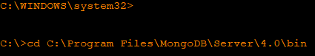

**5. Set the DB path and Log path (Service Creation).**

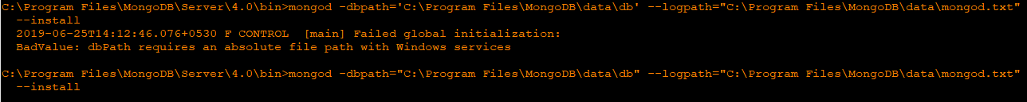

**6. Start Service**



More help is available by typing NET HELPMSG 2182.

**7. Start Mongo Session**

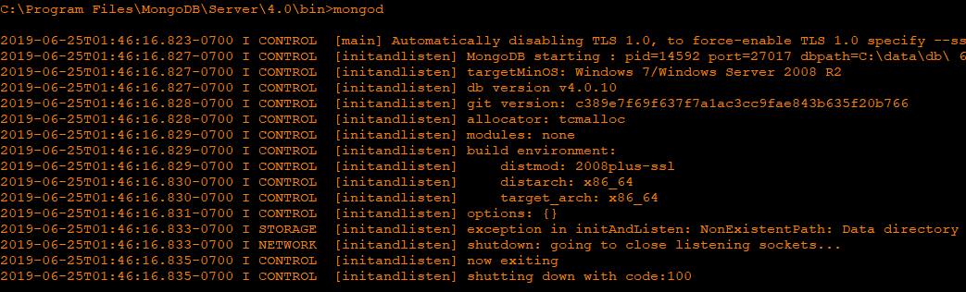

C:\Program Files\MongoDB\Server\4.0\bin>

**8. Open another cmd prompt and go to bin directory and start Mongo**



**Commands:**

* **List of Databases:**

Show dbs | show databases | db.getMongo.getDBNames ()

* **Create database if not present else Switch to database:**

Use mydb

* **Drop a database:**

Switch to DB wish to drop the >>db.dropdatabase ()

* [**Create new collection(table) in mongo DB**](https://www.javamadesoeasy.com/2017/02/create-new-collectiontable-in-mongodb.html)

db.createCollection (“employeeTable”)

* **See All Collection in DB:**

Show collections | show tables | db.getCollectionNames ()

* **DROP Collection in DB:**

db.employeeTable.drop ()

**Example:**

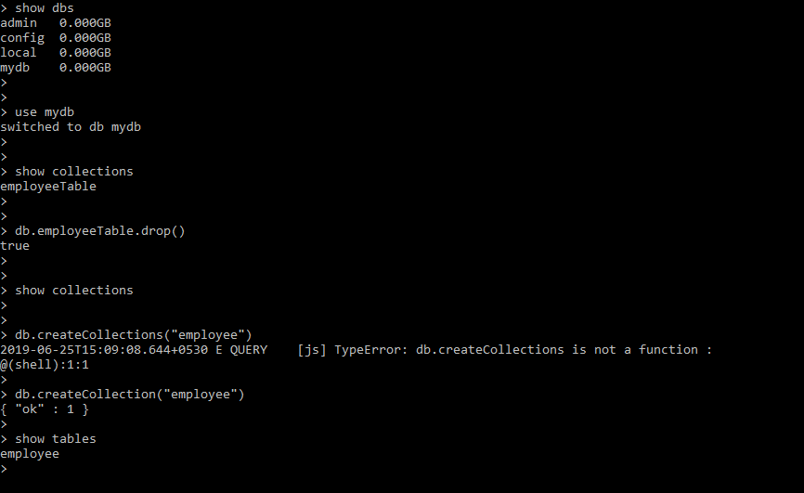

### CRUD Operation in MONGO DB: (Create, Read, Update and Delete)

### Inserting Data into Collection:

### db.collection_name.insert({key1:value1,key2:value2,…})

### 

### Read:

### db.collection_name.find()

### 

### db.collection_name.find().pretty()

### 