**Git:**

**Version Control System**: Tool that help to track changes in code.

* Track the history
* Collaboration of code with team

Website the allows developer store and manage their code using git.

* Created new repository manul
* Make our first commit

**Setting up Git**

* Window (git bash)
* Visual studio code
* Mac (terminal)

**Configuring Git**

**git config --global user.name ”my-name”**

**git config –global user.email “**[**ashish@gmail.com**](mailto:ashish@gmail.com)**”**

**git config --list**

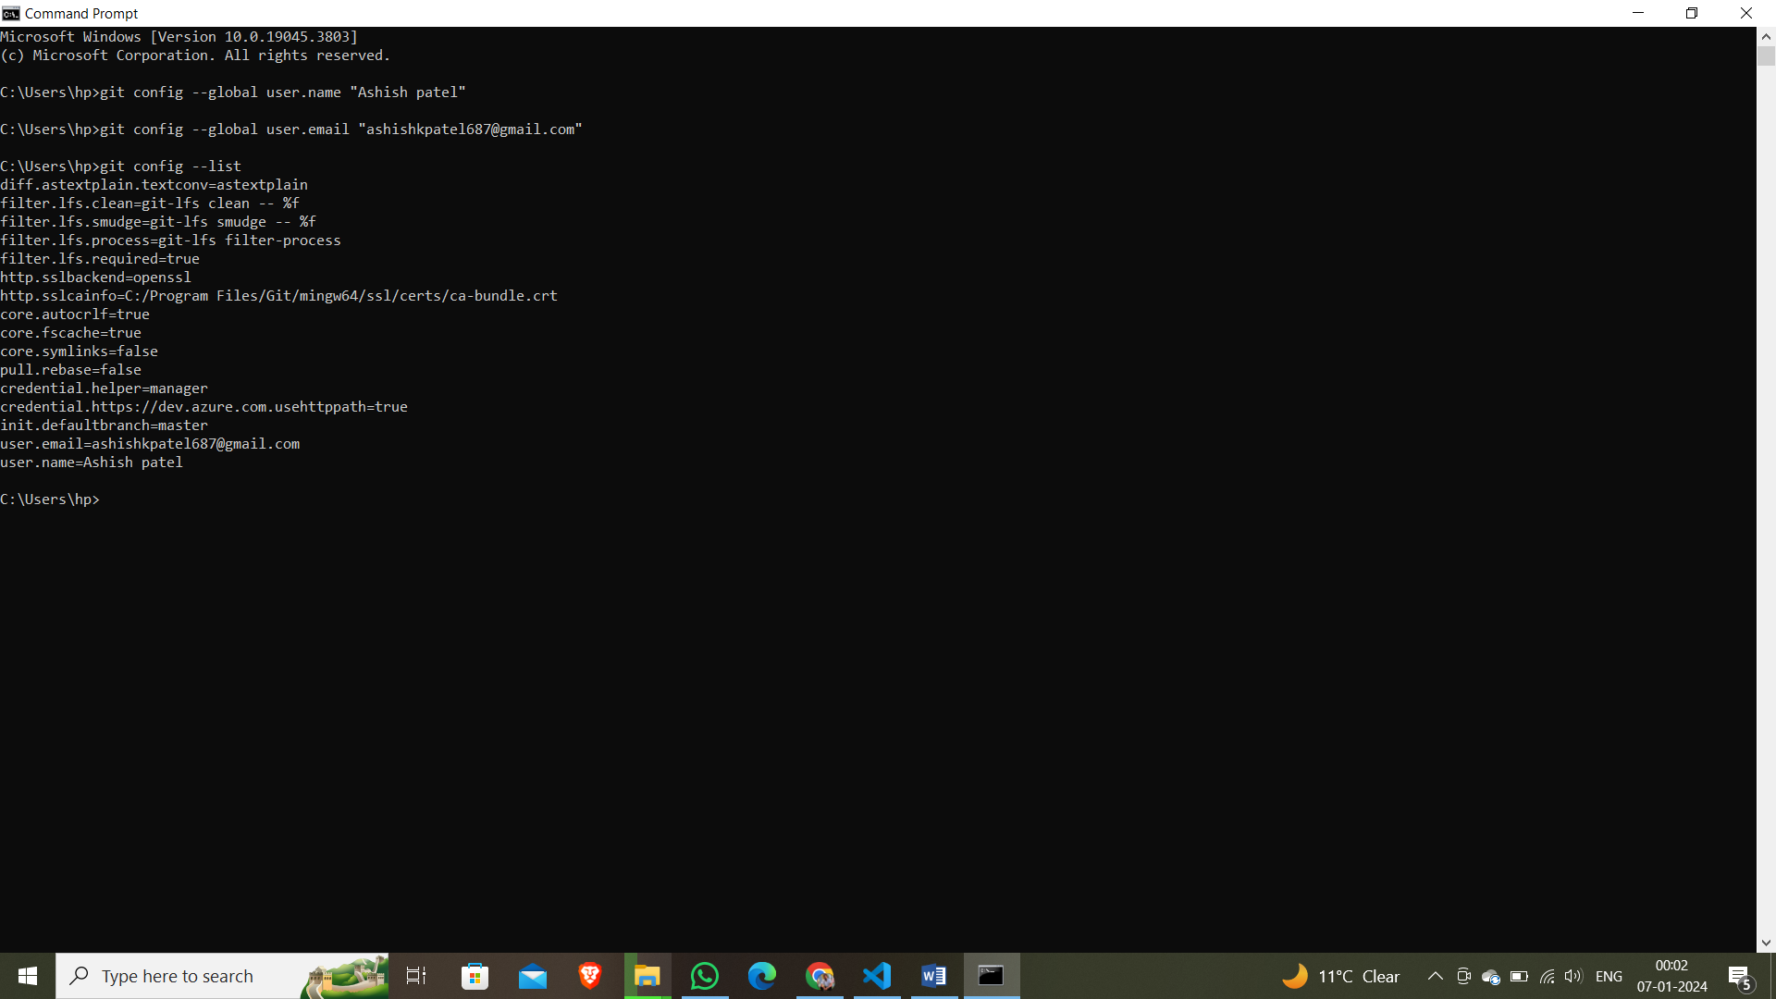

**Clone and Status**

**Clone:** Cloning a rep on our local machine or system. Remote(github), local(laptop or pc)

* git clone <some link> (https://github.com/ashishkpat/git-course-file.git)

Status: Display the status of code

* git status