SkillSyncAI

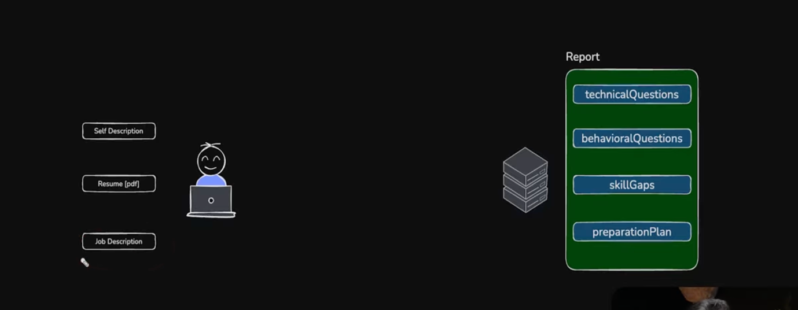

ZOD validation
Multer – For reading the file like pdf
Pdf-parse -> For reading the content of the data of the pdf
Puppeteer -> This package converts the HTML to pdf

FRONTEND (UI-HOOK-STATE-API)
pages(Interview.jsx) -> services(interview.api.js) -> interview.context.jsx -> hooks(useInterview.js) -> pages(Home.jsx)

Page → Hook → Context → API Service → Backend
🔐 Auth Feature
Page → Hook → Context → API Service → Backend
Login.jsx useAuth.js auth.context.jsx auth.api.js localhost:3000
Register.jsx

🎯 Interview Feature
Page → Hook → Context → API Service → Backend
Home.jsx useInterview.js interview.context.jsx interview.api.js localhost:3000
Interview.jsx

✅ All Missing Features Implemented
🔧 Backend Changes
Change | File(s)
Global error handler | src/app.js
Rate limiting — 10 req/15min on auth, 5 req/10min on report generation | src/middlewares/rateLimit.middleware.js (new)
Input validation — express-validator on register, login, jobDescription | src/middlewares/validation.middleware.js (new), routes
Optional resume — no crash if no file uploaded | src/controllers/interview.controller.js
Ownership fix on PDF — users can only generate PDF for their own reports | src/controllers/interview.controller.js
Delete report endpoint — DELETE /api/interview/:interviewId | src/routes/interview.routes.js, controller
Update profile endpoint — PUT /api/auth/update-profile (username, email, password) | src/routes/auth.routes.js,  auth.controller.js
try/catch on all controllers | Both controllers
🎨 Frontend Changes
Change | File(s)
Toast notifications — success/error on every action | src/features/shared/ToastProvider.jsx (new)
Proper error propagation — axios interceptors extract backend messages | auth.api.js,  interview.api.js
Live char counter — updates as you type, warns at 90% | Home.jsx,  home.scss
File name display — shows selected file name with green ✅ | Home.jsx
Empty state — "No plans yet" UI when no reports | Home.jsx,  home.scss
Delete report button — per-card with spinner feedback | Home.jsx,  home.scss,  useInterview.js
Profile / Settings page — update username, email, password + logout | Profile.jsx (new),  profile.scss (new)
User avatar in header → links to /profile | Home.jsx,  Interview.jsx
Logout button on Profile page | Profile.jsx
Dynamic match score label — 4 tiers ("Strong", "Good", "Moderate", "Stretch") | Interview.jsx
Back button → returns to All Plans from Interview page | Interview.jsx
Loading spinners replacing raw <h1>Loading…</h1> | All pages
Generate button disabled when jobDescription is empty | Home.jsx
/profile route added | app.routes.jsx

