**Steps to generate a new .jks file:-**

1. Enter this command in CMD -   
keytool -genkey -v -keystore "C:\Users\krash\OneDrive\Desktop\Flutter\mykey.jks" -storetype JKS -keyalg RSA -keysize 2048 -validity 10000 -alias androiddebugkey

2. Enter the password – “**flutter**” (in my case)   
  
3. It will again ask to enter the password. Enter key password for <androiddebugkey>.

keep it “**flutter**” only.

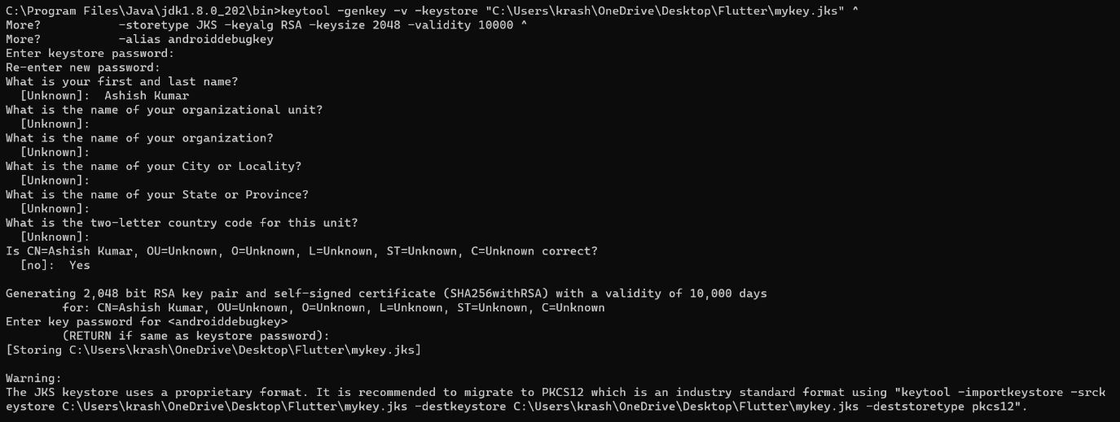

With this mykey.jks file will be generated on the desktop.

**Steps to generate SHA-1 key from the mykey.jks file which was generated above: -**

1. Enter this command in CMD -   
   keytool -list -v -keystore "C:\Users\krash\OneDrive\Desktop\Flutter\mykey.jks" -alias androiddebugkey -storepass flutter -keypass flutter

storePass & keyPass = “flutter”   
  
With this SHA1 key will be generated.