**ANSIBLE PATCH INSTALLER**

**PRE-REQUISITES FOR APPLICATION**

* Ansible can be run from any machine with Python v3.x installed (Windows is not supported for the control machine).This includes Red Hat, Debian, CentOS, OS X, any of the BSDs, and so on.
* For PreTUPSAnsible Installer to run successfully, Ansible Version 2.2.0.0 must be installed on Control machine. PreTUPSAnsible Installer may not support Ansible versions prior to this.
* Direct Access (Open-SSH) with all PreTUPS's instances from Ansible machine.
* parmiko-ssh to connect remote machines, where Open-SSH is obsolete.
* On the host machines, you only need Python v3.x or later, but if you are running less than Python 2.6, you also need python-simplejson.

**PRE-REQUISITES FOR DATABASE:**

**Oracle:**

* Oracle is installed.
* .bash_profile content is copied to the .bashrc file of oracle user.
* .bash profile parameters ORACLE_HOSTNAME ,ORACLE_BASE and ORACLE_HOME should be present in .bashrc file.

**Postgres:**

* Postgres is installed.
* .bash_profile content is copied to the .bashrc file of postgres user.

**STEPS FOR PRETUPS INSTALLATION:**

* Open the ***/etc/hosts*** file on the control machine.

Mention as many unique <IP><hostname> combinations as the number of Tomcat to be shipped on each host machine.

Sample:

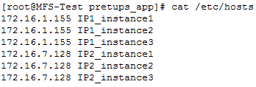

Example:

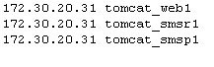

Save and close the file.

* Open the ***hosts*** file.

Enter instance_name mentioned in /etc/hosts according to their group like this :

Under [webservers] group mention the instance_name for WEB instance

Under [smsrservers] group mention the instance_name for SMSR instance

Under [smspservers] group mention the insance_name for SMSP group

Example:

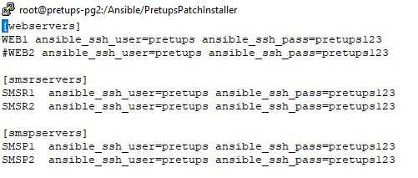

* All patches that need to be patched must be shipped to the **PretupsPatchInstaller/files** folder.
* Navigate to the ***host_vars*** directory.

Copy the existing WEB*.yml*file to create as many variable files as the number of WEB instances, with file name as *<hostname>.yml*, where *<hostname>* is the hostname defined in the */etc/hosts* file and same defined in “hosts” file

**Sample**: *IP1_instance1.yml*, *IP1_instance2.yml ….*

Example :cpWEB.yml tomcat_web1.yml

cpWEB.yml tomcat_web2.yml

Similarly, for SMSR Copy the existing “SMSR*.yml”* file to create as many variable files as the number of SMSR instances, with file name as *<hostname>.yml*, where *<hostname>* is the hostname defined in the */etc/hosts* file and same defined in “hosts” file

Example :cpSMSR.yml tomcat_smsr1.yml

cpSMSR.yml tomcat_smsr2.yml

And again for SMSP, Copy the existing “SMSP*.yml”* file to create as many variable files as the number of SMSP instances, with file name as *<hostname>.yml*, where *<hostname>* is the hostname defined in the */etc/hosts* file and same defined in “hosts” file

Example :cpSMSP.yml tomcat_smsp1.yml

cpSMSP.yml tomcat_smsp2.yml

* Open each variable file created in above step and modify the value of variables. For help regarding variables open attached file in notepad++.

Refer **Readme.md** for each variable in the mentioned variable files.

# 







* Save and close each variable file.
* Use Below Commands For Patch Installaltion :

**WEB**

**ansible-playbook -i hosts installPatchWEB.yml –vvvv**

**SMSP**

**ansible-playbook -i hosts installPatchSMSP.yml –vvvv**

**SMSR**

**ansible-playbook -i hosts installPatchSMSR.yml –vvvv**

* Use Below Command For Patch RollBack

**ansible-playbook -i hosts rollbackPatch.yml -vvvv**

**STEPS FOR DATABSE (ORACLE / POSTGRES)INSTALLATION:**

* Open the ***/etc/hosts*** file on the control machine.

Mention as many unique <IP>combinations as the number of dbservers.

Save and close the file.

* Open the ***hosts*** file.

Under [dbservers] group mention the insance_name for DB_SERVERS group

Example:

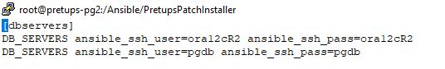

* All DDL/DML scripts that need to be executed must be shipped to the **PretupsPatchInstaller/files** folder.
* Navigate to the ***host_vars*** directory.

Copy the existing DB_SERVERS*.yml*file to create as many variable files as the number of DB_SERVERSinstances, with file name as *<hostname>.yml*, where *<hostname>* is the hostname defined in the */etc/hosts* file and same defined in “hosts” file

* Open each variable file created in above step and modify the value of variables. For help regarding variables open attached file in notepad++.

Refer **Readme.md** for each variable in the mentioned variable files.

# 



* Save and close each variable file.
* Use Below Commands For Patch Installaltion :

**DB_SERVERS**

**ansible-playbook -i hostsinstallDBPatch.yml –vvvv**

* Use Below Command For Patch RollBack

**ansible-playbook-i hosts rollbackPatch.yml -vvvv**