

**Pretups Mobile Application**

Widget and Plug-in functionalities Document

Document Version: 1.0

Contents

Introduction 1

1.1. Overview 1

1.2. Objective and Scope 1

Widgets 2

1.3. Widget list 2

1.4. Registration 2

1.5. Recharge 2

1.6. CardManagement 3

1.7. ChangePin 3

1.8. Xml request/response 3

1.9. Common 3

Retailer widget 3

AESPlugin 3

Widget javascript-API’s 4

1.10. Widget function 4

1.11. Persistence storage 5

1.12. Keyword 5

1.13. Type of inputTags 6

1.14. Calling functions from widget to widget 7

1.15. CustomCDR 7

Configuration 8

1.16. ServiceConfiguration 8

1.17. PinConfiguration And MaxLenth 8

1.18. Server Details Configuration 8

CDR Entries 9

uxDesign 9

1.19. Login and signUp 9

1.20. AddCard 9

1.21. EditCard 9

1.22. DeleteCard 9

1.23. AddBuddy 9

1.24. EditBuddy 9

1.25. DeleteBuddy 9

1.26. Self Recharge with SavedCard 9

1.27. Self Recharge with Adhoc 9

1.28. Recharge to Someone with P2P 9

1.29. Recharge to Someone with SavedCard 10

1.30. Recharge to Someone with Adhoc 10

1.31. TalkMeUp(Ask a friend for Recharge) 10

1.32. SOS(Fast Recharge) 10

1.33. Change PIN 10

New Features Added 10

1.34. Subscriber(Self) Cash Recharge with QR Generation 10

1.35. Subscriber(some one else) Cash Recharge with QR Generation 10

1.36. Recharge Requests 10

1.37. VoucherQR Recharge 11

1.38. FAQ 11

1.39. LogOut 11

Introduction

## Overview

WebAxn is the mobile application framework that enables development and deployment of services across a range of handsets from high-end smartphones to feature phone like J2ME.

Pretups mobile application is developed using WebAxn mobile application framework. It will enable the distributor and retailer to access the pretups function from the mobile application.

## Objective and Scope

The objective of this document is to provide a feature design of Pretups Mobile Application using WebAxn Mobile application framework.

Widgets

## Widget list

The below table can give detail of widgets used for subscriber pretups App.

|  |  |  |
| --- | --- | --- |
| **WIDGET ID** | **WIDGET NAME** | **DESCRIPTION** |
| 913980753 | Registration | Registration, Buddy management,SOS pages |
| 264711061 | Recharge | All Types of Recharge pages |
| 251238406 | Card Management | Card Related pages |
| 252267641 | ChangePIn | ChangePin pages |
| 950181717 | Xml Request/Response | This Widget handled All request/response |
| 214807648 | Common | Css,images |

The below table can give detail of widgets used for Retailer pretups App.

|  |  |  |
| --- | --- | --- |
| **WIDGET ID** | **WIDGET NAME** | **DESCRIPTION** |
| 121929525 | Bill payment | Bill payment pages and transaction |
| 158106024 | Common | Css,images |
| 179878594 | Pretups | Registration,main pages |
| 189153428 | changePin | changePin pages and transaction |
| 194232707 | giftRecharge | giftRecharnge page and transaction |
| 194750352 | Reports | Last 5 trans,daily report,balance enq |
| 203139478 | transfer | Transfer page and transaction |
| 914499429 | Returnstock | Returnstock page and transaction |
| 979446865 | Recharge | Recharge Page and transaction |

## Registration

* Registration pages implemented with help of Registration widget .
* In this widget we can set globally maxlength of each and every input field and Utility function also available.

Flow: User can entire require inputs for registration through MobileApp.Mobile App sends those inputs to pretups server for registration.pretups server validating sends smspin to registered user. user can change pin with smspin.After success change pin user can do pretups provided transactions.

## Recharge

* Recharge pages implemented with help of Recharge widget.
* We can do P2P,rechargewithRegistercard,adhoc recharge transactions.
* Self Recharge : User can do self recharge with register Card
* Recharge Another : User can do recharge another with help of register card and his own account(P2P).
* talkmeUp: User can ask for recharge to friends
* Adhoc Recharge : User can do recharge directly with adhoc

## Card Management

* Card pages implemented with help of card widget.
* Addcard,editcard,viewcard,deletecard transaction can do with cardManagement widget.

## Change Pin

* Changepin pages and transaction can do with help of chagepin widget.

## Xml request / response

* All request and response handled with AJAX call .
* Every financial/nonfinancial request is send to pretups server and gets response .

## Common

* Image and css configuration.
* This widget can identify request come from which device and which flatform. Based on device and flatform it automatically apply css and logos.

Retailer widget

Retailer App:

* Totally nine widgets using for Retailer App. Eight widget for services and one widget for css and image files.
* Each and every service(Registration, Recharge, billpayment, giftRecharge, reports, returnstock, changepin, transfer) using one widget..

Sever details can configure service wise. Each and every service having separate property file. Server details can configure those property file.

Path : Login : 179878594/1.0/widget.prop

Recharge : 179878594/1.0/widget.prop

AESPlugin

* Pretups App sends every request to pretups server with encrypted format.
* AESPlugin can do every request as encryption.

Flow: At time of Registration pretups server sends Encryption key as response with help of that key Pretups MobileApp encrypting every request then send to pretups server.

Except registration request every request will be encrypted.

Widget javascript-API’s

Webaxn server provided some specific function for widgets. the below functions are used by pretups MobileApp.

## Widget function

* **1. Widget.fetchScreenWidth()** **:** It specifies screenwidth of the device.
* **2.widget.fetchScreenHeight():** It specifies screenHeight of the device.
* **3.widget.clientVersion() :** It specifies version no of the app.
* **4.widget.fetchUserAgent() :** It specifies deviceModel either android/iphone/j2me.
* **5.widget.getHeader(“IMEI”):** it specifies get device IMEI number. If mobile having two IMEI number .it always takes first IMEI number.
* **6.-widget.getHeader(“DENSITY”):** it specifies device dpi;Based on the dpi we can decide mobile category either small/medium/high.
* **7.widget.resourcepath :** It specifies path; once path will be set .it will be applicable to all the widgets with in the group.

## Persistence storage

**1.StoreUserData** : Any variable can store using this function with key value (String key, String value)pair. This value will stored in persistence storage.

Syntax : widget.storeUserData(var key,var value);

Ex : widget.storeUserData(“name”,”comviva”);

Note:This value will be stored until reinstalling the app and clear data in the app.

**2.clearUserData :** persistence storage variable can be clean/delete with this function.

Syntax : widget.clearUserData(var key);

Ex: widget.clearUserData(“name”);

**3.retrieveUserData :** persistence storage variable can be retrieve any where with in the widget.

Syntax: widget.retrieveUserData(var key);

Ex: widget.retrieveUserData(“name”);

**4.widgetRetrieverUserData :** persistence storage variable can be retrieve any where with in the group widgets.

Syntax: widget.retrieveWidgetUserData(var key);

Ex: widget.retrieveUserData(“name”);

**4.widgetsecureUserData :** persistence storage variable can be be store as encrypt format in webaxn db.

Syntax: widget.storeSecuretUserData(var key, var value);

Ex: widget.storeSecureUserData(“name”,”comviva”);

## Keyword

Webaxn server provided some specific keywords.These key words handled by widgets. below can see brief explanation of these key words

**1.c3lmenu** : HTML pages can split into multiple pages using this keyword

Page can be show or hide using this keyword.

Pageshow : style.display = “block”;

Page Hide :style.display = “none”;

Note: at any point of time display only one c3lMenu can be in display=”block ” state

**2.c3lmenuGroup:** Group variable object combine on the page using this keyword

**3.c3ltitle :** with in the page some specific code can show on the top.it should not scroll if page will increase/decrease.

**4.c3lNavigation :** with in the page some specific code can show on the bottom.it should not scroll if page will increase/decrease.

**5.c3ltoggle:** we can show/hide some specific code.

## Type of inputTags

1. Text : if can give type=’text’ in inputfied.its take alphanumeric values.

Ex: <input id=’name’ name=’name’ type=’text’/ >

1. Numeric: if can give type= “numeric” in input filed .its takes only numbers

Ex: <input id=’num’ name=’num’ type=’numeric’/ >

1. Password: if can give type=’password in input filed .its takes alphanumeric with masking

Ex: <input id=’num’ name=’num’ type=’password’/ >

1. Numpassword: if can give type=’numpassword in input filed .it accept only numeric with masking.

Ex: <input id=’num’ name=’num’ type=’numpassword’/ >

1. Mobileno: if can give type=’mobileno’ in input filed . mobile number can fetch from mobile contacts.

Ex: <input id=’num’ name=’num’ type=’mobileno’/ >

1. Readonly: this is attribute of input filed.if give this attribute in input filed. we cant write and edit in this filed.

Ex: <input id=’num’ name=’num’ type=’password’ readonly/ >

1. Title : tilte is attribute of input filed.

Ex: <input id=’num’ name=’num’ type=’password’ title=’password’/ >

1. Maxlength : maxLenght is attribute of inputfield.

Ex: <input id=’num’ name=’num’ type=’password’ maxLength=’10’/ >

1. Emptyok : emptyok is the attribute of input filed.user should enter any value if emptyok=’false’ .

Ex: <input id=’num’ name=’num’ type=’numeric’ emptyok=’false’/ >

1. Valign : valign is attribute for input,anchor,button,span, it having three categorys
2. Top : if give valign=’top’ .it will align top of particular text or image
3. Bottom: if give valign = ‘bottom’ it will align bottom of particular text or image
4. Middle : if give valign=’middle’ it will align center of particular text or image

Ex: 1.<span valign=’top’>comviva</span>

2.<span valign=’middle’>comviva</span>

3.<span valign=’bottom’>comviva</span>

Ex: 1.<img src=’text.png’ valign=’top’></img>

2. <img src=’text.png’ valign=’bottom’></img>

3. <img src=’text.png’ valign=’middle’></img>

## Calling functions from widget to widget

Calling functions from one widget to another widget with help of wgt and also use widow.location.

Syntax: 1. wgt:<widgetId>/1.0 :- It will call onload function.

2.wgt:<widgetId>/1.0 :- <function name>: it will call particular function.

Ex: 1.<a href=’wgt:264711061/1.0’>Home</a> . it will call onload function of that widget.

2.<a href =’wgt:264711061/1.0:homeFun()’>home</a> it will call one of the function of the widget.

**Window.location:**

Syntax: window.location = “<calling function>”;

Ex: 1. window.location = “wgt:264711061/1.0:”;

2. window.location = “wgt:264711061/1.0:homeFun()”;

## CustomCDR

Webaxn provided common file for all App’s CDR logs.

If we want separate file need to custom ise CDR. Following steps for CustomCDR given below.

Steps

1. Create a object of CDR with arguments of filename and separator.

syntax: var cdr = new CDR(<filename>,<separator>);

1. Add eachItem with addItem method.

syntax: cdr.addItem(<itemname>);

ex: var cdr = new CDR(“pretups”,”|”);

cdr.addItem(new Date());

Configuration

## ServiceConfiguration

One or group of services can configure.

Configuration services can see below:

1.P2P RECHARGE : one service configuration.

2.ADHOC RECHARGE : onc service configuration.

3.SOS RECHARGE : one service configuration.

4.BUDDY MANAGEMENT : group of services configuration.

5.CARD MANAGEMENT : group of services configuration.

The above services should be configure with help of **true/false**.

Path: 913980753/1.0/configuration.js

And also utility function available in below path.

Path: 913980753/1.0/util.js

## PinConfiguration And MaxLenth

pin can be configure All services or All financial services or All non-financial services or each service and also set maxlength every input filed.

1. PIN : Pin can be configure either **true/false**. If configure true User have to enter Registered PIN every transactions . If false not required to enter PIN.
2. MaxLength : maxlenghth can configure All input fields.

Path : 913980753/1.0/ configuration.js.

## Server Details Configuration

Server details and all services TYPE tag value can configure.

1. ServerDetails: server ip,port ,request_gateway_code,request_gateway_type,Login,password,souceType,service_port these details can configure in server config file.

Path: 913980753/1.0/configuration.js

1. All service TYPE tag values can configure.

Path : 913980753/1.0/ configuration.js.

1. App related strings are available at one common file

Path : 913980753/1.0/strings.js

CDR Entries

All the communication between the mobile application and WebAxn Server are captured in the CDR’s.



uxDesign

## Login and signUp

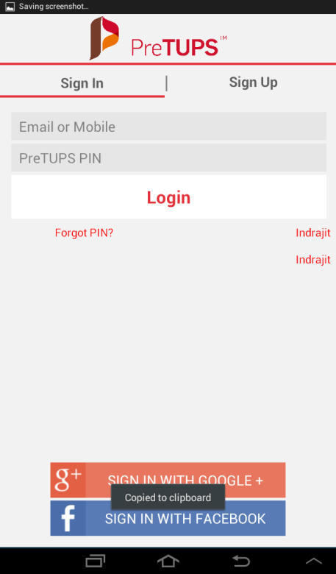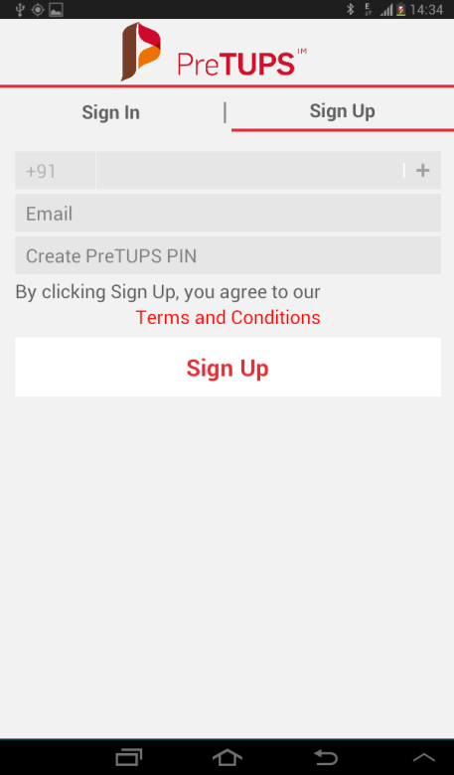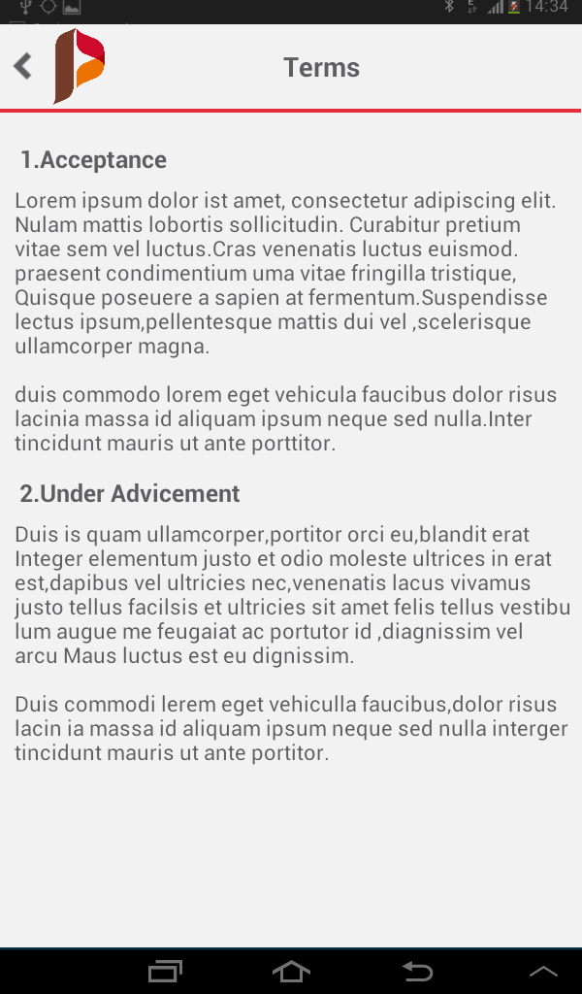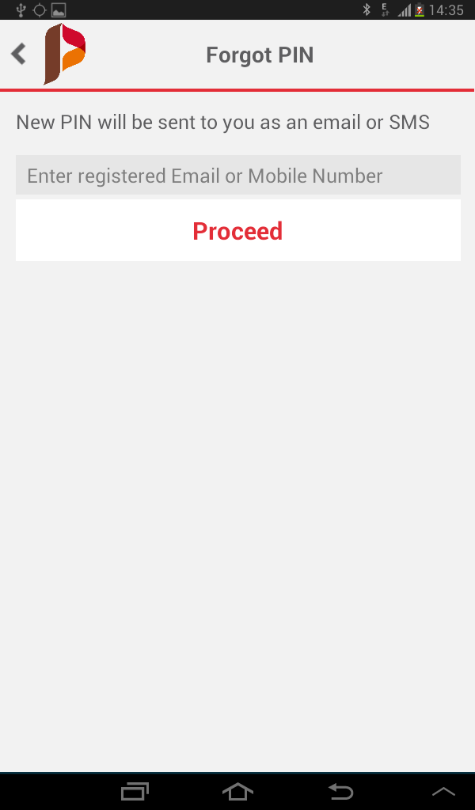

## Login Google

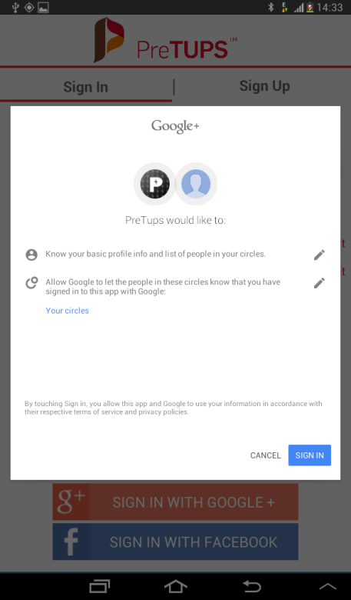

## AddCard

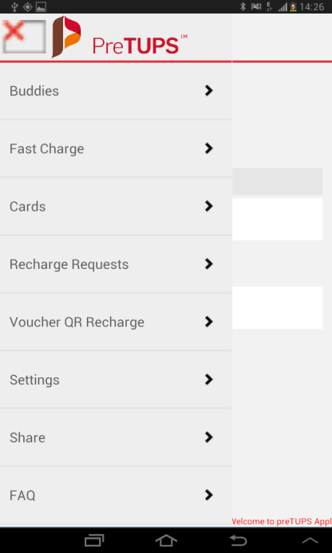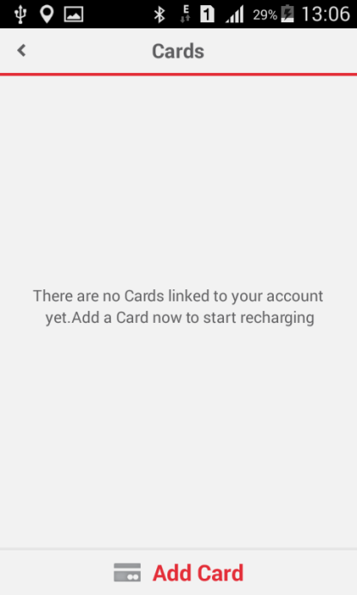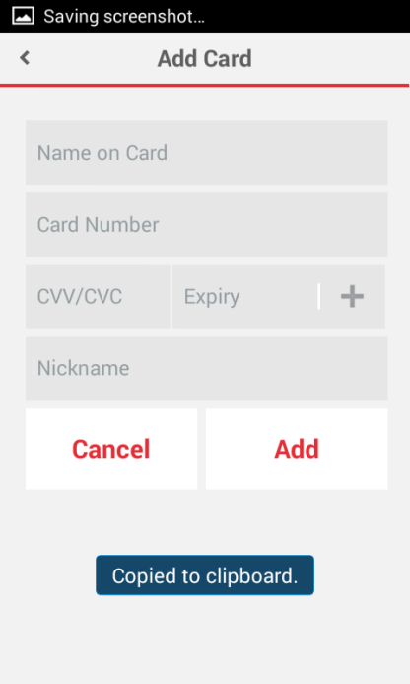 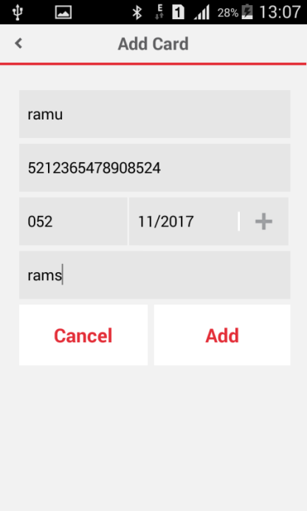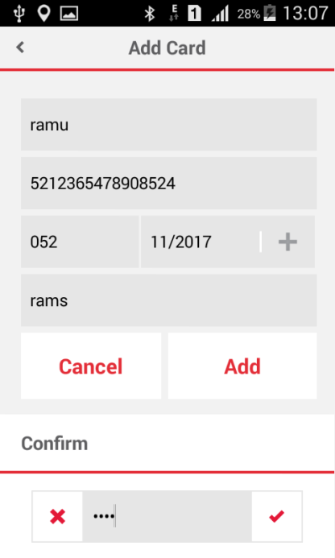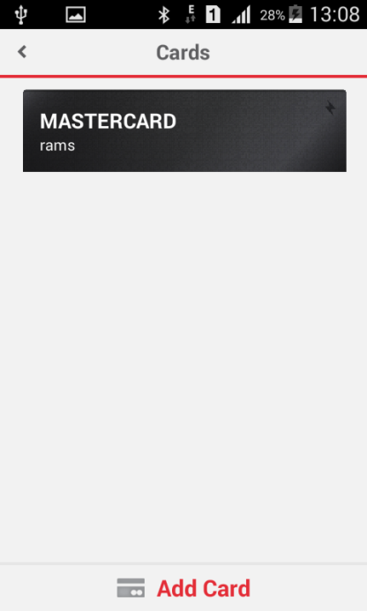 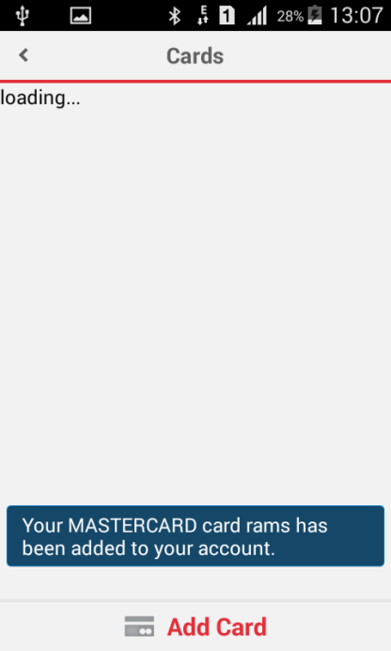

## EditCard

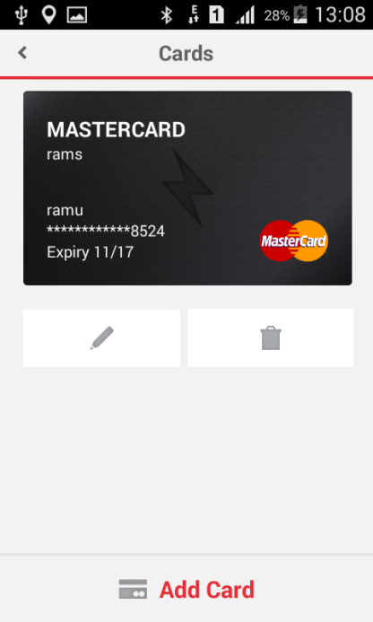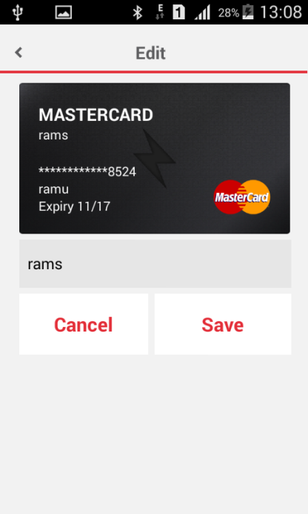

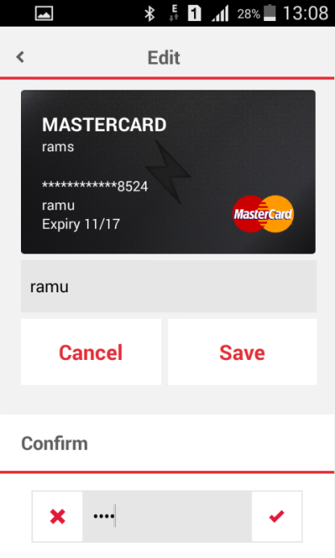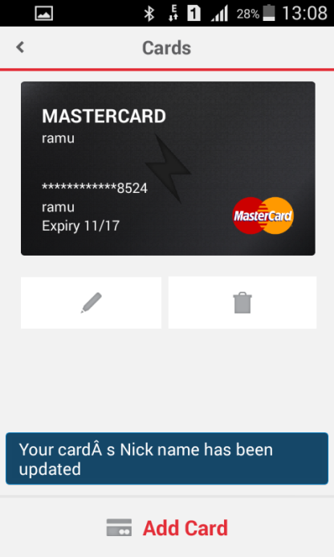

## DeleteCard

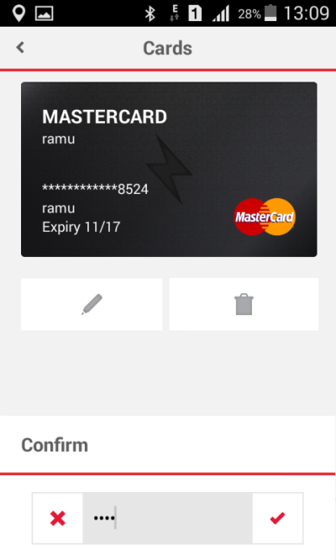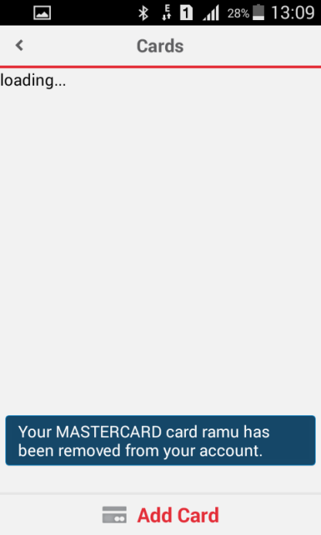

## AddBuddy

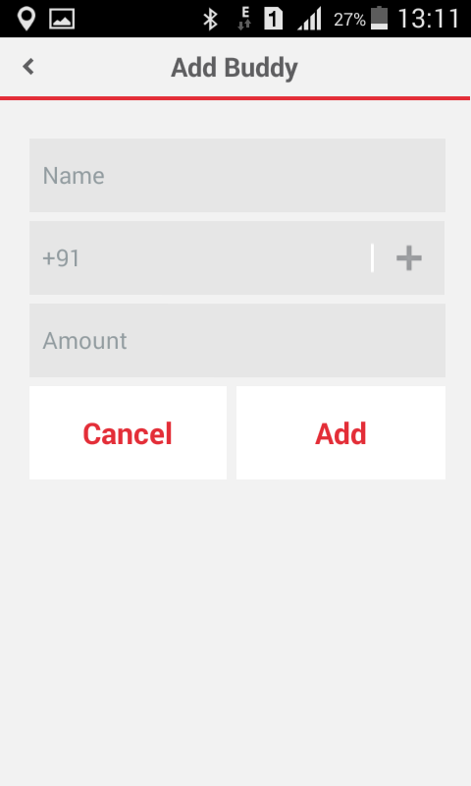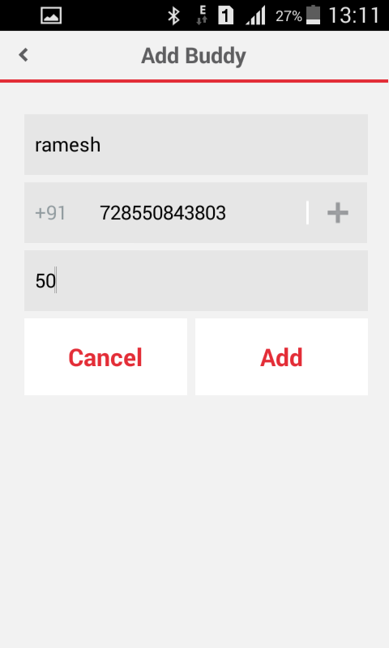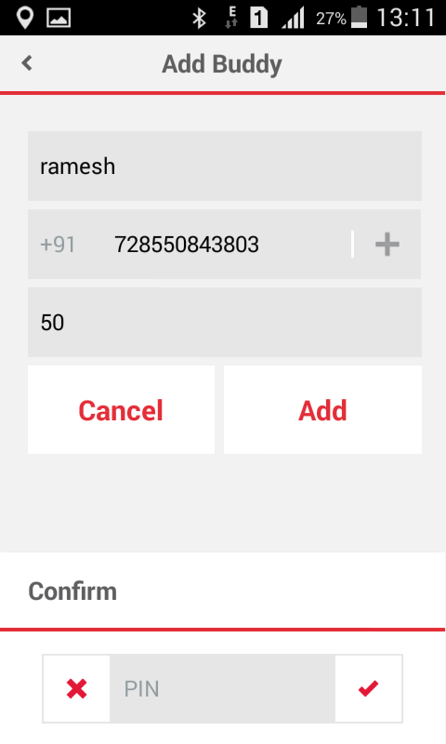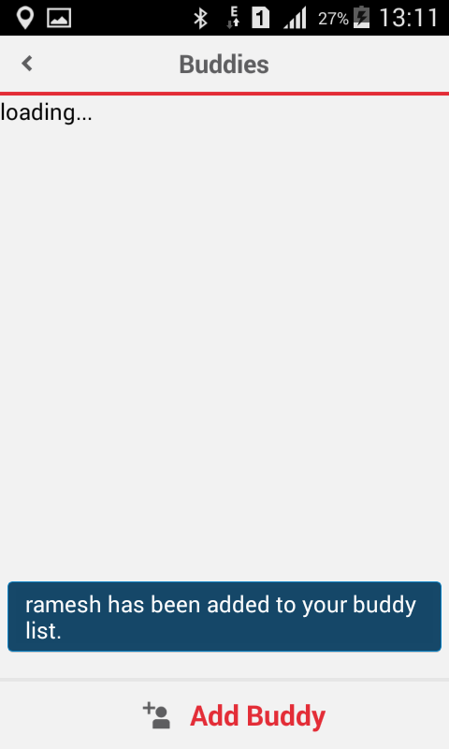

## EditBuddy

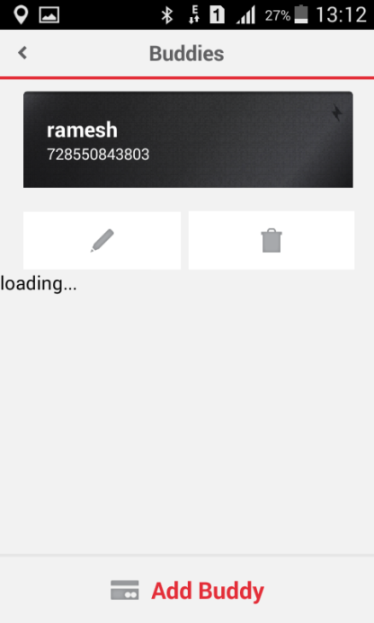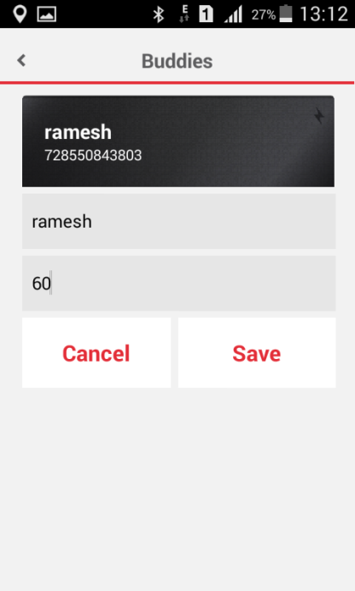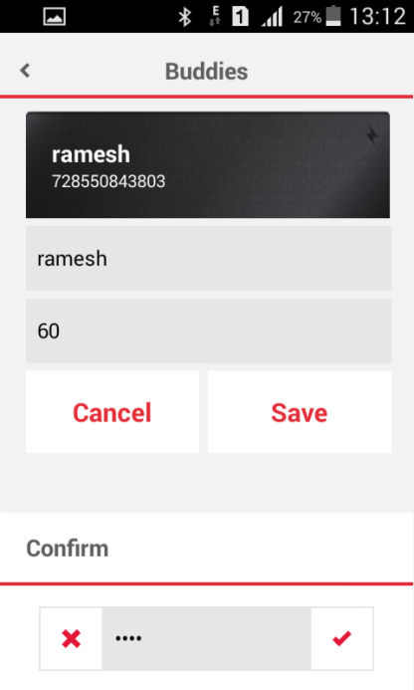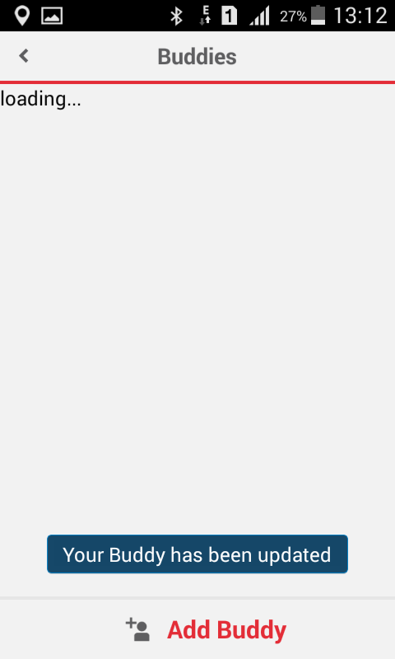

## DeleteBuddy

 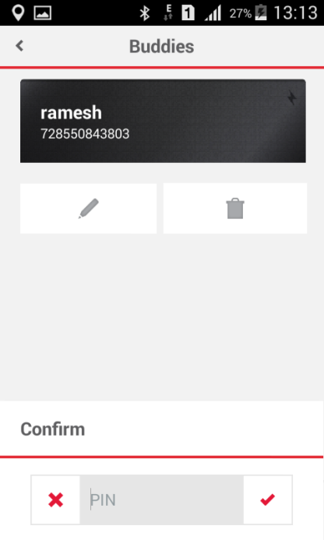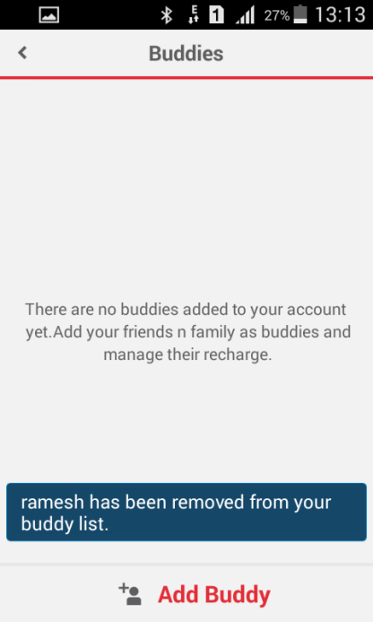

## BuddyRecharge

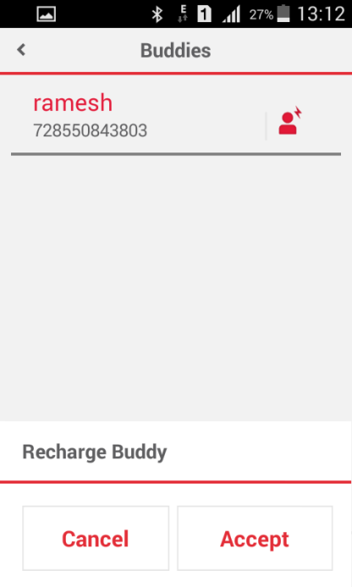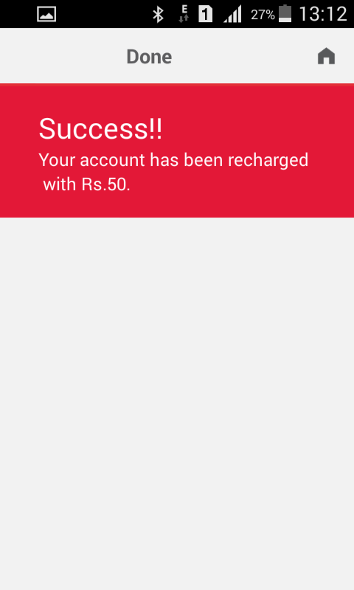

## Self Recharge with SavedCard

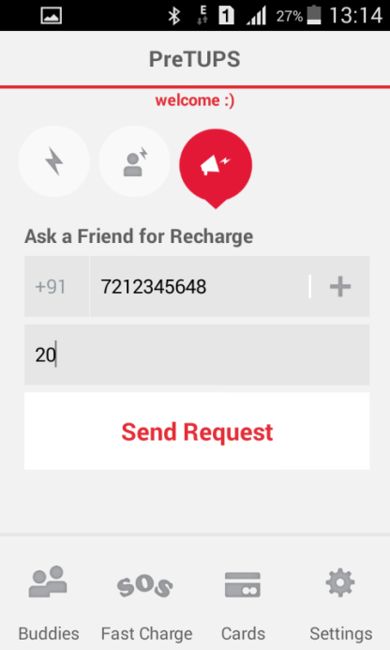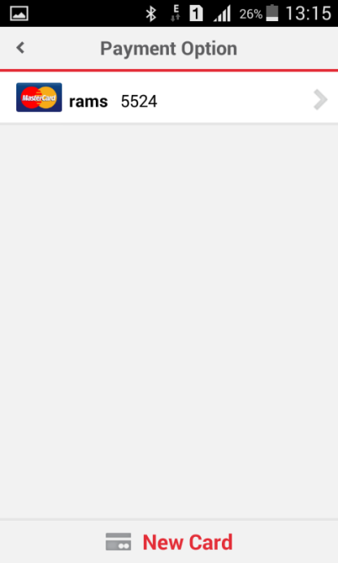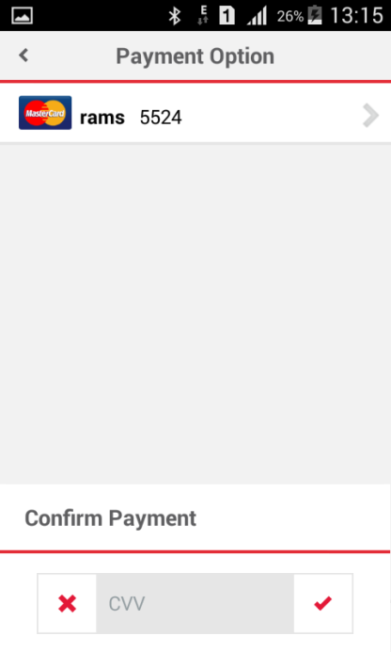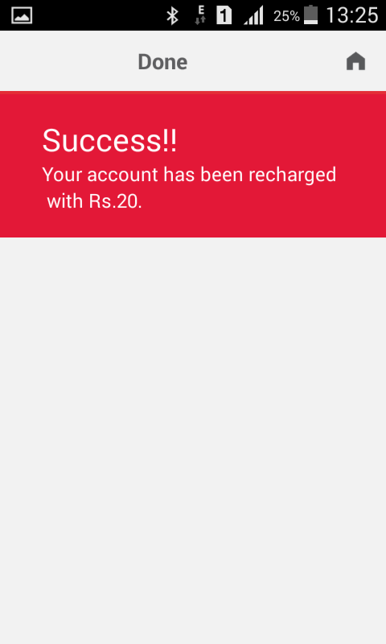

## Self Recharge with Adhoc

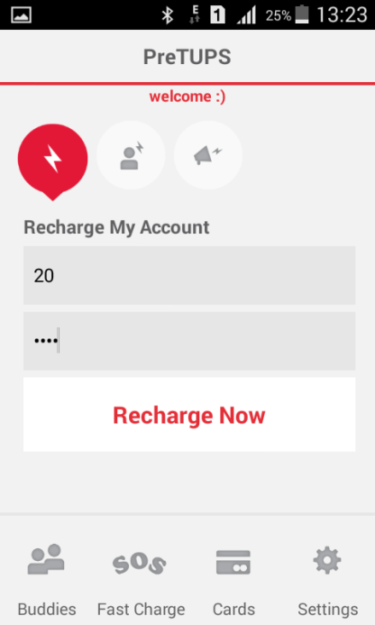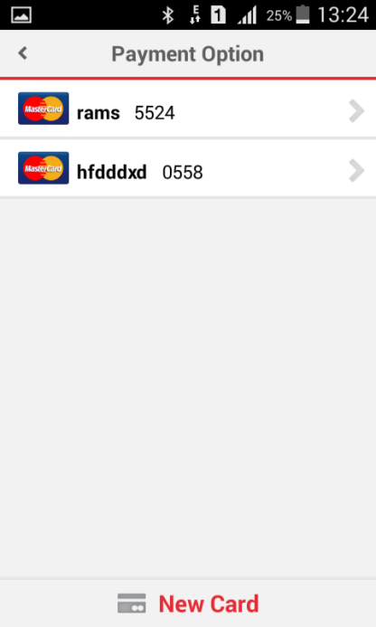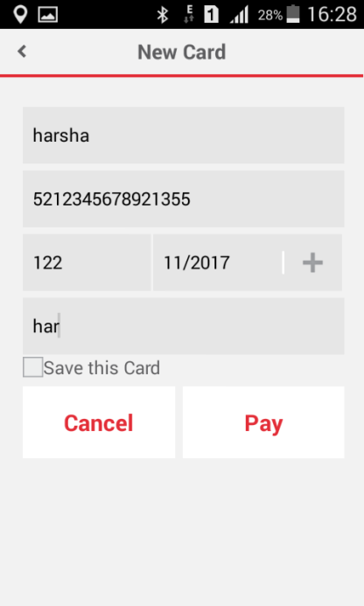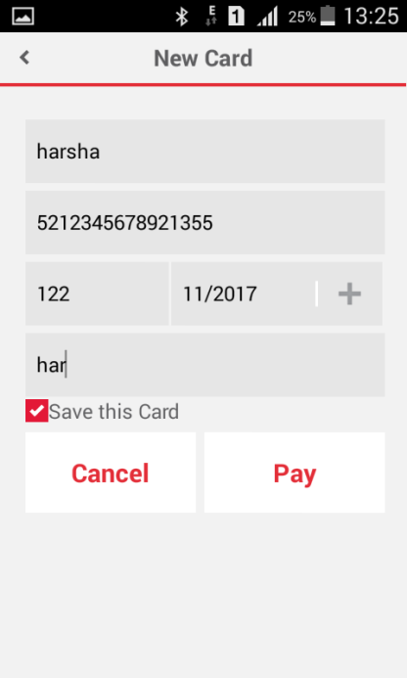

## Recharge to Someone with P2P

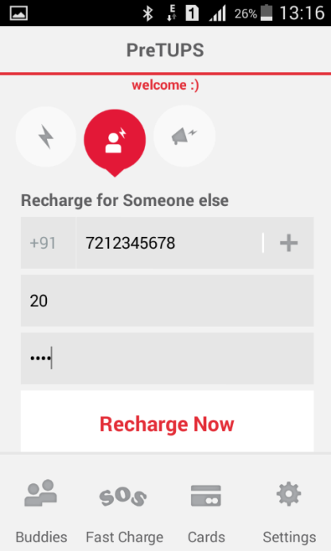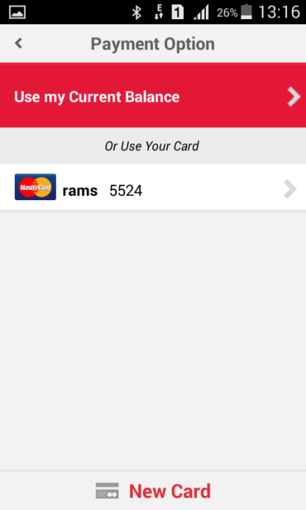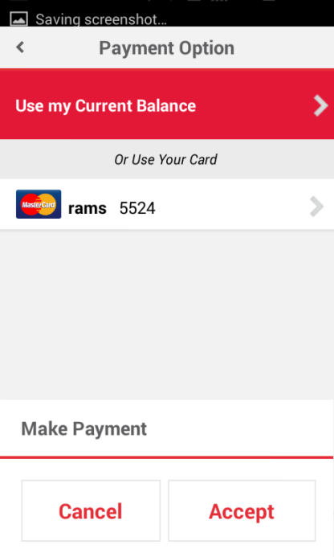

## Recharge to Someone with SavedCard

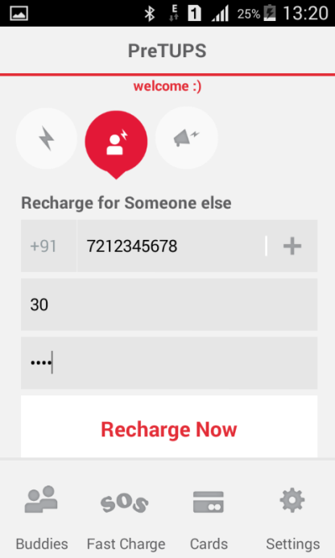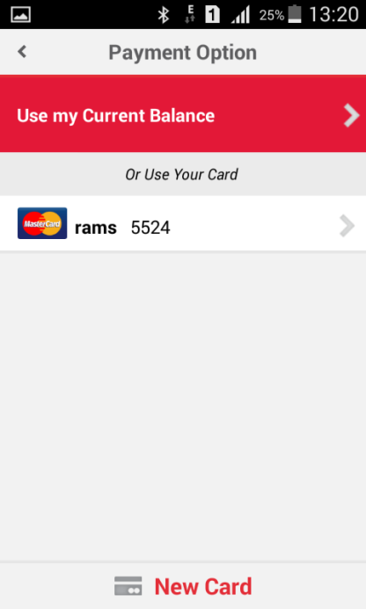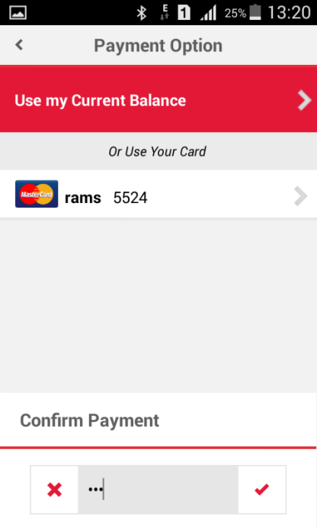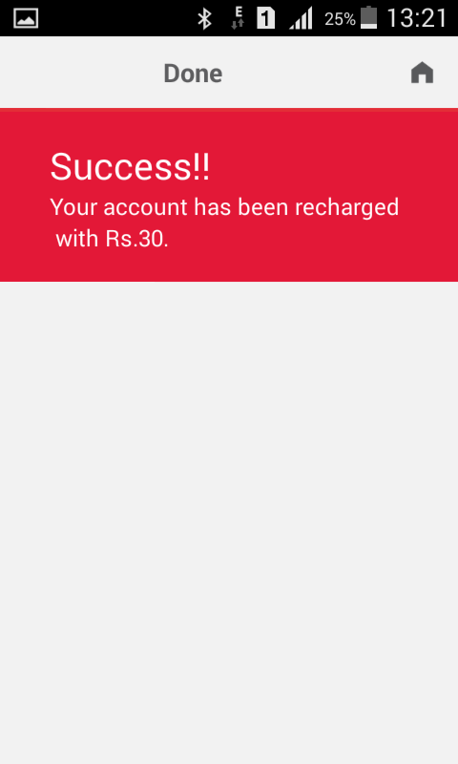

## Recharge to Someone with Adhoc



## TalkMeUp(Ask a friend for Recharge)

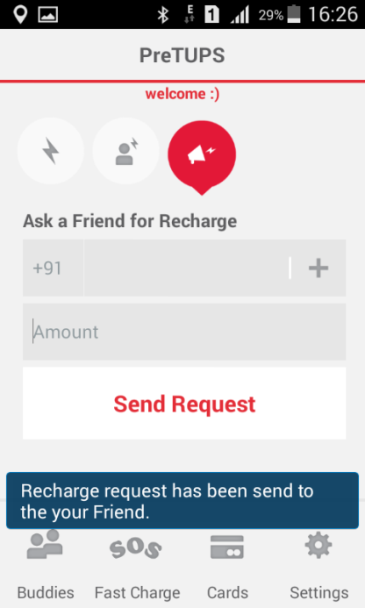

## SOS(Fast Recharge)

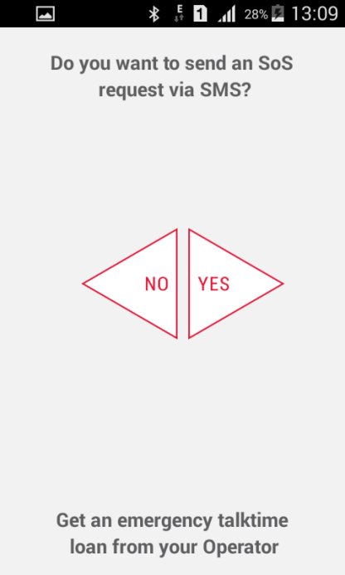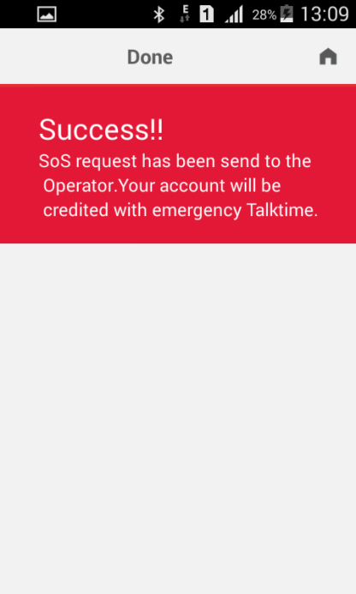

## Change PIN

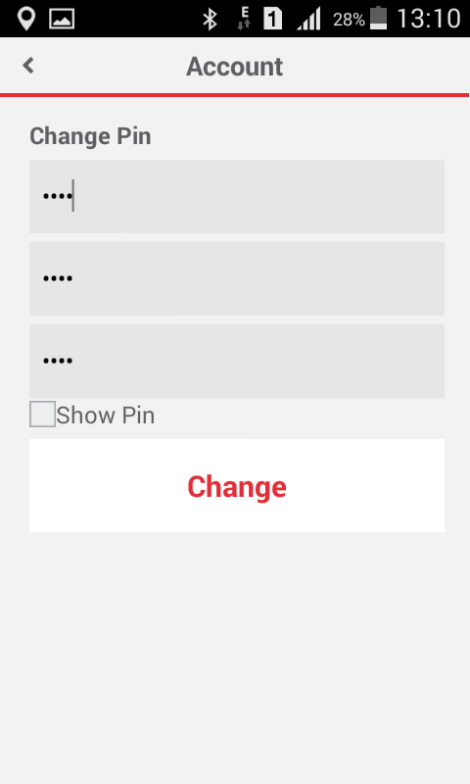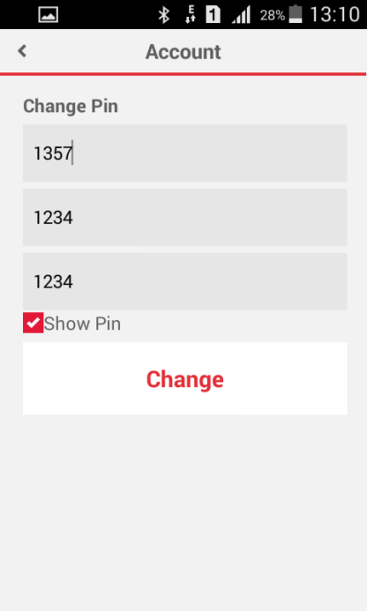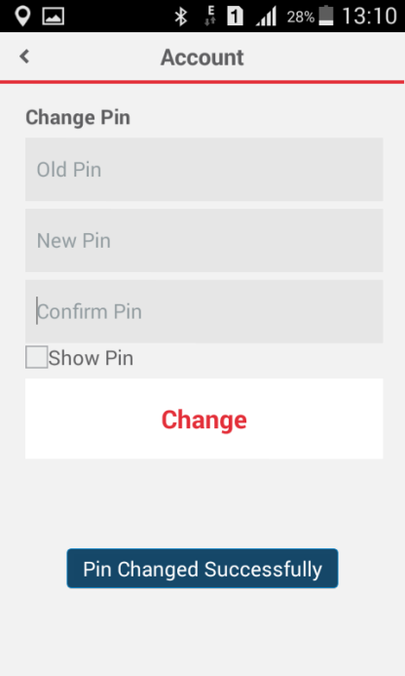

New Features Added

## Subscriber(Self) Cash Recharge with QR Generation

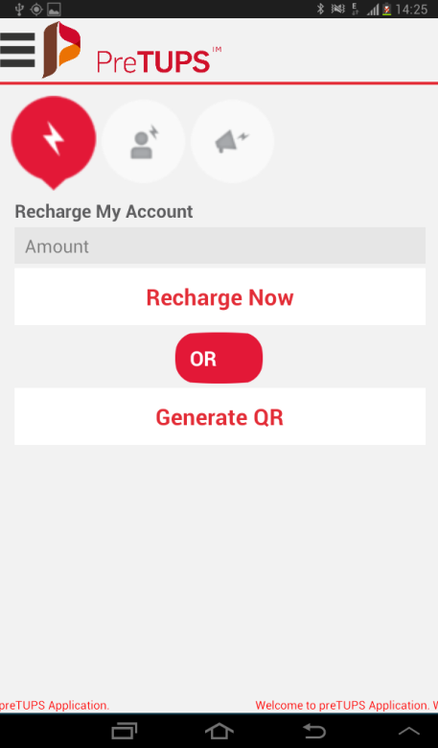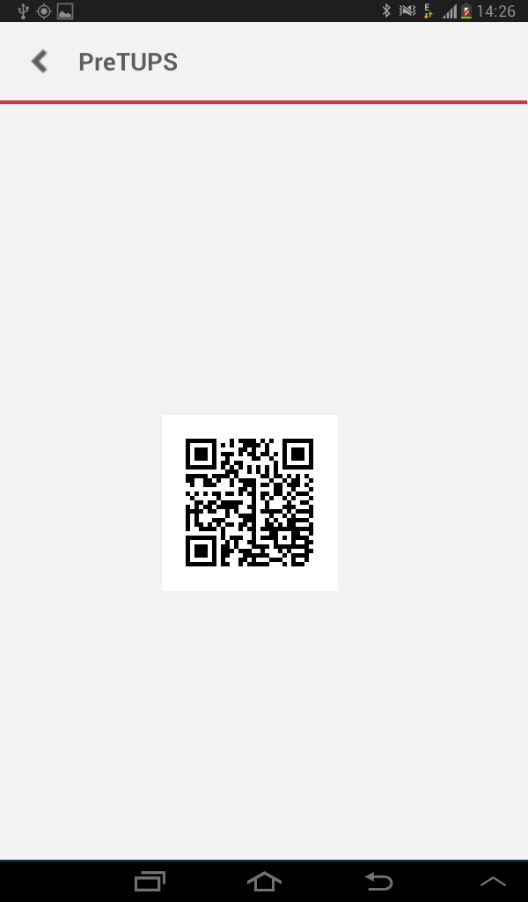

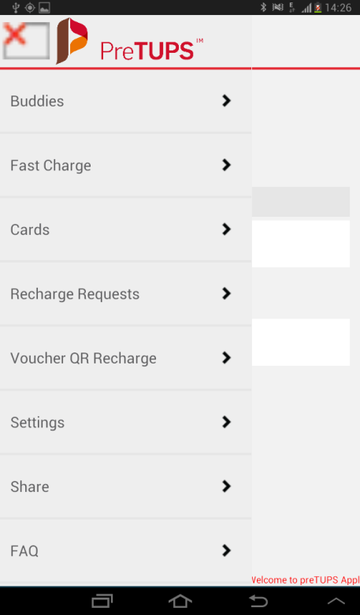

## Subscriber(some one else) Cash Recharge with QR Generation

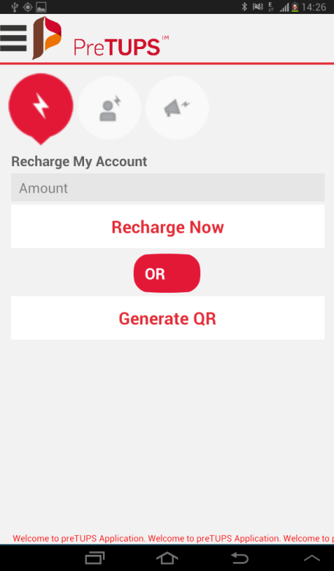

## Recharge Requests

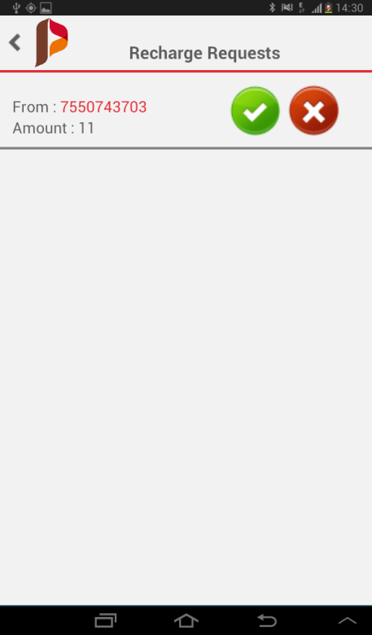

## VoucherQR Recharge

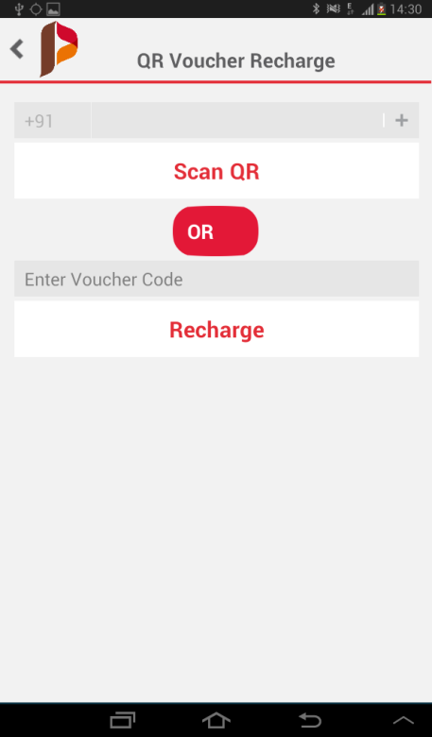

## Share

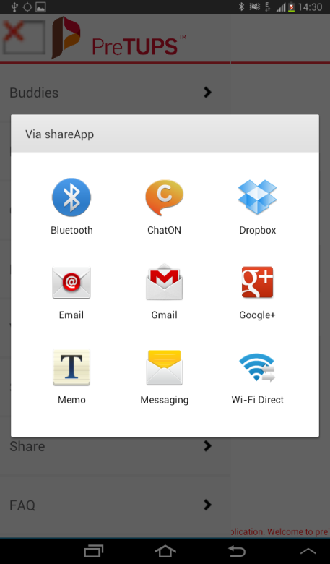

## FAQ

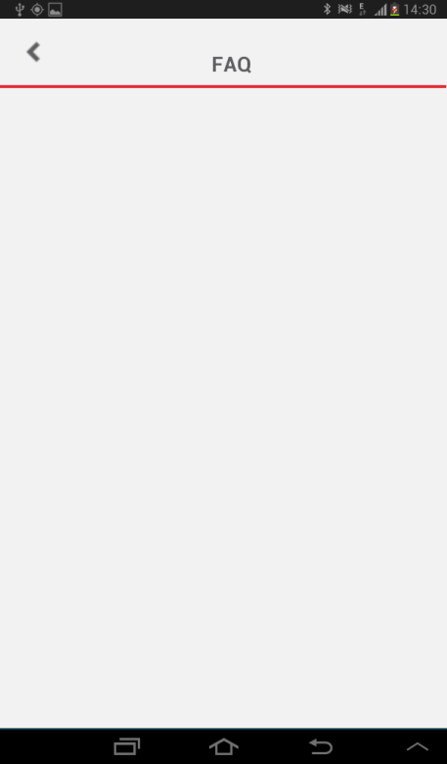

## LogOut



Contact Us

**Corporate Office**

A-26, Info City

Sector 34

Gurgaon 122001

Haryana, India

T: +91-124-4819000

F: +91-124-4819777

**Bangalore Office**

Kirloskar Business park

#50,51, Hebbala, Kempapura,

Next to Columbia Asia Hospital,

Bellary Road,

Bangalore - 560024

India

T: +91-80-43401600

F: +91-80-28565854

**Mumbai Office**

Unit 1-4, 1st Floor, Paradigm Tower

Tower B, Mindspace

Malad(W),

Mumbai 400064,

India

T: +91-22-40774300

F: +91-22-40774333

Restrictions and Copyright Declaration

The information in this document is subject to change without notice and describes only the product defined in the introduction of this documentation. This document is intended for the use of prospective Comviva customers for the sole purpose of the agreement under which the document is submitted. No part of it may be reproduced or transmitted in any form or means without the prior written permission of Comviva. The intended audience for this document is professional personnel, who assume full responsibility for using the document appropriately. Comviva welcomes customer comments as part of the process of continuous development and improvement of its documentation. The information or statements given in this document concerning the suitability, capacity, or performance of the mentioned hardware or software products cannot be considered binding, but shall be defined in contextual specific eventual agreement made between Comviva and the customer.

However, Comviva has made all reasonable efforts to ensure that the instructions contained in the document are adequate, sufficient and free of material errors and omissions. Comviva will, if necessary, explain issues, which may not be covered by the document. Comviva’s liability for any errors in the document is limited to the documentary correction of errors. Comviva will not be responsible, in any event, for errors in this document or for any damages, incidental or consequential, including monetary losses that might arise from the use of this document or the information in it.

This document and the product it describes are considered protected by Patent, Copyright and Trademark laws in accordance with relevant Indian laws.

The only warranties for Comviva products and services are set forth in the express warranty statements accompanying its products and services. Nothing herein should be construed as constituting an additional warranty. Comviva shall not be liable for technical or editorial errors or omissions contained herein.

The Comviva logo is a registered trademark of Comviva Technologies Limited. Other product names mentioned in this document may be trademarks of their respective companies and they are mentioned for identification purposes only.

Copyright © 2014 Comviva Technologies Limited. All rights reserved.