**Low Level Design Document**

Additional Commission Calculator in PreTUPS retailer app:v6.5.0

15/09/2015

Document Version: 1.0

**Revision History**

|  |  |  |  |  |  |  |
| --- | --- | --- | --- | --- | --- | --- |
| Sr. No. | Revision No. | Release Date | Change Description | Prepared By | Reviewed By | Approved By |
| 1 | 1 | 15/09/2015 |  | Parul Nagpal |  |  |
|  |  |  |  |  |  |  |
|  |  |  |  |  |  |  |
|  |  |  |  |  |  |  |
|  |  |  |  |  |  |  |
|  |  |  |  |  |  |  |

Contents

1.0 Introduction 5

1.1 Purpose 5

1.2 Scope 5

1.3 Abbreviations, Acronyms & Definitions 5

1.4 Intended Audience 6

1.5 References 6

2.0 Design Constraints and Considerations 6

3.0 Software Architecture 6

3.1 Physic Task Vs. System Design Unit Process Mapping 6

3.2 Task List 6

3.3 Event List 6

3.4 Database Description 6

3.5 External Interface Design 6

4.0 Global Function Description 6

4.1 Function Description 6

4.2 Interface 6

4.3 Global Data Structure Usage 7

4.4 Processing Logic 7

4.5 Exception/Error handling 7

5.0 Software Detailed Design 7

5.1 Task Description 7

5.2 Task Type 7

5.3 Structure Chart 7

5.4 Database Usage 7

5.5 Library Function/ Common Function Used 8

5.6 Global Data Structure Description 8

5.7 Call Convention 8

5.8 Module Specifications 8

5.8.1 Module Description 8

5.8.2 Module Interface 9

5.8.3 Global Data Structure Usage 9

5.8.4 Local Data Structure Usage 9

5.8.5 Processing Logic 9

5.8.6 Exception/Error Handling 9

5.9 Report Layout and Description 9

6.0 Software Detailed Design For User Interface Processes 9

6.1 Menu Hierarchy 9

6.2 Class Hierarchy Diagram 9

6.3 Class Description 9

6.3.1 Class Name and Type 9

6.3.2 Description 10

6.3.3 Member of Class 10

6.3.4 Dependencies of Class 10

6.4 Task Description 10

6.4.1 Screen(s) Layout 10

6.4.2 Screen Item Description 12

6.4.3 Functions Invoked 13

6.4.4 Database Usage 13

6.4.5 Library Function/Common Function Used 13

6.4.6 Global Data Structure Description 13

6.4.7 Call Convention 13

6.4.8 Report Layout and Description 13

# 1 Introduction

## Purpose

1. Additional Commission Calculator service will help the retailer/channel user to analyze the benefits of selling stock to subscribers.
2. Additional Commission Calculator helps channel user to know the net commission that will be earned by him for selling the stock to subscriber. It helps retailer to estimate the earning from selling the stock so that retailer can plan accordingly.
3. Additional Commission is for C2S services like Customer recharge, postpaid bill payment, gift recharge etc.

## Scope

1. This chapter gives a brief introduction of design of Additional Commission in the retailer mobile application.

## Abbreviations, Acronyms & Definitions

|  |  |
| --- | --- |
| EXTGW | External Gateway / System |
| MAPPGW | Mobile Application Gateway |
| HTTP | Hypertext Transfer Protocol |
| API | Application Program Interface |
| XML | Extensible Markup Language |
| M | Mandatory |
| O | Optional |
| RC | Customer Recharge |
| N | No value |

## Intended Audience

1. Developer
2. Tester
3. Code Reviewer

## References

1. User story : USTRY54 Retailer APP- Calculate Additional Commission

# Design Constraints and Considerations

2. **List of Tasks on Server Side:**
3. **List of Task on Client Side:**
4. **Event List:**

# Software Architecture

## Physic Task Vs. System Design Unit Process Mapping

## Task List

## Event List

## Database Description

## External Interface Design

# Global Function Description

## Function Description

## Interface

## Global Data Structure Usage

## Processing Logic

## Exception/Error handling

# Software Detailed Design

## Task Description

1) User clicks on the link commission calculator then screen navigated to screen with base and additional commission calculator.

2) User selects Additional Commission

3) User selects the sub services whose commission is to be calculated from the drop down.

4) User selects gateway from the dropdown.

5) User enters the amount in the amount field.

6) User clicks on the calculate button.

7) After calculate button is pressed result is displayed on the same screen.

8) Result has the following contents:

a) Additional Commission rate

b) Additional Commission amount

c) Tax Rate

d) Tax value

e) Net Commission



## Task Type

## Structure Chart

## Database Usage

1. Entries for the a new service type "COMMCALC" in **SERVICE_TYPE** table and in **SERVICE_KEYWORDS** table.

## Library Function/ Common Function Used

## Global Data Structure Description

## Call Convention

## Module Specifications

### Module Description

1. Request syntax:
3. TYPE=COMMCALC&MSISDN=7277777779&MODULE=C2S&AMOUNT=100&IM EI=356 530065348522 &PRODUCT=ETOPUP&SERVICE=RC&GATEWAY=MAPPGW

| TAG | Fields | Example | Max Length | Optional/Mandatory | Remarks |
| --- | --- | --- | --- | --- | --- |
| TYPE | COMMCALC | COMMCALC | 10 B | M | Request Type. Static & fixed value |
| MSISDN | Mobile number | 7277777779 | 10 | M | NUMERIC |
| MODULE | Module or service | C2S | 10 B | M | VARCHAR |
| AMOUNT | Requested Quantity for which the commission is to be calculated | 100 |  | M | NUMERIC |
| IMEI | IMEI number | 356530065348522 | 15 | M | NUMERIC |
| PRODUCT | Product code of the product which is assigned for the user | N (for additional commission we can use either N or ETOPUP) | 10 B | M | VARCHAR |
| SERVICE | Service code of the product which is assigned for the user | RC | 10 B | M | VARCHAR |
| GATEWAY | Gateway code of the product which is assigned for the user | MAPPGW | 10 B | M | VARCHAR |

1. Response syntax:
2. TYPE= COMMCALC&TXNSTATUS==<TXN CODE>&MESSAGE=<Message>

| TAG | Fields | Example | Max Length | Optional/Mandatory | Remarks |
| --- | --- | --- | --- | --- | --- |
| TYPE | COMMCALC | COMMCALC | 10 | M | Response Type. Static & fixed value |
| TXNSTATUS | Request Status | 200 | 5 | M | Transaction Status i.e.  Transaction OK (200), failed other status |
| MESSAGE | Transaction Message | Succes or fail. | 150 | M | Message specific to the error code. |

### Module Interface

### Global Data Structure Usage

### Local Data Structure Usage

### Processing Logic

### Exception/Error Handling

## Report Layout and Description

# Software Detailed Design For User Interface Processes

## Menu Hierarchy

## Class Hierarchy Diagram

## Class Description

### Class Name and Type

1. **Java files that are changed:**
2. CommCalculatorController.java (New addition)
3. PretupsI.java
4. PretupsErrorCodesI.java
5. Messages.properties

### Description

### Member of Class

### Dependencies of Class

## Task Description

### Screen(s) Layout

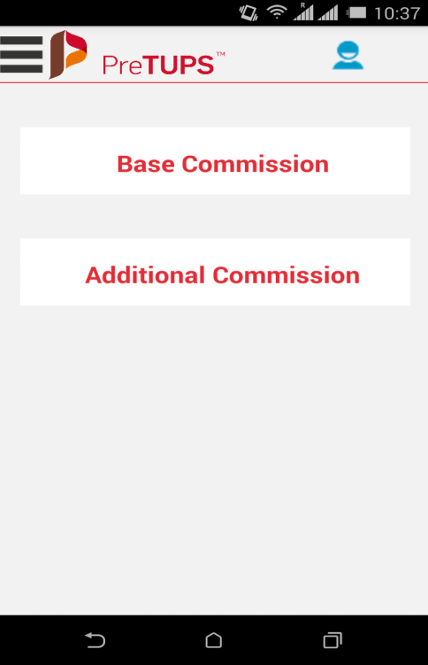

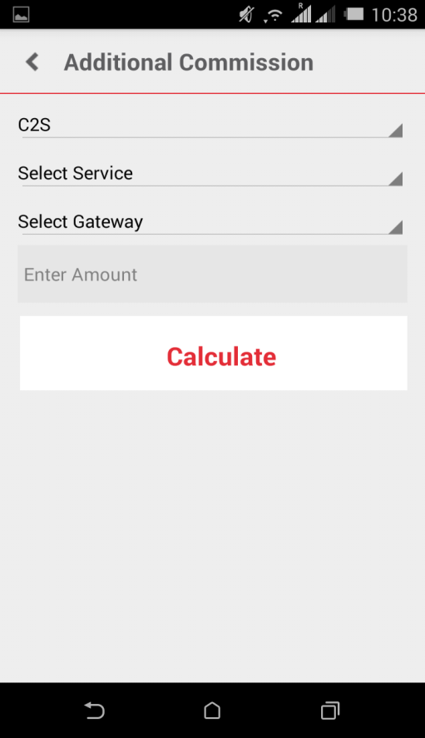

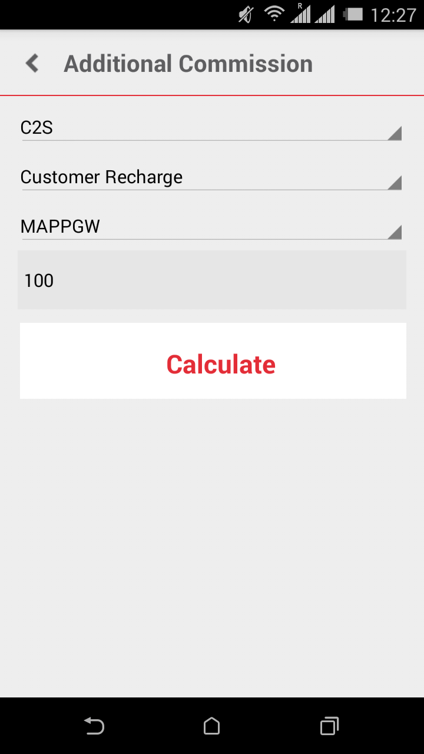

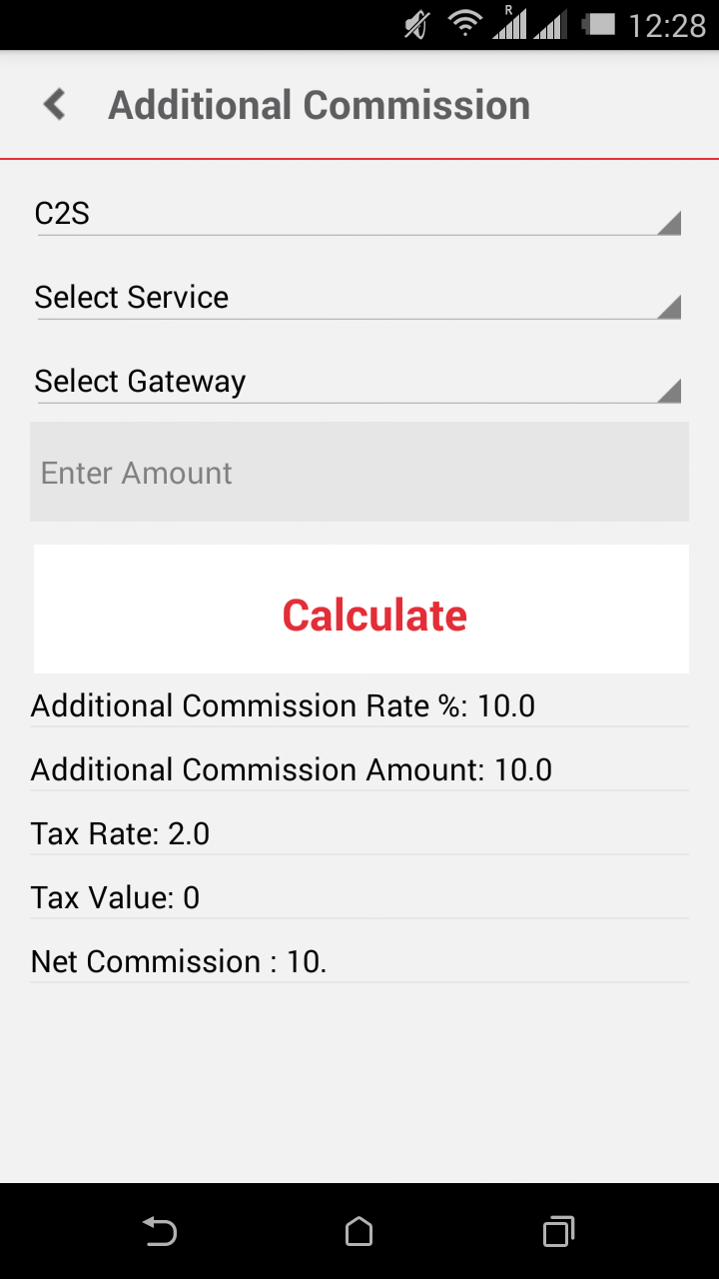

### Screen Item Description

|  |  |  |
| --- | --- | --- |
| 1. ITEM NAME | 1. DATA TYPE | 1. DESCRIPTION |
| 1. ETOPUP | 1. VARCHAR | 1. Product code of the product which is assigned for the user. |
| 1. SELECT SERVICE TYPE | 1. VARCHAR | 1. Service (O2C or C2C). |
| 1. AMOUNT | 1. NUMERIC | 1. Requested Quantity for which the commission is being calculated. |
| 1. ADDITIONAL COMMISSION RATE | 1. DOUBLE | 1. Commission Rate assigned with the commission profile. |
| 1. ADDITIONAL COMMISSION AMOUNT | 1. LONG | 1. Commission value calculated based on the commission rate. |
| 1. TAX RATE | 1. DOUBLE | 1. Tax Rate assigned with the commission profile. |
| 1. TAX VALUE | 1. LONG | 1. Value calculated based on the tax rate. |
| 1. NET COMMISSION | 1. LONG | 1. Commission value after deducting tax. |
| 1. SELECT SERVICE | 1. CHAR | 1. Services available for the user |
| 1. GATEWAY | 1. VARCHAR | 1. Gateway associated with the profile |

### Functions Invoked

### Database Usage

1. Entries for the a new service type "COMMCALC" in **SERVICE_TYPE** table and in **SERVICE_KEYWORDS** table..

### Library Function/Common Function Used

### Global Data Structure Description

### Call Convention

### Report Layout and Description

Appendix A – Contact Us

1. **Delhi Headquarters**
2. Comviva Technologies Limited
3. A-26, Info City
4. Sector 34
5. Gurgaon   122022
6. Haryana, India
7. T: +91-124-4819000
8. F: +91-124-4819777
9. **Bangalore Office**
10. Comviva Technologies Limited
11. 4, 12th Km Stone
12. Bellary Road, Jakkur
13. Bangalore  560064
14. India
15. T: +91-80-28565852/ 53/ 08/ 09
16. F: +91-80-28565854
17. **Mumbai Office**
18. Comviva Technologies Limited
19. Unit 1-4, 1st Floor, Paradigm Tower
20. Tower B, Mindspace
21. Malad(W), Mumbai 400064, India
22. T: +91-22-40774300
23. F: +91-22-40774333

Disclaimer

Copyright © 2013:  Comviva Technologies Ltd, Registered Office at A-26, Info City, Sector 34, Gurgaon-122001, Haryana, India.

All rights about this document are reserved and  shall not be , in whole or in part, copied, photocopied, reproduced, translated, or reduced to any manner including but not limited to electronic, mechanical, machine readable ,photographic, optic recording or otherwise without prior consent, in writing, of Comviva Technologies Ltd  (the Company).

1. The information in this document is subject to changes without notice. This describes only the product defined in the introduction of this documentation. This document is intended for the use of prospective customers of the Company Products Solutions and or Services for the sole purpose of the transaction for which the document is submitted. No part of it may be reproduced or transmitted in any form or manner whatsoever without the prior written permission of the company. The Customer, who/which assumes full responsibility for using the document appropriately. The Company welcomes customer comments as part of the process of continuous development and improvement.
2. The Company has made all reasonable efforts to ensure that the information contained in the document are adequate, sufficient and free of material errors and omissions. The Company will, if necessary, explain issues, which may not be covered by the document. However, the Company does not assume any liability of whatsoever nature, for any errors in the document except the responsibility to provide correct information when any such error is brought to company’s knowledge. The Company will not be responsible, in any event, for errors in this document or for any damages, incidental or consequential, including monetary losses that might arise from the use of this document or of the information contained in it.
3. This document and the Products, Solutions and Services it describes are intellectual property of the Company and/or of the respective owners thereof, whether such IPR is registered, registrable, pending for registration, applied for registration or not.

The only warranties for the Company Products, Solutions and Services are set forth in the express warranty statements accompanying its products and services. Nothing herein should be construed as constituting an additional warranty. The Company shall not be liable for technical or editorial errors or omissions contained herein.

1. The Company logo is a trademark of the Company. Other products, names, logos mentioned in this document, if any, may be trademarks of their respective owners.
2. Copyright © 2013:  Comviva Technologies Ltd.. All rights reserved.
3. **Thank You**

Visit us at [*www.mahindracomviva.com*](http://www.mahindracomviva.com)