DIRECTORY_STRUCTURE
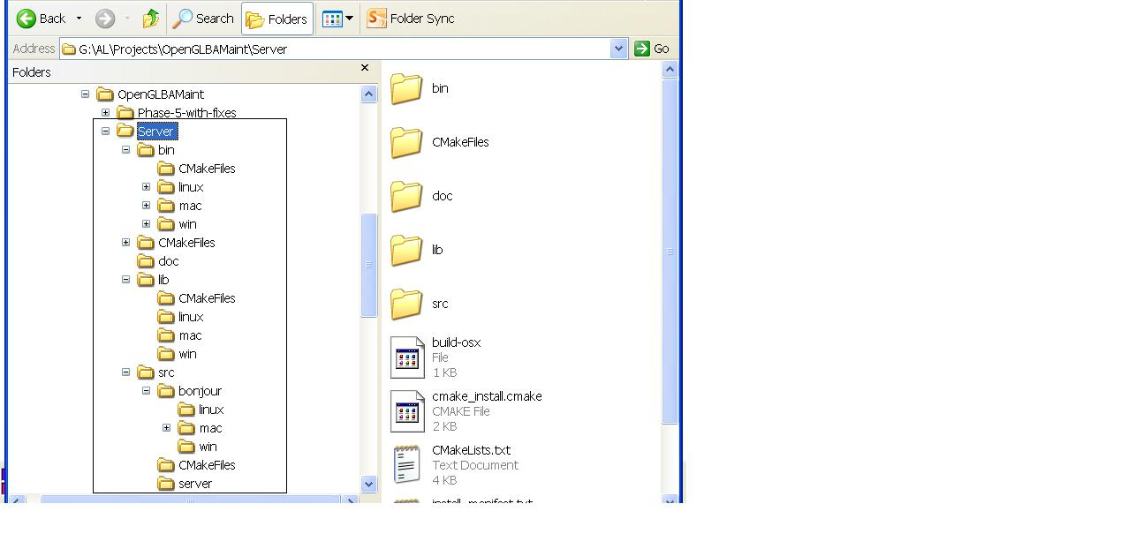
- Extract the given file.
- “cd Server”.
- In the Server directory there are 4 sub-directories as can be seen above (bin, lib, doc, src)
  - “Server/bin” – Executables generated here. Further sub-directories are “Server/bin/mac”, “server/bin/win” and “server/bin/linux”
  - “Server/lib” – For housing libraries needed by the executable.
  - “Server/doc” – Documentation
  - “Server/src” – Server and Bnjour Sources.
    - “Server/src/server” – Broadcast Server sources
    - “server/src/bojnour/mac” - Bonjour sources for mac
    - “server/src/bojnour/win” - Bonjour related stuff for windows
    - “server/src/bojnour/linux” - Bonjour related stuff for linux

COMPILATION INSTRUCTIONS ON OSX USING “build-osx” SCRIPT
- Extract the given zip file.
- Install CMAKE (cmake.org – it has just 1 DMG file)
- Edit CMakeLists.txt and set the PROJECT_ROOT_DIR
- To run build-osx, type “source build-osx” on the command line.
- It does the following –
  - Adds “<FULL_PATH_TO_ROOT>/Server/bin/mac” to DYLD_LIBRARY_PATH
  - Deletes CMakeCache.txt
  - Deletes BonjourServer.app and the build directory (optional)
  - Builds OpenGL and Bonjour servers using CMAKE.
  - Both targets (OpenGLBroadcastServer and BonjourServer.app) are generated in the “bin/mac” directory

COMPILATION INSTRUCTIONS ON OSX USING CMAKE
- Extract the given zip file.
- Install CMAKE (cmake.org – it has just 1 DMG file)
- Delete CMakeCahe.txt (rm CMakeCache.txt)
- Edit the CMakeList.txt file and set the following variables as appropriate
  - PROJECT_ROOT_DIR
- Optionally remove BonjourServer.app from bin/mac and “rm –rf src/bonjour/mac/build”
- Run “cmake .” from command line
- Run “make” from command line.
- Executable is in “bin/mac”. To run type “bin/mac/OpenGLBroadcastServer”

COMPILATION INSTRUCTIONS ON WIN32 USING CMAKE (WORK IN PROGRESS)
- Extract the given zip file.
- Install CMAKE (cmake.org – it has just 1 DMG file)
- Delete CMakeCahe.txt (rm CMakeCache.txt)
- Edit the CMakeList.txt file and set the following variables as appropriate
  - PROJECT_ROOT_DIR
- Run cmake –G “MinGW Makefiles” from command line
- If you see an error run it again.
- On MSYS run cmake –G “MSYS Makefiles” from command line
- Run “C:/MinGW/bin/mingw32-make.exe” from command line.
- Executable is in “bin/win”. To run type “bin/win/OpenGLBroadcastServer.exe”

COMPILATION INSTRUCTIONS ON LINUX USING CMAKE (WORK IN PROGRESS)
- Extract the given zip file.
- Install CMAKE (cmake.org – it has just 1 DMG file)
- Delete CMakeCahe.txt (rm CMakeCache.txt)
- Edit the CMakeList.txt file and set the following variables as appropriate
  - PROJECT_ROOT_DIR
- Run “cmake .” from command line
- Run “make” from command line.
- Executable is in “bin/linux”. To run type “bin/linux/OpenGLBroadcastServer”

ImageMagick Installation on OSX
- Download latest source from imagemagick.org
- Use ./configure --disable-openmp to disable OpenMP as we use pthreads in this project and it causes a crash

