DIRECTORY_STRUCTURE
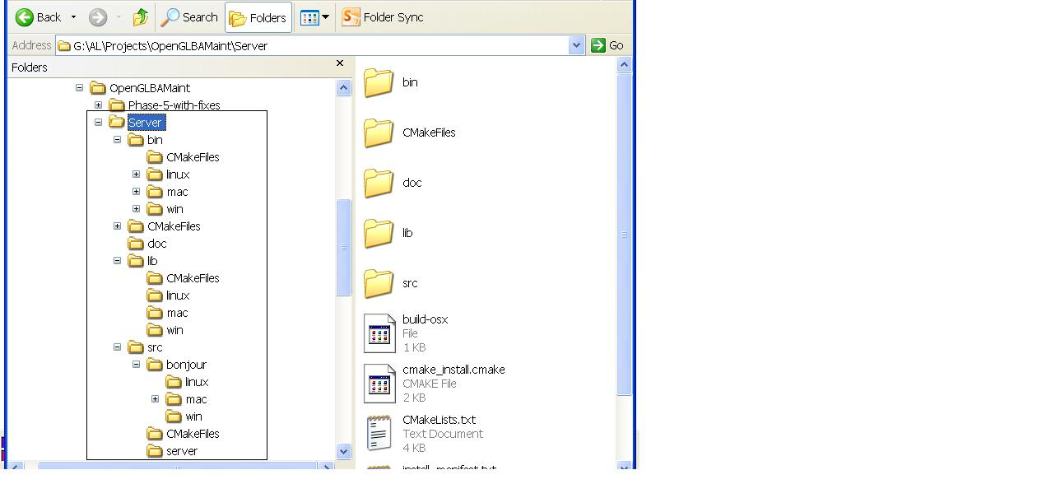
- Extract the given file.
- “cd Server”.
- In the Server directory there are 4 sub-directories as can be seen above (bin, lib, doc, src)
  - “Server/bin” – Executables generated here. Further sub-directories are “Server/bin/mac”, “server/bin/win” and “server/bin/linux”
  - “Server/lib” – For housing libraries needed by the executable.
  - “Server/doc” – Documentation
  - “Server/src” – Server and Bnjour Sources.
    - “Server/src/server” – Broadcast Server sources
    - “server/src/bojnour/mac” - Bonjour sources for mac
    - “server/src/bojnour/win” - Bonjour related stuff for windows
    - “server/src/bojnour/linux” - Bonjour related stuff for linux

Functions Used in the Server

JPEG MODULE
FUNCTION | DESCRIPTION
ICCJpeg *CreateJpeg() | Function: CreateJpeg  Returns: ICCJpeg *  Parameters: None  Notes: Creates a JPEG interface ICCJpeg. Returns a pointer to interface created.
JpegCompressPixelData | Function: JpegCompressPixelData  Returns: void  Parameters: void *threadArg  Notes: This is the public funciton of ICCJpeg called from the OpenGL thread. It takes an argument  that contains pixel data buffers, input, output and window width and height.
init_destination | Function: init_destination  Returns: void  Parameters: j_compress_ptr cinfo  Notes: This function initializes the mem_dest_ptr to be used in jpeg compression
empty_output_buffer | Function: empty_output_buffer  Returns: boolean  Parameters: j_compress_ptr cinfo  Notes: This function resets the values of mem_dest_ptr and returns false always.
term_destination | Function: term_destination  Returns: void  Parameters: j_compress_ptr cinfo  Notes: This function sets the size of the jpeg compression in memory
jpeg_compress | Function: jpeg_compress  Returns: boolean, true on success, false on failure  Parameters: unsigned char buffer: input buffer with raw pixel data  unsigned char outbuffer: output buffer  unsigned long outlen: output buffer length  int jpegLength: length in bytes of jpeg compressed memory  unsigned int buf_win_width: window width with input pixel buffer was read  unsigned int buf_win_height: window height when input pixel buffer was read  Notes: This function compresses the raw pixel data in memory using the given parameters.
jpeg_compress_in_file | Function: jpeg_compress_in_file  Returns: boolean, true on success, false on failure  Parameters: unsigned char buffer: input buffer with raw pixel data  unsigned char outbuffer: output buffer  unsigned long outlen: output buffer length  int jpegLength: length in bytes of jpeg compressed memory  unsigned int buf_win_width: window width with input pixel buffer was read  unsigned int buf_win_height: window height when input pixel buffer was read  Notes: This function compresses the raw pixel data using the given parameters and outputs a given file.
jpeg_mem_dest | Function: jpeg_mem_dest  Returns: void  Parameters: j_compress_ptr cinfo: compression information  JOCTET buf:output buffer  size_t bufsize: output buffer size  Notes: This function allocates inits the memory pointer for in memory compression.
jpeg_mem_size | Function: jpeg_mem_size  Returns: int, size of the compressed memory  Parameters: j_compress_ptr cinfo: compression information  Notes: This function returns the size of compressed memory

OpenGL Module
CreateOpenGL | Function: CreateOpenGL  Returns: ICCOpenGL , pointer to OpenGL interface  Parameters: None  Notes: This function returns a pointer to OpenGL interface
StartOpenGLRenderer | Function: StartOpenGLRenderer  Returns: void  Parameters: void threadArg (renderInBackground, multicolor)  Notes: This function sets up the frame buffers, depth and texture buffers for spinning cube.
initFrameBufferDepthBuffer | Function: initFrameBufferDepthBuffer  Returns: void  Parameters: void  Notes: This function initializes depth buffer
initFrameBufferTexture | Function: initFrameBufferTexture  Returns: void  Parameters: void  Notes: This allocates storage for 2 render buffers (color and depth) and inits color buffer.
initFrameBuffer | Function: initFrameBuffer  Returns: void  Parameters: void  Notes: Allocates storage for a frame buffer, color and depth buffers
initFrameBufferDepthBufferB | Function: initFrameBufferDepthBufferB  Returns: void  Parameters: void  Notes: Initializes the depth buffer B
initFrameBufferTextureB | Function: initFrameBufferTextureB  Returns: void  Parameters: void  Notes: Initializes the texture buffer B
Function: initFrameBufferB
Returns: void
Parameters: void
Notes: Allocates frame buffer B, initializes it.

initA | Function: initA  Returns: void  Parameters: void  Notes: Initializes Frame Texture and depth render buffers, then allocates and inits the frame buffer
initB | Function: initB  Returns: void  Parameters: void  Notes: Initializes Frame Texture and depth render buffers, then allocates and inits the frame buffer
init | Function: init  Returns: void  Parameters: void  Notes: Initializes 2 frame buffers used
keyOperations | Function: keyOperations  Returns: void  Parameters: void  Notes:
renderCubeScene | Function: renderCubeScene  Returns: void  Parameters: unsigned int currFBO  Notes: Binds the given frame buffer object for rendering, clears depth and color buffer,  renders a spinning cube
readFromFB | Function: readFromFB  Returns: void  Parameters: unsigned int currFBO  Notes: 1. binds the FBO to a READ_FRAMEBUFFER_EXT  2. does nothing if no UDT connection  3. Looks for a free buffer, locks it for writing  4. Reads the raw pixel data  5. Sets up JPEG compression arguments.  6. Calls function to compress JPEG pixel data  7. Unbinds the FBO
blitFB | Function: blitFB  Returns: void  Parameters: unsigned int currFBO  Notes: 1. binds the FBO to a READ_FRAMEBUFFER_EXT  2. unbinds from draw buffer, clears depth and color buffers  3. Draws the cube.  4. Swaps buffers if rendering in foreground.
display | Function: display  Returns: void  Parameters: None  Notes: 1. Renders cube scene using 2 buffers
reshape | Function: reshape  Returns: void  Parameters: None  Notes: Called when window is resized.
Function: keyPressed
Returns: void
Parameters: unsigned char key, int x, int y
Notes: called when a key is pressed. Press 'b' to swtich to background rendering.

setup | Function: setup  Returns: void  Parameters: None  Notes: 1. Initialize GLUT, set up basic display buffer, init and create window  2. initialize frame buffer objects, color and depth buffers  3. Set the idle and reshape functions.  4. Call glutMainLoop in rendering in foreground  5. Call reshape fucntion continuously if rendering in background.

UDT Module
Function | Description
CreateUDT | Function: CreateUDT  Returns: ICCUDT *  Parameters: None  Notes: Return an object to UDT interface
CCUDT constructor | Function: CCUDT constructor  Returns: None  Parameters: None  Notes: Starts the UDT library
CCUDT destructor | Function: CCUDT destructor  Returns: None  Parameters: None  Notes: Releases the UDT library
StartUDTClientRequestReceiver | Function: StartUDTClientRequestReceiver  Returns: None  Parameters: None  Notes: Repeatedly call RxRequest to receive requests from client
RxReque | Function: RxRequest  Returns: None  Parameters: None  Notes: Receive requests from client to send next image. If the request matches a signature  set a flag to 1.
StartTx | Function: StartTx  Returns: None  Parameters: None  Notes: 1. Check if a buffer is fresh and unlocked  2. Lock the buffer for transmission to client.  3. Transmit to client.  4. Unlock the buffer after transmission.  5. Set the clientReqRecd flag to 0
StartTestTx | Function: StartTestTx  Returns: None  Parameters: None  Notes: pthread_mutex based function used to test performance using various UDT transmission options.  Legacy code.
StartUDTServer | Function: StartUDTServer  Returns: None  Parameters: None  Notes: 1. Start UDT Server. Creates a UDT socket, binds and listens for an incmoing connection.  2. Terminates after accepting incoming connection from client.
StartUDTClient | Function: StartUDTClient  Returns: None  Parameters: None  Notes: 1. UDT client: connects to a UDT server. Legacy code used to test UDT.

