Distributed Anti-Money Laundering Transaction Analysis and Classification
Using Apache Spark
INT315 – Cluster Computing Project Report

Submitted by: Name: Boddeti Sri Likhith Ashish

Registration No: 12303192

Programme and Section: B. Tech CSE, K4P23WS

Course Code: INT315

Roll No: 02

Under the Guidance of

Pardeep Kumar


Table of Contents
- 1. Project Title
- 2. Problem Statement
- 3. Objectives and Scope
- 4. Dataset Description
- 5. Dataset Source
- 6. Tools and Technologies Used
- 7. Implementation / Methodology
- 8. Notebook Code
- 9. Notebook Execution Outputs
- 10. Output / Result Screenshots
- 11. Results and Discussion
- 12. Conclusion and Future Work
- References

1. Project Title
Distributed Anti-Money Laundering Transaction Analysis and Classification Using Apache Spark. Course: INT315 – Cluster Computing.

2. Problem Statement
Large transaction data requires repeatable preparation, aggregation, and evaluation. Rare positive labels make accuracy alone insufficient: a model may classify nearly every transaction as negative and still appear accurate. This project demonstrates an offline Spark workflow on synthetic AMLSim data and compares precision, recall, F1.
AMLSim labels represent simulator-generated activity, not verified real-world crime. Model scores in this educational notebook are not proof of laundering and are not recommendations for real-world action.
3. Objectives and Scope
1. Prepare a reproducible working dataset. The source file contains over five million transaction rows. A fixed-size, class-stratified sample keeps the local experiment tractable while retaining the rare positive label at its observed rate. Completion is evidenced by the generated sample CSV and the source/sample count table in this section.
2. Load and validate transactions with Spark. Explicit parsing and validation make malformed timestamps, identifiers, amounts, or labels visible before analysis. Completion is evidenced by the prepared Spark DataFrame used by SQL and modeling.
3. Perform transaction-level and account-level SQL analysis. Seven saved queries demonstrate filtering, grouping, aggregation, joining, pattern matching, and label-rate summaries. Their CSV outputs are listed and interpreted in Section 10.
4. Compare three Spark MLlib classifiers. Decision Tree, Random Forest, and Gradient-Boosted Trees provide a small comparison of a single tree and two tree-ensemble approaches. Their saved metrics and test confusion counts are reproduced in Section 11.
5. Evaluate future-period predictions under class imbalance. A chronological train/validation/test design reduces direct future-to-past mixing; thresholds are selected on validation rather than the final test set. The saved CSV and evaluation plots provide the evidence.
6. Persist reproducible result artifacts. Charts, model metric CSVs, and SQL result CSVs make the selected experiment inspectable without claiming that its saved outputs constitute a live deployment.

4. Dataset Description
The local source file is named HI-Small_Trans.csv and has 11 columns. Its header contains Timestamp, From Bank, Account, To Bank, Account, Amount Received, Receiving Currency, Amount Paid, Payment Currency, Payment Format, and Is Laundering. The duplicate Account headers represent the sender and receiver accounts; the loader resolves them using their positions after validating the header.
Direct CSV counts made while preparing this report: the local source contains 5,078,345 transaction rows (5,177 positive and 5,073,168 negative labels). The separate project sample contains 500,000 rows (510 positive and 499,490 negative). The sample is a deterministic-seed, class-stratified selection from the local source and is not a different original dataset.
Dataset file | Rows | AML-positive | AML-negative | Positive rate
HI-Small_Trans.csv (local source) | 5,078,345 | 5,177 | 5,073,168 | 0.10%
HI-Small_Trans_sample_500000.csv | 500,000 | 510 | 499,490 | 0.10%

Source column | Meaning | Role in this project
Timestamp | Transaction time in the source record. | Chronological partitioning; not a model feature.
From Bank | Identifier of the sending bank. | Combined with sender account to form a scoped ID.
Account (first occurrence) | Sending account identifier. | Sender identity; not a model feature.
To Bank | Identifier of the receiving bank. | Combined with receiver account to form a scoped ID.
Account (second occurrence) | Receiving account identifier. | Receiver identity; not a model feature.
Amount Received | Amount received as represented in its source currency. | Retained in raw input; not the model amount column.
Receiving Currency | Currency code associated with received amount. | Source context; not a model feature.
Amount Paid | Amount paid in the transaction. | Cast to numeric and used as the amount model feature.
Payment Currency | Currency code associated with paid amount. | Source context; not a model feature.
Payment Format | Transaction/payment mechanism label. | Indexed category used by the classifier.
Is Laundering | Simulator-generated binary label. | Target label (0/1); not an input feature.

The preparation pipeline uses timestamp, bank/account information, amount paid, payment format, and label. It derives sender/receiver IDs and a transaction identifier. Currency fields are present in the source header but are not retained as model features
The local original source and the prepared sample are distinct files. The source file contains 5,078,345 data rows; the prepared sample contains exactly 500,000 rows. The sampler takes fixed quotas from each binary class with seed 42 so that the small positive class is not omitted by an unconstrained random sample. Stratification retains the observed class proportion approximately;
The loader checks the expected header fields and duplicate-account positions, parses supported timestamp formats, converts the amount field, validates essential identifiers, labels, and non-negative values, and reports preparation counts. These checks establish structural suitability for this pipeline, not semantic correctness of every synthetic record.

5. Dataset Source
The notebook identifies the input as IBM AMLSim HI-Small transaction data. Its saved execution output states that the source CSV and the 500,000-row sample were available, and that the existing sample was reused rather than resampled for this run. Source-row counts were not recalculated in that notebook run.
References: IBM AMLSim, https://github.com/IBM/AMLSim; IBM AMLSim example data wiki, https://github.com/IBM/AMLSim/wiki/Download-Example-Data-Set.

6. Tools and Technologies Used
Technology | Role shown in the notebook
Python 3.10.0 | Notebook orchestration and analysis code.
Apache Spark / PySpark 3.5.9 | Local Spark DataFrames, SQL, and Spark ML.
Spark local[2] | Two local worker threads on one machine.
Pandas / NumPy | Compact metrics, table presentation, and analysis.
Matplotlib / Seaborn | Inline notebook visualizations.
Jupyter | Combined code cells, narrative, tabular outputs, and plots.
The notebook records Python 3.10.0, Spark 3.5.9, and master `local[2]`. This is local execution, not evidence of a multi-machine cluster.

7. Implementation / Methodology
The system initializes Spark locally using eight shuffle partitions, and default parallelism two. It loads the CSV, resolves duplicate Account headers, parses timestamps and transaction fields, validates data, and creates unique sender, receiver, and transaction identifiers. A reproducible, class-stratified sample of 500,000 rows is prepared using seed 42. Feature engineering uses transaction amount, an amount-range indicator, and indexed payment format, while identifiers and timestamps are excluded from model inputs. Seven Spark SQL queries analyze transaction values, sender activity, payment formats, summary statistics, joins, pattern matching, and positive-label rates. Data is split chronologically into training, validation, and test sets. A training-only String Indexer and class weights address categorical encoding and class imbalance. Decision Tree, Random Forest, and Gradient-Boosted Trees classifiers are trained and compared. Each model's classification threshold is selected by maximizing F1 on validation data, then evaluated on the untouched test set using confusion counts, precision, recall, F1, PR-AUC, and ROC-AUC. Finally, the project saves model metrics, seven SQL result CSVs, and eight diagnostic charts under artifacts/hi-small-500k. This workflow demonstrates reproducible batch processing and offline evaluation, not a production or real-time AML system.

8. Notebook Code
The following source is taken only from non-empty code cells in `notebooks\01_aml_spark_workflow.ipynb`. The notebook delegates pipeline logic to project imports; this report intentionally does not append standalone Python modules.

Notebook code cell 3
import csv
import os
import sys
import tempfile
from pathlib import Path
import matplotlib.pyplot as plt
import numpy as np
import pandas as pd
import seaborn as sns
from IPython.display import display
from pyspark import StorageLevel
from pyspark.sql import SparkSession, functions as F
configured_root = os.environ.get("AML_SPARK_PROJECT_DIR")
root_candidates = (
([Path(configured_root)] if configured_root else [])
+ [Path.cwd(), *Path.cwd().parents]
)
PROJECT_DIR = next(
(path.resolve() for path in root_candidates if (path / "main.py").is_file()),
None,
)
if PROJECT_DIR is None:
raise FileNotFoundError(
"Could not find main.py in the current directory or its parents. "
"Launch Jupyter from the project tree or set AML_SPARK_PROJECT_DIR."
)
project_path = str(PROJECT_DIR)
if project_path not in sys.path:
sys.path.insert(0, project_path)
from data_processing import add_features, create_stratified_sample, load_and_clean
from ml_models import train_and_evaluate_models
from spark_sql import run_sql_queries
from visualizations import _curve_points
DATA_PATH = PROJECT_DIR / "data" / "HI-Small_Trans.csv"
SAMPLE_PATH = PROJECT_DIR / "data" / "HI-Small_Trans_sample_500000.csv"
OUTPUT_DIR = PROJECT_DIR / "artifacts" / "hi-small-500k"
SAMPLE_SIZE = 500_000
SAMPLE_SEED = 42
# Training and SQL run so their fresh outputs appear in notebook cells.
# Sampling stays off to reuse the already-generated sample.
RUN_SAMPLING = False
RUN_MODEL_TRAINING = True
RUN_SQL_QUERIES = True
print(f"Project root: {PROJECT_DIR}")
print(f"Python executable: {sys.executable}")
print(f"Python version: {sys.version.split()[0]}")
print(f"Source CSV available: {DATA_PATH.is_file()}")
print(f"Sample available: {SAMPLE_PATH.is_file()}")
print("Run controls:", {
"RUN_SAMPLING": RUN_SAMPLING,
"RUN_MODEL_TRAINING": RUN_MODEL_TRAINING,
"RUN_SQL_QUERIES": RUN_SQL_QUERIES,
})

Notebook code cell 5
spark = (
SparkSession.builder.appName("Simple IBM AML Analysis")
.master("local[2]")
.config("spark.sql.shuffle.partitions", "8")
.config("spark.default.parallelism", "2")
.getOrCreate()
)
spark.sparkContext.setLogLevel("WARN")
print(f"Spark version: {spark.version}")
print(f"Spark master: {spark.sparkContext.master}")

Notebook code cell 7
header_path = DATA_PATH if DATA_PATH.is_file() else SAMPLE_PATH
if not header_path.is_file():
raise FileNotFoundError(
"Neither the source CSV nor the prepared sample was found. Place "
"HI-Small_Trans.csv in data\\, or provide the existing sample."
)
with header_path.open(encoding="utf-8-sig", newline="") as csv_file:
source_header = next(csv.reader(csv_file), None)
if not source_header:
raise ValueError(f"No CSV header found in {header_path}")
print(f"Header read from: {header_path.name}")
print(f"Column count: {len(source_header)}")
display(pd.DataFrame({"column_position": range(len(source_header)), "column_name": source_header}))

Notebook code cell 8
source_stats = {}
if RUN_SAMPLING:
if not DATA_PATH.is_file():
raise FileNotFoundError(f"Cannot sample because the original CSV is missing: {DATA_PATH}")
selected_sample = Path(
create_stratified_sample(
spark,
str(DATA_PATH),
str(SAMPLE_PATH),
SAMPLE_SIZE,
SAMPLE_SEED,
source_stats,
)
)
print(f"Created reproducible sample: {selected_sample}")
else:
selected_sample = SAMPLE_PATH
if not selected_sample.is_file():
raise FileNotFoundError(
f"Prepared sample not found: {selected_sample}. Add the sample file "
"or set RUN_SAMPLING = True and provide the original source CSV."
)
print(f"Reusing existing sample: {selected_sample}")
print("Sampling was not rerun; source class counts are not recalculated in this mode.")

Notebook code cell 10
if "transactions" in globals() and transactions is not None:
transactions.unpersist()
transactions = add_features(load_and_clean(spark, str(selected_sample))).persist(
StorageLevel.DISK_ONLY
)
transaction_count = transactions.count()
if transaction_count != SAMPLE_SIZE:
raise ValueError(
f"Expected {SAMPLE_SIZE:,} valid prepared rows, got {transaction_count:,}."
)
print(f"Prepared rows: {transaction_count:,}")
print(f"Prepared columns: {len(transactions.columns)}")
transactions.printSchema()
display(transactions.limit(8).toPandas())

Notebook code cell 11
null_summary = transactions.agg(
F.count("*").alias("prepared_rows"),
*[
F.sum(F.when(F.col(column).isNull(), 1).otherwise(0)).alias(f"{column}_nulls")
for column in transactions.columns
],
).first().asDict()
display(pd.DataFrame([null_summary]).T.rename(columns={0: "count"}))

Notebook code cell 13
class_distribution = (
transactions.groupBy("is_laundering")
.count()
.orderBy("is_laundering")
.toPandas()
)
class_distribution["class_name"] = class_distribution["is_laundering"].map(
{0: "AML-negative", 1: "AML-positive"}
)
class_distribution["percentage"] = (
class_distribution["count"] / class_distribution["count"].sum() * 100
)
display(class_distribution[["class_name", "count", "percentage"]])
fig, ax = plt.subplots(figsize=(7, 4))
sns.barplot(data=class_distribution, x="class_name", y="count", hue="class_name", legend=False, ax=ax)
for bar, row in zip(ax.patches, class_distribution.itertuples()):
ax.annotate(
f"{row.count:,} ({row.percentage:.2f}%)",
(bar.get_x() + bar.get_width() / 2, bar.get_height()),
ha="center",
va="bottom",
xytext=(0, 4),
textcoords="offset points",
)
ax.set(title="Prepared transaction labels", xlabel="", ylabel="Transactions")
fig.tight_layout()
plt.show()
plt.close(fig)

Notebook code cell 15
feature_summary = (
transactions.groupBy("is_near_threshold")
.agg(
F.count("*").alias("transaction_count"),
F.min("amount").alias("minimum_amount"),
F.avg("amount").alias("average_amount"),
F.max("amount").alias("maximum_amount"),
)
.orderBy("is_near_threshold")
.toPandas()
)
display(feature_summary)

Notebook code cell 17
model_metrics = None
if RUN_MODEL_TRAINING:
# The existing helper writes its metrics CSV; keep that side effect temporary
# so this notebook displays results without adding files to project artifacts.
with tempfile.TemporaryDirectory(prefix="aml-spark-notebook-") as temporary_output:
model_metrics = train_and_evaluate_models(
transactions,
temporary_output,
source_stats=source_stats or None,
sample_size=SAMPLE_SIZE,
sample_seed=SAMPLE_SEED,
)
print("Training complete. Temporary metrics files were removed.")
preview_rows = 20
for result in model_metrics:
probabilities = np.asarray(result["_test_probabilities"], dtype=float)
actual_labels = np.asarray(result["_test_labels"], dtype=int)
predicted_labels = (probabilities >= float(result["threshold"])).astype(int)
prediction_preview = pd.DataFrame({
"test_row_order": np.arange(1, min(preview_rows, len(actual_labels)) + 1),
"actual_label": actual_labels[:preview_rows],
"predicted_label": predicted_labels[:preview_rows],
"positive_probability": probabilities[:preview_rows],
})
print(f"{result['model']} ? first {len(prediction_preview)} test predictions")
display(prediction_preview)
else:
print("Model training skipped. Set RUN_MODEL_TRAINING = True to train all three models.")

Notebook code cell 19
if RUN_SQL_QUERIES:
sql_results = run_sql_queries(spark, transactions)
for query_name, result in sql_results.items():
# The existing queries return at most 20 rows or small aggregate tables.
result_table = result.toPandas()
print(f"{query_name}: {len(result_table):,} rows")
display(result_table)
else:
print("SQL execution skipped. Set RUN_SQL_QUERIES = True to run the seven queries.")

Notebook code cell 21
if model_metrics is None:
raise RuntimeError(
"Fresh metrics are not available. Run the model-training cell first; "
"this notebook intentionally does not load old saved scores."
)
metric_columns = [
"model", "accuracy", "precision", "recall", "f1", "pr_auc", "roc_auc",
"tp", "tn", "fp", "fn", "threshold",
]
metrics_table = pd.DataFrame(
[{column: result[column] for column in metric_columns} for result in model_metrics]
)
split_stats = model_metrics[0]["_split_stats"]
print("Metrics are from the models trained in this notebook run.")
display(
metrics_table.style.format({
"accuracy": "{:.4f}", "precision": "{:.4f}",
"recall": "{:.4f}", "f1": "{:.4f}",
"pr_auc": "{:.4f}", "roc_auc": "{:.4f}",
"threshold": "{:.4f}",
}).set_caption("Fresh chronological test-set model comparison")
)
split_table = pd.DataFrame([
{
"split": split_name.title(),
**counts,
"positive_rate": counts["positive"] / counts["rows"],
}
for split_name, counts in split_stats.items()
])
display(split_table.style.format({"positive_rate": "{:.4%}"}).set_caption("Actual chronological split sizes"))

Notebook code cell 22
if metrics_table is not None:
fig, axes = plt.subplots(1, len(metrics_table), figsize=(5 * len(metrics_table), 4))
if len(metrics_table) == 1:
axes = [axes]
for axis, row in zip(axes, metrics_table.itertuples(index=False)):
confusion = pd.DataFrame(
[[row.tn, row.fp], [row.fn, row.tp]],
index=["Actual negative", "Actual positive"],
columns=["Predicted negative", "Predicted positive"],
)
sns.heatmap(confusion, annot=True, fmt=",d", cmap="Blues", cbar=False, ax=axis)
axis.set_title(row.model)
axis.set_xlabel("Prediction")
axis.set_ylabel("Actual")
fig.suptitle("Test confusion matrices at each model's validation-selected threshold")
fig.tight_layout()
plt.show()
plt.close(fig)
comparison = metrics_table.melt(
id_vars="model",
value_vars=["accuracy", "precision", "recall", "f1", "pr_auc", "roc_auc"],
var_name="metric",
value_name="score",
)
fig, ax = plt.subplots(figsize=(11, 5))
sns.barplot(data=comparison, x="metric", y="score", hue="model", ax=ax)
ax.set(title="Model comparison on chronological test data", xlabel="Metric", ylabel="Score", ylim=(0, 1))
ax.legend(title="Model", bbox_to_anchor=(1.02, 1), loc="upper left")
fig.tight_layout()
plt.show()
plt.close(fig)
best_f1_model = metrics_table.loc[metrics_table["f1"].idxmax(), "model"]
print(f"Highest test F1 in the displayed metrics: {best_f1_model}")
print("Interpret precision/recall together with prevalence and review capacity; accuracy alone is not evidence of useful AML detection.")

Notebook code cell 24
if model_metrics is None:
raise RuntimeError("Run model training before generating current-run plots.")
sns.set_theme(style="whitegrid")
# 1. Correlation heatmap, matching the project's bounded 20,000-row sample.
correlation_sample = (
transactions.select("amount", "is_near_threshold")
.sample(False, 0.1, seed=42)
.limit(20_000)
.toPandas()
)
if correlation_sample.empty:
correlation_sample = transactions.select("amount", "is_near_threshold").limit(20_000).toPandas()
fig, ax = plt.subplots(figsize=(5, 4))
sns.heatmap(correlation_sample.corr(numeric_only=True), annot=True, cmap="coolwarm", center=0, ax=ax)
ax.set_title("Correlation of numeric transaction features")
fig.tight_layout()
plt.show()
plt.close(fig)
# 2?3. Curves use this run's own chronological test labels and probabilities.
for curve_name in ("precision_recall", "roc"):
fig, ax = plt.subplots(figsize=(7, 5))
for result in model_metrics:
recall, precision, fpr, tpr = _curve_points(
result["_test_labels"], result["_test_probabilities"]
)
if curve_name == "precision_recall":
ax.plot(recall, precision, label=result["model"])
else:
ax.plot(fpr, tpr, label=result["model"])
if curve_name == "precision_recall":
prevalence = float(np.mean(model_metrics[0]["_test_labels"]))
ax.axhline(prevalence, linestyle="--", color="gray", label=f"Test prevalence ({prevalence:.3%})")
ax.set(title="Precision-recall curves ? chronological test", xlabel="Recall", ylabel="Precision")
else:
ax.plot([0, 1], [0, 1], linestyle="--", color="gray", label="Chance")
ax.set(title="ROC curves ? chronological test", xlabel="False positive rate", ylabel="True positive rate")
ax.set(xlim=(0, 1), ylim=(0, 1))
ax.legend(loc="best")
fig.tight_layout()
plt.show()
plt.close(fig)
# 4. Random Forest feature importance from the fitted model result.
forest_result = next(result for result in model_metrics if "_feature_importances" in result)
importance = pd.DataFrame([
{"feature": feature, "importance": value}
for feature, value in forest_result["_feature_importances"].items()
]).sort_values("importance", ascending=False)
fig, ax = plt.subplots(figsize=(8, 4))
sns.barplot(data=importance, x="importance", y="feature", hue="feature", legend=False, ax=ax)
ax.set(title="Random Forest feature importance", xlabel="Importance", ylabel="Feature")
fig.tight_layout()
plt.show()
plt.close(fig)
# 5?6. Side-by-side metric comparisons from the current test results.
for columns, title in (
(["accuracy", "pr_auc", "roc_auc"], "Accuracy and ranking metrics"),
(["precision", "recall", "f1"], "Precision, recall, and F1"),
):
chart_data = metrics_table.melt(id_vars="model", value_vars=columns, var_name="metric", value_name="score")
fig, ax = plt.subplots(figsize=(9, 5))
sns.barplot(data=chart_data, x="metric", y="score", hue="model", ax=ax)
ax.set(title=title, xlabel="Metric", ylabel="Score", ylim=(0, 1))
ax.legend(title="Model")
fig.tight_layout()
plt.show()
plt.close(fig)
# 7. Confusion matrices at the validation-selected thresholds.
fig, axes = plt.subplots(1, len(model_metrics), figsize=(5 * len(model_metrics), 4))
if len(model_metrics) == 1:
axes = [axes]
for ax, result in zip(axes, model_metrics):
matrix = pd.DataFrame(
[[result["tn"], result["fp"]], [result["fn"], result["tp"]]],
index=["Actual negative", "Actual positive"],
columns=["Predicted negative", "Predicted positive"],
)
sns.heatmap(matrix, annot=True, fmt=",d", cmap="Blues", cbar=False, ax=ax)
ax.set_title(result["model"])
ax.set_xlabel("Prediction")
ax.set_ylabel("Actual")
fig.suptitle("Confusion matrices ? chronological test")
fig.tight_layout()
plt.show()
plt.close(fig)
print("All charts were rendered inline and were not saved to files.")

Notebook code cell 27
if "transactions" in globals() and transactions is not None:
transactions.unpersist()
if "spark" in globals() and spark is not None:
spark.stop()
print("Spark session stopped and prepared transaction cache released.")

9. Notebook Execution Outputs
These are text outputs embedded in the notebook, not recreated terminal screenshots. They document the notebook's saved execution state; this report does not rerun the Spark workflow.

Output from notebook cell 3
Project root: <project root>
Python version: 3.10.0
Source CSV available: True
Sample available: True
Run controls: {'RUN_SAMPLING': False, 'RUN_MODEL_TRAINING': True, 'RUN_SQL_QUERIES': True}

Output from notebook cell 5
Spark version: 3.5.9
Spark master: local[2]

Output from notebook cell 7
Header read from: HI-Small_Trans.csv
Column count: 11
column_position column_name
0 0 Timestamp
1 1 From Bank
2 2 Account
3 3 To Bank
4 4 Account
5 5 Amount Received
6 6 Receiving Currency
7 7 Amount Paid
8 8 Payment Currency
9 9 Payment Format
10 10 Is Laundering

Output from notebook cell 8
Reusing existing sample: <project root>\data\HI-Small_Trans_sample_500000.csv
Sampling was not rerun; source class counts are not recalculated in this mode.

Output from notebook cell 10
Prepared rows: 500,000
Prepared columns: 8
root
|-- transaction_id: string (nullable = true)
|-- timestamp: timestamp (nullable = true)
|-- sender_account: string (nullable = true)
|-- receiver_account: string (nullable = true)
|-- amount: double (nullable = true)
|-- payment_type: string (nullable = true)
|-- is_laundering: integer (nullable = true)
|-- is_near_threshold: integer (nullable = true)
transaction_id timestamp \
0 105dcf63600629bd34f815df0349202a8231cc92d6d8d1... 2022-09-10 01:51:00
1 c9190d0bca26130f5fe913ee44d84bdf59a75e88e9af5f... 2022-09-02 20:08:00
2 a092e547d7f33382454227b623543cef263b23d58982ae... 2022-09-05 22:57:00
3 8d93756e2048f6153d7ccef5bcc9f0dfda5ba94608d24f... 2022-09-01 19:08:00
4 4147b8620ba26a48299b03ef20f68c12a38dbcc57bfcd1... 2022-09-01 23:51:00
5 a3639725d52a3fc5708ac7f1823bb8de838e2e5b533e29... 2022-09-08 18:10:00
6 4a51a87a7c808a60c3cab92031ef61a1dcb48b63cd548f... 2022-09-06 00:23:00
7 133ad7709850edf24860bd7a8944ba904a1c8a96f206b6... 2022-09-01 07:30:00
sender_account receiver_account amount payment_type \
0 0045304:8115860C0 0046906:811588F30 8885.03 ACH
1 01467:800268E80 001068:800F74A20 183.56 Credit Card
2 003229:8066F3960 001412:806C10A70 3120.89 Credit Card
3 00701:8004E4020 00701:8004E4020 30046.41 Reinvestment
4 029467:80390ABF0 0212156:80C40AFE0 113557.21 Credit Card
5 015:8039DA9B0 015:803F26EA0 684213.18 ACH
6 016224:808D6E8C0 005140:80D1FCB30 11.08 Credit Card
7 070:100428978 0118:80DC09890 30.73 Cheque
is_laundering is_near_threshold
0 0 0
1 0 0
2 0

Output from notebook cell 11
count
prepared_rows 500000
transaction_id_nulls 0
timestamp_nulls 0
sender_account_nulls 0
receiver_account_nulls 0
amount_nulls 0
payment_type_nulls 0
is_laundering_nulls 0
is_near_threshold_nulls 0

Output from notebook cell 17
DATA USAGE REPORT (before model training)
Source row count and source class counts: unavailable.
Sample row count: 500,000; requested size: 500,000; seed: 42.
Sample AML-positive: 510 (0.1020%); AML-negative: 499,490 (99.8980%).
Train: 299,730 rows; AML-positive=212 (0.0707%); AML-negative=299,518.
Validation: 99,881 rows; AML-positive=103 (0.1031%); AML-negative=99,778.
Test: 100,389 rows; AML-positive=195 (0.1942%); AML-negative=100,194.
Model features (3): amount, is_near_threshold, payment_type_index
DecisionTreeClassifier: 100,389 test rows to evaluate; training time pending.
RandomForestClassifier: 100,389 test rows to evaluate; training time pending.
GBTClassifier: 100,389 test rows to evaluate; training time pending.
Total runtime: in progress.
Split policy: chronological by timestamp (60% train, 20% validation, 20% test quantiles). Positive-rate differences are measured temporal distribution shift, not stratified away; timestamps and labels are excluded from model features.
Leakage controls: account IDs and transaction IDs are excluded; the payment-type index is fit on training rows only; class weights use training labels only.
Training DecisionTreeClassifier...
Validation-selected threshold=0.902052; test precision=0.0170, recall=0.9385, F1=0.0335, PR-AUC=0.0165, ROC-AUC=0.9129, accuracy=0.8947.
Test confusion counts: TP=183, TN=89634, FP=10560, FN=12.
Training RandomForestClassifier...
Validation-selected threshold=0.907338; test precision=0.0472, recall=0.4718, F1=0.0857, PR-AUC=0.0315, ROC-AUC=0.9428, accuracy=0.9805.
Test confusion counts: TP=92, TN=98335, FP=1859, FN=103.
Training GBTClassifier...
Validation-selected threshold=0.875354; test precision=0.0332, recall=0.6256, F1=0.0631, PR-AUC=0.0291, ROC-AUC=0.9368, accuracy=0.9639.
Test confus

Output from notebook cell 19
high_value_transactions: 20 rows
transaction_id sender_account \
0 e0565449185c62fec25a8a55dbc168a59ced725410b45a... 004:806B9AF90
1 2762ab5f796daf6a9637530dd4b90dc775e44e300ce097... 015964:8026E7B20
2 06ebe610f53707475e67659429d56a7d9e323ae80b1239... 014433:8023B9740
3 117dea01ede0fcea4b9c46cfb4530e977d0a1b15847513... 0112497:804BB7A20
4 e47956ae7a3919c3c5ad8500b3da1af98baca506fca672... 029467:8039E0E70
5 9d19715c1a3a99b12b0a3d251b040002bef086371b76c7... 0133686:80C776BF0
6 b07882e01f551791debb23beb7576346eff2b194bca509... 0010060:804033940
7 bd65b78117d882530f8ba954f08490d63720b40876edda... 0010060:804033940
8 8562c07ce120fd7b17c2a039d2bfc1512dece669fa9c05... 0010057:803B18040
9 d9c9c1348a42229b0698b4ef1cedee88adfa7f9e4fc12d... 0017554:806BFCF10
10 953e42e08ce254cef3c023ba898695805968ffa0169982... 0016787:806660BC0
11 cea9a862f1a1a590fbfc88692b83baa630e60550db248d... 0212789:804B8F230
12 af36815beec6381f173b5aefe96cfce45fbecc37b88ee2... 0013157:804CB0D10
13 8bf219782f45af7b3ea3f1ac2057e661dffddb5183f001... 0016927:806537530
14 802fca9a6bbaa842050bcefb579dae7170af69caa090e1... 0112637:8053C22F0
15 fa0cd405d5fc0f00ac8f3ba962a3a26e9a60dabfc5be17... 015:80368FF60
16 cb1d6aa5390e19a37b4a90a3fd3eb28232c3333e3b0e40... 016:805424040
17 2ff80b229ab99e7f85373d3be555ece7eb28bb0e40715e... 0287:8060BF530
18 1865c4c5ebc426db5576fc03ffebc1ed51f8b7820c88c6... 0010813:80462D300
19 f5c981032ad7f9f77929984ab85143a3b0fc03cfc5ec06... 01292:800DAF690
receiver_account amount payment_type
0 0116781:806B9B6A0 8.485314e+10 ACH
1 0114590:805FBE280 6.943162e+10 Cheque
2 021:80368E630 5.867878e+10 Cash
3 0

Output from notebook cell 21
Metrics are from the models trained in this notebook run.
<pandas.io.formats.style.Styler at 0x2921365f970>
<pandas.io.formats.style.Styler at 0x292137d18a0>

Output from notebook cell 22
<Figure size 1500x400 with 3 Axes>
<Figure size 1100x500 with 1 Axes>
Highest test F1 in the displayed metrics: RandomForestClassifier
Interpret precision/recall together with prevalence and review capacity; accuracy alone is not evidence of useful AML detection.

Output from notebook cell 24
<Figure size 500x400 with 2 Axes>
<Figure size 700x500 with 1 Axes>
<Figure size 700x500 with 1 Axes>
<Figure size 800x400 with 1 Axes>
<Figure size 900x500 with 1 Axes>
<Figure size 900x500 with 1 Axes>
<Figure size 1500x400 with 3 Axes>
All charts were rendered inline and were not saved to files.

10. Output / Result Screenshots
The figures below are actual inline PNG outputs embedded in the notebook. They are notebook charts, not screenshots of a desktop application, and they are not loaded from the standalone artifacts folder.
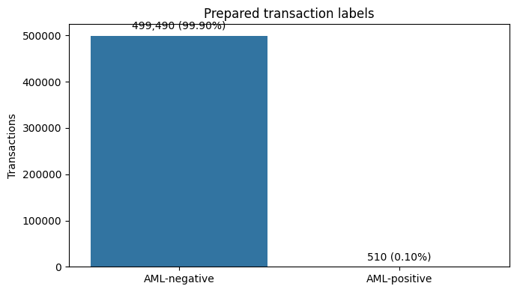
Figure 1. Inline chart output from notebook cell 13.
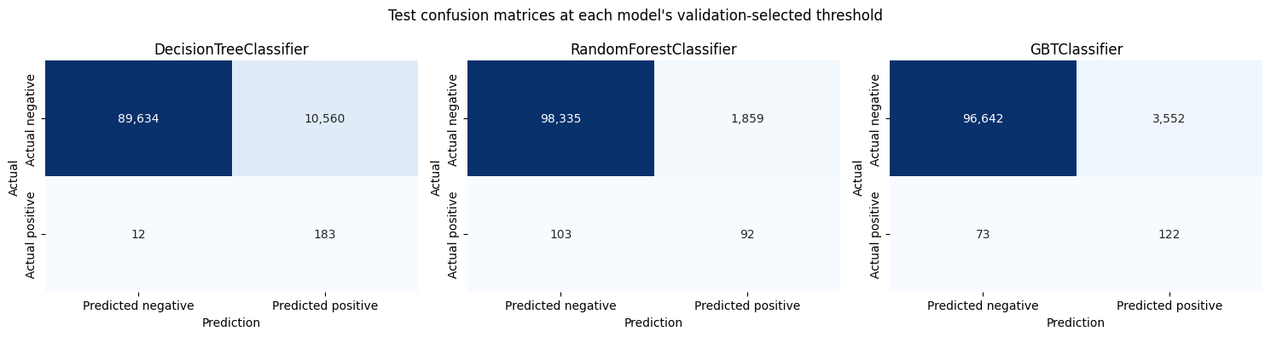
Figure 2. Inline chart output from notebook cell 22.
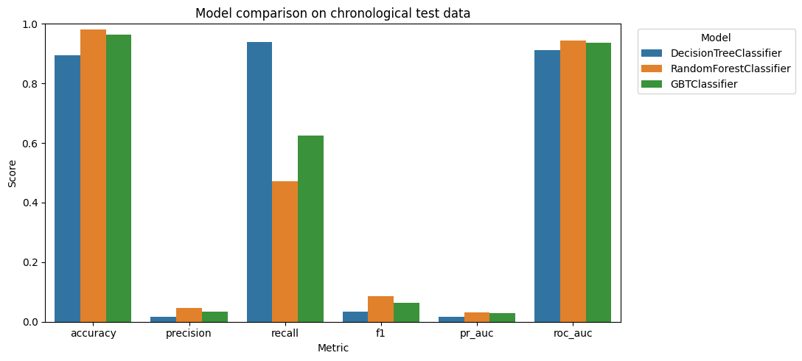
Figure 3. Inline chart output from notebook cell 22.
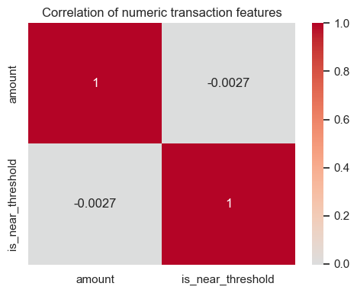
Figure 4. Inline chart output from notebook cell 24.
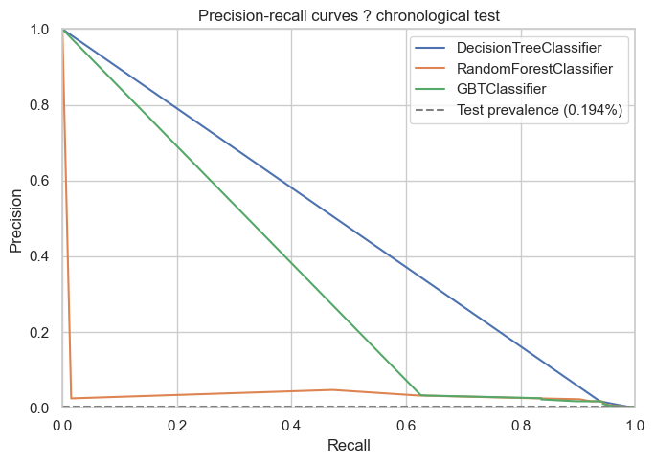
Figure 5. Inline chart output from notebook cell 24.
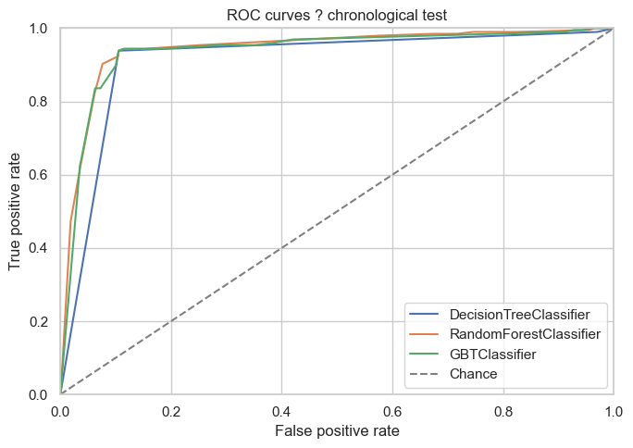
Figure 6. Inline chart output from notebook cell 24.
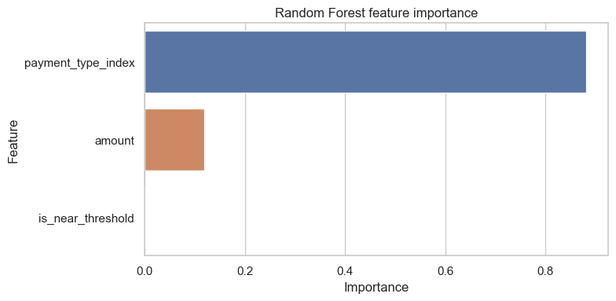
Figure 7. Inline chart output from notebook cell 24.
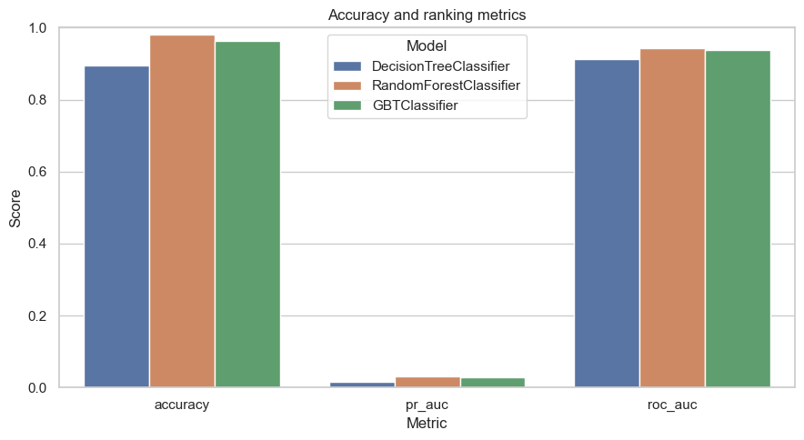
Figure 8. Inline chart output from notebook cell 24.
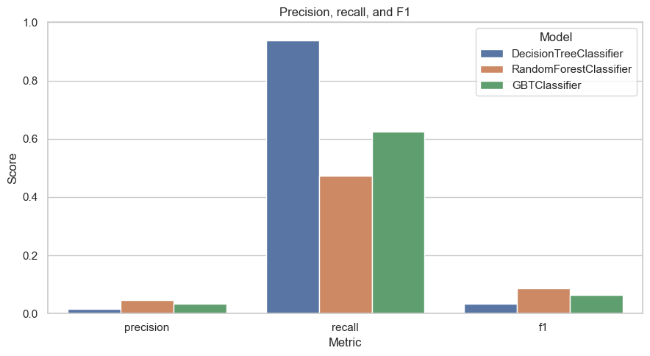
Figure 9. Inline chart output from notebook cell 24.
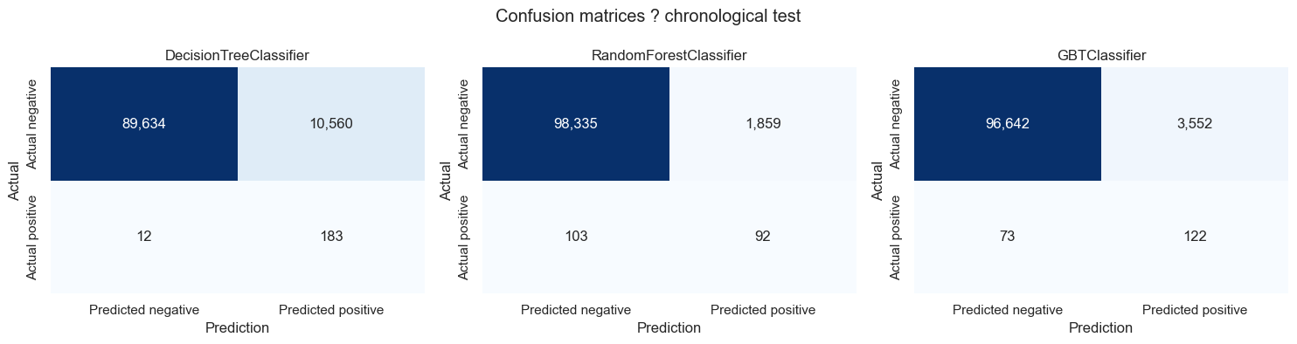
Figure 10. Inline chart output from notebook cell 24.

Notebook output tables

Prepared-data null summary
check | count
prepared_rows | 500000
transaction_id_nulls | 0
timestamp_nulls | 0
sender_account_nulls | 0
receiver_account_nulls | 0
amount_nulls | 0
payment_type_nulls | 0
is_laundering_nulls | 0
is_near_threshold_nulls | 0

Amount-range feature summary
is_near_threshold | transaction_count | minimum_amount | average_amount | maximum_amount
0 | 495007 | 0.0000 | 3,587,389.00 | 84,853,140,000.00
1 | 4993 | 9,000.06 | 9,492.32 | 9,999.92

SQL output sizes
Notebook SQL output |  | Rows displayed
active_senders |  | 20
aml_rate_by_payment_type |  | 7
high_value_transactions |  | 20
payment_types |  | 20
sender_account_join |  | 20
transaction_statistics |  | 1
wildcard_payment_search |  | 20
payment_type | transaction_count | aml_positive | aml_rate
ACH | 59038 | 439 | 0.0074
Cash | 48278 | 14 | 0.0003
Bitcoin | 14370 | 4 | 0.0003
Cheque | 183571 | 32 | 0.0002
Credit Card | 130415 | 21 | 0.0002
Wire | 17004 | 0 | 0.0000
Reinvestment | 47324 | 0 | 0.0000
Label rates describe this synthetic sample; they are not causal risk estimates.

High Value Transactions
transaction_id | sender_account | receiver_account | amount | payment_type
e0565449185c62fec25a8a55dbc168a59ced725410b45a... | 004:806B9AF90 | 0116781:806B9B6A0 | 84,853,140,000.00 | ACH
2762ab5f796daf6a9637530dd4b90dc775e44e300ce097... | 015964:8026E7B20 | 0114590:805FBE280 | 69,431,620,000.00 | Cheque
06ebe610f53707475e67659429d56a7d9e323ae80b1239... | 014433:8023B9740 | 021:80368E630 | 58,678,780,000.00 | Cash
117dea01ede0fcea4b9c46cfb4530e977d0a1b15847513... | 0112497:804BB7A20 | 0014381:80551B160 | 45,882,280,000.00 | Cheque
e47956ae7a3919c3c5ad8500b3da1af98baca506fca672... | 029467:8039E0E70 | 009665:803A9D5B0 | 42,362,270,000.00 | Cheque
First five rows of the saved notebook display; the complete output remains in the notebook.`

Active Senders
sender_account | transaction_count | total_sent
070:100428660 | 16544 | 3,865,869,000.00
070:1004286A8 | 9962 | 3,236,513,000.00
070:100428978 | 2033 | 757,945,800.00
070:1004286F0 | 1814 | 3,424,020,000.00
070:100428780 | 1714 | 15,893,680,000.00
First five rows of the saved notebook display; the complete output remains in the notebook.

Payment Types
transaction_id | sender_account | receiver_account | amount | payment_type
e0565449185c62fec25a8a55dbc168a59ced725410b45a... | 004:806B9AF90 | 0116781:806B9B6A0 | 84,853,140,000.00 | ACH
2762ab5f796daf6a9637530dd4b90dc775e44e300ce097... | 015964:8026E7B20 | 0114590:805FBE280 | 69,431,620,000.00 | Cheque
06ebe610f53707475e67659429d56a7d9e323ae80b1239... | 014433:8023B9740 | 021:80368E630 | 58,678,780,000.00 | Cash
117dea01ede0fcea4b9c46cfb4530e977d0a1b15847513... | 0112497:804BB7A20 | 0014381:80551B160 | 45,882,280,000.00 | Cheque
e47956ae7a3919c3c5ad8500b3da1af98baca506fca672... | 029467:8039E0E70 | 009665:803A9D5B0 | 42,362,270,000.00 | Cheque
First five rows of the saved notebook display; the complete output remains in the notebook.

Transaction Statistics
transaction_count | total_amount | average_amount | minimum_amount | maximum_amount
500000 | 1,775,830,000,000.00 | 3,551,660.00 | 0.0000 | 84,853,140,000.00

Sender Account Join
transaction_id | sender_account | amount | transaction_count | average_amount
58528390079edf2a0eefe445324b37ddb965ee8d159db4... | 070:100428660 | 223,137,400.00 | 16544 | 233,671.99
65fa475bc7d12513c8b94f25dd7f32ff437bb201a2c27d... | 070:100428660 | 180,488,900.00 | 16544 | 233,671.99
5213dda93f65639728dedddd90d2d18df6208fd8ae62b1... | 070:100428660 | 160,331,800.00 | 16544 | 233,671.99
d7f29189284b5b0896e66313cd5d053a00bb31a1c02f22... | 070:100428660 | 152,999,400.00 | 16544 | 233,671.99
cc54ccf431e4b027b4e0cf9e442455556c89b403cdb60f... | 070:100428660 | 147,297,800.00 | 16544 | 233,671.99
First five rows of the saved notebook display; the complete output remains in the notebook.

Wildcard Payment Search
transaction_id | sender_account | receiver_account | amount | payment_type
e0565449185c62fec25a8a55dbc168a59ced725410b45a... | 004:806B9AF90 | 0116781:806B9B6A0 | 84,853,140,000.00 | ACH
2762ab5f796daf6a9637530dd4b90dc775e44e300ce097... | 015964:8026E7B20 | 0114590:805FBE280 | 69,431,620,000.00 | Cheque
06ebe610f53707475e67659429d56a7d9e323ae80b1239... | 014433:8023B9740 | 021:80368E630 | 58,678,780,000.00 | Cash
117dea01ede0fcea4b9c46cfb4530e977d0a1b15847513... | 0112497:804BB7A20 | 0014381:80551B160 | 45,882,280,000.00 | Cheque
e47956ae7a3919c3c5ad8500b3da1af98baca506fca672... | 029467:8039E0E70 | 009665:803A9D5B0 | 42,362,270,000.00 | Cheque
First five rows of the saved notebook display; the complete output remains in the notebook.

11. Results and Discussion
The following results are read from the notebook's embedded metrics and split tables. Threshold-dependent measures use each classifier's validation-selected threshold; PR-AUC and ROC-AUC use continuous test-set scores.
model | accuracy | precision | recall | f1 | pr_auc | roc_auc | tp | tn | fp | fn | threshold
Decision Tree | 0.8947 | 0.0170 | 0.9385 | 0.0335 | 0.0165 | 0.9129 | 183 | 89634 | 10560 | 12 | 0.9021
Random Forest | 0.9805 | 0.0472 | 0.4718 | 0.0857 | 0.0315 | 0.9428 | 92 | 98335 | 1859 | 103 | 0.9073
Gradient-Boosted Trees | 0.9639 | 0.0332 | 0.6256 | 0.0631 | 0.0291 | 0.9368 | 122 | 96642 | 3552 | 73 | 0.8754

Chronological split counts
split | rows | positive | negative | positive_rate
Train | 299730 | 212 | 299518 | 0.0707%
Validation | 99881 | 103 | 99778 | 0.1031%
Test | 100389 | 195 | 100194 | 0.1942%

Confusion counts
Model | TP | TN | FP | FN
DecisionTreeClassifier | 183 | 89634 | 10560 | 12
RandomForestClassifier | 92 | 98335 | 1859 | 103
GBTClassifier | 122 | 96642 | 3552 | 73
The Decision Tree's high recall is accompanied by many false positives. The Random Forest has the strongest F1 and ranking scores in this run but lower recall. Positive prevalence is low, so high accuracy or ROC-AUC alone does not demonstrate useful real-world AML detection.

12. Conclusion and Future Work
The project demonstrates an end-to-end local Spark workflow using synthetic AMLSim data, inline SQL results, three classifiers, and imbalance-aware evaluation. Results are limited by the synthetic labels, notebook's selected features, one sampled dataset, and one chronological test period.
Future educational work could compare additional temporal periods, richer account or network features, calibration, and threshold policies tied to a defined review capacity. Any real-world use would require governed data, independent validation, compliance controls, and human oversight; none is implemented here.

References
- [1] IBM Research, AMLSim: Anti-Money Laundering Simulator. https://github.com/IBM/AMLSim
- [2] IBM AMLSim Wiki, Download Example Data Set. https://github.com/IBM/AMLSim/wiki/Download-Example-Data-Set
- [3] Apache Software Foundation, Spark 3.5 Documentation. https://spark.apache.org/docs/3.5.9/
- [4] Fintech-secure-aml-spark project notebook, notebooks/01_aml_spark_workflow.ipynb.

