Ideation Phase
Brainstorm & Idea Prioritization Template

Date | 18 June 2026
Team ID | -
Project Name | Online Complaint Registration and Management System
Maximum Marks | 4 Marks

Developer Details and Selection the Problem Statement
Developer Name | Kavya Veginati
Role | Full Stack Developer
Selected Problem Statement | Online Complaint Registration and Management System
Problem Focus | A MERN web application to register, track, assign, resolve, and monitor complaints through user, agent, and admin roles.
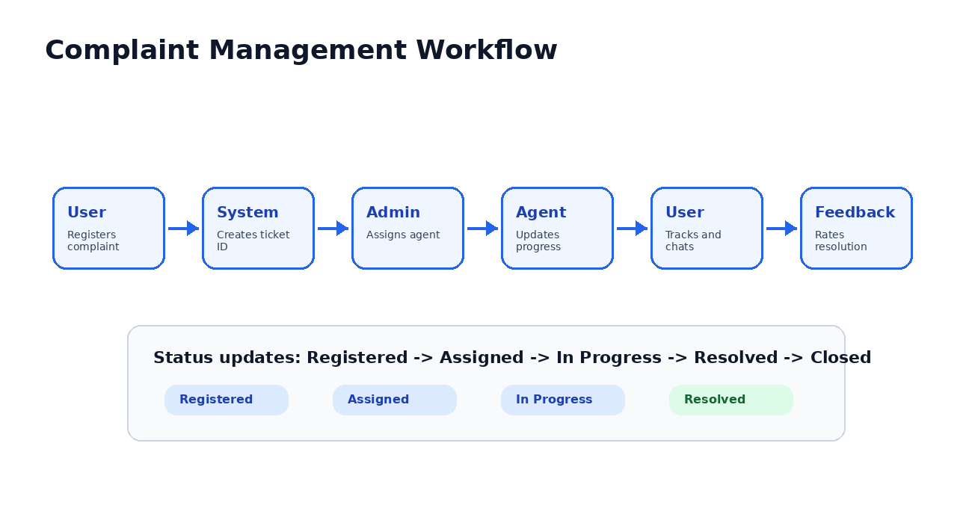
Brainstorm, Idea Listing and Grouping
S.No | Idea | Grouping / Module | Purpose
1 | User registration and login | Authentication | Allows users, agents, and admins to securely access the system.
2 | Complaint submission form | User Module | Captures complaint title, category, description, and priority.
3 | Complaint status tracking | User Module | Provides transparency from registration to resolution.
4 | Agent assignment | Admin Module | Assigns complaints to responsible agents for faster resolution.
5 | Agent dashboard | Agent Module | Helps agents view assigned complaints and update progress.
6 | Admin analytics dashboard | Admin Module | Shows total, pending, in-progress, and resolved complaints.
7 | Feedback and rating | Feedback Module | Collects user satisfaction after complaint resolution.
8 | Email notifications | Communication | Sends automatic updates for complaint actions.
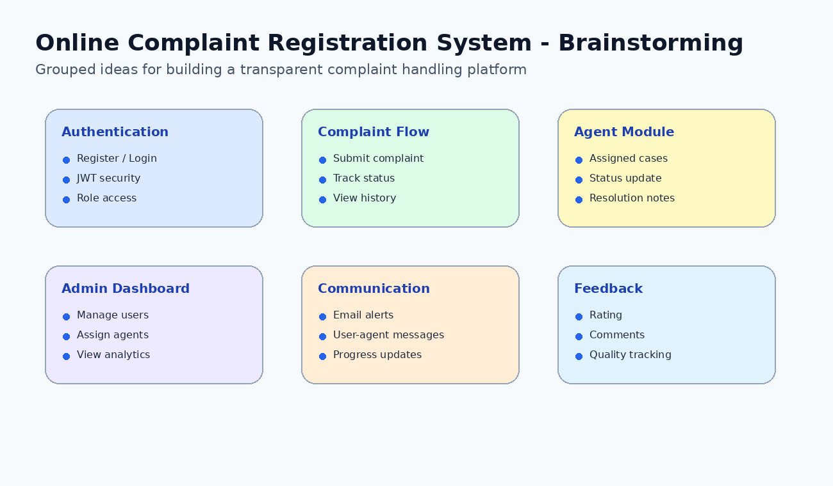
Idea Prioritization
Idea | Priority | Reason | Implementation Order
User Authentication | High | Required for secure role-based access. | 1
Complaint Submission | High | Main feature of the complaint system. | 2
Complaint Tracking | High | Improves transparency for users. | 3
Agent Assignment | High | Connects complaints with responsible agents. | 4
Admin Dashboard | Medium | Helps monitor system performance. | 5
Feedback System | Medium | Improves service quality and user satisfaction. | 6
Email Notifications | Low | Useful enhancement after core flow is complete. | 7
