Ideation Phase
Define the Problem Statements
Date | 18 June 2026
Team ID | -
Project Name | Online Complaint Registration and Management System
Maximum Marks | 2 Marks
Customer Problem Statement Template:
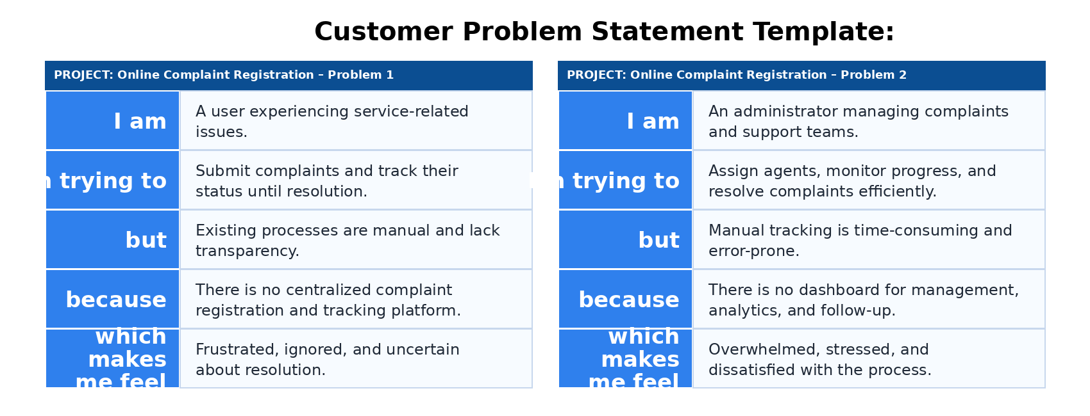
Problem Statement (PS) | I am (Customer) | I’m trying to | But | Because | Which makes me feel
PS-1 | A user experiencing service-related issues. | Submit complaints and track their status until resolution. | Traditional complaint systems are manual and lack transparency. | There is no centralized platform that provides complaint registration, tracking, and communication with support agents. | Frustrated, ignored, and uncertain about issue resolution.
PS-2 | An administrator managing complaints and support teams. | Manage complaints, assign agents, and monitor resolution efficiently. | Manual tracking and assignment processes are time-consuming and error-prone. | There is no centralized dashboard for complaint management, performance monitoring, and analytics. | Overwhelmed, stressed, and dissatisfied with the management process.

