User Acceptance Testing (UAT) Template
Date | 19 June 2026
Team ID | -
Project Name | Online Complaint Registration and Management System
Maximum Marks

Project Overview:
Project Name: Online Complaint Registration and Management System
Project Description: A MERN stack web application that enables users to register complaints, track complaint status, receive updates, and submit feedback. Agents can view assigned complaints, update progress, and resolve issues. Admins can manage users, assign complaints, monitor analytics, and generate reports.
Project Version: 1.0.0
Testing Period: 15 June 2026 to 19 June 2026
Testing Scope:
Features & Functionalities Tested
- User Identity & Security: Role-based registration and login for Users, Agents, and Admins.
- Complaint Registration: Complaint form with title, category, description, priority, and optional attachment.
- Complaint Tracking Flow: Status updates from Registered to Assigned, In Progress, Resolved, and Closed.
- Operations & Notifications: Agent assignment, dashboard monitoring, email alerts, and feedback collection.
User Stories (Requirements) Verified
- USN-1 / USN-2: Users can register securely and log in to raise complaints.
- USN-3: Users can submit complaints with category, description, and priority.
- USN-4 / USN-5: Admins can assign complaints and agents can update resolution progress.
- USN-6 / USN-7: Users can track complaint status and submit feedback after resolution.
Testing Environment:
URL/Location: Local development environment:
- Backend API Server: http://localhost:5000
- Frontend Web App: http://localhost:5173
Credentials (if required):
- User: user@complaints.local / User@123
- Agent: agent@complaints.local / Agent@123
- Admin: admin@complaints.local / Admin@123
- Admin Registration Secret Passcode: ComplaintAdmin2026
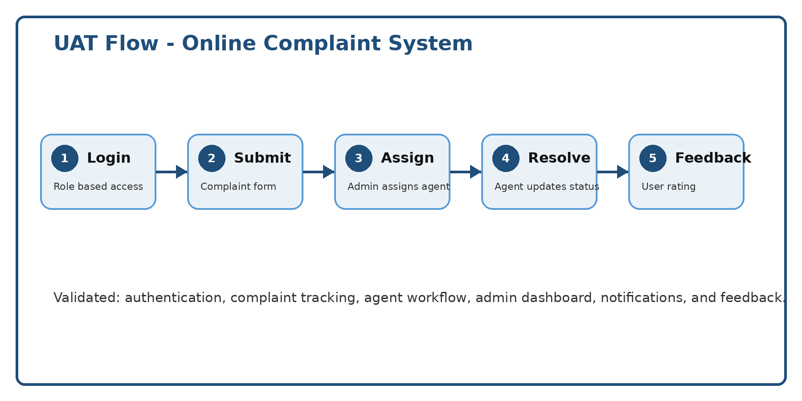
Test Cases:
Test Case ID | Test Scenario | Test Steps | Expected Result | Actual Result | Pass/Fail
TC-001 | User Registration Validation | 1. Go to /register.  2. Enter name, email, phone, and password.  3. Leave required fields blank or use an invalid email.  4. Click Register. | System blocks registration and displays validation messages. | Registration blocked and validation messages displayed correctly. | Pass
TC-002 | Valid User Login | 1. Register or use existing user credentials.  2. Go to /login.  3. Enter valid email and password.  4. Click Login. | User is authenticated and redirected to the user dashboard. | Login successful; dashboard loaded with complaint options. | Pass
TC-003 | Complaint Submission | 1. Log in as User.  2. Open New Complaint form.  3. Enter title, category, description, and priority.  4. Submit complaint. | Complaint is created with unique complaint ID and status Registered. | Complaint saved in database and complaint ID displayed. | Pass
TC-004 | Complaint Status Tracking | 1. Log in as User.  2. Open My Complaints.  3. Select a complaint.  4. Check status timeline. | User can view current status and previous updates. | Status timeline displayed correctly with latest update. | Pass
TC-005 | Admin Complaint Assignment | 1. Log in as Admin.  2. Open complaints dashboard.  3. Select unassigned complaint.  4. Assign it to an agent. | Complaint is assigned to selected agent and status changes to Assigned. | Agent assignment completed and reflected on dashboards. | Pass
TC-006 | Agent Progress Update | 1. Log in as Agent.  2. Open Assigned Complaints.  3. Select complaint.  4. Update status to In Progress / Resolved. | Complaint status updates and user receives visibility on progress. | Status updated successfully and visible to the user. | Pass
TC-007 | Feedback Submission | 1. Log in as User.  2. Open resolved complaint.  3. Provide rating and comments.  4. Submit feedback. | Feedback is saved and linked to the complaint record. | Feedback submitted successfully and visible in admin reports. | Pass
TC-008 | Admin Analytics Dashboard | 1. Log in as Admin.  2. Open Analytics dashboard.  3. Review complaint counts and status metrics. | Dashboard shows total, pending, in-progress, and resolved complaint counts. | Analytics cards and charts displayed correct values. | Pass

Bug Tracking:
Bug ID | Bug Description | Steps to Reproduce | Severity | Status | Additional Feedback / Fix
BG-001 | Complaint status does not refresh immediately after agent update. | 1. Agent updates a complaint status.  2. User opens My Complaints.  3. Old status is still displayed until manual refresh. | High | Closed | Updated frontend state refresh after status update API response.
BG-002 | Admin assignment dropdown shows inactive agents. | 1. Log in as Admin.  2. Open complaint assignment modal.  3. Inactive agents appear in the dropdown. | Medium | Closed | Filtered assignment list to show only active agent accounts.
BG-003 | Feedback form appears before complaint is resolved. | 1. Log in as User.  2. Open an In Progress complaint.  3. Feedback button is visible. | Medium | Closed | Restricted feedback form visibility to Resolved or Closed complaints only.

Sign-off:
Tester Name: Kavya
Date: 19 June 2026
Signature: Kavya

