Experiment-7.1
Aim:
The aim of this code is to create a basic HTTP server using Node.js. It listens on port 3000 and responds with a plain text message: "Hello, this is your first Node.js server!
Code:
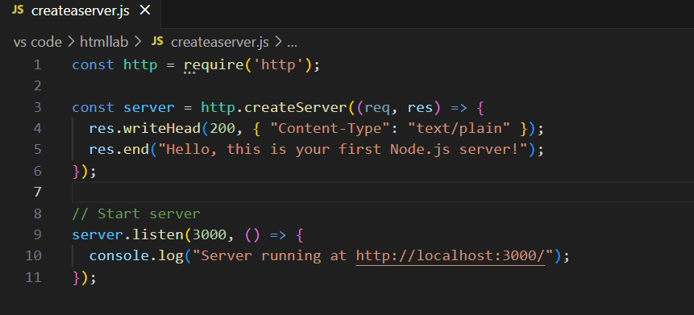
Commend:
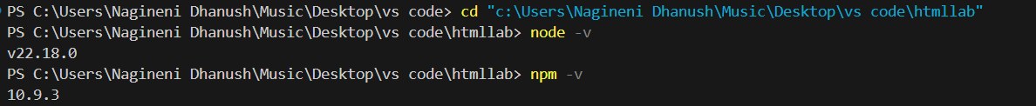
Result:

Output:
