RPA – Report

1. Industry : Telecom

2. Name of the Company : Airtel

3. URL of the website : https://www.airtel.in

4. Name of the process : Port your existing number to airtel prepaid.

5. Technical Requirements :
a) Automation Anywhere : It is a RPA tool, used to automate end to end business processes.
b) Microsoft Excel : A excel sheet contains all required credentials for multiple customers.

6. Project Overview :

a) Description : To port the number is a very lengthy task. This bot will reduce your time and effort
Bot will fetch the details like name, mobile number, address from spreadsheet and loop until it cover rows.
It will fill all the credential present in a row to the form and click on submit button. And repeat this task for each row(i.e. for each customer)

b) Process Diagram :
Open browser
and enter url :
airtel.in
Click on
Prepaid button
Click on
Port to airtel prepaid
Start

Click on
Submit
Row data
remaining
Process
Successful

Column
Data
remaining
Fetch Records
From Excel Sheet
Select first
Date and time
No

Yes

No

Yes

7. Use case : (Algorithm)

i) Open browser and enter url: https://www.airtel.in
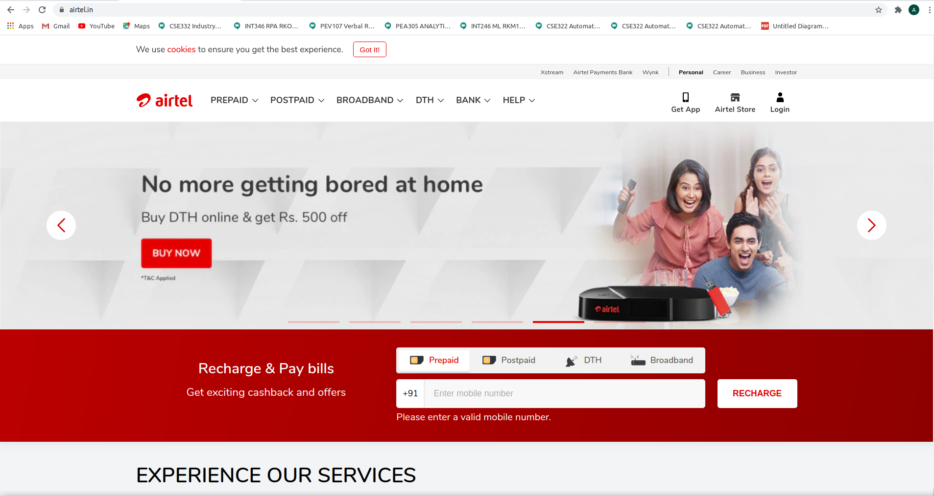
ii) Click on Prepaid and select Port to Airtel Prepaid
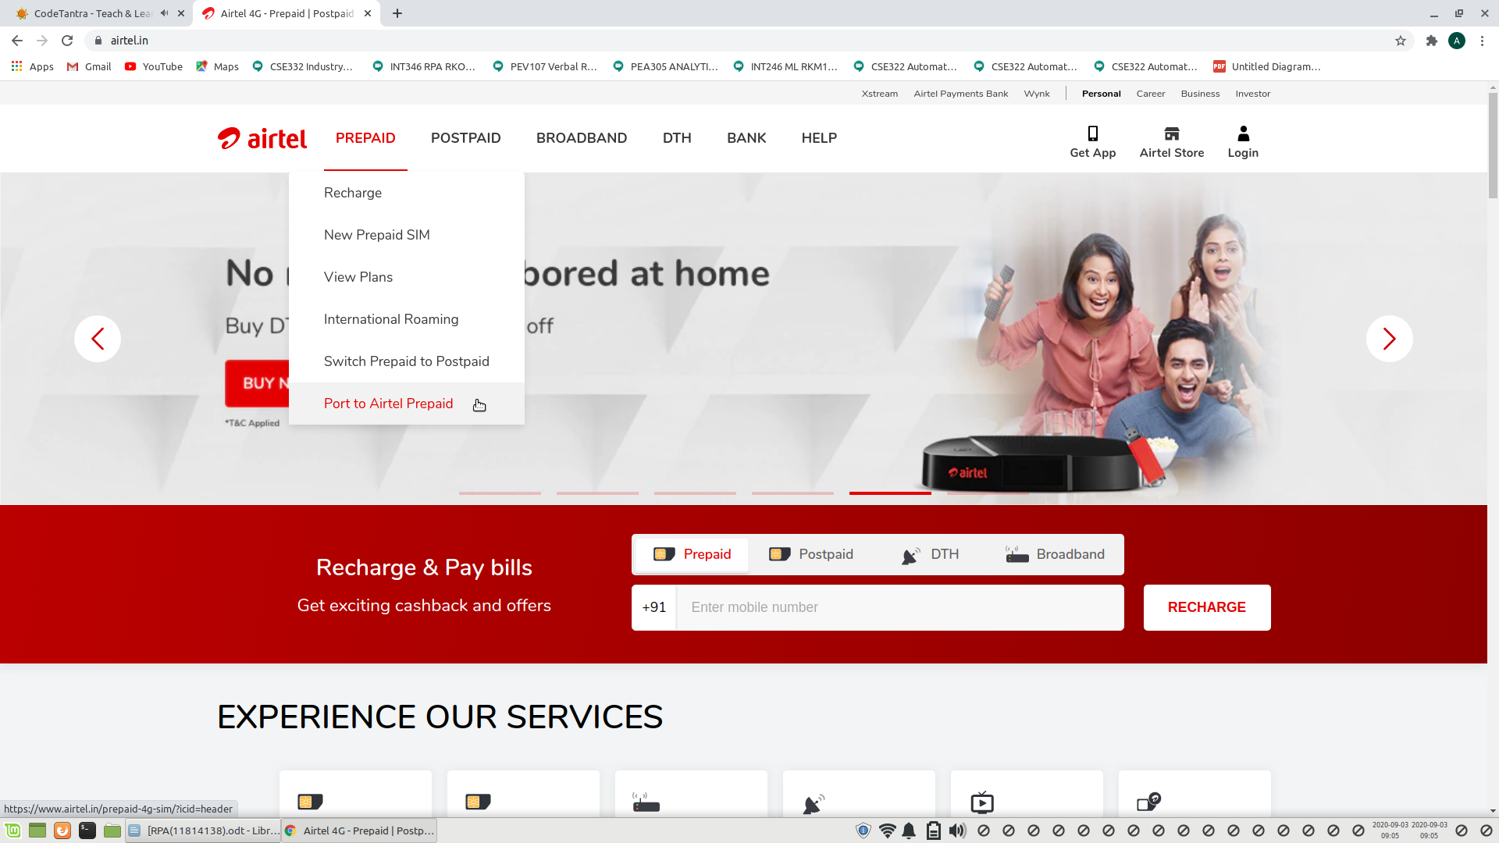

iii) Fill all the credentias, in location fill exact location and select the first one available.
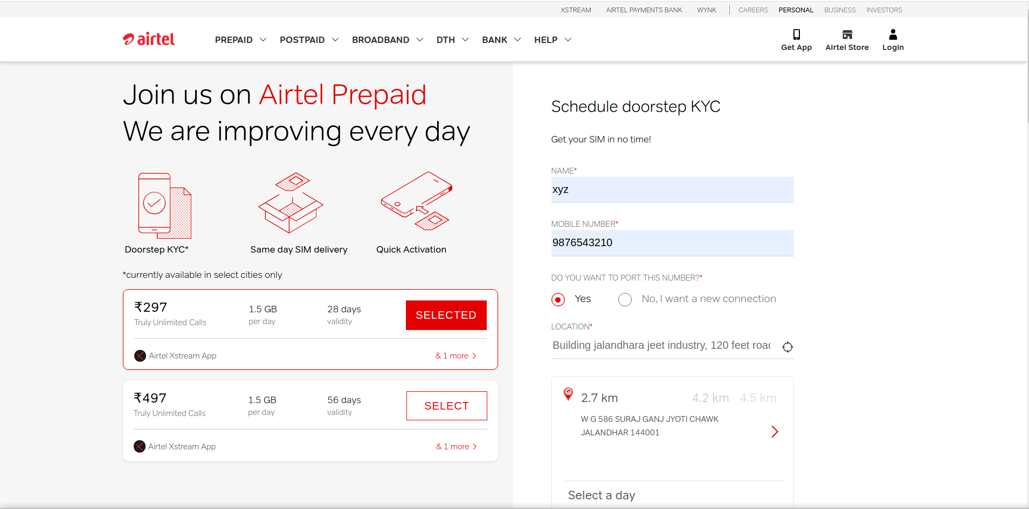
iv) Click on submit button and your process is successful.
