Name: Ashish Verma Course:CS773 Exam1

Solution 1

Given

|  |  |  |
| --- | --- | --- |
| Professional# | Experience (years) | Actual Salary ($K) |
| 1 | 2 | 38 |
| 2 | 4 | 38 |
| 3 | 6 | 50 |

Given Linear Equation

salary($K)=30+2.5×Experience (in years)

Professional 1 Predicted Salary

* Predicted Salary=30+2.5×2= **35K**
* MSE=(38−35)^2
* MSE=9

Professional 2 Predicted Salary

* Predicted Salary=30+2.5×4= **30K**
* MSE=(38−40)^2
* MSE=4

Professional 3 Predicted Salary

* Predicted Salary=30+2.5×6= **45K**
* MSE=(50−45)^2
* MSE=25

Total MSE = 1/3(9+4+25) = **12.67**

Solution 2

Given

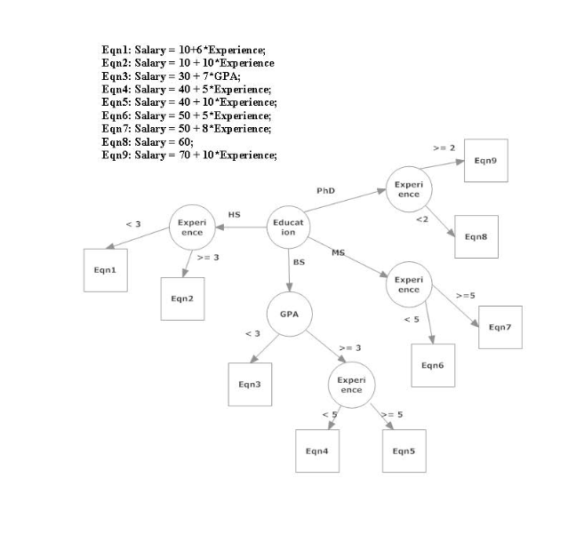

Decision Tree Analysis

Applicant (i): Education=MS, GPA=4.0, Experience=8 years

* + Education: MS
  + GPA: 4.0
  + Experience: 8 years

Following the decision tree:

* For MS, GPA >= 3, experience >= 5:
  + Use Eqn7: Salary = 50 + 8 * Experience
  + Salary = 50 + 8 * 8
  + Salary = 50 + 64
  + Salary = 114 K

Applicant (ii): Education=HS, GPA=3.5, Experience=12years

* Education: HS
* GPA: 3.5
* Experience: 12 years

Following the decision tree:

* For HS, experience >= 3:
  + Use Eqn2: Salary = 10 + 10 * Experience
  + Salary = 10 + 10 * 12
  + Salary = 10 + 120
  + Salary = 130 K

Applicant (iii): Education=PhD, GPA=3.0, Experience=0 years

* + Education: PhD
  + GPA: 3.0
  + Experience: 0 years

Following the decision tree:

* For PhD, experience < 2:
  + Use Eqn8: Salary = 60
  + Salary = 60 K

The estimated salaries for the three applicants are:

* Applicant (i): 114 K
* Applicant (ii): 130 K
* Applicant (iii): 60 K

Solution 3

Given

|  |  |  |  |
| --- | --- | --- | --- |
| Professional# | Name | Education | Experience (years) |
| 1 | John | BS | 10 |
| 2 | Jane | PhD | 5 |
| 3 | Jim | HS | 25 |

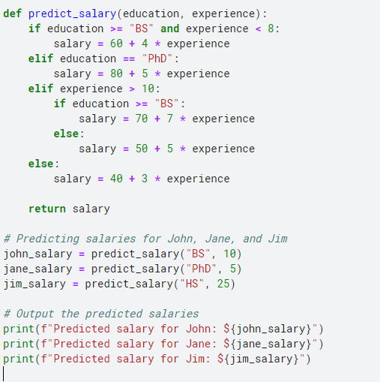

* Predicted salary for John: $70
* Predicted salary for Jane: $80
* Predicted salary for Jim: $245

Solution 4

Given

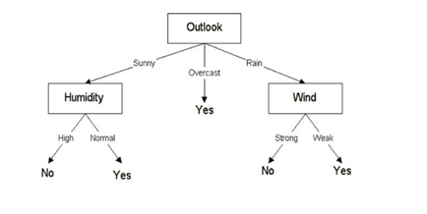

Derived Rules from the decision tree path

* If the outlook is Sunny and the humidity is High, then Play = No.
* If the outlook is Sunny and the humidity is Normal, then Play = Yes.
* If the outlook is Overcast, then Play = Yes.
* If the outlook is Rain and the wind is Strong, then Play = No.
* If the outlook is Rain and the wind is Weak, then Play = Yes.

Solution 5

Given

|  |  |  |  |  |
| --- | --- | --- | --- | --- |
| Instance# | Price | Capacity | Safety | Acceptability |
| 1 | L | 4 | High | Good |
| 2 | H | 2 | High | Bad |
| 3 | M | 4 | Medium | Good |
| 4 | L | 7 | High | Good |
| 5 | M | 7 | Low | Bad |
| 6 | H | 7 | Medium | Bad |

Frequency Table

|  |  |  |  |  |
| --- | --- | --- | --- | --- |
| Acceptability | Price | Capacity | Safety | Count |
| Good | L | 4 | High | 1 |
| Good | L | 7 | High | 1 |
| Bad | H | 2 | High | 1 |
| Bad | M | 7 | Low | 1 |
| Bad | H | 7 | Medium | 1 |

Applying Laplace Smoothing

|  |  |  |  |  |
| --- | --- | --- | --- | --- |
| Acceptability | Price | Capacity | Safety | Count |
| Good | L | 4 | High | 2 |
| Good | L | 7 | High | 2 |
| Bad | H | 2 | High | 2 |
| Bad | M | 7 | Low | 2 |
| Bad | H | 7 | Medium | 2 |

Calculating Probabilities

For Acceptability = Good:

P(Acceptability=Good∣Price=L,Capacity=7,Safety=M)= 0.5×0.67×0.33×0.33=0.0363

For Acceptability = Bad:

P(Acceptability=Bad∣Price=L,Capacity=7,Safety=M)= 0.5×0.33×0.67×0.33 = 0.0363

Normalize Probabilities

P(Acceptability=Good∣Price=L,Capacity=7,Safety=M) = 0.0363/(0.0363+0.0363) = 0.5

P(Acceptability=Bad∣Price=L,Capacity=7,Safety=M) =0.0363/(0.0363+0.0363) = 0.5

Construct the Prediction Table

|  |  |  |  |  |  |  |
| --- | --- | --- | --- | --- | --- | --- |
| Instance# | Price | Capacity | Safety | Acceptability (Predicted) | Probability (Good) | Probability (Bad) |
| 1 | L | 4 | High | Good | 0.5 | 0.5 |
| 2 | H | 2 | High | Bad | 0.5 | 0.5 |
| 3 | M | 4 | Medium | Good | 0.5 | 0.5 |
| 4 | L | 7 | High | Good | 0.5 | 0.5 |
| 5 | M | 7 | Low | Bad | 0.5 | 0.5 |
| 6 | H | 7 | Medium | Bad | 0.5 | 0.5 |
| New | L | 7 | M | ? | 0.5 | 0.5 |

* Acceptability: **Good**
* Probability (Good): **0.5**
* Probability (Bad): **0.5**

Solution 6

Given

|  |  |  |  |  |
| --- | --- | --- | --- | --- |
| Instance# | Price | Capacity | Safety | Acceptability |
| 1 | L | 4 | High | Good |
| 2 | H | 2 | High | Bad |
| 3 | M | 4 | Medium | Good |
| 4 | L | 7 | High | Good |
| 5 | M | 7 | Low | Bad |
| 6 | H | 7 | Medium | Bad |

**Since calculations are very long for entropy with given time frame I am going with python based implementation**

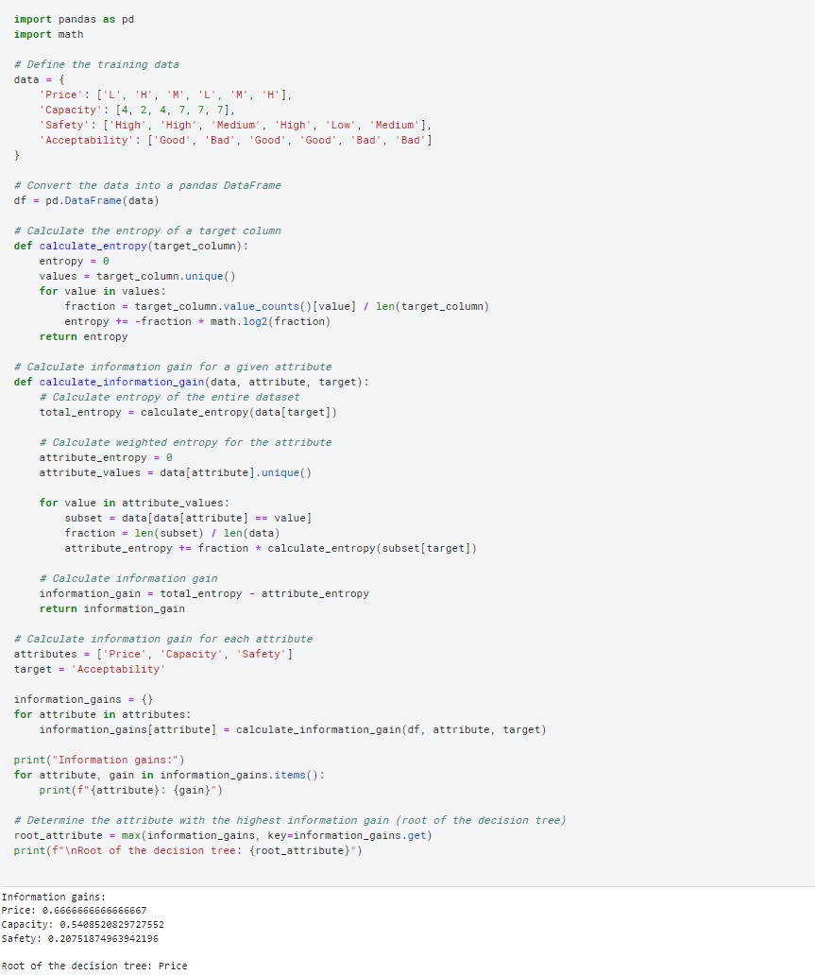

**As we can clearly Price is the root**

Solution 7

Given

|  |  |  |  |  |
| --- | --- | --- | --- | --- |
| Inst# | Age | Height | Weight | Health |
| 1 | 35 | 5.6 | 175 | Excellent |
| 2 | 55 | 6 | 150 | Good |
| 3 | 50 | 5.8 | 200 | Okay |
| 4 | 65 | 5.5 | 175 | Good |
| 5 | 45 | 5.6 | 190 | Okay |

Normalize the attribute

* Age: 30-70
* Height: 4.0-7.0
* Weight: 100-300
* Normalized Age = 50 -30/70 -30 = 0.5
* Normalized Height = 5.5 - 4.0 /7.0 – 4.0 = 0.5
* Normalized Weight = 190 - 100 /300 – 100 = 0.45

The normalized unknown instance is <0.5,0.5,0.45>

Calculate Euclidean distances

Instance 1

* ED1 = sqrt((0.5 – 0.125) ^2+(0.5 -0.533)^2+(0.45 -0.375)^2)
* ED1 = 0.384

Instance 2

* ED2 = sqrt((0.5 – 0.625) ^2+(0.5 -0.6667)^2+(0.45 -0.25)^2)
* ED2 = 0.289

Instance 3

* ED2 = sqrt((0.5 – 0.5) ^2+(0.5 -0.6)^2+(0.45 -0.5)^2)
* ED2 = 0.10125

Instance 4

* ED2 = sqrt((0.5 – 0.875) ^2+(0.5 -0.5)^2+(0.45 -0.375)^2)
* ED2 = 0.382

Instance 5

* ED2 = sqrt((0.5 – 0.375) ^2+(0.5 -0.5333)^2+(0.45 -0.45)^2)
* ED2 = 0.129

The nearest instance to the unknown instance <0.5,0.5,0.45> is instance 1 with a Euclidean distance of approximately 0.129

Predict Health

Age=50, Height=5.5, Weight=190> is **Okay**.

Solution 8

Given

|  |  |  |  |  |
| --- | --- | --- | --- | --- |
| Instance# | Price | Capacity | Safety | Acceptability |
| 1 | L | 4 | High | Good |
| 2 | H | 2 | High | Bad |
| 3 | M | 4 | Medium | Good |
| 4 | L | 7 | High | Good |
| 5 | L | 7 | Low | Bad |
| 6 | H | 7 | High | Bad |

Analyze each attribute

**Price:**

* L: 3 instances (1, 4, 5)
* M: 1 instance (3)
* H: 2 instances (2, 6)

**Capacity:**

* 2: 1 instance (2)
* 4: 2 instances (1, 3)
* 7: 3 instances (4, 5, 6)

**Safety:**

* High: 4 instances (1, 2, 4, 6)
* Medium: 1 instance (3)
* Low: 1 instance (5)

Calculate error rates for each attribute

**Price:**

* L: Error rate = 1/3 (1 incorrect out of 3) = 0.33
* M: Error rate = 0/1 = 0
* H: Error rate = 2/2 = 1.0

**Capacity:**

* 2: Error rate = 1/1 = 1.0
* 4: Error rate = 0/2 = 0
* **7: Error rate = 2/3 = 0.67**

**Safety:**

* High: Error rate = 1/4 = 0.25
* Medium: Error rate = 0/1 = 0
* Low: Error rate = 1/1 = 1.0

Select the attribute with the lowest error rate

From the analysis, **Price** has the lowest error rate:

* L: Error rate = 0.33
* M: Error rate = 0
* H: Error rate = 1.0

Therefore, the 1R rule is to predict **Acceptability** based on **Price**:

* **L** predicts **Good**
* **M** predicts **Good**
* **H** predicts **Bad**

Final Selected Rule:

* If **Price = L**, then **Acceptability = Good**
* If **Price = M**, then **Acceptability = Good**
* If **Price = H**, then **Acceptability = Bad**

Solution 9

Given

|  |  |  |  |  |  |  |  |
| --- | --- | --- | --- | --- | --- | --- | --- |
| Inst# | Age | Height | Weight | Predicted Prob. | | | Actual |
|  |  |  |  | Okay | Good | Excellent |  |
| 1 | 35 | 5.6 | 175 | 0.4 | 0.4 | 0.2 | Okay |
| 2 | 55 | 6 | 150 | 0.3 | 0.2 | 0.5 | Good |
| 3 | 50 | 5.8 | 200 | 0.1 | 0.6 | 0.3 | Excellent |

Quadratic loss function

Instance 1

* Okay: (0.4−1)^2=(0.6)^2=0.36
* Good: (0.4−0)^2=(0.4)^2=0.16
* Excellent: (0.2−0)^2=(0.2)^2=0.04

MSE = 1/3*(0.26+0.16+0.04) =0.153

Instance 2

* Okay: (0.3−0)^2=(0.3)2=0.09
* Good: (0.2−1)^2=(0.8)2=0.64
* Excellent: (0.5−0)^2=(0.5)2=0.25

MSE = 1/3*(0.09+0.64+0.25) =0.3267

Instance 3

* Okay: (0.1−0)2=(0.1)2=0.01
* Good: (0.6−0)2=(0.6)2=0.36
* Excellent: (0.3−1)2=(0.7)2=0.49

MSE = 1/3*(0.01+0.36+0.49)

=0.2867

Total MSE =(0.153+0.3267+0.2867)/3

=**0.2554**

Information loss function

Instance 1

Loss=−(1*log_2(0.4)+0*log_2(0.4)+0*log_2(0.2))

=1.3219

Instance 2

Loss=−(0*log_2​(0.3)+1*log_2​(0.2)+0*log_2​(0.5))

=2.3219

Instance 3

Loss = −(0*log_2​(0.1)+0*log_2​(0.6)+1*log_2​(0.3))

=1.7369

Total Entropy loss =( 1.3219+2.3219 +1.7369)/3

=**1.7936**

Solution 10

Given

* Total number of volunteers (N) = 2500
* Number of volunteers who actually have the disease (Disease positive) = 1500
* Number of volunteers identified by the test as having the disease (Test positive) = 1750
* Number of volunteers correctly identified as having the disease (True positives, TP) = 1000
* TP = 1000
* FN = 1500 – 1000 = 500
* TN = 2500−1500−(1750−1000)=1000
* FP= 1750−1000=750

**Sensitivity = TP/(TP+FN) = 1000/1000+500 = 0.667**

**Specificity = TN/(TN+FP) = 1000/1000+750 = 0.571**

Solution 11

Given

|  |  |  |
| --- | --- | --- |
| Customer# | Predicted Prob (Yes) | Actual |
| 1 | 0.85 | Yes |
| 2 | 0.5 | No |
| 3 | 0.95 | No |
| 4 | 0.99 | Yes |
| 5 | 0.45 | Yes |
| 6 | 0.97 | No |
| 7 | 0.8 | Yes |
| 8 | 0.6 | No |
| 9 | 0.75 | Yes |
| 10 | 0.7 | No |

Python

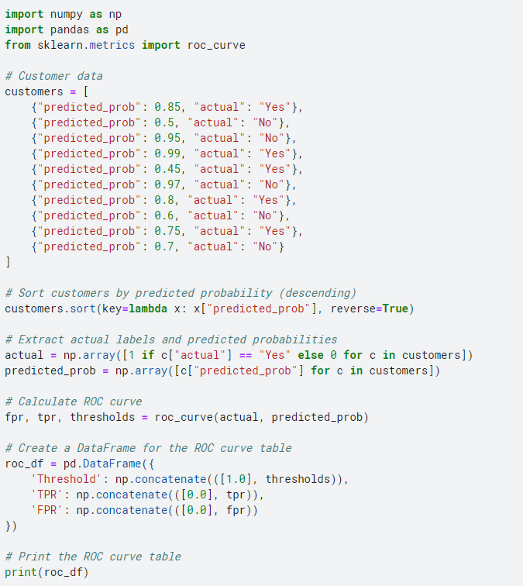

Threshold TPR FPR

0 1.00 0.0 0.0

1 1.99 0.0 0.0

2 0.99 0.2 0.0

3 0.95 0.2 0.4

4 0.75 0.8 0.4

5 0.50 0.8 1.0

6 0.45 1.0 1.0

Sort the data with predicted probability in descending order

|  |  |  |
| --- | --- | --- |
| Customer# | Predicted Prob (Yes) | Actual |
| 4 | 0.99 | Yes |
| 6 | 0.97 | No |
| 3 | 0.95 | No |
| 7 | 0.8 | Yes |
| 1 | 0.85 | Yes |
| 9 | 0.75 | Yes |
| 10 | 0.7 | No |
| 8 | 0.6 | No |
| 2 | 0.5 | No |
| 5 | 0.45 | Yes |

Now, calculate TPR, FPR, and the threshold for each data point:

|  |  |  |
| --- | --- | --- |
| Threshold = 1.0 (All predicted as Yes)   * TPR = 4/4 = 1.00 * FPR = 6/6 = 1.00   Threshold = 0.99   * TPR = 4/4 = 1.00 * FPR = 6/6 = 1.00   Threshold = 0.95   * TPR = 4/4 = 1.00 * FPR = 5/6 = 0.833   Threshold = 0.85   * TPR = 4/4 = 1.00 * FPR = 3/6 = 0.500   Threshold = 0.8   * TPR = 4/4 = 1.00 * FPR = 2/6 = 0.333   Threshold = 0.75   * TPR = 4/4 = 1.00 * FPR = 1/6 = 0.167   Threshold = 0.7   * TPR = 3/4 = 0.75 * FPR = 1/6 = 0.167   Threshold = 0.6   * TPR = 3/4 = 0.75 * FPR = 1/6 = 0.167   Threshold = 0.5   * TPR = 3/4 = 0.75 * FPR = 1/6 = 0.167   Threshold = 0.45   * TPR = 3/4 = 0.75 * FPR = 1/5 = 0.200   Threshold = 0.0 (All predicted as No)   * TPR = 0/4 = 0.00 * FPR = 0/6 = 0.00 |  |  |
| |  |  |  | | --- | --- | --- | | Threshold | TPR | FPR | | 1 | 1 | 1 | | 0.99 | 1 | 1 | | 0.95 | 1 | 0.833 | | 0.85 | 1 | 0.5 | | 0.8 | 1 | 0.333 | | 0.75 | 1 | 0.167 | | 0.7 | 0.75 | 0.167 | | 0.6 | 0.75 | 0.167 | | 0.5 | 0.75 | 0.167 | | 0.45 | 0.75 | 0.2 | | 0 | 0 | 0 | |  |  |
|  |  |  |

Solution 12

Given

|  |  |  |
| --- | --- | --- |
| Instance# | Actual | Predicted |
| 1 | 2.5 | 3 |
| 2 | 4 | 4.3 |
| 3 | 3.5 | 2.5 |
| 4 | 5 | 3 |

**MAE** = (2.5-3 + 4.3-4+ 3.5-2.5 + 5-3)/4 = 0.95

So, the mean absolute error for your predictions is **0.95**

**RAE** = (0.2+0.075+0.286+0.4)/4 = 0.25 = **25%**

Solution 13

Given

|  |  |  |  |  |
| --- | --- | --- | --- | --- |
| instance# | Age | GPA | Salary($K) | Cluster# |
| 1 | 25 | 3.8 | 50 | C1 |
| 2 | 30 | 3.6 | 65 | C1 |
| 3 | 23 | 4 | 40 | C1 |
| 4 | 35 | 3 | 70 | C2 |
| 5 | 55 | 3.3 | 90 | C2 |

Normalized Data

|  |  |  |  |  |
| --- | --- | --- | --- | --- |
| **Instance** | **Normalized Age** | **Normalized GPA** | **Normalized Salary** | **Cluster** |
| 1 | 0.1 | 0.95 | 0.375 | C1 |
| 2 | 0.2 | 0.9 | 0.5625 | C1 |
| 3 | 0.06 | 1 | 0.25 | C1 |
| 4 | 0.3 | 0.75 | 0.625 | C2 |
| 5 | 0.7 | 0.825 | 0.875 | C2 |

Single-linkage method:

Distance(C1_1, C2_1):

Distance(C11​,C21​) = sqrt((0.1 – 0.3)^2 + (0.95-0.75)^2 +(0.375 -0.625)^2)

=0.574

Distance(C1_1, C2_2):

Distance(C11​,C22​) = sqrt((0.1 – 0.7)^2 + (0.95-0.825)^2 +(0.375 -0.875)^2)

= 0.796

Distance(C1_2, C2_1)

Distance(C12​,C21​) = sqrt((0.2 – 0.3)^2 + (0.9-0.75)^2 +(0.5625 -0.625)^2)

= 0.191

Distance(C1_2, C2_2)

Distance(C13​,C21​) = sqrt((0.06 – 0.3)^2 + (1.0-0.75)^2 +(0.25 -0.625)^2)

= 0.55

Distance(C1_3, C2_2):

Distance(C13​,C22​) = sqrt((0.06 – 0.7)^2 + (1.0-0.825)^2 +(0.25 -0.825)^2)

=0.92

Minimum distance = min(0.574, 0.796, 0.191, 0.785, 0.55, 0.92)

**Minimum distance ≈ 0.191**

Centroid-linkage method:

Centroid-linkage method computes the distance between the centroids of the two clusters.

Distance using Centroid-linkage method:

* Distance = sqrt((0.12 - 0.5)^2 + (0.95 - 0.7875)^2 + (0.394 - 0.75)^2)
* Distance = sqrt(0.1696 + 0.02600625 + 0.129936)
* Distance = sqrt(0.32553625)
* Distance ≈ 0.571

Therefore, the distance between the centroids of clusters C1 and C2 using the centroid-linkage method is approximately **0.571**.

Solution 14

Given

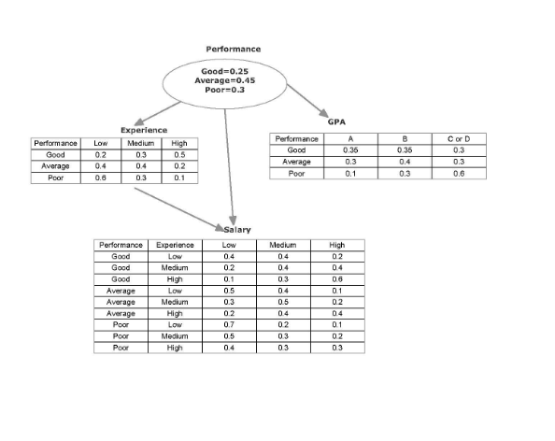

For Performance = Good:

P(Good,GPA=B,Experience=High,Salary=Low)=0.35×0.5×0.1×0.25=0.004375

For Performance = Average:

P(Average,GPA=B,Experience=High,Salary=Low)=0.4×0.2×0.2×0.45=0.0072

For Performance = Poor:

P(Poor,GPA=B,Experience=High,Salary=Low)=0.3×0.1×0.4×0.3=0.0036

Normalization

P(GPA=B,Experience=High,Salary=Low)=0.004375+0.0072+0.0036=0.015175

Conditional probabilities:

* P(Good∣GPA=B,Experience=High,Salary=Low) = 0.004375​/ 0.015175 = 0.288
* P(Average∣GPA=B,Experience=High,Salary=Low) = 0.0072/0.015175 = 0.474
* P(Poor∣GPA=B,Experience=High,Salary=Low) = 0.0036/0.015175 = 0.237

**Good**: 0.288

**Average**: 0.474

**Poor**: 0.237

Solution 15

Given

|  |  |  |  |  |  |
| --- | --- | --- | --- | --- | --- |
| Instance# | Color | Size | Act | Age | Inflated (outcome) |
| 1 | Y | S | S | A | Yes |
| 2 | Y | S | S | C | Yes |
| 3 | Y | S | D | A | Yes |
| 4 | Y | S | S | C | No |
| 5 | Y | L | S | A | Yes |
| 6 | P | L | S | C | Yes |
| 7 | P | L | D | A | No |
| 8 | P | L | D | C | No |
| 9 | P | S | S | A | Yes |
| 10 | P | S | S | C | No |

From the dataset, the instances that satisfy the rule "Color=Y and Size=S and Act=S and Age=A and Inflated=Yes" are:

* Instance 1
* Instance 2
* Instance 5
* Instance 9

So, the number of instances that satisfy the rule = 4

Total number of instances in the dataset = 10

**Support** = 4 / 10 = 0.4

Accuracy:

From the instances that satisfy the rule:

* Instance 1: Inflated=Yes
* Instance 2: Inflated=Yes
* Instance 5: Inflated=Yes
* Instance 9: Inflated=Yes

Number of instances that satisfy the rule and have Inflated=Yes = 4

**Accuracy** = 4 / 4 = 1.0

Therefore, the support of the rule is **0.4** and the accuracy of the rule is **1.0**.

Given conditions:

* Color = Y
* Size = S
* Act = S
* Age = A
* Inflated = Yes

Instances that match these conditions:

* Instance 1: Color=Y, Size=S, Act=S, Age=A, Inflated=Yes
* Instance 2: Color=Y, Size=S, Act=S, Age=C, Inflated=Yes
* Instance 5: Color=Y, Size=L, Act=S, Age=A, Inflated=Yes

Now, calculate the support and accuracy:

Support: Number of instances that match the rule = 3 (instances 1, 2, and 5)

Accuracy: Percentage of instances that are Inflated = Yes among those that match the rule

Out of the 3 instances that match the rule, all 3 have Inflated = Yes.

Accuracy = (3 / 3) * 100 = 100%

Since the accuracy is 100%, we don't need to prune based on accuracy. Let's check the support:

Support = 3

The rule already meets the minimum support (3) and accuracy (100%) criteria. Therefore, the rule is:

**Color = Y AND Size = S AND Act = S AND Age = A => Inflated = Yes**

Solution 16

Given

|  |  |  |  |
| --- | --- | --- | --- |
| # | COLOR | AGE | RESULT |
| 1 | YELLOW | ADULT | F |
| 2 | YELLOW | CHILD | T |
| 3 | YELLOW | ADULT | T |
| 4 | RED | ADULT | F |
| 5 | RED | CHILD | F |
| 6 | RED | ADULT | T |
| 7 | RED | CHILD | F |
| 8 | RED | ADULT | F |
| 9 | RED | CHILD | T |
| 10 | RED | ADULT | F |

Frequency Count

|  |  |
| --- | --- |
| **Item** | **Frequency** |
| YELLOW | 3 |
| RED | 7 |
| ADULT | 6 |
| CHILD | 4 |
| F | 6 |
| T | 4 |

Filtering Items

Items that meet the minimum threshold of 5 are:

* RED
* ADULT
* F

Filtered Transaction

Based on the filtered items, the relevant transactions are:

|  |  |  |  |
| --- | --- | --- | --- |
| **#** | **COLOR** | **AGE** | **RESULT** |
| 4 | RED | ADULT | F |
| 6 | RED | ADULT | T |
| 8 | RED | ADULT | F |
| 10 | RED | ADULT | F |

FP-tree Construction

* **Insert {RED, ADULT, F}**
* **Insert {RED, ADULT}**
* **Insert {RED, ADULT, F}**
* **Insert {RED, ADULT, F}**

FP-TREE

null

|

RED (4)

|

ADULT (4)

|

F (3)

Solution 17

Given

|  |  |
| --- | --- |
| Attr | Class |
| 80 | T |
| 50 | F |
| 65 | F |
| 40 | F |
| 25 | T |
| 119 | T |

**Split Point: Between 25 and 40**

Partitions:

* Left: <25, T>
* Right: <40, F>, <50, F>, <65, F>, <80, T>, <110, T>

H(Left) = 0

Right partition:

* T: 2 (80, 110)
* F: 3 (40, 50, 65)

H(Right) = −(0.4*log_2​0.4+0.6*log_2​0.6)

H(Right) = 0.971

H(Split) =1/6​*0+5/6​*0.971

=**0.809**

**Split Point: Between 40 and 50**

Partitions:

* Left: <25, T>, <40, F>
* Right: <50, F>, <65, F>, <80, T>, <110, T>

H(Left) = -(0.5*log_2​(0.5)+0.5*log_2(​0.5))

=1

Right partition:

* T: 2 (80, 110)
* F: 2 (50, 65)

H(Right) = -(0.5*log_2​(0.5)+0.5*log_2(​0.5))

=1

H(Split) = 2/6*1 + 4/6*1

=1

**Split Point: Between 50 and 65**

Partitions:

* Left: <25, T>, <40, F>, <50, F>
* Right: <65, F>, <80, T>, <110, T>

H(Left) =−(0.333*log_2(​0.333)+0.667*log_2(​0.667) )

= 0.918

H(Right) = −(0.667*log_2(​0.667)+0.333*log_2(​0.333))

=0.918

H(Split) = 3/6*0.918 + 3/6*0.918

=0.918

**Split Point: Between 65 and 80**

Partitions:

* Left: <25, T>, <40, F>, <50, F>, <65, F>
* Right: <80, T>, <110, T>

H(Left)=−(0.25*log_2(​0.25)+0.75*log_2(​0.75) )

H(Left)=0.811

H(Right)=0

H(Split) = 4/6*0.811+0

H(Split) = 0.541

**Split Point: Between 80 and 110**

Partitions:

* Left: <25, T>, <40, F>, <50, F>, <65, F>, <80, T>
* Right: <110, T>

H(Left)=−(0.4*log_2(​0.4)+0.6*log_2(​0.6) )

H(Left)=0.971

H(Right)=0 (since it has only one class)

H(Split) = 5/6*0.971 + 0

=0.809

**Hence minimum entropy we got between 65 and 80 as 0.541**

**First point of division =(65+80)/2 = 72.5**

Python Implementation

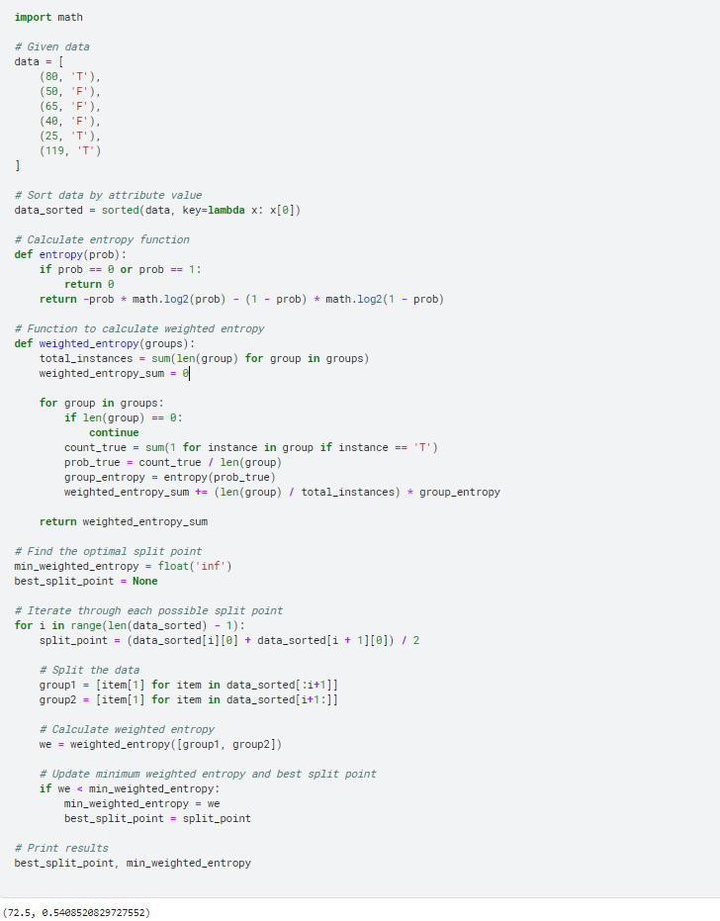

**Hence best split point is 72.5 and minimum entropy is 0.54075**

Solution 18

Given

|  |  |
| --- | --- |
| Class | Class Vector |
| Good | 11100111 |
| Average | 00011000 |
| Poor | 10101010 |

Hamming Distance Calculation

**Good Vs Average:**

* Good: 11100111
* Average: 00011000

Hamming distance = 5 (positions with differences)

**Good vs. Poor**:

* Good: 11100111
* Poor: 10101010

Hamming distance = 4

**Average vs. Poor:**

* Average: 00011000
* Poor: 10101010

Hamming distance = 6

**Minimum Hamming distance (d) = 4**

**Error Calculations=(4-1)/2 = 1.5=1**

* Hamming Distance (d): 4
* Number of errors that can be corrected: 1

Solution 19

Given

|  |  |  |
| --- | --- | --- |
| # | Attr Value | Outcome |
| 1 | 0 | T |
| 2 | 13 | F |
| 3 | 15 | T |
| 4 | 22 | F |
| 5 | 40 | F |
| 6 | 20 | T |
| 7 | 17 | F |
| 8 | 18 | F |
| 9 | 60 | T |

Equal-frequency binning

**Binning:**

* **C1**: [0, 13, 15]
* **C2**: [17, 18, 20]
* **C3**: [22, 40, 60]

**Attribute Value Range and Sample Outcome for Each Category:**

* **C1**: 0-15, Sample Outcome: T (from 0)
* **C2**: 17-20, Sample Outcome: F (from 17)
* **C3**: 22-60, Sample Outcome: F (from 22

Equal-width binning

Width = (Max Value - Min Value) / Number of Bins

= (60 - 0) / 3

= 20

**Binning:**

* **C1**: [0, 20)
* **C2**: [20, 40)
* **C3**: [40, 60]

**Attribute Value Range and Sample Outcome for Each Category:**

* **C1**: 0-19, Sample Outcome: T (from 0)
* **C2**: 20-39, Sample Outcome: T (from 20)
* **C3**: 40-60, Sample Outcome: F (from 40)

Solution 20

An approach to transforming the attributes Color (Yellow, Red, Purple) and Size (SM, MD, LG) into a single attribute is to use a hierarchical encoding method. This involves creating a composite key using both attributes while preserving their original structures, which can then be used as a single unique identifier.

**Approach: Composite Key Encoding**

1. **Concatenate Color and Size**: Combine the two attributes into a single string with a separator.

**Combined Attribute**

* Yellow_SM
* Red_MD
* Purple_LG

**Justification**

1. **Preservation of Information**: This method retains the distinct identity of each combination of Color and Size without losing any information.
2. **Ease of Decoding**: The combined attribute can be easily split back into the original attributes if needed, preserving the flexibility of the dataset.
3. **Efficiency in Modeling**: This combined attribute can be treated as a categorical variable in machine learning models, facilitating better handling of the dataset.

**Example**

Original Data:

* Color: Yellow, Size: SM
* Color: Red, Size: MD
* Color: Purple, Size: LG

Transformed Data:

* Combined Attribute: Yellow_SM
* Combined Attribute: Red_MD
* Combined Attribute: Purple_LG

This approach maintains a clear and distinct identification of each combination of attributes while allowing for efficient data processing and analysis.