Name: Ashish Verma Course:CS773 HW#6

Solution

Given Training Data

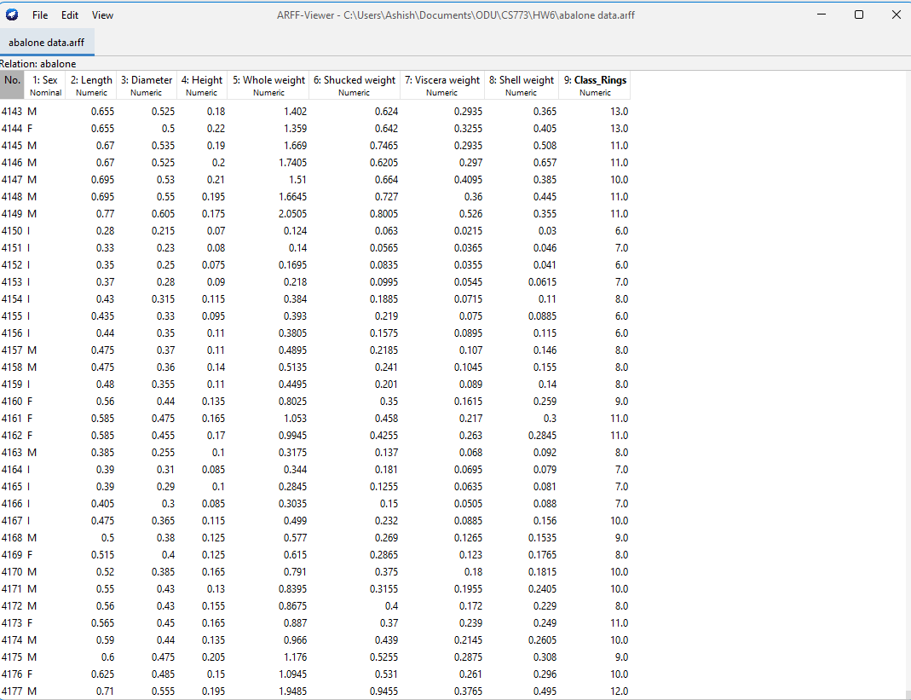

Given Test Data

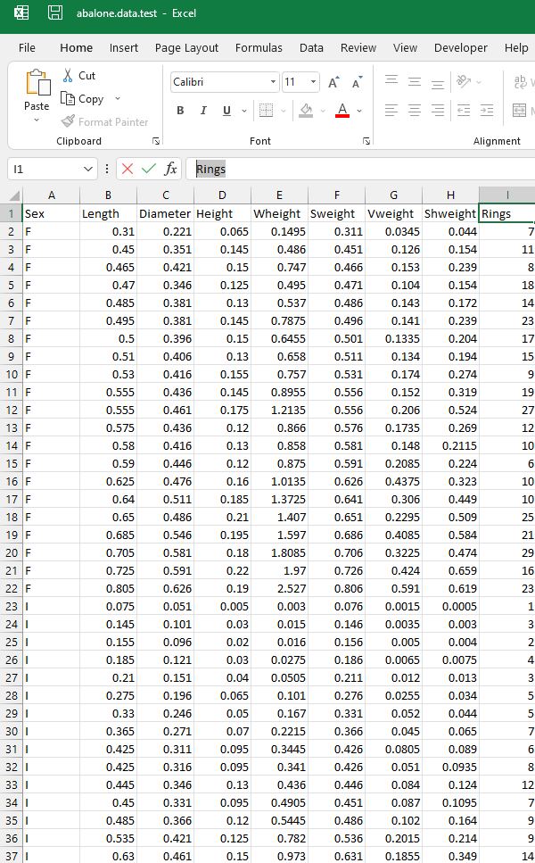

Since the attribute names of the training and test data are different, we will use Arffviewer to rename them as below

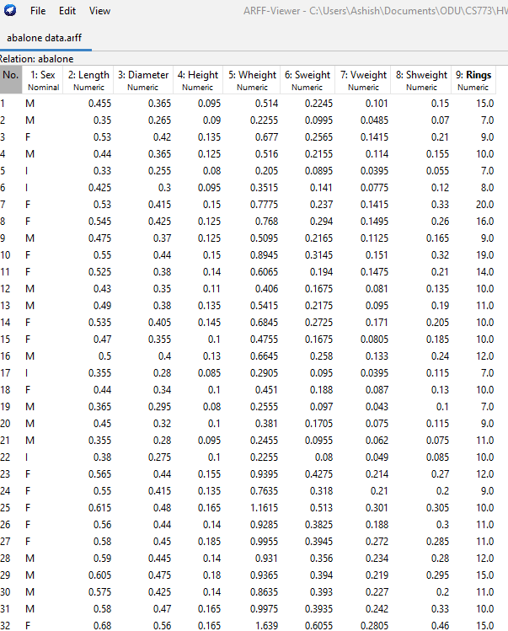

Since the training data label (Rings) is in continuous format, in order to classifier work we need to discretize the data using binning method by setting “**useEqualFrequency**” we will use python code to transform data.

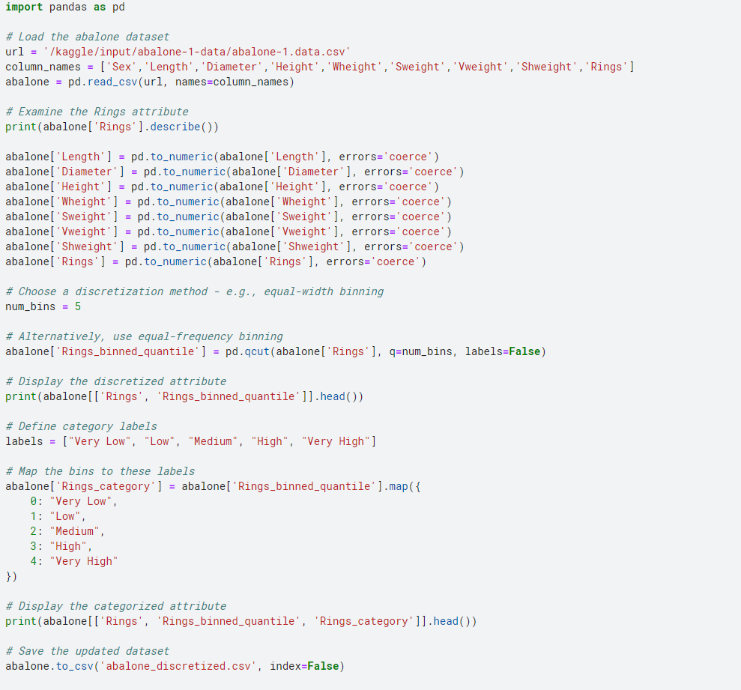

Dataset after discretization looks as below

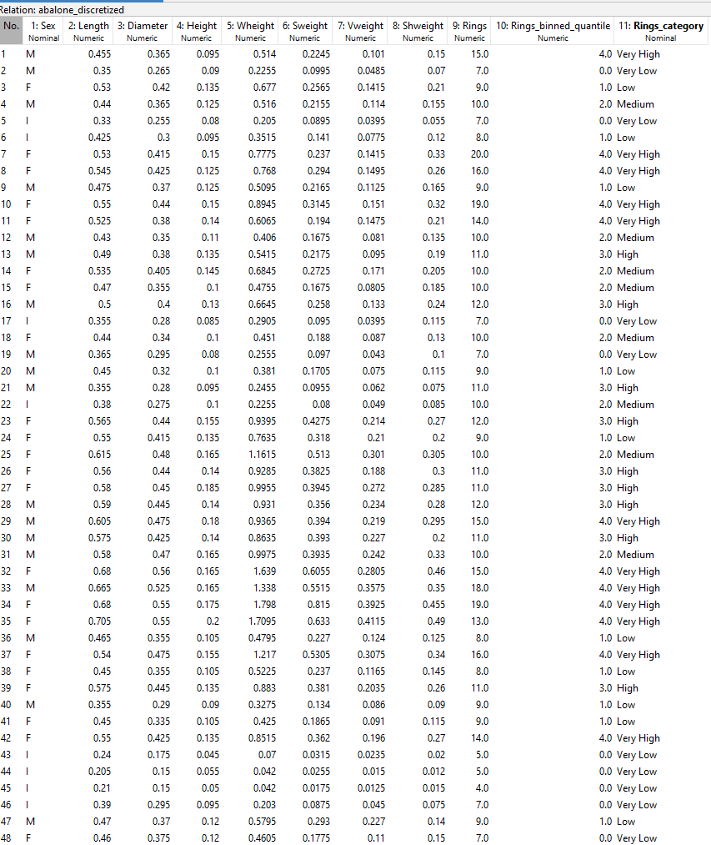

Rings_category is now our new class and we use the classifiers.

Similar processing, we need to do for test data

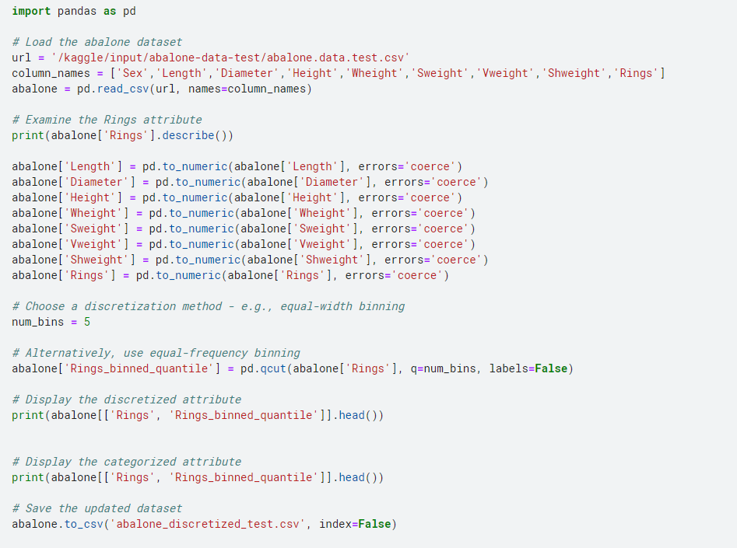

The test data will not have Rings_category which we need to predict.

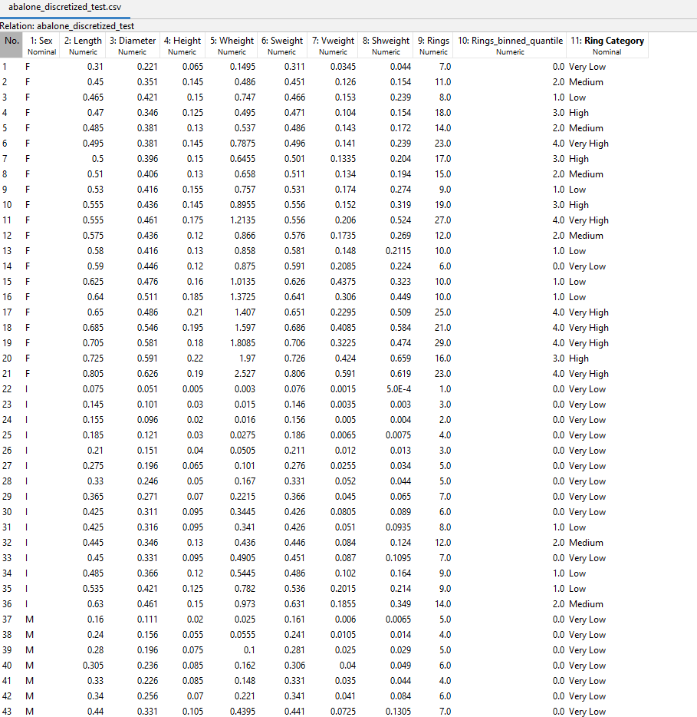

Training AdaBoostM1

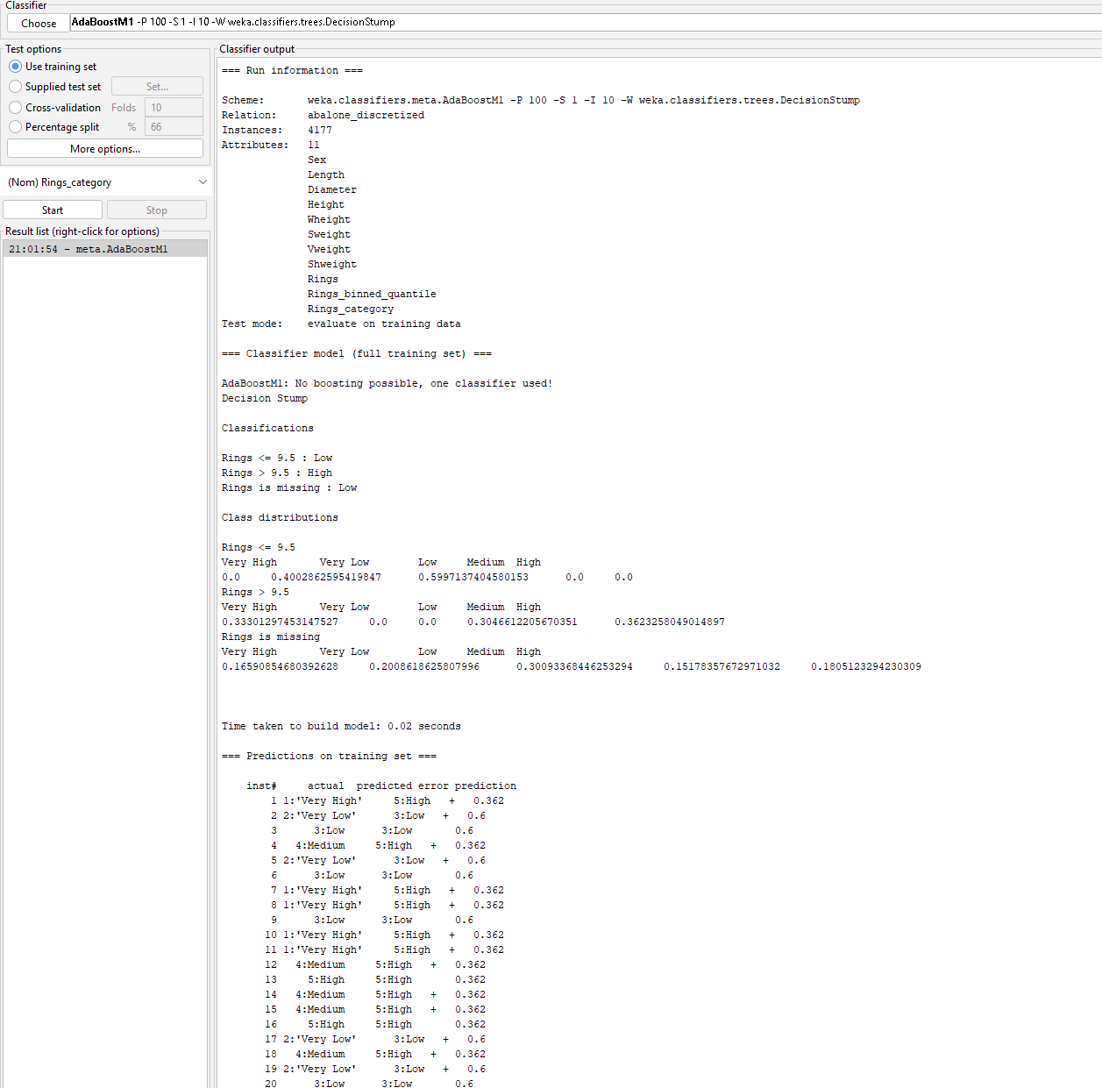

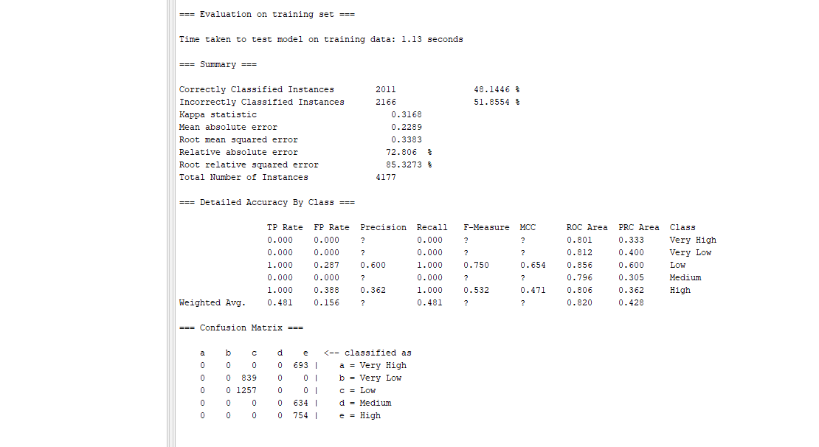

Save the model and load the model

Test AdaBoostM1

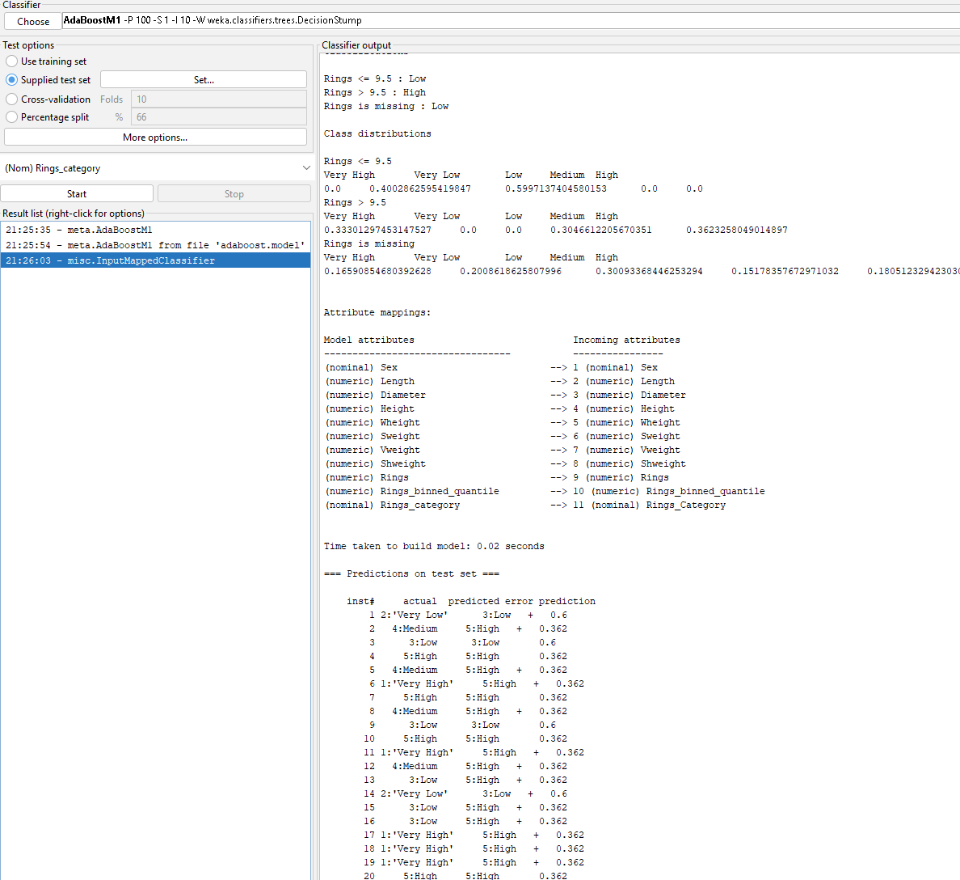

Prediction Output from test sample

|  |  |  |  |
| --- | --- | --- | --- |
| inst# | actual | predicted error | prediction |
| 1 | 2:'Very Low' | 3:Low | 0.6 |
| 2 | 4:Medium | 5:High + | 0.362 |
| 3 | 3:Low | 3:Low | 0.6 |
| 4 | 5:High | 5:High | 0.362 |
| 5 | 4:Medium | 5:High + | 0.362 |
| 6 | 1:'Very High | ' 5:High | 0.362 |
| 7 | 5:High | 5:High | 0.362 |
| 8 | 4:Medium | 5:High + | 0.362 |
| 9 | 3:Low | 3:Low | 0.6 |
| 10 | 5:High | 5:High | 0.362 |
| 11 | 1:'Very High | ' 5:High | 0.362 |
| 12 | 4:Medium | 5:High + | 0.362 |
| 13 | 3:Low | 5:High + | 0.362 |
| 14 | 2:'Very Low' | 3:Low | 0.6 |
| 15 | 3:Low | 5:High + | 0.362 |
| 16 | 3:Low | 5:High + | 0.362 |
| 17 | 1:'Very High | ' 5:High | 0.362 |
| 18 | 1:'Very High | ' 5:High | 0.362 |
| 19 | 1:'Very High | ' 5:High | 0.362 |
| 20 | 5:High | 5:High | 0.362 |
| 21 | 1:'Very High | ' 5:High | 0.362 |
| 22 | 2:'Very Low' | 3:Low | 0.6 |
| 23 | 2:'Very Low' | 3:Low | 0.6 |
| 24 | 2:'Very Low' | 3:Low | 0.6 |
| 25 | 2:'Very Low' | 3:Low | 0.6 |
| 26 | 2:'Very Low' | 3:Low | 0.6 |
| 27 | 2:'Very Low' | 3:Low | 0.6 |
| 28 | 2:'Very Low' | 3:Low | 0.6 |
| 29 | 2:'Very Low' | 3:Low | 0.6 |
| 30 | 2:'Very Low' | 3:Low | 0.6 |
| 31 | 3:Low | 3:Low | 0.6 |
| 32 | 4:Medium | 5:High + | 0.362 |
| 33 | 2:'Very Low' | 3:Low | 0.6 |
| 34 | 3:Low | 3:Low | 0.6 |
| 35 | 3:Low | 3:Low | 0.6 |
| 36 | 4:Medium | 5:High + | 0.362 |
| 37 | 2:'Very Low' | 3:Low | 0.6 |
| 38 | 2:'Very Low' | 3:Low | 0.6 |
| 39 | 2:'Very Low' | 3:Low | 0.6 |
| 40 | 2:'Very Low' | 3:Low | 0.6 |
| 41 | 2:'Very Low' | 3:Low | 0.6 |
| 42 | 2:'Very Low' | 3:Low | 0.6 |
| 43 | 2:'Very Low' | 3:Low | 0.6 |
| 44 | 3:Low | 3:Low | 0.6 |
| 45 | 5:High | 5:High | 0.362 |
| 46 | 3:Low | 5:High + | 0.362 |
| 47 | 5:High | 5:High | 0.362 |
| 48 | 4:Medium | 5:High + | 0.362 |
| 49 | 3:Low | 3:Low | 0.6 |
| 50 | 5:High | 5:High | 0.362 |
| 51 | 4:Medium | 5:High + | 0.362 |
| 52 | 4:Medium | 5:High + | 0.362 |
| 53 | 5:High | 5:High | 0.362 |
| 54 | 5:High | 5:High | 0.362 |
| 55 | 2:'Very Low' | 3:Low | 0.6 |
| 56 | 5:High | 5:High | 0.362 |
| 57 | 4:Medium | 5:High + | 0.362 |
| 58 | 1:'Very High | ' 5:High | 0.362 |
| 59 | 4:Medium | 5:High + | 0.362 |
| 60 | 4:Medium | 5:High + | 0.362 |
| 61 | 5:High | 5:High | 0.362 |
| 62 | 5:High | 5:High | 0.362 |
| 63 | 4:Medium | 5:High + | 0.362 |
| 64 | 1:'Very High | ' 5:High | 0.362 |
| 65 | 1:'Very High | ' 5:High | 0.362 |
| 66 | 4:Medium | 5:High + | 0.362 |
| 67 | 3:Low | 3:Low | 0.6 |
| 68 | 1:'Very High | ' 5:High | 0.362 |
| 69 | 1:'Very High | ' 5:High | 0.362 |
| 70 | 5:High | 5:High | 0.362 |
| 71 | 1:'Very High | ' 5:High | 0.362 |
| 72 | 5:High | 5:High | 0.362 |
| 73 | 1:'Very High | ' 5:High | 0.362 |
| 74 | 1:'Very High | ' 5:High | 0.362 |
| 75 | 4:Medium | 5:High + | 0.362 |
| 76 | 1:'Very High | ' 5:High | 0.362 |
| 77 | 4:Medium | 5:High + | 0.362 |
| 78 | 1:'Very High | ' 5:High | 0.362 |
| 79 | 4:Medium | 5:High + | 0.362 |
| 80 | 4:Medium | 5:High + | 0.36 |

**Correctly Classified Instances 22 27.5 %**

Training Bagging

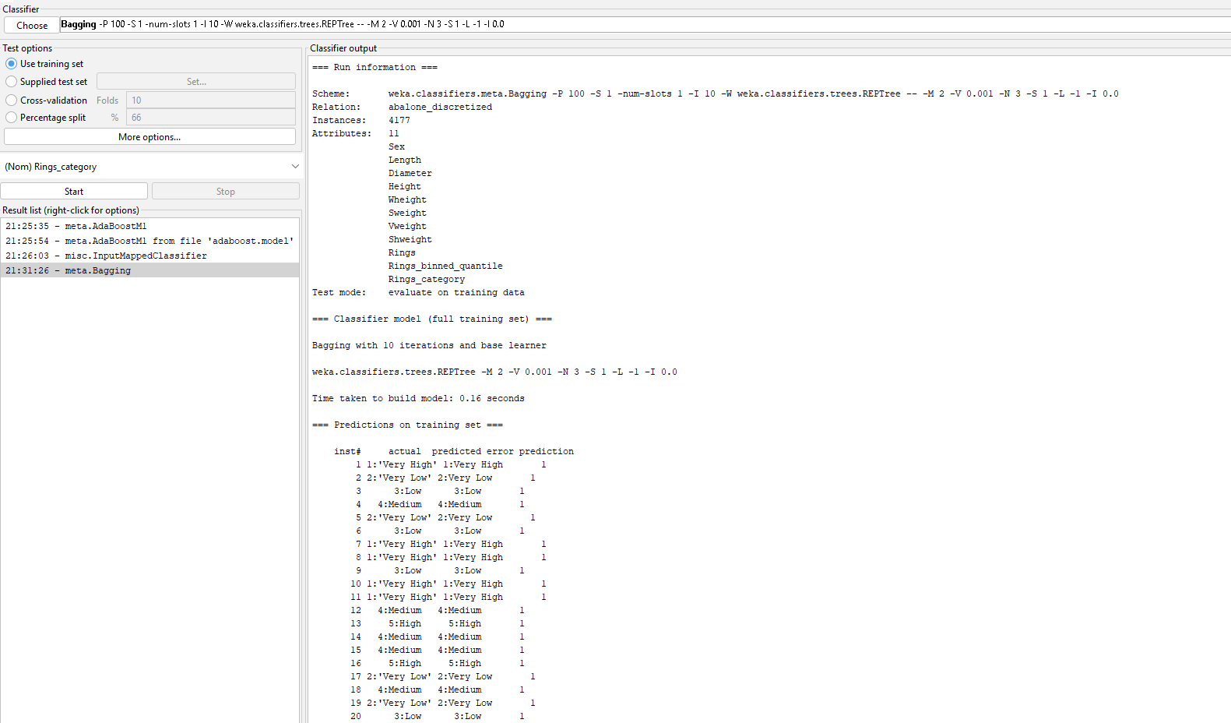

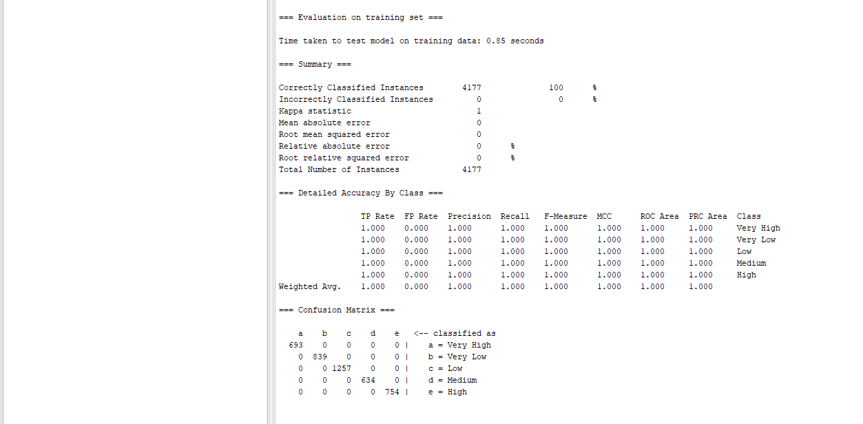

Test Bagging

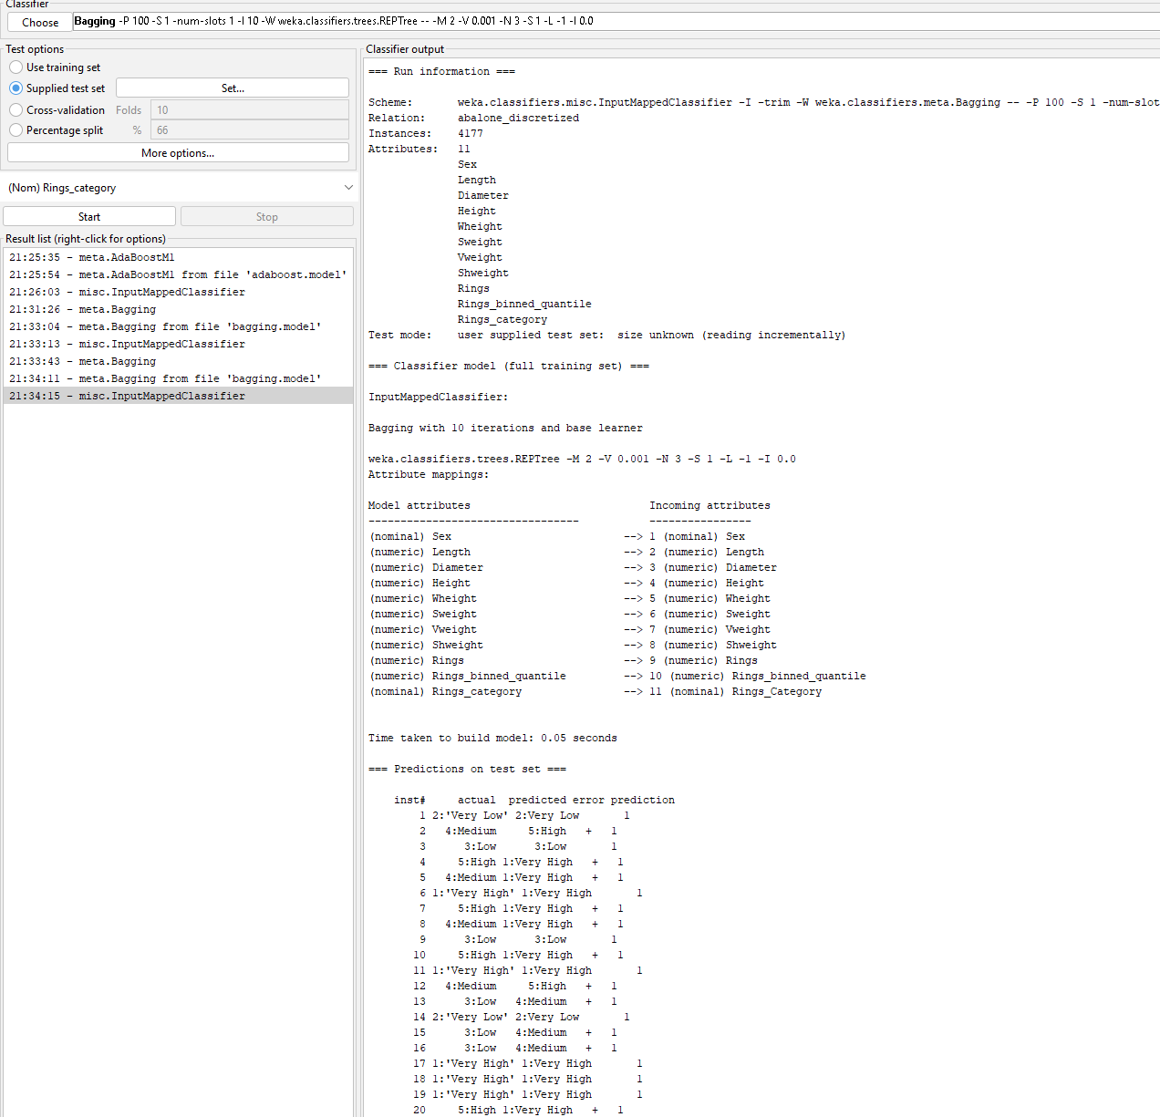

Prediction Output from test sample

inst# actual predicted error prediction

1 2:'Very Low' 2:Very Low 1

2 4:Medium 5:High + 1

3 3:Low 3:Low 1

4 5:High 1:Very High + 1

5 4:Medium 1:Very High + 1

6 1:'Very High' 1:Very High 1

7 5:High 1:Very High + 1

8 4:Medium 1:Very High + 1

9 3:Low 3:Low 1

10 5:High 1:Very High + 1

11 1:'Very High' 1:Very High 1

12 4:Medium 5:High + 1

13 3:Low 4:Medium + 1

14 2:'Very Low' 2:Very Low 1

15 3:Low 4:Medium + 1

16 3:Low 4:Medium + 1

17 1:'Very High' 1:Very High 1

18 1:'Very High' 1:Very High 1

19 1:'Very High' 1:Very High 1

20 5:High 1:Very High + 1

21 1:'Very High' 1:Very High 1

22 2:'Very Low' 2:Very Low 1

23 2:'Very Low' 2:Very Low 1

24 2:'Very Low' 2:Very Low 1

25 2:'Very Low' 2:Very Low 1

26 2:'Very Low' 2:Very Low 1

27 2:'Very Low' 2:Very Low 1

28 2:'Very Low' 2:Very Low 1

29 2:'Very Low' 2:Very Low 1

30 2:'Very Low' 2:Very Low 1

31 3:Low 3:Low 1

32 4:Medium 5:High + 1

33 2:'Very Low' 2:Very Low 1

34 3:Low 3:Low 1

35 3:Low 3:Low 1

36 4:Medium 1:Very High + 1

37 2:'Very Low' 2:Very Low 1

38 2:'Very Low' 2:Very Low 1

39 2:'Very Low' 2:Very Low 1

40 2:'Very Low' 2:Very Low 1

41 2:'Very Low' 2:Very Low 1

42 2:'Very Low' 2:Very Low 1

43 2:'Very Low' 2:Very Low 1

44 3:Low 3:Low 1

45 5:High 1:Very High + 1

46 3:Low 4:Medium + 1

47 5:High 1:Very High + 1

48 4:Medium 1:Very High + 1

49 3:Low 3:Low 1

50 5:High 1:Very High + 1

51 4:Medium 1:Very High + 1

52 4:Medium 5:High + 1

53 5:High 1:Very High + 1

54 5:High 1:Very High + 1

55 2:'Very Low' 2:Very Low 1

56 5:High 1:Very High + 1

57 4:Medium 1:Very High + 1

58 1:'Very High' 1:Very High 1

59 4:Medium 1:Very High + 1

60 4:Medium 1:Very High + 1

61 5:High 1:Very High + 1

62 5:High 1:Very High + 1

63 4:Medium 1:Very High + 1

64 1:'Very High' 1:Very High 1

65 1:'Very High' 1:Very High 1

66 4:Medium 1:Very High + 1

67 3:Low 3:Low 1

68 1:'Very High' 1:Very High 1

69 1:'Very High' 1:Very High 1

70 5:High 1:Very High + 1

71 1:'Very High' 1:Very High 1

72 5:High 1:Very High + 1

73 1:'Very High' 1:Very High 1

74 1:'Very High' 1:Very High 1

75 4:Medium 5:High + 1

76 1:'Very High' 1:Very High 1

77 4:Medium 5:High + 1

78 1:'Very High' 1:Very High 1

79 4:Medium 5:High + 1

80 4:Medium 1:Very High + 1

**Correctly Classified Instances 44 55 %**

Train Randomcommittee

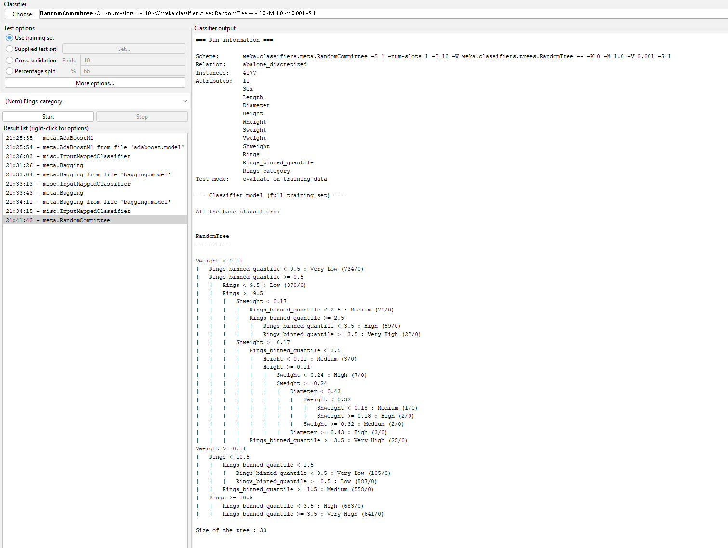

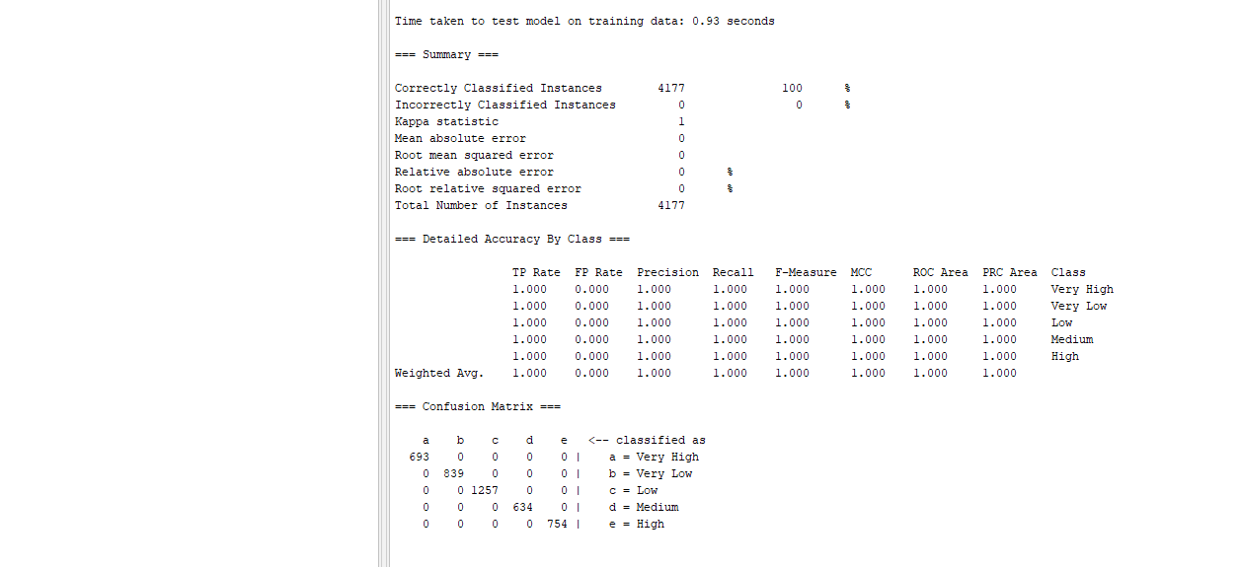

Test Randomcommittee

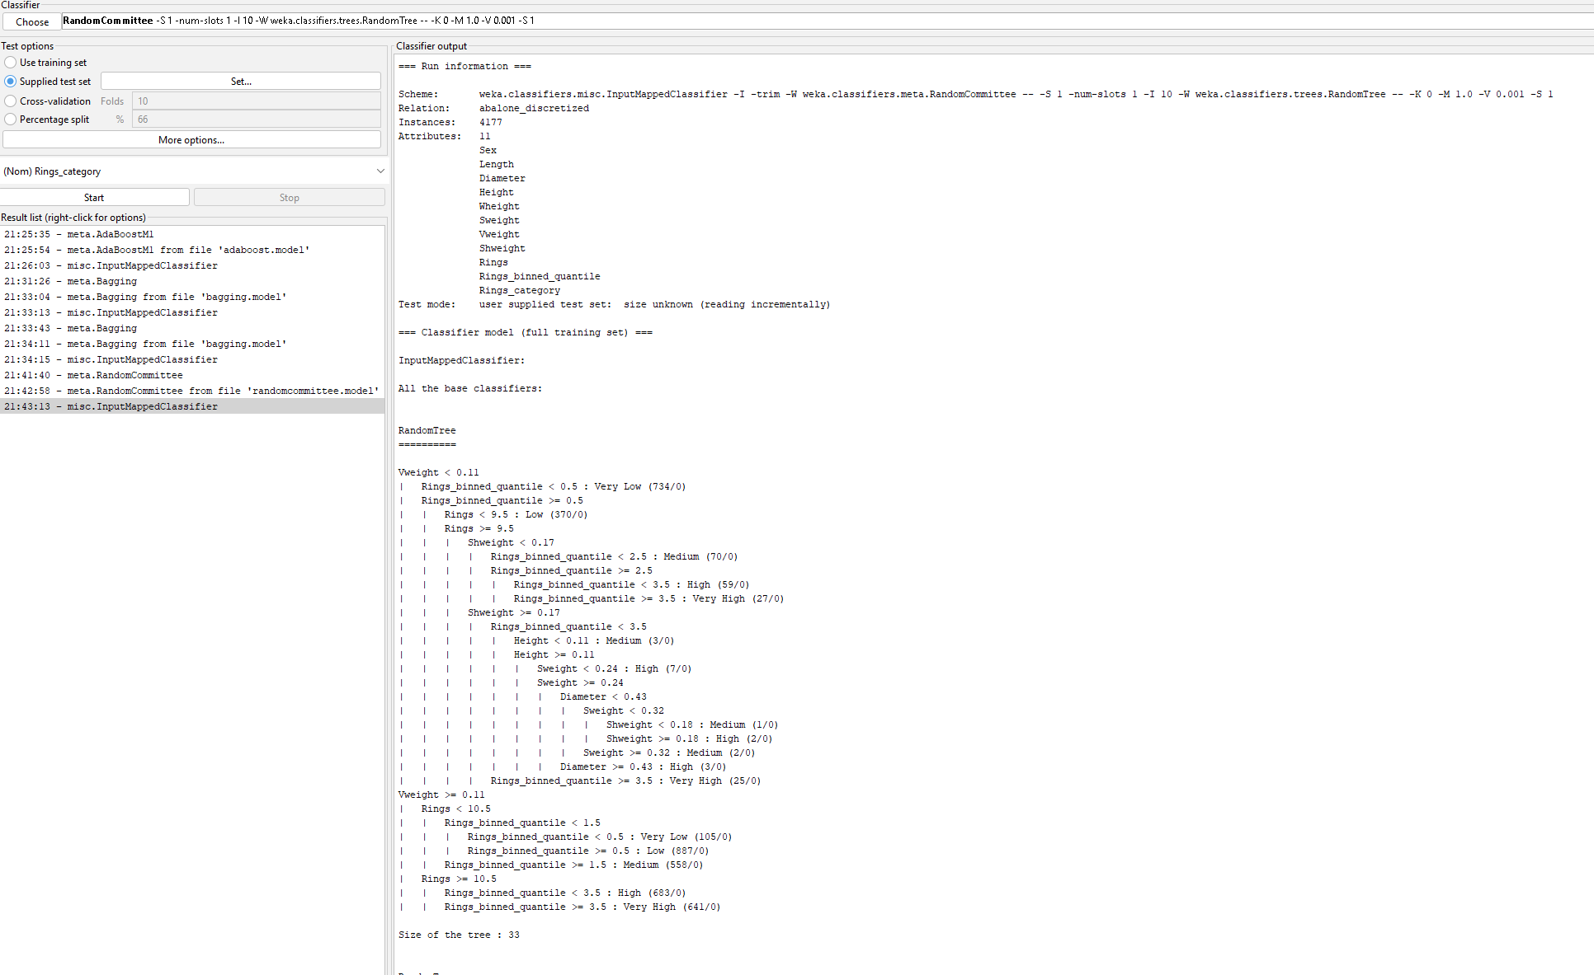

Prediction Results from randomcommitte

=== Predictions on test set ===

inst# actual predicted error prediction

1 2:'Very Low' 2:Very Low 1

2 4:Medium 4:Medium 0.5

3 3:Low 3:Low 1

4 5:High 5:High 0.6

5 4:Medium 4:Medium 0.4

6 1:'Very High' 1:Very High 1

7 5:High 5:High 0.6

8 4:Medium 4:Medium 0.4

9 3:Low 3:Low 1

10 5:High 1:Very High + 0.5

11 1:'Very High' 1:Very High 1

12 4:Medium 4:Medium 0.6

13 3:Low 4:Medium + 0.6

14 2:'Very Low' 2:Very Low 1

15 3:Low 4:Medium + 0.7

16 3:Low 4:Medium + 0.7

17 1:'Very High' 1:Very High 1

18 1:'Very High' 1:Very High 1

19 1:'Very High' 1:Very High 1

20 5:High 1:Very High + 0.5

21 1:'Very High' 1:Very High 1

22 2:'Very Low' 2:Very Low 1

23 2:'Very Low' 2:Very Low 1

24 2:'Very Low' 2:Very Low 1

25 2:'Very Low' 2:Very Low 1

26 2:'Very Low' 2:Very Low 1

27 2:'Very Low' 2:Very Low 1

28 2:'Very Low' 2:Very Low 1

29 2:'Very Low' 2:Very Low 1

30 2:'Very Low' 2:Very Low 1

31 3:Low 3:Low 1

32 4:Medium 5:High + 0.7

33 2:'Very Low' 2:Very Low 1

34 3:Low 3:Low 1

35 3:Low 3:Low 1

36 4:Medium 4:Medium 0.6

37 2:'Very Low' 2:Very Low 1

38 2:'Very Low' 2:Very Low 1

39 2:'Very Low' 2:Very Low 1

40 2:'Very Low' 2:Very Low 1

41 2:'Very Low' 2:Very Low 1

42 2:'Very Low' 2:Very Low 1

43 2:'Very Low' 2:Very Low 1

44 3:Low 3:Low 1

45 5:High 5:High 0.6

46 3:Low 4:Medium + 0.6

47 5:High 5:High 0.6

48 4:Medium 4:Medium 0.4

49 3:Low 3:Low 1

50 5:High 1:Very High + 0.5

51 4:Medium 4:Medium 0.4

52 4:Medium 4:Medium 0.5

53 5:High 1:Very High + 0.5

54 5:High 1:Very High + 0.5

55 2:'Very Low' 2:Very Low 1

56 5:High 1:Very High + 0.5

57 4:Medium 4:Medium 0.4

58 1:'Very High' 1:Very High 1

59 4:Medium 4:Medium 0.5

60 4:Medium 4:Medium 0.4

61 5:High 1:Very High + 0.5

62 5:High 1:Very High + 0.5

63 4:Medium 4:Medium 0.6

64 1:'Very High' 1:Very High 1

65 1:'Very High' 1:Very High 1

66 4:Medium 4:Medium 0.5

67 3:Low 3:Low 1

68 1:'Very High' 1:Very High 1

69 1:'Very High' 1:Very High 1

70 5:High 1:Very High + 0.6

71 1:'Very High' 1:Very High 1

72 5:High 1:Very High + 0.6

73 1:'Very High' 1:Very High 1

74 1:'Very High' 1:Very High 1

75 4:Medium 4:Medium 0.5

76 1:'Very High' 1:Very High 1

77 4:Medium 4:Medium 0.6

78 1:'Very High' 1:Very High 1

79 4:Medium 4:Medium 0.5

80 4:Medium 1:Very High + 0.4

**Correctly Classified Instances 64 80 %**

Training LogitBoost

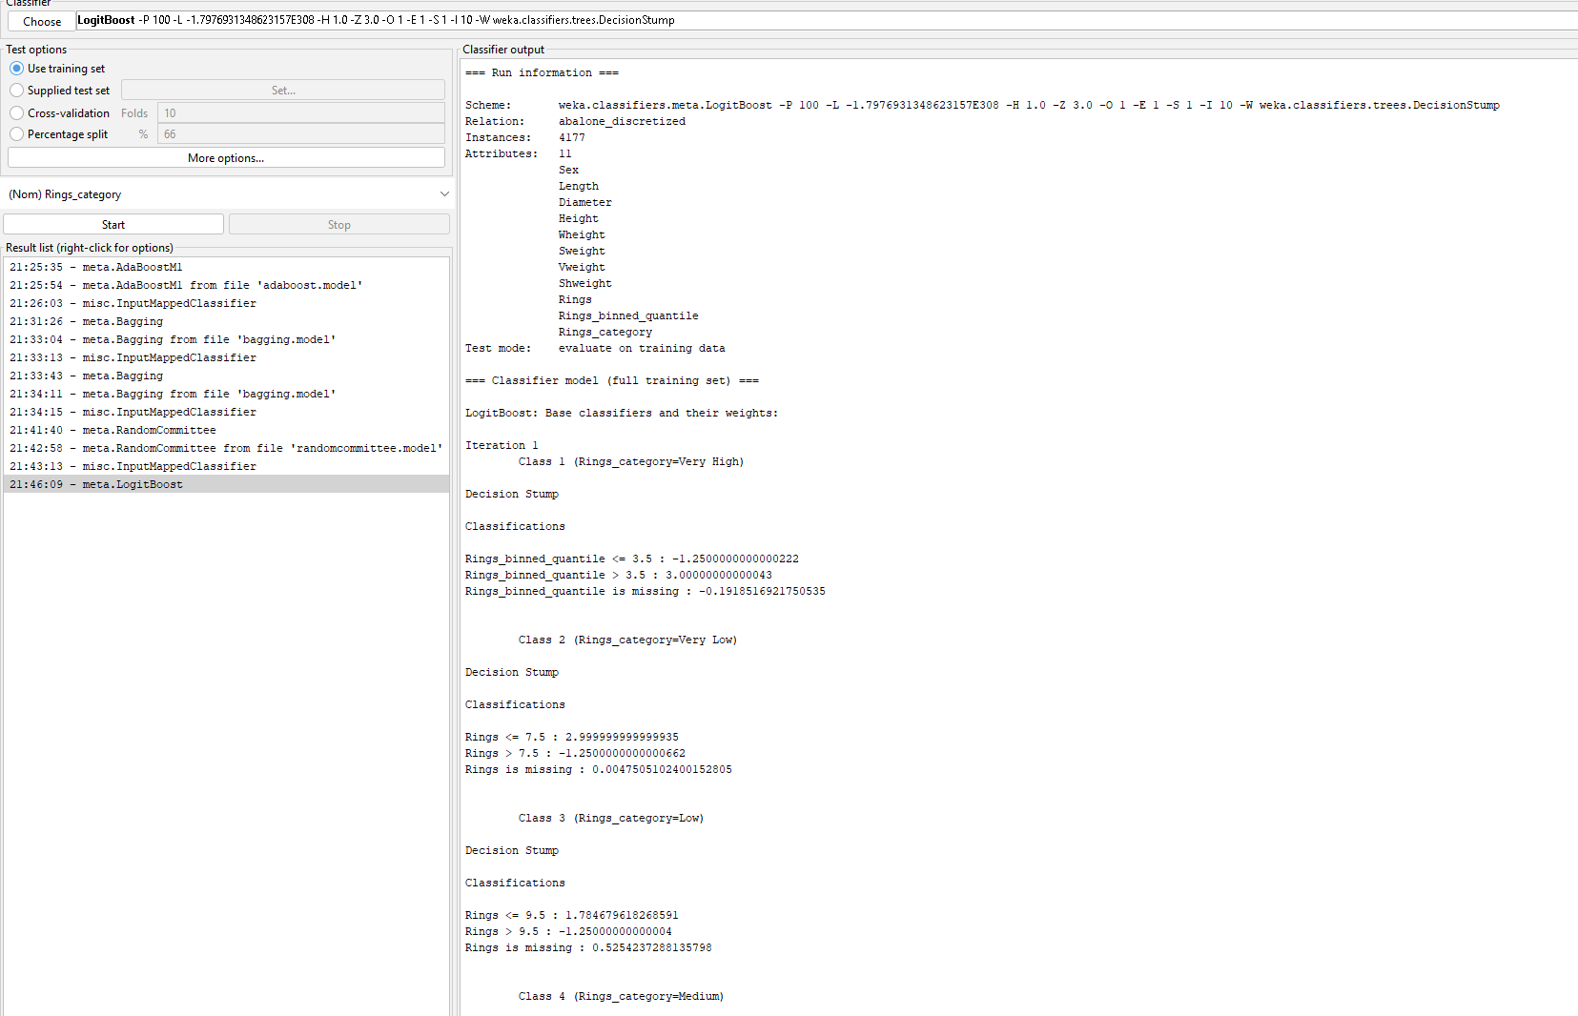

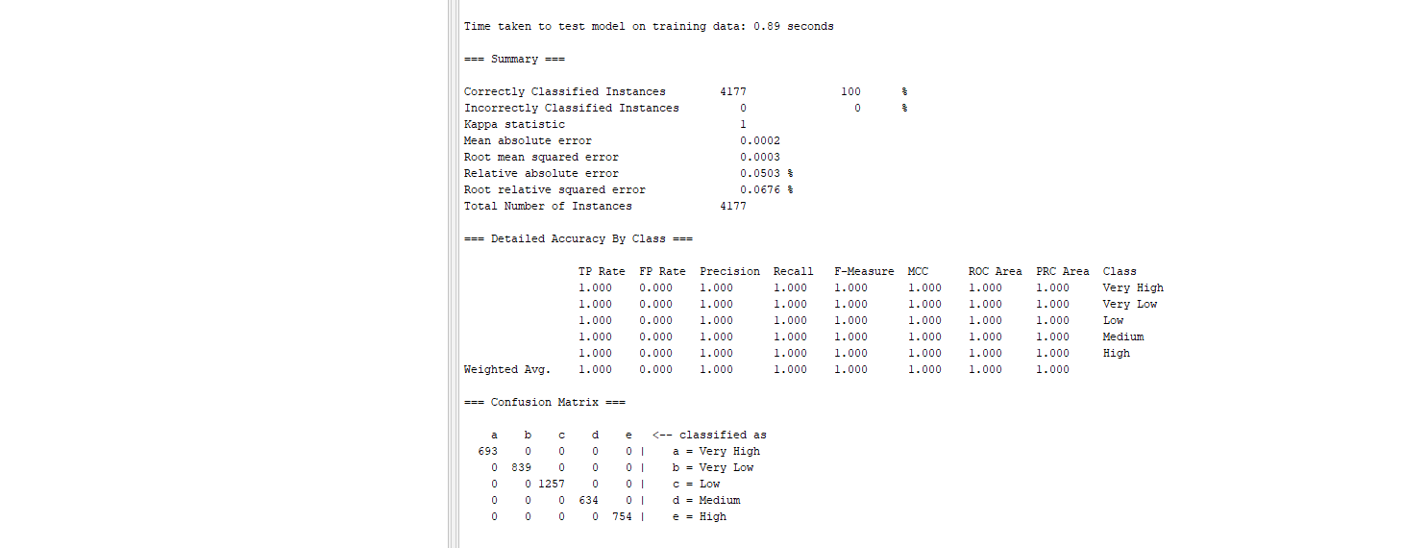

Test LogitBoost

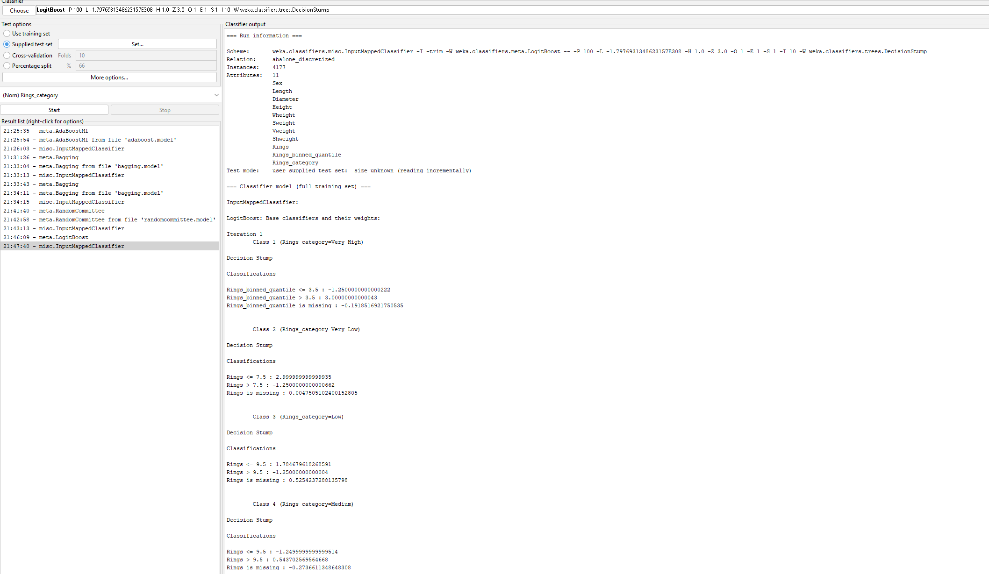

Prediction Results

=== Predictions on test set ===

inst# actual predicted error prediction

1 2:'Very Low' 2:Very Low 1

2 4:Medium 5:High + 0.797

3 3:Low 3:Low 1

4 5:High 5:High 0.895

5 4:Medium 1:Very High + 0.7

6 1:'Very High' 1:Very High 1

7 5:High 5:High 0.895

8 4:Medium 1:Very High + 0.7

9 3:Low 3:Low 1

10 5:High 5:High 0.895

11 1:'Very High' 1:Very High 1

12 4:Medium 5:High + 0.797

13 3:Low 4:Medium + 0.847

14 2:'Very Low' 2:Very Low 1

15 3:Low 4:Medium + 0.847

16 3:Low 4:Medium + 0.847

17 1:'Very High' 1:Very High 1

18 1:'Very High' 1:Very High 1

19 1:'Very High' 1:Very High 1

20 5:High 5:High 0.895

21 1:'Very High' 1:Very High 1

22 2:'Very Low' 2:Very Low 1

23 2:'Very Low' 2:Very Low 1

24 2:'Very Low' 2:Very Low 1

25 2:'Very Low' 2:Very Low 1

26 2:'Very Low' 2:Very Low 1

27 2:'Very Low' 2:Very Low 1

28 2:'Very Low' 2:Very Low 1

29 2:'Very Low' 2:Very Low 1

30 2:'Very Low' 2:Very Low 1

31 3:Low 3:Low 1

32 4:Medium 5:High + 0.797

33 2:'Very Low' 2:Very Low 1

34 3:Low 3:Low 1

35 3:Low 3:Low 1

36 4:Medium 1:Very High + 0.7

37 2:'Very Low' 2:Very Low 1

38 2:'Very Low' 2:Very Low 1

39 2:'Very Low' 2:Very Low 1

40 2:'Very Low' 2:Very Low 1

41 2:'Very Low' 2:Very Low 1

42 2:'Very Low' 2:Very Low 1

43 2:'Very Low' 2:Very Low 1

44 3:Low 3:Low 1

45 5:High 5:High 0.895

46 3:Low 4:Medium + 0.847

47 5:High 5:High 0.895

48 4:Medium 1:Very High + 0.7

49 3:Low 3:Low 1

50 5:High 5:High 0.895

51 4:Medium 1:Very High + 0.7

52 4:Medium 5:High + 0.797

53 5:High 5:High 0.895

54 5:High 5:High 0.895

55 2:'Very Low' 2:Very Low 1

56 5:High 5:High 0.895

57 4:Medium 1:Very High + 0.7

58 1:'Very High' 1:Very High 1

59 4:Medium 1:Very High + 0.7

60 4:Medium 1:Very High + 0.7

61 5:High 5:High 0.895

62 5:High 5:High 0.895

63 4:Medium 1:Very High + 0.7

64 1:'Very High' 1:Very High 1

65 1:'Very High' 1:Very High 1

66 4:Medium 1:Very High + 0.7

67 3:Low 3:Low 1

68 1:'Very High' 1:Very High 1

69 1:'Very High' 1:Very High 1

70 5:High 5:High 0.895

71 1:'Very High' 1:Very High 1

72 5:High 5:High 0.895

73 1:'Very High' 1:Very High 1

74 1:'Very High' 1:Very High 1

75 4:Medium 5:High + 0.797

76 1:'Very High' 1:Very High 1

77 4:Medium 5:High + 0.797

78 1:'Very High' 1:Very High 1

79 4:Medium 5:High + 0.797

80 4:Medium 1:Very High + 0.7

**Correctly Classified Instances 58 72.5 %**

Train Random Tree

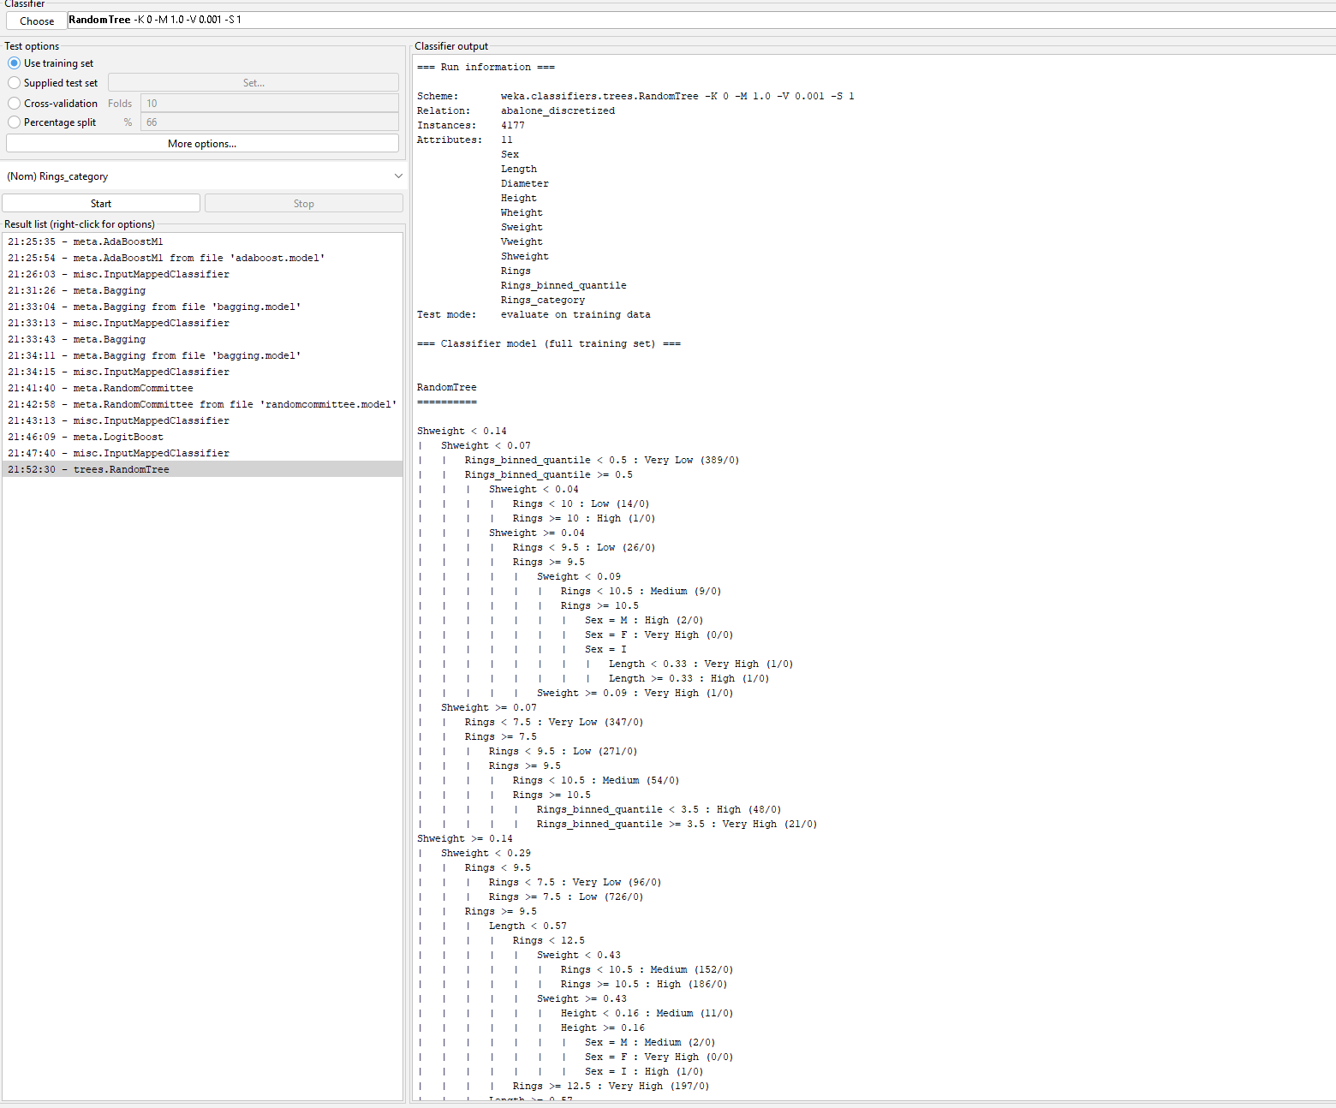

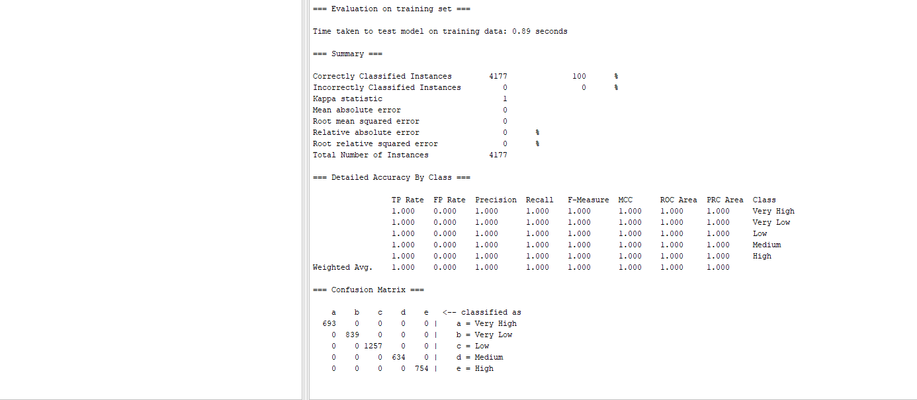

Test Random Tree

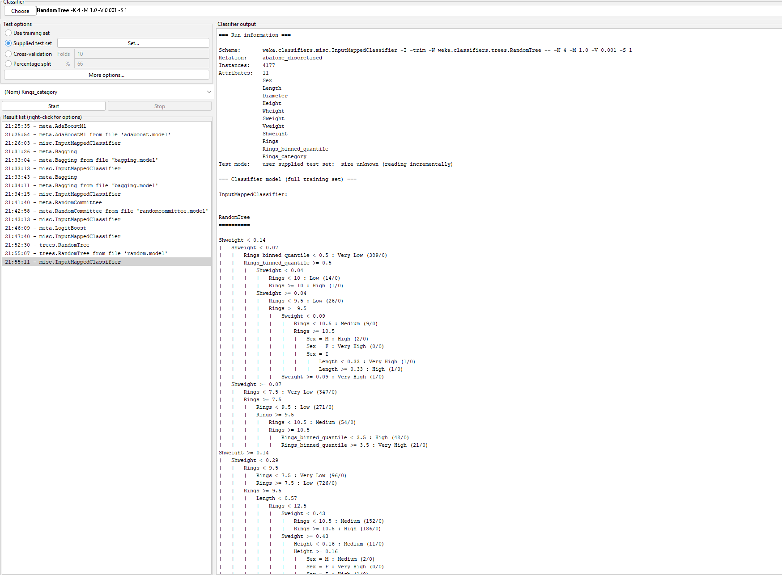

Prediction Results

=== Predictions on test set ===

inst# actual predicted error prediction

1 2:'Very Low' 2:Very Low 1

2 4:Medium 4:Medium 1

3 3:Low 3:Low 1

4 5:High 1:Very High + 1

5 4:Medium 1:Very High + 1

6 1:'Very High' 1:Very High 1

7 5:High 1:Very High + 1

8 4:Medium 1:Very High + 1

9 3:Low 3:Low 1

10 5:High 5:High 1

11 1:'Very High' 1:Very High 1

12 4:Medium 4:Medium 1

13 3:Low 4:Medium + 1

14 2:'Very Low' 2:Very Low 1

15 3:Low 3:Low 1

16 3:Low 3:Low 1

17 1:'Very High' 1:Very High 1

18 1:'Very High' 1:Very High 1

19 1:'Very High' 1:Very High 1

20 5:High 5:High 1

21 1:'Very High' 1:Very High 1

22 2:'Very Low' 2:Very Low 1

23 2:'Very Low' 2:Very Low 1

24 2:'Very Low' 2:Very Low 1

25 2:'Very Low' 2:Very Low 1

26 2:'Very Low' 2:Very Low 1

27 2:'Very Low' 2:Very Low 1

28 2:'Very Low' 2:Very Low 1

29 2:'Very Low' 2:Very Low 1

30 2:'Very Low' 2:Very Low 1

31 3:Low 3:Low 1

32 4:Medium 5:High + 1

33 2:'Very Low' 2:Very Low 1

34 3:Low 3:Low 1

35 3:Low 3:Low 1

36 4:Medium 4:Medium 1

37 2:'Very Low' 2:Very Low 1

38 2:'Very Low' 2:Very Low 1

39 2:'Very Low' 2:Very Low 1

40 2:'Very Low' 2:Very Low 1

41 2:'Very Low' 2:Very Low 1

42 2:'Very Low' 2:Very Low 1

43 2:'Very Low' 2:Very Low 1

44 3:Low 3:Low 1

45 5:High 1:Very High + 1

46 3:Low 4:Medium + 1

47 5:High 1:Very High + 1

48 4:Medium 1:Very High + 1

49 3:Low 3:Low 1

50 5:High 5:High 1

51 4:Medium 1:Very High + 1

52 4:Medium 4:Medium 1

53 5:High 1:Very High + 1

54 5:High 5:High 1

55 2:'Very Low' 2:Very Low 1

56 5:High 5:High 1

57 4:Medium 1:Very High + 1

58 1:'Very High' 1:Very High 1

59 4:Medium 4:Medium 1

60 4:Medium 1:Very High + 1

61 5:High 5:High 1

62 5:High 1:Very High + 1

63 4:Medium 4:Medium 1

64 1:'Very High' 1:Very High 1

65 1:'Very High' 1:Very High 1

66 4:Medium 4:Medium 1

67 3:Low 3:Low 1

68 1:'Very High' 1:Very High 1

69 1:'Very High' 1:Very High 1

70 5:High 5:High 1

71 1:'Very High' 1:Very High 1

72 5:High 5:High 1

73 1:'Very High' 1:Very High 1

74 1:'Very High' 1:Very High 1

75 4:Medium 4:Medium 1

76 1:'Very High' 1:Very High 1

77 4:Medium 4:Medium 1

78 1:'Very High' 1:Very High 1

79 4:Medium 4:Medium 1

80 4:Medium 4:Medium 1

**Correctly Classified Instances 65 81.25 %**

Training Dagging

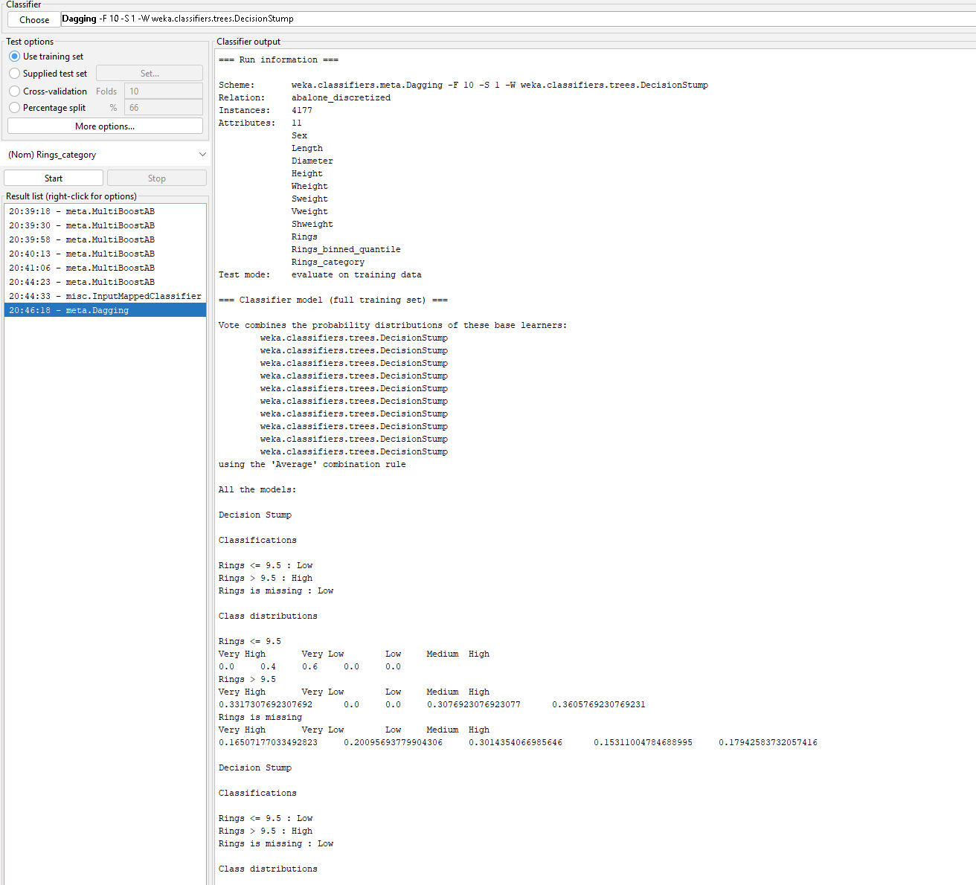

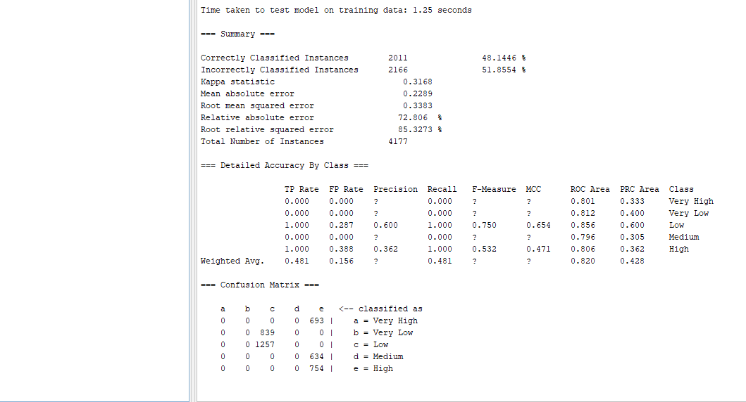

Test Dagging

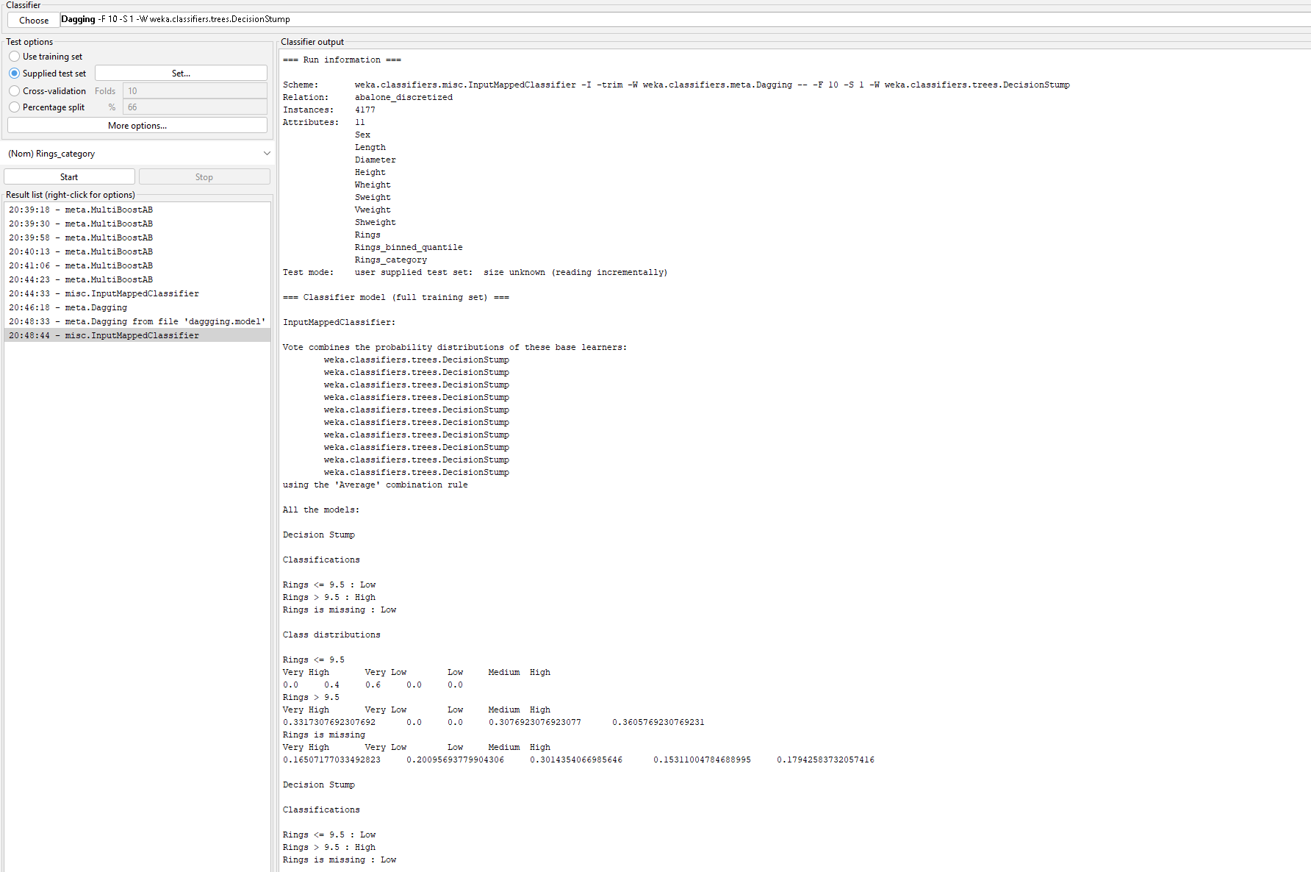

Prediction Results

=== Predictions on test set ===

inst# actual predicted error prediction

1 2:'Very Low' 3:Low + 0.6

2 4:Medium 5:High + 0.362

3 3:Low 3:Low 0.6

4 5:High 5:High 0.362

5 4:Medium 5:High + 0.362

6 1:'Very High' 5:High + 0.362

7 5:High 5:High 0.362

8 4:Medium 5:High + 0.362

9 3:Low 3:Low 0.6

10 5:High 5:High 0.362

11 1:'Very High' 5:High + 0.362

12 4:Medium 5:High + 0.362

13 3:Low 5:High + 0.362

14 2:'Very Low' 3:Low + 0.6

15 3:Low 5:High + 0.362

16 3:Low 5:High + 0.362

17 1:'Very High' 5:High + 0.362

18 1:'Very High' 5:High + 0.362

19 1:'Very High' 5:High + 0.362

20 5:High 5:High 0.362

21 1:'Very High' 5:High + 0.362

22 2:'Very Low' 3:Low + 0.6

23 2:'Very Low' 3:Low + 0.6

24 2:'Very Low' 3:Low + 0.6

25 2:'Very Low' 3:Low + 0.6

26 2:'Very Low' 3:Low + 0.6

27 2:'Very Low' 3:Low + 0.6

28 2:'Very Low' 3:Low + 0.6

29 2:'Very Low' 3:Low + 0.6

30 2:'Very Low' 3:Low + 0.6

31 3:Low 3:Low 0.6

32 4:Medium 5:High + 0.362

33 2:'Very Low' 3:Low + 0.6

34 3:Low 3:Low 0.6

35 3:Low 3:Low 0.6

36 4:Medium 5:High + 0.362

37 2:'Very Low' 3:Low + 0.6

38 2:'Very Low' 3:Low + 0.6

39 2:'Very Low' 3:Low + 0.6

40 2:'Very Low' 3:Low + 0.6

41 2:'Very Low' 3:Low + 0.6

42 2:'Very Low' 3:Low + 0.6

43 2:'Very Low' 3:Low + 0.6

44 3:Low 3:Low 0.6

45 5:High 5:High 0.362

46 3:Low 5:High + 0.362

47 5:High 5:High 0.362

48 4:Medium 5:High + 0.362

49 3:Low 3:Low 0.6

50 5:High 5:High 0.362

51 4:Medium 5:High + 0.362

52 4:Medium 5:High + 0.362

53 5:High 5:High 0.362

54 5:High 5:High 0.362

55 2:'Very Low' 3:Low + 0.6

56 5:High 5:High 0.362

57 4:Medium 5:High + 0.362

58 1:'Very High' 5:High + 0.362

59 4:Medium 5:High + 0.362

60 4:Medium 5:High + 0.362

61 5:High 5:High 0.362

62 5:High 5:High 0.362

63 4:Medium 5:High + 0.362

64 1:'Very High' 5:High + 0.362

65 1:'Very High' 5:High + 0.362

66 4:Medium 5:High + 0.362

67 3:Low 3:Low 0.6

68 1:'Very High' 5:High + 0.362

69 1:'Very High' 5:High + 0.362

70 5:High 5:High 0.362

71 1:'Very High' 5:High + 0.362

72 5:High 5:High 0.362

73 1:'Very High' 5:High + 0.362

74 1:'Very High' 5:High + 0.362

75 4:Medium 5:High + 0.362

76 1:'Very High' 5:High + 0.362

77 4:Medium 5:High + 0.362

78 1:'Very High' 5:High + 0.362

79 4:Medium 5:High + 0.362

80 4:Medium 5:High + 0.362

**Correctly Classified Instances 22 27.5 %**

Training MultiBoostAB

Weka tool showing an error for same training and test data.

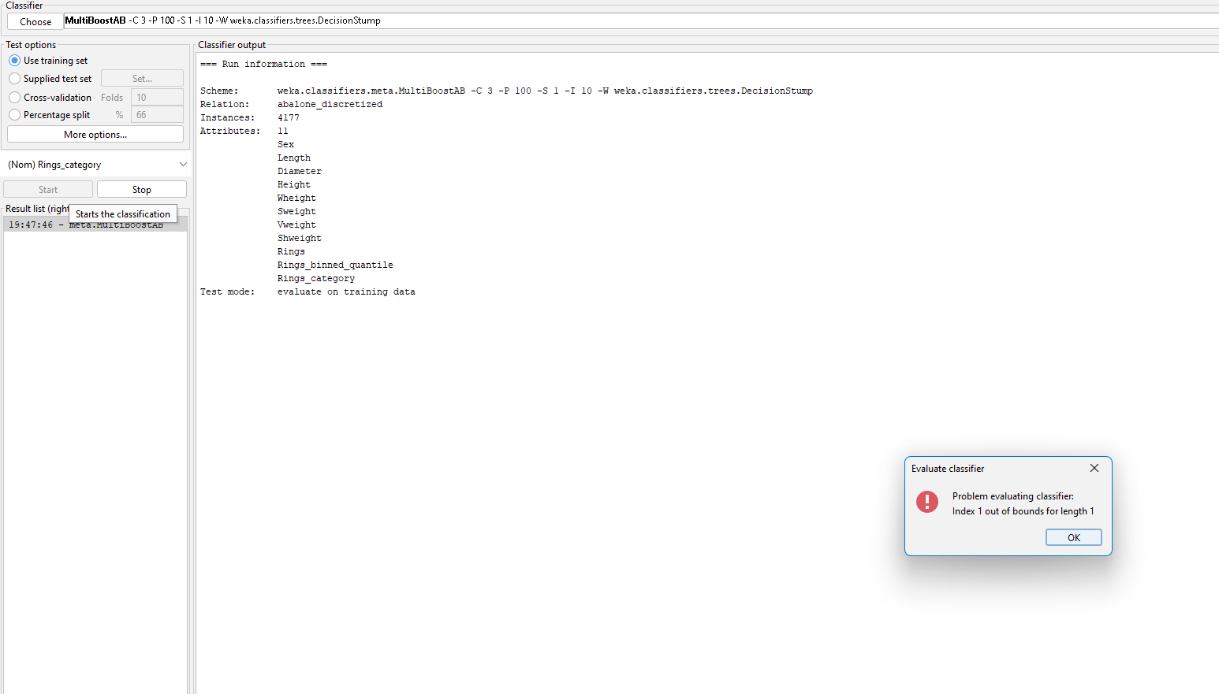

**Final Accuracy table**

|  |  |  |
| --- | --- | --- |
| **Classifier** | **Accuracy(%)** | **Correct Instance** |
| RandomTree | 81.25 | 65 |
| RandomCommittee | 80 | 64 |
| Logitboost | 72.5 | 58 |
| Bagging | 55 | 44 |
| AdaBoostM1 | 27.5 | 22 |
| Dagging | 27.5 | 22 |