CS480 Assignment -2

**Hill Climbing**

Implement a Hill Climbing Search algorithm to find a solution of the N-queens problem from a random given position. Use the number of pairwise attacks as the objective function.  Repeat the program 100 times for N = 8, N = 16, and N = 32 and show how many times you can find the solutions. Plot the initial state and the final state (not necessary the solution) of the first 10 times.

**Number of Queens = 16, output for first run**

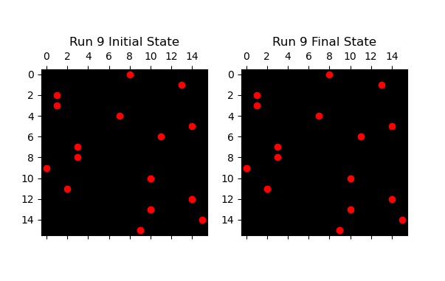

C:\Users\Ashish\anaconda3\python.exe C:\Users\Ashish\PycharmProjects\EightQueen\HillClimbingAlgorightmEightQueen.py

Run 1: Initial Attacks = 18, Final Attacks = 5

Run 2: Initial Attacks = 36, Final Attacks = 5

Run 3: Initial Attacks = 16, Final Attacks = 4

Run 4: Initial Attacks = 15, Final Attacks = 3

Run 5: Initial Attacks = 14, Final Attacks = 5

Run 6: Initial Attacks = 22, Final Attacks = 3

Run 7: Initial Attacks = 21, Final Attacks = 5

Run 8: Initial Attacks = 11, Final Attacks = 4

Run 9: Initial Attacks = 16, Final Attacks = 6

Run 10: Initial Attacks = 15, Final Attacks = 4

Total solutions found for N = 16: 0 out of 100 runs

**Number of Queens = 16, output for second run**

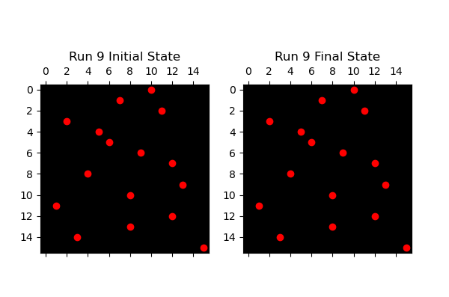

Run 1: Initial Attacks = 14, Final Attacks = 6

Run 2: Initial Attacks = 12, Final Attacks = 5

Run 3: Initial Attacks = 16, Final Attacks = 5

Run 4: Initial Attacks = 25, Final Attacks = 6

Run 5: Initial Attacks = 15, Final Attacks = 6

Run 6: Initial Attacks = 12, Final Attacks = 5

Run 7: Initial Attacks = 14, Final Attacks = 4

Run 8: Initial Attacks = 17, Final Attacks = 5

Run 9: Initial Attacks = 13, Final Attacks = 5

Run 10: Initial Attacks = 13, Final Attacks = 5

Total solutions found for N = 16: 0 out of 100 runs

**Number of Queens = 32, output for first run**

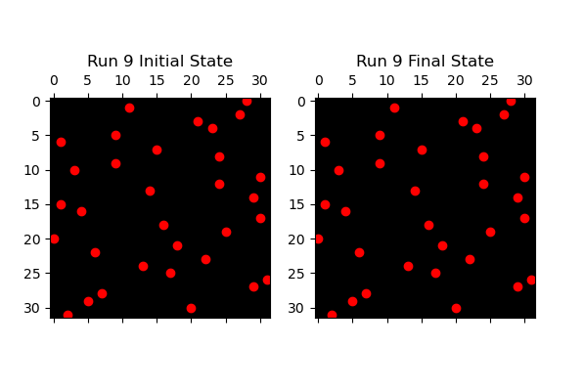

Run 1: Initial Attacks = 36, Final Attacks = 12

Run 2: Initial Attacks = 33, Final Attacks = 13

Run 3: Initial Attacks = 41, Final Attacks = 15

Run 4: Initial Attacks = 32, Final Attacks = 13

Run 5: Initial Attacks = 31, Final Attacks = 9

Run 6: Initial Attacks = 36, Final Attacks = 18

Run 7: Initial Attacks = 35, Final Attacks = 11

Run 8: Initial Attacks = 37, Final Attacks = 12

Run 9: Initial Attacks = 35, Final Attacks = 10

Run 10: Initial Attacks = 29, Final Attacks = 14

Total solutions found for N = 32: 0 out of 100 runs

**Number of Queens = 32, output for second run**

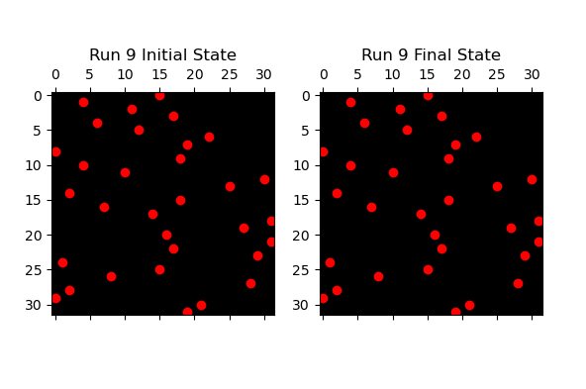

Run 1: Initial Attacks = 37, Final Attacks = 16

Run 2: Initial Attacks = 36, Final Attacks = 11

Run 3: Initial Attacks = 36, Final Attacks = 13

Run 4: Initial Attacks = 34, Final Attacks = 15

Run 5: Initial Attacks = 33, Final Attacks = 10

Run 6: Initial Attacks = 32, Final Attacks = 12

Run 7: Initial Attacks = 35, Final Attacks = 13

Run 8: Initial Attacks = 38, Final Attacks = 13

Run 9: Initial Attacks = 31, Final Attacks = 14

Run 10: Initial Attacks = 28, Final Attacks = 15

Total solutions found for N = 32: 0 out of 100 runs

**Number of Queens = 8, output for first run**

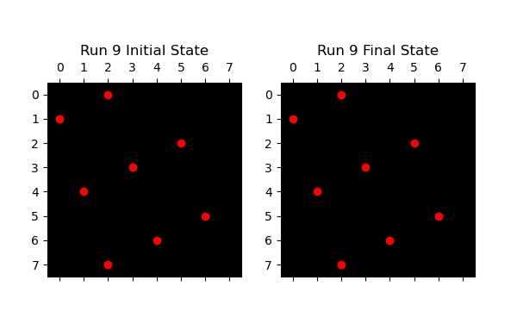

Run 1: Initial Attacks = 11, Final Attacks = 2

Run 2: Initial Attacks = 6, Final Attacks = 1

Run 3: Initial Attacks = 4, Final Attacks = 1

Run 4: Initial Attacks = 7, Final Attacks = 1

Run 5: Initial Attacks = 11, Final Attacks = 1

Run 6: Initial Attacks = 11, Final Attacks = 2

Run 7: Initial Attacks = 11, Final Attacks = 2

Run 8: Initial Attacks = 9, Final Attacks = 4

Run 9: Initial Attacks = 10, Final Attacks = 1

Run 10: Initial Attacks = 10, Final Attacks = 1

Total solutions found for N = 8: 7 out of 100 runs

**Number of Queens = 8, output for second run**

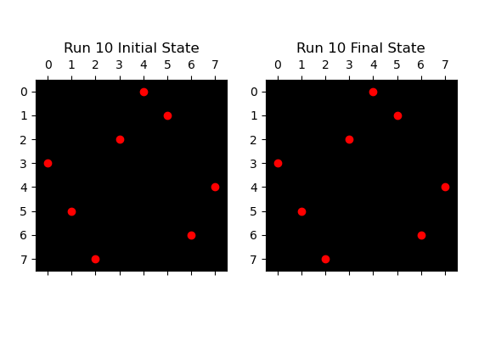

Run 1: Initial Attacks = 7, Final Attacks = 1

Run 2: Initial Attacks = 9, Final Attacks = 1

Run 3: Initial Attacks = 4, Final Attacks = 0

Run 4: Initial Attacks = 6, Final Attacks = 1

Run 5: Initial Attacks = 8, Final Attacks = 2

Run 6: Initial Attacks = 14, Final Attacks = 1

Run 7: Initial Attacks = 7, Final Attacks = 1

Run 8: Initial Attacks = 6, Final Attacks = 2

Run 9: Initial Attacks = 7, Final Attacks = 2

Run 10: Initial Attacks = 6, Final Attacks = 2

Total solutions found for N = 8: 5 out of 100 runs