CS480 Assignment -2

**Genetic Algorithm**

Implement a Genetic algorithm to find a solution of the N-queens problem. Use the number of pairwise attacks as the objective function. Repeat the program 100 times for N = 8, N = 16, and N = 32 and show how many times you can find the solutions.

**Output for Queens = 8 Solution 1**

Each dot indicates the position of queens on 8X8 chess board for one of the possible results out of 92 distinct solutions which may or may not be found.

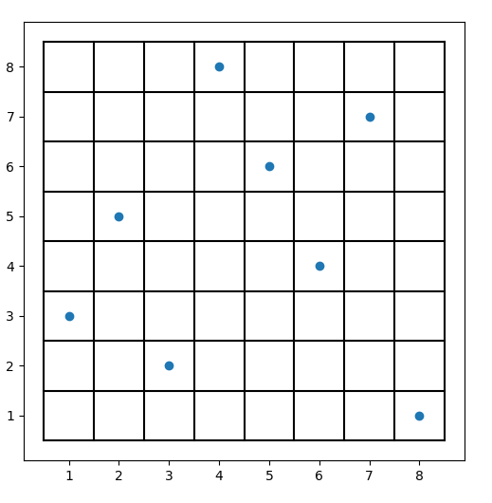

Code Output

C:\Users\Ashish\anaconda3\python.exe C:\Users\Ashish\PycharmProjects\EightQueen\GeneticAlgorithmEightQueen.py

-------------------------------------------------------

Epoch 1

Best Solution: [2, 4, 2, 8, 1, 4, 7, 3, 3]

-------------------------------------------------------

Epoch 2

Best Solution: [2, 4, 2, 8, 1, 4, 7, 3, 3]

-------------------------------------------------------

Epoch 3

Best Solution: [2, 4, 2, 8, 1, 4, 7, 3, 3]

-------------------------------------------------------

Epoch 4

Best Solution: [2, 5, 2, 8, 1, 4, 7, 3, 1]

-------------------------------------------------------

Epoch 5

Best Solution: [2, 5, 2, 8, 1, 4, 7, 3, 1]

-------------------------------------------------------

Epoch 6

Best Solution: [2, 5, 2, 8, 1, 4, 7, 3, 1]

-------------------------------------------------------

Epoch 7

Best Solution: [2, 5, 2, 8, 1, 4, 7, 3, 1]

-------------------------------------------------------

Epoch 8

Best Solution: [2, 5, 2, 8, 1, 4, 7, 3, 1]

-------------------------------------------------------

Epoch 9

Best Solution: [2, 5, 2, 8, 1, 4, 7, 3, 1]

-------------------------------------------------------

Epoch 10

Best Solution: [2, 5, 2, 8, 1, 4, 7, 3, 1]

-------------------------------------------------------

Epoch 11

Best Solution: [2, 5, 2, 8, 1, 4, 7, 3, 1]

-------------------------------------------------------

Epoch 12

Best Solution: [2, 5, 2, 8, 1, 4, 7, 3, 1]

-------------------------------------------------------

Epoch 13

Best Solution: [2, 5, 2, 8, 1, 4, 7, 3, 1]

-------------------------------------------------------

Epoch 14

Best Solution: [2, 5, 2, 8, 1, 4, 7, 3, 1]

-------------------------------------------------------

Epoch 15

Best Solution: [2, 5, 2, 8, 1, 4, 7, 3, 1]

-------------------------------------------------------

Epoch 16

Best Solution: [2, 5, 2, 8, 1, 4, 7, 3, 1]

-------------------------------------------------------

Epoch 17

Solution Found: [3, 5, 2, 8, 6, 4, 7, 1, 0]

**Output for Queens = 8 Solution 2**

Each dot indicates the position of queens

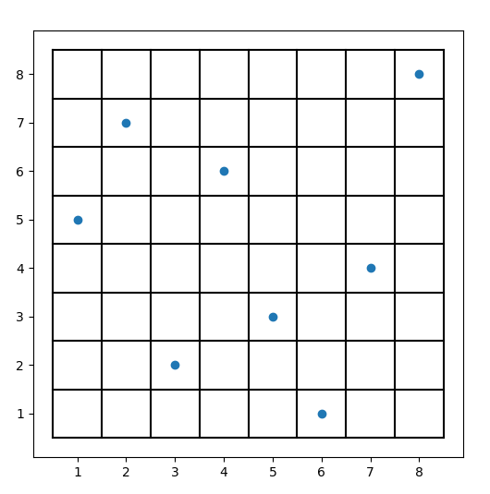

C:\Users\Ashish\anaconda3\python.exe C:\Users\Ashish\PycharmProjects\EightQueen\GeneticAlgorithmEightQueen.py

-------------------------------------------------------

Epoch 1

Best Solution: [2, 7, 1, 6, 4, 6, 1, 5, 3]

-------------------------------------------------------

Epoch 2

Best Solution: [2, 7, 1, 6, 4, 6, 1, 5, 3]

-------------------------------------------------------

Epoch 3

Best Solution: [2, 7, 1, 6, 3, 1, 4, 8, 2]

-------------------------------------------------------

Epoch 4

Best Solution: [2, 7, 1, 6, 3, 1, 4, 8, 2]

-------------------------------------------------------

Epoch 5

Best Solution: [2, 7, 1, 6, 3, 1, 4, 8, 2]

-------------------------------------------------------

Epoch 6

Best Solution: [2, 7, 1, 6, 3, 1, 4, 8, 2]

-------------------------------------------------------

Epoch 7

Best Solution: [2, 7, 1, 6, 3, 1, 4, 8, 2]

-------------------------------------------------------

Epoch 8

Best Solution: [2, 7, 1, 6, 3, 1, 4, 8, 2]

-------------------------------------------------------

Epoch 9

Best Solution: [2, 7, 2, 6, 3, 1, 4, 8, 1]

-------------------------------------------------------

Epoch 10

Solution Found: [5, 7, 2, 6, 3, 1, 4, 8, 0]

**Output for Queens = 32 Solution 1**

Each dot indicates the position of queens

Since the epoch values are very large, I am copying the last few

-------------------------------------------------------

Epoch 2609

Best Solution: [11, 22, 8, 17, 12, 32, 16, 27, 23, 18, 15, 28, 3, 5, 7, 9, 1, 29, 25, 19, 6, 24, 10, 21, 5, 26, 2, 14, 30, 13, 20, 4, 1]

-------------------------------------------------------

Epoch 2610

Best Solution: [11, 22, 8, 17, 12, 32, 16, 27, 23, 18, 15, 28, 3, 5, 7, 9, 1, 29, 25, 19, 6, 24, 10, 21, 5, 26, 2, 14, 30, 13, 20, 4, 1]

-------------------------------------------------------

Epoch 2611

Best Solution: [11, 22, 8, 17, 12, 32, 16, 27, 23, 18, 15, 28, 3, 5, 7, 9, 1, 29, 25, 19, 6, 24, 10, 21, 5, 26, 2, 14, 30, 13, 20, 4, 1]

-------------------------------------------------------

Epoch 2612

Best Solution: [11, 22, 8, 17, 12, 32, 16, 27, 23, 18, 15, 28, 3, 5, 7, 9, 1, 29, 25, 19, 6, 24, 10, 21, 5, 26, 2, 14, 30, 13, 20, 4, 1]

-------------------------------------------------------

Epoch 2613

Solution Found: [11, 22, 31, 17, 12, 32, 16, 27, 23, 18, 15, 8, 3, 5, 7, 9, 1, 29, 25, 19, 6, 24, 10, 21, 28, 26, 2, 14, 30, 13, 20, 4, 0]

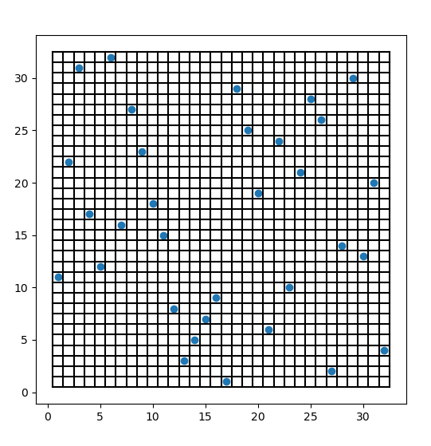

**Output for Queens = 32 Solution 2**

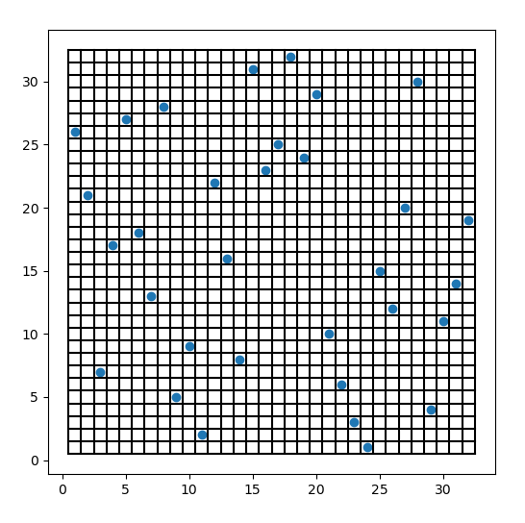

Since the epoch values are very large, I am copying the last few

Epoch 735

Best Solution: [26, 21, 7, 4, 6, 29, 13, 28, 5, 9, 2, 22, 16, 8, 31, 23, 25, 32, 24, 17, 10, 6, 3, 1, 15, 12, 20, 30, 27, 11, 14, 19, 1]

-------------------------------------------------------

Epoch 736

Best Solution: [26, 21, 7, 4, 6, 29, 13, 28, 5, 9, 2, 22, 16, 8, 31, 23, 25, 32, 24, 17, 10, 6, 3, 1, 15, 12, 20, 30, 27, 11, 14, 19, 1]

-------------------------------------------------------

Epoch 737

Best Solution: [26, 21, 7, 4, 6, 29, 13, 28, 5, 9, 2, 22, 16, 8, 31, 23, 25, 32, 24, 17, 10, 6, 3, 1, 15, 12, 20, 30, 27, 11, 14, 19, 1]

-------------------------------------------------------

Epoch 738

Best Solution: [26, 21, 7, 4, 6, 29, 13, 28, 5, 9, 2, 22, 16, 8, 31, 23, 25, 32, 24, 17, 10, 6, 3, 1, 15, 12, 20, 30, 27, 11, 14, 19, 1]

-------------------------------------------------------

Epoch 739

Solution Found: [26, 21, 7, 17, 27, 18, 13, 28, 5, 9, 2, 22, 16, 8, 31, 23, 25, 32, 24, 29, 10, 6, 3, 1, 15, 12, 20, 30, 4, 11, 14, 19, 0]

**Output for Queens = 16 Solution 1**

Each dot indicates the position of queens

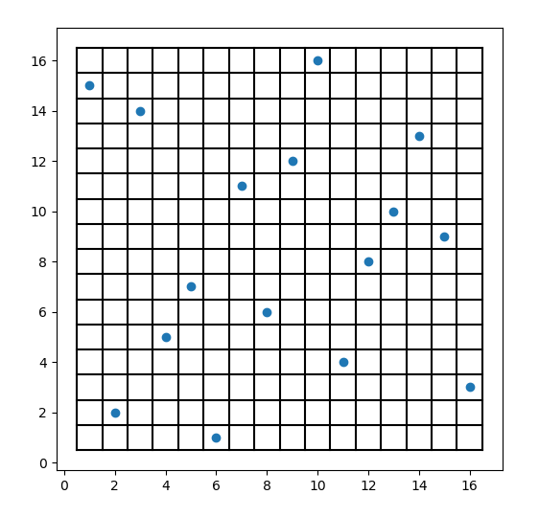

Since the epoch values are very large, I am copying the last few

Epoch 96

Best Solution: [15, 2, 10, 5, 7, 1, 11, 6, 14, 16, 4, 8, 4, 13, 9, 3, 1]

-------------------------------------------------------

Epoch 97

Best Solution: [15, 2, 10, 5, 7, 1, 11, 6, 14, 16, 4, 8, 4, 13, 9, 3, 1]

-------------------------------------------------------

Epoch 98

Best Solution: [15, 2, 10, 5, 7, 1, 11, 6, 14, 16, 4, 8, 4, 13, 9, 3, 1]

-------------------------------------------------------

Epoch 99

Best Solution: [15, 2, 10, 5, 7, 1, 11, 6, 14, 16, 4, 8, 4, 13, 9, 3, 1]

-------------------------------------------------------

Epoch 100

Solution Found: [15, 2, 14, 5, 7, 1, 11, 6, 12, 16, 4, 8, 10, 13, 9, 3, 0]

**Output for Queens = 16 Solution 2**

Each dot indicates the position of queens

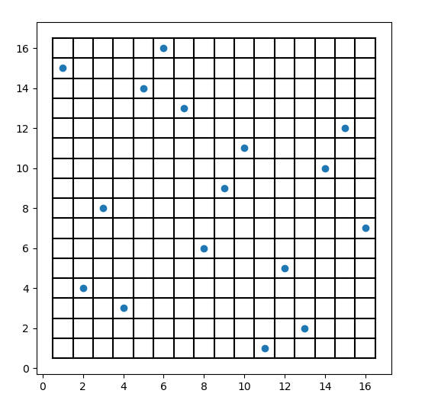

Since the epoch values are very large, I am copying the last few

Epoch 202

Best Solution: [15, 4, 8, 3, 14, 16, 13, 6, 1, 11, 15, 5, 2, 10, 12, 7, 1]

-------------------------------------------------------

Epoch 203

Best Solution: [15, 4, 8, 3, 14, 16, 13, 6, 1, 11, 15, 5, 2, 10, 12, 7, 1]

-------------------------------------------------------

Epoch 204

Best Solution: [15, 4, 8, 3, 14, 16, 13, 6, 1, 11, 15, 5, 2, 10, 12, 7, 1]

-------------------------------------------------------

Epoch 205

Solution Found: [15, 4, 8, 3, 14, 16, 13, 6, 9, 11, 1, 5, 2, 10, 12, 7, 0]