[Exercise] Create a database “Company”

[Exercise] Create a database “University”

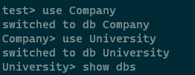

[Exercise] Drop "University"

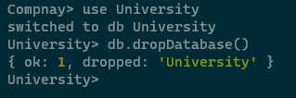

[Exercise] Create user for the database “Company”



[Exercise] Create a collection “customers” for Company database

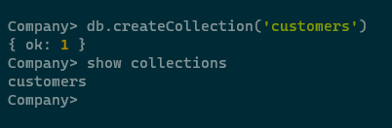

[Exercise] Create 5 customers and the fields for their first_name and last_name:

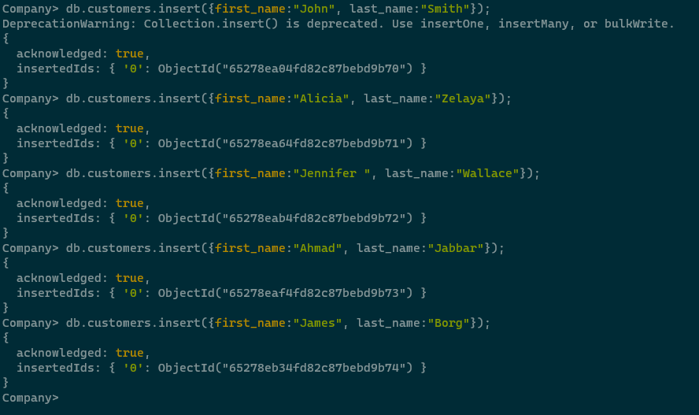

[Exercise] Find the data for document where the first_name is Jennifer

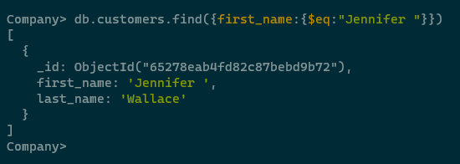

[Exercise] use an array to insert following to a database "petshop" and collection "pets"

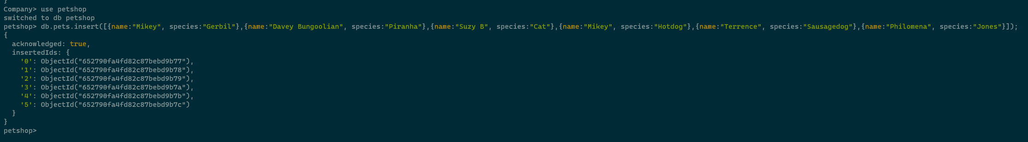

[Exercise] Update all the customers to include gender and age fields

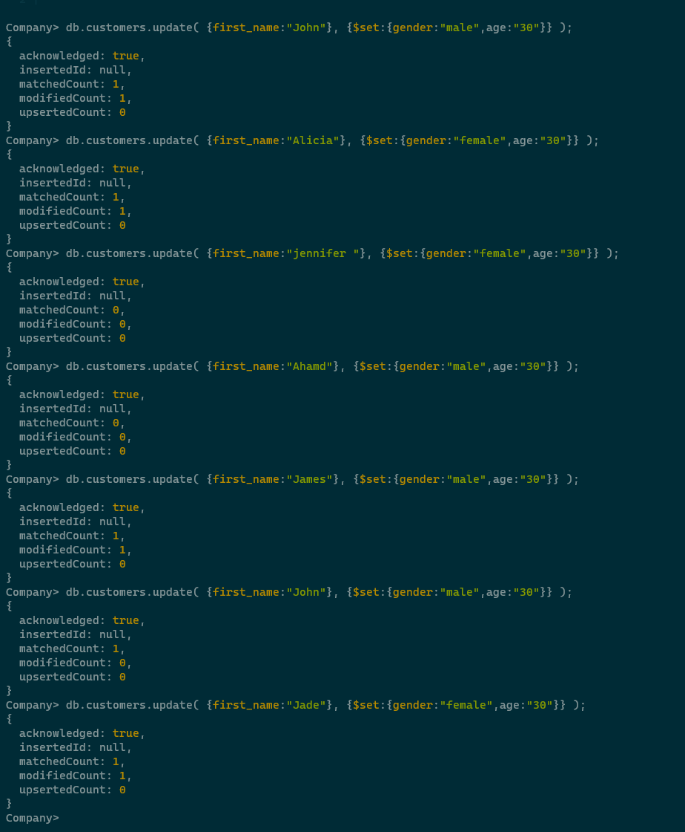

[Exercise] Use the given

https://www.cs.odu.edu/~sampath/courses/data/stocks.json for this exercise

