# Project – Aquatix – P03

**Link:** <https://bitbucket.org/team5c/hidden-leaf>

**My work:** https://bitbucket.org/team5c/hidden-leaf/issues?responsible=S525078

1. **Contributions:**

* In the aquatix project, I dealt mainly with the functionalities of the admin and designing those pages and grids.
* Integrating it with the page was done with the collaboration of my team.
* I have also tried to integrate it with external login which works fine on my localhost as there are some hosting issues to do it on azure.
* The bug fixes of admin as suggested was done independently by me and partially with the help of my team

1. **Challenges:**

* Dealing with the monitoring of the users was bit tough and raised many errors.
* Providing archive rather than delete option to store in the secondary database by compressing the data.
* Providing external login in the later phase of development of application.
* Fixing the bugs and hoping that no further bugs should arise.

1. **Bug fixes:**

* Date field bug was fixed in the special occasions tab.
* Validations were fixed in the admin login and registration.
* Creating of the events were fixed using the button and the style for it.

1. **Assistance:**

* I got assistance from my team in fixing bugs and testing my work.
* I assisted in interface design of admin and also assisted in bit-bucket issues.
* Krishna assisted everyone in the class for their work and was available all time.

**Screenshots of my work:**

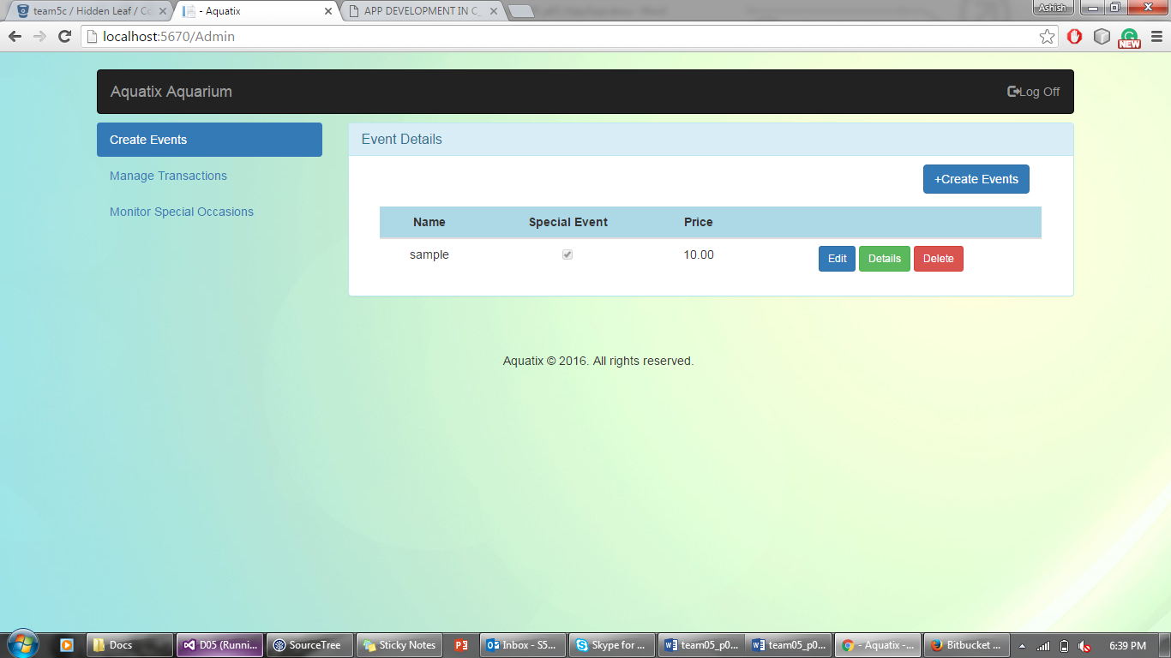

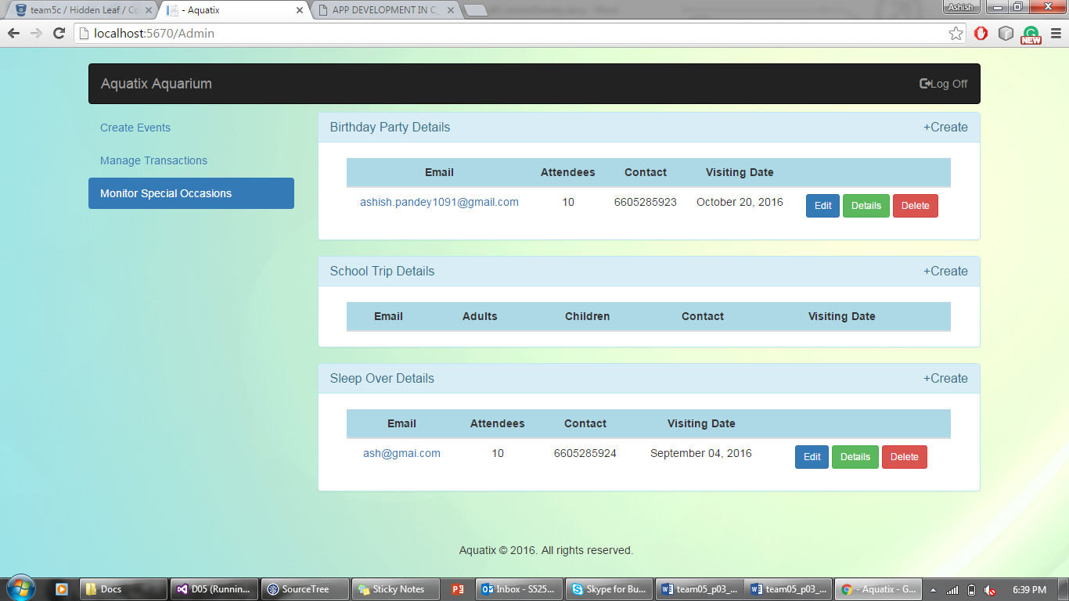

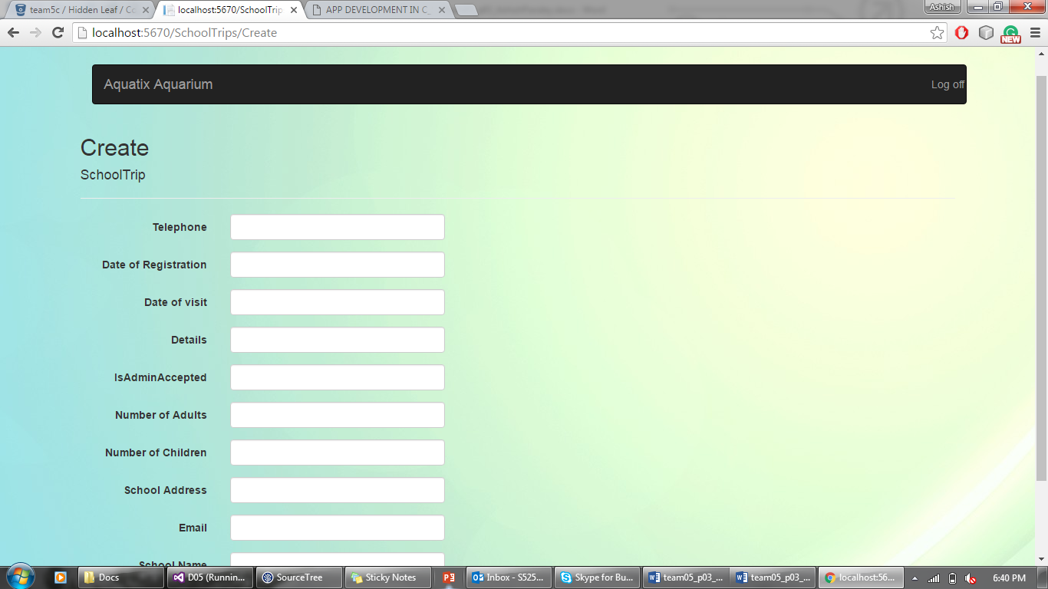

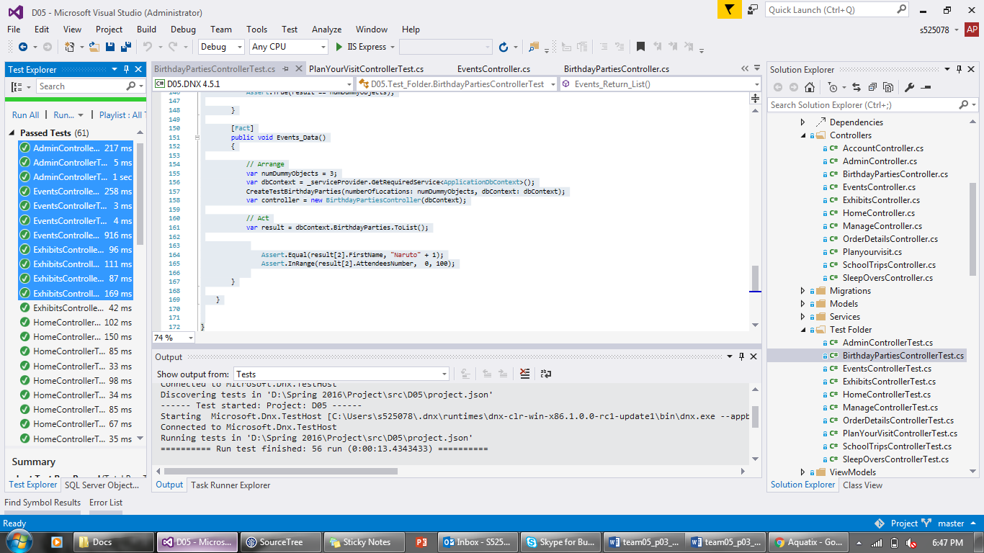

**A part of the code where I helped:**

public IActionResult Index()

{

var viewModel = new CustomViewModel

{

Events = _context.Events.ToList(),

Price = _context.Prices.ToList(),

Order = _context.OrderDetails.ToList(),

Coupons = _context.Coupons.ToList(),

Users = _context.Users.ToList(),

birthdayparties = _context.BirthdayParties.ToList(),

sleepovers = _context.SleepOvers.ToList(),

schooltrips = _context.SchoolTrips.ToList(),

eventNew = new Event()

};

return View(viewModel);

}

[HttpPost]

[ValidateAntiForgeryToken]

public IActionResult Edit(Event eventNew)

{

if (ModelState.IsValid)

{

_context.Update(eventNew);

_context.SaveChanges();

return Redirect("/Admin/Index"); // This modification for redirecting.

}

return View(eventNew);

}

There were some UI Changes where I helped my team and styling buttons.

**Individual contribution levels:**

1. **Vijay Gopi :** Vijay is an important asset for our team and he maintained his calmness and coolness to resolve many issues for us and also he is technically expert person, he did the events, special eventsand home page of our project with a good UI and business logic.
2. **Nadeem Ansari :** Nadeem is very supportive and deals with his tasks patiently on time and he dealt with all the other functionalities of our project from maintaining the copyrights to designing the flyers and highlighting us on this project in “about us” page.
3. **Sai Sharanya Deevakonda :** She is the base of our team dealing with the major functionalities of our project suchas authentication, shopping cart, ticket transactions and the overviews of our work.
4. **Suprem Raju Manthena :** Suprem is a good team player, he handles all the tasks perfectly and on time with his best efforts. He is good at UI designs and worked in the forms of birthday parties, school trips and sleepovers.
5. **Ashish Pandey :** As I have worked in the Admin module, I dealt with the functionalities for creating events, special occasions and managing transactions for the user.

If we have 800$, I will divide it equally and advise them to enhance this app by acquiring more developers so that the app can make some more good profits and can be the base of our start up. Everyone is equally responsible for this app development as the work had been scaled such and was managed effectively. Team management was good and best to my experience, I wish to work with this team once more.