Project – Aquatix – P03

**Link:** <https://bitbucket.org/team5c/hidden-leaf>

My work: <https://bitbucket.org/team5c/hidden-leaf/issues?responsible=nadeem_ansari>

1. Contributions:

* In the project I worked on designing the About, Contact Us, Milestones, FAQs and other page components from the home page.
* I have contributed my time in understanding Bootstrap which I found really interesting and hope to improve more.
* I tried to integrate Facebook login but due to internal errors and time constraints, we had to abandon it.

1. Challenges:

* In the project while designing the About page, I had to come up with a clever to adjust every team member is a certain style.
* While designing the FAQs, I had to make sure the FAQs obtained were licensed. Apart from that I also learned how to implement Accordions in Bootstrap.

1. Bug Fixes:

* Fixed navigation bar that become distorted when navigating through the website.

1. Assistance:

* I assisted my team with documentation and presentation.
* Assisted other team members with their goals and fixes.

**Screenshots:**

**About page:**

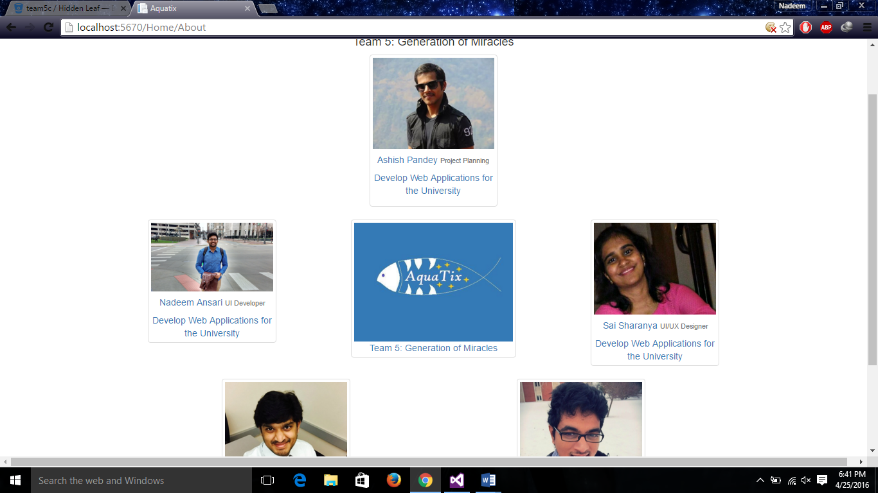

**FAQs:**

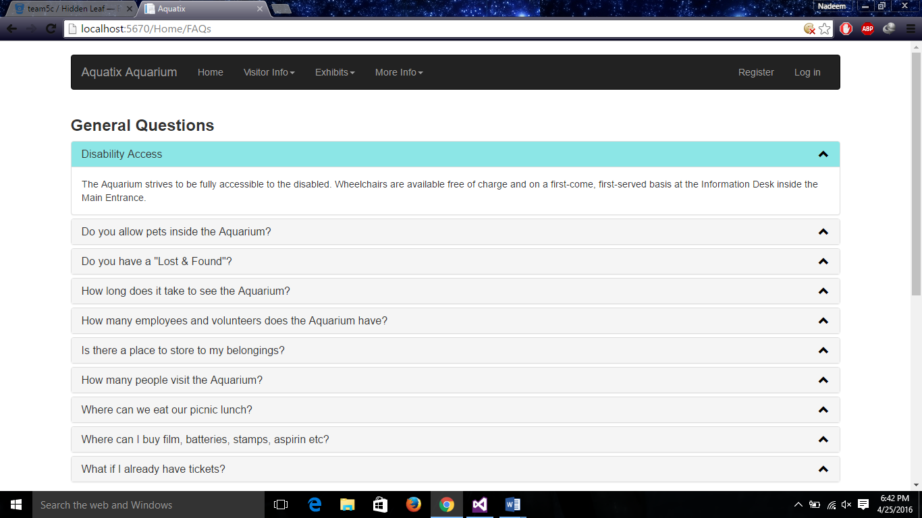

**Test cases for Home Controller:**

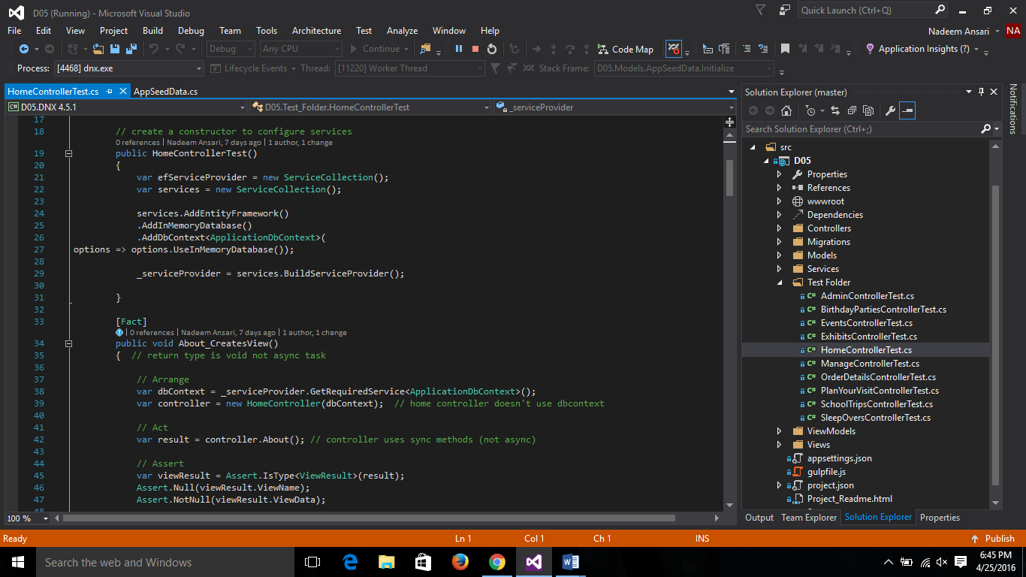

**Part of the code where I assisted:**

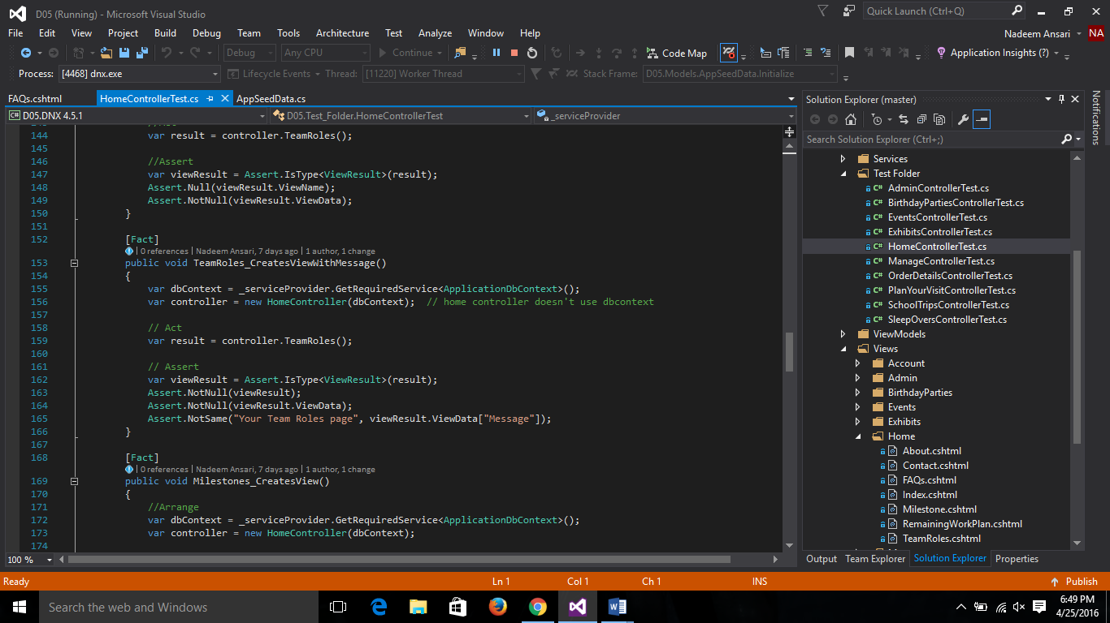

**Individual Contribution Levels:**

1. **Ashish Pandey:** Ashish worked really hard on the Admin module and the result of his hard work paid off. He was consistent to team meetings and never complained or raised any issues with the other team members.
2. **Nadeem Ansari:** I worked mainly on static pages like About, Contact Us, FAQs etc as a result I gained a lot of knowledge in Bootstrap. I hope to further improve.
3. **Sai Sharanya :** She was the lead for the team and she lead the team the right way. Encouraging and praising when work was done and making sure we got the task done before the deadline.
4. **Suprem Raju Manthena:** He was extremely consistent to team meetings and played well with others.
5. **Vijay Gopi:** He was also extremely well disciplined when it came to the project. I would really like to work with him the future as well.

If our team was granted $ 800 I would encourage my team members to invest in technologies that would help us enhance our project beyond expectation in the future. Apart from that, I’m 100% satisfied with their efforts and participation and so would love to work with them again and again.