# Project – Aquatix – P03

**Link:** <https://bitbucket.org/team5c/hidden-leaf>

**My work:** <https://bitbucket.org/team5c/hidden-leaf/issues?responsible=sharanyarao>

1. **Contributions:**

* I have contributed in designing the web pages of the applications
* Implemented complete ticket booking functionalities
* Implemented Role based authentication and authorization for registration and login of the application
* Analysis of requirements

1. **challenges:**

* While developing the ticket booking module I faced issues in data binding between views and controllers
* While implementing Role based authentication and authorization I did not have proper guidance to proceed with the implementation. I took help of official Microsoft asp.net website and explored other technical blogs related to asp.net 5 and MVC6
* Implementing unit test cases

1. **bug fixes:**

* In the admin module there was no navigation to home button and which is fixed now.
* Changed the date formats for all the special events.
* Addressed all the copyrights

1. **assistance:**

* I was involved in designing the web pages of all the modules.
* Helped team members in resolving technical issues they faced in their modules.
* Proactively took up others team members module in their absence

**Screenshots of my work:**

**1. Hours and Prices page**

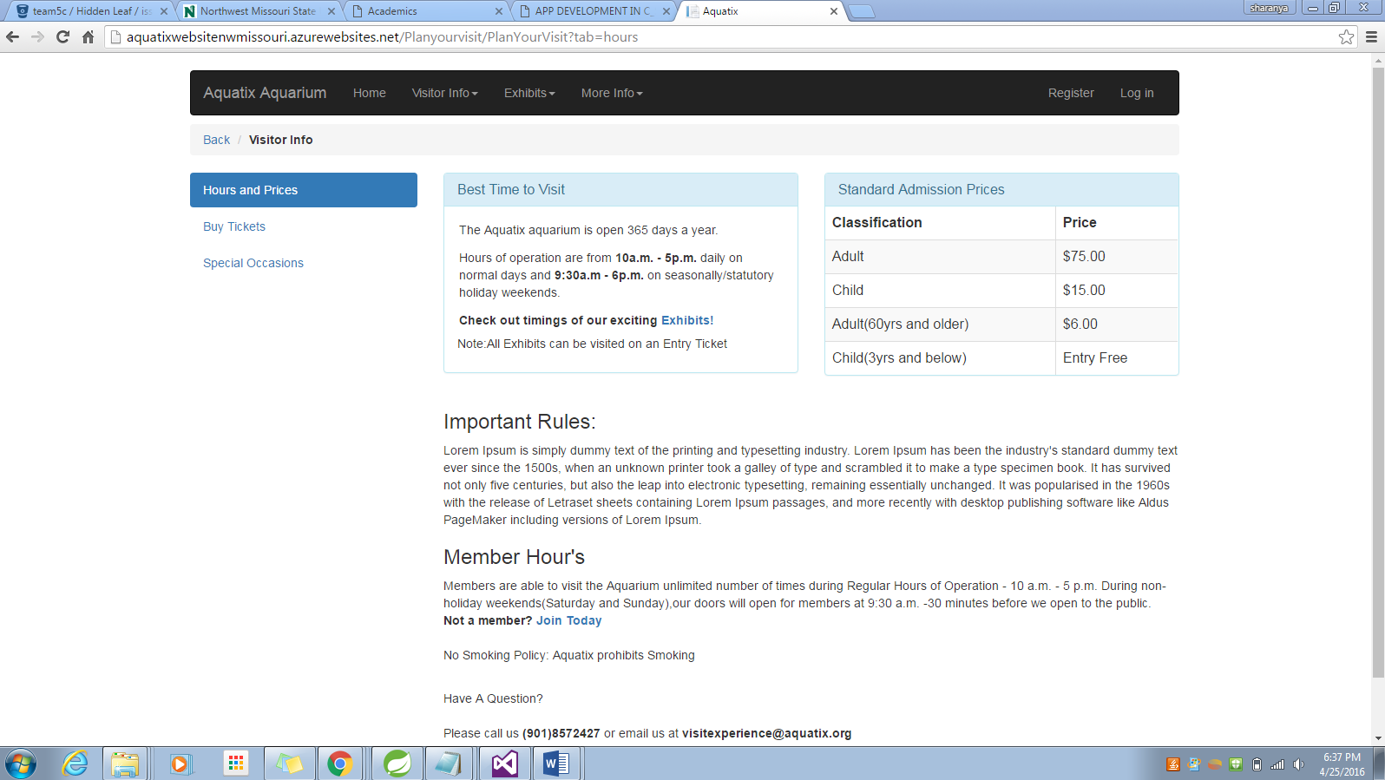

**2. Ticket Booking Page**

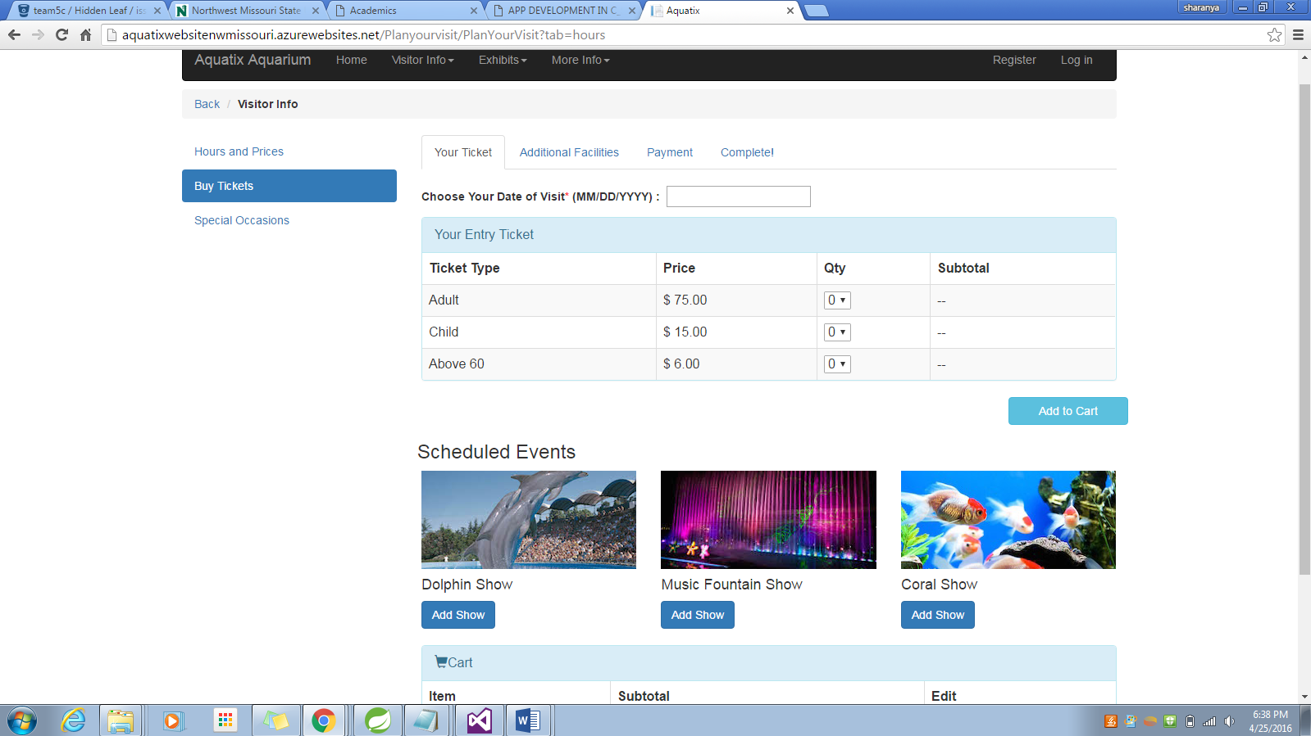

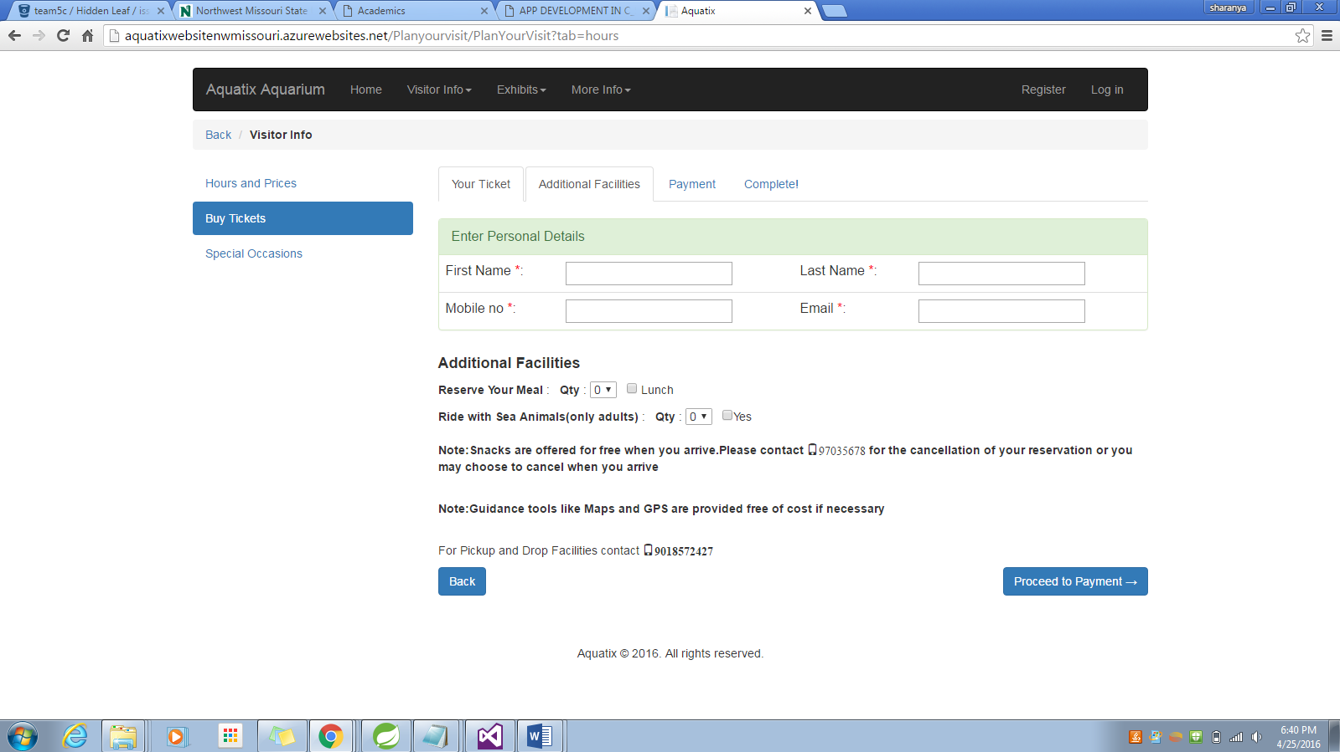

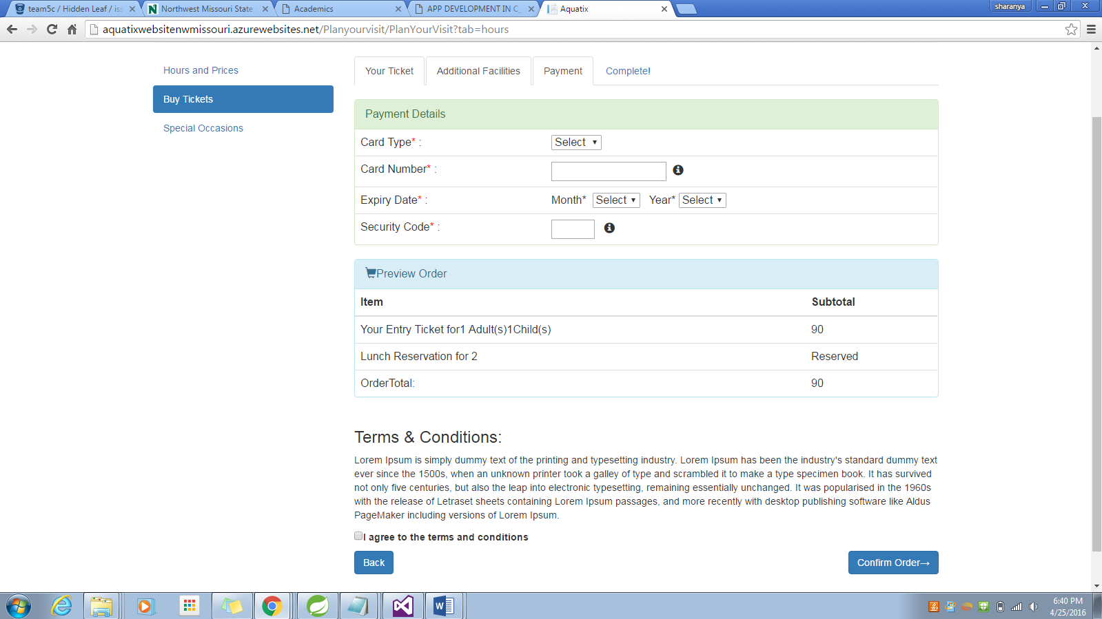

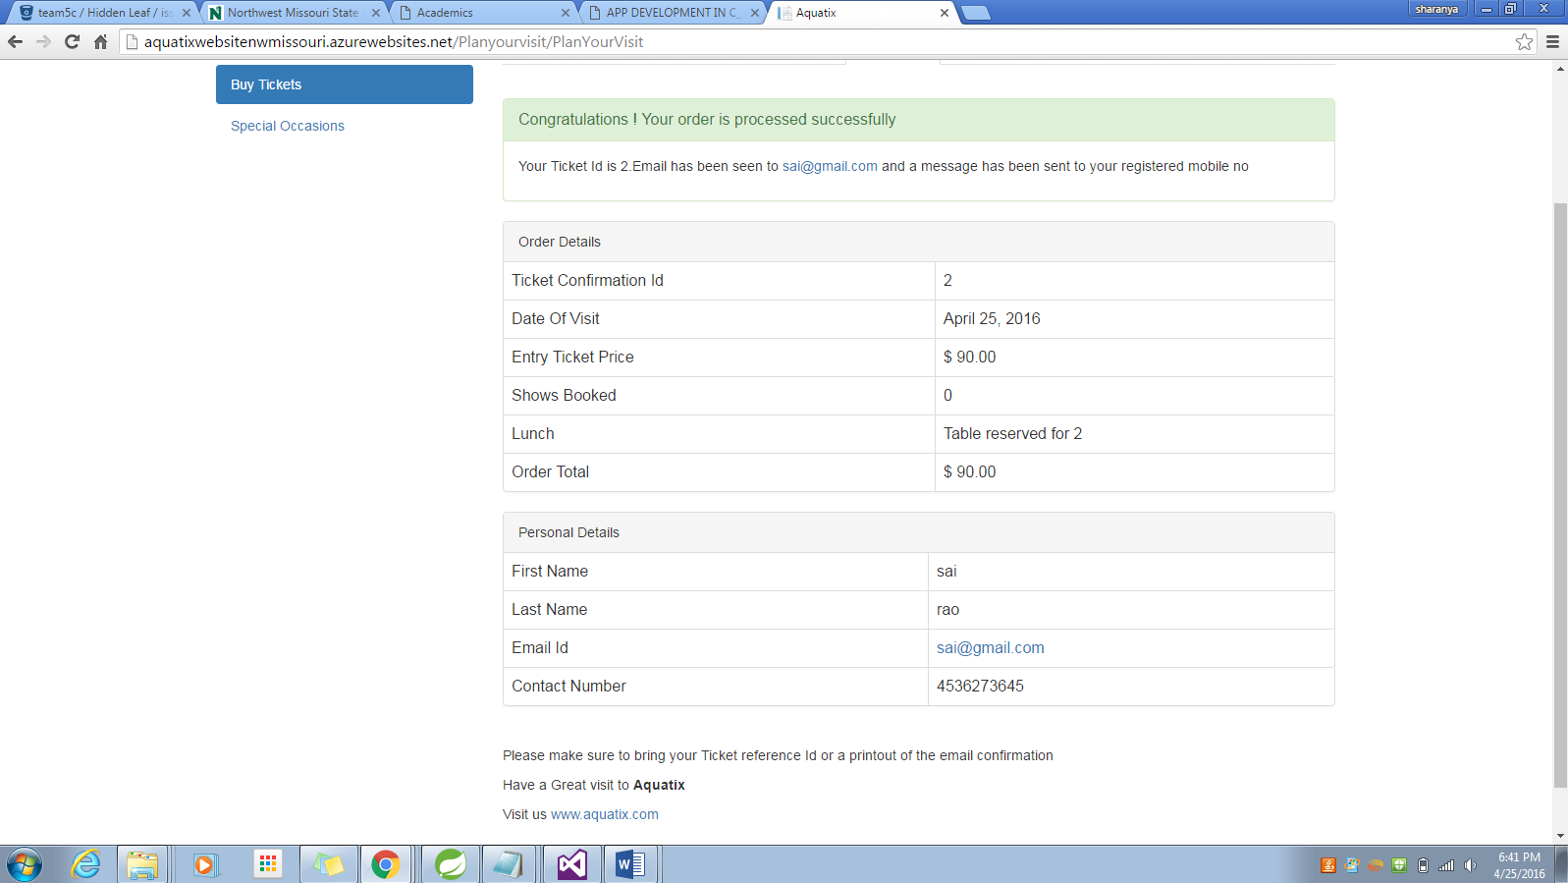

**3. Test Cases**

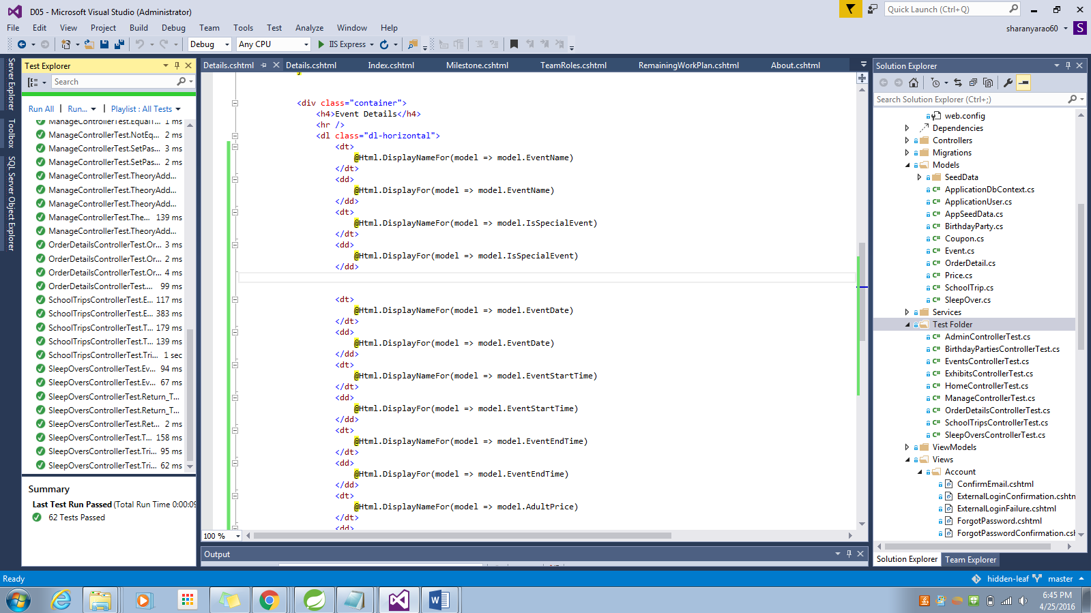

**A part of code I contributed**

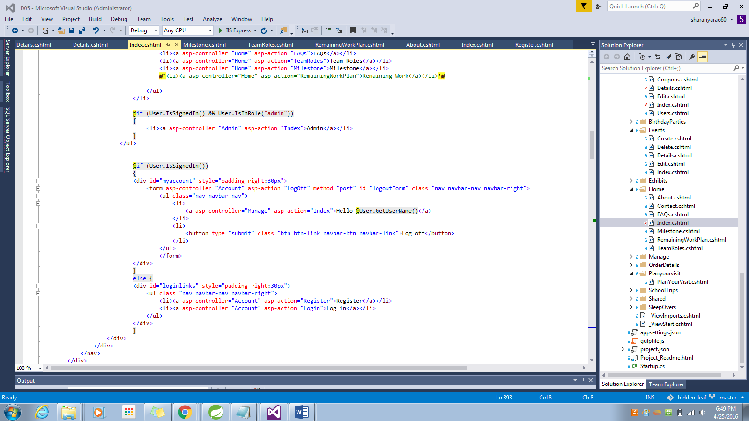

**Individual contribution levels:**

**I would give 20% of contribution made by each team member which resulted in 100% success of the project. All the members of the team have contributed equally for projects success.**

1. **Ashish Pandey:**  Responsible for the admin module and completed the functionality to the best of his efforts. He is technically very strong and good user interface sense.
2. **Nadeem Ansari:** He has very good knowledge on User Interface development and has been a good team player.
3. **Vijay Gopi:** He is the savior of the project who does all the last minute fixes and rescues the team. Strong technical skills.
4. **Suprem Raju Manthena:** This person is one of my motivator, he is very good at UI and helped me in my UI stylings. He worked with Special occasions and helped in the forms of birthday parties, school trips and sleepovers.
5. **Sai Sharanya Deevakonda:** I am one of the key members in the project who handled the authentication, shopping cart, ticket transactions and all the over views of the UI.

I we have $800/team, I would divide it equally among all the team members. In my view a projects success is the result of team work. Working with Team 05 has proved that by being punctual, efficient, proactive and supportive. All the members have contributed equally. Each member in the team has different abilities with expertise in their own domain, hence the effort of the individual has to be considered. Hence I would divide the amount equally to all the team members. The amount could also be used for enhancing the team or developing the project further by taking it to a next level by using new technologies.