# Project – Aquatix – P03

**Link:** <https://bitbucket.org/team5c/hidden-leaf>

My Key Contributions To Project

1. **Contributions Made:**

* Created few model classes and saved data from these models into Database
* Worked on improving UI of the website
* Taken care of Business Logic in the Project
* Persisting data in Database
* CRUD operations
* Analyzing requirements

1. **Challenges Faced:**

* Working on merge conflicts when occurred while pulling a code from bit-bucket
* Writing test cases

1. **Bugs Fixed:**

* Fixed bugs identified in Home Page by coordinating with the team.

1. **Assistance Provided:**

* Dr. Denise Case, Krishna Painuley, Manasa Bojja.

**Screenshots of my work.**

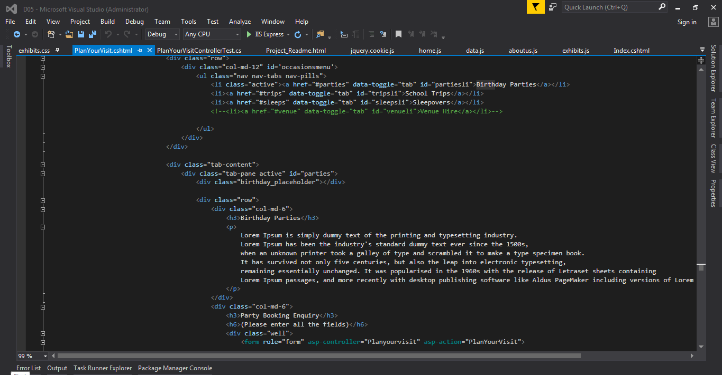

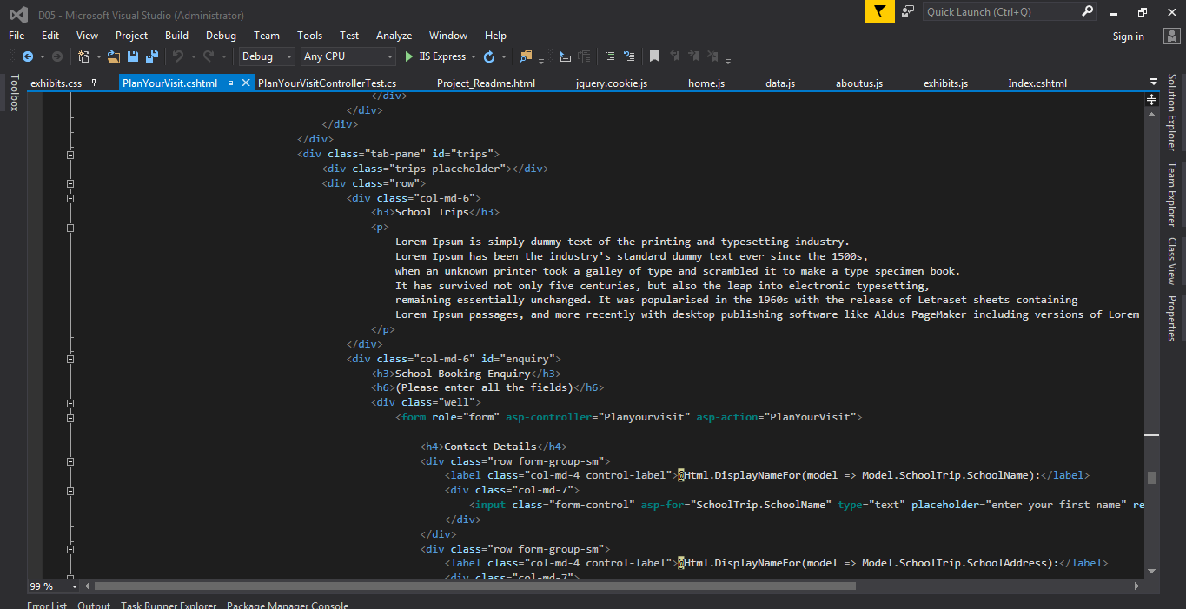

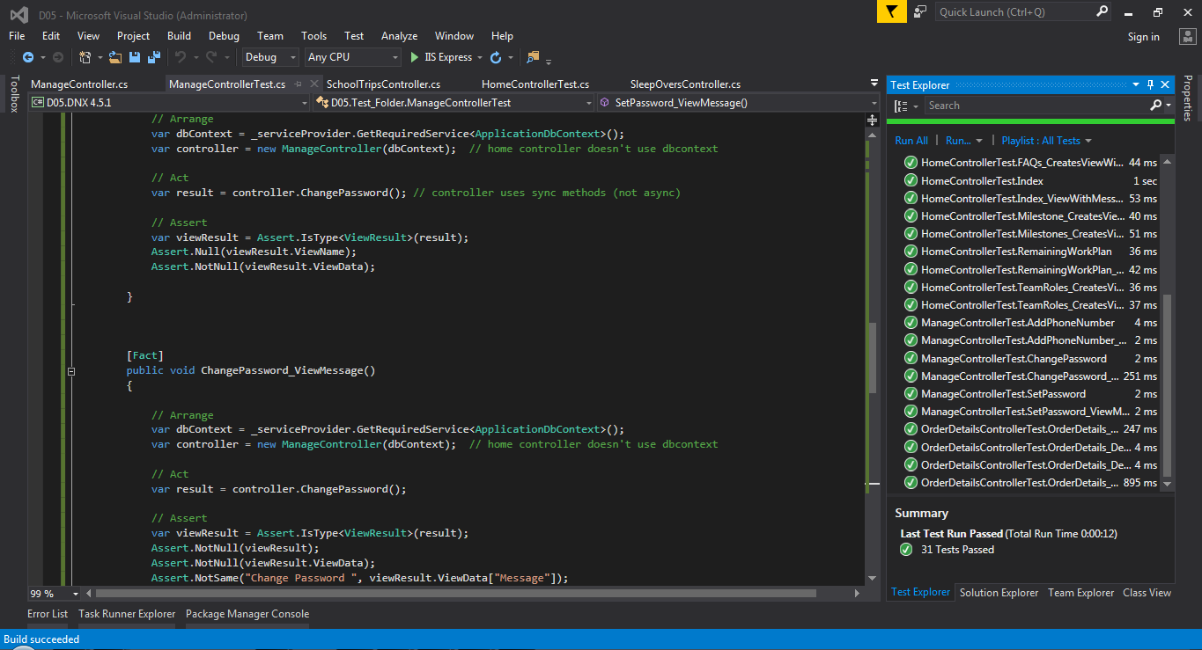

**Individual contribution levels:**

1. **Ashish Pandey 20%**
2. **Nadeem Ansari 20%**
3. **Sai Sharanya Deevakonda 20%**
4. **Suprem Raju Manthena 20%**
5. **Vijay Gopi 20%**

If I was credited $800 for the project, I would distribute the amount among the team members based on their contributions towards the project. All my team members worked equally towards the project in an efficient way. So, I would like to distribute the amount equally among the Team Members.