# Project – Aquatix – P03

**Link:** <https://bitbucket.org/team5c/hidden-leaf>

**My work:**

1. **Contributions:**

* In my Project, complete events, special events modules are done by me
* Home page design is done by me.
* I have contributed my time in understanding System Transaction package in Nuget which are helpful for real-time transactions in an asynchronous way.
* I have tried working on Internationalization, localization and globalization which are initiated by me in the project but failed to work on because of DNX core 5.0 issue and lack of time.

1. **challenges:**

* In Our UI we have to make the view models for most of all the pages. For which the page redirection is a problem and resolved by me.
* The Shopping cart view modal is one which carries the ticket transaction as well as all the special occasions. While adding the cart to the transaction one of my teammate faced a problem and I faced a critical situation to handle the null object of other data with very efficient technique.

1. **bug fixes:**

* The home page buttons are not worked in previous before the testing by other teams. I have worked on it and fixed this issue.
* Initially while the admin create the Event, if the event is not selected as a special event it is taken as null. Now this was fixed.

1. **assistance:**

* I’m supported to most of all my team members in the situations like, managing cart with one kind of object at a time.
* Birthday party page creation with a form and interactive modal with the database.
* Admin manage transactions and Special occasions management is where I supported and assisted my team.

**Screenshots of my work.**

**Home page:**

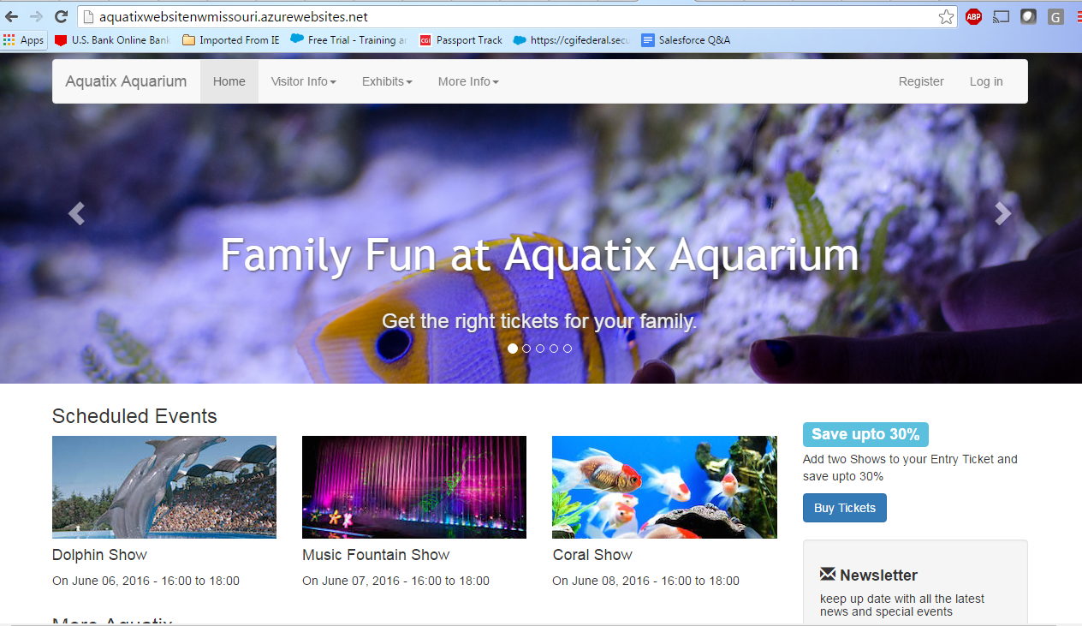

**Exhibits page:**

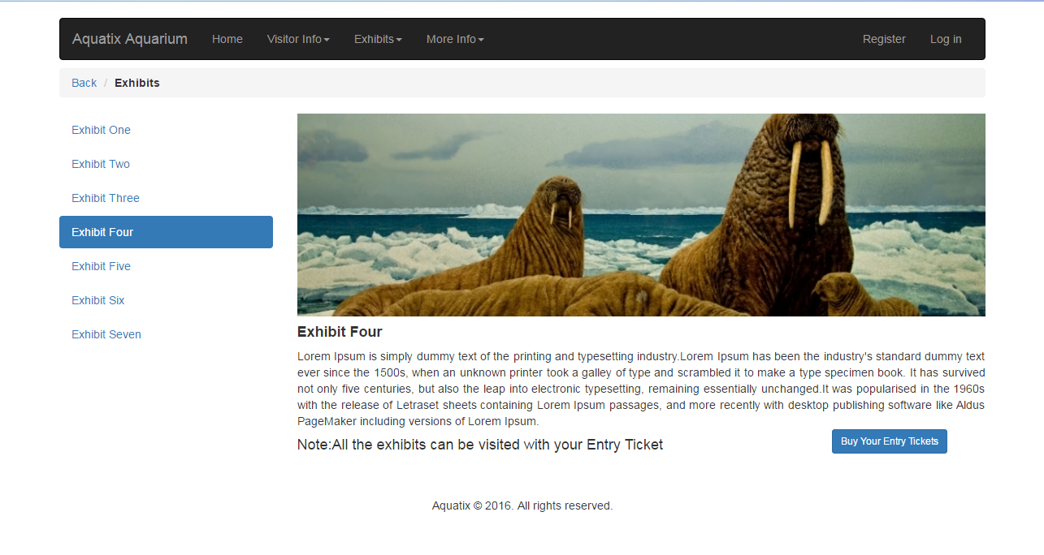

**Logo for Aquatix in about us:**



**Test cases:**

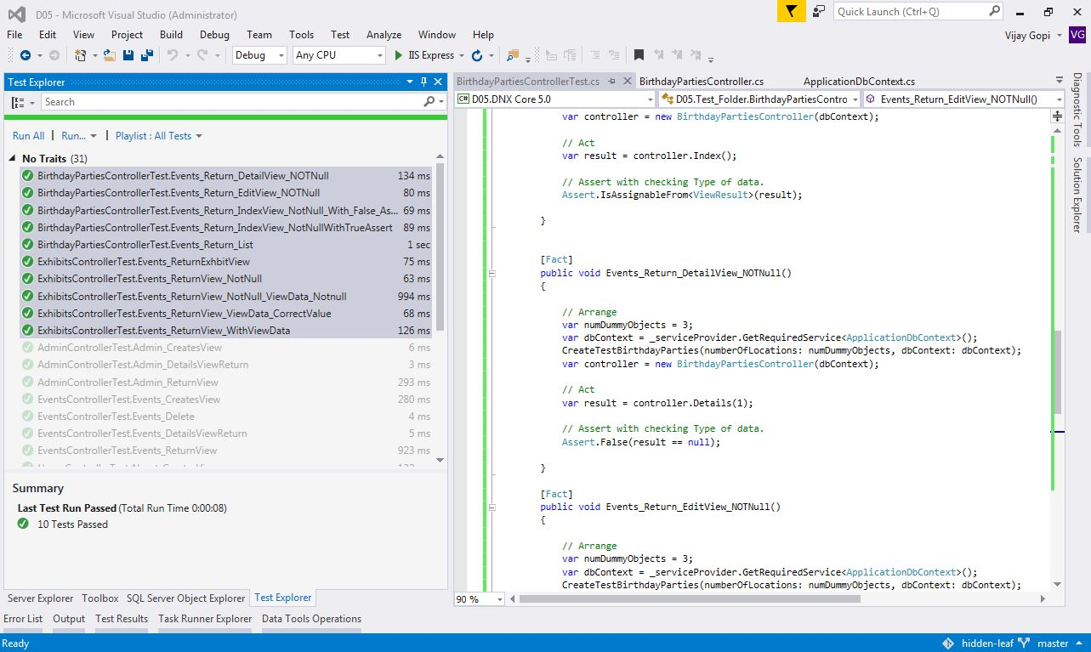

**Apart of code I have helped:**

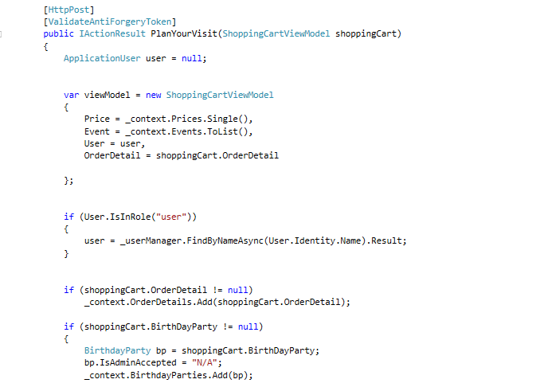

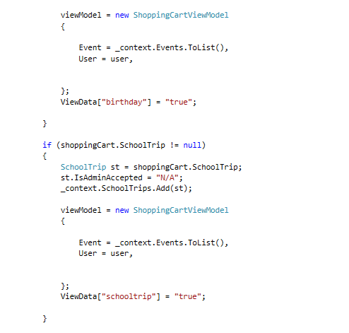

There are lot more partial fixes I have helped my team.

**Individual contribution levels:**

1. **Ashish Pandey:**  He worked for most of the admin part and it is working absolutely fine as we prototyped. I feel like he is one of the best team mate with the best UI knowledge.
2. **Nadeem Ansari:** He is also a very best team member with the good UI knowledge and in creating the Pages as instructed. He work with most of all static pages like about us, FAQs, contact pages and also with some of the controllers which handle them.
3. **Sai Sharanya Deevakonda:** She is one the key members in the project who handled the authentication, shopping cart, ticket transactions and all the over views of the UI.
4. **Suprem Raju Manthena:** This person is one of my motivator, he is very good at UI and helped me in my UI stylings. He worked with Special occasions and helped in the forms of birthday parties, school trips and sleepovers.
5. **Vijay Gopi:** I myself worked in events, special events and home page of my project with complete UI and business logic. I also assisted for Admin modules like handling transactions, multiple models with view models. The shopping cart with null has be resolved by me and working fine.

If we have $800 as a team, in my view I will divide it to 5 parts. That means $160 for each person is my suggestable view to distribute. I have a reason that the participation and activeness in the project is much more important thing to be considered. One or two might be very good in the project but, the work which we scaled, managed, scheduled and helped each other are completely transparent to each other. So, the participation is the most important thing I will consider and the rate of effort they have to accomplish. These are the two most important things I will consider to divide and distribute this money. So, I feel dividing 800 to the 5 parts is the very good choice as of my feeling. I’m 100% satisfied with their efforts and participation. Thanks to Team 05.