# Pollinate-AKS Create Azure AKS Cluster

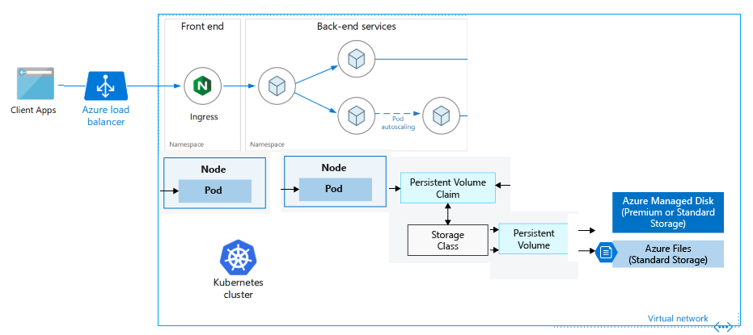

Overview

This repository is offered for create features with the Azure Kubernetes Service (AKS). This repository is monitored by the AKS Monitor

Also create 2 Pod for one pod for database and second pod for web server.

Overview

AKS Cluster creates with No of Azure Components

Azure Resource Group name: - azure-aks-rg inside resouce group creates

AKS Monitor: - aksmonitor-17231297914367105045

AKS Cluster: - az-aks-Cluster

AKS Network: - azure-aks-rg-network

AKS Routetable: azure-aks-rg-routetable

AKS ContainerInsights:-ContainerInsights(aksmonitor-17231297914367105045)

This script runs in Two Parts, First Parts: - Terraform script creates AKS, Second Parts: - Create Pod and mount Image to Pod

1. First Parts use Terraform script for create AKS cluster.

Terraform script runs from your Local computer or Azure Pipeline.

Terraform scrips runs from your Local Computer then require following prerequisite tools.

1. Azure CLI
2. Azure Powershell
3. Visual Studio 2019 with Kubernetes
4. Visual Studio code
5. Git install
6. kubernetes-cli
7. Terraform
8. Docker
9. Azure Account for Create AKS

Very easy way to installed to your local computer on Powershell (adminsrator) using choco install docker-desktop –y.

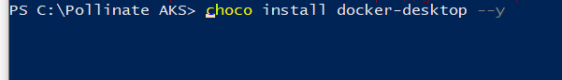

Go to <https://github.com/ashishpatel3/Pollinate-AKS> and download repository to your local computer folder.

Then got to your folder & open Powershell.exe

Login into Azure using command az Login

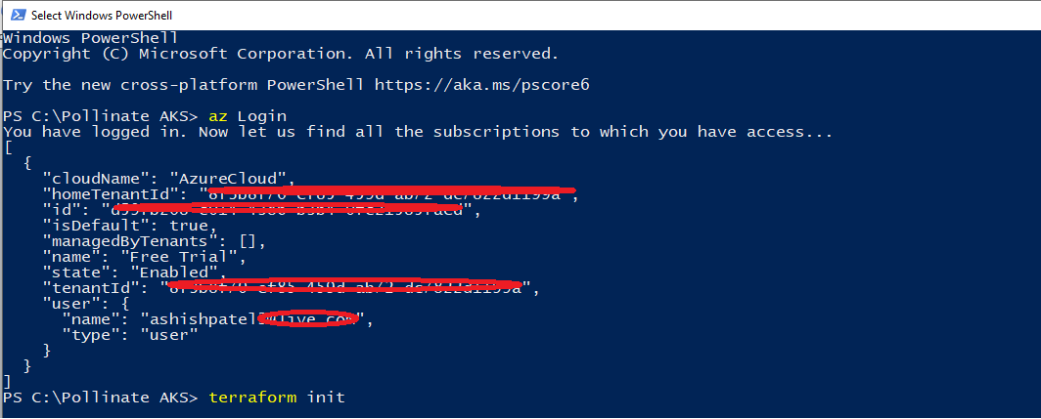

Run command terraform init for terraform initialisation.

Terrform Code :- terraform init

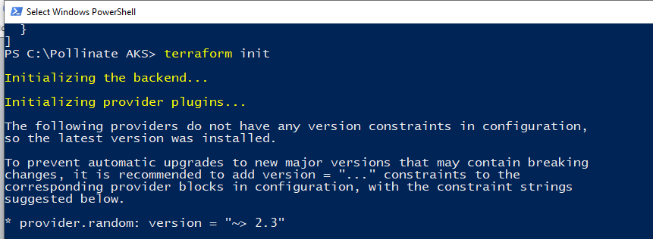

Run command terraform plan for terraform plan

Terrform Code: - terraform plan

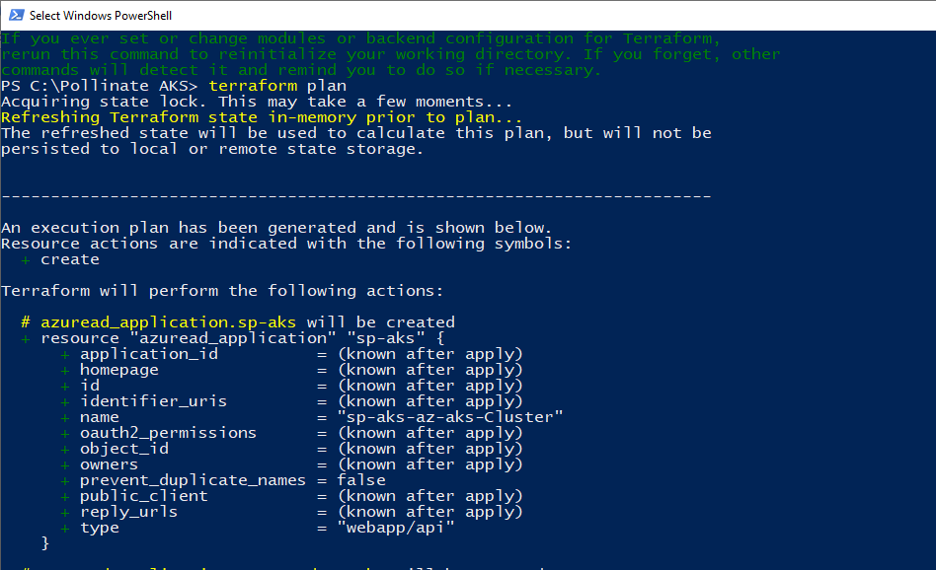

Run Terraform code apply for create aks into resource group.

Terraform code:-terraform apply --auto-approve

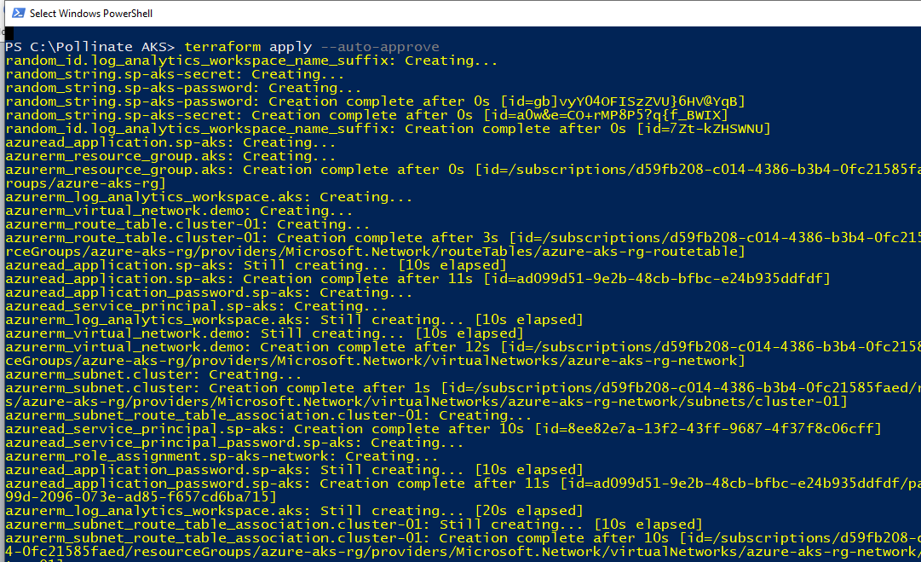

Terraform created following resource group including aks.

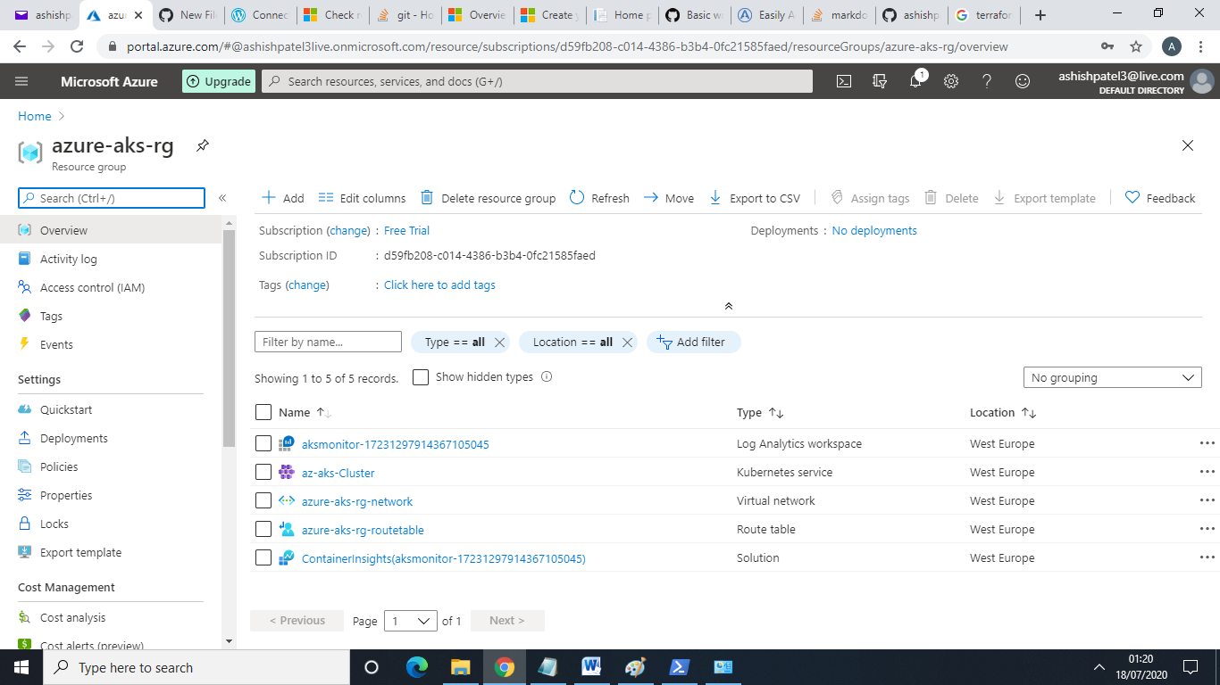

Also Terraform code run from Azure Pipeline.

Go to Azure Devops , click on pipline create new pipeline , click on classic editor on bottom

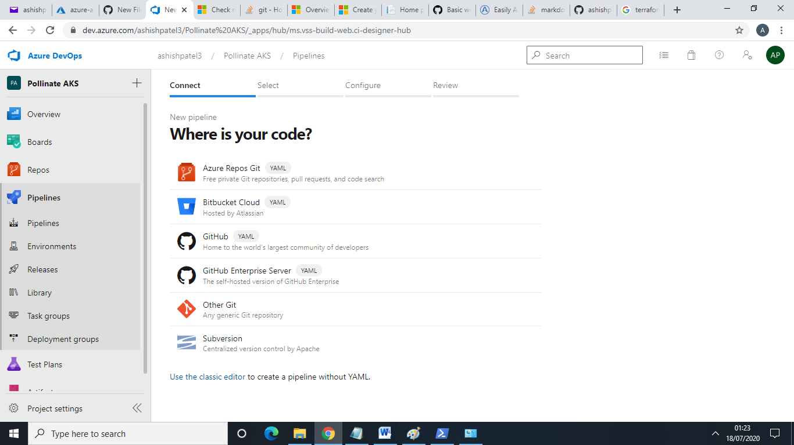

Click on GitHub or import git hub repository to Azure Repository then use Azure Repos Git

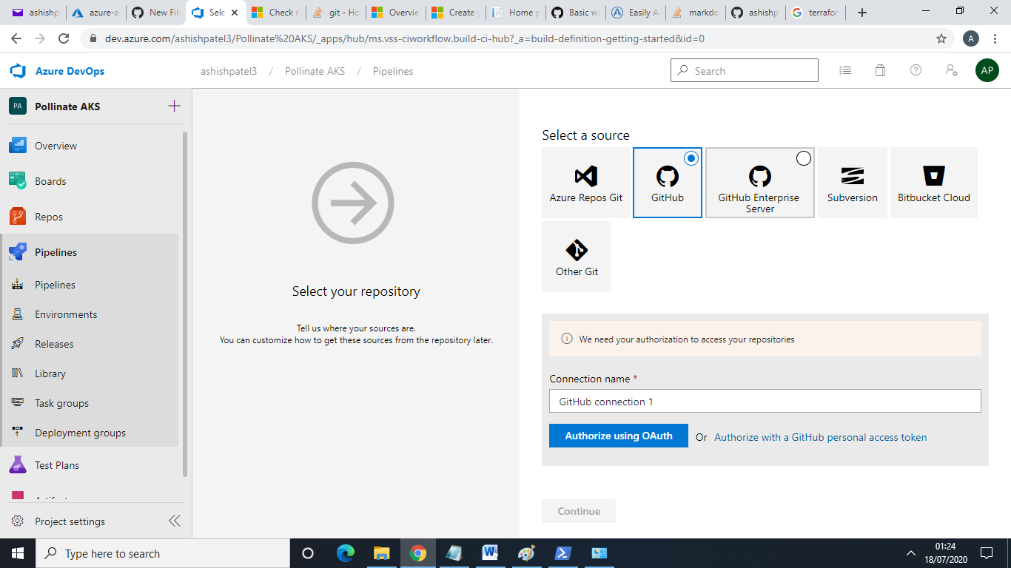

Select Project with branch then click on empty job

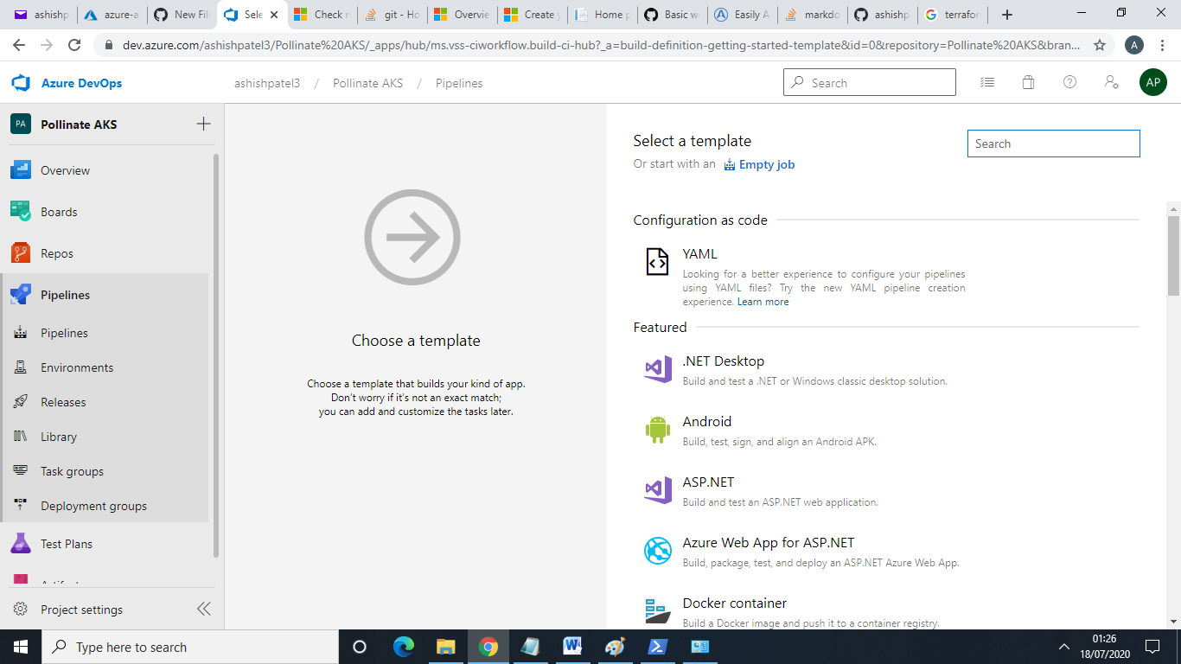

Then go to agent job and search terraform

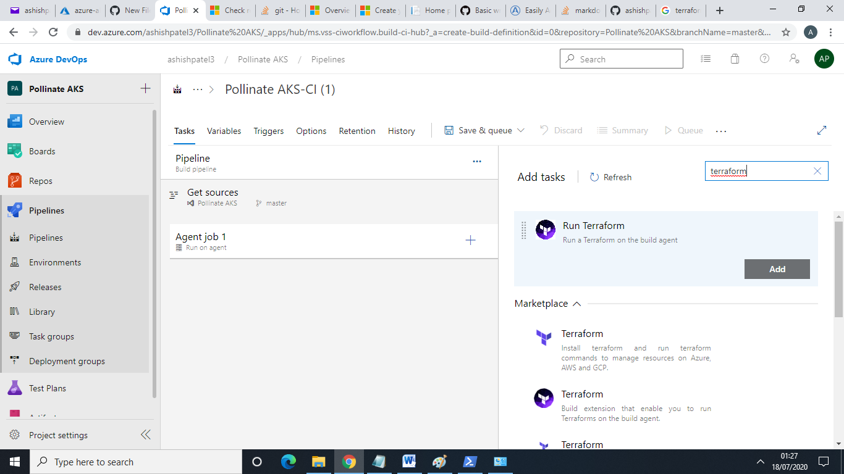

Create Terraform 3 job

Terraform Init

Terraform plan

Terraform apply

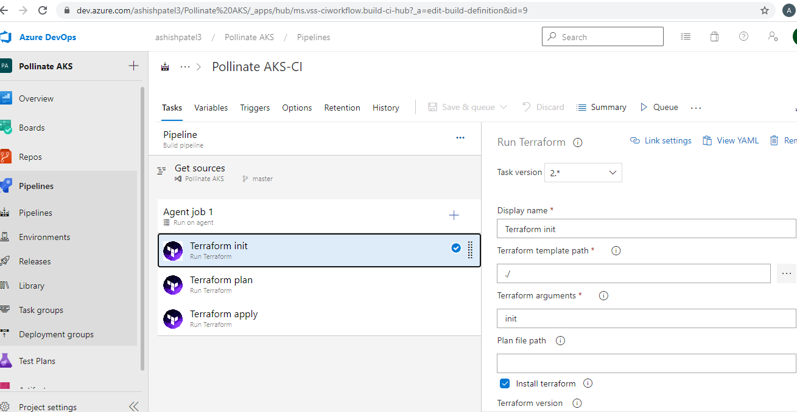

Then run pipeline after successfully run pipeline created AKS.

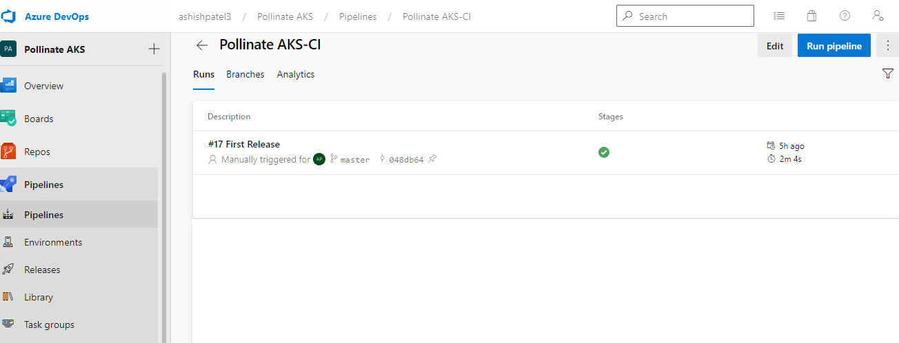



1. Second Parts of repository to create 2 Pod , one for webserver and second for mySql server.

This script you will run from your local computer or Azur Portal CLI

Go to visual code and verify using Azure AZ login

Command:- Kubectl create –f “C:\Pollinate AKS”

This command find yaml and run code.

Yaml file created with 2 Pod with mysql-persistent-storage and also mount docket image to web pod.

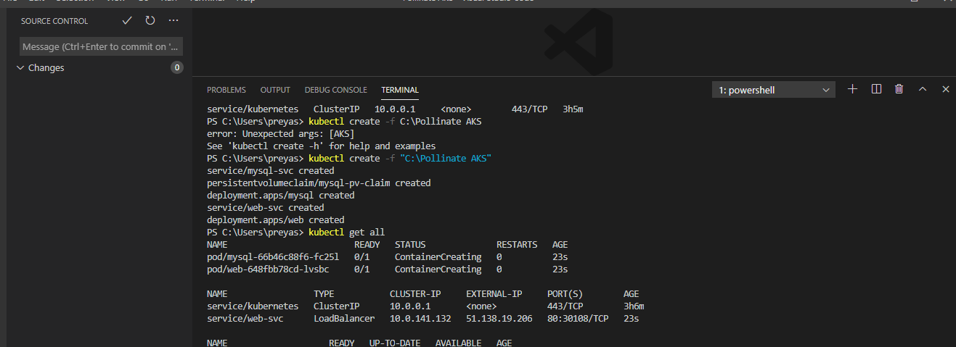

Also create secret for mysql server password

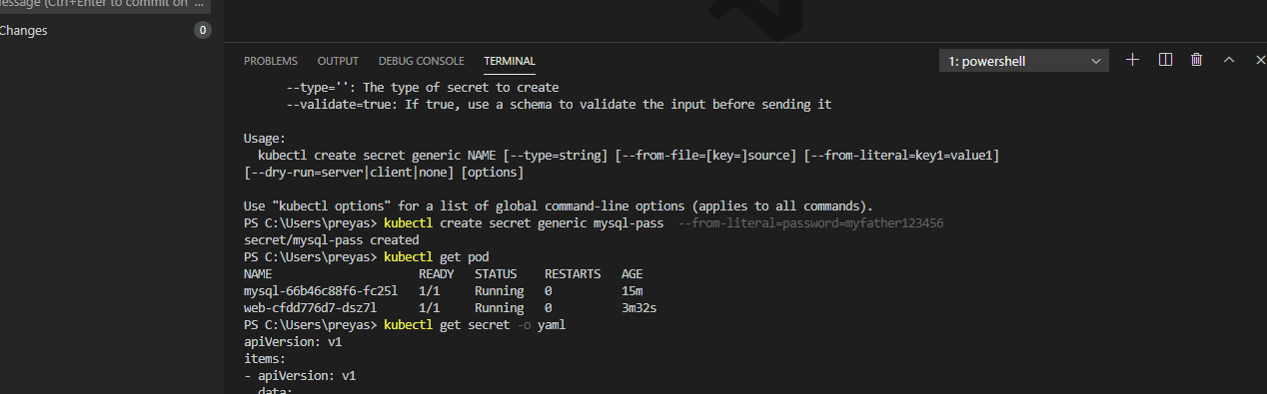

Check Kubernetes pod with load balancer.

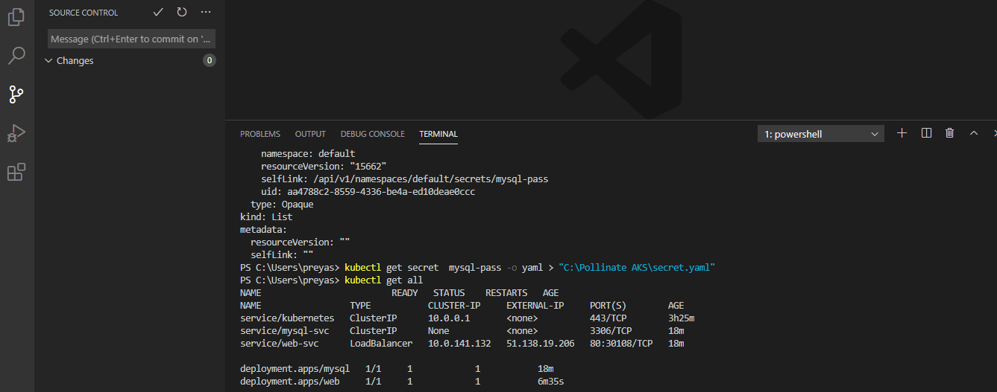



1. Website run over IP Address:- 51.138.19.206

