CASE STUDY
ClassifyAI: An AI-Assisted Platform for Categorizing High-Volume Text Data
AI-Assisted Categorization | Human-in-the-Loop Review | Data Operations

PROJECT AT A GLANCE
Project | ClassifyAI: AI-Assisted CSV Categorization Platform
Industry | Data Operations / Customer Experience / Business Intelligence
Services | Product Design and Full-Stack Engineering | LLM Integration and Prompt Engineering | Human-in-the-Loop Review Workflow | Cloud Deployment and Documentation
Technologies | React (Vite) | FastAPI (Python) | Google Gemini | Pandas | Render | Cloudflare Pages
INTRODUCTION
About the Project and Objective
ClassifyAI categorizes large CSV datasets of unstructured text, such as support tickets, product reviews, and survey responses, into review-ready data. The goal was to give operations, analytics, and customer-experience teams a consistent way to sort thousands of free-text rows into meaningful categories while keeping a person in control of the outcome. The model does not act as a black box: ClassifyAI returns a confidence level and a short reason for each row, so reviewers can assess results directly and concentrate on the rows that need attention.
BUSINESS CHALLENGES
- Categorizing high volumes of free-text records was slow, manual, and inconsistent, with different reviewers applying labels in different ways.
- Off-the-shelf AI tools returned labels with no explanation, giving teams no basis to trust or audit a categorization before acting on it.
- Batching large files into small chunks caused the model to lose context, producing labels that were inconsistent from one batch to the next.
- There was no efficient way to separate confident results from ambiguous ones, so every row had to be re-checked manually or accepted without verification.
- Handling sensitive text meant data privacy and key management had to be handled carefully, not left to client-side code or third-party UIs.
ARCHITECTURE OVERVIEW
ClassifyAI uses a single-pass design. The model reads the entire dataset in one request so it labels similar rows consistently, rather than splitting the file into batches that lose context. A FastAPI service holds the data in memory, sends the full dataset to the model, and returns a category, confidence level, and reason for every row. These results then pass to a review step before export.
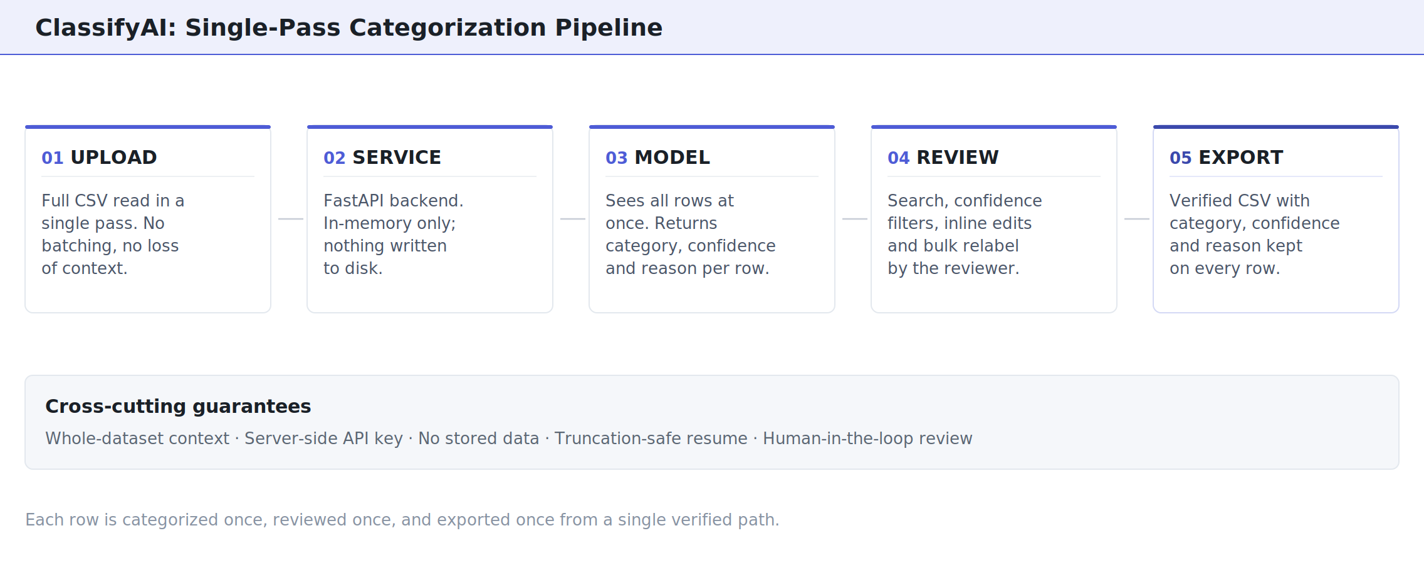
Figure 1: ClassifyAI Single-Pass Categorization Pipeline
Pipeline Flow:
- CSV Upload: The full dataset is uploaded and read in a single pass. Files stay in memory and are never written to disk.
- FastAPI Service: A stateless Python backend orchestrates category suggestion and assignment, keeping the Gemini API key server-side so end users never handle credentials.
- Gemini Model (single-pass): The model sees all rows at once and returns a category, a confidence level, and a short reason for each, naming the competing category when a row is ambiguous.
- Review Layer: Reviewers search, filter by confidence, edit any row inline, and bulk-relabel filtered sets. Reviewer edits stay distinct from model decisions.
- Export: A verified CSV is produced with the category, confidence, and reason preserved on every row for full downstream auditability.
SOLUTION
ClassifyAI is a split React (Vite) and FastAPI application built for transparency and human control. The platform proposes categories from the data, optionally audits that set for overlap and gaps, assigns every row a confidence level and reason, and passes the result to a reviewer for correction before export. Each capability is designed to make the output easy to verify.
Platform Capabilities:
- Data-Driven Category Suggestion: ClassifyAI reads the whole dataset and proposes a fitting set of categories, which the user can rename, remove, or extend before any row is labeled.
- Optional Scheme Self-Audit: A second whole-dataset pass reviews the proposed categories for overlap, gaps, vagueness, and redundancy, and flags when it improves them.
- Per-Row Reasoning and Confidence: Every row is returned with a High, Medium, or Low confidence level and a one-line justification, included in the exported file.
- Focused Review Workflow: Full-text search, per-category confidence bars, and a dedicated "needs review" view let reviewers concentrate on ambiguous rows instead of the entire dataset.
- Reviewer-Authoritative Edits: Manual changes are marked as reviewer decisions; reselecting the model’s original category cleanly restores its confidence and reason, keeping the audit trail accurate.
- Privacy by Design: The uploaded file is processed in memory and never saved. It is not retained after the session ends. The model key stays in the server environment and is never exposed to the browser or committed to the repository.
- Truncation-Safe Assignment: If a very large response is cut off, the backend resumes from where it stopped rather than silently dropping rows, and flags anything it could not complete.
BUSINESS IMPACT
ClassifyAI gave teams a consistent, reviewable way to categorize large volumes of free-text data. Instead of reviewing every row, teams accept the high-confidence majority and focus on the smaller set the model flags as uncertain. Every result carries a confidence level and a reason, so categorizations can be audited rather than accepted without context. Because the data stays in server memory and the key stays server-side, the platform handles sensitive text responsibly. The outcome is a repeatable workflow that replaces a manual, one-off task with a self-service process.
“Seeing a confidence level and a short reason on every row changed how the team works. We now correct the rows that need attention instead of re-checking the entire dataset.”
Operations Lead, Customer Experience Team
SUCCESS METRICS TO HIGHLIGHT

~60%  Reduction in manual review time by focusing effort on flagged low-confidence rows | 100%  Of exported rows carry a category, confidence level, and reason for full auditability | <5 min  From raw CSV upload to a reviewed, exportable categorized dataset
WORK WITH US
Categorize your text data with confidence.
We build AI-assisted data tools that keep people in control, with transparent results that hold up to review.
LINKS
Live Application: https://classifyai.pages.dev

