**Web Application for Social Welfare Donation**



A minor project report submitted to

Rajiv Gandhi Proudyogiki Vishwavidhyalaya, Bhopal

towards partial fulfilment of

the degree of

**MASTER OF COMPUTER APPLICATION**

**2018-19**

**Guided By: Submitted By:**

Mrs. Varshali Jaiswal Ashish Patidar

Department of InformationDeepak Bharti

TechnologyIshan Siddiqui

Sakshi Singhal

MCA 3rd year

**Department of Information Technology**

**SHRI G.S INSTITUTE OF TECHNOLOGY AND SCIENCE**

**INDORE (M.P)**

**SHRI G.S INSTITUTE OF TECHNOLOGY AND SCIENCE**

**INDORE (M.P)**



***Recommendation***

The minor project report entitled “ **Web Application for Social Welfare Donation** “ submitted by **Ashish Patidar, Deepak Bharti, Ishan Siddiqui** and **Sakshi Singhal** students of MCA final year in the session 2018-19 , towards partial fulfilment of the degree of **MASTER OF COMPUTER APPLICATION** of Rajiv Gandhi Proudyogiki Vishwavidhyalaya, Bhopal , is a satisfactory account of their work.

**Mrs. Varshali Jaiswal Dr.Sunita Varma**

**Project Guide Head**

Department of Information Department of Information

Technology Technology

**SHRI G.S INSTITUTE OF TECHNOLOGY AND SCIENCE**

**INDORE (M.P)**



***Certificate***

The minor project report entitled “ **Web Application for Social Welfare Donation** “ submitted by **Ashish Patidar, Deepak Bharti, Ishan Siddiqui** and **Sakshi Singhal** students of MCA final year in the session 2018-19 , towards partial fulfilment of the degree of **MASTER OF COMPUTER APPLICATION** of Rajiv Gandhi Proudyogiki Vishwavidhyalaya, Bhopal , is a satisfactory account of their work.

**Internal Examiner External Examiner**

**Date: - Date**:-

***Acknowledgement***

We are heartily pleased to acknowledgement all those people who are helped us in the successful completion of this project. With great pleasure we express our heartfelt gratitude to our esteemed guide **Mrs. Varshali Jaiswal** Assistant Professor Department of Information Technology, S.G.S.I.T.S. Indore. Her persistent encouragement, perpetual motivation, everlasting patience and valuable technical inputs in discussion have enabled the successful competition of this project. Her invaluable help, advice and constant encouragement helped us a lot and provide impetus to the progress of the project. We extend our profound indebtedness to the Head of the Department **Dr. Sunita Varma**, the word lose their worth for her invaluable guidance, continuous encouragement and cooperation in every respect.

We sincerely wish to express our gratitude to all the member of staff of M.C.A. who have extended their cooperation at all the times and have contributed in their own way in developing the project. Successfully completion of a project effort. It is an outcome of the cumulative effort of a number of persons, each having his own importance to the objective. We are thankful to our parents for being a constant source of encouragement in all our endeavours. Indeed it is their support that helps us through the ups and downs of life. The support and suggestion of our friends are worth appreciation and thankfulness.

Ashish Patidar

Deepak Bharti

Ishan Siddiqui

Sakshi Singhal

***Abstract***

The main purpose of this application is to donate things like food, money and clothes using a single platform via online. This system allow the user to have multiple choices in terms to donate the needy using a single platform. This system contains three modules that are administrator, NGO’s, and donator. Admin managed overall activities such as registration of donator and NGO. Donator can perform task such as registration, login, donate donation according to given choices. NGO’s can perform task such as registration, login and request donation according to their need.

***Table of Contents***

**Chapter-1 Page No.**

**Introduction**  **... 01**

* 1. Preamble 01
  2. Objective 01
  3. Scope 01
  4. Organization Report 02- 03

**Chapter-2**

**Literature Survey**  **...04**

2.1 Technology Description 04-06

2.2 Tools used 06

**Chapter -3**

**Analysis**  **...07**

3.1FeasibilityStudy

1. Technical Feasibility 07

2. Behavioural Feasibility 07

3. Economic Feasibility 07-08

4. Operational Feasibility 08

5. Financial Feasibility 08

6. Time Feasibility 08

**3.2 Information Flow Representation** 08

1. Use Case Specification 08-09

2. Use Case Diagram 10

**Chapter-4**

**Planning**  .**..11**

4.1 Software Project Estimation 11

4.2 Timeline (Gantt) Chart 11-12

4.3 Team Organization 12

4.4 Resource Planning 12

**Chapter-5**

**Design**  **...13**

5.1 Architecture Design 13

5.1.1 Activity Diagram of Project 14-20

5.2 Design class Diagram 21

5.3 Sequence Diagram 22-23

**Chapter-6**

**Implementation**  **...24**

6.1 Coding 24-25

6.2 Testing 26

6.3 Levels of testing 26

**Chapter-7**

**Interface Design ...27**

7.1 Home Screen 27

7.2 Sign-Up User Page 28

7.3 User Donation 29

7.4 Food Donation 30

7.5 Funds Donation 31

7.6 Clothes Donation 32

7.7 Sign-Up NGO Page 33

7.8 NGO Request 34

7.9 Food Request 35

7.10 Funds Request 36

7.11 Clothes Request 37

**Chapter -8**

**Conclusion ...38**

8.1 Conclusion 38

8.2 Limitations 38

8.3 Future Enhancements 38

**References ...39**

# Chapter-1

## Introduction

Social welfare donation is a software solution which helps an individual to donate donation and also allows NGO’S to request donation according to their need via online. This system provides the donator different categories of donation on a single platform where user can select according to their choices and in the same way NGO’s can also request among different categories of donation provided to them.

#### Preamble

The problem mentioned in the above scenario is that today user don’t have such kind of web application which provide the facility to the user where they can select multiple options of donation using a single platform which is time consuming and there is also no such platform exist, which allow the NGO’s to request donation according to their need. So by developing this system will overcame their entire problem and help the donator and NGO’s to accomplish the task and save the time.

#### Objective

The main objective of this system is to allow the donator to donate the donation where donator has multiple options of donation such as food, clothes and funds on a single platform. The donator can select any option according to their choice and donate via online.

This system also provides the facility to the NGO’s where they can request for donation according to their need via online.

#### Scope

This software system will be social welfare donation which consists of their separate modules. First is to be used by donator who will fill the donation details and donate the items. Second is NGO’s who fill the donation details and request the donation and the third is the Administrator who manages all the activities of donator and NGO’s and keep information of donator and NGO confidential.

#### Organization of Report Chapter 1: Introduction

This chapter includes brief description, objective and scope of application.

#### Chapter 2: Literature Survey

This chapter contains the conceptual framework needed for implementing the application and explains the basic concepts to understand the project and the technology, which have been to accomplish the project.

#### Chapter 3: Analysis

This chapter describes the analysis phase of the project .It gives an abstract of the feasibility study, requirement analysis and specification, functional description of the system, along with the system flow diagram and behavioural description of the system**.**

#### Chapter 4: Planning

This section deals with management dexterity. It depicts the software planning process adopted for the system. It specifies the necessary hardware and software required for the project**.**

#### Chapter 5: Design

This chapter elaborates the design process used. In the phase analyzed problem is framed into a design. It describes the architectural design, data design and the interface design of the system.

#### Chapter 6: Implementation

This chapter deals with the implementation part of the system.

#### Chapter 7: Interface Design

This chapter includes the main part of the report with a interface section.

#### Chapter 8: Conclusion

This chapter concludes the main part of the report with a conclusion section. It also presents the limitation that is encountered and possible future enhancements of the application.

#### References

This chapter concludes the references from where we refer the basic concepts regarding to our domain

.

# Chapter-2

## Literature Survey / Conceptual Framework

* 1. **Technology Description**

Technology Description is a description of technology required in development of this application. In development of proposed system following tools and technologies are used**.**

1. **HTML**

Hyper Text**:** Hyper Text simply means "Text within Text". A text has a link within it, is a hypertext. Every time when you click on a word which brings you to a new webpage, you have clicked on a hypertext. **Markup language:** A markup language is a programming language that is used make text more interactive and dynamic. It can turn a text into images, tables, links etc. An HTML document is made of many HTML tags and each HTML tag contains different content.

#### CSS

CSS**:** CSS stands for Cascading Style Sheet.CSS is used to design HTML tags.CSS is a widely used language on the web.HTML, CSS and JavaScript are used for web designing. It helps the web designers to apply style on HTML tags.

#### Bootstrap 4

Bootstrap**:** Bootstrap is [a free and open source](https://whatis.techtarget.com/definition/Free-and-open-source-software-FOSS-or-free-libre-open-source-software-FLOSS) [front end](https://whatis.techtarget.com/definition/front-end) development framework for the creation of websites and [web apps.](https://searchsoftwarequality.techtarget.com/definition/Web-application-Web-app) The Bootstrap framework is built on [HTML,](https://www.theserverside.com/definition/HTML-Hypertext-Markup-Language) [CSS](https://www.theserverside.com/definition/cascading-style-sheet-CSS), and JavaScript ([JS](https://www.theserverside.com/definition/JavaScript)) to facilitate the development of [responsive](https://whatis.techtarget.com/definition/responsive-design), [mobile-first](https://searchmobilecomputing.techtarget.com/definition/mobile-first) sites and apps. Bootstrap includes user interface components, layouts and JS tools along with the framework for implementation. The software is available precompiled or as [source code](https://searchmicroservices.techtarget.com/definition/source-code).

#### JavaScript

Java Script**:** JavaScript is a lightweight, interpreted programming language. It is designed for creating network-centric applications. It is complimentary to and integrated with Java. JavaScript is very easy to implement because it is integrated with HTML. It is open and cross-platform.

#### Java

Java**:** Java programming language was originally developed by Sun Microsystems which was initiated by James Gosling and released in 1995 as core component of Sun Microsystems' Java platform (Java 1.0 [J2SE]).

The latest release of the Java Standard Edition is Java SE 8. With the advancement of Java and its widespread popularity, multiple configurations were built to suit various types of platforms. For example: J2EE for Enterprise Applications, J2ME for Mobile Applications.

#### JSP (Java Server Pages)

JSP**:** Java Server Pages (JSP) is a technology used to develop interactive Web pages. JSP was developed by Sun Microsystems and is an improved version of Java servlets.JSP may be developed in a simplified manner and has a wide range of applications. As with most server- based technologies, JSP separates business logic from the presentation layer.

#### JSP Architecture

The web server needs a JSP engine, i.e., a container to process JSP pages. The JSP container is responsible for intercepting requests for JSP pages. This tutorial makes use of Apache which has built-in JSP container to support JSP pages development. A JSP container works with the Web server to provide the runtime environment and other services a JSP needs. It knows how to understand the special elements that are part of JSPs.

#### Features of JSP

* 1. JSP uses pure java and takes the advantage of its object oriented nature.
  2. JSP uses a combination of tags and scripting to create dynamic web pages.
  3. The JSP page uses the components like EJB, JavaBeans which are reusable.
  4. **Tools Used:**

NetBeans**:** NetBeans is an open-source integrated development environment (IDE) for developing with Java, PHP, C++, and other programming languages. NetBeans is also referred to as a platform of modular components used for developing Java desktop applications.NetBeans is coded in Java and runs on most operating systems with a Java Virtual Machine (JVM), including Solaris, Mac OS, and Linux. Net Beans uses components, also known as modules, to enable software development. NetBeans dynamically installs modules and allows users to download updated features and digitally authenticated upgrades. NetBeans IDE modules include NetBeans Profiler, a Graphical User Interface (GUI) design tool; NetBeans framework reusability simplifies Java Swing desktop application development, which provides platform extension capabilities to third-party developers.

#### 1. SQLyog

SQLyog Job Agent (SJA) is a high-performance, multithreaded, multi-platform application that lets you run maintenance scripts with your MySQL databases, have e-mailed formatted resultsets of a query, import data and metadata from ODBC-sources, synchronize MySQL databases and tables and do high-performance scheduled backups. On Windows, it is included with SQLyog Enterprise and SQLyog Ultimate. SJA for Linux is free for commercial and personal use. SJA is a command line tool that accepts a Job Definition file encoded in XML as one of the parameters. You can either create the Job Definition file manually or use one of the wizards included with SQLyog. If you use SQLyog to create your job files, you don’t need to have any knowledge about XML or the Job Definition schema. The Windows version also can be run from inside the SQLyog GUI, making its command line nature transparent to users if you want so.

# Chapter-3

## Analysis

#### Feasibility Study

This chapter shows the feasibility of implementation of the proposed project.

#### Technical Feasibility

In technical Feasibility following issues are taken consideration.

1. Whether the required technology is available or not. This project is based on angular js technology. This technology is open source, licence free and compatible.
2. What other modification in the specification those have to take under consideration to choose the given technology?

No such modification is required, as there is no such requirement. Even if any part is replace it requires minimum cost and does not affect the working of the system.

#### Behavioural Feasibility

This application will be readily accepted by the customer because this system was found to be:

* Efficient
* Less time consuming
* Accurate
* Reliable
* Fast

#### Economic Feasibility

If for this software the expected benefits equal or exceed costs his software will be economically feasible. In economic feasibility, costs benefits analysis was done in which expected costs and benefits were evaluated. About the cost of the software, all technologies are freely available and there is no requirement of any licence also. Hence, it is economically feasible

#### Operational Feasibility

This system as a proper GUI which make it very convenient to be used by user.

#### Financial Feasibility

This project is financially feasible since the all software being used have been downloaded from the internet.

#### Time Feasibility

It is used to determine whether the project is feasible within time constraints. Development of software within given interval of time id tedious donate by user and take donation by NGo’s

.Time feasibility for this project meets to the given requirements . Proper guidance and our sincere scheduling made it possible to complete the system in required period of time**.**

#### Information Flow Representation

1. **Use Case Specification**

The use case we specified in our diagram are described in detail in this section. This section will be include the detail specification of the use case module tells which actor is going to interact with the system , what will be his pre and post condition of this use case with their basis flow of events.

**Sign-Up-Page: User**

* Main Flow: User will be registered.
* Pre-Condition: The use should give valid name, mobile number, email-id to register.
* Post-Condition: The system transfer control to the login from after registration.
* Alterative Flow: User goes back after login.

**Login**

* Main Flow: To interact in the system, the user should enter user name and password & registration with his system.
* Pre-Condition: User must be existing in database.
* Post-Condition: System should be transfer control to the user main screen to precede desire further actions.
* Alterative Flow: User Id and Password is incorrect, use will be prompted a message regarding the error. Transfer control back to login screen.

**Sign-Up-Page: NGO’s**

* Main Flow: Ngo’s will be registered.
* Pre-Condition: The use should give valid name, mobile number, email-id to register.
* Post-Condition: The system transfer control to the login from after registration.
* Alterative Flow: Ngo’s goes back after login.

**Login**

* Main Flow: To interact in the system, the user should enter username and password & registration with his system.
* Pre-Condition: Ngo’s must exist in database.
* Post-Condition: System should be transfer control to the user main screen to precede desire further actions.
* Alterative Flow: Ngo’s Id and Password is incorrect, use will be prompted a message regarding the error. Transfer control back to login screen.

1. **Use Case Diagram**

Use case diagrams are a set of use cases, actors, and their relationships. They represent the use case view of a system. A use case represents a particular functionality of a system. Hence, use case diagram is used to describe the relationships among the functionalities and their internal/external controllers. These controllers are known as actors.

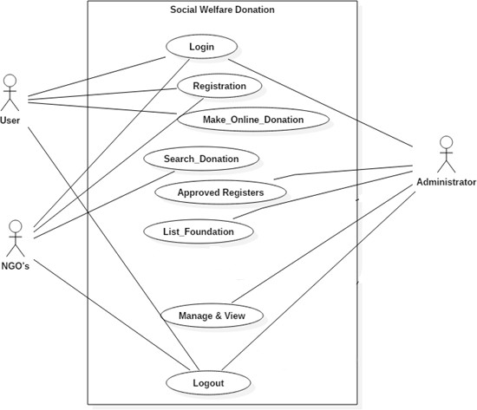

**Figure 3.1 Use Case diagram of Web Application for Social Welfare Donation**

**Chapter-4**

**Planning**

Planning is the act of thinking about actions before they are carried out specific details are decided before carrying out the plan as well as organising the steps of the plan.

* 1. **Software Project Estimation**
* Levels of the app – Base Days 10
* Levels of the UI -50
* User and accounts – Base Day 1
* User generated content – Base Day 5
* Mobile Specific Features- Base Day 5
* Dates and Location – Day 3
* Social and engagement – Day 5
* External API’s and Integration- Day 3s

After taking theses all factors the software project estimation cost is the newer $250.

#### Timeline (Gantt) Chart

When a creating a software project scheduled, the planner begins with a set of tasks the breakdown structure.

|  |  |  |  |  |
| --- | --- | --- | --- | --- |
| **Work Task** | **August (weeks)** | **September (weeks)** | **October (weeks)** | **November (weeks)** |
| 1.Problem Identificati  on | 3 weeks |  |  |  |
| 2.Analysis &  Planning |  | 2-3 weeks |  |  |
| 3.Design |  | 4-7 weeks |  |  |

|  |  |  |  |  |
| --- | --- | --- | --- | --- |
| 4.Coding |  |  | 8-9  weeks |  |
| 5.Report |  |  |  | 9 weeks |

* 1. **Team Organization**

When we developing our web application may have noticed that they quickly choose the overviews of the layouts, packages etc. developers considered some rules because they help them a lot to know about the projects. Developers work as a team it is even are important to define the rules for the naming and the organisation of the project team organization is one of the key constraints to project success.

#### Resource Planning

1. **Hardware Requirements**

* Processor : Core 2 Dual or above
* RAM : 4 GB RAM or above
* Hard Disk : 4GB
* Internet Connection

#### Software Requirements for developing

* Operating System : Windows 2007 or above
* HTML
* CSS
* Bootstrap 4
* JavaScript
* Java
* Mysql database

# Chapter-5

## Design

Design is meaningful data representation of something that is to be built. It can be traced to a customer‘s requirement and at the same time accessed for quality against a set of predefined criteria for good designing.

#### 5.1 Architecture Design

It can be defined is the set of structures needed to reason about a software systems which comprises the software elements and relations.

INTERNET

USER

LOGIN

HOME

PAGE

DONATION

TYPE

MAKE

DONATIONN

NGO

LOGIN

HOME

PAGE

REQUEST

TYPE

MAKE

REQUEST

SERVER

#### 5.1.1 Activity Diagram

Activity diagram is basically a flowchart to represent the flow from one activity to another activity. The activity can be described as an operation of the system. The control flow is drawn from one operation to another. This flow can be sequential, branched, or concurrent. Activity diagrams deal with all type of flow control by using different elements such as fork, join, etc.

**5.1.1.1** This diagram shows the registration of NGO while valid or invalid details.

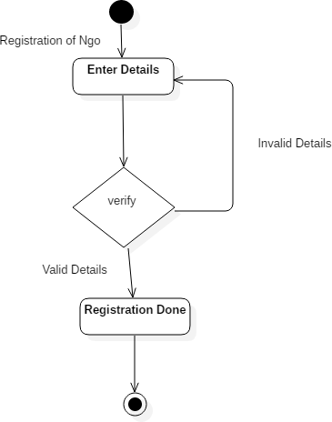

**Figure: 5.1.1.1 Activity Diagram of Web Application for Social Welfare Donation**

**5.1.1Activity Diagram**

Activity diagram is basically a flowchart to represent the flow from one activity to another activity. The activity can be described as an operation of the system. The control flow is drawn from one operation to another. This flow can be sequential, branched, or concurrent. Activity diagrams deal with all type of flow control by using different elements such as fork, join, etc.

**5.1.1.2** This diagram shows the Login of NGO whether ID & password is correct or not.

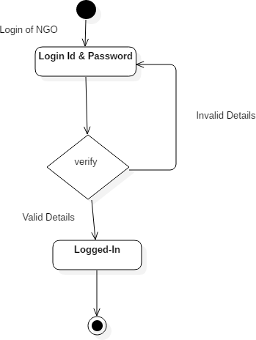

**Figure: 5.1.1.2 Activity Diagram of Web Application for Social Welfare Donation**

**5.1.1Activity Diagram**

Activity diagram is basically a flowchart to represent the flow from one activity to another activity. The activity can be described as an operation of the system. The control flow is drawn from one operation to another. This flow can be sequential, branched, or concurrent. Activity diagrams deal with all type of flow control by using different elements such as fork, join, etc.

**5.1.1.3** This diagram shows the request donation for NGO if it is fulfilled or not

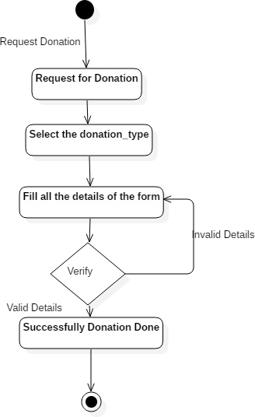

**Figure: 5.1.1.3 Activity Diagram of Web Application for Social Welfare Donation**

**5.1.1Activity Diagram**

Activity diagram is basically a flowchart to represent the flow from one activity to another activity. The activity can be described as an operation of the system. The control flow is drawn from one operation to another.

**5.1.1.4** This diagram shows the search the donation from the user when the donation are fulfil or not.

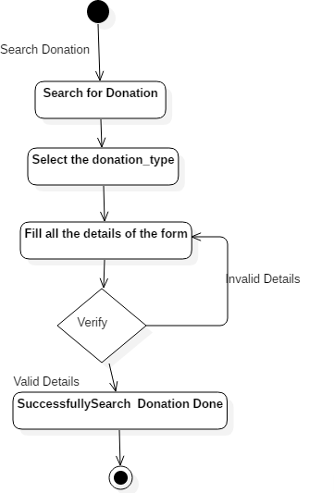

**Figure: 5.1.1.4 Activity Diagram of Web Application for Social Welfare Donation**

* + 1. **Activity Diagram**

Activity diagram is basically a flowchart to represent the flow from one activity to another activity. The activity can be described as an operation of the system. The control flow is drawn from one operation to another. This flow can be sequential, branched, or concurrent. Activity diagrams deal with all type of flow control by using different elements such as fork, join, etc

* + - 1. This diagram shows the registration of user is valid and invalid details

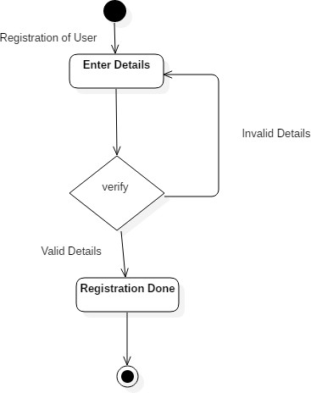

**Figure: 5.1.1.5 Activity Diagram of Web Application for Social Welfare Donation**

**5.1.1Activity Diagram**

Activity diagram is basically a flowchart to represent the flow from one activity to another activity. The activity can be described as an operation of the system. The control flow is drawn from one operation to another. This flow can be sequential, branched, or concurrent. Activity diagrams deal with all type of flow control by using different elements such as fork, join, etc

* + - 1. This diagram shows the registration of the user is valid or invalid details.

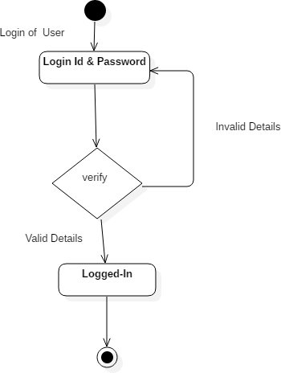

**Figure: 5.1.1.6 Activity Diagram of Web Application for Social Welfare Donation**

**5.1.1Activity Diagram**

Activity diagram is basically a flowchart to represent the flow from one activity to another activity. The activity can be described as an operation of the system. The control flow is drawn from one operation to another. This flow can be sequential, branched, or concurrent. Activity diagrams deal with all type of flow control by using different elements such as fork, join, etc

* + - 1. This diagram shows the Make the donation for NGO to the user**.**

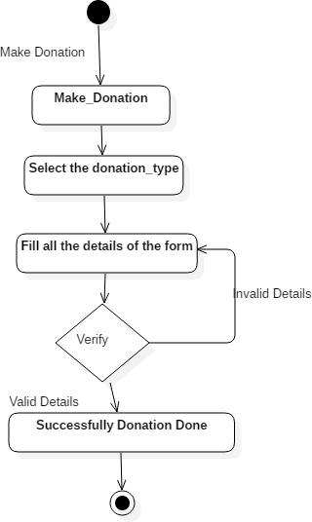

**Figure: 5.1.1.7 Activity Diagram of Web Application for Social Welfare Donation**

* 1. **Design Class diagram**

A class diagram is a type of static structure that describes the structure of the system by showing the system’s classes their attributes, operations and their relationships among objects. Figure represents class diagram of the system.

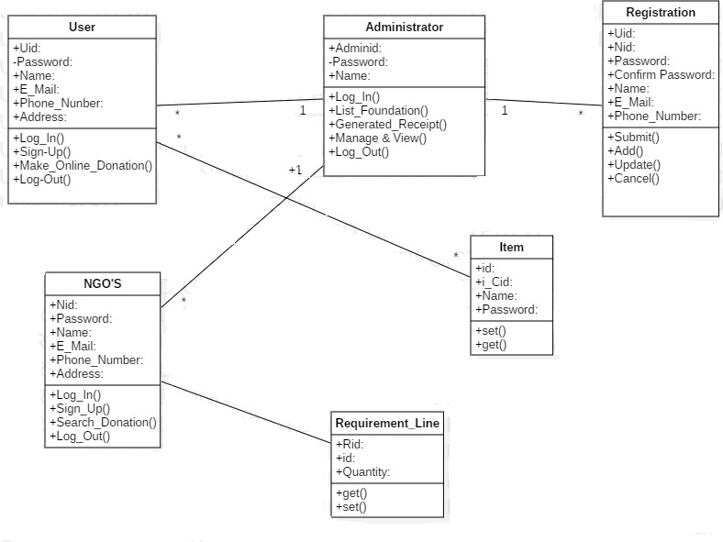

**Figure 5.2 Design Class Diagram of Web Application for Social Welfare Donation**

* 1. **Sequence Diagram**

A sequence diagram is an interaction that shows how processes operate with one another and in what order. It is a construct of a Message Sequence Chart. The purpose of interaction diagrams is to visualize the interactive behavior of the system. Visualizing the interaction is a difficult task. Hence, the solution is to use different types of models to capture the different aspects of the interaction.

* + 1. **:** The sequence diagram captures the time sequence of the message flow from one object to another object.

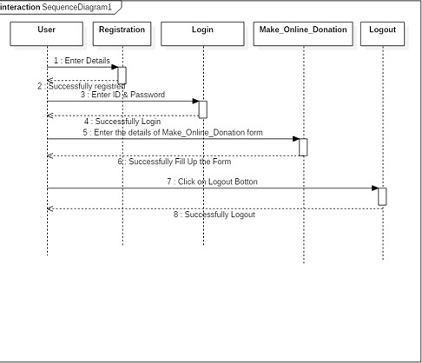

**Figure: 5.3.1 Sequence Diagram of Web Application for Social Welfare Donation**

* + 1. **:** The sequence diagram captures the time sequence of the message flow from one object to another object.

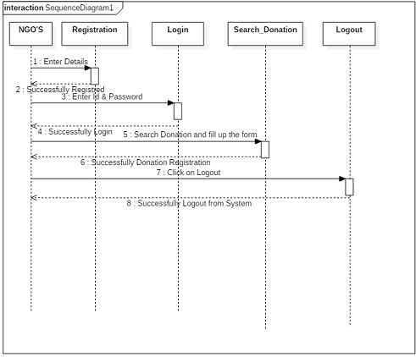

**Figure: 5.3.2 Sequence Diagram of Web Application for Social Welfare Donation**

**Chapter-6**

**Implementation**

Implementation deals with the actual development of the project. This combines the concept of coding and testing of the developed system. Coding refers to the converting design blue print into a computer under stable language like Java, C++, C, C# etc. Testing refers to the identifying bugs, error and fault into the code.

#### Coding

Coding is the phase of software development project where developers actually input the source code into a computer that will be complied into the final software program. Whole coding of application is done the under the following classes**:**

#### Following modules are there- User signup and NGO signup

<!DOCTYPE html>

<html lang="en">

<head>

<title>Ngo</title>

<link rel="stylesheet" href="css/bootstrap.min.css">

<link rel="stylesheet" href="css/owl.carousel.css">

<link rel="stylesheet" href="css/owl.theme.default.min.css">

<link rel="stylesheet" href="css/font-awesome.min.css">

<!-- MAIN CSS -->

<link rel="stylesheet" href="css/tooplate-style.css">

</head>

<body>

<h2>Sign Up</h2>

<a href="signup.html"><button class="button" style="vertical-align:middle"><span>SingUp As User </span></button><br></a>

<a href="ngosignup.html"><button href="ngosignup.html" class="button1" style="vertical- align:middle"><span>SignUp As NGO </span></button></a>

</body>

</html>

**User login and NGO login**

<html**>**

<body>

<h2>Login</h2>

<form action="">

<div class="container">

<label for="uname"><b>Username</b></label>

<input type="text" placeholder="Enter Username" name="uname" required><br>

<label for="psw"><b>Password</b></label>

<input type="password" placeholder="Enter Password" name="psw" required><br>

<button type="submit">Login</button>

<label>

<input type="checkbox" checked="checked" name="remember"> Remember me

</label>

</div>

</form>

</body>

</html>

#### Testing

Testing is the process of evaluating a system or its component(s) with the intent to find whether it satisfies the specified requirements or not. Testing is executing a system in order to identify any gaps, errors, or missing requirements in contrary to the actual requirements. Testing assesses the quality of the product. Software testing is a process that should be done during the development process. In other words software testing is a verification and validation process.

#### Levels of Testing

There are three levels of testing are as follows:

#### Unit Testing

This type of testing is performed by developers before the setup is handed over to the testing team to formally execute the test cases. Unit testing is performed by the respective developers on the individual units of source code assigned areas.

#### Integration Testing

Integration testing is defined as the testing of combined parts of an application to determine if they function correctly. Integration testing can be done in two ways: Bottom-up integration testing and Top-down integration testing.

#### Manual Testing

In manual testing tester observe that overall system is working according to user requirement. In this tester test overall validation of project and tester enter data manually and properly checks whether pages are redirecting or not. Tester checks manually overall system.

# Chapter-7

## Interface Design

### 7.1 Interface Design

**Home Screen:** When we first open the project the home screen is displayed.

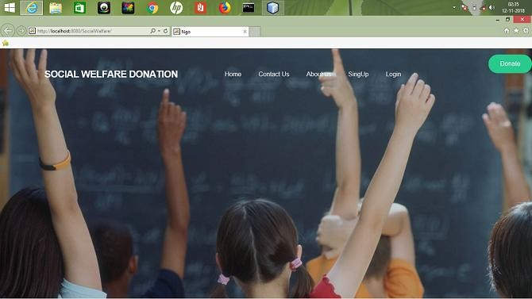

**Figure 7.1: Home Screen**

**User Sign-up:** A sign-up or registration page that provides the authority to the user to access features of application.

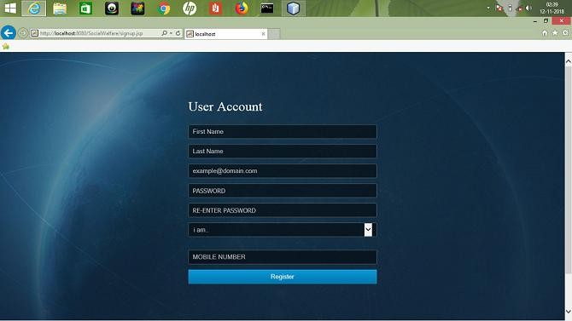

**Figure: 7.2**

**User Donation:** A User Donation page that provides the authority to the user to access features of application for Donation.

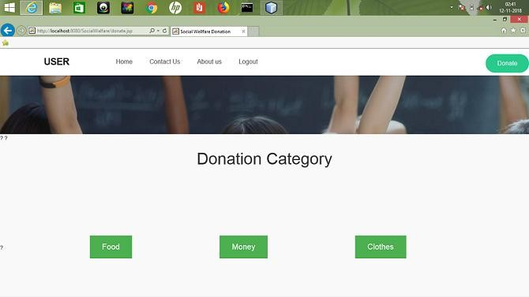

**Figure 7.3**

**Food Donation:**

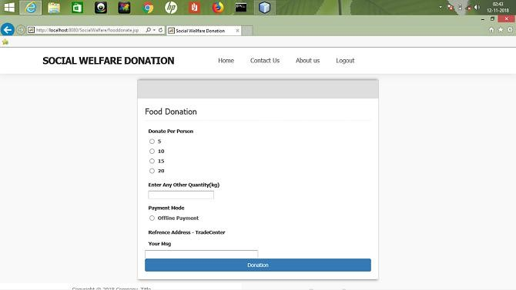

**Figure: 7.4**

**Funds Donation:**

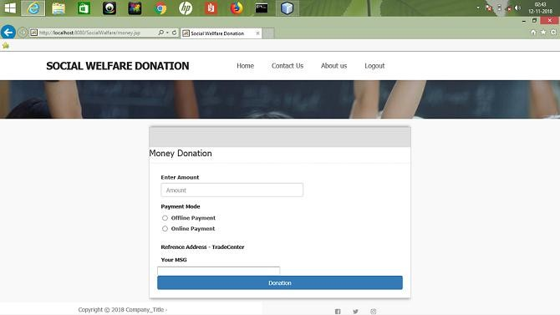

**Figure: 7.5**

**Clothes Donation**

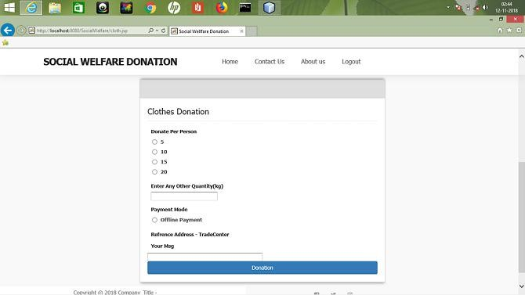

**Figure: 7.6**

**NGO’s Sign-up:** A sign-up or registration page that provides the authority to the NGO to access features of application.

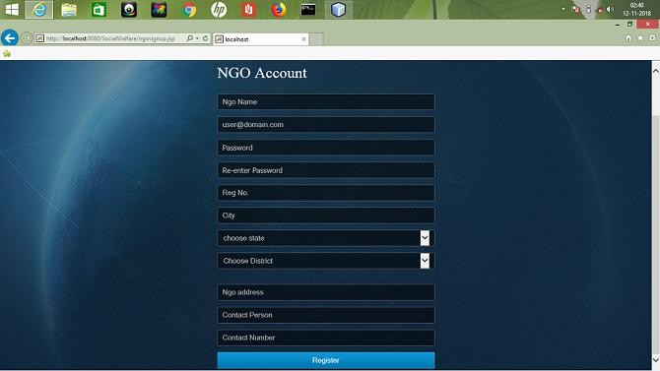

**Figure: 7.7**

**NGO’s Request:**

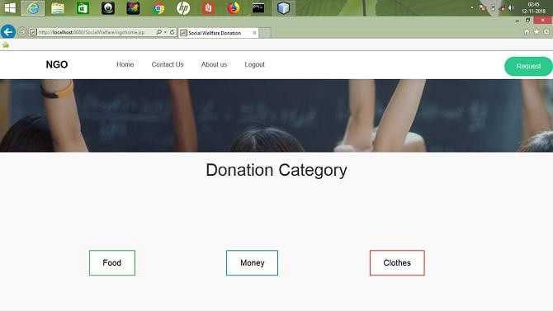

**Figure 7.8**

**Food Request:**

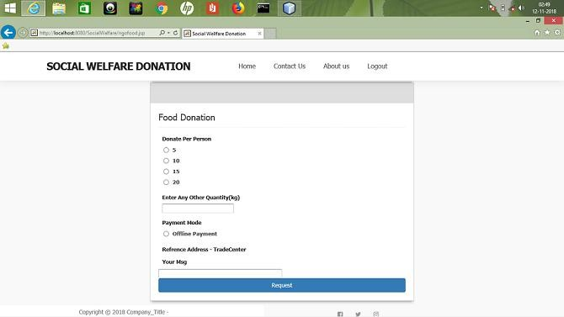

**Figure: 7.9**

**Funds Request:**

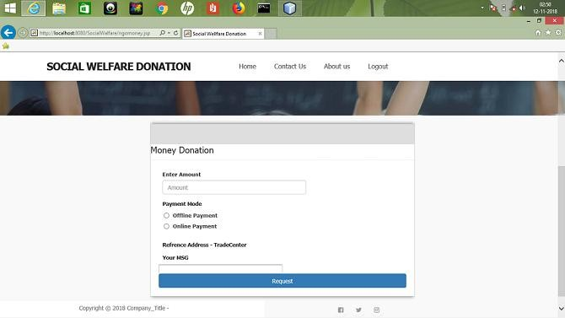

**Figure: 7.10**

**Clothes Request:**

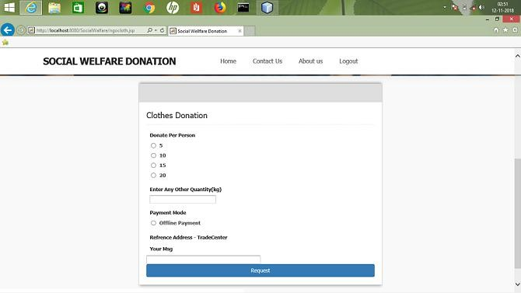

**Figure: 7.11**

**Chapter-8**

**Conclusion**

* 1. **Conclusion**

By doing automation of social welfare donation application having the best solution for the donator to donate among given categories and it also allows the NGO’s to request donation according to their need. This web application reduces the time of user and also user details and NGO’s details are separately managed by the Administrator and hence by the doing this user information is secure.

* 1. **Limitations**

The system has following limitation

1. Requires an active internet Connection
2. This System only works in English Language..

#### Future Enhancements

i. In future the project can be enhanced by increasing more categories of donation.

## References

[1]. Roger S.Pressman,”Software Engineering”, 5th Edition, Tata McGraw-Hill, 2001.

[2]. Herbert Scheldt “Java TM the Complete Reference “, 5th Edition, Tata McGraw-Hill, 2004.

[3][. http://nevonprojects.com/personality-prediction-system-through-CV-analysis/](http://nevonprojects.com/personality-prediction-system-through-CV-analysis/)

[4][. http://W3schools.com](http://w3schools.com/)

[5]. https:/[/www.javapoint.com/jsp](http://www.javapoint.com/jsp-tutorial)-[tutorial](http://www.javapoint.com/jsp-tutorial)