

***Individual Assignment***

***Student Name: Ashish Patil***

***Student ID: 10575987***

***Network and Systems Administration***

***Dublin Business School***

**Table of Contents**

1. **Introduction**
2. **Background**
3. **Technical description of the Proof of Concept**
   1. **Investigation and choices of technologies**
      1. **Listing technologies to be utilized**
      2. **Cisco Packet Tracer**
      3. **Virtualization**
      4. **Dynamic Host Control Protocol – DHCP**
      5. **Domain Name System – DNS**
      6. **Secure Shell – SSH**
   2. **Implementation**
      1. **Creating network branches with switches**
      2. **Configuring router**
      3. **Configuring server in server room**
      4. **Configuring DHCP**
      5. **Configuring DNS**
      6. **Configuring SSH**
4. **Project Testing and Evaluation**
5. **Demonstration of Proof of Concept**
   1. **Working of the artifact**
   2. **Key features**
6. **Value and Usability of the Artifact**
7. **Learning Experience**
8. **Conclusion**
9. **References and Bibliography**
10. **Appendices Note**

**1. Introduction:**

An ideal Bank Networking framework will be completely network base and friendly user interface for task management where any banking system manages their networking system. Any bank has Reception, Manager Cabin, Cash Counter, Check Clearance, Loan Section and a server room to run the bank successful. This network system is managed by number of end devices, switches for each network and a common router to make the bank fully functional and provide services to the customers. Banks use LAN, MAN, WAN to manage their networks. LAN is used by local area networking systems. Man is used by metro Politian area network. Wan is used by wide area networks. Here in our implementation we are using local area network to maintain manage our bank operations. Here this network system is specific to a bank branch and assuming all other branches has same network system to form wide area network.

**2. Background:**

To understand the virtual banking network system you need to go through this below bundle of notes. Here I am building a virtual banking network system where I have used virtual devices to create and demonstrate the actual banking network which can be used in the banking systems.

To create a virtual network, I will be using cisco packet tracer software which provides all the different kinds of devices and protocols which are required to build a virtual network. In cisco packet tracer we have end devices like computers, laptops and printers. Also we have switches which can connect to multiple end devices to form a network. It also has a router which connects to all the switches to form a local area network. There are many advantages of router that is we can configure different protocols in router like dhcp, dns and OpenSSH for different functionalities. DHCP, DNS and OpenSSH these are the three protocols which I will be using in our implementation. DHCP protocol helps in assigning ip address to the end devices. DNS protocol helps for naming of resource with ip address (ip to name mapping). OpenSSH protocol helps for accessing remote device.

Generally bank systems are divided into different sections according to type of there work. Here, I have divided a bank system into 6 different sections that is reception, manager cabin, cash counter, check clearance, loan section and server room. Reception sections solves general queries for the customer in the bank. Manager cabin, where manager can monitor the working of the bank. Cash counter handles the money transactions. Check clearance will work for check related activities. Loan section work for customer loan. Server room has server and it will be a resource for the entire bank.

**3. Technical description of the Proof of Concept**

**3.1 Investigation and choices of technologies:**

Below are some of the technologies which I have listed and explained each of them. This explanation contains how these technologies are helpful in implementing my banking network system.

3.1.1 Listing technologies to be utilized:

* Cisco Packet Tracer
* Virtualization
* Dynamic Host Control Protocol – DHCP
* Domain name System - DNS
* Secure Shell - SSH

3.1.2 Cisco Packet Tracer:

Cisco Packet tracer is a network designing tool. I will be using Cisco packet tracer as a platform for creating my banks network system. This platform allowed me to create a complete bank network system with the use of PC's, laptops, printers, switches, routers, servers.

3.1.3 Virtualization:

Virtualization is the act of creating virtual version of the artifact. here we are developing a proof of concept hence we will not be using the real resources, instead we will be using virtual devices and hence creating a virtual network for demonstration. Cisco packet tracer provided ability to create virtualization for any networking system. Here we will be creating our bank network system as a virtual system.

3.1.4 Dynamic Host Control Protocol – DHCP:

DHCP protocol is a network management protocol. Here end device request for IP address from the remote device. In the remote device DHCP is configured. Here we will be using the same protocol for automatic assigning of IP addresses to the end devices.

3.1.5 Domain Name System – DNS:

The domain name system is a naming system where IP addresses are linked / mapped with names. The end device can access the resource just by using the name and without knowing the IP address. Here we will be using the same DNS protocol and configuring the DNS in one of the server.

3.1.6 Secure Shell – SSH:

For operating and accessing remote devices we need some kind of cryptographic protocol. And here we have Secure Shell protocol which provides the same. Here we will be configuring SSH protocol for accessing and operating remote computer by using any end device.

**3.2 Implementation:**

Now we have all the technologies and can proceed to implement the actual artifact. During the implementation I failed many times and then got success at the end. In these failed attempts I have learnt a lot. Below are the steps how I gathered all above technologies and proceeded with implementation.

3.2.1 Creating Network Branches:

In a bank system generally we see Reception section, Manager Cabin, Cash counter, Check clearance, Loan section, and server room. I have considered these all the sections and divided them. I have considered each of the section as network. All the end devices in a particular section came under single network. After that all the end devices like Personal computers, Printers have connected with a common switch. So that each of the device in a single network can communicate with each other using this switch. Each of these networks assigned with Gateway IP address. Each of the networks has class-C IP address. Once all the networks formed. Now to connect this entire network with each other i took one router and connected switches to that router. Now end devices from one network/section can communicate end devices from other network. This has established a connection for performing data sharing and day to day banking activities.

3.2.2 Configuring router:

Router is a networking device which connects multiple networks to form a local area network. We can connect multiple switches to the router to make a bigger connection and to form LAN. Here we have joined each of these sections that is reception, cash counter, manager cabin, loan section, check clearance and server section. These all sections main switch is connected to the router with a connection line and we need to configure in router that this switch from this network is has a connection. This makes sense when a packet from other network transfers to some other network. At this time router understand where exactly we need to transfer since it has information about each of the network during starting configuration.

3.2.3 Configuring Server in Server Room:

Each of the banking system has server room where servers are maintained and it handles all the bank activities by providing resource to the entire network. In the same way, in our banking section we have added one server room where we have two servers that is server0 and server1 which provides resource to all the sections. To illustrate this I have provided a DNS service which I will explain in DNS implementation section.

3.2.4 Configuring DHCP:

Dynamic Host Configuration Protocol is used to assign automatic IP address to the end device. We need to configure DHCP protocol in the router so that the entire end device can use this service. I have configured DHCP protocol with couple of commands in the router. Once the configuration is successful, I opened IP configuration setting of end device and just requested for an IP address from router with the help of DHCP protocol. And the request was successful, DHCP protocol provided unique IP address with correct format to that end device. I verified by providing IP address to all the end devices and it worked as expected.

3.2.5 Configuring DNS:

Domain Name System is a decentralized system, used to map IP address to names or names to IP address. Since server is one resource and can be used everywhere for operations I have configured this as a DNS server. Here in our banking system basically I have mapped servers IP address with name in DNS setting and this added one record in the DNS entry. After the successful configuration, I have cross verified by visiting www.banksys.com (which is a name entry) in the managers’ cabin that this is working or not. I found this entry is working fine and DNS configuration is successful.

3.2.6 Configuring SSH:

Secure shell is a cryptographic protocol for operating network service securely over unsecure network. To use this service we need to configure SSH protocol. I have configured by writing couple of commands in the router. After the successful SSH configuration, I opened one of the end device and typed commands on command prompt to access the remote device which is router. I found I got rights to do changes in the remote device (router) which is due to configuration of SSH.

**4. Project Testing and Evaluation:**

Project testing is a part of implementing complete proof of concepts. This section involves testing and validation of all the parts of artifact and verifying everything is working as per the requirement and implementation. During implementation I did unit testing to get final testing with good accuracy.

While doing unit testing some test cases failed and I have again implemented them correctly and corrected the test cases and then moved forward. In the final testing I have verified below scenarios

1. Verified all the end devices in a particular network are connected with each other or not

Here I picked two end devices from a specific network (Let’s say loan section) and performed packet transfer operation and validated packet transfer is successful or not. I did this with all the end devices in all different section.

2. Verified all the end devices in the entire banking system are connected with each other or not

Here I picket two end devices from two different networks and performed packet transfer over two different networks and validated packet transfer is successful or not.

3. Verified DHCP implementation fetching IP automatically or not

Here after configuration of DHCP protocol in router, considered end devices from reception section and checked IP's are getting automatically assigned or not. And came to know its working as per the implementation.

4. Verified DNS implementation working correctly or not

Here, I have given DNS entry in the server and utilizing this in manager’s cabin. After the DNS configuration checked in the managers cabin that banksys.com website is showing results or not.

5. Verified Open SSH implementation working as per the requirement or not

Here, after Open SSH configuration validated secure connection is able to establish or not between a device and a remote computer.

**5. Demonstration of Proof of Concept**

5.1 Working of the artifact

Below diagram shows the complete bank network system. In this system we have different branches namely Reception (192.168.10.0), Manager Cabin (192.168.20.0), Cash counter (192.168.30.0), check clearance (192.168.40.0), Loan section (192.168.50.0), Server room (192.168.60.0). Each of these branches can be considered as a network system. Each of the devices in a particular network are connected via switch. These end devices has class c network ip address. All of these switches are connected with a single router which is shown at the middle.

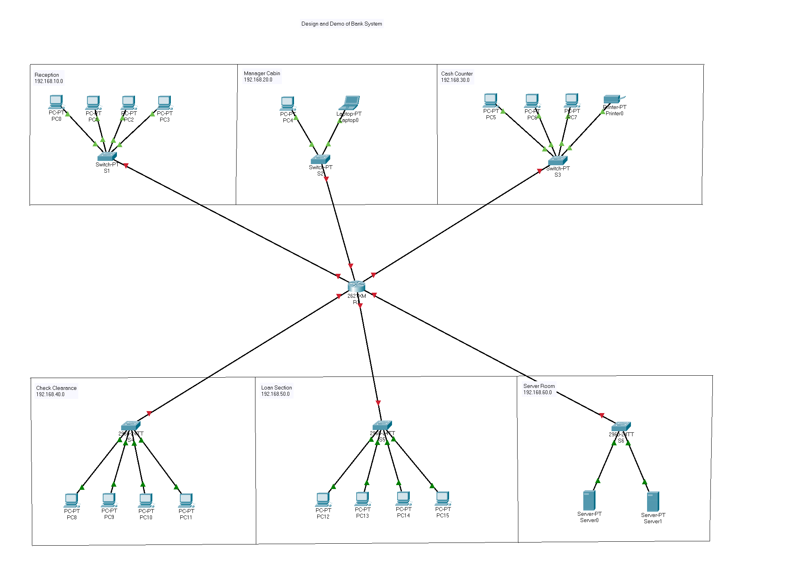

Fig 1. Bank Network Structure

Dynamic Host Configuration Protocol is a network management protocol used to automate the process of configuring devices in IP network. Here we have configured dhcp protocol in the router for all the devices. Now whenever a device is added in the network, dhcp protocol automatically assigns ip address to it. Below figure shows an example where dhcp request is successful after clicking on dhcp option.

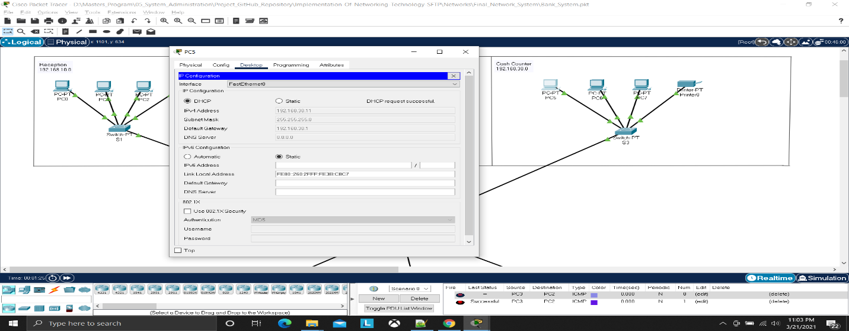

Fig 2. DHCP IP assigning

To ensure that all the devices in the network are connected and able to transfer data with other for day to day operation for that we can ping devices and verify. In the below figure i have opened the command prompt of PC12 which is present in Loan section and pinging PC0 which is present in Reception section. After the ping command, PC0 is replying to us, which ensures the devices are connected and working fine.

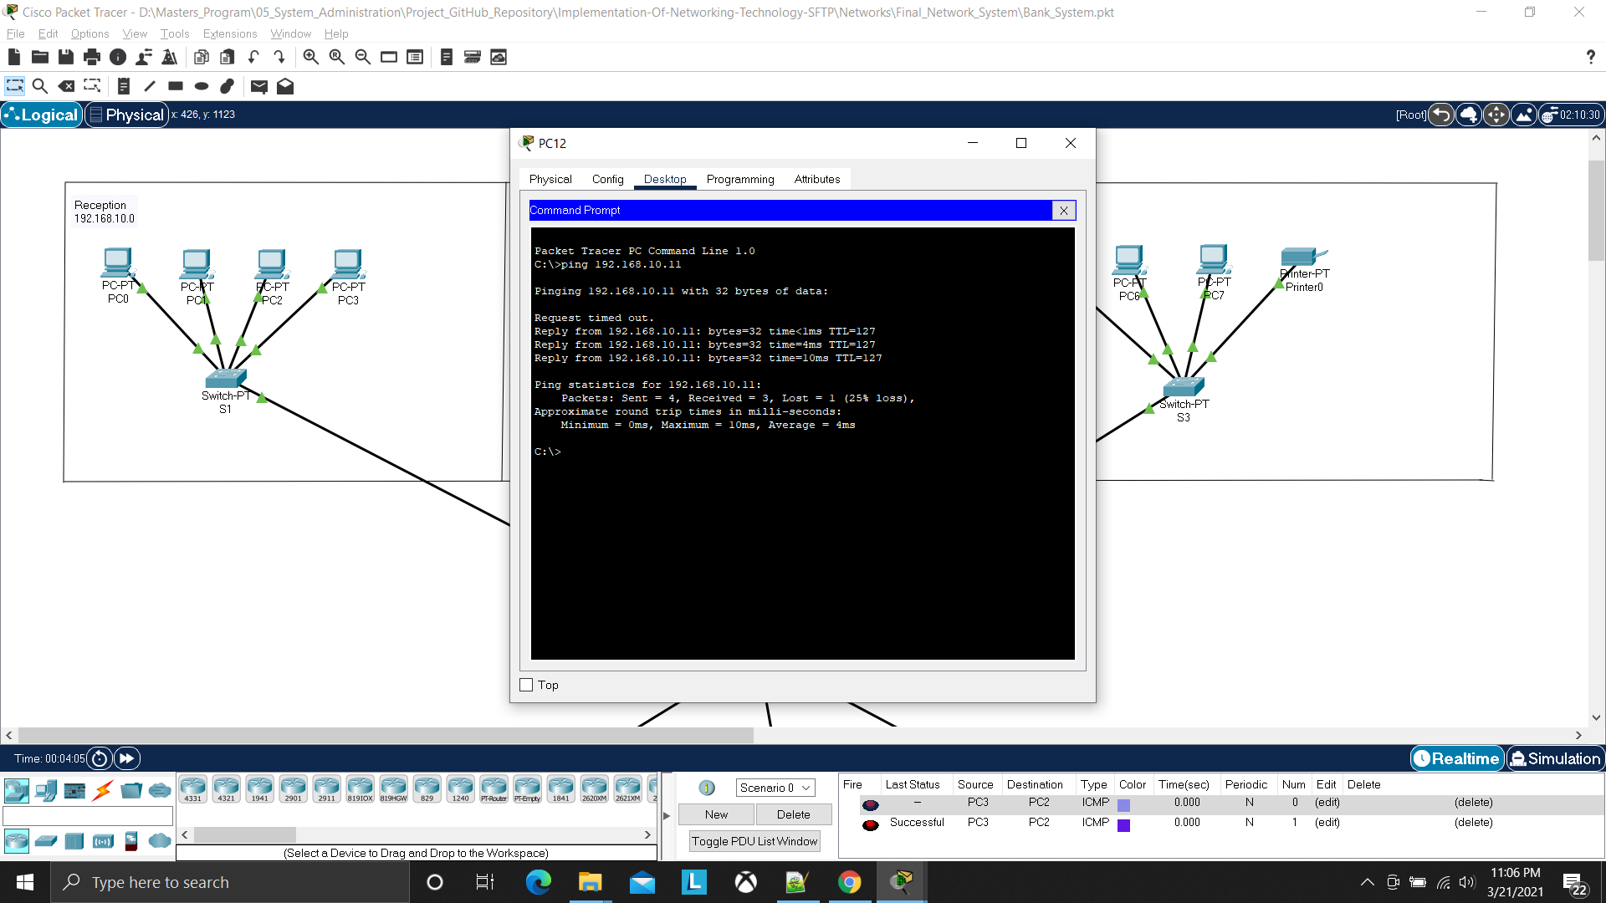

Fig 3. Ping Device

Simulation is one of the feature which is present in cisco packet tracer. With simulation we can show the flow of packets in the network. In the below figure i have clicked on simulation button to show the flow of packets in our network system and we can see the flow of packets to cash counter section and reception section.

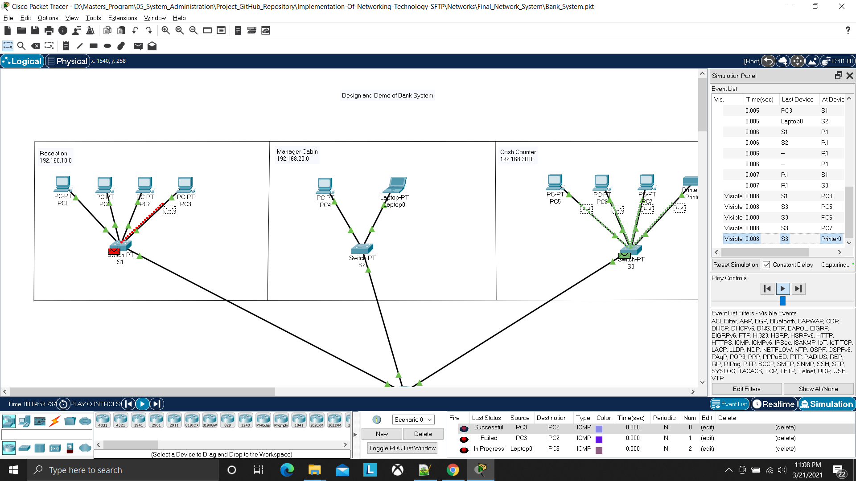

Fig 4. Simulation

Domain Name System is a decentralized naming system for computers, servers or other resources which are connected to internet or private network. Here I have configured and added a record in server0 which is present in server room. We have entry with name www.banksys.com in server0 and now showing how that resource can be accessed in the manager’s cabin. In the below figure you can see how manager can access the resource just by entering name which is saved in the entry without bothering ip address of that resource.

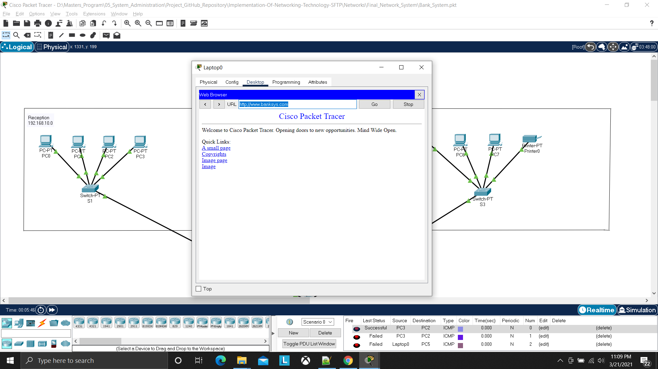

Fig 5. Domain Name System

SSH or Secure Shell is a cryptographic network protocol which gives access to operate remote system securely. In the below figure, we have configured ssh protocol in the router with 1024 cryptographic bits. With ssh configuration now i have entered command in command prompt of PC1 which is present in reception section and now i can able to do access the router which is a remote device and can perform any operations on it.

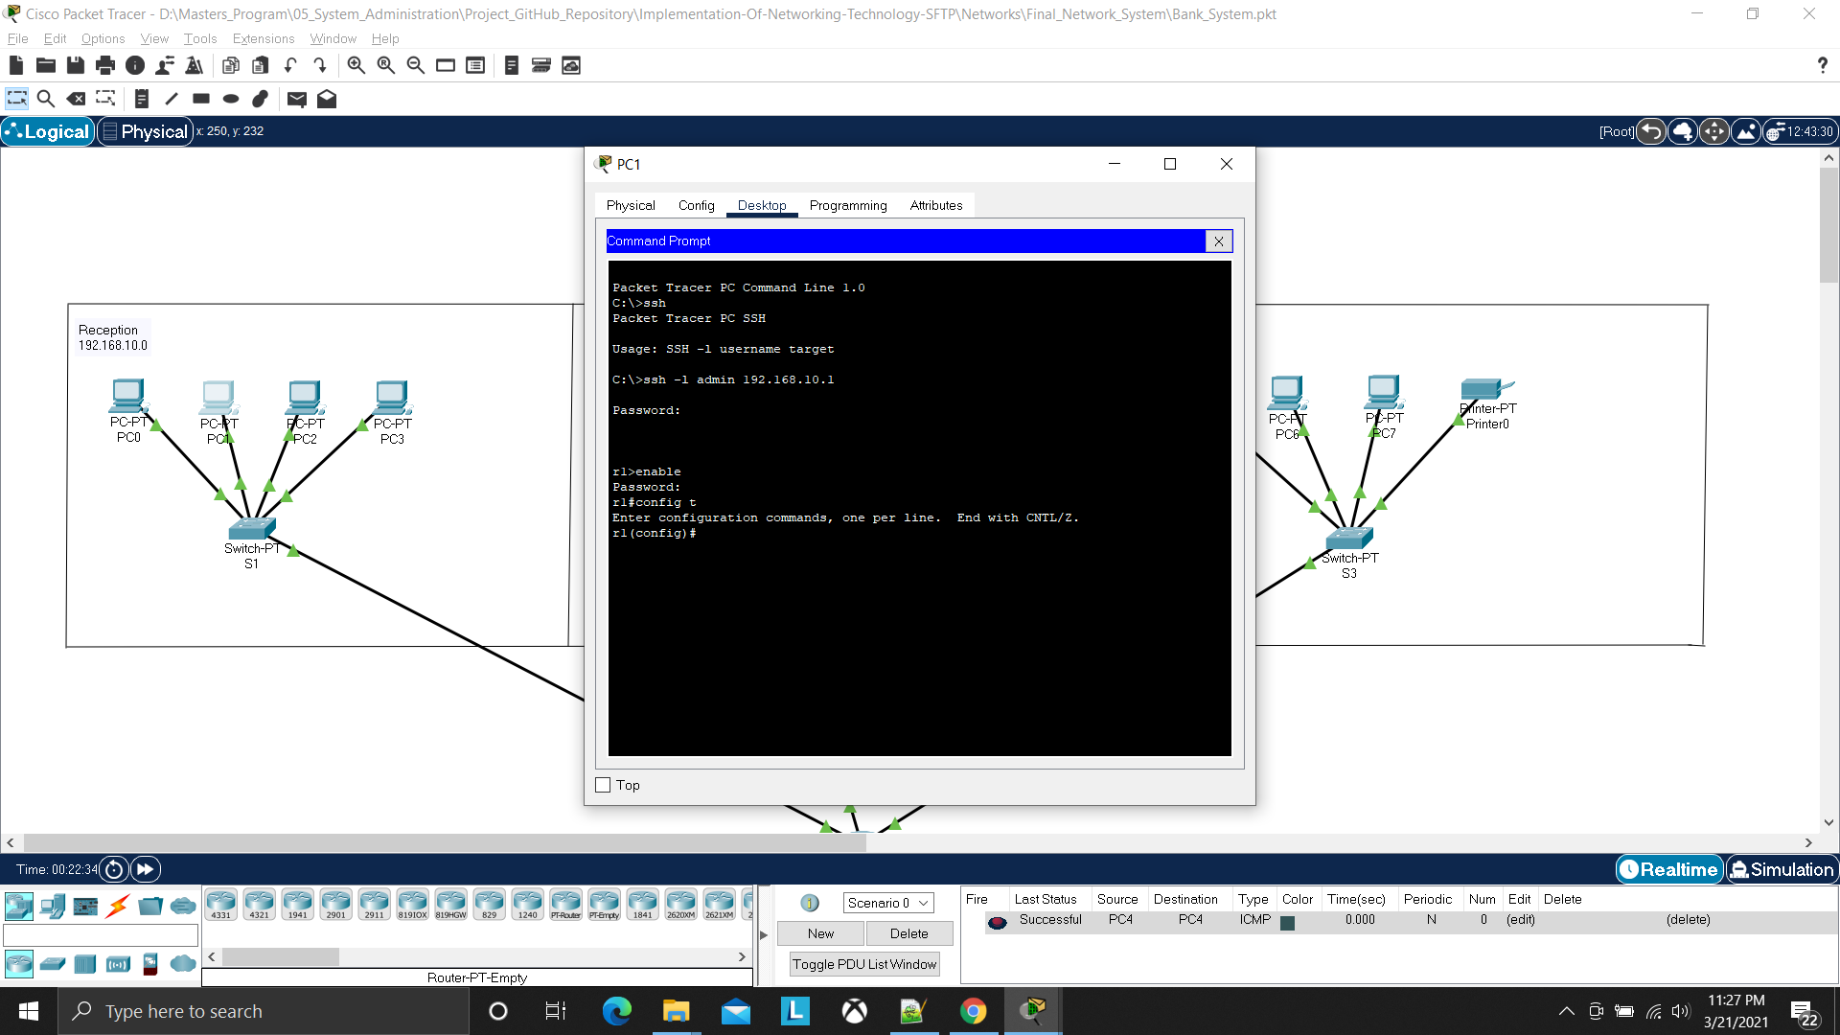

Fig 6. OpenSSH

5.2 Key features

* This is a secure bank banking system network.
* Easily manage all banking tasks/activities.
* This banking system is managed centrally.
* All the banks transactions are online.
* Saves time and cost since easy and online based.
* Manager can easily monitors all the sections.
* Easy to maintain everyday work.

**6. Value and Usability of the Artifact:**

* By referring this artifact, we can implement real time networking for any banks
* This network system is designed in such a way, so that it can manage any banking tasks.
* Since this network is central system based, it can be managed centrally not by any specific device.
* Since this was a secure way of communication, we can implement in any bank branch in real time.
* This networking system establishes relation/connection between all the sections within a branch.
* Online based day to day transmission
* Saves time and cost because of online based system.
* Online based updates and maintains everyday work

**7. Learning Experience**

I would want to thank our lecture Obinna Izima who has given us the opportunity to bundle up and give our personal contributions towards design and implementation of proof of concept. This project work helped me to improve my skills in the field of networking and gave me confidence to handle and implement further artifacts with these technologies. Initially failed to implement but after giving many attempts came to a result. These failed attempts are part of learning process. Since networking area was new to me, I felt interesting in understanding small things like end devices, switches, routers , IP address, classful IP addresses, DNS, DHCP, SSH etc. After this artifact development, got complete idea how a real world networking system works.

**8. Conclusion**

As per the requirement, Bank system network is designed and implemented with mentioned technologies that is DHCP with DNS and SSH.

**9. References and Bibliography**

* Microsoft.2020. Understanding IP addressing and sub netting basics

https://docs.microsoft.com/en-us/troubleshoot/windows-client/networking/tcpip-addressing-and-subnetting

* Networking Academy (No Date). Getting familiar with cisco packet tracer

https://www.netacad.com/courses/packet-tracer/introduction-packet-tracer

* www.netmanias.com.2013. Understanding DHCP basic operations of dhcp

https://www.netmanias.com/en/post/techdocs/5998/dhcp-network-protocol/understanding-the-basic-operations-of-dhcp

* Computer Networking.2018. Configuration ssh in switch and router

https://computernetworking747640215.wordpress.com/2018/07/05/secure-shell-ssh-configuration-on-a-switch-and-router-in-packet-tracer/

* learningnetwork.2020. Configuration of dns and dhcp basics

https://learningnetwork.cisco.com/s/question/0D53i00000KsvSS/configuring-dns-with-dhcp-in-packet-tracer-62

**10. Appendices Note**

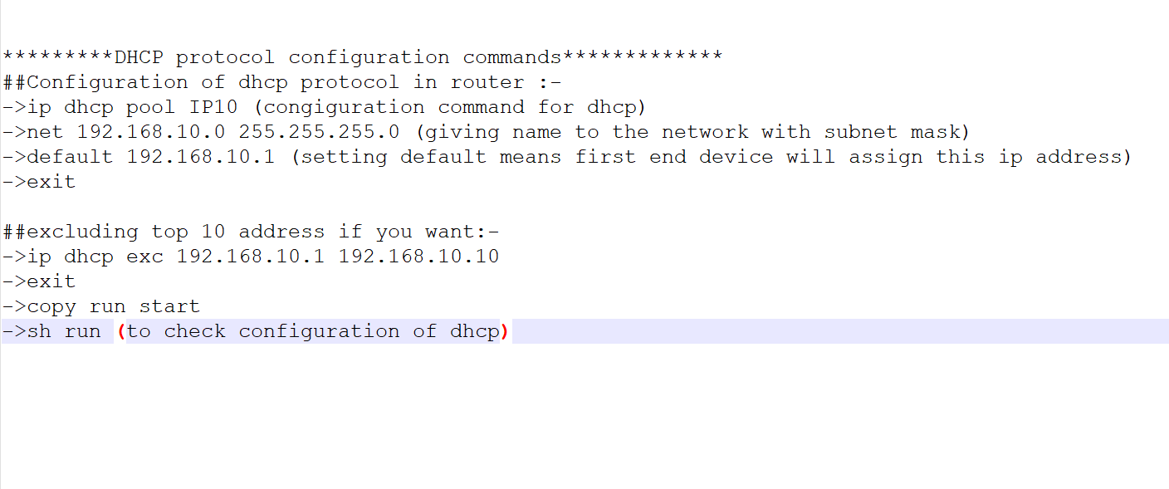

Fig 7. DHCP Configuration Commands

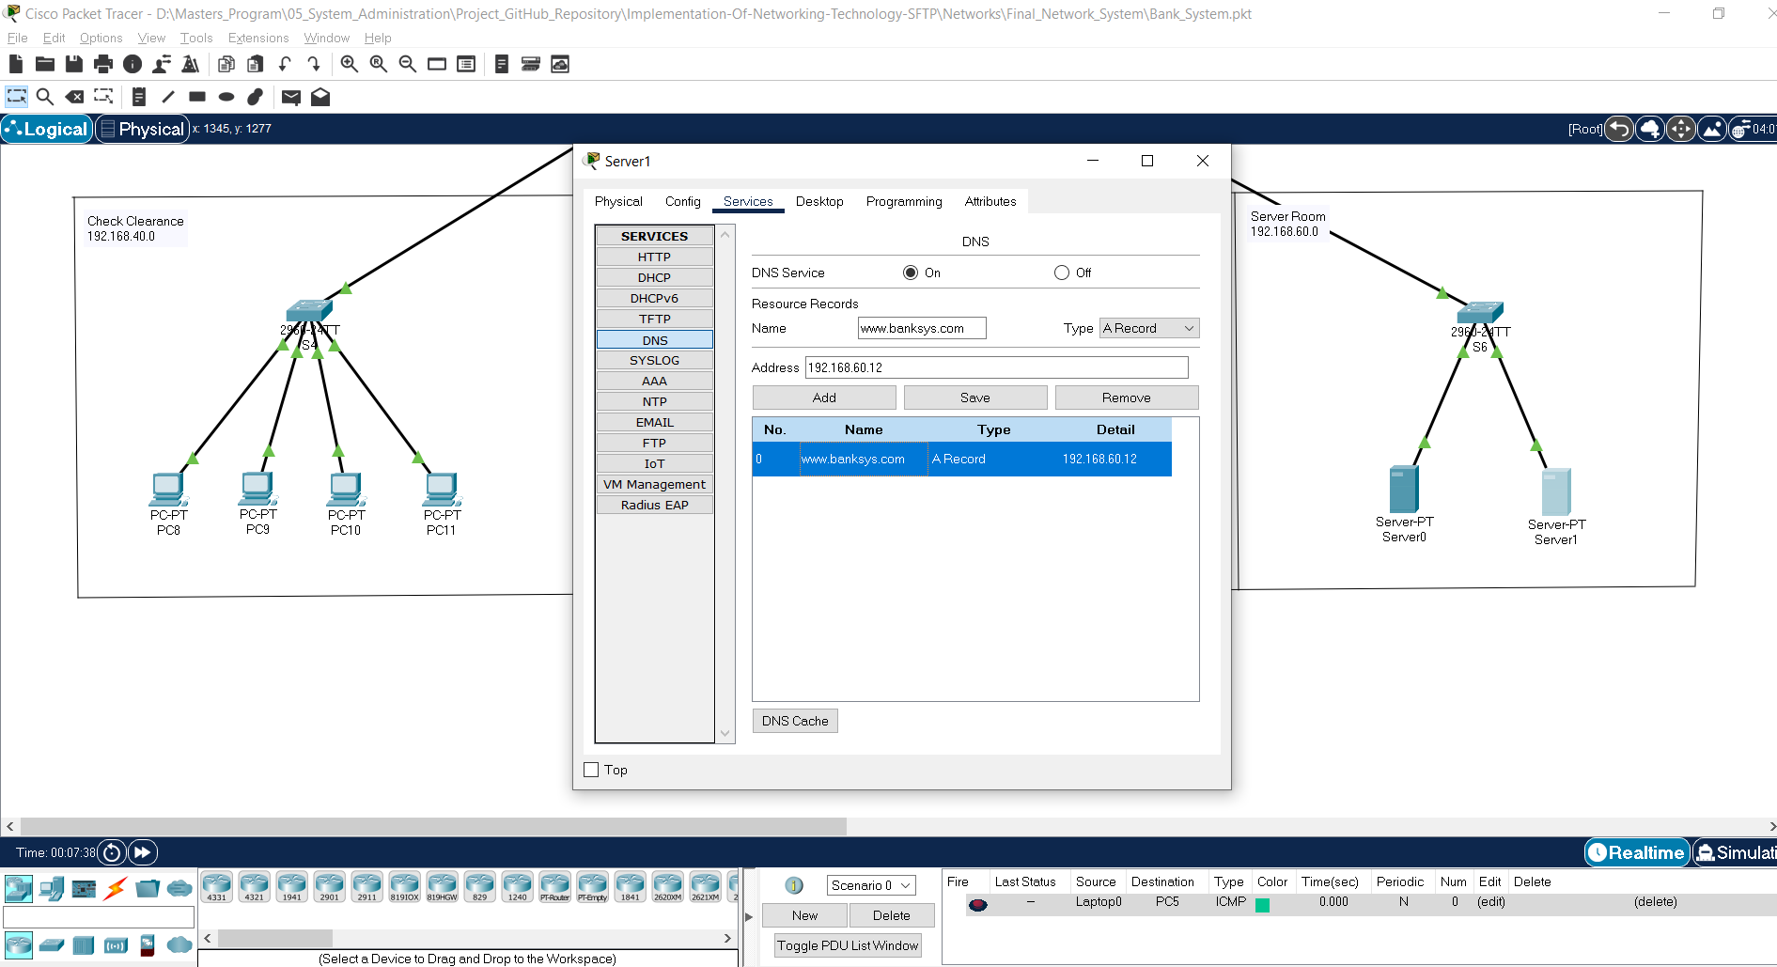

Fig 7. DNS Configuration in server

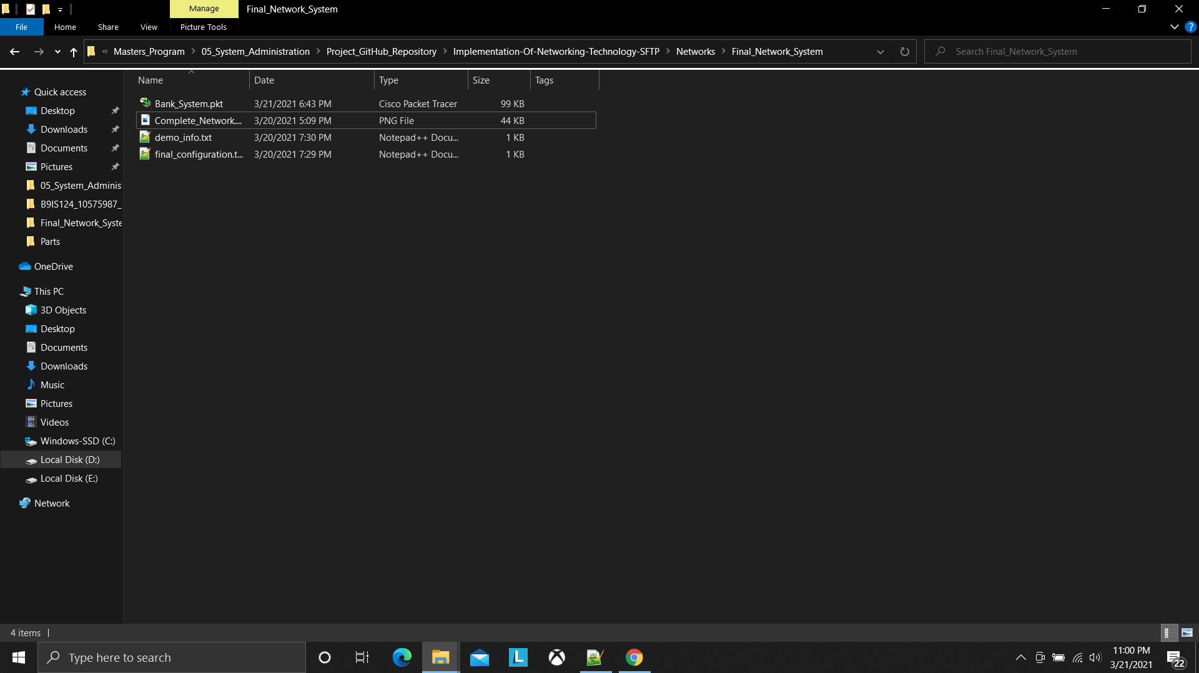

Fig 8. Folder Structure

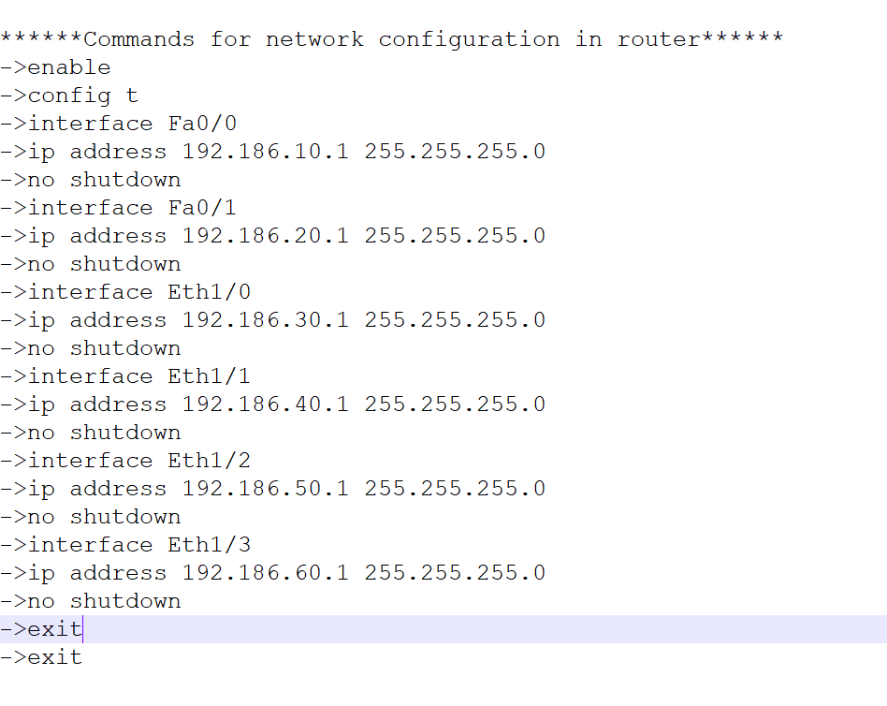

Fig 9. Network Configuration Commands

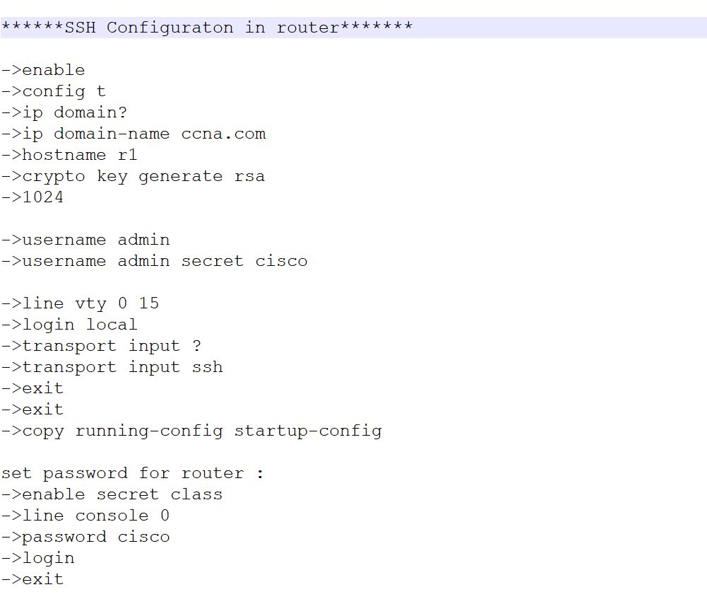

Fig 10. SSH Configuration Commands