**III. DESIGN PHARSE**

**Class Diagram**

A class diagram is a description of relationship between different classes. It is a static diagram which represent static view of system. It describes the attributes and operations of class. It also shows a collection of classes, interface, association

**Initial Class Diagram**

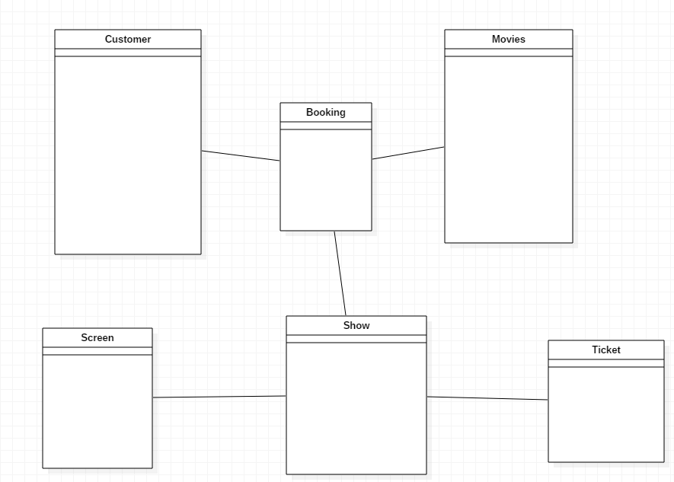

Figure : Initial Class Diagram

**Final Class Diagram**

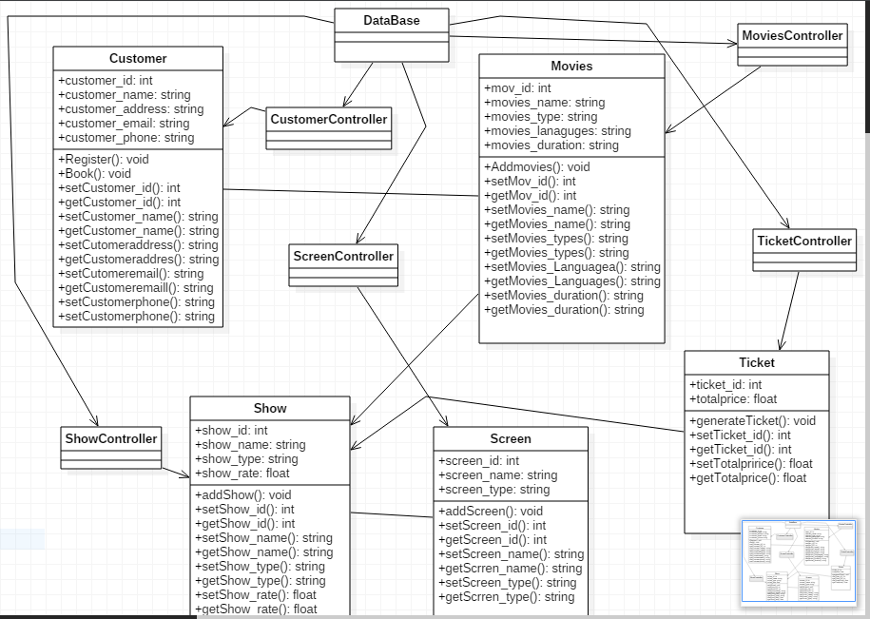

Figure : Final Class Diagram

**ER DIAGRAM**

Entity Relationship Diagram also called as ERD, ER Diagram or ER model, is a type of structural diagram for use in database design.  A basic ER model is composed of entity types and specifies relationships that can exist between entities.

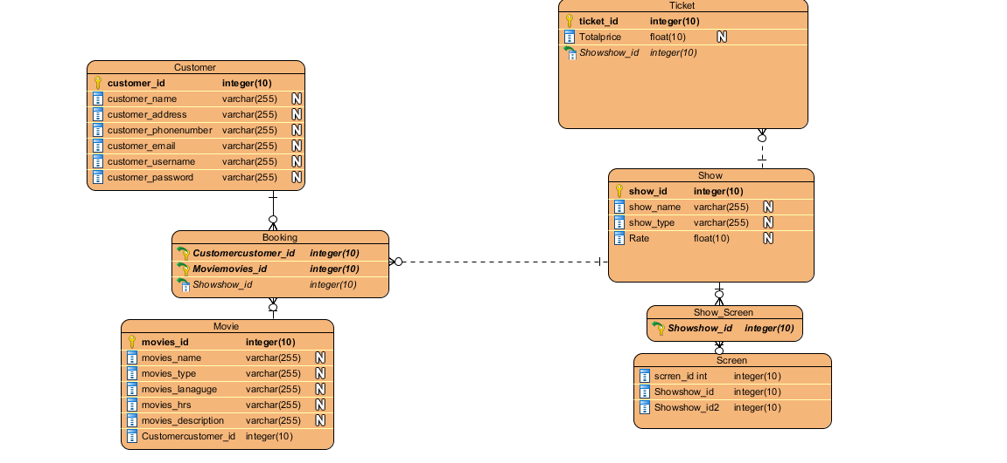

Figure : ER-diagram

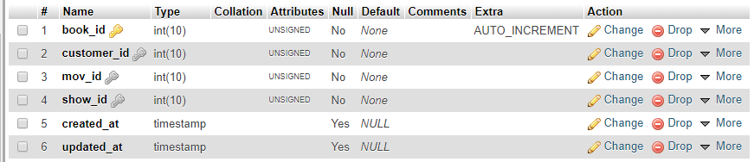

Figure : Booking Table

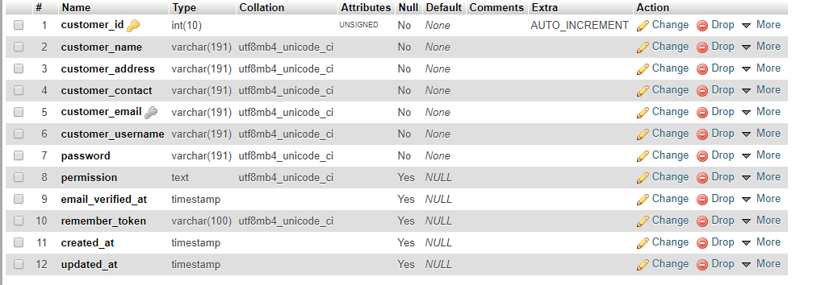

Figure : Customer Table

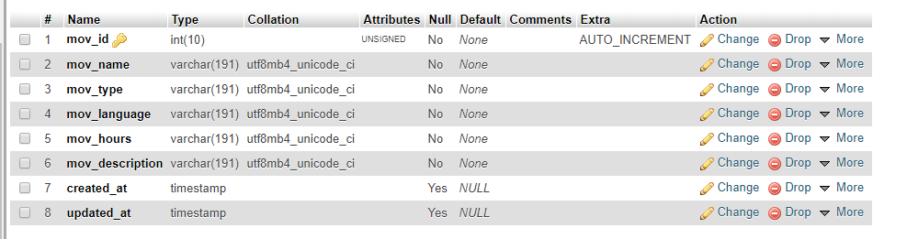

Figure : Movies Table

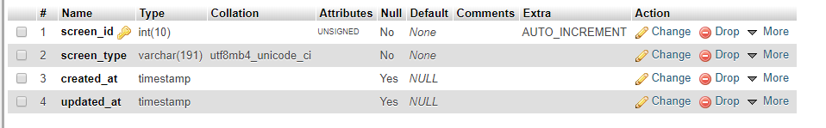

Figure : Screen Table

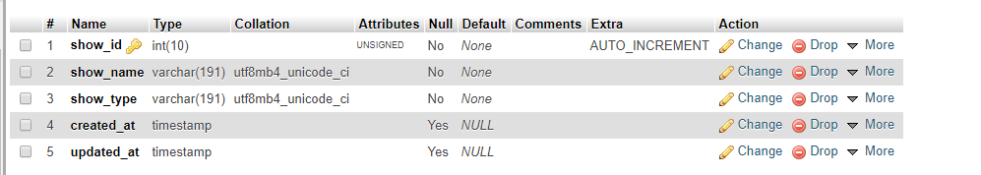

Figure :Show Table

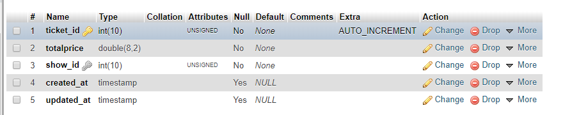

Figure : Ticket Table