- Mass Timings :
Table name : mass_timing
Column : Intention
This column will have values ‘GENERAL’ , ‘NOVEENA’, ‘GOOD FRIDAY’,’EASTER’,’CHURCH FEAST’, ‘CHRISTMAS’ etc. The value ‘GENERAL’ will have standard mass timings . The other intentions if added latest ( updated_at greater than current_date ) will be displayed on top beside the snap which is selected for the special occasion. Tamil Will not be there its just for display. For now we have language ‘MARATHI’ only , but in future we might have ‘ENGLISH’ language added.
Special Occasion Snap | 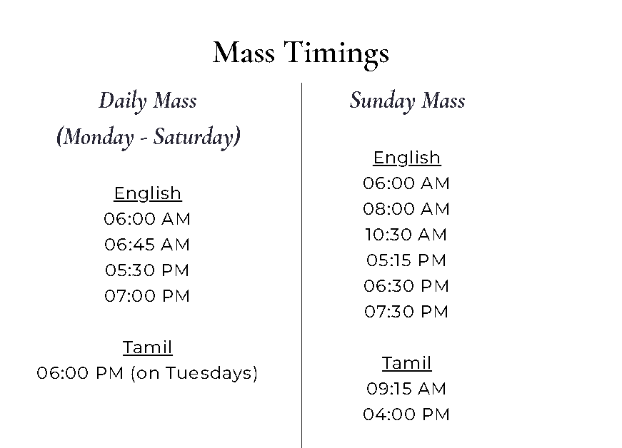

Action Items :
- Need to create forms to enter data for Admin Role.
- Any Clarifications to be discussed.

2.Cells & Association
Table : cell_association
Data : Data Insertion done . we need to have a form for modifications if any .
We need to give a more better UI experience to this page.

Action Items :
- Data insertion done . Updates to some columns in progress
- Need to give a form for data updations
- Better UI experience.

3.Communities
Table : community
Data : Data Insertion done . we need to have a form for modifications if any .
We need to give a more better UI experience to this page.

Action Items :
- Data pending.
- Need to give a form for data updations
- Better UI experience.

